

INVENTORY MANAGEMENT SYSTEM

Visual Programming project





BS Computer Science

Section: B

Group: 9

Contents

1. Chapter 1: Introduction.................................................................3
   1. INTRODUCTION…….……………………………..…………………3
   2. BACKGROUND…………………………………………………….…4
   3. OBJECTIVES………………….……………………………………..5
   4. Scope………………………………………………………………....6
   5. Summary…………………………………………………………...7
2. Chapter 2:

DATABASE Design......................................................11

1. Chapter 3: Simulation............................................................17
2. Chapter 4: Conclusion...........................................................25
   1. References…………………………………..……………25

**Database Report:**

**Products:**

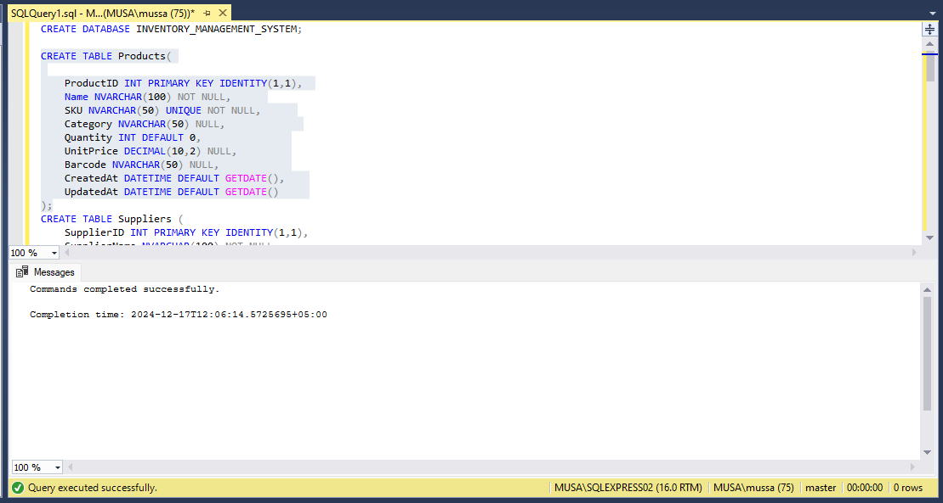

**Suppliers:**

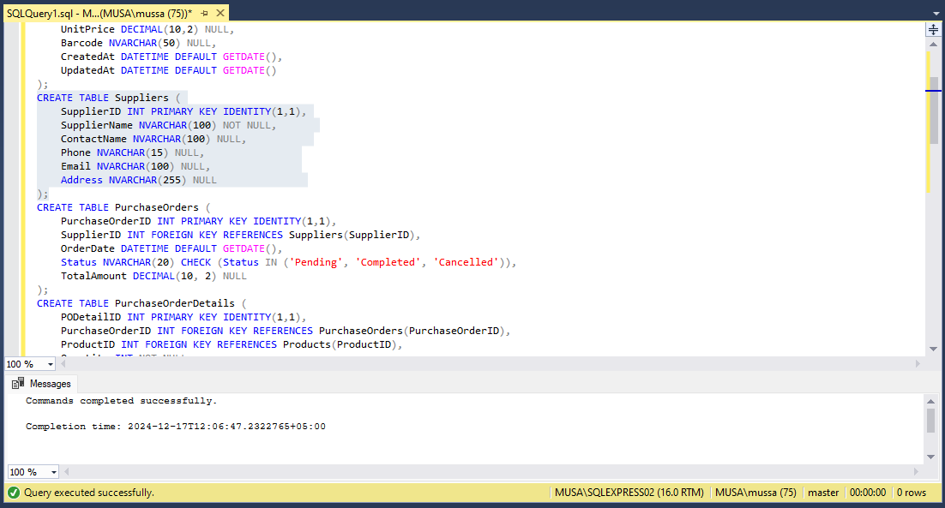

**Purchase Orders:**

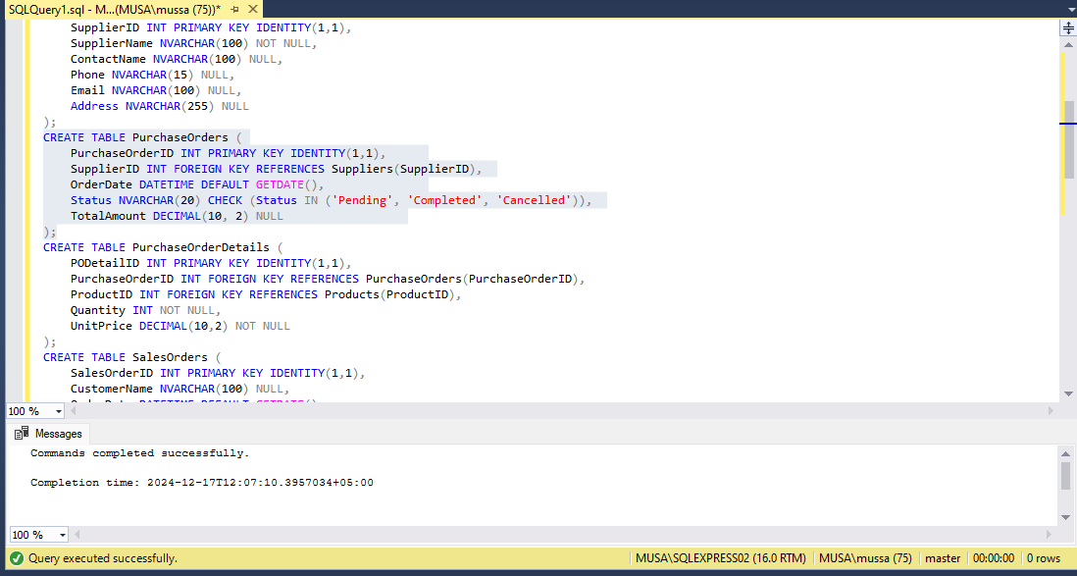

**PurchaseOrderDetails:**

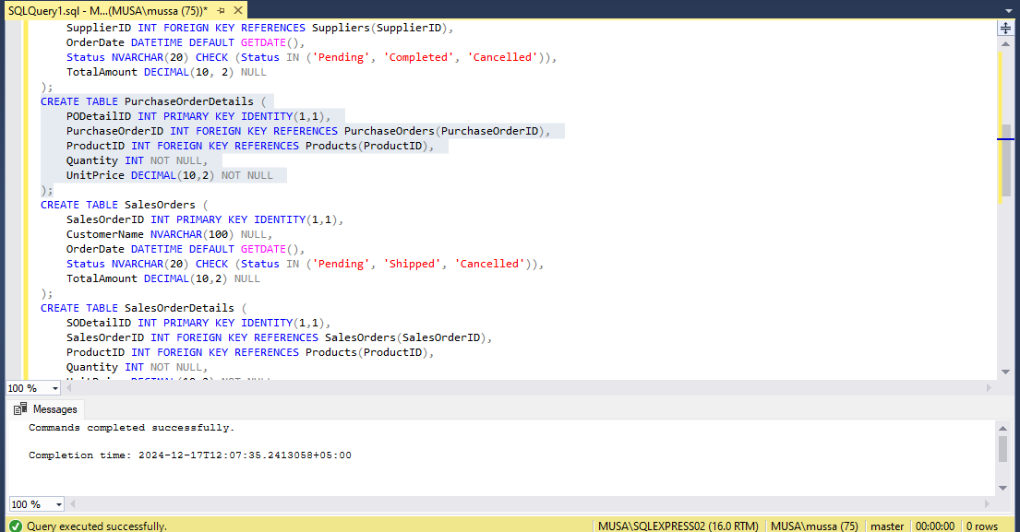

**Sales Orders:**

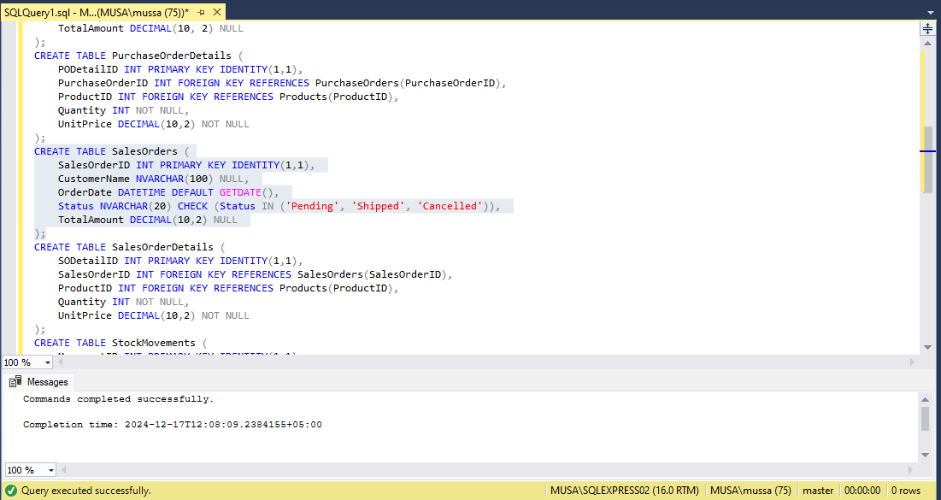

**SalesOrderDetails:**

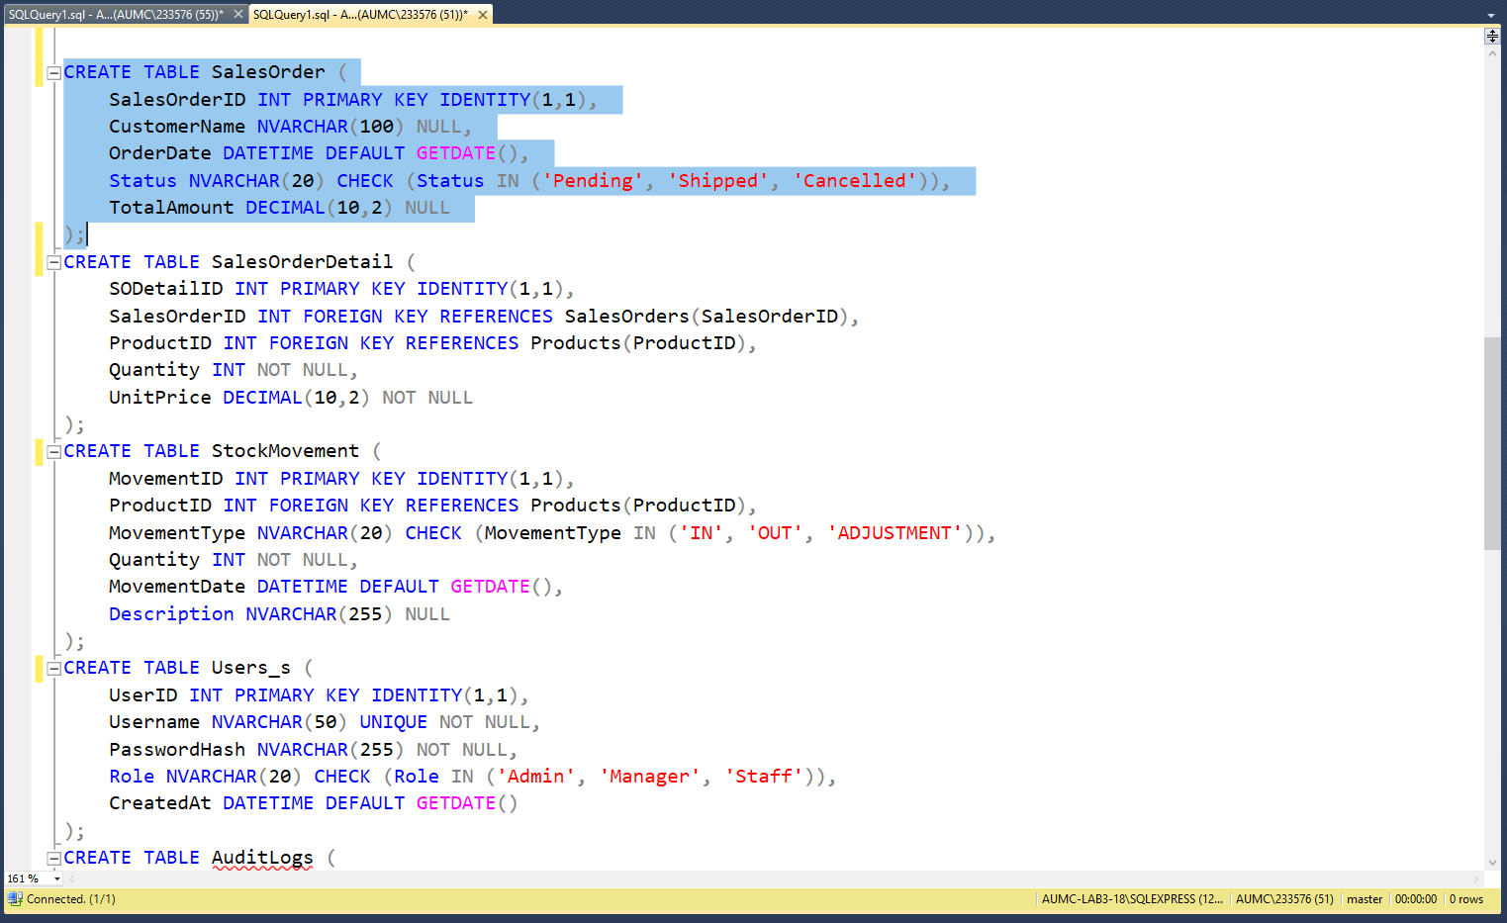

**Stock Movements:**

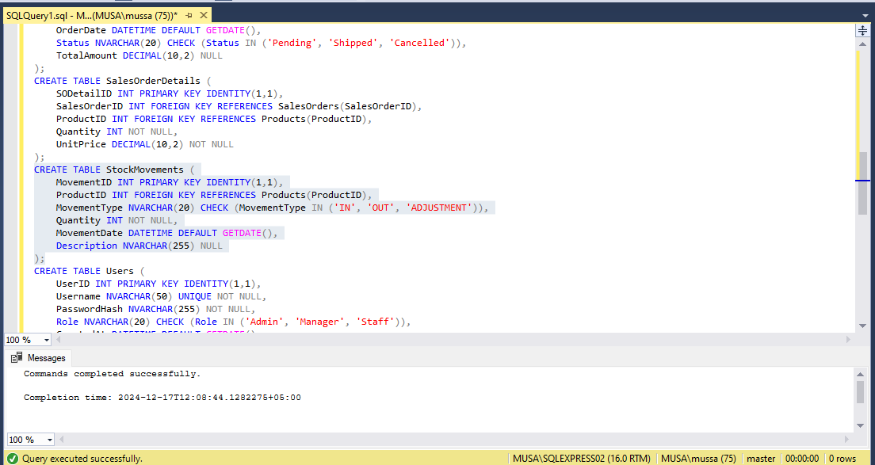

**Users:**

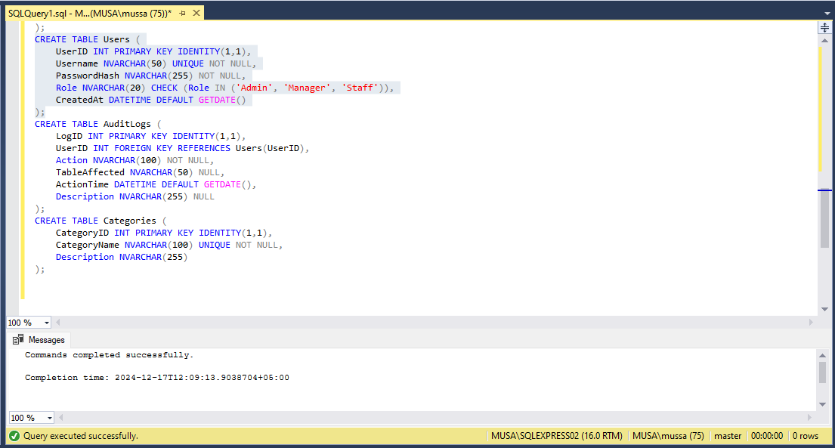

**Audit Logs:**

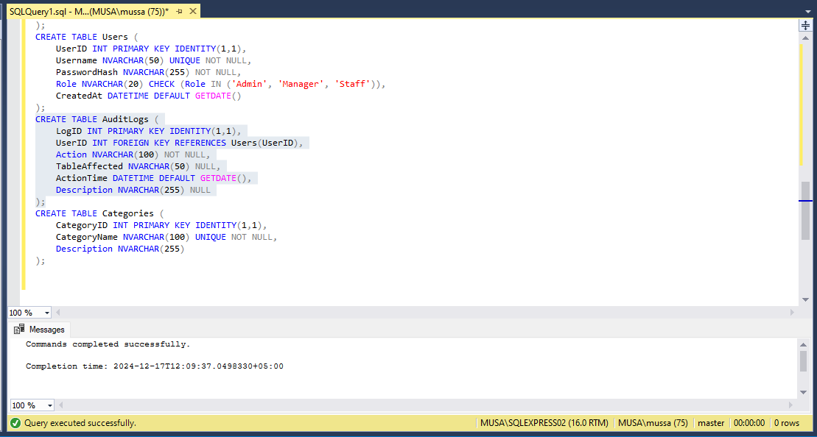

**Categories:**

