
Project Title:
Plan to Minimize the Harmful Effects of Social Media Use
Submitted by:
233576 MUSA BIN ABDULLAH
233588 M. DANIAL
233514 M. MUZAMIL
233578 M. ARBAB
233546 M. JAVED
Group No:
09
Submitted to:
Dr.Imran

Contents:
Project Title: Plan to Minimize the Harmful Effects of Social Media Use 3
1. Introduction: 3
2. Problem Statement: 3
2.1 High Daily Usage Among Youth: 3
2.2 Reduced Civic Awareness and Reading Habits: 3
2.3 Physical Health Decline: 3
2.4 Mental Health Risks: 3
2.5 Dangerous & Misleading Content: 4
3. Project Objectives: 4
4. Awareness-Based Strategy: 4
4.1 Self-Assessment: 4
4.2 Identify Core Needs: 4
4.3 Use of Healthy Alternatives: 4
4.4 Managing Digital Urges: 5
4.5 Gradual Usage Control: 5
5. Implementation Plan (Gantt Chart): 5
6. Conclusion: 6

Project Title: Plan to Minimize the Harmful Effects of Social Media Use

1. Introduction:
A Plan to Minimize the Harmful Effects of Social Media Use aims to reduce the over-dependence on digital platforms, especially among youth. With the rise of smartphone usage, social media has become deeply integrated into daily life—affecting mental focus, physical health, sleep cycles, and real-world engagement. This project offers practical strategies to help users become more mindful of their habits, reclaim their time, and nurture a balanced digital life.

2. Problem Statement:
In Pakistan, 75.9% of youth and 92% of teenage internet users access social media daily. Overuse is not only linked to mental and physical issues but also diminishes productivity, weakens real-world relationships, and promotes misinformation.

2.1 High Daily Usage Among Youth:
Teenagers spend over 6 hours daily on social media, significantly impacting their focus and real-life interactions.

2.2 Reduced Civic Awareness and Reading Habits:
Social media fosters short attention spans. Youth prefer quick content, avoid deep reading, and are less engaged in civic activities.

2.3 Physical Health Decline:
Prolonged use leads to:
- Muscle weakness
- Chronic back pain
- Poor posture
- Sleep disruption due to nighttime screen exposure

2.4 Mental Health Risks:
Excessive use can cause:
- Social media addiction
- Cyberbullying
- Unhealthy self-image and comparisons
- Decline in empathy and social skills

2.5 Dangerous & Misleading Content:
Social media exposes youth to:
- Fake news and scams
- Risky trends and drug normalization
- Inappropriate adult content and hate speech

3. Project Objectives:
- Reduce screen time to under 2 hours/day
- Replace digital distractions with healthy, real-world activities
- Raise awareness of risks related to social media overuse
- Encourage critical thinking and digital hygiene practices
- Improve sleep, mental health, and physical well-being

4. Awareness-Based Strategy:

4.1 Self-Assessment:
Encouraging users to:
- Track usage
- Understand motivations (boredom, validation, escape)
- Reflect on post-use feelings

4.2 Identify Core Needs:
Recognizing real needs behind scrolling:
- Connection → Talk to family or friends
- Entertainment → Read, paint, play sports
- Validation → Celebrate wins offline

4.3 Use of Healthy Alternatives:
Promoting:
- Journaling, breathing exercises, gratitude writing
- Screen-free time before sleep
- Positive offline habits

4.4 Managing Digital Urges:
Tactics include:
- Visualizing a blank screen
- Using the 5 senses technique for grounding
- Banning morning phone usage
- Mute unnecessary notifications

4.5 Gradual Usage Control:
- Set time limits with digital wellbeing apps
- Replace usage time with hobbies
- Track progress with a 7-day screen detox challenge

5. Implementation Plan (Gantt Chart):

No. | Activity | Predecessor | Duration
1 | Data Collection on Youth Usage | None (Project Start) | 2 week
2 | Problem Analysis & Risk Mapping | Data Collection | 3 week
3 | Strategy Design & Steps Formulation | Problem Analysis | 2 weeks
4 | Visual Content and Campaign Creation | Strategy Design | 3 weeks
5 | Execution of Awareness Program | Content Creation | 2 weeks
6 | Tracking and Feedback Collection | Program Execution | 2 week
7 | Report Finalization and Submission | Feedback Collection | 1 week

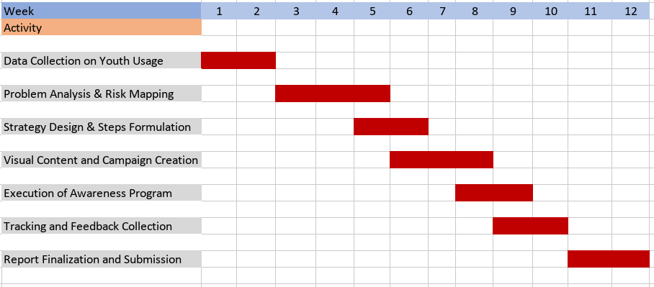

6. Conclusion:
This project offers a simple, practical, and human-centered plan to help youth manage and reduce their social media use. By understanding usage patterns and emotional triggers, replacing screen time with real-life engagement, and encouraging mindfulness, users can reclaim their focus, improve sleep, restore social relationships, and build stronger communities. The 7-day challenge helps build the first steps toward a balanced digital lifestyle—one that prioritizes mental wellness, real connections, and overall health.

