
Project Title:
Scalable Enterprise Network Design
Submitted by:
233576 MUSA BIN ABDULLAH
233588 M. DANIAL
233550 AMMAR YAQUB
Group No:
09
Submitted to:
Sir Abdul Ghani
Contents:
Project Report: Jackson Company Network Infrastructure 2
1. Introduction 3
2. VLAN Design & Subnetting 3
Sydney Branch 3
Melbourne Branch 4
Brisbane Branch 4
Hong Kong Branch 4
3. DHCP Configuration 5
4. Internal Server Configuration 5
5. Routing Configuration 6
6. ACL Firewall Rules 6
7. Device Security Configuration 6
8. Wireless & VoIP 7
9. Testing & Verification 7

Project Report: Jackson Company Network Infrastructure

1. Introduction
This report presents the comprehensive network infrastructure design and configuration for Jackson Company's branches located in Sydney, Melbourne, Brisbane, and Hong Kong.
- Student ID: 233588
- VLAN segmentation for department isolation
- Subnetting using Variable Length Subnet Masking (VLSM)
- DHCP configuration for client devices
- Static and OSPF-based dynamic routing
- Internal servers for DNS and HTTP
- ACL-based firewall for security
- Basic device hardening
- Wireless access points and VoIP integration
- Final testing using simulation tools
The IP address space allocated for this project is 188.88.0.0/16, based on the student ID. All addressing schemes are derived from this base using VLSM for optimal usage.

2. VLAN Design & Subnetting

Sydney Branch
VLAN | Department | Subnet | Gateway
10 | HR | 188.88.0.0/21 | 188.88.0.1
20 | IT | 188.88.8.0/21 | 188.88.8.1
30 | Finance | 188.88.20.0/21 | 188.88.20.1
40 | Admin | 188.88.16.0/22 | 188.88.16.1
50 | Servers | 188.88.36.0/25 | 188.88.36.1
60 | Guest WiFi | 188.88.32.0/21 | 188.88.32.1

Melbourne Branch
VLAN | Department | Subnet | Gateway
10 | HR | 188.88.64.0/19 | 188.88.64.1
20 | IT | 188.88.96.0/23 | 188.88.96.1
30 | Finance | 188.88.98.0/23 | 188.88.98.1
40 | Admin | 188.88.100.0/23 | 188.88.100.1
50 | Servers | 188.88.102.0/25 | 188.88.102.1
60 | Guest WiFi | 188.88.104.0/23 | 188.88.104.1

Brisbane Branch
VLAN | Department | Subnet | Gateway
10 | HR | 188.88.76.0/20 | 188.88.76.1
20 | IT | 188.88.80.0/23 | 188.88.80.1
30 | Finance | 188.88.82.0/23 | 188.88.82.1
40 | Admin | 188.88.84.0/23 | 188.88.84.1
50 | Servers | 188.88.86.0/25 | 188.88.86.1
60 | Guest WiFi | 188.88.88.0/23 | 188.88.88.1

Hong Kong Branch
VLAN | Department | Subnet | Gateway
10 | HR | 188.88.96.0/23 | 188.88.96.1
20 | IT | 188.88.100.0/23 | 188.88.100.1
30 | Finance | 188.88.102.0/23 | 188.88.102.1
40 | Admin | 188.88.104.0/23 | 188.88.104.1
50 | Servers | 188.91.36.0/25 | 188.91.36.1
60 | Guest WiFi | 188.88.108.0/23 | 188.88.108.1

3. DHCP Configuration
DHCP services are enabled for all client-facing VLANs using Layer 3 switches. Static reservations are used for servers. DNS settings for each branch:
Branch | DNS Server IP
Sydney | 188.88.36.12
Melbourne | 188.88.64.12
Brisbane | 188.88.90.12
Hong Kong | 188.88.106.12

4. Internal Server Configuration
Each branch hosts 6 core servers on VLAN 50:
Service | Sydney | Melbourne | Brisbane | Hong Kong
DNS Server | 188.88.36.12 | 188.88.102.12 | 188.88.90.12 | 188.91.36.12
HTTP Server | 188.88.36.11 | 188.88.102.11 | 188.88.90.11 | 188.91.36.11
FTP Server | 188.88.36.13 | 188.88.102.13 | 188.88.90.13 | 188.91.36.13
Mail Server | 188.88.36.14 | 188.88.102.14 | 188.88.90.14 | 188.91.36.14
Database Server | 188.88.36.15 | 188.88.102.15 | 188.88.90.15 | 188.91.36.15
Backup Server | 188.88.36.16 | 188.88.102.16 | 188.88.90.16 | 188.91.36.16

5. Routing Configuration
All routers use OSPF for dynamic routing. Example: Sydney Router (R1)
- G0/0: 188.88.254.1 (to Core Switch)
- G0/1: 10.0.0.1 (to Melbourne)
OSPF Configuration:
router ospf 1
network 188.88.0.0 0.0.255.255 area 0
network 10.0.0.0 0.0.0.3 area 0

6. ACL Firewall Rules
Access-list applied to Server VLANs to restrict Guest VLAN access.
Example (Sydney):
ip access-list extended SERVERS_PROTECT
deny ip 188.88.32.0 0.0.7.255 188.88.36.0 0.0.0.127
permit ip any any

7. Device Security Configuration
- Hostnames configured
- Console password: class123
- VTY password: remote123
- Enable secret: cisco123
- Service password-encryption enabled
- Banner: Unauthorized access is prohibited!
- IP domain lookup disabled

8. Wireless & VoIP
- Access Points deployed in each branch for wireless clients
- Devices include , smartphone, and laptop
- IP phones configured per department

9. Testing & Verification
- DHCP IP allocation

Sydney Branch
Hr
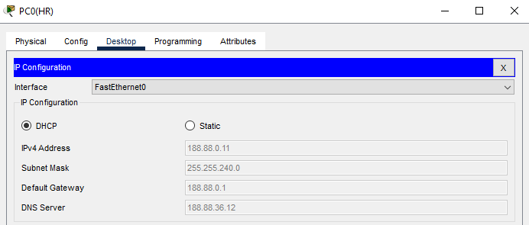
IT
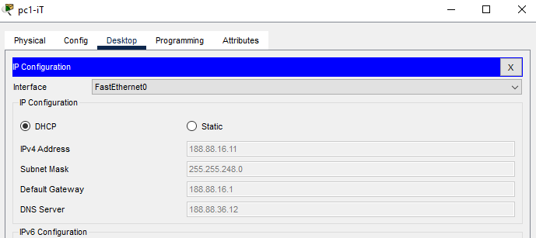

Finance
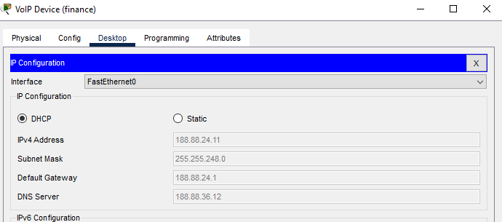
Admin
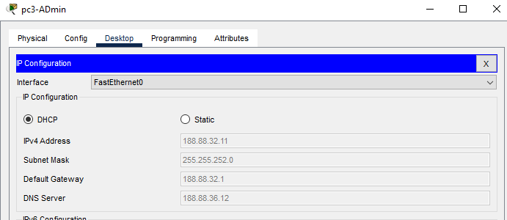

Melbourne Branch
Hr
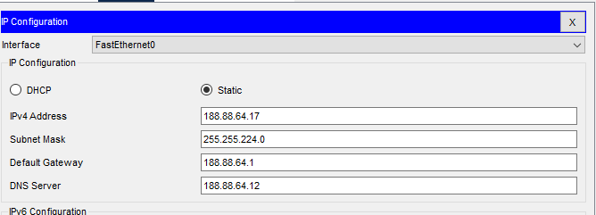
IT
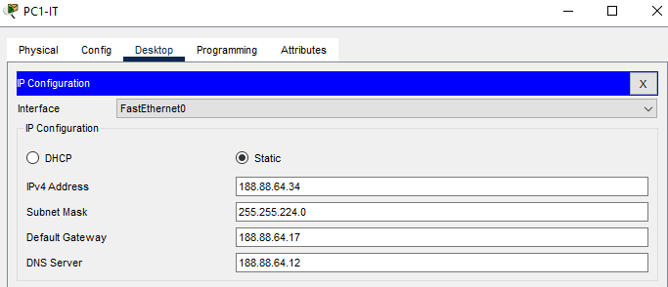
Finance
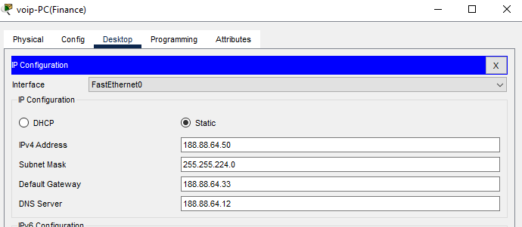
Admin
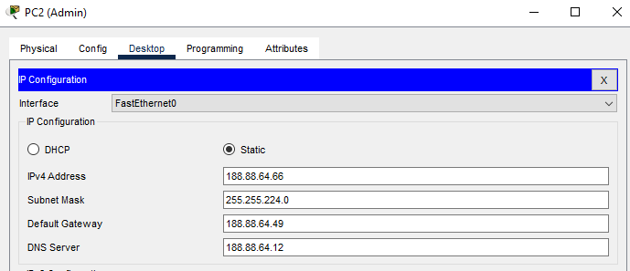

Brisbane Branch
Hr
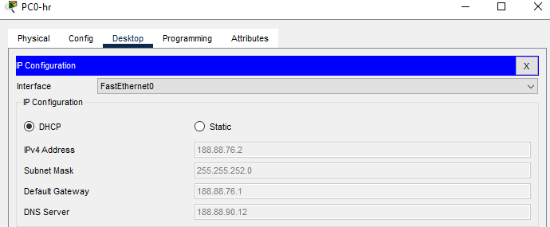
IT
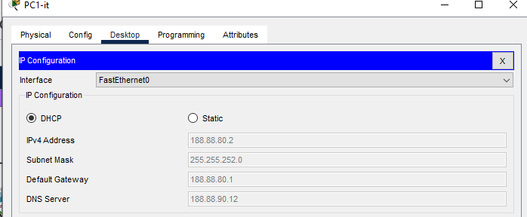
Finance
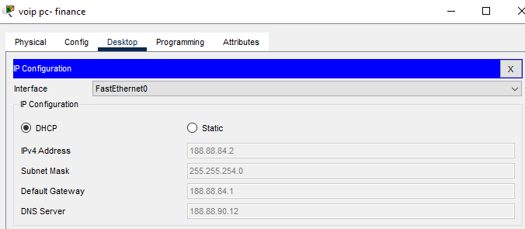
Admin
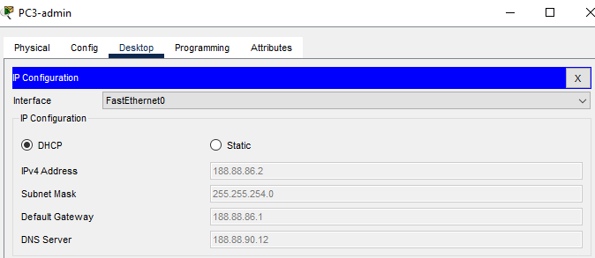

Hong Kong Branch
Hr
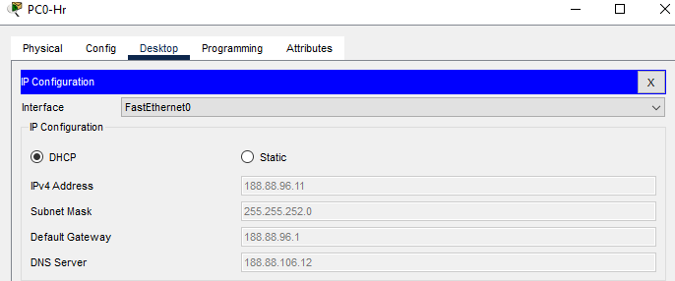
IT
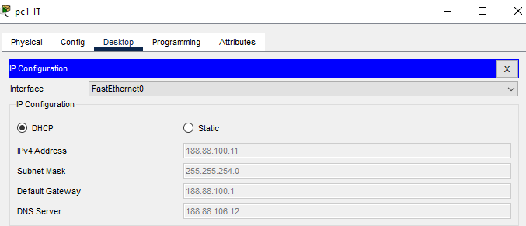
Finance
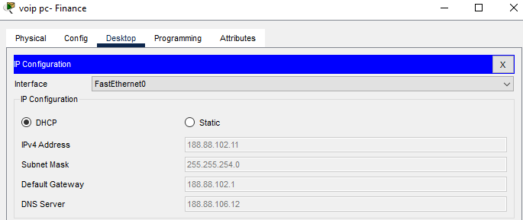
Admin
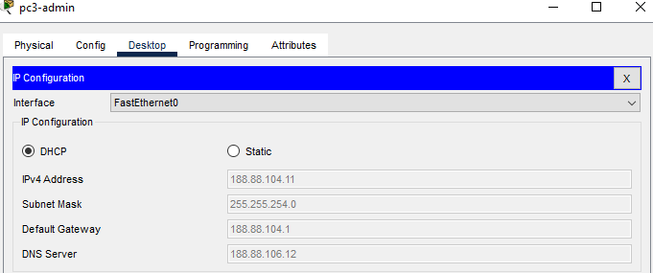
- DNS Resolution

Sydney Branch
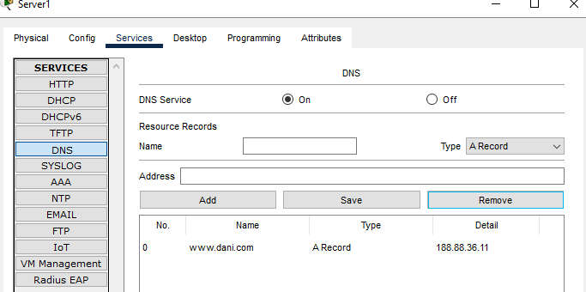

Melbourne Branch
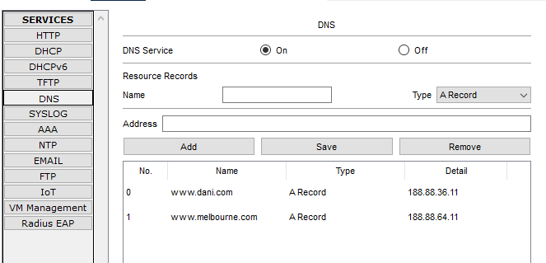

Brisbane Branch
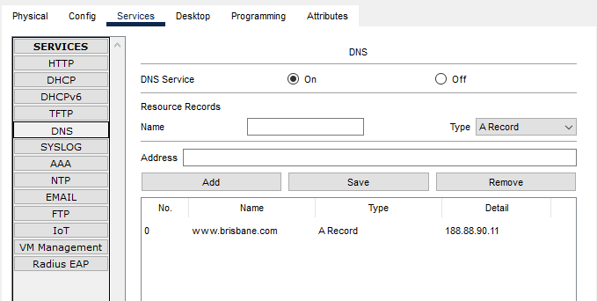

Hong Kong Branch
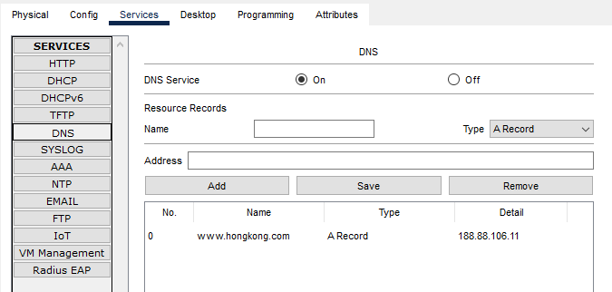

- HTTP Access

Sydney Branch
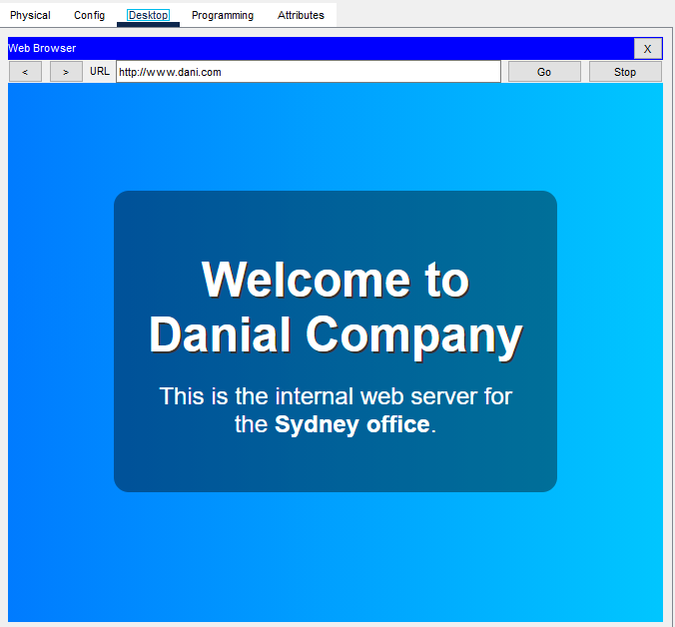

Melbourne Branch
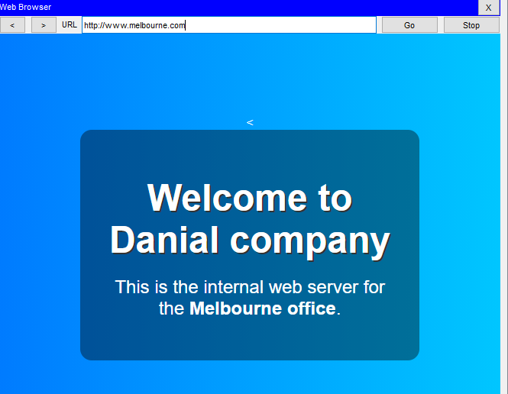

Brisbane Branch
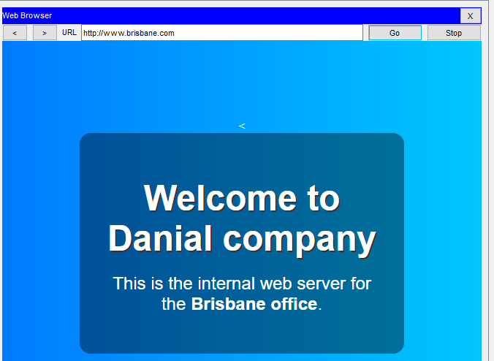

Hong Kong Branch
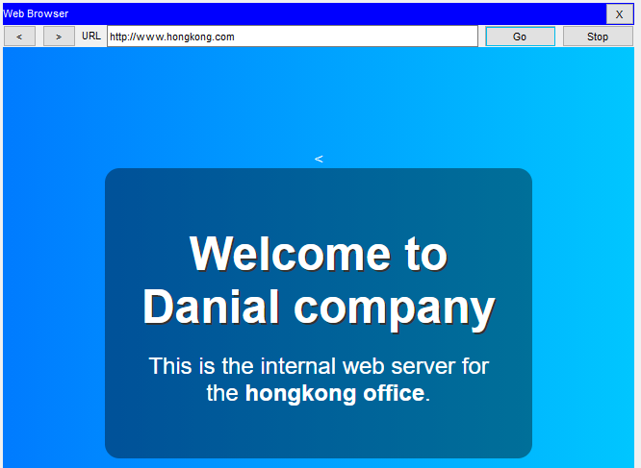

- Inter-Branch Ping
Melbourne to Sydney
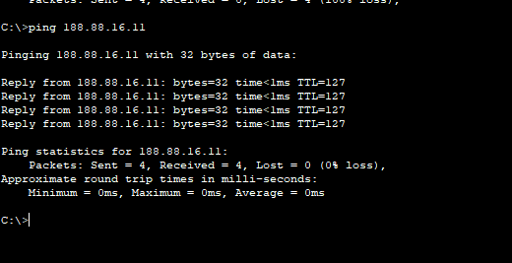

Sydney to Melbourne
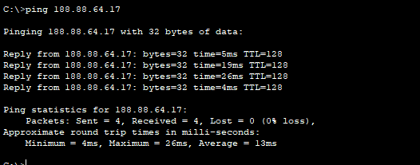
Melbourne to Brisbane
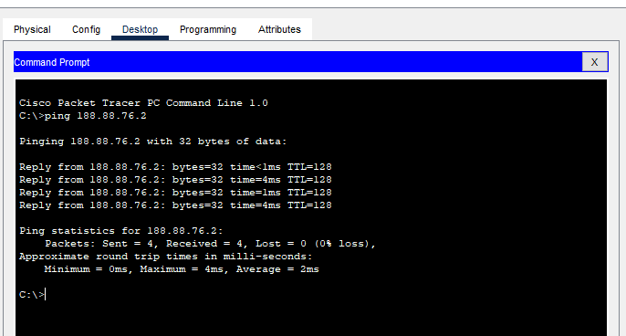
Brisbane to Melbourne

Brisbane to Hong Kong
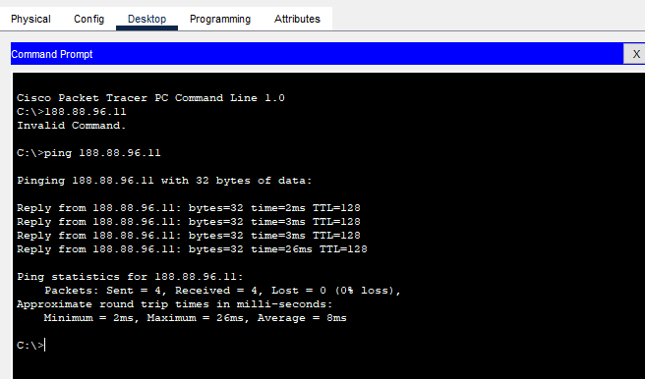
Hong Kong to Brisbane

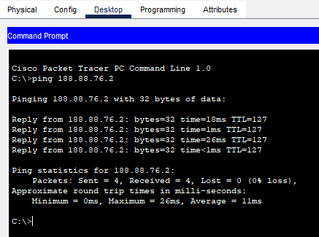

- Banner on routers

Sydney Branch
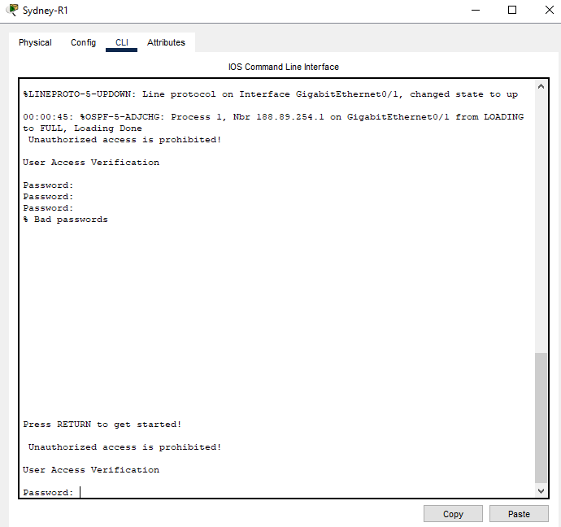

Melbourne Branch
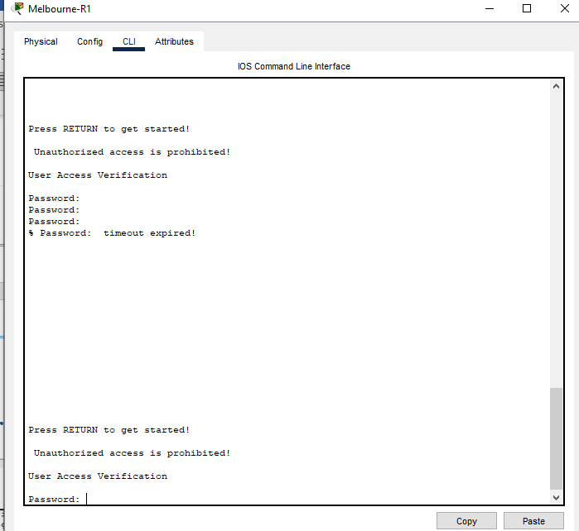

Brisbane Branch
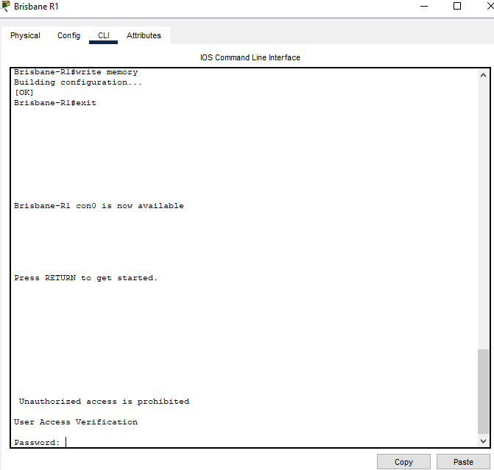

Hong Kong Branch
