LAB#09

LAB#09

**TASK#1:**

Fill the data 56781234 from 4000 to 4100 addresses.

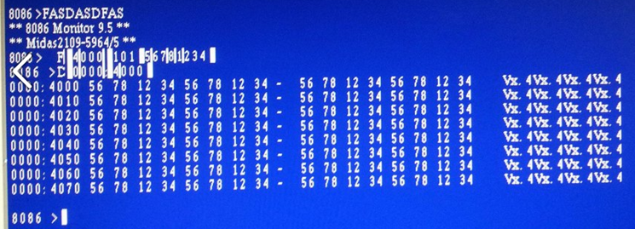

**TASK#2:**

Move the above filled data to address 2000.

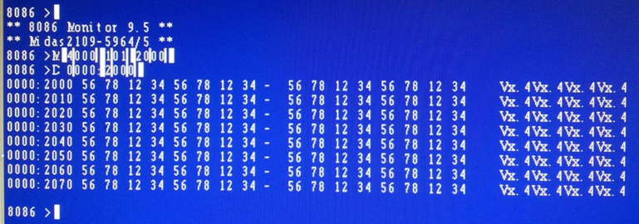

**TASK#3:**

Assume your roll number as data and fill it from 0 to 256 addresses. Note your roll no should contain four digit. Example 0001.

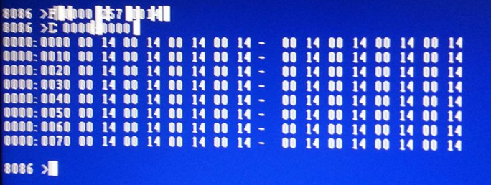

**TASK#4:**

Using the machine code of the instruction

MOV AL,3E

AND AL,0F

NOP

Perform AND operation and then Trace the instruction using T command.

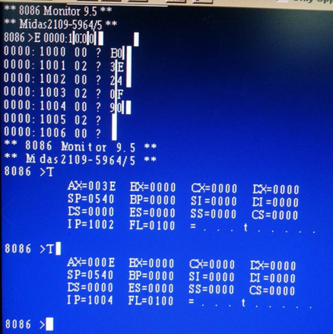

Calculation:

0011 1110 3E AL

& 0000 1111 0F BL

0000 1110 0E AL & BL

**Verified.**