**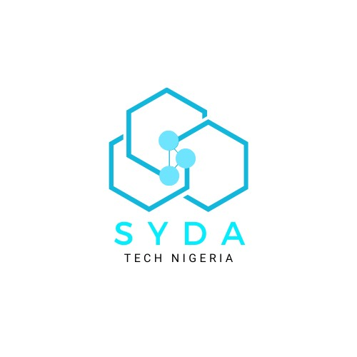  
Website Redesign & Development Proposal**

For: **Ideas and Data Global Academy**

Submitted By: **SYDA TECH**

Date: April 20, 2025

### 

### i. Executive Summary

This proposal outlines our approach to redesigning and redeveloping the official website for **Ideas and Data Global Academy**, a forward-thinking academic institution committed to excellence in research, data science, and global education.

We recognize the unique requirements of academic institutions—including the need for responsive design, accessibility, intuitive navigation, content scalability, and adherence to SEO best practices. However, beyond technical performance, this redesign is also about **enhancing the digital identity** of the academy.

Our goal is to transform the current website into a **high-performing, multilingual, and visually modern platform** that reflects the academy’s values and ambitions. The redesigned site will feature a **contemporary, user-friendly interface** that elevates the user experience while aligning with institutional branding and professionalism.

Key enhancements will include:

* **Multilingual Support**: The new site will be accessible in **English, Hausa, and Arabic**, accommodating a diverse audience and supporting the academy’s participation in initiatives like the **Arabic Spelling Bee**.
* **Engagement Features**: A dedicated **"Learn More" section** will allow prospective students or collaborators to easily **enroll** or **request consultations**.
* **Social Media Integration**: Strategically placed **social sharing buttons** will allow content to be promoted seamlessly across platforms.
* **Chatbot Integration**: An intelligent **chatbot** will be available to assist users in real time, improving access to information and support.

This redesign will not only improve functionality but also **position the academy as a modern, accessible, and globally-minded institution** online—ready to meet the expectations of students, educators, and partners in today’s digital world.

### ii. Approach and Methodology

At the heart of our work is a collaborative, strategic approach that prioritizes thoughtful ideation and problem-solving. We view each project not simply as a technical task, but as a partnership built on shared vision and mutual respect. From our first interaction, we aim to understand the unique goals, values, and challenges of **Ideas and Data Global Academy**—and from that understanding, craft solutions that exceed expectations.

Our methodology is grounded in open communication, careful listening, and deep engagement. We believe that the ideation process begins the moment we connect with your team. By asking the right questions, and listening intently (and then listening again), we ensure our solutions are not only creative and effective, but aligned with your institutional mission.

From initial concept to post-launch support, our commitment to quality and responsiveness guides every step. We bring both expertise and flexibility to the process, making the experience smooth, collaborative, and ultimately transformative for your digital presence.

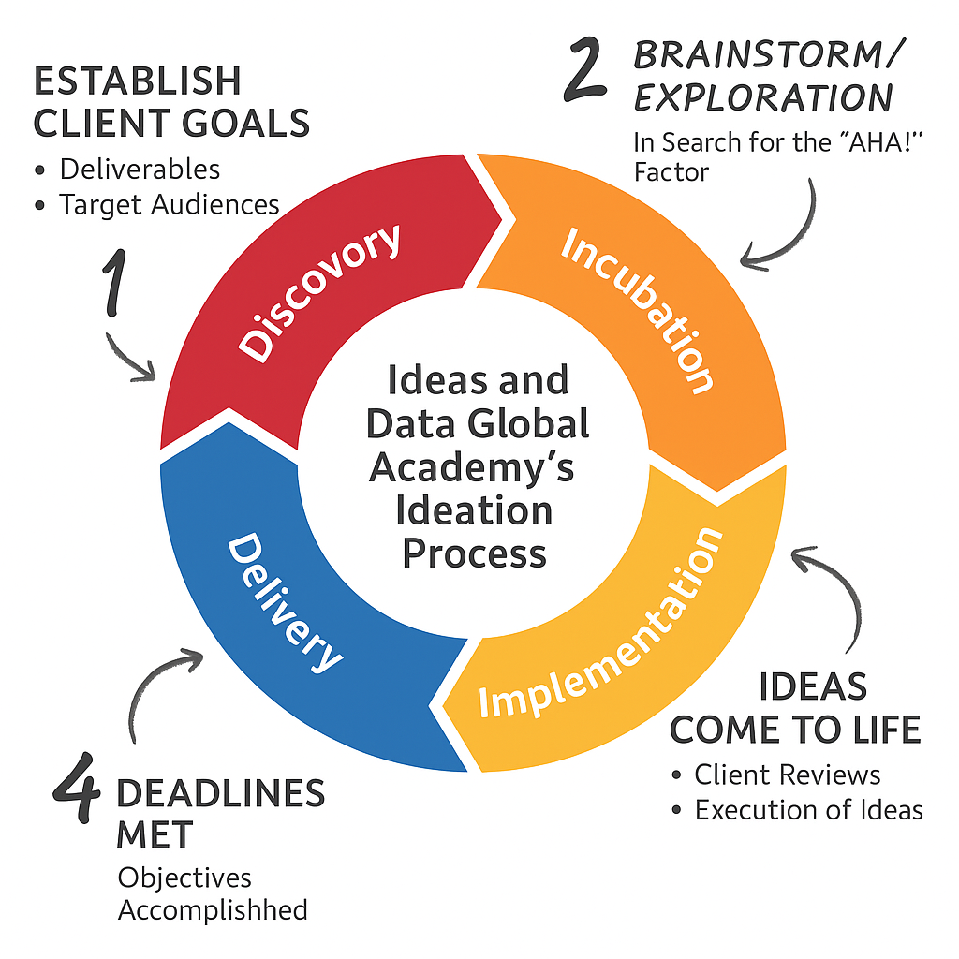

### iii. Management Approach

Our approach to project management is simple, structured, and effective—designed specifically for agile, small-to-medium scale web development projects. Each client engagement begins with the assignment of a dedicated **project lead**, who serves as your primary point of contact throughout the entire engagement.

This project lead ensures that communication remains clear and consistent, deadlines are met, and quality is upheld at every phase. While we do follow a set of proven processes and tools, we intentionally keep things lean and flexible to suit the unique needs and pace of academic institutions like Ideas and Data Global Academy.

We conduct **regular check-ins**—typically bi-weekly or as needed—with a focus on three key questions:

* What’s been completed?
* What’s coming next?
* Are there any blockers we should address?

This method promotes transparency and allows for quick adjustments when needed, keeping the project aligned with your vision. Behind the scenes, our internal team stays closely coordinated through lightweight tools like Trello (for task tracking), Google Workspace (for collaboration), and Slack or email (for real-time communication).

Our goal is to ensure a **smooth, collaborative, and responsive experience**, without the complexity of enterprise-level bureaucracy.

### IV. Development Process

We follow a clear, phased process to ensure the successful delivery of your new website. Our development methodology balances structure with flexibility, ensuring each step is aligned with your goals and institutional values.

### Phase 0: Discovery & Planning

1. **Project Kick-off & Goal Alignment** Understand your priorities, audience, and success metrics.
2. **Information Architecture** Define navigation structure, sitemap, and content flow.
3. **Wireframing** Create basic visual outlines for key pages to map user experience.
4. **Technical Design** Determine CMS, hosting, and any integrations required.

### Phase 1: Design & Implementation

1. **UI/UX Design** Apply visual branding and accessibility standards across layouts.
2. **Content Gathering & Guidance** Collaborate with your team to organize, format, or create content.
3. **Development & CMS Integration** Build the site, configure content areas, and implement functionality.
4. **Testing** Ensure performance, responsiveness, SEO readiness, and accessibility.
5. **Training & Handover** Provide a walkthrough of the CMS with basic training for your staff.
6. **Launch** Seamless transition to live environment.
7. **Post-launch Support** Includes a three-month support window for any fixes or adjustments.

# VI. Scope of Work

1. Discovery & Planning
2. Design
3. Development
4. Testing & QA
5. Deployment
6. Training
7. Maintenance & Support

### VII. Team Roles & Key Personnel

| **Name** | **Role** | **Responsibilities** |
| --- | --- | --- |

| Project Manager | Oversight & Client Liaison | Timeline, deliverables, client communication |
| --- | --- | --- |

| UX/UI Designer | User Experience Design | Layouts, visual elements, accessibility |
| --- | --- | --- |

| Web Developer | Front-end & CMS Development | Coding, integrations, responsive build |
| --- | --- | --- |

| SEO Specialist | Optimization & Analytics | SEO structure, metadata, performance tuning |
| --- | --- | --- |

| QA Tester | Testing | Browser/device testing, bug tracking |
| --- | --- | --- |

### VIII. Technologies to Be Used

Our technology stack is thoughtfully selected to balance performance, simplicity, and ease of maintenance—while ensuring your site is modern, scalable, and user-friendly. For the Ideas and Data Global Academy project, we propose the following:

1. **Front-End**
   * **HTML5, CSS3, JavaScript** – For responsive and accessible interface design
   * **Lightweight frameworks** or components as needed for interactivity (e.g., Alpine.js)
2. **Back-End**
   * **PHP (Plain PHP)** – Clean, secure, and efficient server-side scripting tailored for academic websites with manageable complexity
   * Optional CMS modules (if content updates are frequent), or custom-built admin tools
3. **Chatbot Integration**
   * Integration of a **simple AI or rules-based chatbot**, such as **Tidio**, **Landbot**, or a **custom PHP-based chatbot**, to assist with inquiries, program information, and user engagement
4. **Hosting**
   * **Shared or cloud hosting** via platforms like **Namecheap, SiteGround, or DigitalOcean**, depending on budget and preference
5. **Database**
   * **MySQL** – A reliable, well-supported database solution for storing content and user data
6. **SEO Tools**
   * **Yoast SEO** or **RankMath** (if a CMS is used)
   * Manual SEO optimization via metadata, structured content, and Google Search Console setup

### IX. Deliverables

Upon completion of the project, the following will be delivered:

1. **Fully Functional and Responsive Website** A modern, mobile-first website with cross-device and cross-browser compatibility, built to reflect the academic excellence and global outlook of Ideas and Data Global Academy.
2. **Multilingual Content Support** The website will support **English**, **Hausa**, and **Arabic** to reflect the academy’s inclusive and culturally diverse audience—particularly important for activities like the **Arabic Spelling Bee**.
3. **User Engagement Features**
   * A prominent **“Learn More” section** guiding users toward **enrollment** and **consultation request** options
   * Integrated **chatbot** to provide real-time assistance, answer FAQs, and guide visitors through services or programs
   * **Social media sharing buttons** to promote news, blog posts, and program content easily across platforms like Facebook, Twitter, LinkedIn, and WhatsApp
4. **Content Management Tools**
   * A **lightweight custom CMS** or admin panel (if using PHP backend) enabling staff to manage content easily without technical intervention
5. **SEO-Optimized Structure**
   * All content areas will be structured with SEO best practices, metadata, and schema markup to improve visibility in search engines
6. **Training Guide and Onboarding Session**
   * A concise and clear **training guide**
   * A **live session (or video walkthrough)** to train internal staff on how to update the site and manage basic operations
7. **Post-Launch Maintenance Plan**
   * Three-month complimentary support to handle minor updates, performance tuning, and bug fixes
8. **Source Code and Documentation**
   * All website code, assets, and backend logic will be provided in a structured format with clear documentation for future use or handover

# X. Terms and Conditions

1. Ownership: All design and code will become the property of the academy
2. Confidentiality: All proprietary content remains secure

### XI. Conclusion

**Syda** is genuinely excited about the opportunity to collaborate with **Ideas and Data Global Academy** on the redesign and redevelopment of its website. We understand the unique expectations of academic institutions and are confident in our ability to deliver a solution that is not only technically sound, but also modern, engaging, and easy to manage.

With a strong emphasis on usability, multilingual accessibility, responsive design, and user experience, Syda is well-positioned to provide a high-quality digital platform that reflects the Academy’s mission and supports its growth.

If you’re seeking a reliable partner who values collaboration, clear communication, and results-driven execution, **Syda is the right choice**. We bring not only expertise, but also a personalized, hands-on approach that ensures both your team and your users are fully supported throughout the journey.

We look forward to the opportunity to bring your vision to life and are happy to answer any questions regarding this proposal.