Interface Report

# Login Page

Description: This is the login interface with a dropdown to select one of the four user types: Traveller, Tour Operator, Admin, and Service Provider.

Screenshot:

# 

# Traveller Interfaces

## Home Page

Description: Displays featured trips, promotions, and a navigation panel tailored for travellers.

Screenshot:

## 

## Profile Page

Description: Lets travellers view and update their personal information and preferences.

Screenshot:

## 

## Registration Page

Description: New travellers can create their accounts with required details

Screenshot:

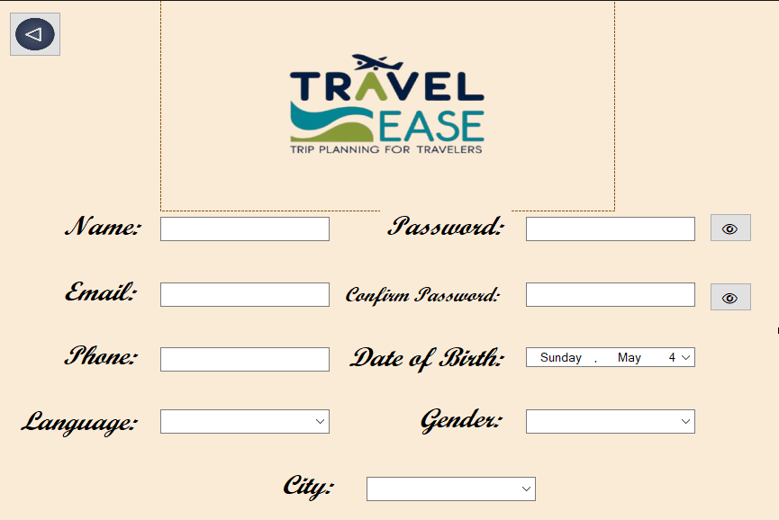

## Reviews Page

Description: Enables travellers to write, view, and manage reviews for trips

Screenshot:

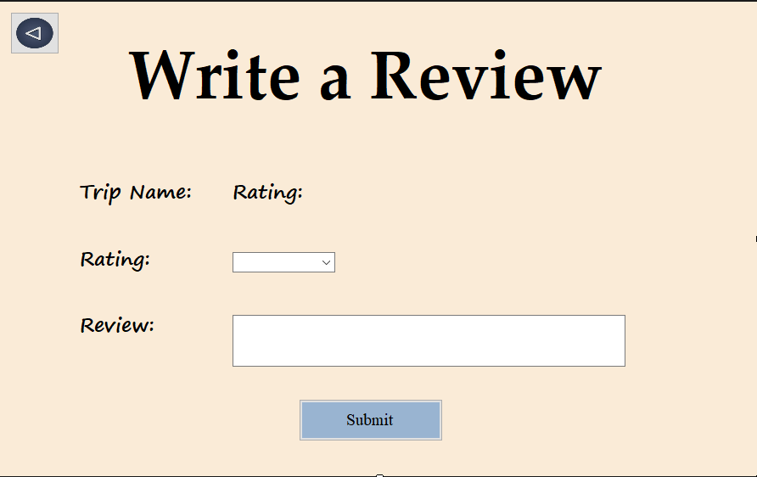

## Travel Pass Page

Description: Shows subscription status and benefits available to the traveller.

Screenshot:

## 

## Trip Dashboard Page

Description: Displays upcoming, ongoing, and past trips booked by the traveller

Screenshot:

## 

## Trip Search Page

Description: Allows travellers to search and filter trips based on location, price, and date.

Screenshot:

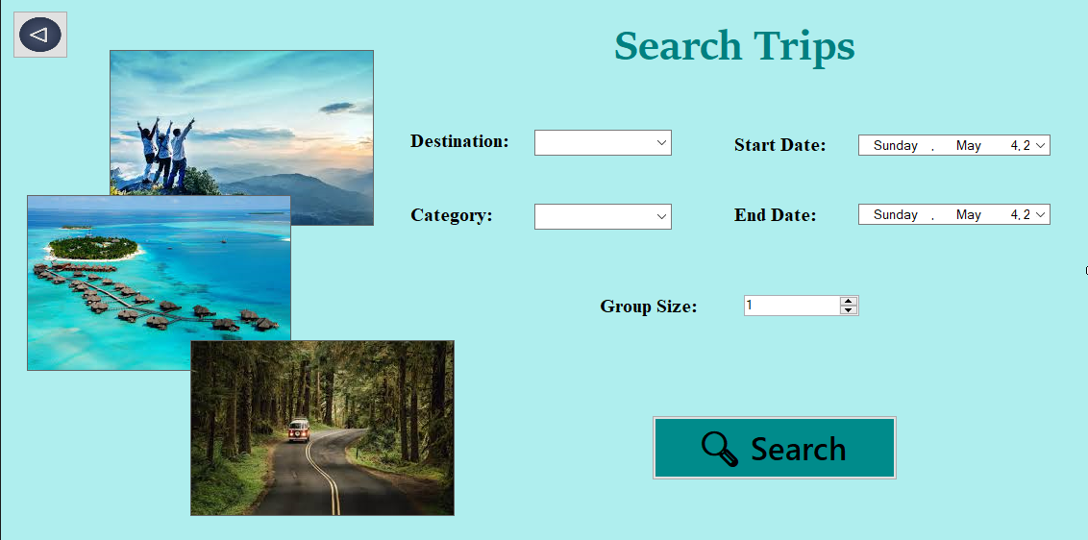

Booking:

Description: Shows the Completed Bookings made by the Traveller

ScreenShot:

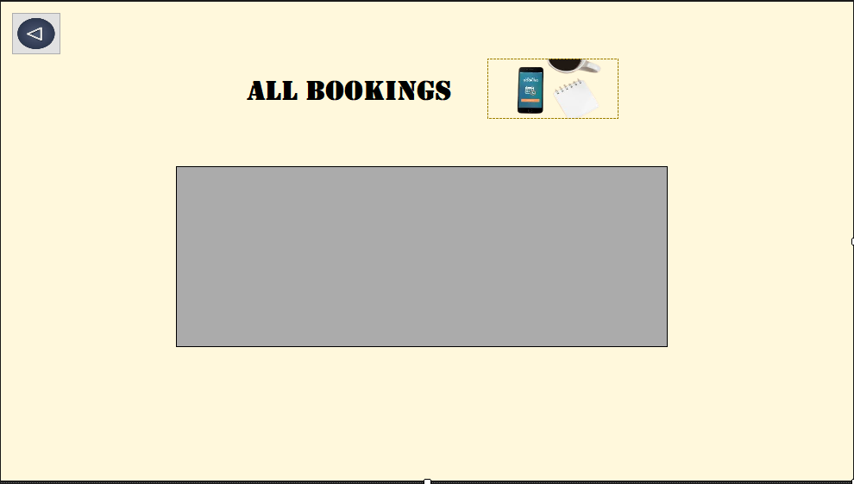

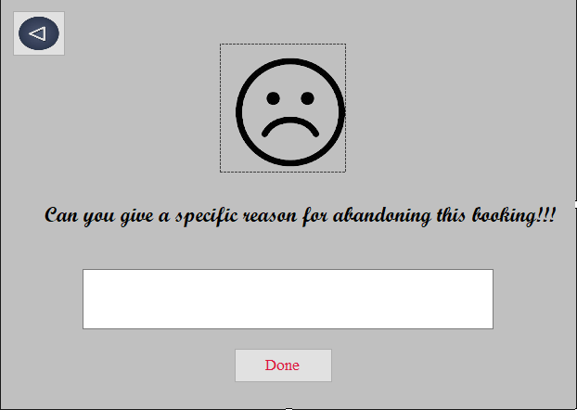

# Tour Operator Interfaces

## Registration Page

Description: Lets tour operators sign up and submit their company information for approval

Screenshot:

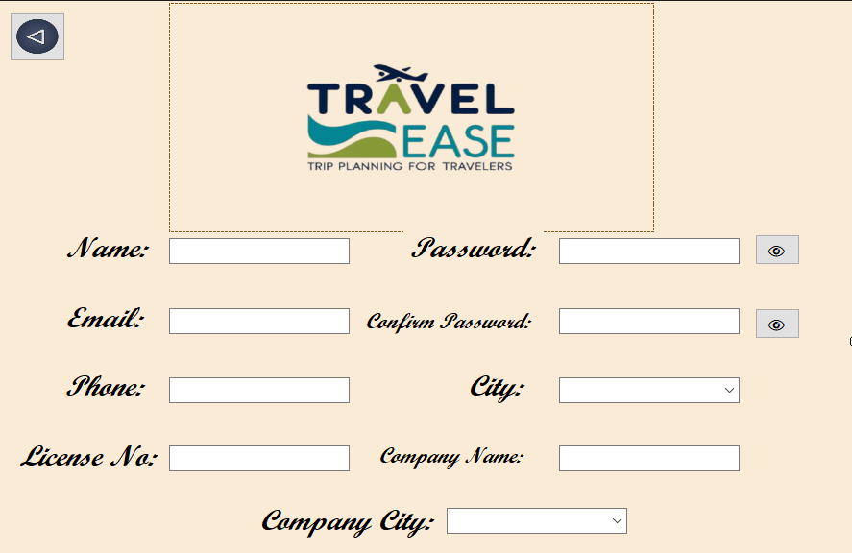

## Home Page

Description: Shows key statistics and summaries related to trips, bookings, and feedback

Screenshot:

## Booking Management Page

Description: Allows operators to view, accept, or reject trip bookings

Screenshot:

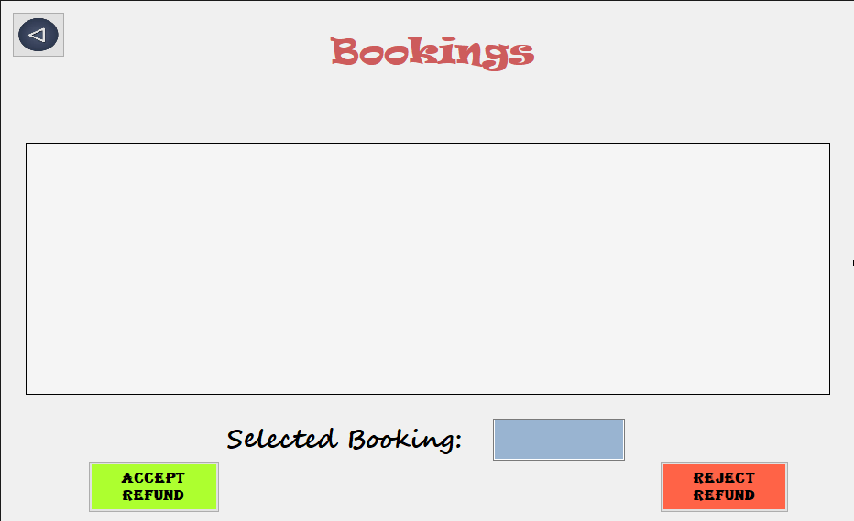

## Manage Services Page

Description: Enables operators to add or update services they provide within trips.

Screenshot:

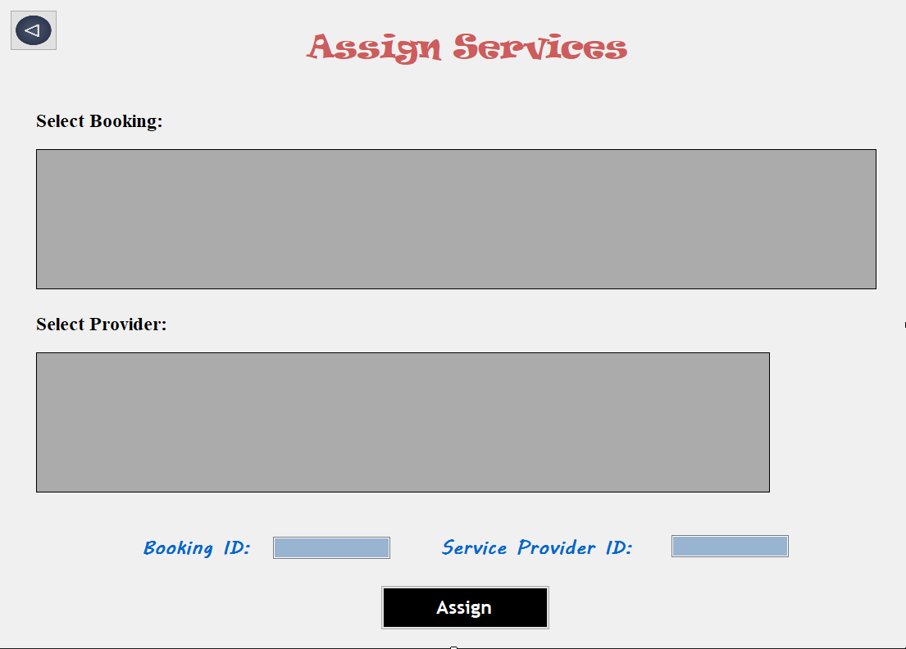

## Manage Trips Page

Description: Provides tools to create, update, or delete trip packages.

Screenshot:

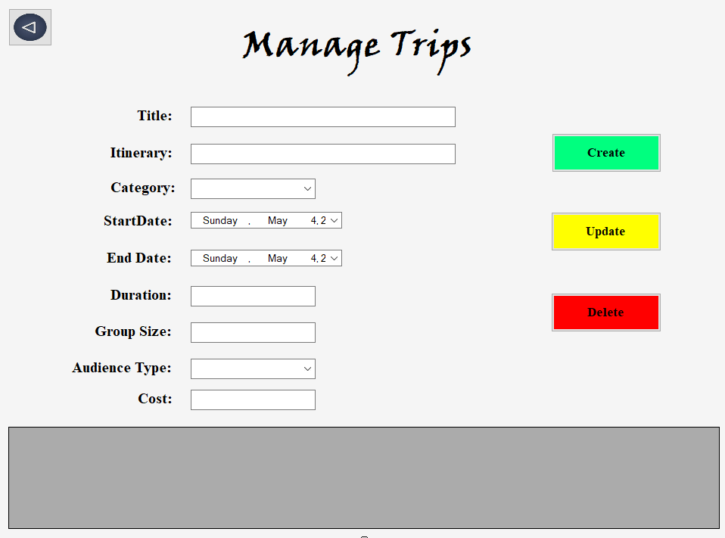

## Performance Page

Description: Shows performance analytics like ratings, booking trends, and reviews.

Screenshot:

# Admin Interfaces

## Home Page

Description: Displays admin dashboard with system overview and alerts.

Screenshot:

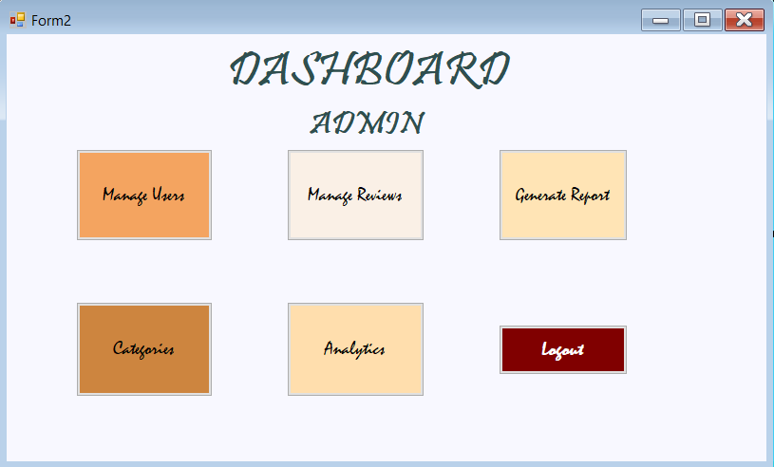

## Manage Categories Page

Description: Allows the admin to create and manage categories for trips and services.

Screenshot:

## 

## Manage Reviews Page

Description: Admin can monitor and moderate user-submitted reviews.

Screenshot:

## 

## Manage Users Page

Description: Lets the admin view and control user accounts across all roles

Screenshot:

## 

## Performance Page

Description: Displays global analytics and system-wide reports.

Screenshot:

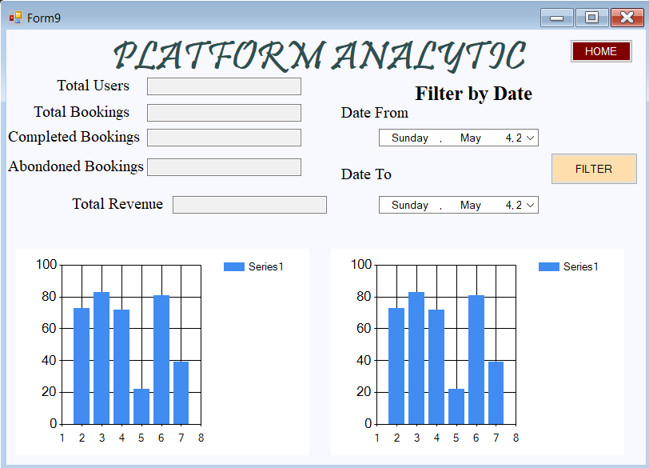

# Service Provider Interfaces

## Booking Management Page

Description: Allows service providers to handle service-specific bookings.

Screenshot:

## 

## Dashboard Page

Description: Shows summaries of bookings, services offered, and service status

Screenshot:

## 

## Registration Page

Description: Enables service providers to register with their company and contact in

Screenshot:

## 

## Service Management Page

Description: Lets providers add, update, or remove services such as hotels or transport

Screenshot:

