打算仿照这篇广医专硕的论文的格式来写

[1]胡晓锋. 生活环境暴露对哮喘发生及FeNO值水平测定的影响[D].广州医科大学,2022.DOI:10.27043/d.cnki.ggzyc.2022.000041.

引言

研究目的

研究目的一: 探索胃癌患者合并贫血患者的临床特征

研究目的二: 探索随访时, 血红蛋白较基线变化的情况, 和实验室检查较基线变化情况的关联

实验设计

1. 病例收集, 临床变量收集 (谢来完成)

应包括诊断标准, 收集的指标, 单位, 诊断要点, 诊断标准等, 列一个表格

1. 对于研究目的一, 患者分成两部分, 基线贫血/基线不贫血, 尔后进行单因素分析和多因素分析, 随机森林回归评估变量重要性
2. 对于研究目的二, 患者分成三部分, 贫血状况恶化 (血红蛋白下降大于10g), 贫血状况没有恶化 (血红蛋白变化在-10g到10g之间), 贫血状况改善 (血红蛋白上升10g以上), 尔后进行单因素分析和多因素分析, 随机森林回归评估变量重要性

统计方法

1. 介绍单因素分析和多因素分析的方法学 (采用何种假设检验, p的阈值等)
2. 介绍随机森林回归如何评估变量重要性

结果

1. ~~表: 入组人群一般资料 (人口学变量)~~

补充探索性数据分析的结果, 并且补充变量赋值表

说明为何做转换.

1. 研究目的一对应的结果

~~表: 变量赋值表~~

表: 单因素分析的表格 ~~(OR值)~~

|  |  |  |  |  |  |
| --- | --- | --- | --- | --- | --- |
| Variables | Total (n = 101) | 0 (n = 47) | 1 (n = 54) | p | statistic |
| 年龄, Median (Q1,Q3) | 67 (58, 76) | 64 (58.5, 71.5) | 71.5 (58, 77) | 0.138 | 1051 |
| 性别, n (%) | |  |  | 0.716 | 0.133 |
| 0 | 68 (67) | 33 (70) | 35 (65) |  |  |
| 1 | 33 (33) | 14 (30) | 19 (35) |  |  |
| bmi, Mean ± SD | 20.91 ± 3.66 | 20.8 ± 4.17 | 21.01 ± 3.2 | 0.775 | -0.287 |
| , hu, n (%) | |  |  | 0.959 | 0.003 |
| 0 | 12 (12) | 5 (11) | 7 (13) |  |  |
| 1 | 89 (88) | 42 (89) | 47 (87) |  |  |
| kps, Mean ± SD | 74.9 ± 17.83 | 79.89 ± 17.11 | 70.48 ± 17.44 | 0.008 | 2.693 |
| 确诊部位, n (%) | |  |  | 0.948 | Fisher |
| 残胃癌 | 1 (1) | 1 (2) | 0 (0) |  |  |
| 胃体 | 39 (39) | 19 (40) | 20 (38) |  |  |
| 胃底 | 1 (1) | 0 (0) | 1 (2) |  |  |
| 胃窦 | 29 (29) | 13 (28) | 16 (30) |  |  |
| 贲门 | 30 (30) | 14 (30) | 16 (30) |  |  |
| 病理类型, n (%) | |  |  | 0.722 | Fisher |
| 不详 | 7 (7) | 3 (6) | 4 (7) |  |  |
| 印戒细胞 | 2 (2) | 0 (0) | 2 (4) |  |  |
| 印戒细胞癌 | 3 (3) | 1 (2) | 2 (4) |  |  |
| 粘液细胞腺癌 | 1 (1) | 0 (0) | 1 (2) |  |  |
| 腺癌 | 87 (86) | 43 (91) | 44 (81) |  |  |
| 鳞癌 | 1 (1) | 0 (0) | 1 (2) |  |  |
| 分化程度, n (%) | |  |  | 0.885 | Fisher |
| 0 | 48 (54) | 21 (54) | 27 (54) |  |  |
| 1 | 18 (20) | 9 (23) | 9 (18) |  |  |
| 2 | 21 (24) | 8 (21) | 13 (26) |  |  |
| 3 | 2 (2) | 1 (3) | 1 (2) |  |  |
| 用药时间, n (%) | |  |  | < 0.001 | 19.461 |
| 0 | 29 (29) | 24 (51) | 5 (9) |  |  |
| 1 | 72 (71) | 23 (49) | 49 (91) |  |  |

|  |  |  |  |  |  |
| --- | --- | --- | --- | --- | --- |
| Variables | Total (n = 101) | 0 (n = 47) | 1 (n = 54) | p | statistic |
| CRP, Median (Q1,Q3) | 1.17 (0.08, 2.58) | 1.13 (0.12, 2.54) | 1.58 (0.2, 2.55) | 0.563 | 1184 |
| IL.6.0.7pg.ml., Median (Q1,Q3) | 2.41 (1.4, 3.41) | 2.41 (1.68, 3.42) | 2.41 (1.4, 3.4) | 0.585 | 1349.5 |
| mcv, Median (Q1,Q3) | 90.2 (85.6, 94.4) | 91.9 (88.05, 96.15) | 88.9 (81.93, 92.55) | 0.023 | 1603 |
| mch, Median (Q1,Q3) | 3.41 (3.34, 3.45) | 3.42 (3.38, 3.48) | 3.39 (3.26, 3.45) | 0.008 | 1659.5 |
| mchc, Median (Q1,Q3) | 5.78 (3.56, 5.82) | 5.79 (3.54, 5.83) | 5.77 (5.68, 5.8) | 0.412 | 1390 |
| 中性粒细胞绝对值, Median (Q1,Q3) | 1.28 (0.79, 1.63) | 1.28 (1.02, 1.63) | 1.27 (0.51, 1.67) | 0.622 | 1342 |
| 淋巴细胞绝对值, Median (Q1,Q3) | 0 (-0.42, 0.26) | 0.05 (-0.39, 0.32) | -0.1 (-0.58, 0.23) | 0.125 | 1495 |
| 中性粒.淋巴, Median (Q1,Q3) | 1.32 (0.82, 1.95) | 1.21 (0.9, 1.63) | 1.42 (0.73, 2.09) | 0.622 | 1196 |

表: 多因素分析的表格 ~~(OR值)~~

Table 1:***\*\*模型比较\*\****

|  | 不纳入用药时间 | | | 纳入用药时间 | | |
| --- | --- | --- | --- | --- | --- | --- |
| Characteristic | OR1 | 95% CI1 | p-value | OR1 | 95% CI1 | p-value |
| 年龄 | 1.00 | 0.96, 1.03 | >0.9 | 0.98 | 0.93, 1.02 | 0.4 |
| kps | 0.97 | 0.94, 0.99 | 0.022 | 0.95 | 0.91, 0.98 | 0.003 |
| mcv | 0.96 | 0.91, 1.01 | 0.12 | 0.94 | 0.88, 1.00 | 0.056 |
| 淋巴细胞绝对值 | 0.48 | 0.21, 1.00 | 0.060 | 0.59 | 0.22, 1.49 | 0.3 |
| 用药时间 |  |  |  |  |  |  |
| 0 |  |  |  | — | — |  |
| 1 |  |  |  | 23.7 | 6.13, 130 | <0.001 |
| 1OR = Odds Ratio, CI = Confidence Interval | | | | | | |

~~图: 多因素分析显著的因素的森林图~~

图: 随机森林回归得到的变量重要性排序

文字描述: 从以上表格和图里面得到什么结果, 这些OR值怎么被解释

1. 研究目的二对应的结果

~~表: 变量赋值表~~

表: 相关变量的描述性统计也假设检验 (单因素分析结果)

|  |  |  |  |  |  |  |
| --- | --- | --- | --- | --- | --- | --- |
| Variables | Total (n = 101) | 0 (n = 23) | 1 (n = 23) | 2 (n = 55) | p | statistic |
| 年龄, Median (Q1,Q3) | 67 (58, 76) | 66 (59, 72.5) | 70 (65.5, 77) | 65 (55.5, 76) | 0.221 | 3.022 |
| 性别, n (%) | |  |  |  | 0.153 | 3.75 |
| 0 | 68 (67) | 13 (57) | 19 (83) | 36 (65) |  |  |
| 1 | 33 (33) | 10 (43) | 4 (17) | 19 (35) |  |  |
| bmi, Mean ± SD | 20.91 ± 3.66 | 20.6 ± 4.07 | 19.99 ± 3.2 | 21.43 ± 3.64 | 0.26 | 1.367 |
| 化疗有无, n (%) | |  |  |  | 0.597 | Fisher |
| 0 | 12 (12) | 3 (13) | 4 (17) | 5 (9) |  |  |
| 1 | 89 (88) | 20 (87) | 19 (83) | 50 (91) |  |  |
| kps, Mean ± SD | 74.9 ± 17.83 | 71.14 ± 21.38 | 75 ± 14.39 | 76.39 ± 17.63 | 0.512 | 0.674 |
| 确诊部位, n (%) | |  |  |  | 0.018 | Fisher |
| 残胃癌 | 1 (1) | 0 (0) | 1 (4) | 0 (0) |  |  |
| 胃体 | 39 (39) | 9 (39) | 7 (30) | 23 (43) |  |  |
| 胃底 | 1 (1) | 0 (0) | 1 (4) | 0 (0) |  |  |
| 胃窦 | 29 (29) | 5 (22) | 3 (13) | 21 (39) |  |  |
| 贲门 | 30 (30) | 9 (39) | 11 (48) | 10 (19) |  |  |
| 病理类型, n (%) | |  |  |  | 0.87 | Fisher |
| 不详 | 7 (7) | 3 (13) | 1 (4) | 3 (5) |  |  |
| 印戒细胞 | 2 (2) | 0 (0) | 1 (4) | 1 (2) |  |  |
| 印戒细胞癌 | 3 (3) | 0 (0) | 0 (0) | 3 (5) |  |  |
| 粘液细胞腺癌 | 1 (1) | 0 (0) | 0 (0) | 1 (2) |  |  |
| 腺癌 | 87 (86) | 20 (87) | 21 (91) | 46 (84) |  |  |
| 鳞癌 | 1 (1) | 0 (0) | 0 (0) | 1 (2) |  |  |
| 分化程度, n (%) | |  |  |  | 0.427 | Fisher |
| 0 | 48 (54) | 12 (75) | 12 (55) | 24 (47) |  |  |
| 1 | 18 (20) | 3 (19) | 4 (18) | 11 (22) |  |  |
| 2 | 21 (24) | 1 (6) | 5 (23) | 15 (29) |  |  |
| 3 | 2 (2) | 0 (0) | 1 (5) | 1 (2) |  |  |
| 用药时间, n (%) | |  |  |  | < 0.001 | 29.513 |
| 0 | 29 (29) | 16 (70) | 8 (35) | 5 (9) |  |  |
| 1 | 72 (71) | 7 (30) | 15 (65) | 50 (91) |  |  |

|  |  |  |  |  |  |  |
| --- | --- | --- | --- | --- | --- | --- |
| Variables | Total (n = 101) | 0 (n = 23) | 1 (n = 23) | 2 (n = 55) | p | statistic |
| CRP差异, Median (Q1,Q3) | 0.24 (-1.17, 1.91) | 0.25 (-1.12, 1.32) | 1.1 (-0.33, 2.72) | 0.02 (-1.89, 1.33) | 0.138 | 3.967 |
| IL6差异, Median (Q1,Q3) | -0.17 (-1.17, 1.01) | -0.17 (-0.64, 1.06) | 0 (-0.91, 1.65) | -0.23 (-1.31, 0.71) | 0.422 | 1.727 |
| mcv差异, Median (Q1,Q3) | -0.2 (-6.7, 8.9) | 5.2 (-3.3, 12.55) | 0.3 (-5.9, 7.65) | -1.1 (-9.22, 6.05) | 0.34 | 2.159 |
| mch差异, Median (Q1,Q3) | 0.01 (-0.09, 0.09) | 0.03 (-0.08, 0.12) | -0.01 (-0.08, 0.08) | 0.01 (-0.08, 0.09) | 0.916 | 0.176 |
| mchc差异, Median (Q1,Q3) | -0.02 (-2.16, 0.02) | -0.03 (-0.07, 0.02) | -0.02 (-0.07, 0.01) | -0.02 (-2.19, 0.02) | 0.981 | 0.038 |
| 中性粒细胞绝对值差异, Median (Q1,Q3) | -0.04 (-0.68, 0.71) | -0.35 (-1.09, 0.24) | -0.04 (-0.37, 0.89) | 0.02 (-0.77, 0.82) | 0.185 | 3.377 |
| 淋巴细胞绝对值差异, Median (Q1,Q3) | -0.06 (-0.58, 0.49) | -0.5 (-1.07, -0.07) | 0.23 (-0.46, 0.49) | 0.07 (-0.35, 0.66) | 0.013 | 8.756 |
| 中性粒比淋巴差异, Median (Q1,Q3) | -0.05 (-0.78, 0.89) | 0.34 (-0.54, 0.64) | -0.26 (-0.73, 0.95) | -0.16 (-0.82, 0.88) | 0.904 | 0.201 |

图: 单因素分析中, 假设检验的结果可视化 (像这种)

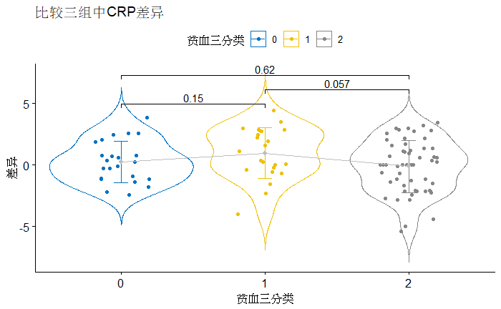

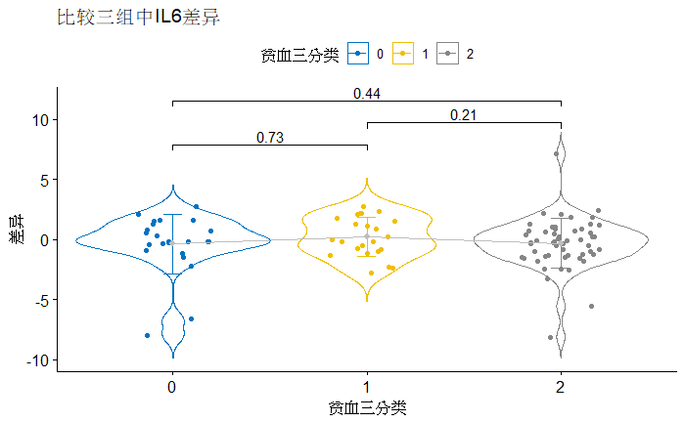

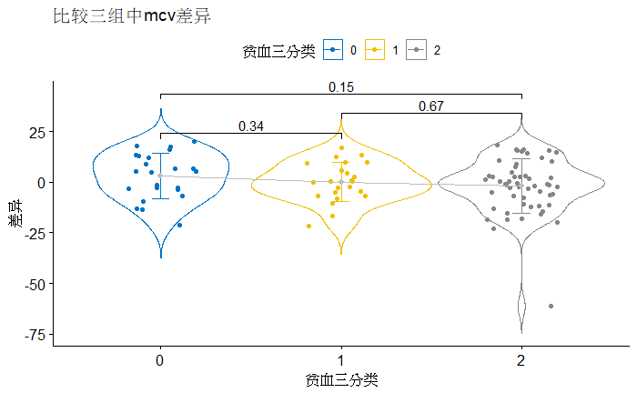

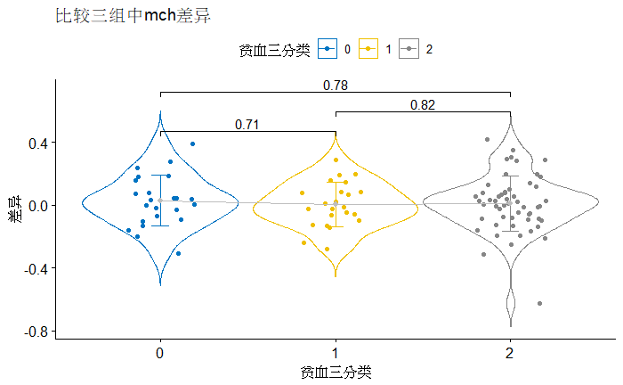

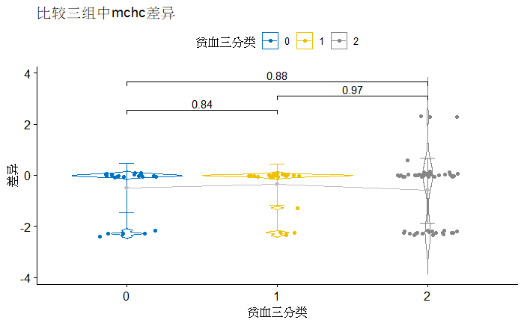

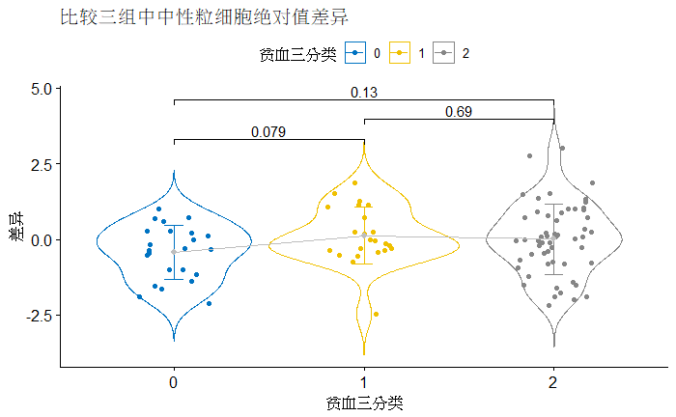

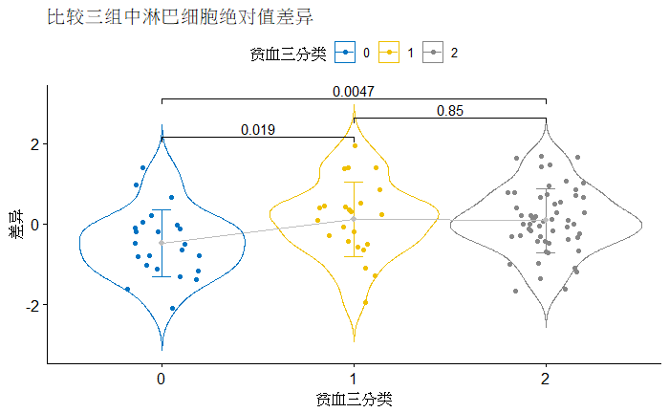

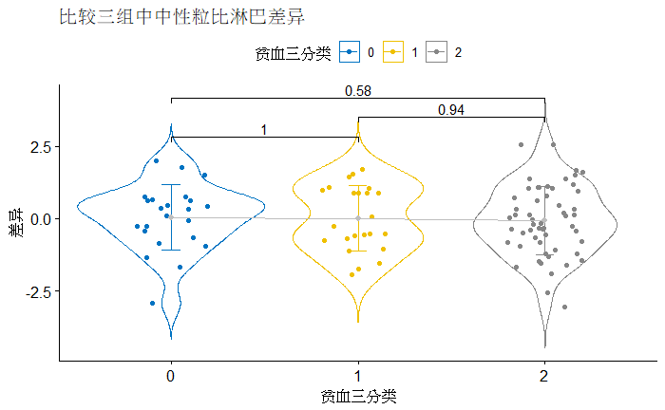

表: 多因素分析的结果 (OR值, 若适用)

文字描述: 从上面的表格和图里面得到什么结果, 它们怎么被解释

讨论

结论