**Recommendation**

Feb. 12th, 2023

To whom it may concern,

I am writing this letter of reference and support for Ms. Bai Hanzhe, whom I have known since I taught her an undergraduate course in *Medical Immunology* at the College of Clinical Medicine, Jiamusi University, China. I would gladly provide my references for Bai regarding the programme at the City University of Hongkong.

When we first met in 2020 Spring, Bai was a 2-rd year undergraduate student majoring in clinical medicine. At that time, although our lectures were forced to take the online form because of the emergency situation of COVID-19 pandemic, Bai left a deep impression on me. During the 4-mouth online lecture, Bai performed excellently with her active and enthusiastic participation via the VooV platform. We always had nice discussions, not only on immunology, and but also on broader topics about public health and cutting-edge biomedical research, like novel therapeutics against COVID-19 and cancer. Particularly, in her final presentation, she introduced cytokine storm to the class, and later illustrated the relationship between cytokine storm and the ARDS in COVID-19 patients, which I considered a very interesting report, showing her great interest in saving and improving lives. Finally, she got an excellent grade (93 of 100) in my class.

The end of the classes is not the end of our relationship. Impressed by her passion for exploration, I gave her an opportunity to join my lab, to develop immunotherapies for unmet clinical needs. We later worked together to perform an undergraduate training project. During that time, she participated in regular group meetings, conducted literature reviews to identify a concrete research question, then collaborated with other lab members to carry out animal experiments and data analysis. In this way, she has developed hands-on skills in operating instruments like flow cytometry (FCM) and applied her theoretical knowledge in biomedicine and statistics to research. As a research outcome of this training project, Bai drafted a manuscript titled *Repairing Effect of Oleanolic Acid on the Damage of Intestinal Immune Function in Mice*, which has been submitted to a peer-reviewed journal in Dec. 2022. In summary, this work showed her critical thinking and hardworking in doing research.

Apart from academic training, Bai is also trained well as a medical student at the First Affiliated Hospital of Jiamusi University as well as the Heilongjiang Provincial Hospital, I believe she is active in collaborating with people in different roles, and has developed a good understanding of real-world healthcare practices.

From my encounters and discussions with her, among the hundreds of undergraduates I have taught, Bai should be one of the top 5% of students, in sense of talent, passion, hardworking, and communication skills. Thus, I am willing to recommend her to the programme without any reservations.

Do not hesitate to contact me if you need more information.

Sincerely,

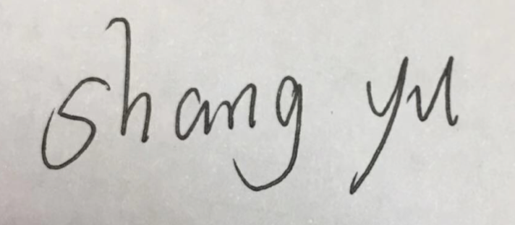

Shang Yu, BMed, PhD

Position: Associate Professor, Associate Director of Basic Medical Experiment Center, College of Basic Medicine, Jiamusi University

Address: Room 310, Experimental Building, Jiamusi University, Jiamusi, 154000, Heilongjiang Province, China

Email: [shangyu0454@jmsu.edu.cn](mailto:shangyu0454@jmsu.edu.cn)

Tel: +86-00-13339558842