




PROJECT REPORT

FIFO Verification Plan

Release: 1.0 Date: 25-July-2024
NUST Chip Design Centre (NCDC), Islamabad, Pakistan

Copyrights ©, NUST Chip Design Centre (NCDC). All Rights Reserved. This document is prepared by NCDC and is for intended recipients only. It is not allowed to copy, modify, distribute or share, in part or full, without the consent of NCDC officials.

Revision History

Revision Number | Revision Date | Revision By | Nature of Revision | Approved By
1.0 | 25/07/2024 | Amber Khan | Complete Manual | -

Contents
Contents 2
Introduction 3
Components Explained 3
Template Table Format: 3

INTRODUCTION:
FIFO (First-In-First-Out) is a fundamental digital design structure used for temporary data storage and buffering between components operating at different rates. A FIFO stores data in the order it is written and returns the data in the same order when read. Correct operation therefore depends on proper memory access, read and write pointer management, and correct handling of empty and full conditions.
This project focuses on the functional verification of three synchronous FIFO implementations using SystemVerilog. The verification environment was designed to test the FIFOs under different parameter configurations, including variations in depth and data width. Directed and randomized test cases were developed to verify reset behavior, data integrity, sequential read/write operation, and general FIFO functionality.
The verification results were used to determine whether each FIFO implementation behaved according to its expected functionality. The testing successfully identified a functional issue in FIFO1 during the data-index test, while FIFO2 and FIFO3 passed the implemented test cases.
OBJECTIVES:
The main objectives of the project were:
- To develop a reusable SystemVerilog-based verification environment for synchronous FIFOs.
- To verify FIFO reset and initialization behavior.
- To verify correct storage and retrieval of data using the FIFO.
- To verify First-In-First-Out ordering of data.
- To test FIFO operation using directed test cases.
- To introduce randomized data patterns for additional functional coverage.
- To verify FIFO behavior across different depth and data-width configurations.
- To identify functional failures and determine which FIFO implementations satisfy the expected behavior.

Verification Approach / Methodology
A reusable SystemVerilog testbench was developed to verify the FIFO implementations. The testbench maintains a reference queue, expected_fifo, which stores the expected sequence of data independently of the FIFO under test. Whenever data is successfully written into the FIFO, the same data is pushed into the reference queue. During a read operation, the oldest value is removed from the reference queue and compared with the FIFO output. A matching value indicates a successful read operation, while a mismatch indicates a functional error.
The verification environment includes reusable tasks for reset, write, read, and different test scenarios. The write_fifo() task performs a write only when the FIFO is not full, while the read_fifo() task performs a read only when the FIFO is not empty and compares the received data with the expected value. This approach allows the same verification logic to be used with FIFOs having different depths and data widths.

Table :

No. | Test Case | FIFO1 STATUS | FIFO2 STATUS | FIFO3 STATUS | COMMENTS
1 | Clearing Memory | passed | passed | passed
2 | Data = index | failed | passed | passed | FIFO1 failed this test because the data read from the FIFO did not match the expected sequential values written into it. This indicates an issue in FIFO1's data storage or pointer management logic.
3 | Read after Write (RAW) | passed | passed | passed
4 | Random Test | passed | passed | passed

FIFO 1:OUTPUT:
Clear test: data-index test Read after write test:
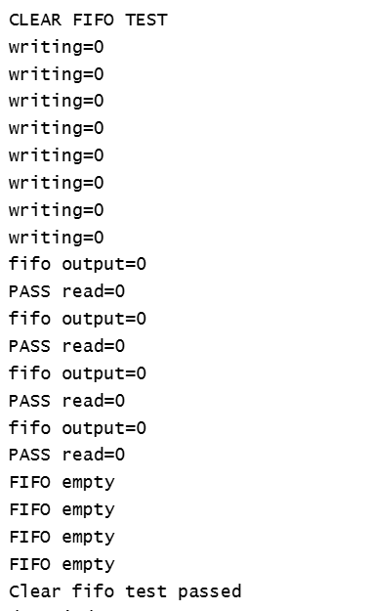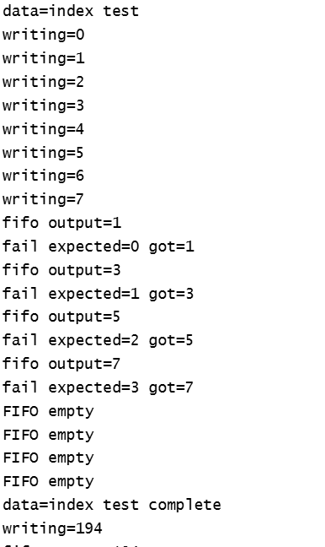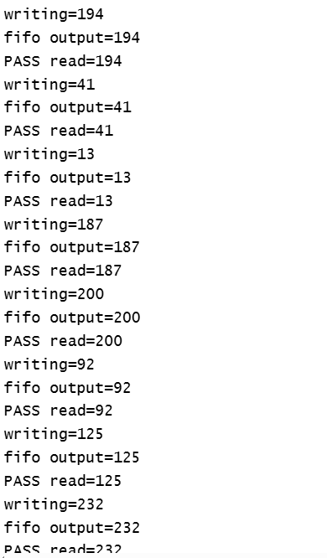

Random Test:
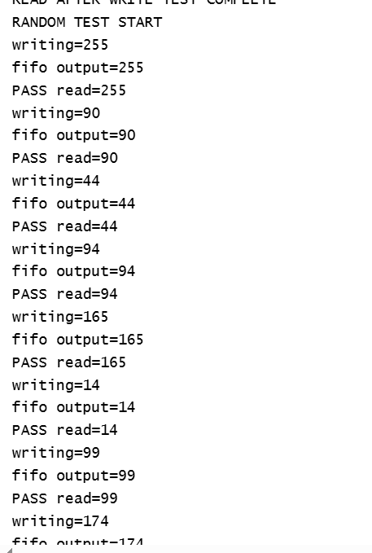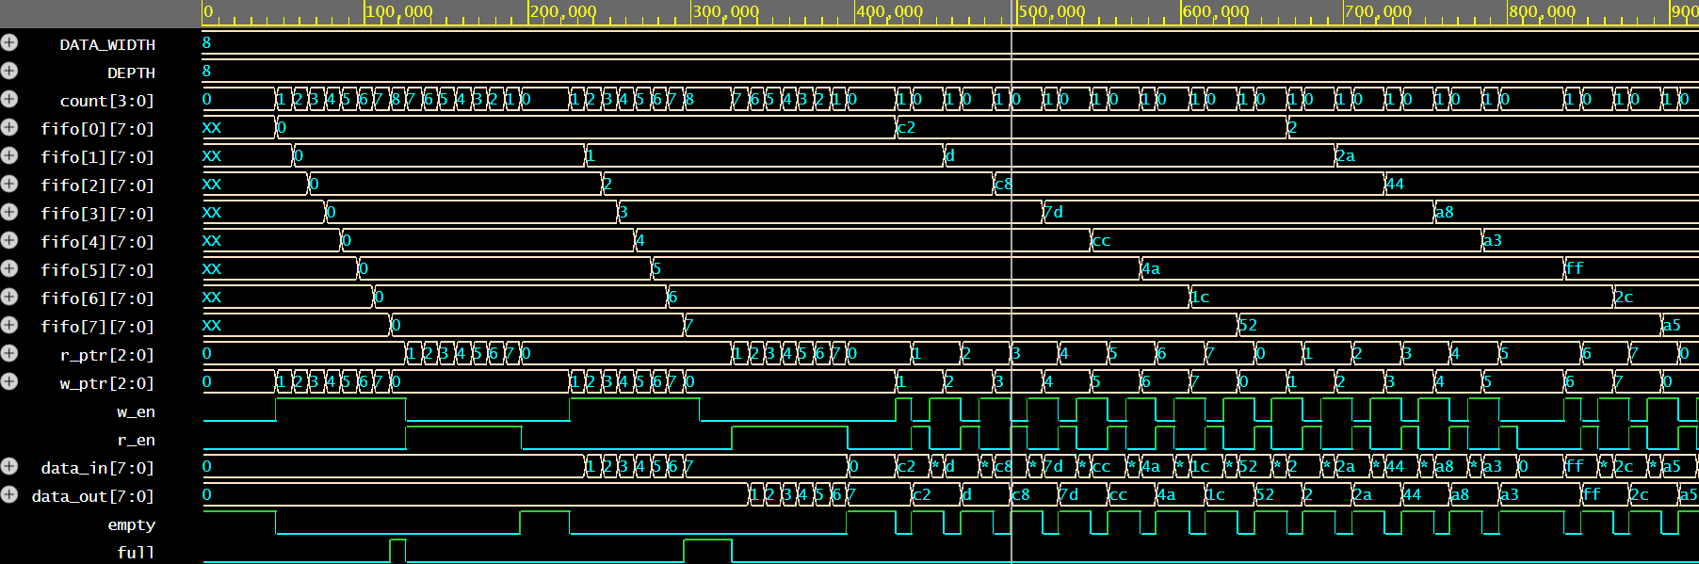
DEPTH=16
DATA_WIDTH=8

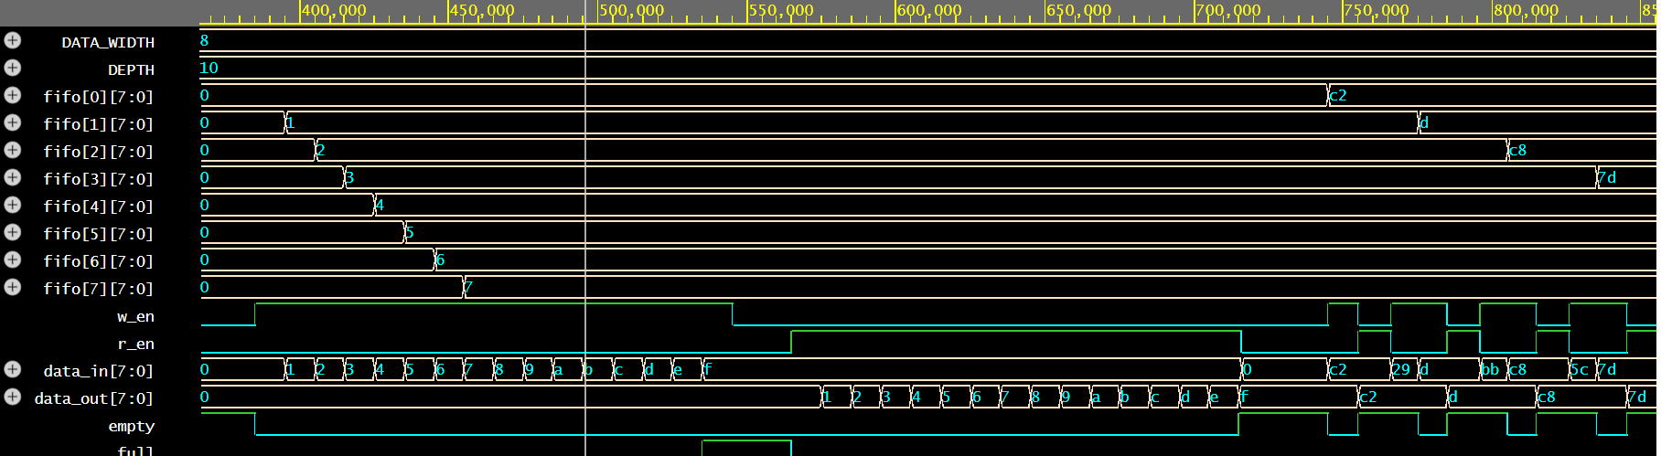

DATA_WIDTH=16
DEPTH=16
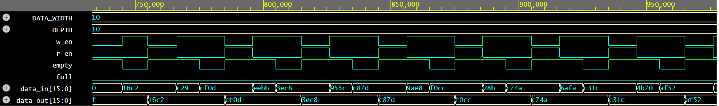

TASK3:
FIFO2:
DEPTH:8
DATA_WIDTH=8;
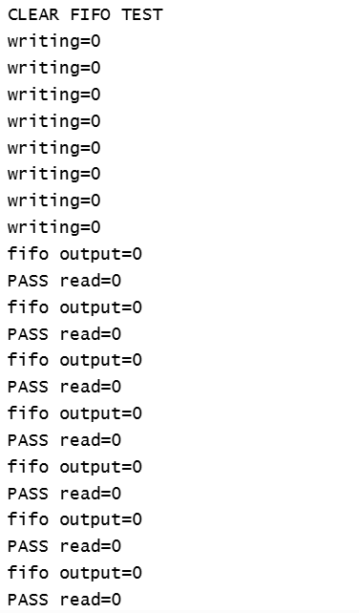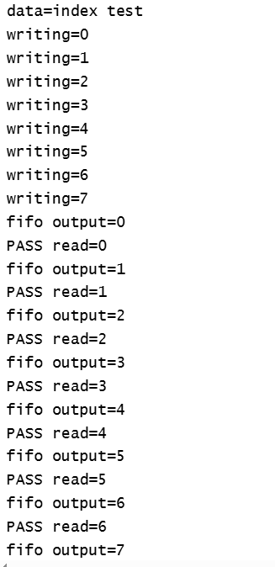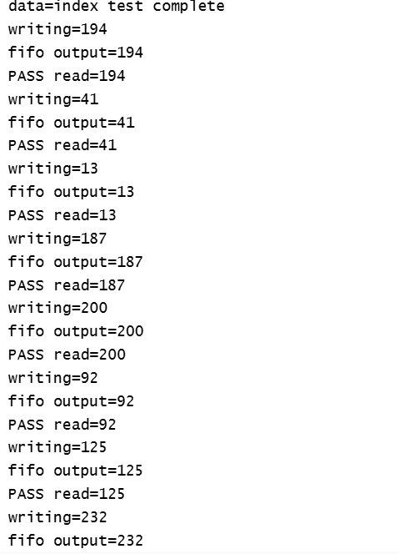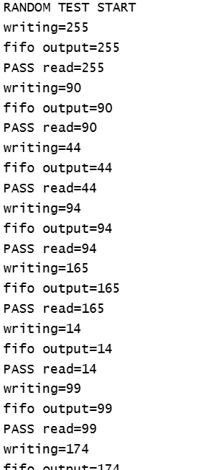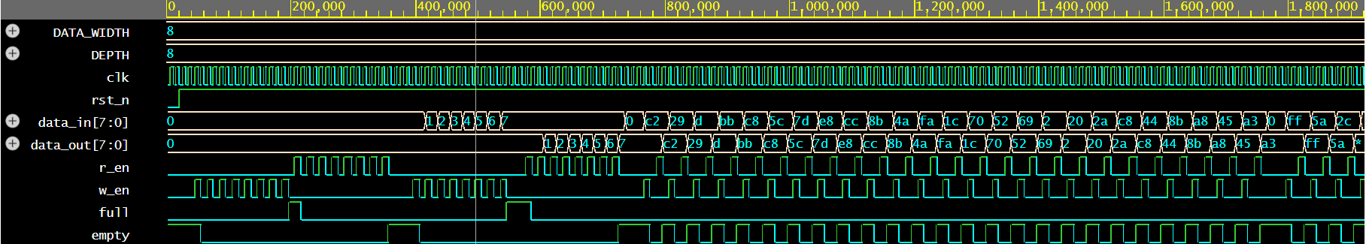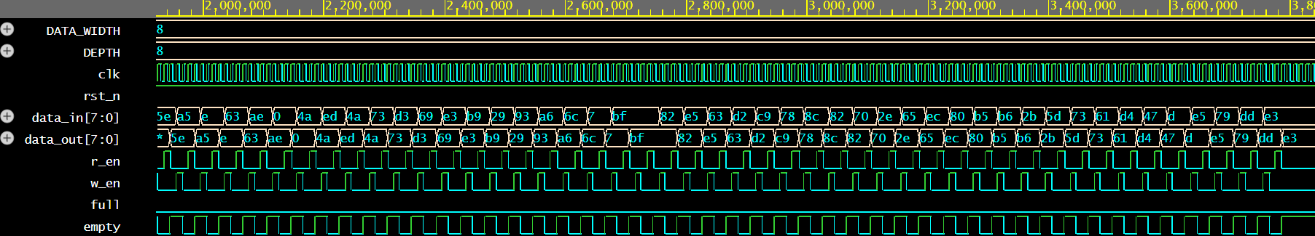

Depth=16
Data_width=8
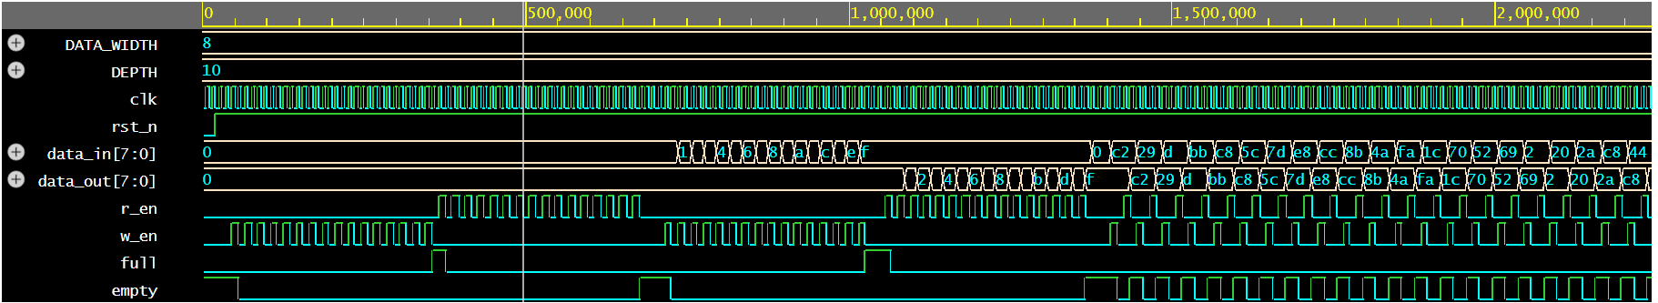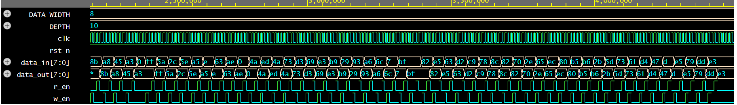

Depth=16
Data_width=16
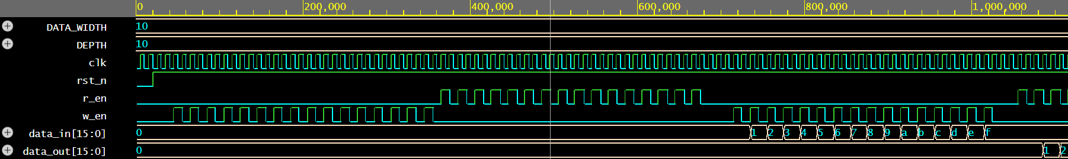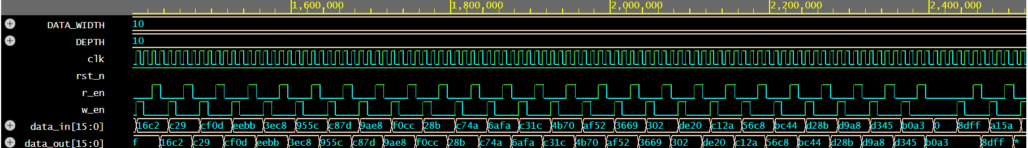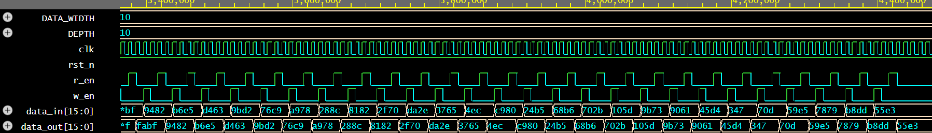

FIFO3:
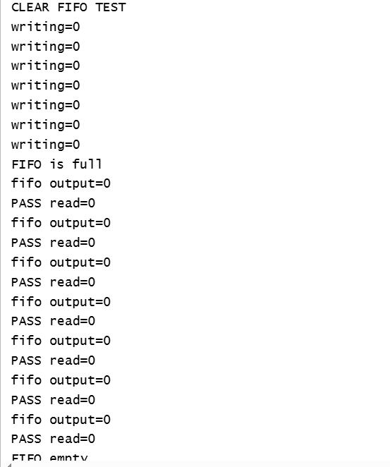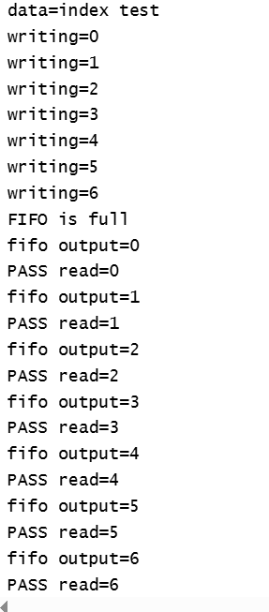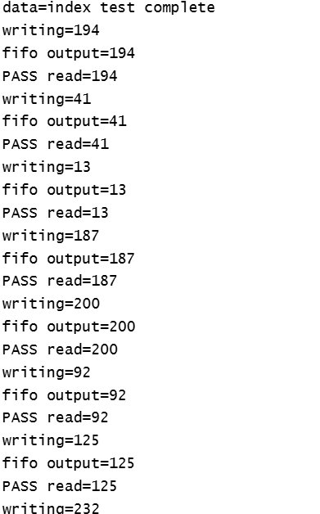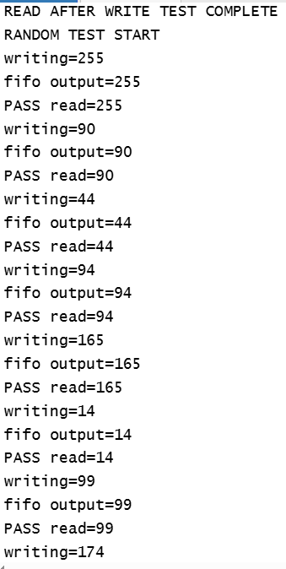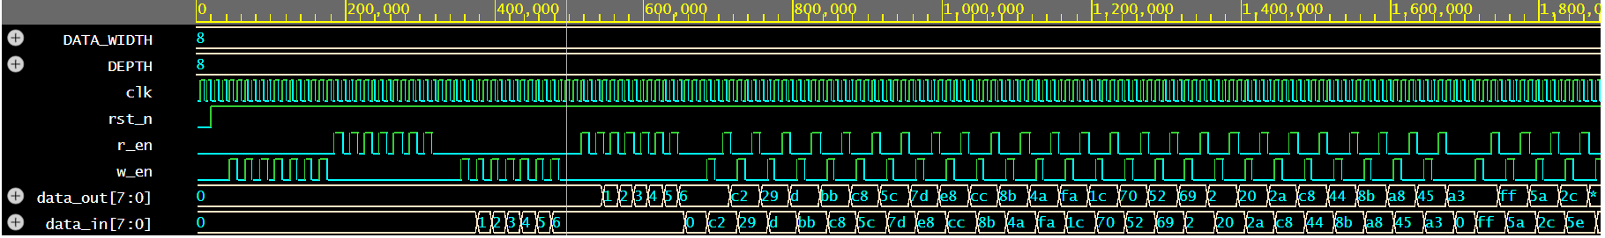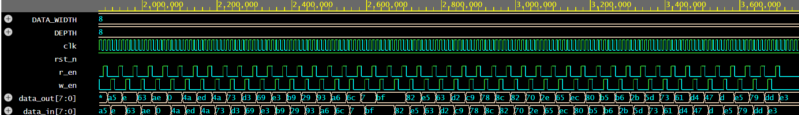

Depth=16
Data_width=8
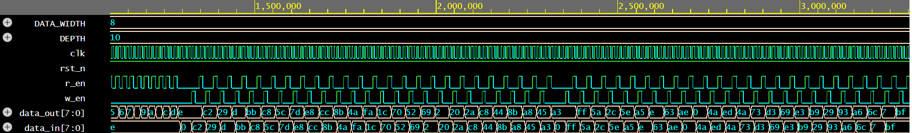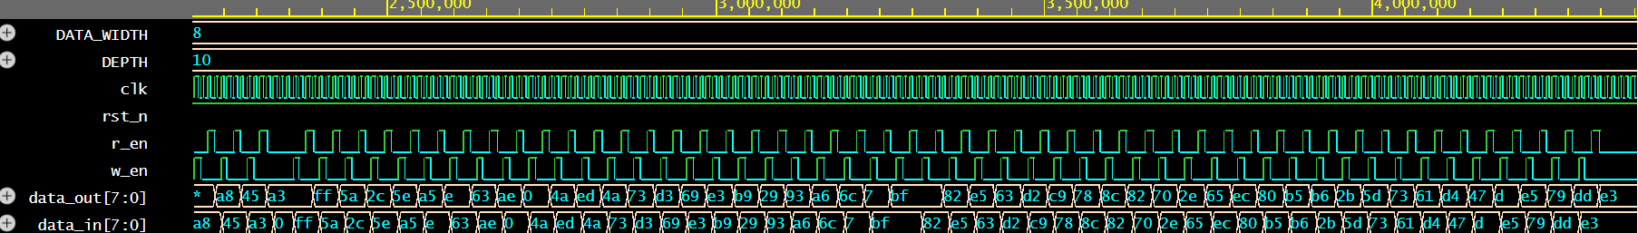

Depth=16
Data_width=16
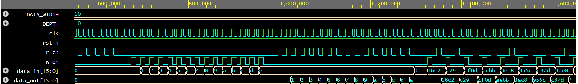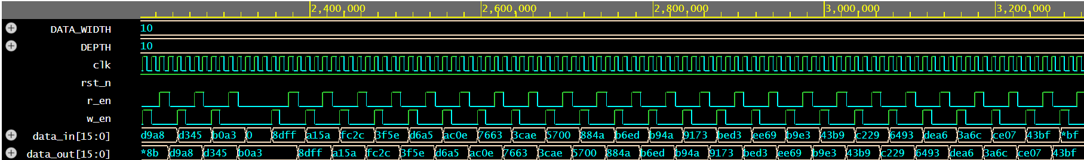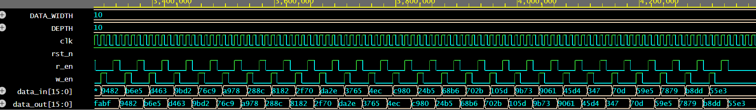

CODE:
`timescale 1ns/100ps
module fifo_test #(DEPTH,DATA_WIDTH)(
fifo_interface fif
);
logic [DATA_WIDTH-1:0] expected_fifo[$];
logic [DATA_WIDTH-1:0] temp;

//clocking at positive edge tasl
task tick;
@(posedge fif.clk);
endtask

//reset task
task reset_fifo();
fif.w_en=0;
fif.r_en=0;
fif.data_in=0;

expected_fifo.delete();

wait(fif.rst_n); //wait til the rst reaches 1
repeat(3)
tick();
endtask

//---WRITE TASK--//
task write_fifo(input [DATA_WIDTH-1:0] data);
if(!fif.full)begin
$display("writing=%0d",data);
expected_fifo.push_back(data);
fif.data_in=data;
fif.w_en=1;

tick();

fif.w_en=0;
tick();
end
else begin
$display("FIFO is full");
end

endtask

//----READ TASK-----//
task read_fifo();
if(!fif.empty)begin
fif.r_en=1;
tick();
#1;
$display("fifo output=%0d",fif.data_out);
if(expected_fifo.size()>0)
temp=expected_fifo.pop_front();
else begin
$display("ERROR: Scoreboard empty!");
return;
end
if(fif.data_out==temp)
$display("PASS read=%0d",temp);
else
$display("fail expected=%0d got=%0d",temp,fif.data_out);
fif.r_en=0;
tick();

end
else
$display("FIFO empty");

endtask

//-------CLEAR FIFO TEST-----------//
task clear_fifo_test();

logic [DATA_WIDTH-1:0] data;

$display("CLEAR FIFO TEST");
expected_fifo.delete();

//write 0s in fifo
for(int i=0;i<DEPTH;i++)begin
write_fifo('0);
end
//read everything back from fifo
for(int i=0;i<DEPTH;i++)begin
read_fifo();
end
if(fif.empty)
$display("Clear fifo test passed");
else
$display("clar fifo test failed");
endtask

//---DATA=ADDRESS TEST-----//
task data_index_test();

$display("data=index test");

expected_fifo.delete();

for(int i=0;i<DEPTH;i++) begin
write_fifo(i);
end
repeat(2)
tick();
for(int i=0;i<DEPTH;i++)
read_fifo();

$display("data=index test complete");
endtask

//---READ AFTER WRITE TEST------//
task read_after_write();
logic [DATA_WIDTH-1:0] rand_data;
repeat(25)
begin
rand_data=$urandom;
write_fifo(rand_data);
read_fifo();
end
$display("READ AFTER WRITE TEST COMPLETE");
endtask

//---RANDOM TEST-----//
task random_test();
logic [DATA_WIDTH-1:0] rand_data;

$display("RANDOM TEST START");
expected_fifo.delete();

repeat(50) begin // 50 pairs = 100 operations
// Step 1: always write first
rand_data = $urandom;
write_fifo(rand_data);

// Step 2: always read after
read_fifo();
end

// drain anything left
while(!fif.empty)
read_fifo();

$display("RANDOM TEST COMPLETE");
endtask

initial begin
reset_fifo();
clear_fifo_test();

reset_fifo();
data_index_test();

reset_fifo();
read_after_write();

reset_fifo();
random_test();
#50;
$finish;
end
endmodule
RESULT:
The three FIFO implementations were evaluated using the developed verification environment. The Clearing Memory, Read After Write, and Random tests passed for all three FIFOs. During the Data = Index test, FIFO1 failed because the data read from the FIFO did not match the expected sequential values. This indicates a functional issue in the data storage or read/write pointer management of FIFO1. FIFO2 and FIFO3 passed the implemented test cases, including the Data = Index test. The verification results therefore demonstrated that the testbench was capable of detecting functional discrepancies between the FIFO implementations.

UNDERSTANDING:
Successfully verified three synchronous FIFO implementations using a reusable SystemVerilog verification environment. Directed and random test cases validated reset, data integrity, and FIFO functionality across multiple parameter configurations. The verification identified a functional bug in FIFO1 while FIFO2 and FIFO3 met the design specification

CONCLUSION:
The project successfully verified three synchronous FIFO implementations using a reusable SystemVerilog verification environment. The developed testbench used a reference queue to independently track expected FIFO behavior and included directed as well as randomized test cases for checking reset, data integrity, sequential ordering, and read/write functionality.
The verification successfully identified a functional failure in FIFO1 during the Data = Index test, where the received data did not match the expected sequence. FIFO2 and FIFO3 passed the implemented test cases for the tested configurations. This project demonstrated the importance of functional verification in identifying design-level issues that may not be apparent from the FIFO interface alone. It also provided practical experience in developing reusable SystemVerilog testbench components, creating verification tasks, applying directed and random stimulus, and using a reference model to compare expected and actual DUT behavior.

