




Submitted by:Museera Itlish

Digital Design Verification

END PROJECT:SPI CORE VERIFICATION

NUST Chip Design Centre (NCDC), Islamabad, Pakistan

Copyrights ©, NUST Chip Design Centre (NCDC). All Rights Reserved. This document is prepared by NCDC and is for intended recipients only. It is not allowed to copy, modify, distribute or share, in part or full, without the consent of NCDC officials.

Introduction:
The objective of this project was to develop a Universal Verification Methodology (UVM)-based verification environment for the Simple SPI Core. The verification environment was designed to validate the functional correctness of the SPI controller by generating various test scenarios, driving transactions to the Design Under Test (DUT), monitoring DUT responses, and comparing the observed behavior with the expected results using a scoreboard.
The project focuses on verifying key SPI functionalities, including reset behavior, register read/write operations, and SPI enable/disable control. Directed and constrained-random test cases were implemented to evaluate the DUT under different operating conditions. Functional checking was performed using a monitor and scoreboard, while the UVM architecture provided a reusable and modular verification environment. The simulation results obtained from each test case were analyzed to determine whether the DUT behaved according to the expected specifications.

VERIFICATION FLOW DIAGRAM:

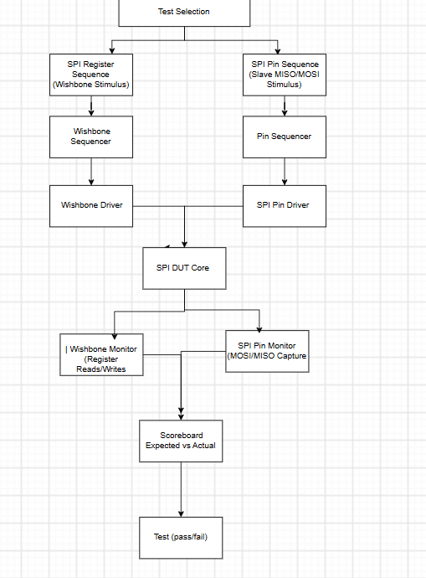

VERIFICATION STRATEGY
The verification of the SPI Core was carried out using a structured UVM-based approach. The strategy consisted of developing reusable verification components, generating directed and random test scenarios, and validating the DUT responses through functional checking.
The overall verification strategy included the following steps:
- Develop a complete UVM verification environment consisting of a test, environment, Wishbone agent, SPI Pin UVC, sequencer, driver, monitor, scoreboard, and coverage collector.
- Generate stimulus using dedicated UVM sequences for different verification scenarios.
- Drive Wishbone read and write transactions to configure and control the SPI Core.
- Use the SPI Pin UVC to emulate an SPI slave by driving MISO responses and monitoring MOSI/MISO serial communication.
- Monitor all DUT register accesses and serial pin transactions, and forward them to the scoreboard for checking.
- Compare actual DUT outputs with expected reference values to determine functional correctness.
- Execute multiple directed test cases to verify individual SPI functionalities.
- Apply constrained-random stimulus to evaluate the robustness of the SPI Core under varying input conditions.
- Analyze simulation logs, monitor outputs, and scoreboard reports to determine the pass/fail status of each test.
The verification strategy focused on validating the following functional areas:
- SPI Reset Verification – Confirm that all registers are initialized to their default values after reset.
- Register Verification – Verify correct read and write operations for the SPCR, SPER, and Slave Select registers.
- SPI Enable/Disable Verification – Verify that enabling and disabling the SPI module correctly updates the control register.
- Random Verification – Apply randomized register transactions to evaluate the DUT under diverse operating conditions and identify unexpected behavior.
- MOSI Loopback Verification – Verify that data transmitted on the MOSI line is correctly received back by the SPI Core using loopback mode, confirming the integrity of the transmit and receive paths.
- SPI Full-Duplex Verification – Verify simultaneous transmission and reception by transmitting data on MOSI while receiving predefined data from the SPI slave model through MISO during the same transfer.
- Multi-Byte Transfer Verification – Verify reliable transmission and reception of multiple consecutive SPI data bytes without data corruption or loss, ensuring correct operation during continuous data transfers.
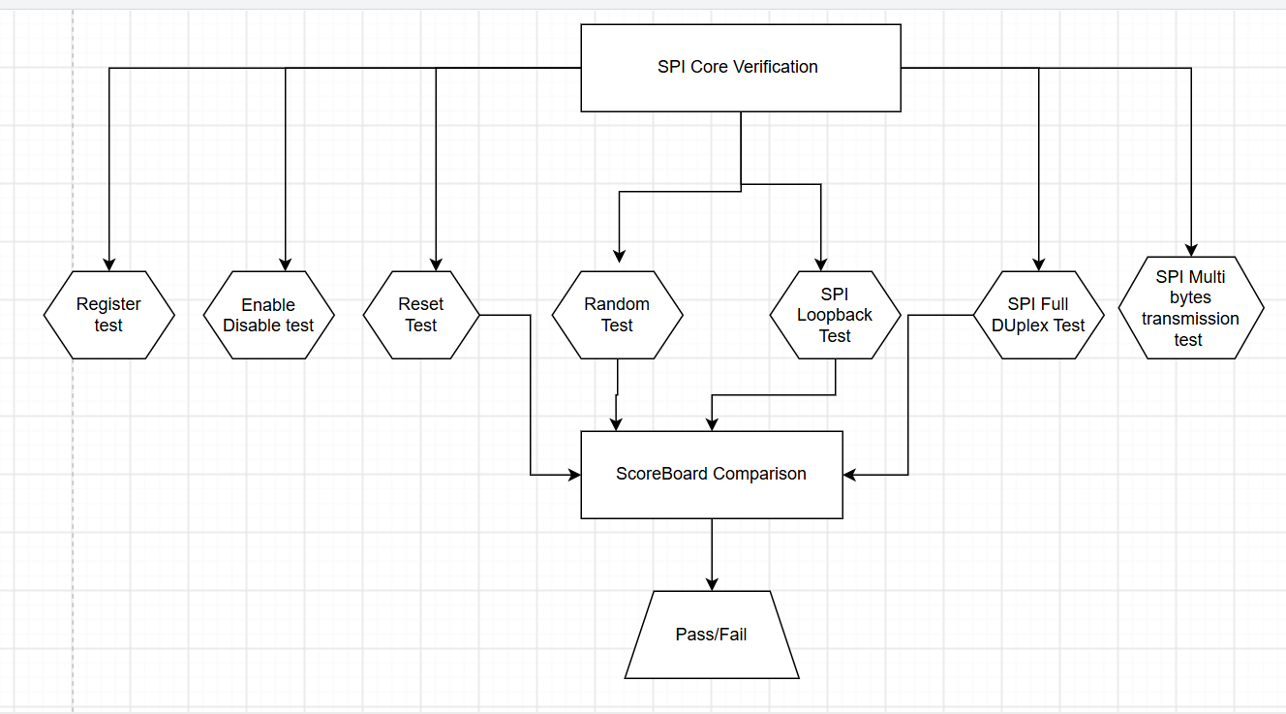
- SPI Reset Test:
Code:
`ifndef SPI_RESET_TEST_SV
`define SPI_RESET_TEST_SV

class spi_reset_test extends spi_base_test;

`uvm_component_utils(spi_reset_test)

spi_reset_sequence seq;

function new(string name="spi_reset_test",
uvm_component parent=null);

super.new(name,parent);

endfunction

task run_phase(uvm_phase phase);

phase.raise_objection(this);

seq = spi_reset_sequence::type_id::create("seq");

seq.start(env.agent.sequencer);

phase.drop_objection(this);

endtask

endclass

`endif
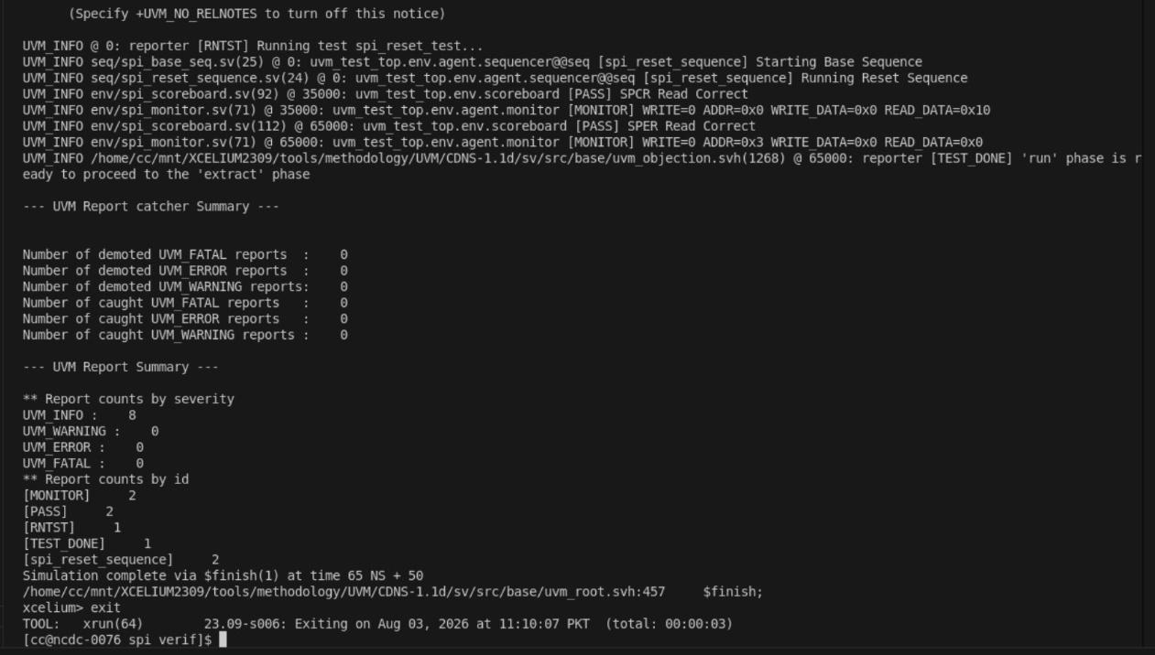

- SPI Register Test:
Code:
`ifndef SPI_REGISTER_TEST_SV
`define SPI_REGISTER_TEST_SV

class spi_register_test extends spi_base_test;

`uvm_component_utils(spi_register_test)

spi_register_sequence seq;

function new(string name="spi_register_test",
uvm_component parent=null);

super.new(name,parent);

endfunction

task run_phase(uvm_phase phase);

phase.raise_objection(this);

seq = spi_register_sequence::type_id::create("seq");

seq.start(env.agent.sequencer);

phase.drop_objection(this);

endtask

endclass

`endif
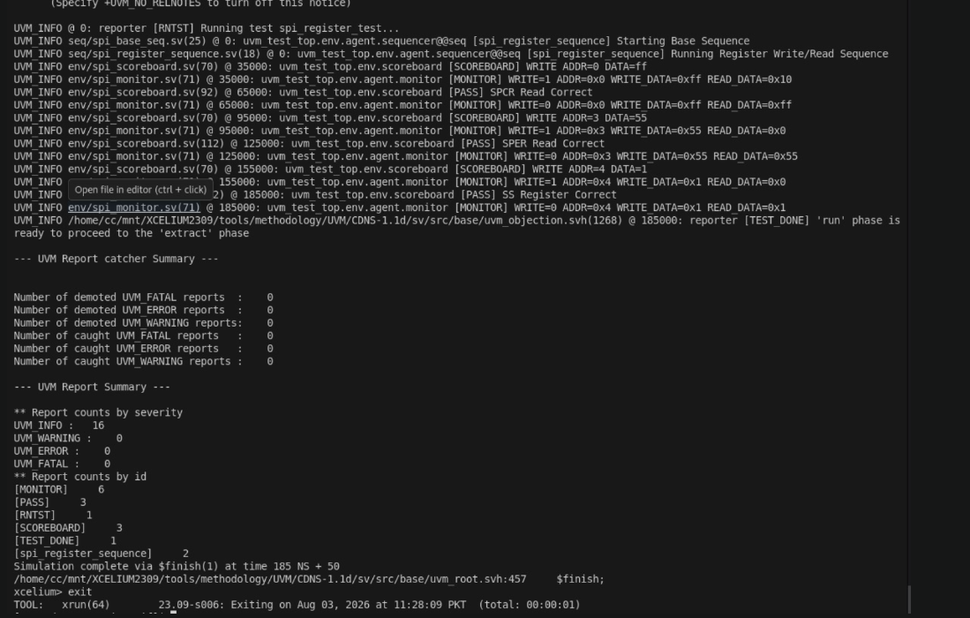

- SPI Random Test:
Code:
`ifndef SPI_RANDOM_TEST_SV
`define SPI_RANDOM_TEST_SV

class spi_random_test extends spi_base_test;

`uvm_component_utils(spi_random_test)

spi_random_sequence seq;

function new(string name="spi_random_test",
uvm_component parent=null);

super.new(name,parent);

endfunction

task run_phase(uvm_phase phase);

phase.raise_objection(this);

seq = spi_random_sequence::type_id::create("seq");

seq.start(env.agent.sequencer);

phase.drop_objection(this);

endtask

endclass

`endif
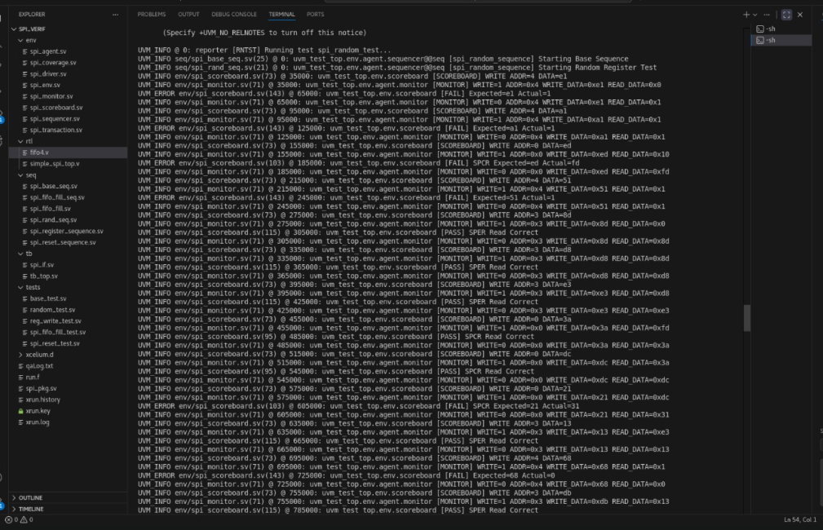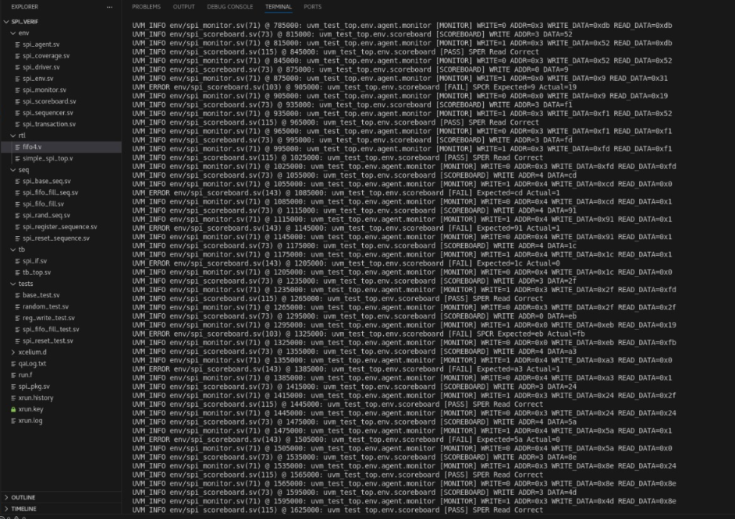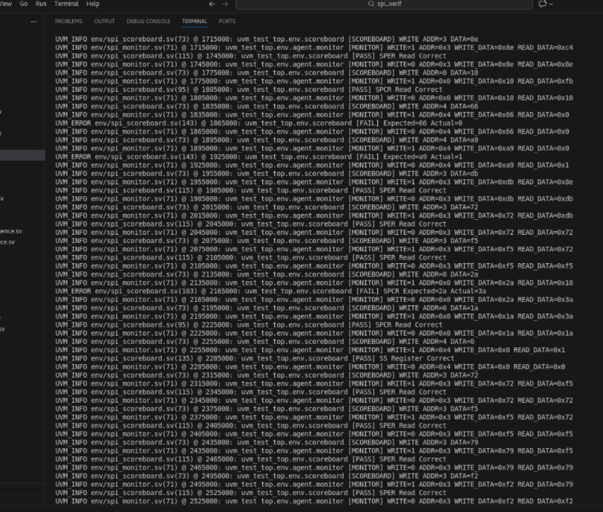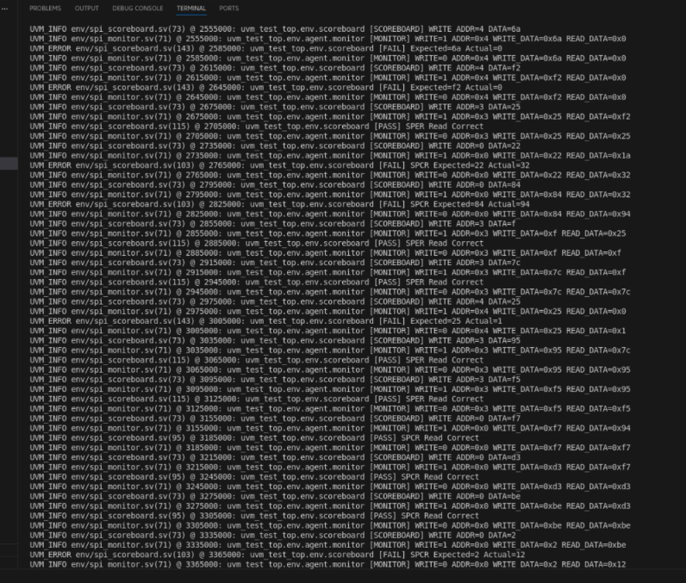
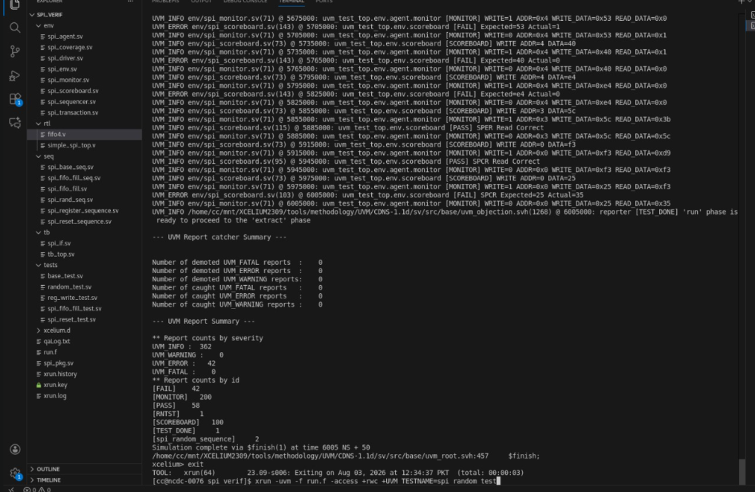

- SPI Enable Disable Test:
Code:
`ifndef SPI_ENABLE_DISABLE_TEST_SV
`define SPI_ENABLE_DISABLE_TEST_SV

class spi_enable_disable_test extends spi_base_test;

`uvm_component_utils(spi_enable_disable_test)

function new(string name="spi_enable_disable_test",
uvm_component parent=null);

super.new(name,parent);

endfunction

virtual task run_phase(uvm_phase phase);

spi_enable_disable_seq seq;
phase.raise_objection(this);

seq = spi_enable_disable_seq::type_id::create("seq");

seq.start(env.agent.sequencer);

#500;

phase.drop_objection(this);

endtask

endclass
`endif
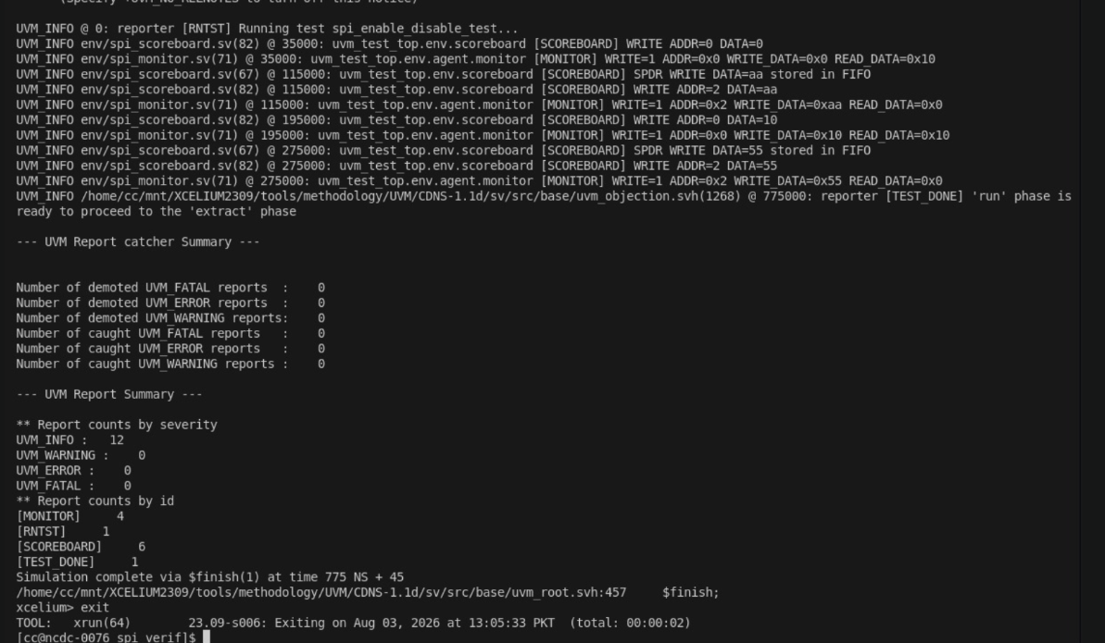
DUT waveform:

- SPI_FIFO_FILL_SEQ:
`ifndef SPI_FIFO_FILL_TEST_SV
`define SPI_FIFO_FILL_TEST_SV

class spi_fifo_fill_test extends spi_base_test;

`uvm_component_utils(spi_fifo_fill_test)

spi_fifo_fill_sequence seq;

//-----------------------------------------
// Constructor
//-----------------------------------------

function new(string name="spi_fifo_fill_test",
uvm_component parent=null);

super.new(name,parent);

endfunction

//-----------------------------------------
// Run Phase
//-----------------------------------------

task run_phase(uvm_phase phase);

phase.raise_objection(this);

seq = spi_fifo_fill_sequence::type_id::create("seq");

seq.start(env.agent.sequencer);

phase.drop_objection(this);

endtask

endclass

`endif
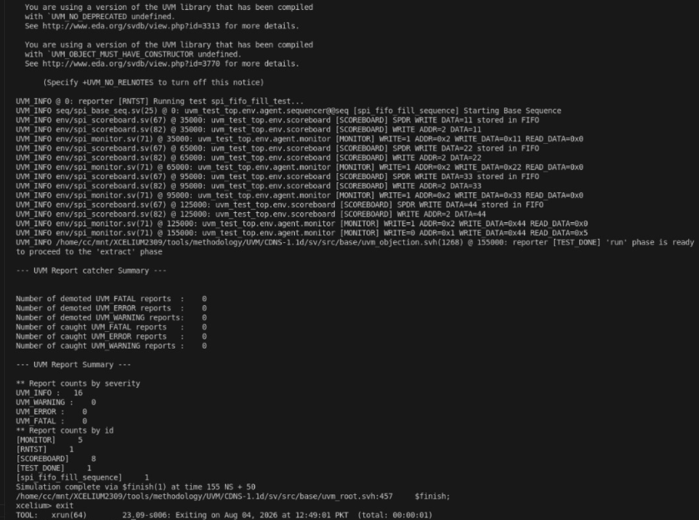
- SPI_LOOPBACK_TEST
`ifndef SPI_MOSI_LOOPBACK_TEST_SV
`define SPI_MOSI_LOOPBACK_TEST_SV

class spi_mosi_loopback_test extends spi_base_test;

`uvm_component_utils(spi_mosi_loopback_test)

spi_mosi_loopback_seq seq;
function new(string name="spi_mosi_loopback_test",
uvm_component parent=null);

super.new(name,parent);

endfunction

task run_phase(uvm_phase phase);

phase.raise_objection(this);

// Enable pin-level checking
env.pin_scoreboard.enable_checks();

seq = spi_mosi_loopback_seq::type_id::create("seq");

// Drive Wishbone side
seq.start(env.agent.sequencer);

phase.drop_objection(this);

endtask

endclass

`endif
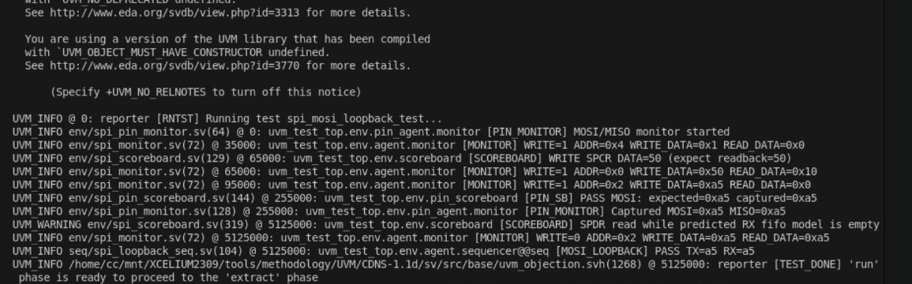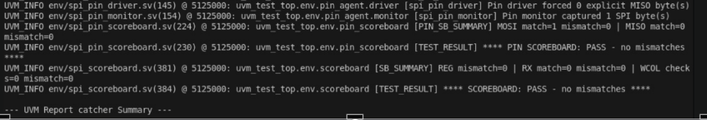
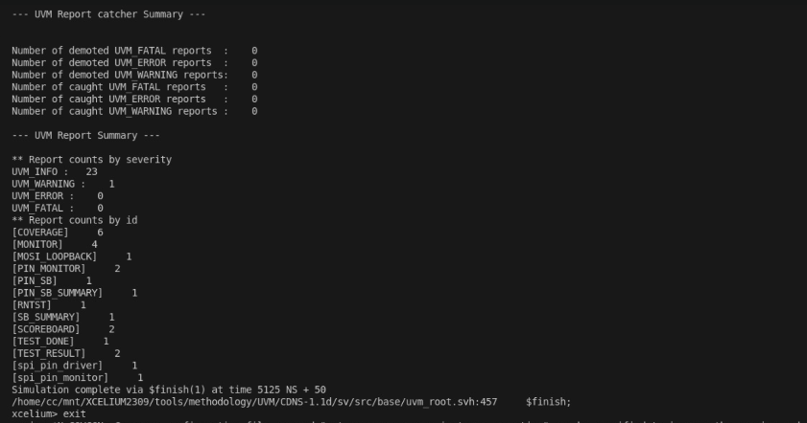
- SPI FULL DUPLEX TEST
class spi_full_duplex_test extends spi_base_test;

`uvm_component_utils(spi_full_duplex_test)

function new(
string name="spi_full_duplex_test",
uvm_component parent=null);

super.new(name,parent);

endfunction

virtual task run_phase(uvm_phase phase);

spi_full_duplex_seq seq;

phase.raise_objection(this);

seq =
spi_full_duplex_seq::type_id::create("seq");

seq.start(
env.agent.sequencer
);

phase.drop_objection(this);

endtask

endclass
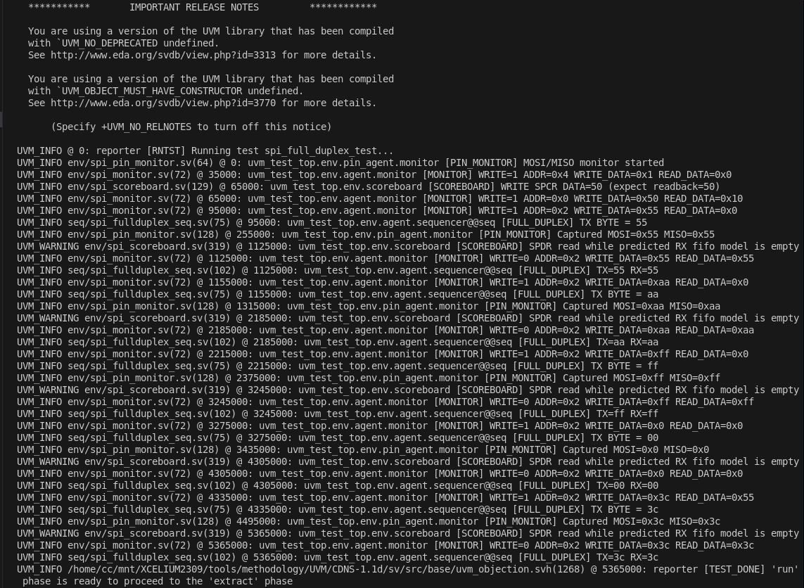
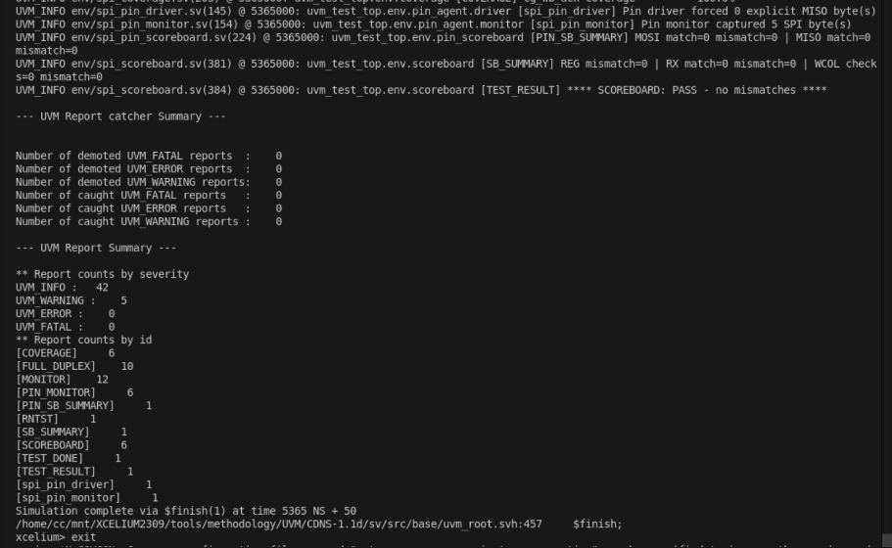
- SPI MULTI BYTES TRANSFER TEST:
`ifndef SPI_MULTI_BYTE_TEST_SV
`define SPI_MULTI_BYTE_TEST_SV

class spi_multi_byte_test extends spi_base_test;

`uvm_component_utils(spi_multi_byte_test)

function new(string name="spi_multi_byte_test",
uvm_component parent=null);
super.new(name,parent);
endfunction

virtual task run_phase(uvm_phase phase);

spi_multi_byte_seq spi_seq;
spi_pin_response_seq pin_seq;

phase.raise_objection(this);

// Create sequences
spi_seq = spi_multi_byte_seq::type_id::create("spi_seq");
pin_seq = spi_pin_response_seq::type_id::create("pin_seq");

// Run master and slave together
fork
begin
spi_seq.start(env.agent.sequencer);
end

begin
pin_seq.start(env.pin_agent.sequencer);
end
join

phase.drop_objection(this);

endtask

endclass

`endif
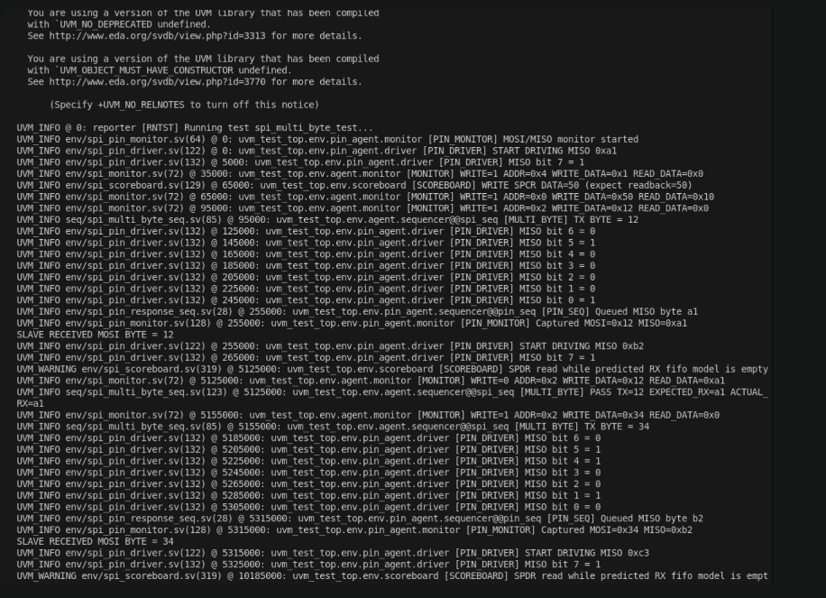
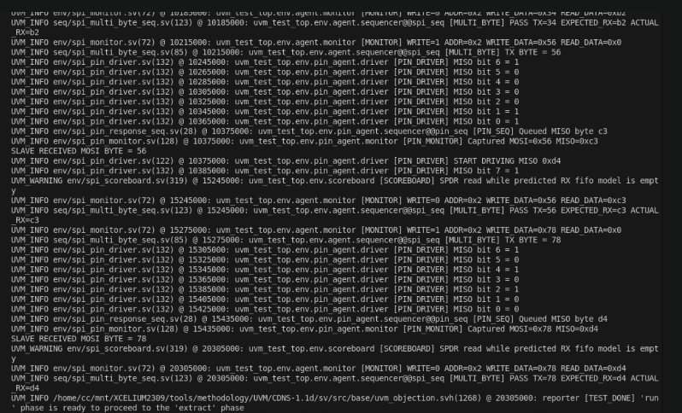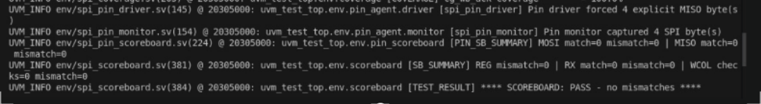
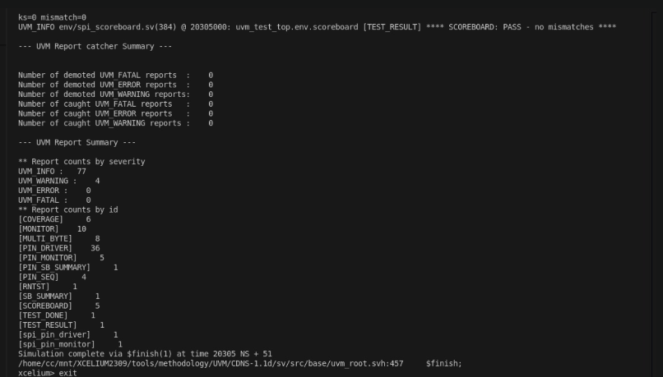

TESTS | PURPOSE | EXPECTED RESULT | REMARKS | STATUS
SPI Reset Test | Verifies that after reset, the SPI control and extension registers are initialized to their default values. The scoreboard compares the values read from the DUT with the expected reset values | SPCR and SPER should contain their default reset values. | The scoreboard confirmed all reset register values matched the expected defaults. | PASSED
SPI Register Test | Verifies read/write functionality of the SPI configuration registers (SPCR, SPER and Slave Select register). The test writes known values and reads them back for comparison. | The values read from each register should exactly match the values written | All register writes and reads matched correctly, and the scoreboard reported successful comparisons.. | PASSED
SPI Random Test | Applies randomly generated register addresses and data values to verify the SPI controller under random stimulus and check for unexpected behavior. | Random transactions should complete correctly and read-back values should match the expected values. | The random sequence produced transactions that were not fully supported by the current scoreboard/reference model (for example, invalid register accesses, unsupported random transaction ordering, or expectations that were not modeled). As a result, mismatches were reported. The failure is due to the verification environment needing additional handling for random scenarios rather than a confirmed DUT functional bug. | FAILED
SPI Enable Disable Test | Verify SPI enable and disable control | Writes to the SPI Control Register (SPCR) to enable and disable the SPI module by modifying the enable bit, then reads the register to verify the bit changes correctly. | The SPI enable bit was successfully updated, and the register values matched the expected results after each operation. | PASSED
SPI Loopback test | Verify that data transmitted on the MOSI line is correctly received by the SPI master through loopback. | The byte written to the transmit register is observed on MOSI and the same byte is received in the receive register. | Loopback connection successfully verified the MOSI transmit path and receive functionality. | PASSED
SPI Full Duplex Test | Verify simultaneous transmission on MOSI and reception on MISO during a single SPI transfer. | Master transmits the programmed MOSI byte while simultaneously receiving the expected MISO byte from the slave during the same transfer. | All transmitted MOSI bytes and received MISO bytes matched the expected values, confirming correct full-duplex operation. | PASSED
SPI Multi bytes Transfer Test | Verify reliable transmission and reception of multiple consecutive SPI transfers without data corruption | Each transmitted byte is correctly sent over MOSI and the corresponding programmed MISO response is received for every transfer. | Four consecutive transfers (0x12, 0x34, 0x56, 0x78) completed successfully with expected responses (0xA1, 0xB2, 0xC3, 0xD4). | PASSED

Reason for Failure of Random Test: The random test generated unconstrained transactions, including unsupported or invalid register accesses. Since the DUT does not return valid data for such accesses, the scoreboard reported mismatches. Constraining the random stimulus to valid SPI register operations would allow the test to pass.

CHALLENGES FACED AND SOLUTIONS
During the development of the UVM-based verification environment for the SPI Core, several challenges were encountered during testbench development, simulation, and debugging. The major challenges and the solutions implemented are described below.

1.Synchronization Between Wishbone Transactions and SPI Transfers
One of the challenges was ensuring that data written through the Wishbone interface reached the SPI transfer logic at the correct time. The SPI transfer starts only when the SPI module is enabled and data is available in the transmit FIFO.
Solution:
Directed sequences were developed to first configure the required registers, write data into the transmit FIFO, enable the SPI module, and then allow sufficient simulation time for the serial transfer to complete. This ensured that the verification environment followed the same sequence expected by the DUT

2.Debugging UVM Testbench Integration
Integrating multiple UVM components, including the Wishbone agent, SPI Pin UVC, scoreboard, coverage collector, and different sequencers, required careful debugging of connections and synchronization between components.
Solution:
UVM messages, monitor outputs, scoreboard reports, and coverage results were used to trace transactions through the verification environment. Tests were developed incrementally, starting with basic register-level functionality and then extending the environment to pin-level and full-duplex verification.

3. MOSI Monitor Captured Zero Bytes
When the MOSI pin-level test was first run, the Wishbone transactions completed successfully and the test ended without a scoreboard error, but the MOSI monitor reported that it had captured zero bytes. This showed that the test had verified the register-level operations but had not actually allowed enough time for the SPI transfer to be observed at the pins.
Solution:
The simulation output was traced from the Wishbone transactions to the SPI pins. The test sequence was modified so that the SPI transfer was given sufficient time to start and complete before the test ended. This also highlighted the importance of checking pin-monitor activity rather than considering a test successful only because the main scoreboard reported no mismatch.

4. Separating Bus-Level and Pin-Level Verification
The original Wishbone agent was useful for checking register accesses, but it could not directly verify whether the correct serial data appeared on MOSI or whether the correct data was received through MISO.
Solution:
A separate SPI Pin UVC was added to the verification environment. The pin monitor observes the MOSI signal and reconstructs transmitted bytes from the SPI clock, while the pin driver provides MISO data as an external-slave model. This extended the testbench from register-level verification to actual SPI pin-level verification.

Overall Resolution
The challenges encountered during the project helped improve the verification environment from basic register-level testing to a more comprehensive environment capable of checking SPI serial communication. The final environment used directed and random stimulus, register-level monitoring, pin-level monitoring, scoreboard-based checking, and functional coverage to evaluate the SPI Core.

CONCLUSION
A complete UVM-based verification environment was successfully developed for the Simple SPI Core. The environment included reusable verification components such as the driver, monitor, sequencer, scoreboard, and functional test cases, enabling efficient verification of the DUT.
Four verification scenarios were implemented to validate the SPI controller. The SPI Reset Test, SPI Register Test, and SPI Enable/Disable Test all passed successfully, confirming the correct operation of the corresponding SPI functionalities. The SPI Random Test did not pass because the generated random transactions included unsupported or invalid register accesses that were not handled by the current scoreboard and reference model. This indicates a limitation of the verification environment rather than a confirmed functional error in the DUT.
Overall, the project demonstrates the effectiveness of UVM in creating a modular, reusable, and scalable verification environment. The developed framework can be further extended with additional constrained-random sequences, improved scoreboard functionality, and enhanced functional coverage to achieve more comprehensive verification of the SPI Core.
窗体顶端

窗体底端

