Names: INEZA MUSEKURA Esperance

ID: 28777

Instructor: Eric MANIRAGUHA

**ORACLE 21C PDB AND OEM PRACTICAL TASKS REPORT**

1.**OVERVIEW OF TASKS**

This assignment went through various tasks like:

* Creating new pluggable database in oracle 21c
* Create and delete a PDB
* Configure oracle enterprise manager(OEM)

1. **STEPS TAKEN**
2. **Creating a new PDB**

**Steps I followed iclude:**

* I started by logging in into sql plus as a dbadmistrator(sys as sysdba)
* I created a new PDB as:

CREATE PLUGGABLE DATABASE es_pdb_28777

ADMIN USER esperance_plsqlauca_28777 IDENTIFIED BY INEZA

ROLES = (DBA)

FILE_NAME_CONVERT =(‘C:\ORACLE21C\ORADATA\ORCL\PDBSEED\’, C:\ORACLE21C\ORADATA\ORCL\es_pdb_28777\’ );

* Then a new pluggable database was created.

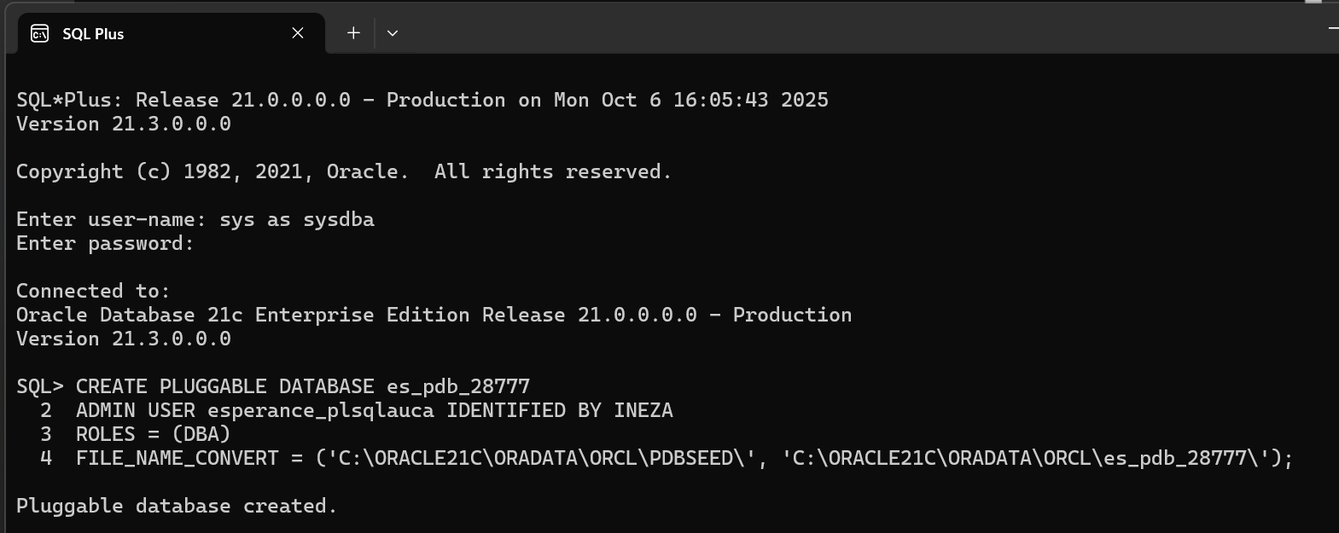

* I opened my PDB as follows: ALTER PLUGGABLE DATABASE es_pdb_28777 OPEN;
* After, I verified if the creation was successful : SHOW PDBS;

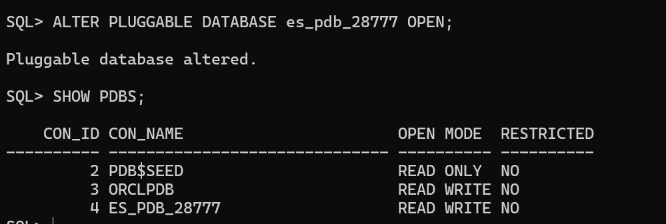

Notes: No issues encoutered

1. **Create and delete another PDB**

**Steps**:

* I created another pluggable database called es_to_delete_pdb_28777:

CREATE PLUGGABLE DATABASE es_to_delete_pdb_28777

ADMIN USER esperance_delete_plsqlauca IDENTIFIED BY INEZA

ROLES = (DBA)

FILE_NAME_CONVERT =(‘C:\ORACLE21C\ORADATA\ORCL\PDBSEED\’, C:\ORACLE21C\ORADATA\ORCL\es_to_delete_pdb_28777\’ );

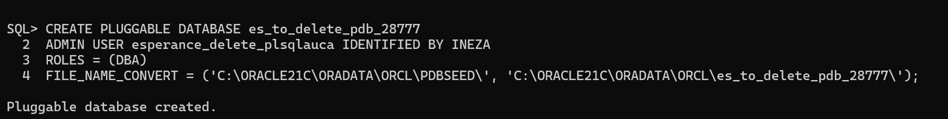

* Show pluggable database es_to_delete_pdb_28777

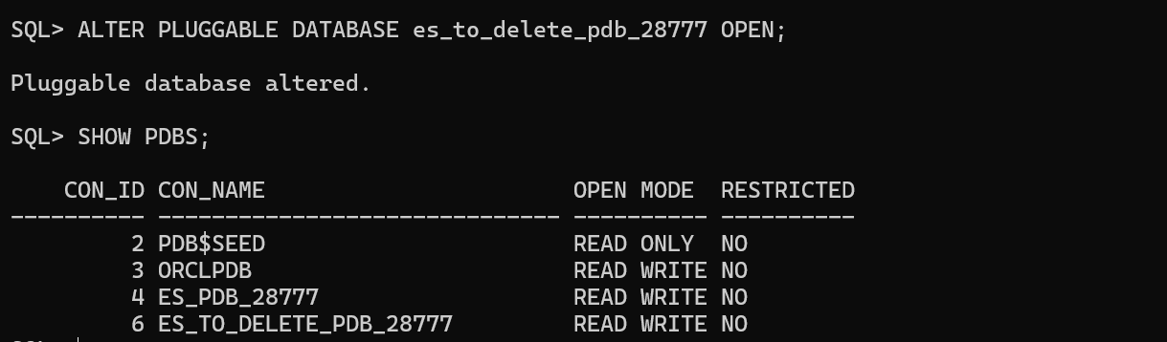

* I closed the PDB so as it can be possible to delete it:

ALTER PLUGGABLE DATABASE es_to_delete_pdb_28777 CLOSE IMMEDIATE;

* Then I dropped the PDB and checked if it was really removed:

DROP PLUGGABLE DATABASE es_to_delete_pdb_28777 INCLUDING DATAFILES;

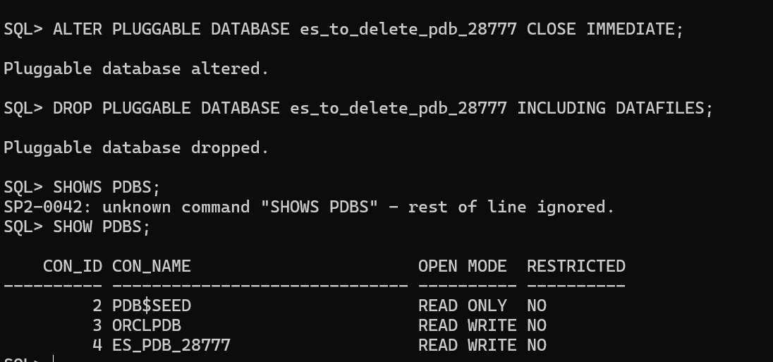

Notes:

Initially, I got an error when I tried to drop my PDB while it was still open and then I run this querry: ALTER PLUGGABLE DATABASE es_to_delete_pdb_28777 CLOSE IMMEDIATE , then database was closed , then after I dropped it well.

1. **Configuring oracle enterprise manager**

**Steps taken**:

* I set HTTP port for OEM: EXEC DBMS_XDB_CONFIG.SETHTTPSPORT(5510);
* Then I verified if it has been set successfully by : SELECT DBMS_XDB_CONFIG.GETHTTPSPORT() FROM DUAL;
* I opened the browser and went to <https://localhost:5510/em>
* I logged in using sys credentials
* I verified if es_pdb_28777is listed there

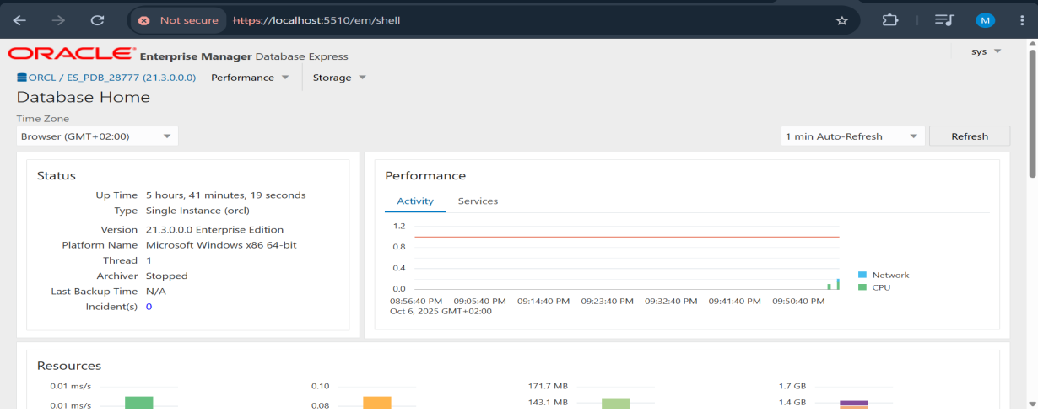

**Notes:**

Initially, OEM didn’t open due to incorrect port (5500) because I thought is the default one , then after I realized that ports can vary , then I created the new one by:

EXEC DBMS_XDB_CONFIG.SETHTTPSPORT(5510); and after I joined using <https://localhost:5510/em>

And it worked.

**As conclusion**, I can say that I have completed all my tasks successfully and screenshots provided are proofs to what I did. Also , I have got new skills as I was trying to resolve encountered issues by providing proper sql commands.