TCI Moderator/Agent Design Specification

Protocol
Who ever starts the event is designated as moderator. Each agent can then join the event using the viewer. Once the agent has joined the event they will have the information needed to communicate to the moderator. When the agent starts the moderator console the userID of the event will be passed from the viewer to the moderator.

Moderator
Starts the event
Agent
Viewer
Agent
Viewer
Agent
Viewer
Agent
Viewer
Agents join the event using the Palace Presents Viewer

After an agent joins the event they will need to get Wizard Privileges by entering the wizard password. At this point they can then start (load) the Moderator/Agent Console. When an agent starts the console a new message will automatically be sent to the moderator with their AgentUserID (see AMSG_AGENTCONNECT).

Moderator
Event is running
Agent
Viewer
Agent
Viewer
Agent
Viewer
Agent
Viewer
Agents can still monitor the event using the Palace Presents Viewer

Agent
Console
Agent
Console
Agent
Console
Agent
Console
Blow thru communications establised

AMSG_AGENTCONNECT
Sends the UserID that will become the AgentUserID.

This message will indicate to the Moderator that the agent has their console running and is ready, which will be indicated in the Status field of the Audience Property Page. At this time the moderator will then send them the information about the event, which will be all the current questions and question information, audience members, and a list of agent information (see AMSG_NEWAGENT). This will take place when the moderator presses the Make Agent button on an agent from the Audience Property Page. This will change the status to “Agent on Stage”. Since the agent did not start the event they will have less privileges than the moderator.

AMSG_NEWAGENT
The packet information will include the following:
- Number of questions in the queue.
- The current Question/Answer pairs and all question information.
- Agent information. This is a list of all of the other agents.
- Current Agent UserRec information
- Agent(s) state information, position on stage, etc.
- Current Questions assigned to the agent
- Audience information. This will be the current list of members in the audience
- Information needed to take over the event. Stage GIF, pointers to files on the network, etc.
- Information concerning the Log File.
- Size of the Packet

Once the packet has been received correctly the Agent will send a message back to the moderator to acknowledge a success or failure as follows:

AMSG_REMOVEAGENT
This message will be sent to remove an agent from the stage. It will contain the AgentUserID and will be sent to all of the agents and audience members.

AMSG_ACKSUCCESS
This message indicates a successful transfer. It will contain the AgentUserID.

AMSG_ACKFAILURE
This message indicates that the packet was not received correctly. It will contain the AgentUserID, size of the packet, and maybe the type of packet (e.g. AMSG_NEWAGENT).

AMSG_NEWQUEST
Whenever a new question comes to the moderator it will be sent to all of the agents. This packet will contain the UserRec structure of the audience member that submitted the question, the questionNbr, and the questionText.

AMSG_ASSIGNQUEST
When the moderator receives a new question and assigns it to an agent, he will send a packet of information to each agent containing AgentUserID, agentName, questionNbr, question, and questStatus will be sent.

AMSG_DELQUEST
When the moderator deletes a question a message will be sent to all agents that will delete the question from the Monitor view. This message will include the questionNbr, time question was received, and question text so it can be verified.

This message will be also sent out when once a Question/Answer has been displayed and written to the log.

AMSG_REQ_QUEST
This message is sent to the moderator when a agent request to take or assign himself to a question. It will contain the AgentUserID and the questionNbr.

AMSG_NEWAUDMEM
Any time a new audience member appears the moderator will send a message to each agent sending the user information. This will be the current UserRecord structure. This information is mainly needed in case the moderator goes down or we want to take over the moderator duties.

AMSG_NEWMODERATOR
This message will be used to take over moderator duties. When an agent presses this button the current moderator will lose control over the event. This message will be sent to all agents.

This message includes the AgentUserID of the new moderator. At this point all the information needed to have control of the messaging will be disable on the current moderator and enabled on the new moderator.

Communications Diagram
Server
Moderator
Console
Agent
Console
Agent Console
Blow Through Communications between Moderator and Agents.

Moderator/Agent Console

Preference Property Page (1 – 1.5 Days to Complete )
Refer to Figure 1.

Add the extra check boxes to the Preference Property Sheet. New BN_CLICKED message handlers will be implemented for each one.

Moderator Mode

“Allow Agents” Check Box
The default is unchecked (off).
If the Allow Agents is checked then the Audience and Monitor property sheets will reflect it by not showing any agents in the drop down boxes (CComboBox) and the List Control (CListCtrl). A boolean variable will be used to indicate this to the classes used for the Audience and Moderator property pages.

“Send Question Confirmation” Check Box (Phase Two)
The default is checked (on).
This will send a private message back to the user indicating that the question is being submitted.

This will appear in the upper left corner and the message could read as, “Agent Bob is processing your question”. This will help the user know which agent to watch.

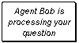

This will be done the same way the Moderator sends information to the user now. SendMessage function.

“Allow Agents to Assign” Check Box – Added 10/28/97
The default is unchecked (off).
This check box gives agents permission to assign themselves to questions they see in the queue. This will be done by enabling or disabling the Combo box in the Agent Monitor property page. If it is off then the moderator is the only one that can assign questions to agents.

Agents will only be allowed to assign themselves to an open question. If the agent cannot answer the question they will be able to un-assign the question (re-open) allowing other agents to answer the question. Refer to the AMSG_REQ_QUEST message.

“Queue Delay Time” Edit Box
Whenever the moderator presses the “Display Q&A” from the Monitor Property Page, the Q&A will be sent to the end of a queue. This edit box allows the delay time of the emptying of the queue to be set in seconds. There should be a minimum and maximum setting for this. (5sec min, 90sec max) TBD

All other functionality will remain the same as the current Preferences Tab.

Agent Mode
In Agent mode the preferences tab will reflect the current settings of the event but all the controls will be disabled.

Figure 1
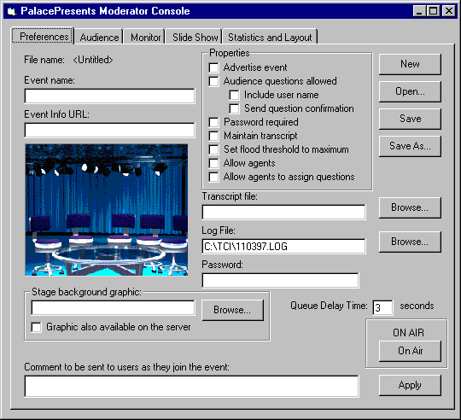

Audience Property Page (5 Days)
Refer to Figure 2.

Add the new “Audience” property sheet. This will most likely be a new class (currently closest class is the CMonPage).

The main view in this page will be made using a CListCtrl. This control will show the Type of user (Stage invitation requested, stage invitation sent, onstage, agent, agent onstage, etc.), Username, and Time they joined the audience.

This property sheet will allow the moderator to choose and view the audience and available agents. Once a member of the audience is assigned as an agent then they will automatically be put on the stage. Audience members that are none agents may be invited on the stage as well.
We should be able to have up to thirty agents on the stage at time.

This list can be sorted by Type, User Name or Time.

All other functionality will remain the same as the current Monitor Tab of the Moderator Console.

“Moderator/Agent” Button
This button allows an agent to take over moderator duties. The current moderator will be able to resign as moderator by pressing the Agent button. This will be the same button only it will say Agent in Moderator mode and Moderate in agent mode. This will change a flag set in the UserRecord structure.

If the moderators’ computer goes down an agent will be able to assume moderator duties.

Agent Mode
The Audience tab will allow an agent to view the audience but all control functionality will be disabled except the Moderator/Agent button.

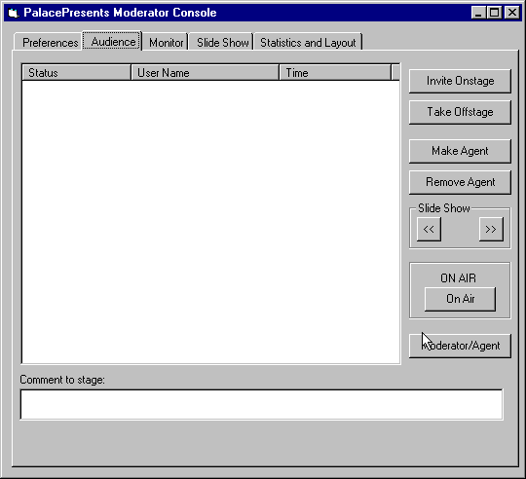

Audience Property Page
Figure 2

Monitor Property Page (23 Days)
Refer to Figure 3.
The Monitor Property Page will be the most used.

“Question in queue:” Edit Box
This is a read only edit box that reflects the number of “unanswered” questions.

“Average Hold Time:” Edit Box
This is a read only edit box that will indicate the average time a person is waiting for the answer. It will be calculated by averaging the amount of time between the “submitted time” and the current time of the questions in the queue. This field will be updated once a minute.

“Reset #” Button
This button is used to reset the question # back to 1. The question number will be an integer but only the last 2 digits will be shown though the full number will be logged. This will not effect the current answers in the queue but only the new questions submitted.

“List Control”
The main view of the Monitor tab will be created using a CListCtrl or a possible 3rd party Grid Control. The list control will show the questions that have been submitted by a member of the audience. It will show the Question #, Question, Time Submitted, Username of the author, Agent Assigned to, Status (open, Assigned, Work in progress, Work Completed, Answered), and the Answer.

All question/answers will be logged after the question is answered by writing to a file on a local server.

When the moderator clicks on a question, the question will be highlighted and the “Assigned to” and “Status” will be selected in the CComboBox’s accordingly. The “Question” and “Answer” will be displayed in the Question and Answer edit boxes accordingly.

Once a question is answered by an agent it will still remain in the list until the “Display Q&A” or “Delete” button has been pressed. All answers will come back to the queue (back to the moderator) where the moderator can manually push the Q&A to the stage or where the queue will automatically send the Q&As back to the stage based on the Status of the question and the Time submitted.

The list control will give the user the ability to sort the questions by Time, Agent, or Status. The default will be Time in ascending order.

“Assigned to” Combo Box
This combo box is used to select the agent the question is to be assigned to. This will act as a dropdown list box allowing names to only be selected from the list. The moderator will not be able to add new names from this property page.

“Status” Combo Box
This combo box will be used to change the status of the question and will be available to the moderator and the agent. This will be a select only dropdown list box. The status definitions are as follows:
- Open
Indicates the question has not been assigned.
- Assigned
Indicates the question has been assigned.
- In Progress
Indicates the question is at this time being reviewed by an agent.
- Completed
Indicates the question has been completed.

Allowing the agent to change the status could be used to let the moderator know that the question needs to be re-assigned to another agent. To do this the agent would change the status to Open.

“Answer Privately” Check Box
Default is unchecked (off).
If this box is checked the answer will go directly to the user that asked the question. This is also known as “Whisper” Mode.

“Question” Edit Box
This edit box shows the text of the current question selected in the list. This edit box will give the moderator opportunity to rephrase the question if needed. The moderator will able to view up to 256 characters.

Note: All edit boxes will allow edit commands Cut, Copy, and Paste, which can be accessed by clicking on the right mouse button.

“Answer” Edit box
This edit box shows the answer of the current question selected in the list control. The moderator has the ability to edit the answer or answer the question. The answer is limited to 256 characters. If it is longer than 256 characters it will be packaged as FAQs.

“Comment to Stage” Edit Box
This control allows the moderator to ask questions or make comments directly to the stage for everyone to see.

“URL” Combo Box
This combo box allows the moderator to send URLs to the person asking the question along with the answer.

“URL Private” Button – Added 10/28/1997
This button will push the URL directly to the user instead of to all viewers.

“Display Q&A” Button
This button will send the Q&A to the stage if we are in manual mode. See “Auto Answer check box” for the Preference Property page.

“Delete” Button
This button allows the moderator to delete the question. The deleted question will be logged.

Agent Mode
In agent mode the dialog will only be able to:
- Answer the question
- Change the status of the question

Monitor Property Page
Figure 3
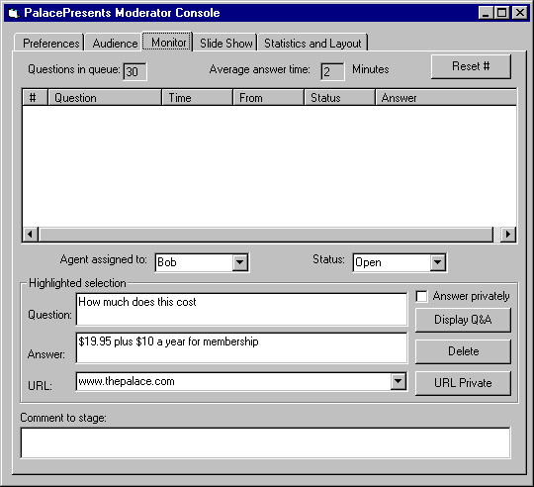
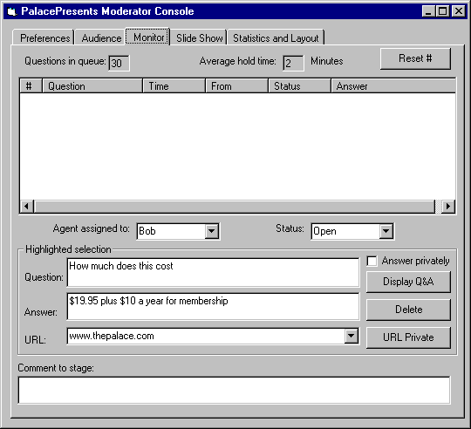

Log File
The new log file will be a comma delimited text file. There will be five types of events that will be logged. Session Start/End, Agent Log-on/Log-off event, User Join/Leave, Question/Answer sent to the stage, Moderator Duties Change.

Session Start/End
- Session Started
- Date/Time

Agent Log-on/Log-off event
- Agent
- AgentUserName
- AgentUserID
- Palace Unique ID
- Log-on or Log-off
- Date/Time
User Join/Leave
- User
- UserID
- UserName
- Palace Unique ID
- Log-on or Log-off
- Date/Time

Question/Answer sent to the stage
- Question #
- Date/Time Submitted
- Question
- Date/Time answered
- Answer
- Agent who answered the question
- AgentUserID
- AgentUserName
- Palace Unique ID
- URL
- User information that submitted the question
- UserRec structure

Moderator Duties Change
- Moderator Change
- AgentUserID
- AgentUserName
- Palace Unique ID
- Date/Time

Below is a preliminary example of what a log file might look like.

Session Started,10/31/1997 00:20:48 Session Started by moderator
User,Bob,223,ZHAOOBEHI,logged on, 10/31/1997 00:20:58 Bob joins the session
Agent,Bob,223,ZHAOOBEHI,logged on, 10/31/1997 00:21:23 Bob is made an agent
User,Fred G,305,ZHAO2BEFF,logged on,10/31/1997 02:10:47 A user joins the session

13,10/31/1997 02:24:33,”How Much does it Cost?”,10/31/1997 02:26:03,”19.95,plus tax”,Bob,223,ZHAOOBEHI,”www.tci.com” The Q&A is submitted to the stage

Moderator Change,Bob,223,ZHAOOBEHI Bob becomes the moderator
User,Fred G,305,ZHAO2BEFF,logged off,10/31/1997 02:31:47 Fred Logged Off

NOTE:
The “Slide Show” and “Statistics and Layout” Property Pages will remain the same.

