

TCI Customer Support Project Proposal
Charles Kawasaki
November 4, 1997
Confidential Information

Introduction 3
Project Goals 3
Proposal for Organization of Palace Site 4
Proposal for changes to the Palace Software 6
Proposal for User Interface, Moderator Console 6
Moderator Preferences Tab 6
Moderator Audience Tab 7
Moderator Monitor Tab 8
New PalacePresents Agent Console 9
Agent Preferences Tab 10
Agent Monitor Tab 11
Agent Audience Tab 11
New Log File Format 12
Step-by-Step flow 13
Schedule and Cost Estimates 14
Technical Notes 14
System Requirements 14
Architectural Overview 15
Implementation of Agent Console 15
Changes to the Moderator Console 16
Outstanding Issues: 16

Introduction
This document outlines the proposal for a custom engineering project for TCI’s total on-line customer service solution. This is a high-level, first pass analysis, subject to modification based on further engineering research.

Project Goals
The goal of this project is to supply TCI with an efficient, easy to use, and comprehensive solution to their on-line tech support and customer service needs. This proposal attempts to address the goals described by TCI, which include the following
- Provide a moderated forum to answer user questions. Use the on-line forum, since the users are already on-line. Answer the questions publicly, so that many customers get the benefit at the same time.
- Support up to 30 customer service technicians and representatives answering questions, possibly segmented by major topic areas such as “Acquisition/Membership”, “Tech Support/Customer Service.” Possibly segment further in the future, by topic area. “Acquisition/Membership” must be separate, because it is designed for low-bandwidth.
- Provide a forum where multiple customers can have their questions answered at once.
- Support up to 1,000 simultaneous customers, with a likely traffic average of 200 customers.
- Support a transaction rate averaging 8 questions per hour per agent. This is equivalent to 160 questions/answer pairs per hour, or 2.67 per minute. This is equal to 1280 questions per “shift”
- Allow all tech reps and service rep “agents” in a specific topic area, to see all incoming questions.
- Allow a master moderator to assign questions, and guide the flow of Q&A.
- Allow a master moderator, and agents, to select from a database of URLs, to push web content as answers. This may be HTML, or streaming media.
- Support this as a Java application inside Netscape Communicator, on Windows 3.11, Windows 95, and Mac. (Mac is possibly low priority). However, we can require Communicator. Do not need to support IE or old Navigator versions.
- Support the ability for “agents” to privately answer questions, if needed.
- Inform customers about the status of their question (nice to have)
- Track metrics on the question answering performance, including metrics on the time it takes to answer a question, the # of questions answered per Agent, the total number of questions answered, the “abandon” rate, etc.
- Output logs into a format parse-able by PERL.
- Support the ability for the agent to submit question/answer pairs to the stage, so they stay synchronized.
- Support whatever technology is required to get questions answered in 2 minutes.
- Support a means to keep events running smoothly, even if the master moderator PC goes down. This would include keeping end-users logged in, and losing no questions. It would be great to transition the moderator function to an agent, until the moderator came back up.
- Modify the IP Presents user interface to support larger stage areas, to accommodate up to 15 agents on stage.
- Modify the IP Presents user interface have users mouse click a door, and go straight into the “stage” view of Palace Presents.
- Would like to have the user list tab in IP Presents stage view. (Nice to have)
- Roll out of a demo on Oct 23rd and Oct 24th, with a real implementation date ASAP, was shooting for November 15th. We may be able to roll out the first offering with one big CRT to begin with.

Proposal for Organization of Palace Site
The palace site hosted by TCI should consist of a number of rooms, including one or more main rooms hosted by “greeter/concierge” type staff. In addition, it may include rooms for users to discuss issues among themselves.
Figure 1 shows an example of the first room a TCI customer will see when the click the web link to visit TCI @Home customer and technical service. This will be staffed by a person at the customer service desk, directing customers to various resources and rooms on the site.

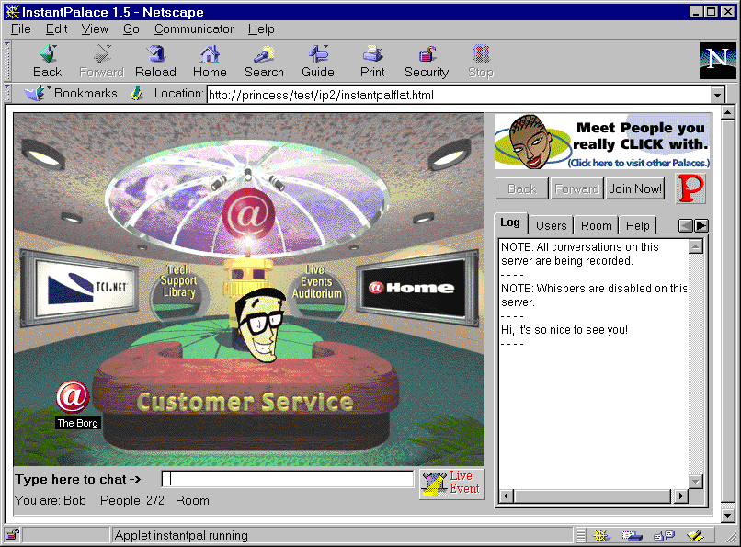
Figure 1. TCI Service Lobby

Notice that this runs inside the Netscape Communicator web browser, as a Java-application. Customers may ask basic questions by typing in text in the bottom of the screen.
This @HOME palace will include a number of rooms, including a lounge, a library, and the lobby. For detailed customer support and server by TCI agents, the palace will also include a number of rooms broken down into several categories: “Customer Server/Tech Support”, and “Acquisition/Membership.” Each of these topics would run their own PalacePresents event, with at least one moderator, and a number of agents called “agents.”
The customer should be able to enter one of the PalacePresents events, simply by clicking on a door in the lobby, and possibly from other rooms as well. This will cause the customer to enter into a customer support “event” auditorium. In this auditorium, the customer may see as many as 15 agents on stage, available to answer detailed technical or service questions. An example of a customer service auditorium can be seen in Figure 2.

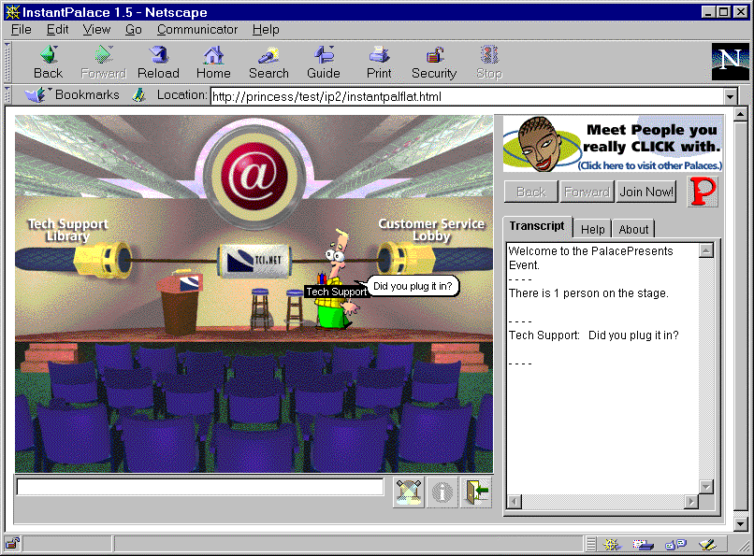
Figure 2. Customer Service Auditorium

By typing into the text area at the bottom of the graphic, the customers can submit questions. These questions will be sent to a moderator, who will sort the questions, and assign specific questions to specific agents on the stage. The agents will answer the questions, and may also “push” web content to the customer, via a separate browser window.
The above graphic will have to accommodate up to 15 customer service representatives, so the final rendition will not include an “audience” area, it will only include a “stage” representation. Customers will not see their avatars on the stage unless they are explicitly invited by the moderator.
Customers may join and leave the event at will, by using the control buttons below the stage graphic.

Detailed Feature Notes for Browser
When a question is “answered” by an agent on the stage, the original question will display in the upper left hand corner, and the agent’s avatar will “say” the question.
When a question is answered and it includes a URL (and, when it is not a “private” answer) users will see the web content pushed into a “frame” below the palace chat area. For the customer who asked the question originally, they will see the answer URL pop-up in a separate browser. This allows the end user to book mark the answer to their specific question, while not filling up their screen for every URL answer.

Proposal for changes to the Palace Software
We believe we can support TCI’s requirements, with limited changes to the client and server software. However, this will require substantial changes to the current implementation of PalacePresents. This project proposes a new mode, dubbed “Multi-Agent Mode,” designed to support access to the Q&A session by many customers and customer support personnel simultaneously.

Proposal for User Interface, Moderator Console
TPI will design new screens and new functions to make this possible. These screens include changes to the moderator console, and a new “agent” console.
The moderator console will primarily be in charge of starting and stopping the event, inviting agents and customers onto the stage, and coordinating which agents answer which questions.
This console consists if 5 tab control panels, including preferences, audience, monitor, slide show, and statistics and multimedia.

Moderator Preferences Tab
The preference tab is used to set up the configuration of the event, including the graphic to display in the event, the name and location of the log file, and various settings regarding announcing the event.
The current “preferences” tab in the moderator console will need to be modified to specify:
- whether or not the event allows agents
- whether or not to send question status confirmations. (Nice to have)
- specify the name of the “log file”
See Figure 3 below.
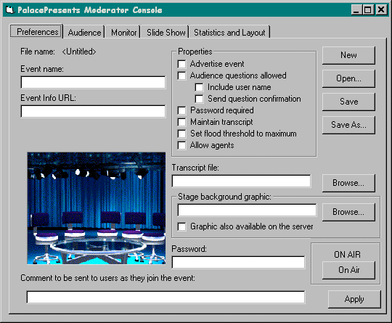
Figure 3. Moderator Preferences Tab

Moderator Audience Tab
The current “preferences” tab in the moderator console will need to be modified to specify whether or not the event is an Agent enabled event. In this mode, the “Audience” tab performs the following functions:
- Displays all customers in the event.
- Allows the moderator to invite customers onto the stage.
- Allows the moderator to designate who is in “agent” mode, and to remove “agents” from agent mode.
- Allows the moderator to start and end the event.
- Allows the moderator to comment to stage
- Allows the moderator to push slides
See Figure 4 below for an illustration of this tab.

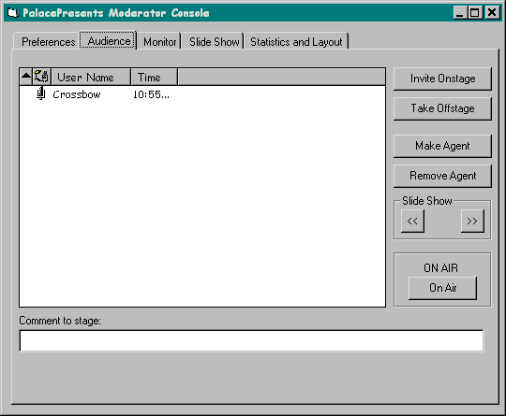
Figure 4. Moderator Audience Tab

Moderator Monitor Tab
The new “Monitor” tab of the moderator console includes the following controls/features:
- Ability to see all questions, including question text, question #, name of submitter, name of assigned agent, date/time of question, date/time of proposed answer, status (open, assigned, in progress, answered)
- Ability to delete questions.
- Ability to assign/re-assign questions to an Agent.
- Ability to determine status of a question. (Open, Assigned, Work In Progress, Work Completed, Answered)
- Ability to whisper to the question submitter.
- Ability to sort questions by Agent , Time, or Status
- Ability to Edit/Cut/Copy questions and answers, and execute all other “Agent” features.
- Ability to send the completed question/answer pairs to the stage.

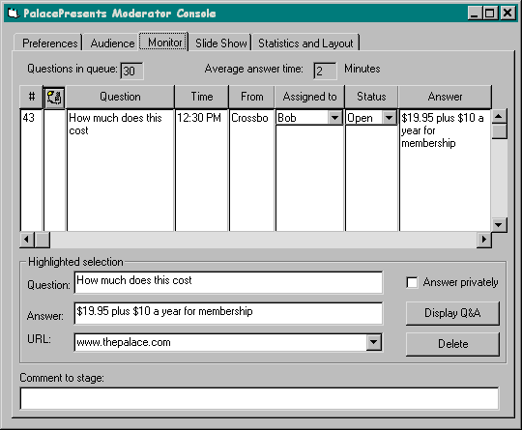
Figure 5. Moderator Monitor Tab

The “Monitor” tab allows the moderator to also function as an Agent, should the need arise.
Functionality Notes:
- The monitor has a “reset #” button, which resets the question counter back to 0. Otherwise, question numbers are unique, and continue to roll forward. Only the last 2 digits are displayed, though the full number is logged.
- Questions and answers will be limited to 256 characters. Longer answers should be packaged as FAQs.

New PalacePresents Agent Console
The new agent console is a duplicate copy of the Moderator console, but running in “Agent” mode. This console has some features disabled, and it operates considerably differently “under the hood” when in Agent mode. However, it can pick up moderator duties, should the need arise.
In order to load an Agent console, the Agent must use the Wizard password.
The log-on sequence for a multi-Agent event requires that the moderator start the event first. Then all agents log on and join the event. Once an agent has joined the event, the moderator can invite the agents to the stage, and designate them as in “agent mode”.
In “Agent” mode, the only functions disabled are:
- Ability to invite customers on stage.
- Ability to assign questions. Agents may be allowed to “unassign” them selves off of a question.
- The Agent does not broadcast-advertise the event on the viewer blow-through channel.
- Ability to take the event off-air.
- Ability to comment to stage
- Ability to designate other people as “agents”
- Ability to push slides from slide show mode.
- Ability to change event preferences.
Agents may leave and re-join events. However, any agent which leaves an event will no longer track user status and question status. As a result, when the agent logs back into the event, and the moderator will send the current status of users, agents, and questions to the agent.

Agent Preferences Tab
Preferences will be disabled for agents, except for the ability to load a .STG file. And, during an event, all controls will disabled.
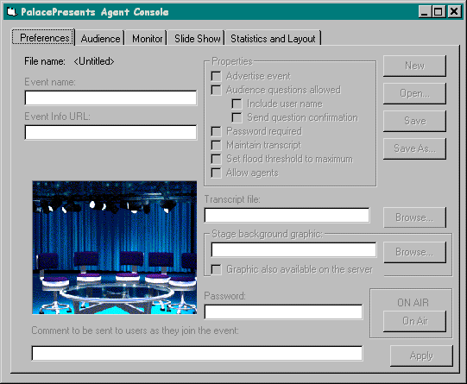
Figure 6. Agent Preferences Tab

Agent Monitor Tab
This tab is the main working area for an agent. It includes the ability to answer questions, see all questions in the queue.

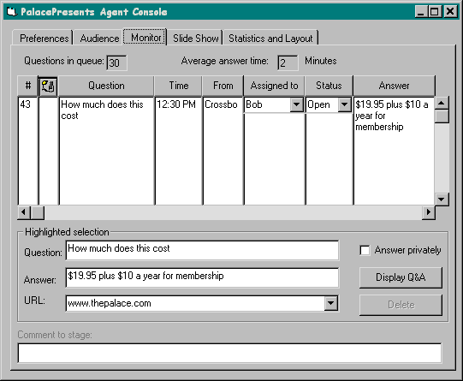
Figure 7. Agent Monitor Tab
This version is the same as the moderator version of this tab, except:
- Agents may not comment to stage directly
- Agents may not delete questions
- Agents may not assign questions to anyone other than “none”, in effect, un-assigning themselves.

Agent Audience Tab
The agent Monitor tab will track all activity of customers and agents attending the event, but will not allow agents to modify the settings. However, should the agent need to assume moderator duties, the agent pushes the “moderate” button.

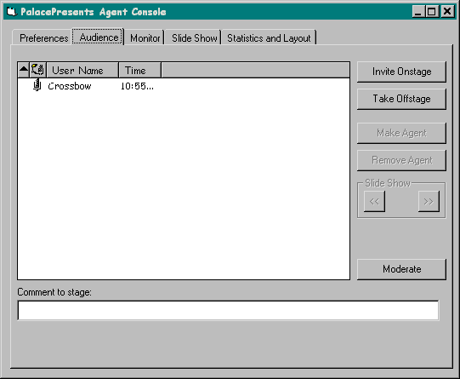
Figure 8. Agent Audience Tab
After the following confirmation dialog, the agent console broadcasts the change of moderator message, and then assumes full moderator duties.
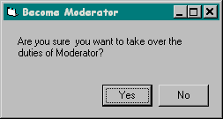
Figure 9. Moderate Confirmation Dialog
The agent console then switches into moderator mode, and has all of the full capabilities as described in the moderator section of this document.

New Log File Format
The current log file needs to be enhanced to include the following information:
- Questions/Answer pair indication.
- Question #, Date/Time submitted, Time Answered.
- Agent who answered the question.
- Agent log-on and log-off date/time
- URL for FAQ answer.
- Customer Join/Leave event markers.
This will allow PERL scripts to determine:
- % of questions responded to within 2 minutes
- # of questions handled by specific techs, and response time of specific techs.
- % of Agent availability
- # of questions per shift and per ½ hour.
- # of people attending, over which hours.

Step-by-Step flow
Here is a step-by-step walk through of how a Q&A session might work.
- The moderator starts an event, with the “Allow Agents” mode chosen.
- Agents, log onto the Palace, and join the event. If they have the “Agent” plug-in, the moderator can invite them on stage, and give them agent status.
- Once all of the agents are on-line and ready to go, the moderator announces that the event has begun.
- As the event progresses, end users may as questions. The moderator console receives the questions. Questions include the name of the submitter asking the question, as well as the time the question was submitted. The question status is defaulted to “open”.
- The moderator assigns the questions to specific agents.
- Once the question has been assigned, the person asking the question receive notification that the question has now been assigned to an agent. The question’s status automatically changes to “assigned.”
- This question is now “in the queue” of the agent. The monitor console shows the number of questions in the queue for each agent.
- The agent can type in the answer to the question, and may also specify an URL to be pushed to every customer’s web browser, in conjunction with the answer At this point, the agent can mark the question/answer pair as private. The agent sends the question/answer pair back to the moderator once the answer is prepared.
- The moderator can see all of the questions that have had answers prepared. The moderator may simply click on the question/answer pair, and can press the “display Q&A” button to send the questions/answer pair to the stage. Or, the moderator can review the answer, edit it, or send it back to the agent for further work, by changing the status.
- Once the moderator “submits” the Question/Answer pair to the stage, the question, the answer, and the optional URL are put in the queue to be sent to the stage. The moderator code automatically buffers the Q/A pairs to make sure they aren’t sent to fast. Once the Q/A pair is sent it is taken off the console, and written into the log, with all of the attributes associated with it.
- Agents may opt out of the session at any time by closing their “agent” console. The moderator may also dismiss them as well.
- When the moderator determines that the session is completed, the moderator can shut down the event, by selecting “off air”.

Technical Notes

System Requirements
Moderators and Agents must run PCs with Win 95, recommend P133 with high-speed internet access.
Agents and Moderators must run the Viewer plug in.
All agents must be on-stage, in order to answer questions.
Agents may work at home, but again, we recommend high-speed internet access.
The “.STG” file should reside on a shared network drive, so that all moderators and agents share the same PalacePresents configuration.
The “LOG” file for the event should reside on the server. In the event that an agent needs to take over moderation duties, it needs to APPEND to the log file, not restart it.

Architectural Overview
The system is made up of a number of parts, as illustrated in Figure 10. This diagram illustrates the communication channels between server, client, moderator and agents. These channels are further described in the implementation section of this document.

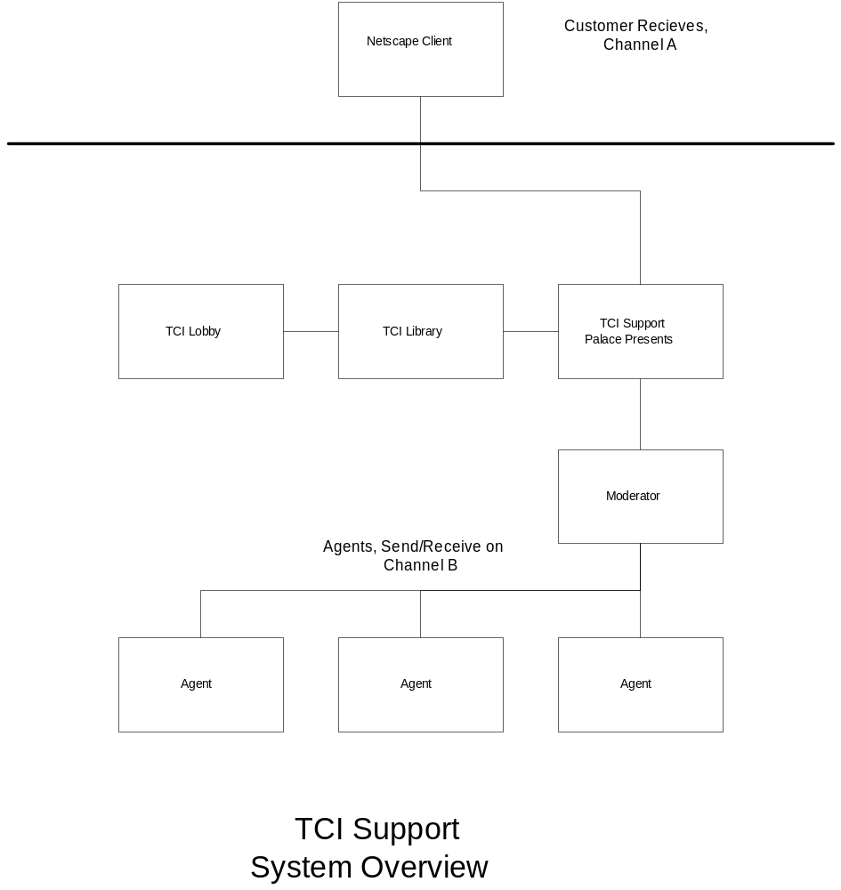
Figure 10. System Architectural Overview

Implementation of Agent Console
Agents will listen to the moderator on the agent blow-through channel <B>. The moderator is responsible for “reflecting” all important state information to all agents listening on that channel <B>. For this reason, the moderator console must maintain a list of all agent USERIDs.
Agents will send completed question answer pairs to the moderator on channel <B>. The moderator will be responsible for submitting them to the stage, by displaying the question in the upper left corner, and the answer next to the agent who submitted the question/answer pair. While the moderator code is responsible for display, this may be automatic. This is due to the fact that viewers listen on channel <A>, and only from the USERID of the moderator.
Graceful degradation support – If an agent joints after the event has begun the moderator sends an update to the agent, of the current state. This is simply a matter of sending preference information, the attendee list, the current questions, and the agent list. The moderator can send this information one item at a time, using the same protocol as is used during regular event traffic.

Changes to the Moderator Console
The moderator console will be in charge of all communication to viewers. Agents will not perform that function. This includes advertising events, sending questions and answers and urls, and supplying event information to viewers. This is done via viewer channel <A>.
The moderator will receive all completed question/answer pairs from agents, on channel <B>.
The moderator will be responsible for reflecting all state information to all agents, including customers attending events, questions that have been asked, comments to stage, and q&a pairs submitted to the stage.
The moderator will be the only console responsible for writing the log to the central location.
The moderator will be responsible for informing all agents regarding which USERIDs are on stage, and which are agents as well.
The moderator will be responsible for bulk-updating any agent the comes on line after an event begins.

Outstanding Issues:
What is the OS for the main server? NT or Unix? If Unix, what hardware? [Answer is, NT]
What documentation will be required? Can we do this all on-line, with HTML files? [Proposal: Yes, let’s do it that way, ck – 10/22/97]
Who is responsible for deleting bogus questions or non-questions? The moderator? Do all agents see them? [Everyone sees them, Moderator is responsible for deleting them – ck – 10/22/97]

Development Notes
Note to QA: We need to be sure to test Win 3.11. Browsers on that OS may not work well with Java.
Need to clarify how to keep the log file from corrupting. [Proposal: Save and close the log file on a timer, or open only in read/write non-exclusive, but only the current “moderator” can do this]
What happens if a second moderator manually switches to moderator mode, when the first moderator is already running? Do we “ping” the first moderator to see if it is alive? [Proposal: Not for release 1. This should happen almost never – ck – 10/22/97]

Schedule Issues:
What amount of time do we need to set aside for the installation process? Do we need to travel to Englewood for installation and training?

