

Firewall Project Proposal
Charles Kawasaki
February 2, 1998
Confidential Information

Introduction 3
Project Goals 3
Background Information 4
Common Firewall Configurations 4
Screening Routers 5
Application Proxy Servers (Bastion Hosts) 5
Solution Proposal, Benefits and Downsides 6
Proposal Details 7
Add a new protcol mode supporting HTTP 7
Proposal 1. HTTP with broadcast connection left open 7
Proposal 2. HTTP connect established/taken down for each message 7
Unix Server Modifications 7
Instant Palace Modifications 7
Web Port Conflict Issues 8
Scenario 1: Use an alternate port 8
Scenario 2: CGI interface between TPI and Web Server 10
Issues 11

Introduction
This document outlines the proposal for an engineering project a short term firewall solution for TPI. This is a high-level, first pass analysis, subject to modification based on further engineering research.
This first pass is based on market research done by Charlie, with discussions and technical input from Todd, Carl, Throck, Sean, Alan, Nizar, JBUM and Steven Neighorn. In addition, the IT side input comes from discussions with Wells Fargo Bank, Entex, Microsoft, and Sapient Info Systems.

Project Goals
The goal of this project is to address our chronic problem regarding The Palace’s ability to work with firewall. This project is designed as a short-term solution, until more robust solutions can be found and implemented. One of the most promising, longer-term solutions is RMA support. The project described here does not invalidate that approach, instead, simply positions it as a longer-term project.
Based on extensive customer interactions and preliminary market research, the following requirements for the project are expressed below.
Critical Requirements
- To provide a solution which allows client users access to the majority of palaces, from within organizations which have firewalls installed. For example, we need to allow client usage for employees of large corporations such as Intel, Microsoft, 3COM, Entex, and Oracle. These users represent a very large number of potential customers.
- To provide a solution which requires no changes to firewalls, nor intervention by IT administrators, for client access from behind a firewalls.
- To provide a solution which does not add additional complexity to our installation process of our client software, and which requires as little end-user expertise as possible.
- To provide a solution which is compatible with both our Java and “C” clients.
- To provide a solution that does not require significant additional costs to our software. (I.E., no royalties).
- To provide a solution which is compatible with our target Server and Client platforms.
- To release a solution as soon as possible, which addresses the largest possible audience.
- To work with commonly installed firewall technologies including screen routers, application proxies, and hybrid systems.
Important Requirements
- To provide a solution which is easy for TPI to maintain and which does not significantly increase the complexity of our software.
Lower Priority Requirements
- Server customers should have the appropriate documentation to allow our standard protocol through their firewalls, if possible. In addition, they should be equipped with documentation necessary to set up secure intranets using our technology.

Background Information
The initiation of this project comes from feedback from existing and potential server customers, and manifests itself in several ways.
- Server customers believe they will not reach a large percentage of their clients, because clients are behind firewalls. Examples include 3COM, Entex.
- Potential server customers cannot run our software, even to try it out. Examples include Sapient Information Systems, Microsoft.
- Potential investors cannot run our systems. Examples include @Ventures, Intel.
- Server customers have problems configuring their Palace Server systems to follow existing corporate policies. Examples include Microsoft, Wells Fargo. Both of these companies have explicit security policies. Well Fargo has a proxy-server requirement.
- Our sales force cannot be sure that they can reliably connect to our servers for demonstration purposes, except by connecting to an analog phone line.

Common Firewall Configurations
The high-level architecture for the end to end solution commonly looks as follows:

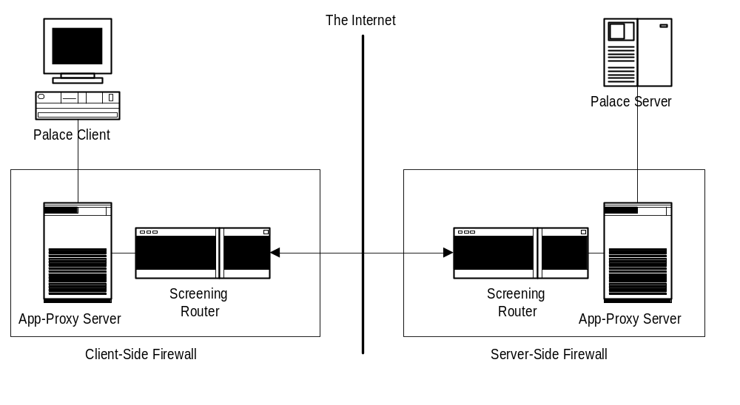
Point to point connection via screened subnets
This architecture represents layout of a typical point-to-point connection between business sites , and consists of 2 firewalls, one located inside the business in which the Palace Client is running (Client-Side Firewall), and the other running inside the business hosting the Palace Server (Server-Side Firewall). In addition, to the above, many Clients may have to traverse through additional routers on the internal LAN, before connecting to the App-Proxy machine.
The worst-case scenario for our technology requires that we are able to pass our protocol through all of the firewall equipment from Palace Client to Palace Server and back, with no intervention required by any IT personnel.
To make matters worse, there is no clear standard for firewall configurations. There are dozens of vendors, each with incompatible implementations of systems. Because of this fragmentation of the market, it does not make sense to build custom solutions for specific firewall vendors.
According to IDC, here was the market share of firewalls as of 6/1/97.
- Checkpoint – 35%
- Cisco/TIS – tied for the #2 slot at 8% each
- Raptor – 7%
- Secure Computing – 5%
- IBM – 3%
- Everyone else is in the noise level
However, some new people may be moving into this market space too. Like Symantec or McAfee. Also of note, Cisco had only been in the market for 6 months before gathering 8% of it, so they may do a steamroller to the top of the heap.

Screening Routers
Generally, screening routers allow types of protocols (TCP, UDP) to pass from the Internet, into your internal net. They are configurable in terms of which ports to allow, and in terms of which IP addresses can establish connections. In general, they do not do much filtering on the contents of the protocols as they pass through.
These devices are configurable through a set of rules, and can generally allow our protocol through, if they “open” port 9998. The issue with this approach is that most big IT people will not take the time to do this, nor are they inclined to do it (thereby reducing the overall security of the system) for an application considered non-essential.
Some variants of routers include Cisco’s filtering router, which is a little smarter than the standard variety router.

Application Proxy Servers (Bastion Hosts)
Application proxy servers generally are computers which are dual-homed (have 2 network cards, one for the Internet and one for the internal network), and which run real applications to perform security.
The applications running on the proxy server read the incoming packets from one network card, run security and permission checks on the connection, and take a peek at the contents of the protocol, before forwarding it to the other network card.
Some proxy servers run SOCKs, a generic TCP/IP application proxy software package. This has been reported to work with The Palace, but requires both IT intervention, and requires special software (SOCKSCAP) to be loaded on all client machines. Lastly, SOCKs is not supported by many systems, and continues to loose market share.
Besides working with SOCKs, for those proxies that support it, the only other way to work with app proxies are to either disable them for our protocol (which is not acceptable for many large companies), or to write special plug-ins for each major firewall. Because this is time consuming, and would most likely require IT administrator intervention for the installed base of firewalls, again.

Solution Proposal, Benefits and Downsides
Our proposed solution involves a technique called HTTP tunneling. The concept is for The Palace to emulate a web browser’s protocol for our Chat protocol. The proposed benefits to this approach are:
- HTTP is supported as the Web protocol, from end-to-end, for any corporation that allows web access.
- Because this is a standard protocol, we believe that all future technology developments on the web, either hardware or software will support this protocol, and thus, The Palace.
- If our product uses this protocol, our Chat will pass through firewalls with no problem, and with no IT administrator intervention required.
- We can support this protocol in such a way that users of our Client software will not need to manually download any additional software.
- This protocol is cross platform, for servers and clients.
- This protocol is supported by ALL firewall hardware and software systems.
- This protocol works today with our “C” and “Java” clients.
- We have code in-house to support large pieces of this protocol.
- We can implement this HTTP support in addition to our existing protocol.
The problems with this approach are:
- We may have significantly reduced performance of the client, for those clients running in this HTTP mode.

Proposal Details
Here are the major pieces of the implementation required to accomplish this project.

Add a new protcol mode supporting HTTP
The concept here had 2 possible implementation strategies.

Proposal 1. HTTP with broadcast connection left open
Have our client software perform an HTTP GET, with a 0 length file request. We believe this will open a HTTP connection which will allow our servers to pump out-going messages to the client, for the duration of the session.
For each communication send back from the client to the server, the client will have to open 1 addition connection, setting it up, and tearing it down.

Proposal 2. HTTP connect established/taken down for each message
If proposal #1 does not work, then we may be forced with a lower-performance approach of making a new HTTP request, on a timed basis, initiated by the client. This model would be similar in performance to iChat’s HTML based client.
This request would occur each time the user sends a chat message, or performs an action that requires server communication, such as moving their avatar, requesting a room list, or executing a command.
Otherwise, the new HTTP request would occur on a timed basis, for example every 5 seconds, to retrieve any pending chat messages which are queued on the server.

Unix Server Modifications
Here are a few details regarding the Unix server implementation.
- First, we need to install the new protocol support. Estimates range at about 2,000 lines of code for this.
- We believe we can leverage some of the existing UDP/TCP work that Carl has done on the Unix server for this. We also believe we can leverage the HTTP library that Carl has written for the Mac.
- We will need to test our ability to turn off the proxy cache through use of the HTTP protocol. In order to do this, we will need to acquire a proxy-server for testing purposes.

Instant Palace Modifications
Here are a few implementation ideas for the Instant Palace implementation of this project.
- On the client side, do IP only.
- The current architecture could stay mostly the same, but it appears we need to insert this HTTP handling between the data-stream and socket layers in the Java code.
- We will need to add an error message to the client, which includes instructions for the user for connecting via the HTTP proxy server established for their company. We believe that InstantPalace will automatically use the proxy server settings in the web browsers, because the Java sockets we are calling honor existing browser settings.

Web Port Conflict Issues
In addition to the projects listed above, we will need to resolve a significant issue related to the Ports assigned for web servers. At this time, we do not know if we will be able to run our HTTP emulated protocol through a port other than port 80, in order to be compatible with the commonly installed versions of firewalls.
However, because we now require that a web browser run on the same IP address as our PalaceServer, in order for InstantPalace to work, we will have 2 applications attempting to read from port 80.
Because of this issue, we have a 2 tier strategy for dealing with this issue:

Scenario 1: Use an alternate port
I have researched several iChat sites using ports other than port 80. If we can use a port other than port 80, then we can serve InstantPalace off a web server on port 80, and our TPI protocol off port 9996.
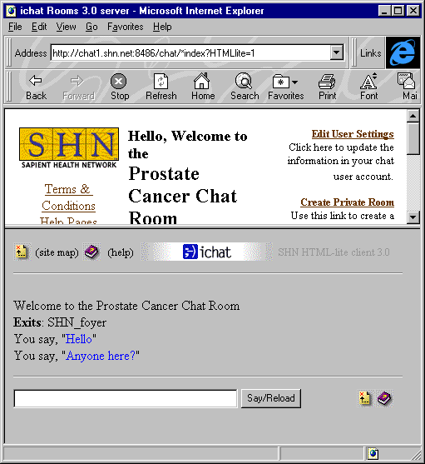
According to Sapient Health Networks, who implemented the HTML iChat client, they have been able to work over all firewalls using the iChat HTML client. This client software alternate ports. As shown above, the SHN site uses port 8486. The ParentSoup site by iVillage uses port 4080, and I bet they are not having problems either. Yahoo chat uses port 4280.
However, here is the FAQ from the iChat web site.
Subject: General Firewall
Topic: Windows 95/NT Internet Explorer
Author: admin
Date: 11/06/97 17:14:21
You will need to contact your ISP to see if you are behind a firewall. If you are, you will need access to the ports that the chat site uses. The default port settings for our ROOMS chat server are 4020 and 4080. However, these ports can and frequently do change, particularly for large chat sites. Access to these ports can be gained by either having your ISP open their firewall for the ports that you need or they need to define proxies for these ports on their proxy server. You will need TCP inbound and outbound access for these ports.
Note: none of these ports (4020, 4080 and 8486) appear to be assigned by IANA.
So, either we are missing something basic here, or Sapient’s customers are not running from inside firewall protected businesses.
More data on this:
In an effort to validate this issue, I have tested the ability for people behind firewalls to connect to non-port 80 web servers. Specifically, I asked employees to connect to my web server on port 9996. This was successful for employees working inside the following large corporations, and organizations:
Intel
Microsoft
Oracle
TCI (@Home network)
Stanford University
Teleport
Earthlink
AOL
US Bank (did not have direct web access via their LAN, yet. But had workstations using AOL around the office. AOL was able to connect no problem.)
Standard Insurance – works fine for all users authorized to use the web.
The Oregonian
Nike
Sapient reported that they received many complaints from users regarding the disconcerting refresh of the standard iChat client. TPI should not suffer from this syndrome, as long as we behave well in our rendering.

Scenario 2: CGI interface between TPI and Web Server
Should Scenario 1 turn out to not work, we will have to fall back to integrating between web servers and Palace servers. This is a very undesirable solution, because of the complexity of the implementation, and installation issues.
In addition to having to write CGIs for both channels for generic Unix-based web servers, we would also need to develop an optimized NT solution.
Additionally, we would have more complexity added to the system, with more possibility of introducing failure points. This also makes our installation process more complicated.
Below is a diagram for how this would be laid out.
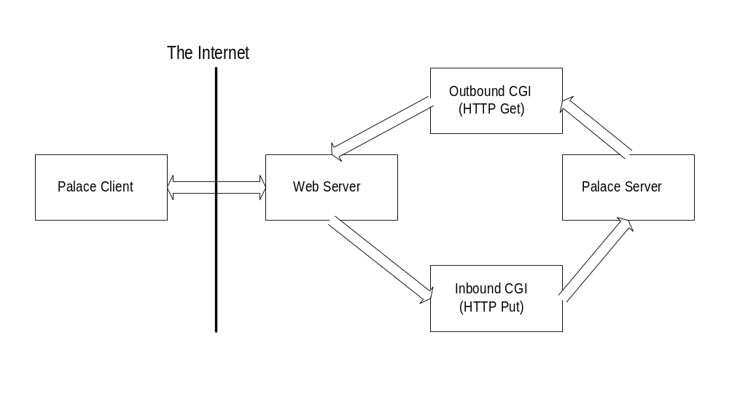

Issues
HTTP 1.0 vs. HTTP 1.1. We need to determine if HTTP 1.1 persistent bi-directional connections are supported by currently installed proxy servers. If not, we may be forced to close and reopen the HTTP connection for each communication. Details we need to determine are:
- How long has HTTP 1.1 been an approved standard?
- Do the majority of proxy servers support 1.1
- Do our target browsers support 1.1
[Resolved 2/2/98 – HTTP 1.1 is brand new. This means we will have to open and close the up-link connection for each communication. According to Carl M, HTTP 1.0 will support a 0 length file for persistent downlinks.]

