**import** numpy **as** np

**import** matplotlib.pyplot **as** plt

**%matplotlib** inline

**def** spirals(n_points, noise**=**.5):

n **=** np**.**sqrt(np**.**random**.**rand(n_points,1)) **\*** 200 **\*** (2**\***np**.**pi)**/**180

d1x **=** **-**np**.**cos(n)**\***n **+** np**.**random**.**rand(n_points,1) **\*** noise

d1y **=** np**.**sin(n)**\***n **+** np**.**random**.**rand(n_points,1) **\*** noise

**return** (np**.**vstack((np**.**hstack((d1x,d1y)),np**.**hstack((**-**d1x,**-**d1y)))),

np**.**hstack((np**.**zeros(n_points),np**.**ones(n_points))))

X, Y **=** spirals(100)

plt**.**title('train')

plt**.**plot(X[Y**==**0,0], X[Y**==**0,1], '.', label**=**'A')

plt**.**plot(X[Y**==**1,0], X[Y**==**1,1], '.', label**=**'B')

plt**.**legend()

plt**.**show()

**import** numpy **as** np

**import** matplotlib.pyplot **as** plt

**%matplotlib** inline

**def** spirals(n_points, noise**=**.5):

n **=** np**.**sqrt(np**.**random**.**rand(n_points,1)) **\*** 200 **\*** (2**\***np**.**pi)**/**180

d1x **=** **-**np**.**cos(n)**\***n **+** np**.**random**.**rand(n_points,1) **\*** noise

d1y **=** np**.**sin(n)**\***n **+** np**.**random**.**rand(n_points,1) **\*** noise

**return** (np**.**vstack((np**.**hstack((d1x,d1y)),np**.**hstack((**-**d1x,**-**d1y)))),

np**.**hstack((np**.**zeros(n_points),np**.**ones(n_points))))

X, Y **=** spirals(100)

plt**.**title('train')

plt**.**plot(X[Y**==**0,0], X[Y**==**0,1], '.', label**=**'A')

plt**.**plot(X[Y**==**1,0], X[Y**==**1,1], '.', label**=**'B')

plt**.**legend()

plt**.**show()

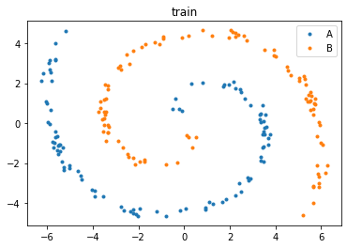

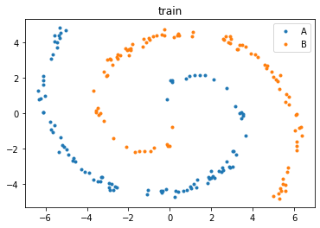

In [6]:

color**=**["red","green","blue"]

items**=**["apple","pant","juice"]

**for** x **in** color:

**for** y **in** items:

print(x,y)

print('')

red apple

red pant

red juice

green apple

green pant

green juice

blue apple

blue pant

blue juice