

OOP Semester Project S23

**MUSFIRAH ZAIB**

**L1S23BSSE0107**

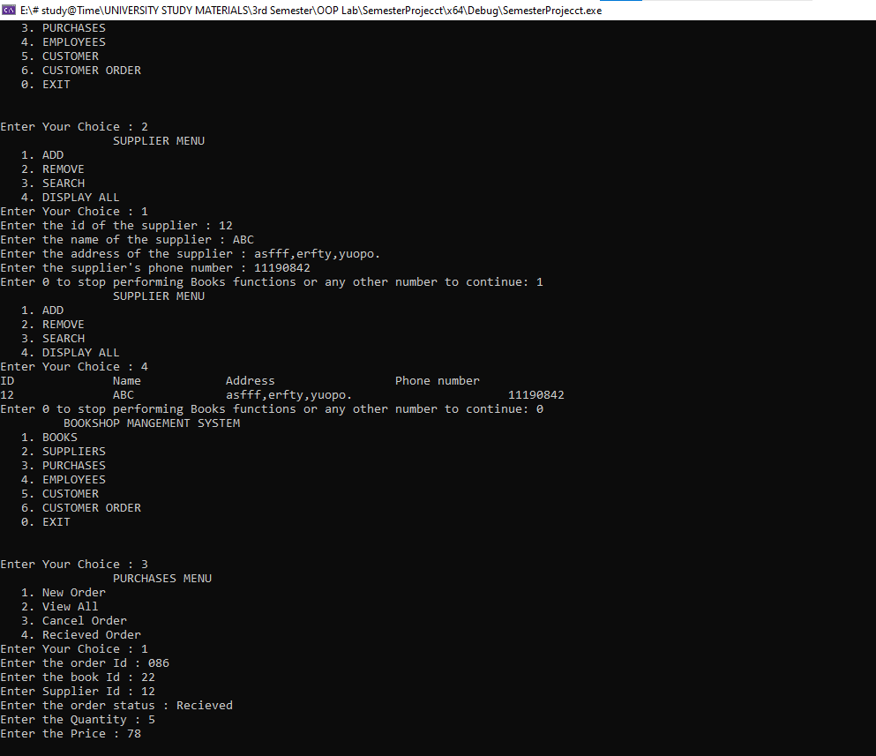

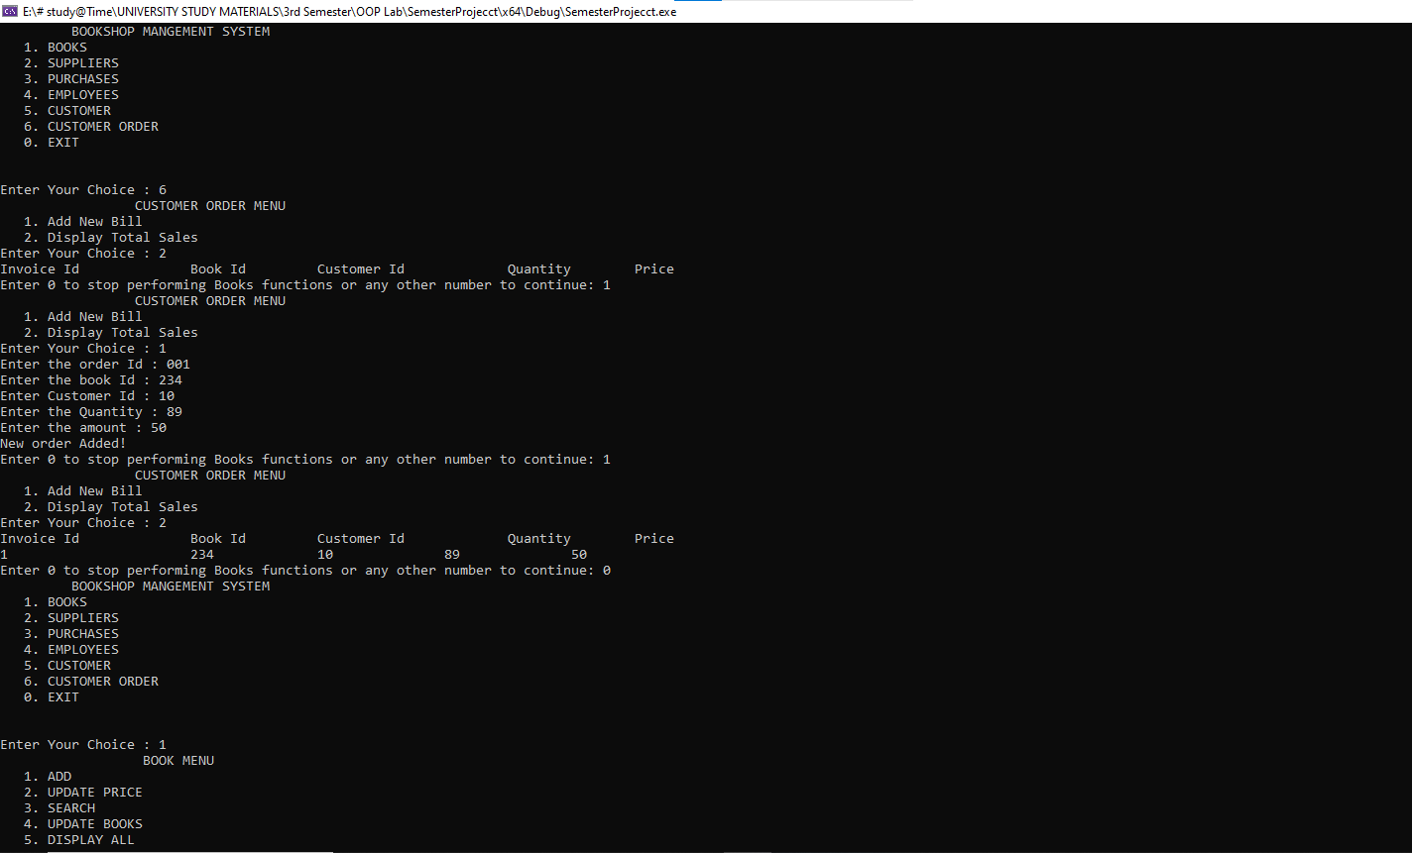

#include<iostream>

#include<string>

using namespace std;

class Person

{

protected:

int id;

string name;

string phone_no;

string address;

};

class books

{

private:

int id;

string name;

string author;

int price;

int quantity;

public:

static int no_of_books;

public:

books* add(books* b);

books* update_price(books* b);

void search(books* b);

books* update(books* b);

void display(books* b);

books* book_menu(books* b);

};

books* books::add(books* b)

{

string n, a;

int o, p, q;

cout << "Enter the id of the book : ";

cin >> o;

cin.ignore();

cout << "Enter the name of the book : ";

getline(cin, n);

cout << "Enter the name of the author : ";

getline(cin, a);

cout << "Enter the Price : ";

cin >> p;

cout << "Enter the quantity Recived : ";

cin >> q;

books* ptr = new books[no_of_books + 1];

int i;

for (i = 0; i < no_of_books; i++)

{

*(ptr + i) = *(b + i);

}

ptr[i].id = o;

ptr[i].name = n;

ptr[i].author = a;

ptr[i].price = p;

ptr[i].quantity = q;

no_of_books++;

delete[]b;

b = nullptr;

return ptr;

}

books* books::update_price(books* b)

{

int p, bid;

cout << "Enter the id of the book whose price you want to update : ";

cin >> bid;

cout << "Enter the updated Price : ";

cin >> p;

books* ptr = new books[no_of_books];

for (int i = 0; i < no_of_books; i++)

{

(ptr + i)->id = (b + i)->id;

(ptr + i)->name = (b + i)->name;

(ptr + i)->author = (b + i)->author;

(ptr + i)->quantity = (b + i)->quantity;

if (b[i].id == bid)

{

(ptr + i)->price = p;

}

else

{

(ptr + i)->price = (b + i)->price;

}

}

delete[]b;

b = nullptr;

return ptr;

}

void books::search(books* b)

{

int n;

cout << "Enter the id of the book who price you want to search : ";

cin >> n;

for (int i = 0; i < no_of_books; i++)

{

if (b[i].id == n)

{

cout << "Book id is : " << (b + i)->id << endl;

cout << "Name of book is : " << (b + i)->name << endl;

cout << "Name of Author : " << (b + i)->author << endl;

cout << "Price : " << (b + i)->price << endl;

cout << "Quantity : " << (b + i)->quantity << endl;

}

}

}

books* books::update(books* b)

{

int bid, nbid, p, q;

string n, a;

cout << "Enter the id of the book who price you want to update : ";

cin >> bid;

cout << "Enter the id of the book : ";

cin >> nbid;

cin.ignore();

cout << "Enter the name of the updated book : ";

getline(cin, n);

cout << "Enter the name of the author : ";

getline(cin, a);

cout << "Enter the Price : ";

cin >> p;

cout << "Enter the quantity Recived : ";

cin >> q;

books* ptr = new books[no_of_books];

for (int i = 0; i < no_of_books; i++)

{

if (b[i].id == bid)

{

ptr[i].id = nbid;

ptr[i].name = n;

ptr[i].author = a;

ptr[i].price = p;

ptr[i].quantity = q;

}

else

{

ptr[i].id = b[i].id;

ptr[i].name = b[i].name;

ptr[i].author = b[i].author;

ptr[i].price = b[i].price;

ptr[i].quantity = b[i].quantity;

}

}

delete[]b;

b = nullptr;

return ptr;

}

void books::display(books* b)

{

cout << "ID Book Name Author Name Price Quantity" << endl;

for (int i = 0; i < no_of_books; i++)

{

cout << (b + i)->id << " " << (b + i)->name << " " << (b + i)->author << " " << (b + i)->price << " " << (b + i)->quantity << endl;

}

}

books* books::book_menu(books* b)

{

int c, e;

do {

cout << " BOOK MENU" << endl;

cout << " 1. ADD" << endl;

cout << " 2. UPDATE PRICE" << endl;

cout << " 3. SEARCH" << endl;

cout << " 4. UPDATE BOOKS" << endl;

cout << " 5. DISPLAY ALL" << endl;

cout << "Enter Your Choice : ";

cin >> c;

if (c == 1)

{

b = add(b);

}

else if (c == 2)

{

b = update_price(b);

}

else if (c == 3)

{

search(b);

}

else if (c == 4)

{

b = update(b);

}

else if (c == 5)

{

display(b);

}

else

{

cout << "Invalid input" << endl;

}

cout << "Enter 0 to stop performing Books functions or any other number to continue: ";

cin >> e;

} while (e != 0);

return b;

}

class suppliers : public Person

{

public:

static int no_of_supplier;

public:

suppliers* add(suppliers* s);

suppliers* remove_supplier(suppliers* s);

void search_id(suppliers* s);

void display(suppliers* b);

suppliers* supplier_menu(suppliers* s);

};

suppliers* suppliers::add(suppliers* s)

{

suppliers* b1 = new suppliers;

cout << "Enter the id of the supplier : ";

cin >> b1->id;

cin.ignore();

cout << "Enter the name of the supplier : ";

getline(cin, b1->name);

cout << "Enter the address of the supplier : ";

getline(cin, b1->address);

cout << "Enter the supplier's phone number : ";

cin >> b1->phone_no;

suppliers* ptr = new suppliers[no_of_supplier + 1];

int i;

for (i = 0; i < no_of_supplier; i++)

{

*(ptr + i) = *(s + i);

}

(ptr + i)->id = b1->id;

(ptr + i)->name = b1->name;

(ptr + i)->phone_no = b1->phone_no;

(ptr + i)->address = b1->address;

no_of_supplier++;

delete[]s;

s = nullptr;

delete b1;

b1 = nullptr;

return ptr;

}

suppliers* suppliers::remove_supplier(suppliers* s)

{

int j;

cout << "Enter the id of the supplier you want to remove : ";

cin >> j;

suppliers* ptr = new suppliers[no_of_supplier - 1];

for (int i = 0, k = 0; i < no_of_supplier; i++)

{

if (s[i].id != j)

{

*(ptr + k) = *(s + i);

k++;

}

}

no_of_supplier--;

delete[]s;

s = nullptr;

return ptr;

}

void suppliers::search_id(suppliers* s)

{

int j;

cout << "Enter the id of the supplier you want to search : ";

cin >> j;

for (int i = 0; i < no_of_supplier; i++)

{

if (s[i].id == j)

{

cout << "Supplier id is : " << (s + i)->id << endl;

cout << "Name of supplier is : " << (s + i)->name << endl;

cout << "Address of supplier : " << (s + i)->address << endl;

cout << "Phone numbers of supplier is : " << (s + i)->phone_no << endl;

}

}

}

void suppliers::display(suppliers* b)

{

cout << "ID Name Address Phone number" << endl;

for (int i = 0; i < no_of_supplier; i++)

{

cout << (b + i)->id << " " << (b + i)->name << " " << (b + i)->address << " " << (b + i)->phone_no << endl;

}

}

suppliers* suppliers::supplier_menu(suppliers* s)

{

int c, e;

do {

cout << " SUPPLIER MENU" << endl;

cout << " 1. ADD" << endl;

cout << " 2. REMOVE" << endl;

cout << " 3. SEARCH" << endl;

cout << " 4. DISPLAY ALL" << endl;

cout << "Enter Your Choice : ";

cin >> c;

if (c == 1)

{

s = add(s);

}

else if (c == 2)

{

s = remove_supplier(s);

}

else if (c == 3)

{

search_id(s);

}

else if (c == 4)

{

display(s);

}

else

{

cout << "Invalid input" << endl;

}

cout << "Enter 0 to stop performing Books functions or any other number to continue: ";

cin >> e;

} while (e != 0);

return s;

}

class purchases_Book

{

private:

int order_id;

int book_id;

int sup_id;

int quantity;

int price_each;

public:

static int no_of_purchased_books;

purchases_Book* new_ord(purchases_Book* b);

void view(purchases_Book* p);

purchases_Book* remove_order(purchases_Book* s);

purchases_Book* purchaseBook_menu(purchases_Book* p);

};

purchases_Book* purchases_Book::remove_order(purchases_Book* s)

{

int j;

cout << "Enter the id of the Order you want to remove : ";

cin >> j;

purchases_Book* ptr = new purchases_Book[no_of_purchased_books - 1];

for (int i = 0, k = 0; i < no_of_purchased_books; i++)

{

if (s[i].order_id != j)

{

*(ptr + k) = *(s + i);

k++;

}

}

no_of_purchased_books--;

delete[]s;

s = nullptr;

return ptr;

}

purchases_Book* purchases_Book::new_ord(purchases_Book* p)

{

purchases_Book b1; //= new purchases_Book;

cout << "Enter the order Id : ";

cin >> b1.order_id;

cout << "Enter the book Id : ";

cin >> b1.book_id;

cout << "Enter Supplier Id : ";

cin >> b1.sup_id;

cout << "Enter the Quantity : ";

cin >> b1.quantity;

cout << "Enter the Price : ";

cin >> b1.price_each;

purchases_Book* ptr = new purchases_Book[no_of_purchased_books + 1];

int i;

for (i = 0; i < no_of_purchased_books; i++)

{

*(ptr + i) = *(p + i);

}

ptr[i].order_id = b1.order_id;

ptr[i].book_id = b1.book_id;

ptr[i].sup_id = b1.sup_id;

ptr[i].quantity = b1.quantity;

ptr[i].price_each = b1.price_each;

no_of_purchased_books++;

cout << "New order Added!\n";

return ptr;

}

void purchases_Book::view(purchases_Book* p)

{

cout << "Order Id Book Id Supplier Id Quantity Price " << endl;

for (int i = 0; i < no_of_purchased_books; i++)

{

cout << p[i].order_id << " " << p[i].book_id << " " << p[i].sup_id << " " << p[i].quantity << " " << p[i].price_each << endl;

}

}

purchases_Book* purchases_Book::purchaseBook_menu(purchases_Book* p)

{

int c, e;

do {

cout << " PURCHASES MENU" << endl;

cout << " 1. New Order" << endl;

cout << " 2. View All" << endl;

cout << " 3. Cancel Order" << endl;

cout << "Enter Your Choice : ";

cin >> c;

if (c == 1)

{

p = new_ord(p);

}

else if (c == 2)

{

view(p);

}

else if (c == 3)

{

p = remove_order(p);

}

else

{

cout << "Invalid input" << endl;

}

cout << "Enter 0 to stop performing Books functions or any other number to continue: ";

cin >> e;

} while (e != 0);

return p;

}

class employees : public Person

{

private:

long int salary;

public:

static int no_of_employee;

public:

employees* add(employees* b);

void search_emp(employees* b);

void display(employees* b);

employees* update_salary(employees* b);

employees* employee_menu(employees* p);

};

employees* employees::add(employees* b)

{

employees* b1 = new employees;

cout << "Enter the id of the employees : ";

cin >> b1->id;

cin.ignore();

cout << "Enter the name of the employees : ";

getline(cin, b1->name);

cout << "Enter the salary of the employees : ";

cin >> b1->salary;

cout << "Enter the employees's phone number : ";

cin >> b1->phone_no;

cin.ignore();

cout << "Enter the address of the employee : ";

getline(cin, b1->address);

employees* ptr = new employees[no_of_employee + 1];

int i;

for (i = 0; i < no_of_employee; i++)

{

*(ptr + i) = *(b + i);

}

(ptr + i)->id = b1->id;

(ptr + i)->name = b1->name;

(ptr + i)->salary = b1->salary;

(ptr + i)->phone_no = b1->phone_no;

(ptr + i)->address = b1->address;

no_of_employee++;

delete[]b;

b = nullptr;

delete b1;

b1 = nullptr;

return ptr;

}

employees* employees::update_salary(employees* b)

{

int p, eid;

cout << "Enter the id of the employees whose salary you want to update : ";

cin >> eid;

cout << "Enter the updated salary : ";

cin >> p;

employees* ptr = new employees[no_of_employee];

for (int i = 0; i < no_of_employee; i++)

{

(ptr + i)->id = (b + i)->id;

(ptr + i)->name = (b + i)->name;

(ptr + i)->phone_no = (b + i)->phone_no;

(ptr + i)->address = (b + i)->address;

if (b[i].id == eid)

{

(ptr + i)->salary = p;

}

else

{

(ptr + i)->salary = (b + i)->salary;

}

}

delete[]b;

b = nullptr;

return ptr;

}

void employees::search_emp(employees* b)

{

int eid;

cout << "Enter the id of the employees you want to search : ";

cin >> eid;

for (int i = 0; i < no_of_employee; i++)

{

if (b[i].id == eid)

{

cout << "Employee id is : " << (b + i)->id << endl;

cout << "Name of employee is : " << (b + i)->name << endl;

cout << "Salary of employee : " << (b + i)->salary << endl;

cout << "Phone number : " << (b + i)->phone_no << endl;

cout << "Address of employee : " << (b + i)->address << endl;

}

}

}

void employees::display(employees* b)

{

cout << "ID Employee Name Salary Phone_number Address" << endl;

for (int i = 0; i < no_of_employee; i++)

{

cout << (b + i)->id << " " << (b + i)->name << " " << (b + i)->salary << " " << (b + i)->phone_no << " " << (b + i)->address << endl;

}

}

employees* employees::employee_menu(employees* p)

{

int c, e;

do {

cout << " EMPLOYEE MENU" << endl;

cout << " 1. New Employee" << endl;

cout << " 2. Search Employee" << endl;

cout << " 3. View All" << endl;

cout << " 4. Update Salary" << endl;

cout << "Enter Your Choice : ";

cin >> c;

if (c == 1)

{

p = add(p);

}

else if (c == 2)

{

search_emp(p);

}

else if (c == 3)

{

display(p);

}

else if (c == 4)

{

p = update_salary(p);

}

else

{

cout << "Invalid input" << endl;

}

cout << "Enter 0 to stop performing Books functions or any other number to continue: ";

cin >> e;

} while (e != 0);

return p;

}

class Customer : public Person

{

public:

static int no_of_Customers;

public:

Customer* add(Customer* b);

void search_Customers(Customer* b);

void display(Customer* b);

Customer* Customer_menu(Customer* p);

};

Customer* Customer::add(Customer* b)

{

Customer* b1 = new Customer;

cout << "Enter the id of the Customer : ";

cin >> b1->id;

cin.ignore();

cout << "Enter the name of the Customer : ";

getline(cin, b1->name);

cout << "Enter the Customer's phone number : ";

cin >> b1->phone_no;

cin.ignore();

cout << "Enter the address of the Customer : ";

getline(cin, b1->address);

Customer* ptr = new Customer[no_of_Customers + 1];

int i;

for (i = 0; i < no_of_Customers; i++)

{

*(ptr + i) = *(b + i);

}

(ptr + i)->id = b1->id;

(ptr + i)->name = b1->name;

(ptr + i)->phone_no = b1->phone_no;

(ptr + i)->address = b1->address;

no_of_Customers++;

delete[]b;

b = nullptr;

delete b1;

b1 = nullptr;

return ptr;

}

void Customer::search_Customers(Customer* b)

{

int cid;

cout << "Enter the id of the Customer you want to search : ";

cin >> cid;

for (int i = 0; i < no_of_Customers; i++)

{

if (b[i].id == cid)

{

cout << "Customer id is : " << (b + i)->id << endl;

cout << "Name of Customer is : " << (b + i)->name << endl;

cout << "Phone number of Customer is : " << (b + i)->phone_no << endl;

cout << "Address of Customer : " << (b + i)->address << endl;

}

}

}

void Customer::display(Customer* b)

{

cout << "ID Customer Name Phone_number Address" << endl;

for (int i = 0; i < no_of_Customers; i++)

{

cout << (b + i)->id << " " << (b + i)->name << " " << (b + i)->phone_no << " " << (b + i)->address << endl;

}

}

Customer* Customer::Customer_menu(Customer* p)

{

int c, e;

do {

cout << " CUSTOMER MENU" << endl;

cout << " 1. New Customer" << endl;

cout << " 2. Search Customer" << endl;

cout << " 3. Display Customers" << endl;

cout << "Enter Your Choice : ";

cin >> c;

if (c == 1)

{

p = add(p);

}

else if (c == 2)

{

search_Customers(p);

}

else if (c == 3)

{

display(p);

}

else

{

cout << "Invalid input" << endl;

}

cout << "Enter 0 to stop performing Books functions or any other number to continue: ";

cin >> e;

} while (e != 0);

return p;

}

class Customer_order

{

private:

int invoice_id;

int Customer_id;

int book_id;

int quantity;

int amount;

public:

static int no_of_orders;

public:

Customer_order* add(Customer_order* p);

void Display_total_sales(Customer_order* p);

Customer_order* CustomerOrder_menu(Customer_order* p);

};

Customer_order* Customer_order::add(Customer_order* p)

{

int in, b, c, q, a;

cout << "Enter the order Id : ";

cin >> in;

cout << "Enter the book Id : ";

cin >> b;

cout << "Enter Customer Id : ";

cin >> c;

cout << "Enter the Quantity : ";

cin >> q;

cout << "Enter the amount : ";

cin >> a;

Customer_order* ptr = new Customer_order[no_of_orders + 1];

int i;

for (i = 0; i < no_of_orders; i++)

{

*(ptr + i) = *(p + i);

}

ptr[i].invoice_id = in;

ptr[i].book_id = b;

ptr[i].Customer_id = c;

ptr[i].quantity = q;

ptr[i].amount = a;

no_of_orders++;

delete p;

p = nullptr;

cout << "New order Added!\n";

return ptr;

}

void Customer_order::Display_total_sales(Customer_order* p)

{

cout << "Invoice Id Book Id Customer Id Quantity Price\n";

for (int i = 0; i < no_of_orders; i++)

{

cout << p[i].invoice_id << " " << p[i].book_id << " " << p[i].Customer_id << " " << p[i].quantity << " " << p[i].amount << endl;

}

}

Customer_order* Customer_order::CustomerOrder_menu(Customer_order* p)

{

int c, e;

do {

cout << " CUSTOMER ORDER MENU" << endl;

cout << " 1. Add New Bill" << endl;

cout << " 2. Display Total Sales" << endl;

cout << "Enter Your Choice : ";

cin >> c;

if (c == 1)

{

p = add(p);

}

else if (c == 2)

{

Display_total_sales(p);

}

else

{

cout << "Invalid input" << endl;

}

cout << "Enter 0 to stop performing Books functions or any other number to continue: ";

cin >> e;

} while (e != 0);

return p;

}

int books::no_of_books = 0, suppliers::no_of_supplier = 0, purchases_Book::no_of_purchased_books = 0;

int employees::no_of_employee = 0, Customer::no_of_Customers = 0, Customer_order::no_of_orders = 0;

void main_menu();

int main()

{

int c;

books* b1 = new books[books::no_of_books];

suppliers* s1 = new suppliers[suppliers::no_of_supplier];

purchases_Book* p1 = new purchases_Book[purchases_Book::no_of_purchased_books];

employees* e1 = new employees[employees::no_of_employee];

Customer* c1 = new Customer[Customer::no_of_Customers];

Customer_order* o1 = new Customer_order[Customer_order::no_of_orders];

do

{

main_menu();

cin >> c;

if (c == 1)

{

b1 = b1->book_menu(b1);

}

else if (c == 2)

{

s1 = s1->supplier_menu(s1);

}

else if (c == 3)

{

p1 = p1->purchaseBook_menu(p1);

}

else if (c == 4)

{

e1 = e1->employee_menu(e1);

}

else if (c == 5)

{

c1 = c1->Customer_menu(c1);

}

else if (c == 6)

{

o1 = o1->CustomerOrder_menu(o1);

}

else if (c == 0)

{

break;

}

else

{

cout << "Invalid input" << endl;

}

} while (c != 0);

return 0;

}

void main_menu()

{

cout << " BOOKSHOP MANGEMENT SYSTEM" << endl;

cout << " 1. BOOKS" << endl;

cout << " 2. SUPPLIERS" << endl;

cout << " 3. PURCHASES" << endl;

cout << " 4. EMPLOYEES" << endl;

cout << " 5. CUSTOMER" << endl;

cout << " 6. CUSTOMER ORDER" << endl;

cout << " 0. EXIT" << endl << endl << endl;

cout << "Enter Your Choice : ";

}