Week 2 Technical Report: Feed-Forward and CNN Image Classifiers in PyTorch
Author: Musfirah Ather

1. Objective
This report covers a feed-forward neural network and a convolutional neural network (CNN) built in PyTorch to classify Fashion-MNIST images. I also tested different hyperparameters to see how they change accuracy.

2. Dataset and setup
Fashion-MNIST has 70,000 grayscale images (28x28 pixels) in 10 clothing classes. I used 54,000 images for training, 6,000 for validation and the official 10,000 for testing. Pixels were scaled to 0-1 and then normalized. The test set was used only once, at the end.

3. Models
Feed-forward network: the image is flattened to 784 values, then two hidden layers (256 and 128 neurons, ReLU, dropout 0.2) and 10 outputs (235,146 parameters). CNN: two blocks of 3x3 convolution + ReLU + max-pooling (32 and 64 filters), then a 128-neuron dense layer with dropout and 10 outputs (421,642 parameters). Both used cross-entropy loss.

4. Hyperparameter experiments
I started from a baseline (Adam, learning rate 0.001, batch size 64, dropout 0.3) and changed one setting at a time. Each run trained for 5 epochs. I compared runs by validation accuracy.
Experiment | LR | Batch | Optimizer | Dropout | Train Acc % | Val Acc % | Time (s)
Baseline | 0.001 | 64 | Adam | 0.3 | 92.59 | 92.27 | 40.8
LR 0.01 | 0.01 | 64 | Adam | 0.3 | 10.11 | 10.03 | 46.4
LR 0.0001 | 0.0001 | 64 | Adam | 0.3 | 87.96 | 88.85 | 44.3
Batch 32 | 0.001 | 32 | Adam | 0.3 | 92.71 | 91.78 | 67.8
Batch 128 | 0.001 | 128 | Adam | 0.3 | 91.77 | 91.85 | 35.4
Batch 256 | 0.001 | 256 | Adam | 0.3 | 90.86 | 90.78 | 30.0
SGD | 0.01 | 64 | SGD | 0.3 | 90.89 | 91.32 | 51.7
Dropout 0.0 | 0.001 | 64 | Adam | 0.0 | 93.87 | 91.9 | 46.6
Dropout 0.5 | 0.001 | 64 | Adam | 0.5 | 91.29 | 91.85 | 40.2

Learning rate: validation accuracy was 10.03% at 0.01, 92.27% at 0.001 and 88.85% at 0.0001. Batch size: 91.78% at 32, 92.27% at 64, 91.85% at 128 and 90.78% at 256. Optimizer: Adam reached 92.27% and SGD with momentum reached 91.32%. Dropout: 91.90% at 0.0, 92.27% at 0.3 and 91.85% at 0.5. The best run was "Baseline" (92.27%), so I used its settings for the final CNN.

5. Final results
Model | Parameters | Test Accuracy % | Test Loss | Training time (s)
Feed-forward network | 235,146 | 88.47 | 0.3299 | 67
CNN (best settings) | 421,642 | 92.20 | 0.2323 | 83
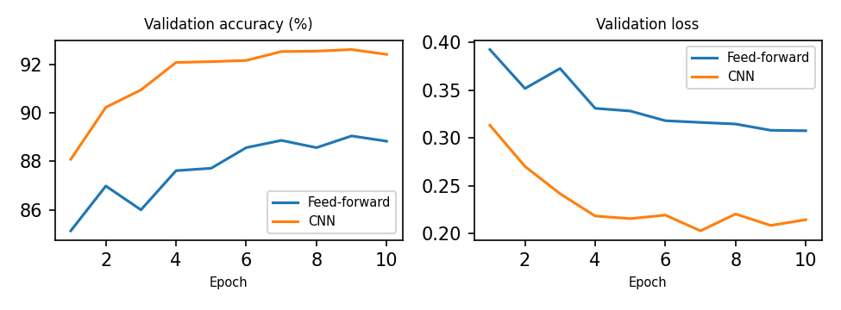
The CNN scored 92.20% on the test set and the feed-forward network scored 88.47%, a difference of +3.73 points. The most common CNN mistake was predicting "T-shirt/top" when the true class was "Shirt" (97 images). At the end of training, the CNN's training accuracy was +2.94 points compared with its validation accuracy.

6. Discussion and conclusion
The CNN looks at small patches and reuses the same filters across the whole image, so it keeps the shape of the clothes. The feed-forward network flattens the image and loses that layout. This is why CNNs are the normal choice for image tasks. The experiments show that learning rate and optimizer choice can change results more than small changes such as batch size or dropout. In future work I would try data augmentation, batch normalization and a learning-rate schedule.

