Activity1:

using System;

namespace activity1{

public class testClass{

public static void Main(){

Console.WriteLine("Hello World!");

Console.WriteLine("Press any key to exit");

Console.ReadKey();

}

}

}

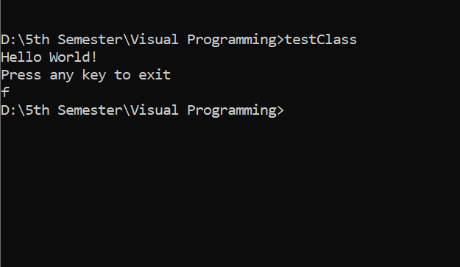

Activity2:

using System;

namespace activity1{

public class testClass{

public static void Main(string[] args){

Console.WriteLine("Name: "+args[0]);

}

}

}

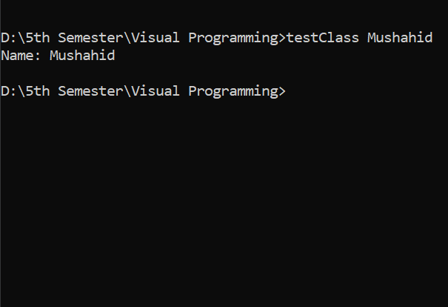

Activity 3:

using System;

namespace activity1

{

public class testClass

{

public static void Main(string[] args)

{

Console.WriteLine("Hello, Welcome!\n");

char oprtr= Convert.ToChar(args[0]);

int operand1;

operand1 = int.Parse(args[1]);

int operand2;

operand2 = int.Parse(args[2]);

switch(oprtr)

{

case '+':

Console.WriteLine(operand1 + operand2); break;

case '-':

Console.WriteLine(operand1 - operand2); break;

case '\*':

Console.WriteLine(operand1 \* operand2); break;

case '/':

Console.WriteLine(operand1 / operand2); break;

default:

Console.WriteLine("Wrong operator input"); break;

}

}

}

}

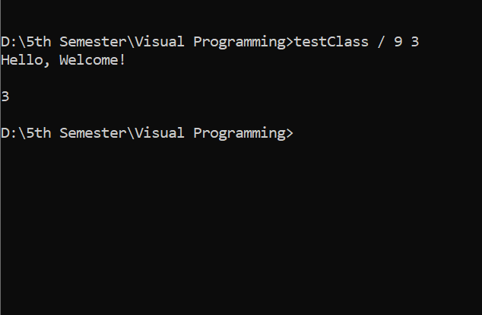

Activity 5

using System.Collections.Generic;

using System.Linq;

using System.Text;

using System.Threading.Tasks;

namespace ConsoleApplication3

{

class Program

{

static void Main(string[] args)

{

string line;

Console.WriteLine("Hello World!\n");

line= Console.ReadLine();

Console.WriteLine("Your entered text is: "+line+'\n');

Console.WriteLine("Press any key to exit");

Console.ReadKey();

}

}

}

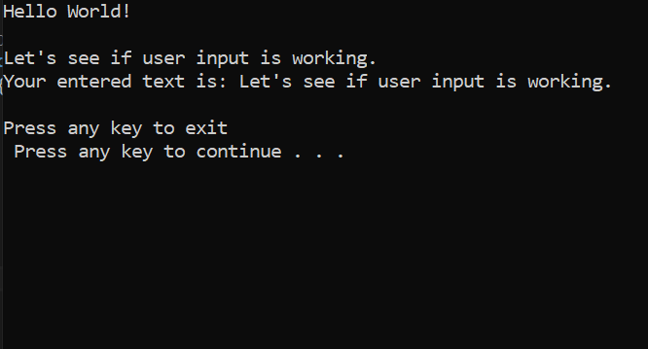

Activity 6 using System;

using System.Collections.Generic;

using System.Linq;

using System.Text;

using System.Threading.Tasks;

namespace ConsoleApplication3

{

class Program

{

static void Main(string[] args)

{

Console.WriteLine("let's make a basic calculator:\n\nEnter an operator: ");

char oprtr = Convert.ToChar(Console.ReadLine());

int operand1;

Console.WriteLine("Enter an operand1/value1: ");

operand1 = int.Parse(Console.ReadLine());

int operand2;

Console.WriteLine("Enter an operand2/value2: ");

operand2 = int.Parse(Console.ReadLine());

switch (oprtr)

{

case '+':

Console.WriteLine("The sum is: " + (operand1 + operand2)); break;

case '-':

Console.WriteLine("The subtraction is: " + (operand1 - operand2)); break;

case '\*':

Console.WriteLine("The multiplication is: " + (operand1 \* operand2)); break;

case '/':

Console.WriteLine("The division is: " + (operand1 / operand2)); break;

default:

Console.WriteLine("Wrong operator input"); break;

}

}

}

}

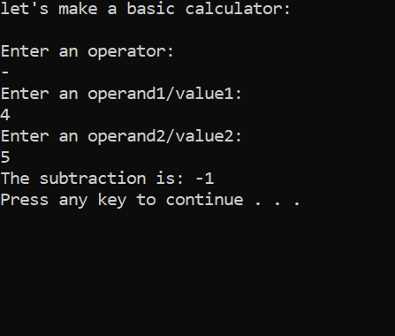

Activity 7

using System;

using System.Collections.Generic;

using System.Linq;

using System.Text;

using System.Threading.Tasks;

namespace ConsoleApplication3

{

class Program

{

static void Main(string[] args)

{

Console.WriteLine("Enter two number for division");

int dividend, divisor;

dividend = int.Parse(Console.ReadLine());

divisor = int.Parse(Console.ReadLine());

dividewithoutoperator(dividend, divisor);

}

static void dividewithoutoperator(int dividend, int divisor)

{

int count = 0;

Console.WriteLine("The division of "+dividend+" and "+divisor+" is: ");

while (dividend>=divisor){

count++;

dividend = dividend - divisor;

}

Console.WriteLine("\t"+count);

}

}

}

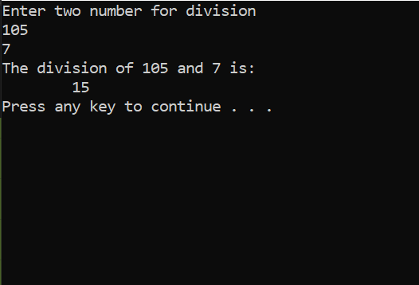

Task1

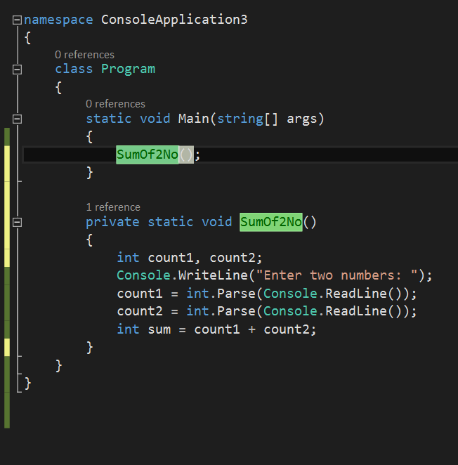

Task2

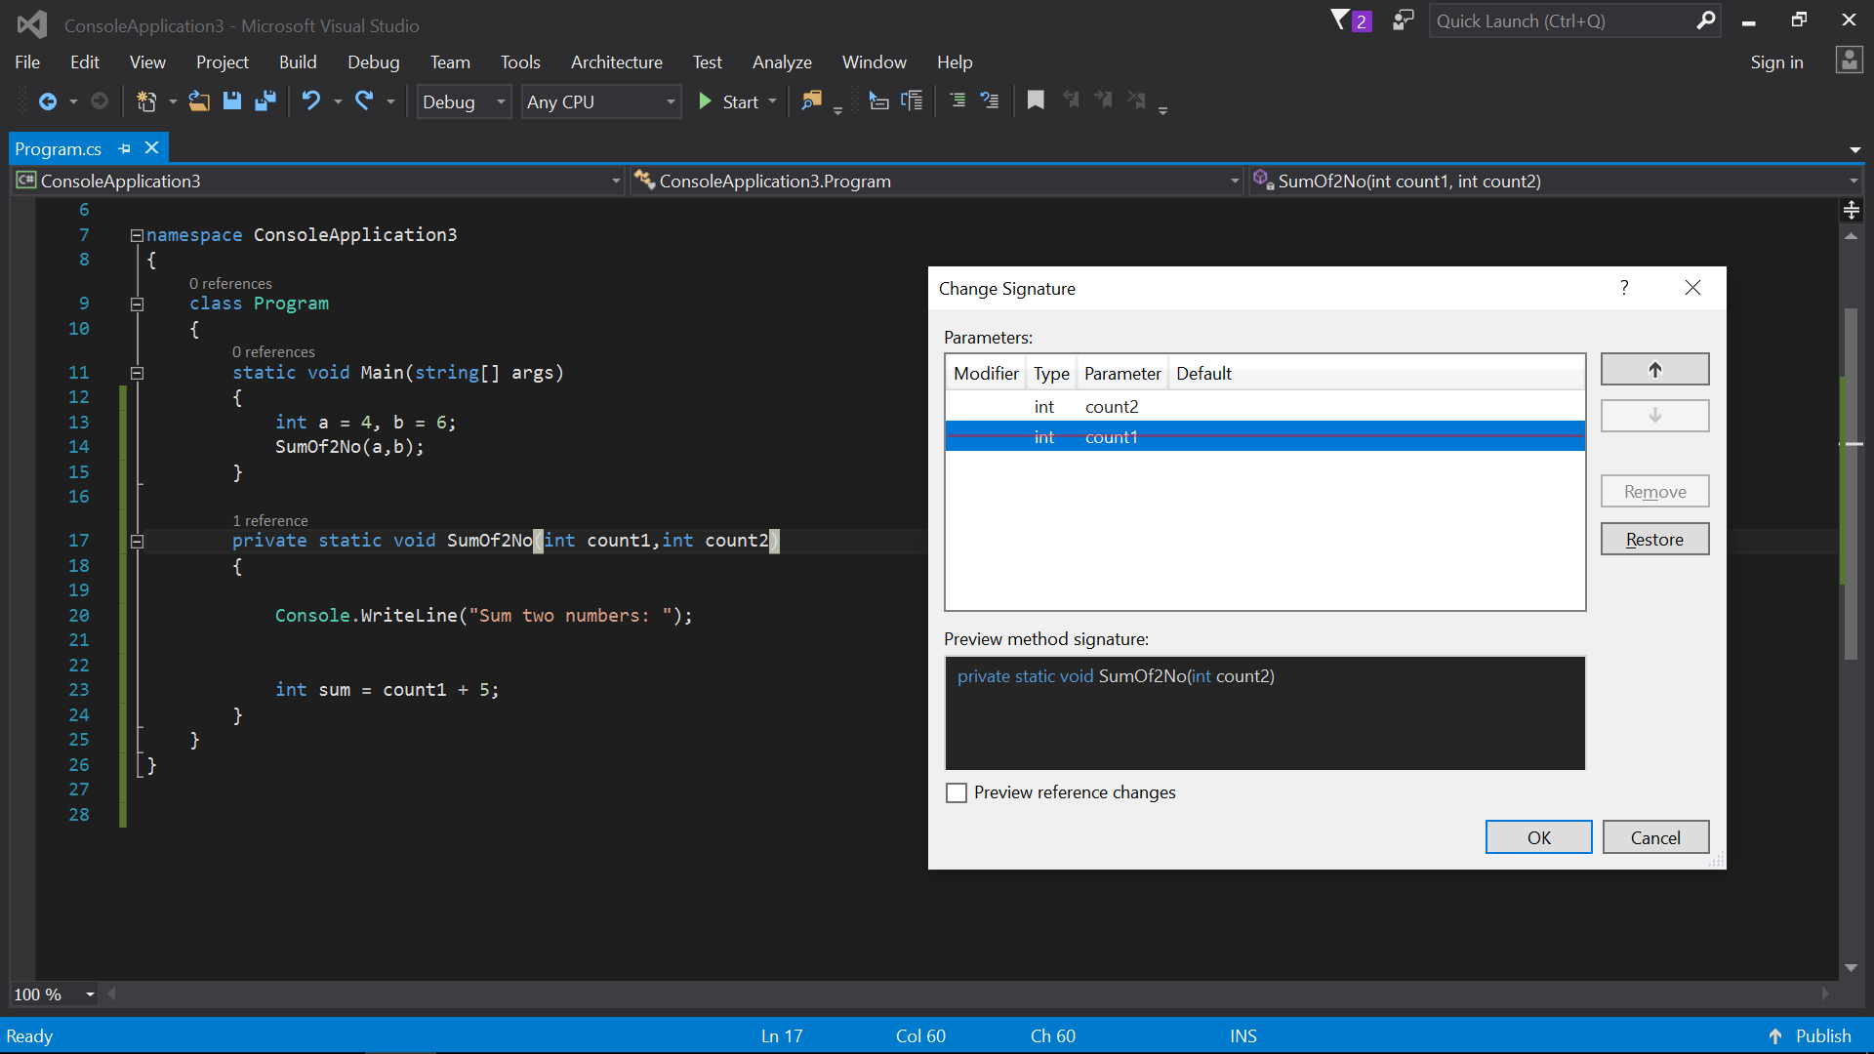

Task3

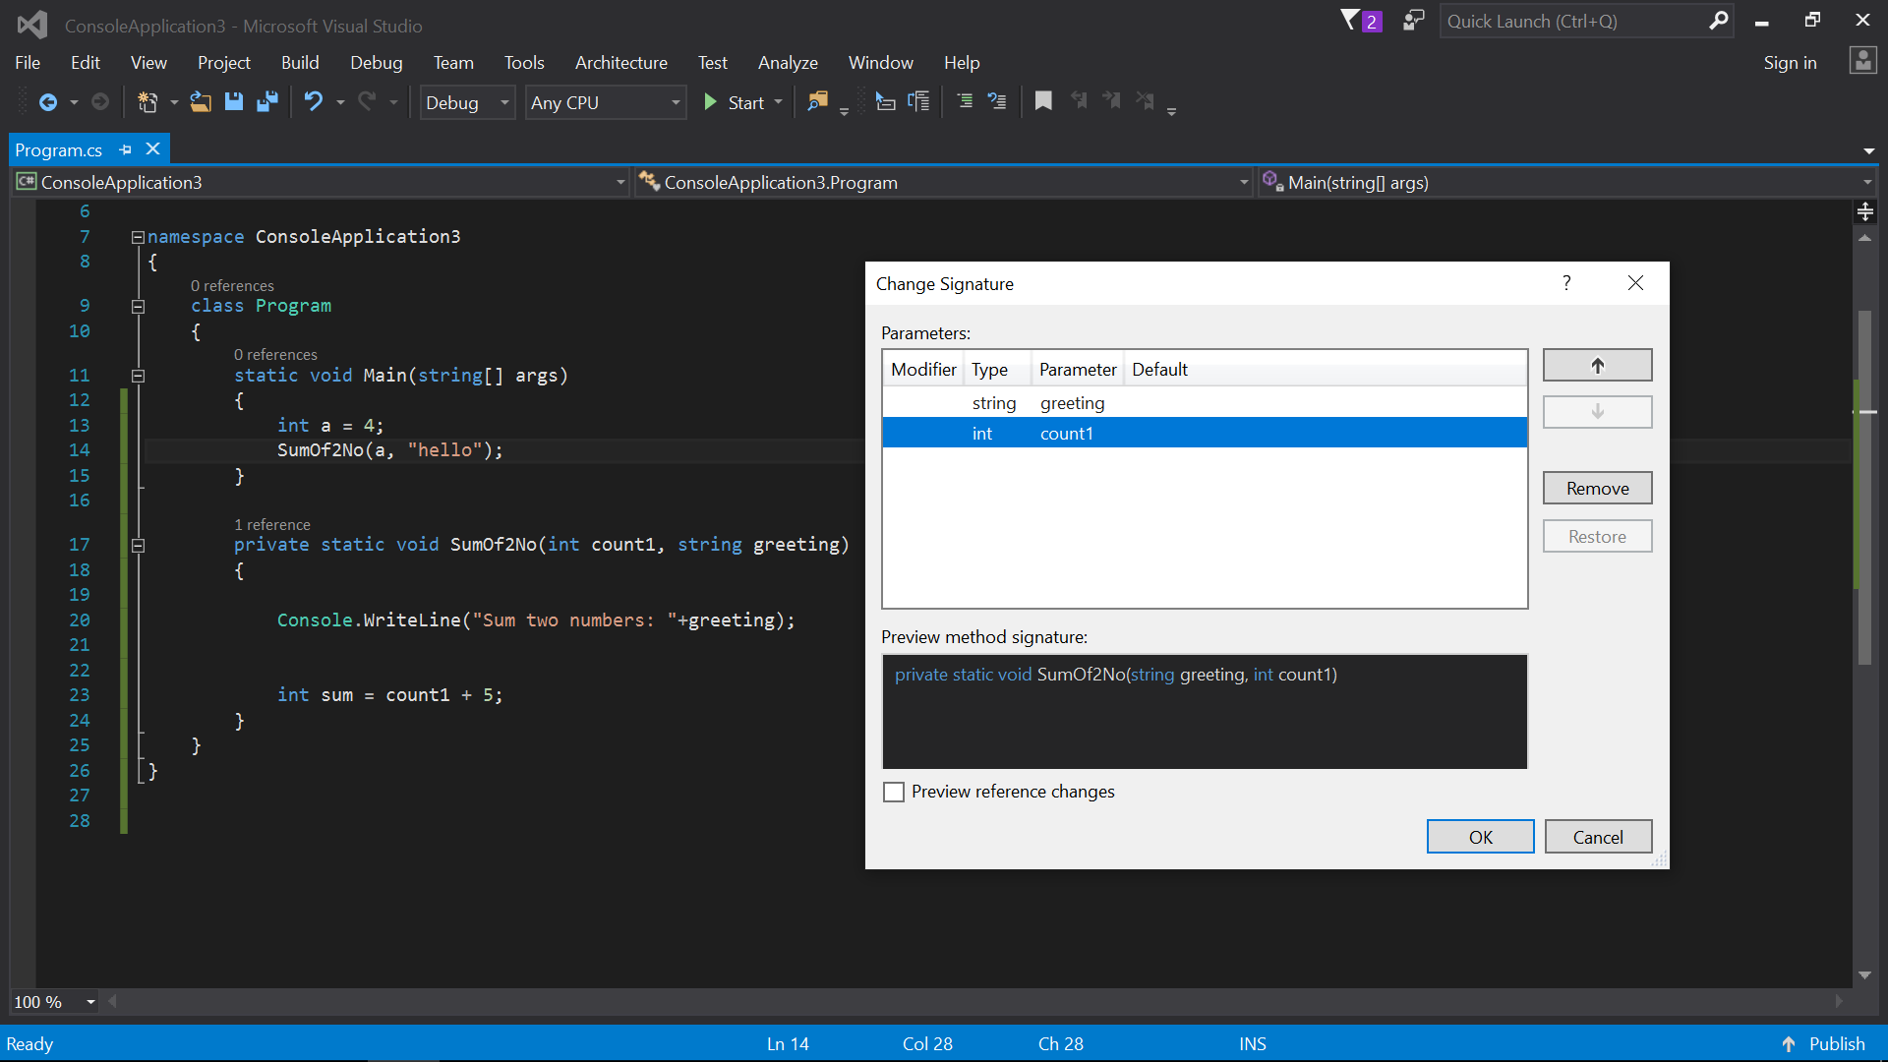

Task4

