Activity 4:

Just like discribed in activity,

The breakpoints window showed me the list of breakpoints in my program.

The watch window was empty but as I double clicked under name section, and wrote a variable name, it

showed me the value and type of the variable.

The locals window showed me the all variable such as variable named shapeName along with its value and type.

It also showed me args variable name plus its values which was string[0] and its type.

The autos window also only showed varaible name, its value and its type.

About call stack, i did not really understand what it means.

I also used the step into, step over and step out, but what I observed was that they all kind of worked the same.

Activity 5;

using System;

using System.Collections.Generic;

using System.Linq;

using System.Text;

using System.Threading.Tasks;

namespace ConsoleApplication2

{

class Program

{

static void Main(string[] args)

{

MathClass obj = new MathClass();

Console.WriteLine("Enter Operator: ");

obj.setOperator(Convert.ToString(Console.ReadKey().KeyChar));

Console.WriteLine("\nEnter First Value");

obj.setFirstValue(int.Parse(Console.ReadLine()));

Console.WriteLine("\nEnter Second Value");

obj.setSecondValue(int.Parse(Console.ReadLine()));

if (obj.getOperator() == "+")

{

Console.WriteLine("Addition of two values is: " + (obj.getfirstValue() + obj.getSecondtValue()));

}

else if (obj.getOperator() == "-")

{

Console.WriteLine("Subtration of two values is: " + (obj.getfirstValue()-obj.getSecondtValue()));

}

else if (obj.getOperator() == "*")

{

Console.WriteLine("Multiplication of two values is: "+ (obj.getfirstValue()*obj.getSecondtValue()));

}

else if (obj.getOperator() == "/")

{

Console.WriteLine("Division of two values is: " + (obj.getfirstValue() / obj.getSecondtValue()));

}

else

{

Console.WriteLine("Enter correct operator, please bro");

}

}

}

}

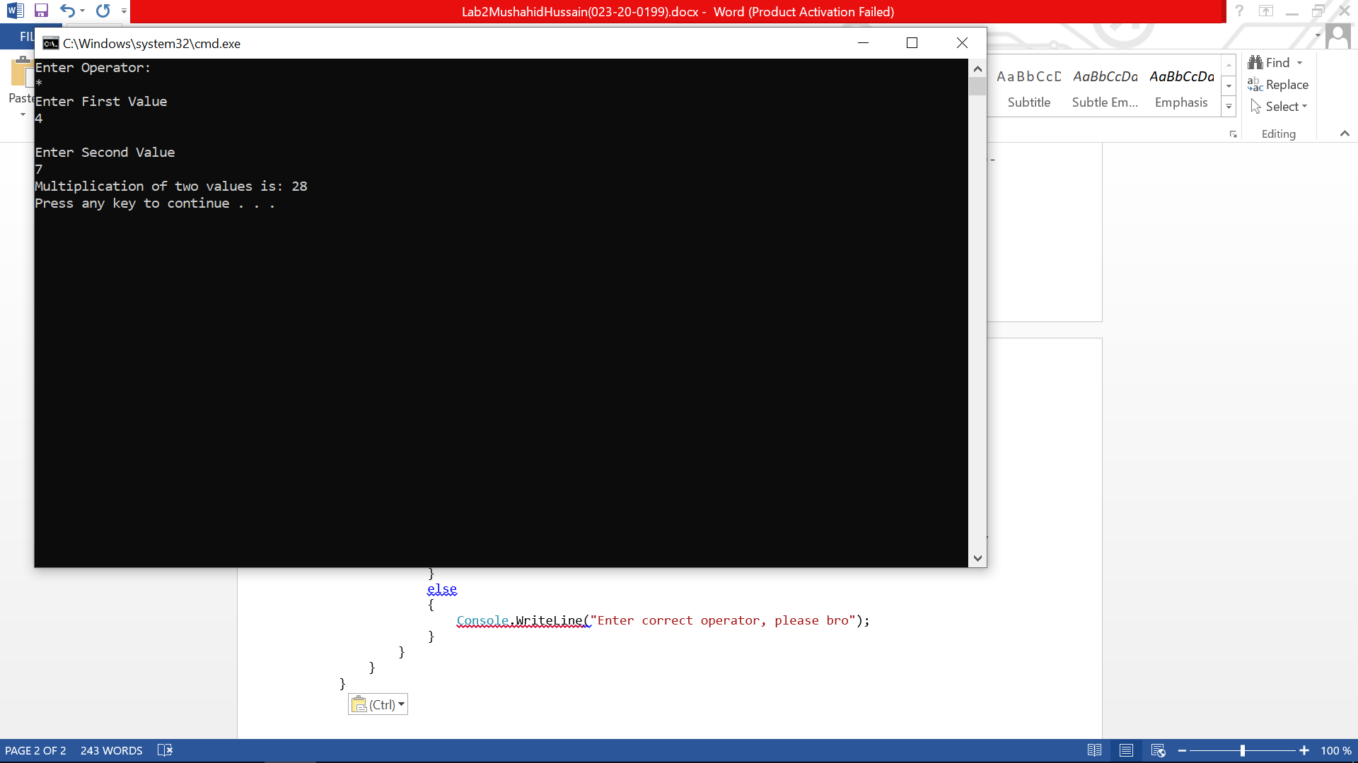

Activity 6:

using System;

using System.Collections.Generic;

using System.ComponentModel;

using System.Data;

using System.Drawing;

using System.Linq;

using System.Text;

using System.Threading.Tasks;

using System.Windows.Forms;

namespace WindowsFormsApplication1

{

public partial class Form1 : Form

{

public Form1()

{

InitializeComponent();

}

private void Form1_Load(object sender, EventArgs e)

{

}

private void label1_Click(object sender, EventArgs e)

{

}

private void btnSeason_Click(object sender, EventArgs e)

{

int month = int.Parse(this.txtMonth.Text);

if (month == 1 || month == 2 || month == 12)

{

this.lblSeason.Text = "Winter";

}

if (month == 3 || month == 4 || month == 5)

{

this.lblSeason.Text = "Spring";

}

if (month == 6 || month == 7 || month == 8)

{

this.lblSeason.Text = "Summer";

}

if (month == 9 || month == 10 || month == 11)

{

this.lblSeason.Text = "Autumn";

}

}

}

}

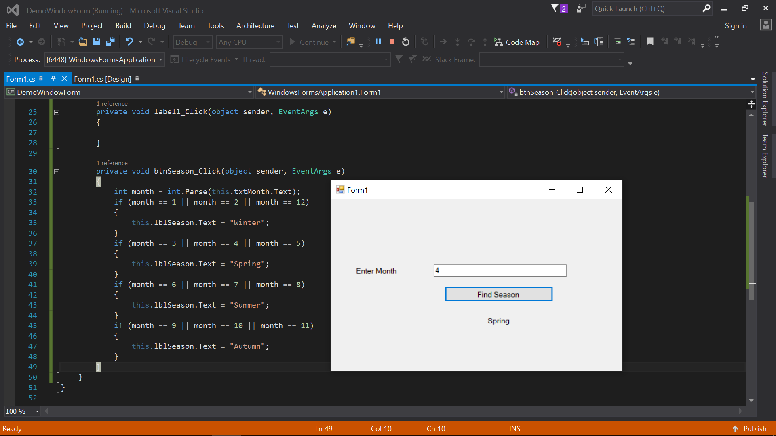

Activity 7:

using System;

using System.Collections.Generic;

using System.ComponentModel;

using System.Data;

using System.Drawing;

using System.Linq;

using System.Text;

using System.Threading.Tasks;

using System.Windows.Forms;

namespace WindowsFormsApplication1

{

public partial class BillCalculation : Form

{

int units;

public BillCalculation()

{

InitializeComponent();

}

private void txtUnits_TextChanged(object sender, EventArgs e)

{

units = int.Parse(this.txtUnits.Text);

}

private void btnCalculateBill_Click(object sender, EventArgs e)

{

int bill=0;

int temp = units;

if (units <= 100)

{

bill = units * 2;

this.lblBill.Text = Convert.ToString(bill);

}

else if (units > 100)

{

units = units - 100;

bill = bill+( 100 * 2);

if (units > 100)

{

units = units - 100;

bill = bill + (100 * 3);

if (units <=100)

{

bill = bill + (100 * 4);

}

else if (units > 100)

{

bill = bill+ (units * 7);

}

}

else if (units <= 100)

{

bill = bill + (units * 3);

}

this.lblBill.Text = Convert.ToString(bill);

}

}

private void BillCalculation_Load(object sender, EventArgs e)

{

}

}

}

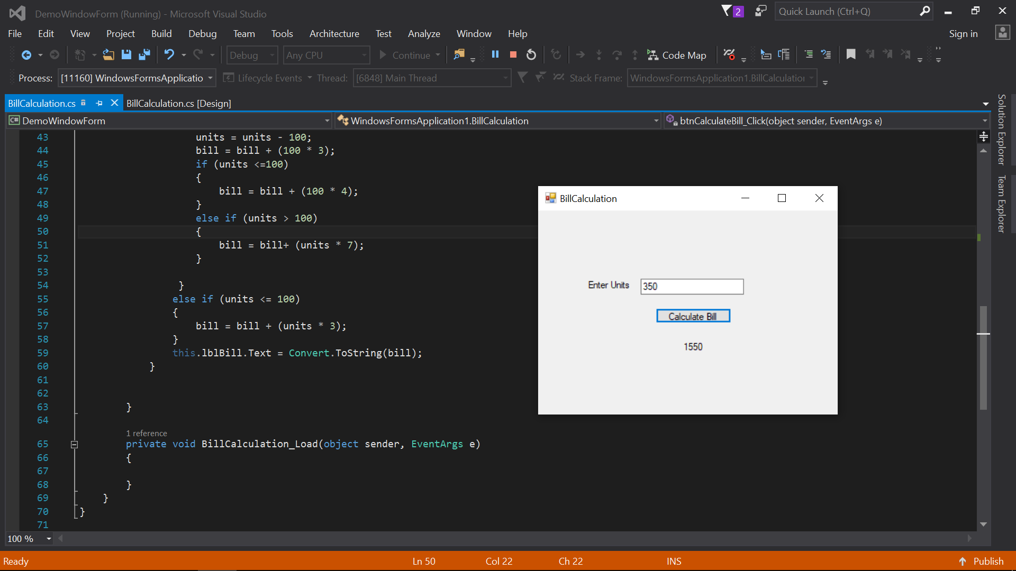

Activity 8:

using System;

using System.Collections.Generic;

using System.ComponentModel;

using System.Data;

using System.Drawing;

using System.Linq;

using System.Text;

using System.Threading.Tasks;

using System.Windows.Forms;

namespace WindowsFormsApplication2

{

public partial class frmDemo : Form

{

public frmDemo()

{

InitializeComponent();

}

private void button1_Click(object sender, EventArgs e)

{

this.btnDemo.Left = btnDemo.Left - 10;

if (this.btnDemo.Left < -60)

this.btnDemo.Left = 441;

}

private void button3_Click(object sender, EventArgs e)

{

this.btnDemo.Top = btnDemo.Top - 10;

if (this.btnDemo.Top <= 160)

this.btnDemo.Top = 300;

}

private void frmDemo_Load(object sender, EventArgs e)

{

}

private void button2_Click(object sender, EventArgs e)

{

this.btnDemo.Left = this.btnDemo.Left + 10;

if (this.btnDemo.Left > 450)

this.btnDemo.Left = -61;

}

private void button4_Click(object sender, EventArgs e)

{

}

private void btnBottom_Click(object sender, EventArgs e)

{

this.btnDemo.Top = this.btnDemo.Top + 10;

if (this.btnDemo.Top > 300)

this.btnDemo.Top = 160;

}

}

}

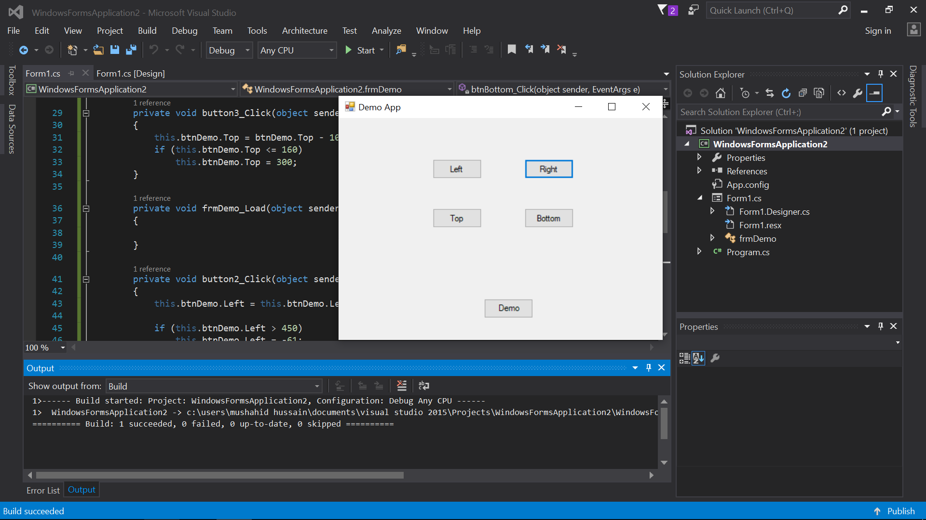

Activity 9:

using System;

using System.Collections.Generic;

using System.ComponentModel;

using System.Data;

using System.Drawing;

using System.Linq;

using System.Text;

using System.Threading.Tasks;

using System.Windows.Forms;

namespace WindowsFormsApplication2

{

public partial class SimpleCalculator : Form

{

int firstValue;

int secondValue;

public SimpleCalculator()

{

InitializeComponent();

}

private void label2_Click(object sender, EventArgs e)

{

}

private void btnAdd_Click(object sender, EventArgs e)

{

firstValue = Convert.ToInt32(this.txtFirstValue.Text);

secondValue = Convert.ToInt32(this.txtSecondValue.Text);

this.txtResult.Text = "" + (firstValue + secondValue);

}

private void btnSubtract_Click(object sender, EventArgs e)

{

firstValue = Convert.ToInt32(this.txtFirstValue.Text);

secondValue = Convert.ToInt32(this.txtSecondValue.Text);

this.txtResult.Text = "" + (firstValue - secondValue);

}

private void btnMultiply_Click(object sender, EventArgs e)

{

firstValue = Convert.ToInt32(this.txtFirstValue.Text);

secondValue = Convert.ToInt32(this.txtSecondValue.Text);

this.txtResult.Text = "" + (firstValue * secondValue);

}

private void btnDivide_Click(object sender, EventArgs e)

{

firstValue = Convert.ToInt32(this.txtFirstValue.Text);

secondValue = Convert.ToInt32(this.txtSecondValue.Text);

this.txtResult.Text = "" + (firstValue / secondValue);

}

private void btnClear_Click(object sender, EventArgs e)

{

this.txtFirstValue.Text = "";

this.txtSecondValue.Text = "";

this.txtResult.Text= "";

}

}

}

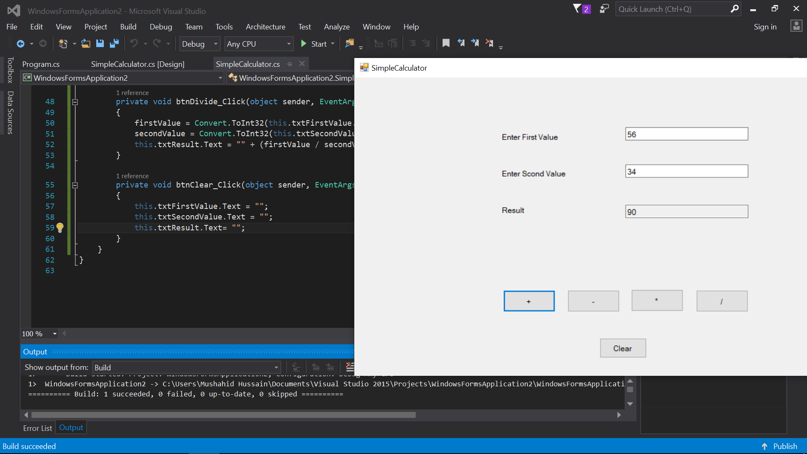

Activity 10;

using System;

using System.Collections.Generic;

using System.ComponentModel;

using System.Data;

using System.Drawing;

using System.Linq;

using System.Text;

using System.Threading.Tasks;

using System.Windows.Forms;

namespace HangmanGame

{

public partial class space : Form

{

string chars = "x y o m n ";

char[] characterOfWord;

int leftGuess = 7;

char[] spaces;

char guessedChar;

public void game()

{

string[] words = { "noise", "creap", "wiser", "micros", "moist","computer" };

Random random = new Random();

int index = random.Next(0, words.Length);

string wordToGuess = words[index];

characterOfWord = wordToGuess.ToCharArray();

spaces = new char[wordToGuess.Length];

List<int> randomList = new List<int>();

for(int space=0; space<spaces.Length; space++)

{

spaces[space]= '-';

}

for (int i = 0; i < characterOfWord.Length; i++)

{

int MyNumber = random.Next(0, characterOfWord.Length);

while (randomList.Contains(MyNumber))

MyNumber = random.Next(0, characterOfWord.Length);

randomList.Add(MyNumber);

chars += characterOfWord[MyNumber] + " ";

this.blanckSpace.Text += Convert.ToString(spaces[i]);

}

this.label1.Text = this.label1.Text + chars;

this.leftguesses.Text = Convert.ToString(leftGuess);

}

public space()

{

InitializeComponent();

game();

}

private void textBox1_TextChanged(object sender, EventArgs e)

{

}

private void space_Load(object sender, EventArgs e)

{

}

private void btnGuess_Click(object sender, EventArgs e)

{

try

{

guessedChar = Convert.ToChar(this.GuessBox.Text);

}

catch (Exception)

{

label3.Text = "Wrong input";

label3.Visible = true;

}

Boolean check = false;

int index = 0;

for (int k = 0; k < characterOfWord.Length; k++)

{

if (characterOfWord[k] == guessedChar)

{

//characterOfWord[k] = '@';

check = true;

index = k;

}

}

if (check)

{

spaces[index] = guessedChar;

this.blanckSpace.Text = "";

for (int space = 0; space < spaces.Length; space++)

{

this.blanckSpace.Text += Convert.ToString(spaces[space]);

}

this.GuessBox.Text = "";

}

else

{

this.leftguesses.Text = Convert.ToString(--leftGuess);

if(leftGuess==6)

{

picGuess.Image = Properties.Resources.hangman6;

}

else if (leftGuess == 5)

{

picGuess.Image = Properties.Resources.hangman5;

}

else if (leftGuess == 4)

{

picGuess.Image = Properties.Resources.hangman4;

}

else if (leftGuess == 3)

{

picGuess.Image = Properties.Resources.hangman3;

}

else if (leftGuess == 2)

{

picGuess.Image = Properties.Resources.hangman2;

}

else if (leftGuess == 1)

{

picGuess.Image = Properties.Resources.hangman1;

}

else if (leftGuess == 0)

{

picGuess.Image = Properties.Resources.hangman0;

}

this.GuessBox.Text = "";

if (leftGuess <= 0)

{

this.label3.Visible = true;

this.label3.Text = "Game Over! You Lose";

Environment.Exit(0);

}

}

Boolean win = false;

int count = 0;

for (int i = 0; i < characterOfWord.Length; i++)

{

if (characterOfWord[i] == spaces[i])

{

win = true;

count++;

}

else

win = false;

}

if (win&&count==characterOfWord.Length)

{

this.label3.Text = "Hurrah! You Won";

label3.Visible = true;

}

}

private void label3_Click(object sender, EventArgs e)

{

}

private void label5_Click(object sender, EventArgs e)

{

}

private void leftguess_Click(object sender, EventArgs e)

{

}

private void label3_Click_1(object sender, EventArgs e)

{

}

private void label3_Click_2(object sender, EventArgs e)

{

}

private void picGuess_Click(object sender, EventArgs e)

{

}

}

}

