Activity1

1. With default modifier, I got an error saying class could not be found.
2. With public modifier too, I am getting the same error.
3. Same Error as above
4. Same Error as above
5. The error is saying elements defined in namespace cannot be explicitly defined as private, protected or protected internal.
6. Error

Activity 2

using System;

using System.Collections.Generic;

using System.ComponentModel;

using System.Data;

using System.Drawing;

using System.Linq;

using System.Text;

using System.Threading.Tasks;

using System.Windows.Forms;

namespace Calculator

{

public partial class Calculator : Form

{

string getNumber;

int value;

char opratr;

public Calculator()

{

InitializeComponent();

}

private void button1_Click(object sender, EventArgs e)

{

getNumber += button1.Text;

textBox.Text = getNumber;

}

private void button2_Click(object sender, EventArgs e)

{

getNumber += button2.Text;

textBox.Text = getNumber;

}

private void button3_Click(object sender, EventArgs e)

{

getNumber += button3.Text;

textBox.Text = getNumber;

}

private void button4_Click(object sender, EventArgs e)

{

getNumber += button4.Text;

textBox.Text = getNumber;

}

private void button5_Click(object sender, EventArgs e)

{

getNumber += button5.Text;

textBox.Text = getNumber;

}

private void button6_Click(object sender, EventArgs e)

{

getNumber += button6.Text;

textBox.Text = getNumber;

}

private void button7_Click(object sender, EventArgs e)

{

getNumber += button7.Text;

textBox.Text = getNumber;

}

private void button8_Click(object sender, EventArgs e)

{

getNumber += button8.Text;

textBox.Text = getNumber;

}

private void button9_Click(object sender, EventArgs e)

{

getNumber += button9.Text;

textBox.Text = getNumber;

}

private void btnClear_Click(object sender, EventArgs e)

{

this.textBox.Text = "";

getNumber = "";

}

private void btnZero_Click(object sender, EventArgs e)

{

getNumber += btnZero.Text;

textBox.Text = getNumber;

}

private void btnDiv_Click(object sender, EventArgs e)

{

value = int.Parse(getNumber);

opratr = '/';

getNumber = "";

textBox.Text = "" + "/";

}

private void btnMultip_Click(object sender, EventArgs e)

{

value = int.Parse(getNumber);

opratr = '*';

getNumber = "";

textBox.Text = "*";

}

private void btnSub_Click(object sender, EventArgs e)

{

value = int.Parse(getNumber);

opratr = '-';

getNumber = "";

textBox.Text =""+"-";

}

private void btnAdd_Click(object sender, EventArgs e)

{

value = int.Parse(getNumber);

opratr = '+';

getNumber = "";

textBox.Text = "+";

}

private void btnEqual_Click(object sender, EventArgs e)

{

if (opratr == '/')

{

try

{

textBox.Text = "" + (value / int.Parse(getNumber));

}

catch (Exception)

{

textBox.Text = "Undefined";

}

}

else if (opratr == '*')

{

textBox.Text = "" + (value * int.Parse(getNumber));

}

else if (opratr == '-')

{

textBox.Text = "" + (value - int.Parse(getNumber));

}

else if (opratr == '+')

{

textBox.Text = "" + (value + int.Parse(getNumber));

}

}

private void Form1_Load(object sender, EventArgs e)

{

}

private void textBox1_TextChanged(object sender, EventArgs e)

{

}

}

}

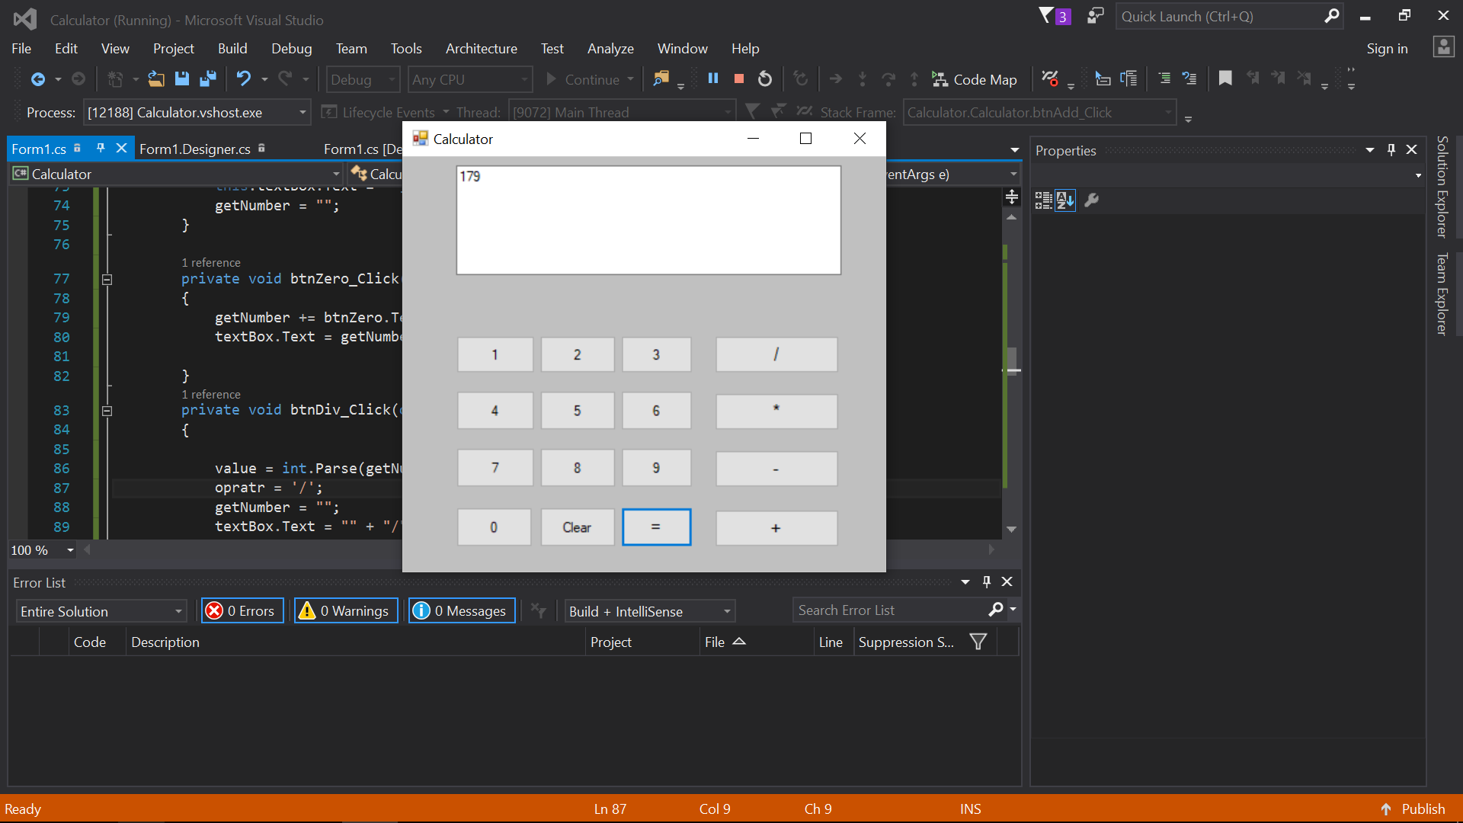

Activity 3

using System;

using System.Collections.Generic;

using System.ComponentModel;

using System.Data;

using System.Drawing;

using System.Linq;

using System.Text;

using System.Threading.Tasks;

using System.Windows.Forms;

namespace Calculator

{

public partial class Calculator : Form

{

string getNumber;

int value1 = 0;

int value2=0;

char opratr;

public Calculator()

{

InitializeComponent();

}

private void button1_Click(object sender, EventArgs e)

{

getNumber += button1.Text;

textBox.Text = getNumber;

}

private void button2_Click(object sender, EventArgs e)

{

getNumber += button2.Text;

textBox.Text = getNumber;

}

private void button3_Click(object sender, EventArgs e)

{

getNumber += button3.Text;

textBox.Text = getNumber;

}

private void button4_Click(object sender, EventArgs e)

{

getNumber += button4.Text;

textBox.Text = getNumber;

}

private void button5_Click(object sender, EventArgs e)

{

getNumber += button5.Text;

textBox.Text = getNumber;

}

private void button6_Click(object sender, EventArgs e)

{

getNumber += button6.Text;

textBox.Text = getNumber;

}

private void button7_Click(object sender, EventArgs e)

{

getNumber += button7.Text;

textBox.Text = getNumber;

}

private void button8_Click(object sender, EventArgs e)

{

getNumber += button8.Text;

textBox.Text = getNumber;

}

private void button9_Click(object sender, EventArgs e)

{

getNumber += button9.Text;

textBox.Text = getNumber;

}

private void btnClear_Click(object sender, EventArgs e)

{

this.textBox.Text = "";

getNumber = "";

}

private void btnZero_Click(object sender, EventArgs e)

{

getNumber += btnZero.Text;

textBox.Text = getNumber;

}

private void btnDiv_Click(object sender, EventArgs e)

{

//value = int.Parse(getNumber);

//opratr = '/';

//getNumber += btnDiv.Text;

//getNumber = "";

//textBox.Text = "" + "/";

opratr = Convert.ToChar(btnDiv.Text);

getNumber += opratr;

textBox.Text = getNumber;

}

private void btnMultip_Click(object sender, EventArgs e)

{

//value = int.Parse(getNumber);

//opratr = '*';

//getNumber = "";

//textBox.Text = "*";

opratr = Convert.ToChar(btnMultip.Text);

getNumber += opratr;

textBox.Text = getNumber;

}

private void btnSub_Click(object sender, EventArgs e)

{

/* value = int.Parse(getNumber);

opratr = '-';

getNumber = "";

textBox.Text =""+"-";*/

opratr= Convert.ToChar(btnSub.Text);

getNumber += opratr;

textBox.Text = getNumber;

}

private void btnAdd_Click(object sender, EventArgs e)

{

/*value = int.Parse(getNumber);

opratr = '+';

getNumber = "";

textBox.Text = "+";*/

opratr = Convert.ToChar(btnAdd.Text);

getNumber += opratr;

textBox.Text = getNumber;

}

private void btnEqual_Click(object sender, EventArgs e)

{

string[] value;

try

{

value= getNumber.Split(opratr);

value1 = int.Parse(value[0]);

value2 = int.Parse(value[1]);

if (value.Length > 2)

throw new Exception();

}

catch (Exception)

{

textBox.Text = "Only provide two values";

}

if (opratr == '/')

{

try

{

textBox.Text = "" + (value1/value2);

getNumber = "";

}

catch (Exception)

{

textBox.Text = "Undefined";

getNumber = "";

}

}

else if (opratr == '*')

{

textBox.Text = "" + (value1 * value2);

getNumber = "";

}

else if (opratr == '-')

{

textBox.Text = "" + (value1 - value2);

getNumber = "";

}

else if (opratr == '+')

{

textBox.Text = "" + (value1 + value2);

getNumber = "";

}

}

private void Form1_Load(object sender, EventArgs e)

{

}

private void textBox1_TextChanged(object sender, EventArgs e)

{

}

}

}

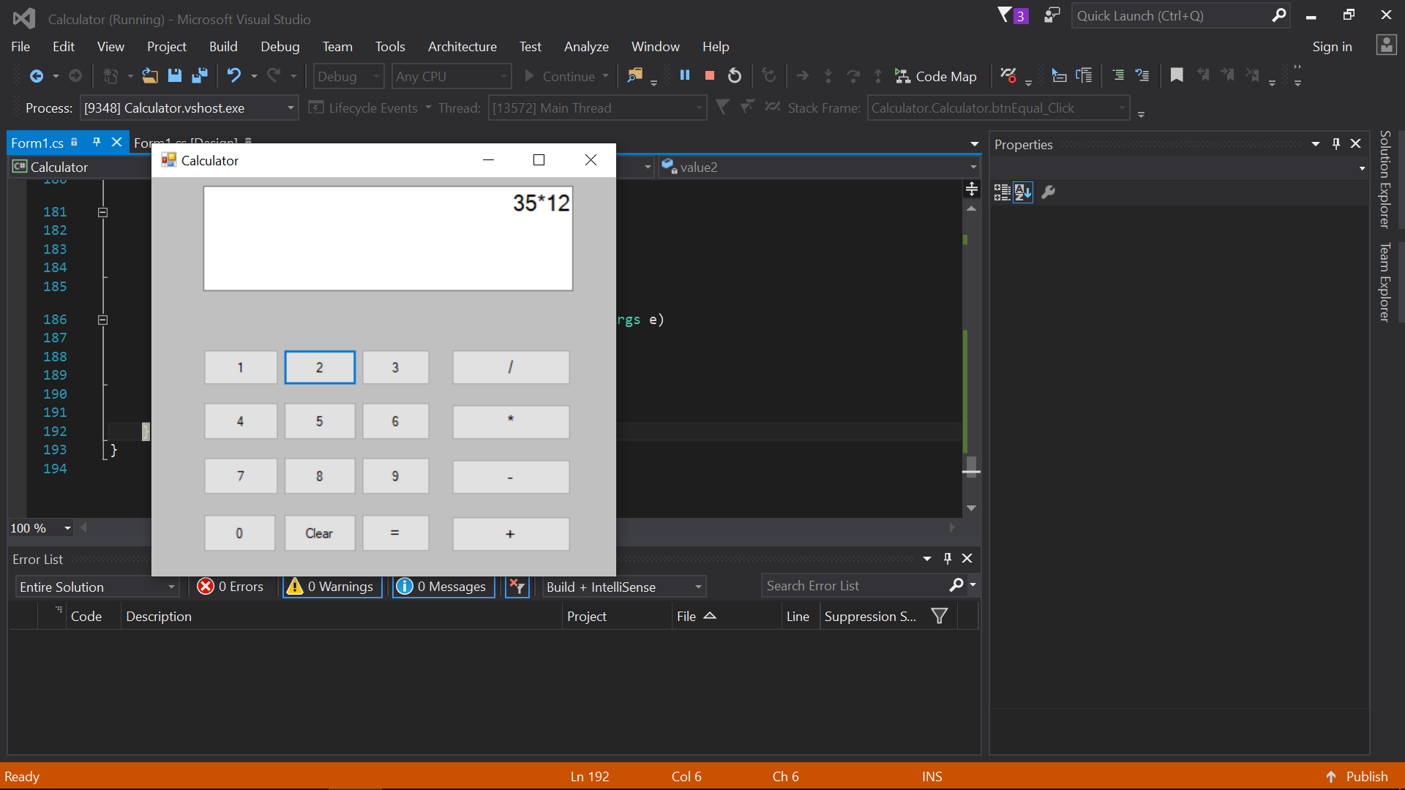

Activity4,5

using System;

using System.Collections.Generic;

using System.ComponentModel;

using System.Data;

using System.Drawing;

using System.Linq;

using System.Text;

using System.Threading.Tasks;

using System.Windows.Forms;

namespace TictacToeGame

{

public partial class Form1 : Form

{

Boolean turn = true;

Boolean player1 = false;

Boolean player2 = false;

public Form1()

{

InitializeComponent();

}

private void declareWinner()

{

if(button1.Text=="X" && button2.Text=="X" && button3.Text == "X"|| button1.Text == "X" && button5.Text == "X" && button9.Text == "X"|| button1.Text == "X" && button4.Text == "X" && button7.Text == "X"|| button2.Text == "X" && button5.Text == "X" && button8.Text == "X"|| button3.Text == "X" && button6.Text == "X" && button9.Text == "X"|| button4.Text == "X" && button5.Text == "X" && button6.Text == "X"|| button7.Text == "X" && button8.Text == "X" && button9.Text == "X")

{

player1 = true;

}

if (button1.Text == "O" && button2.Text == "O" && button3.Text == "O" || button1.Text == "O" && button5.Text == "O" && button9.Text == "O" || button1.Text == "O" && button4.Text == "O" && button7.Text == "O" || button2.Text == "O" && button5.Text == "O" && button8.Text == "O" || button3.Text == "O" && button6.Text == "O" && button9.Text == "O" || button4.Text == "O" && button5.Text == "O" && button6.Text == "O" || button7.Text == "O" && button8.Text == "O" && button9.Text == "O")

{

player2 = true;

}

if (player1)

label1.Text = "Player1 Won";

if (player2)

label1.Text = "Player2 Won";

}

private void Form1_Load(object sender, EventArgs e)

{

}

private void table_Paint(object sender, PaintEventArgs e)

{

}

private void hardToolStripMenuItem_Click(object sender, EventArgs e)

{

}

private void backgroundWorker1_DoWork(object sender, DoWorkEventArgs e)

{

}

private void button1_Click(object sender, EventArgs e)

{

if (turn)

{

button1.Text = "X";

circle.BackColor = Color.LightSalmon;

Cross.BackColor = Color.LightGray;

turn = false;

button1.Enabled = false;

declareWinner();

}

else

{

button1.Text = "O";

Cross.BackColor = Color.LightSalmon;

circle.BackColor = Color.LightGray;

turn = true;

button1.Enabled = false;

declareWinner();

}

}

private void button2_Click(object sender, EventArgs e)

{

if (turn)

{

button2.Text = "X";

circle.BackColor = Color.LightSalmon;

Cross.BackColor = Color.LightGray;

turn = false;

button2.Enabled = false;

declareWinner();

}

else

{

button2.Text = "O";

Cross.BackColor = Color.LightSalmon;

circle.BackColor = Color.LightGray;

turn = true;

button2.Enabled = false;

declareWinner();

}

}

private void button3_Click(object sender, EventArgs e)

{

if (turn)

{

button3.Text = "X";

circle.BackColor = Color.LightSalmon;

Cross.BackColor = Color.LightGray;

turn = false;

button3.Enabled = false;

declareWinner();

}

else

{

button3.Text = "O";

Cross.BackColor = Color.LightSalmon;

circle.BackColor = Color.LightGray;

turn = true;

button3.Enabled = false;

declareWinner();

}

}

private void button4_Click(object sender, EventArgs e)

{

if (turn)

{

button4.Text = "X";

circle.BackColor = Color.LightSalmon;

Cross.BackColor = Color.LightGray;

turn = false;

button4.Enabled = false;

declareWinner();

}

else

{

button4.Text = "O";

Cross.BackColor = Color.LightSalmon;

circle.BackColor = Color.LightGray;

turn = true;

button4.Enabled = false;

declareWinner();

}

}

private void button5_Click(object sender, EventArgs e)

{

if (turn)

{

button5.Text = "X";

circle.BackColor = Color.LightSalmon;

Cross.BackColor = Color.LightGray;

turn = false;

button5.Enabled = false;

declareWinner();

}

else

{

button5.Text = "O";

Cross.BackColor = Color.LightSalmon;

circle.BackColor = Color.LightGray;

turn = true;

button5.Enabled = false;

declareWinner();

}

}

private void button6_Click(object sender, EventArgs e)

{

if (turn)

{

button6.Text = "X";

circle.BackColor = Color.LightSalmon;

Cross.BackColor = Color.LightGray;

turn = false;

button6.Enabled = false;

declareWinner();

}

else

{

button6.Text = "O";

Cross.BackColor = Color.LightSalmon;

circle.BackColor = Color.LightGray;

turn = true;

button6.Enabled = false;

declareWinner();

}

}

private void button7_Click(object sender, EventArgs e)

{

if (turn)

{

button7.Text = "X";

circle.BackColor = Color.LightSalmon;

Cross.BackColor = Color.LightGray;

turn = false;

button7.Enabled = false;

declareWinner();

}

else

{

button7.Text = "O";

Cross.BackColor = Color.LightSalmon;

circle.BackColor = Color.LightGray;

turn = true;

button7.Enabled = false;

declareWinner();

}

}

private void button8_Click(object sender, EventArgs e)

{

if (turn)

{

button8.Text = "X";

circle.BackColor = Color.LightSalmon;

Cross.BackColor = Color.LightGray;

turn = false;

button8.Enabled = false;

declareWinner();

}

else

{

button8.Text = "O";

Cross.BackColor = Color.LightSalmon;

circle.BackColor = Color.LightGray;

turn = true;

button8.Enabled = false;

declareWinner();

}

}

private void button9_Click(object sender, EventArgs e)

{

if (turn)

{

button9.Text = "X";

circle.BackColor = Color.LightSalmon;

Cross.BackColor = Color.LightGray;

turn = false;

button9.Enabled = false;

declareWinner();

}

else

{

button9.Text = "O";

Cross.BackColor = Color.LightSalmon;

circle.BackColor = Color.LightGray;

turn = true;

button9.Enabled = false;

declareWinner();

}

}

private void btnStrt_Click(object sender, EventArgs e)

{

Cross.BackColor = Color.LightSalmon;

turn = true;

btnStrt.Enabled = false;

}

private void button10_Click(object sender, EventArgs e)

{

Button[] buttons = { button1, button2, button3, button4, button5, button6, button7, button8, button9 };

turn = true;

Cross.BackColor = Color.LightGray;

circle.BackColor = Color.LightGray;

foreach (Button but in buttons)

{

but.Text = "";

but.Enabled = true;

}

}

}

}

