Activity 1:

using System;

using System.Collections.Generic;

using System.ComponentModel;

using System.Data;

using System.Drawing;

using System.Linq;

using System.Text;

using System.Threading.Tasks;

using System.Windows.Forms;

namespace SlideShowMaking

{

public partial class Form1 : Form

{

int counter = 0;

string location = "c:\\users\\mushahid hussain\\documents\\visual studio 2015\\Projects\\SlideShowMaking\\SlideShowMaking\\picDirectory\\";

string[] pics = { "1.jpg", "2.jpg", "3.jpg", "4.jpg", "5.jpg" };

bool prevBtnClicked = false;

bool nextBtnClicked = false;

public Form1()

{

InitializeComponent();

picBox.ImageLocation = location + pics[counter];

counter = 1;

}

private void pictureBox1_Click(object sender, EventArgs e)

{

}

private void button2_Click(object sender, EventArgs e)

{

nextBtnClicked = true;

if (counter >= pics.Length)

counter =0;

picBox.ImageLocation = location + pics[counter++];

prevBtnClicked = false;

}

private void btnPrev_Click(object sender, EventArgs e)

{

prevBtnClicked = true;

if (counter < 0)

counter=pics.Length-1;

picBox.ImageLocation = location + pics[counter--];

nextBtnClicked = false;

}

private void label1_Click(object sender, EventArgs e)

{

}

private async void btnStart_Click(object sender, EventArgs e)

{

if (prevBtnClicked)

{

while (prevBtnClicked)

{

if (counter <= 0)

counter = pics.Length - 1;

picBox.ImageLocation = location + pics[counter--];

await Task.Delay(1000);

}

}

else if (nextBtnClicked)

{

while (nextBtnClicked)

{

if (counter >= pics.Length)

counter = 0;

picBox.ImageLocation = location + pics[counter++];

await Task.Delay(1000);

}

}

}

private void btnClose_Click(object sender, EventArgs e)

{

Application.Exit();

}

private void btnPause_Click(object sender, EventArgs e)

{

if (prevBtnClicked)

prevBtnClicked = false;

else if (nextBtnClicked)

nextBtnClicked = false;

}

}

}

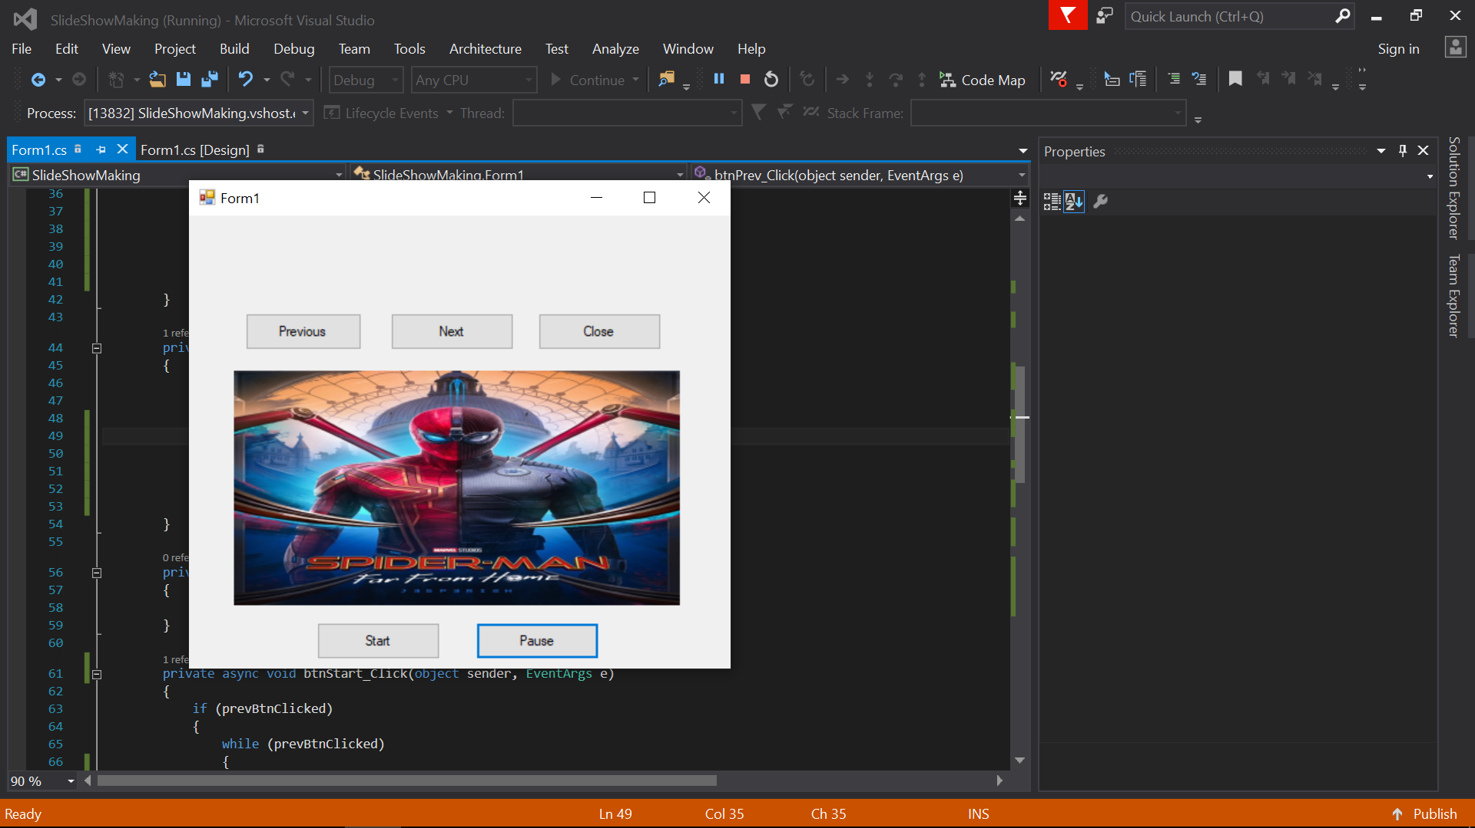

Activity 2:

V1:

using System;

using System.Windows.Forms;

namespace MyNameSpace

{

public class MyForm: Form

{

public MyForm()

{

this.Text="My Form";

}

public static void Main(string[] args)

{

Application.Run(new MyForm());

}

}

}

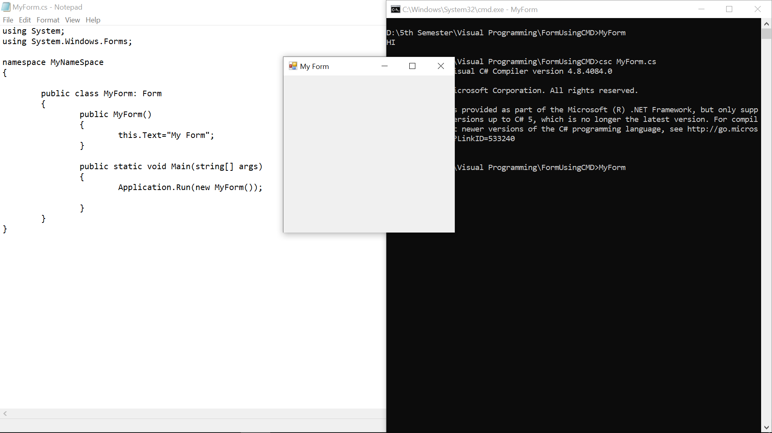

V2:

using System;

using System.Windows.Forms;

namespace MyNameSpace

{

public class MyForm: Form

{

private Button btnLoad;

private PictureBox pboxPhoto;

public MyForm()

{

this.Text="My Form";

btnLoad=new Button();

btnLoad.Text="&Load";

btnLoad.Width=this.Width/2;

btnLoad.Height=20;

btnLoad.Left=(this.Width-btnLoad.Width)/2;

btnLoad.Top=50;

btnLoad.UseMnemonic=true;

pboxPhoto=new PictureBox();

pboxPhoto.BorderStyle=BorderStyle.Fixed3D;

pboxPhoto.Width=this.Width/2;

pboxPhoto.Height=this.Height/2;

pboxPhoto.Left=(this.Width-pboxPhoto.Width)/2;

pboxPhoto.Top=(this.Height-pboxPhoto.Height)/2;

this.Controls.Add(btnLoad);

this.Controls.Add(pboxPhoto);

}

public static void Main(string[] args)

{

Application.Run(new MyForm());

}

}

}

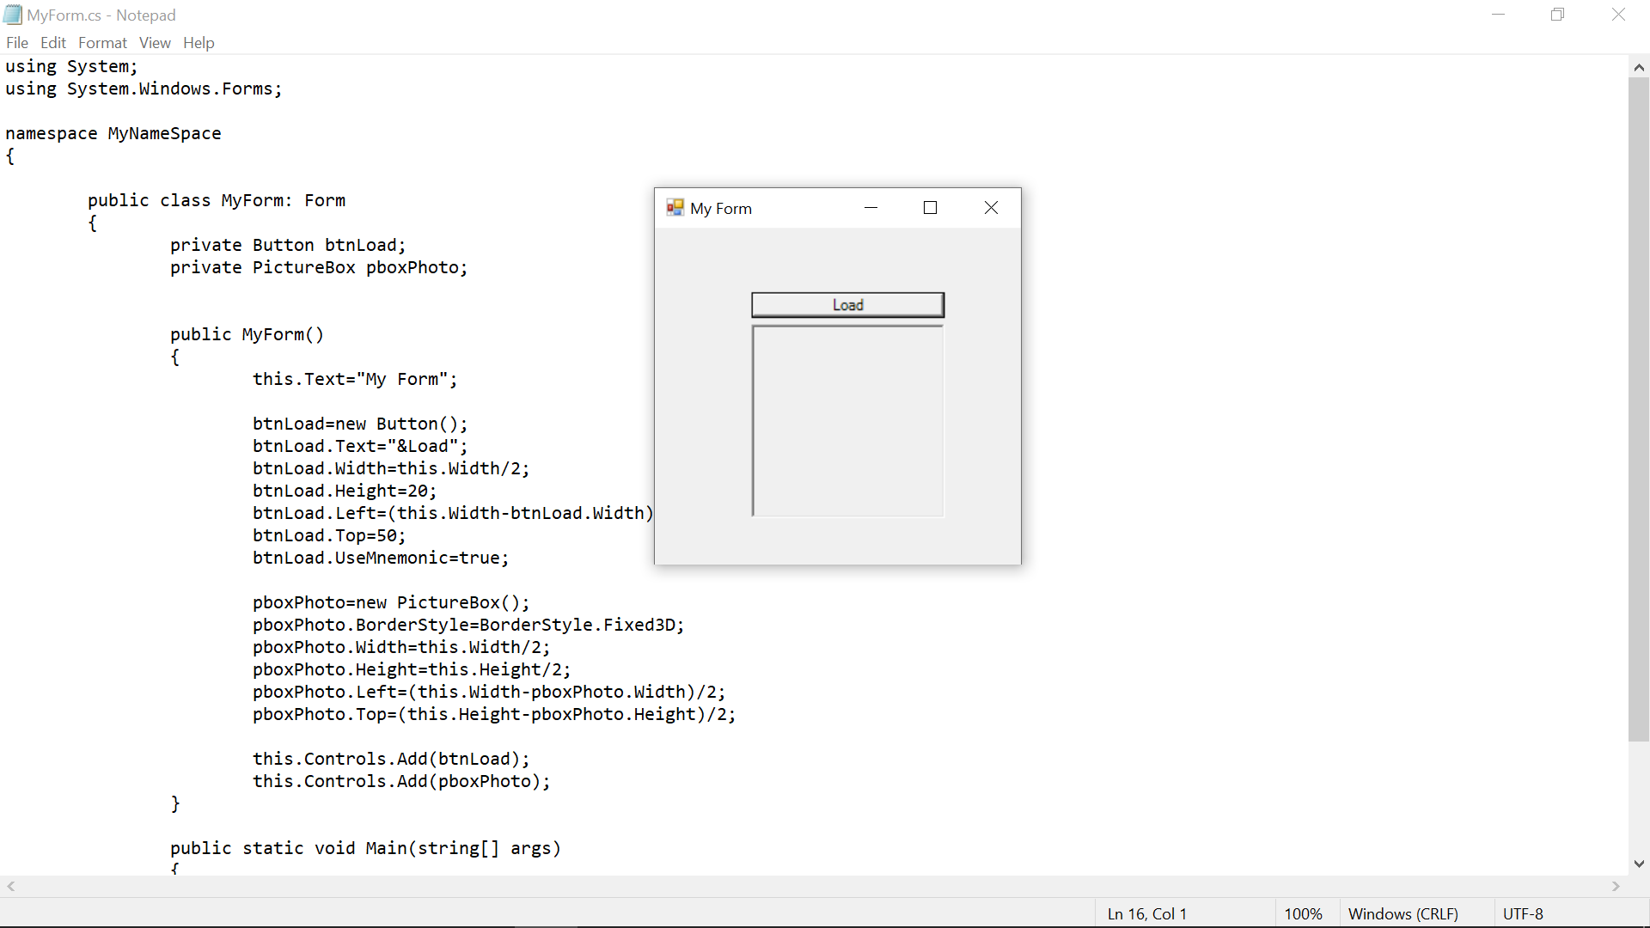

V3;

using System;

using System.Windows.Forms;

namespace MyNameSpace

{

public class MyForm: Form

{

private Button btnLoad;

private PictureBox pboxPhoto;

public MyForm()

{

this.Text="My Form";

btnLoad=new Button();

btnLoad.Text="&Load";

btnLoad.Width=this.Width/2;

btnLoad.Height=20;

btnLoad.Left=(this.Width-btnLoad.Width)/2;

btnLoad.Top=50;

btnLoad.UseMnemonic=true;

btnLoad.Click += new System.EventHandler(this.OnLoadClick);

pboxPhoto=new PictureBox();

pboxPhoto.BorderStyle=BorderStyle.Fixed3D;

pboxPhoto.Width=this.Width/2;

pboxPhoto.Height=this.Height/2;

pboxPhoto.Left=(this.Width-pboxPhoto.Width)/2;

pboxPhoto.Top=(this.Height-pboxPhoto.Height)/2;

this.Controls.Add(btnLoad);

this.Controls.Add(pboxPhoto);

}

private void OnLoadClick(object sender, System.EventArgs e)

{

this.pboxPhoto.ImageLocation=@"E:\\wallpaper\\2.jpg";

}

public static void Main(string[] args)

{

Application.Run(new MyForm());

}

}

}

Activity 3;

using System;

using System.Collections.Generic;

//using System.Collections.ArrayList;

using System.Collections;

using System.ComponentModel;

using System.Data;

using System.Drawing;

using System.Linq;

using System.Text;

using System.Threading.Tasks;

using System.Windows.Forms;

namespace frmSignUp

{

public partial class Form1 : Form

{

int fromLeft=153, fromTop=208,increment=30,val=2;

ArrayList textboxes=new ArrayList();

public Form1()

{

InitializeComponent();

}

private void btnClear_Click(object sender, EventArgs e)

{

this.textBoxUserName.Text = "";

this.txtBoxContact1.Text = "";

this.txtBoxPassword.Text = "";

foreach (TextBox i in textboxes)

this.Controls[i.Name].Text="";

this.lblShowInfo.Text = "";

}

private void createTextBox() {

TextBox obj1 = new TextBox();

textboxes.Add(obj1);

obj1.Name = $"txtContact{val}";

obj1.Width = 145;

obj1.Height = 37;

obj1.Left = fromLeft;

obj1.Top = fromTop;

this.Controls.Add(obj1);

}

private void createLabel() {

Label lbl = new Label();

lbl.Name = "newContact";

lbl.Text = $"Enter Contact No # {val++}";

lbl.Width = 150;

lbl.Height = 20;

lbl.Left = 28;

lbl.Top = fromTop;

this.Controls.Add(lbl);

}

private void btnAddNew_Click(object sender, EventArgs e)

{

createTextBox();

btnAddNew.Left = 320;

btnAddNew.Top = fromTop;

createLabel();

btnClear.Top = fromTop + 30;

btnSubmit.Top = fromTop + 30;

if (btnSubmit.Top > 310)

this.Height += 30;

fromTop += increment;

}

private void btnSubmit_Click(object sender, EventArgs e)

{

this.lblShowInfo.Visible = true;

string username, pswrd, contct;

username = $"User-Name: {this.textBoxUserName.Text}\n\n";

pswrd = $"Password: {this.txtBoxPassword.Text}\n\n";

contct= $"Contact No #: {this.txtBoxContact1.Text}\n\n";

string contacts="";

foreach(TextBox i in textboxes)

contacts += this.Controls[i.Name].Text+"\n";

this.lblShowInfo.Text = username+pswrd+contct+contacts;

}

}

}

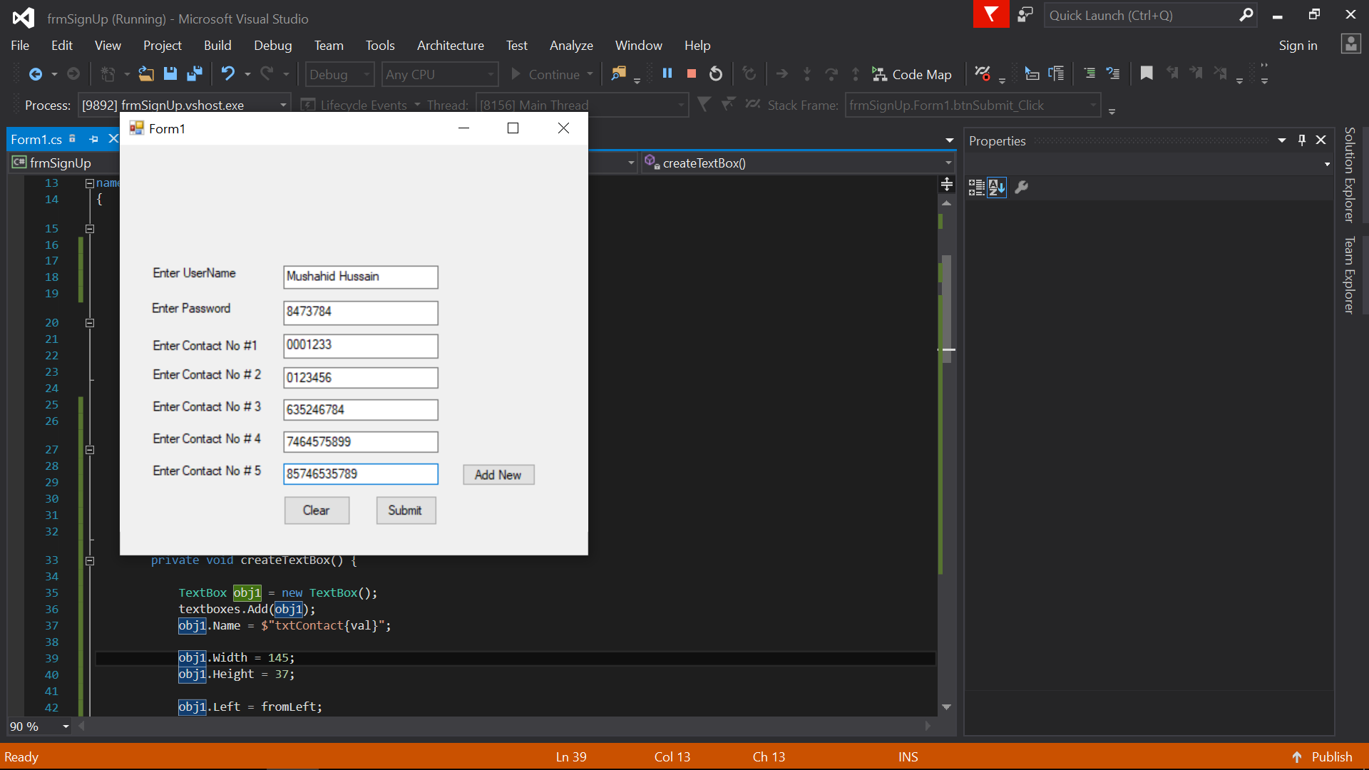

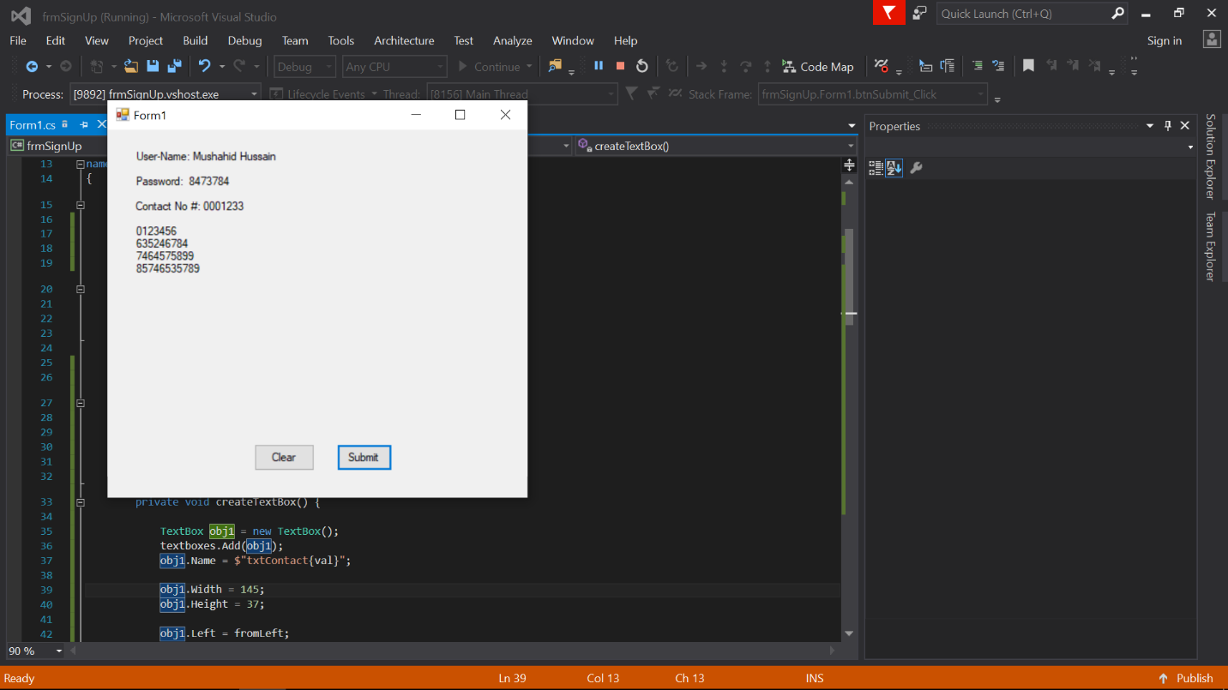

Activity 5;

using System;

using System.Collections.Generic;

using System.Linq;

using System.Text;

using System.Threading.Tasks;

namespace StudentManagement

{

public class StoreStudentInfo

{

private string fname, lname, city, phoneNo, address;

public StoreStudentInfo()

{

}

public StoreStudentInfo(string fname,string lname,string city, string phoneNo,string address)

{

this.fname = fname;

this.lname = lname;

this.city = city;

this.phoneNo = phoneNo;

this.address = address;

}

public string GetFname()

{

return fname;

}

public string GetLname()

{

return lname;

}

public string GetCity()

{

return city;

}

public string GetPhonno()

{

return phoneNo;

}

public string GetAddress()

{

return address;

}

}

}

using System;

using System.Collections;

using System.ComponentModel;

using System.Data;

using System.Drawing;

using System.Linq;

using System.Text;

using System.Threading.Tasks;

using System.Windows.Forms;

namespace StudentManagement

{

public partial class FetchShowInfoForm : Form

{

StoreStudentInfo[] Objects;

int k;

public FetchShowInfoForm()

{

InitializeComponent();

}

public void addDataToList(StoreStudentInfo[] Objectt,int j)

{

Objects = new StoreStudentInfo[10];

Objects = Objectt;

k = j;

for (int i=0; i<=j-1; i++)

{

listBox.Items.Add(Objects[i].GetFname());

}

}

private void listBox_SelectedIndexChanged(object sender, EventArgs e)

{

string str = listBox.SelectedItem.ToString();

for (int i = 0; i <= k - 1; i++)

{

if (str == Objects[i].GetFname())

{

this.txtName.Text = Objects[i].GetFname();

this.txtLastName.Text = Objects[i].GetLname();

this.txtAddress.Text = Objects[i].GetAddress();

this.txtCity.Text = Objects[i].GetCity();

this.txtMobileNo.Text = Objects[i].GetPhonno();

}

}

}

}

}

using System;

using System.Collections.Generic;

using System.ComponentModel;

using System.Data;

using System.Drawing;

using System.Linq;

using System.Text;

using System.Threading.Tasks;

using System.Windows.Forms;

using System.Collections;

namespace StudentManagement

{

public partial class frmStudentInfo : Form

{

StoreStudentInfo[] objects = new StoreStudentInfo[10];

int i = 0;

public frmStudentInfo()

{

InitializeComponent();

}

private void btnAdd_Click(object sender, EventArgs e)

{

StoreStudentInfo stdObj = new StoreStudentInfo(this.txtName.Text, this.txtLastName.Text, this.txtCity.Text, this.txtMobileNo.Text, this.txtAddress.Text);

objects[i++]=stdObj;

this.txtName.Text = "";

this.txtLastName.Text = "";

this.txtCity.Text = "";

this.txtAddress.Text = "";

this.txtMobileNo.Text = "";

}

private void btnClear_Click(object sender, EventArgs e)

{

this.txtName.Text = "";

this.txtLastName.Text = "";

this.txtCity.Text = "";

this.txtAddress.Text = "";

this.txtMobileNo.Text = "";

}

private void btnShow_Click(object sender, EventArgs e)

{

FetchShowInfoForm f= new FetchShowInfoForm();

f.addDataToList(objects, i);

this.Hide();

f.ShowDialog();

this.Dispose();

}

public void getStudentInfo(string studentName)

{

}

}

}

