using System;

using System.Collections.Generic;

using System.ComponentModel;

using System.Data;

using System.Drawing;

using System.Linq;

using System.Text;

using System.Threading.Tasks;

using System.Windows.Forms;

namespace StudentManagement2

{

public partial class formSplash : Form

{

public formSplash()

{

InitializeComponent();

}

private void Form1_Load(object sender, EventArgs e)

{

}

private void button1_Click(object sender, EventArgs e)

{

this.progressBar1.Minimum = 1;

this.progressBar1.Maximum = 100;

this.progressBar1.Value = 1;

for(int i=0; i<50; i++)

{

this.progressBar1.Value++;

}

}

}

}

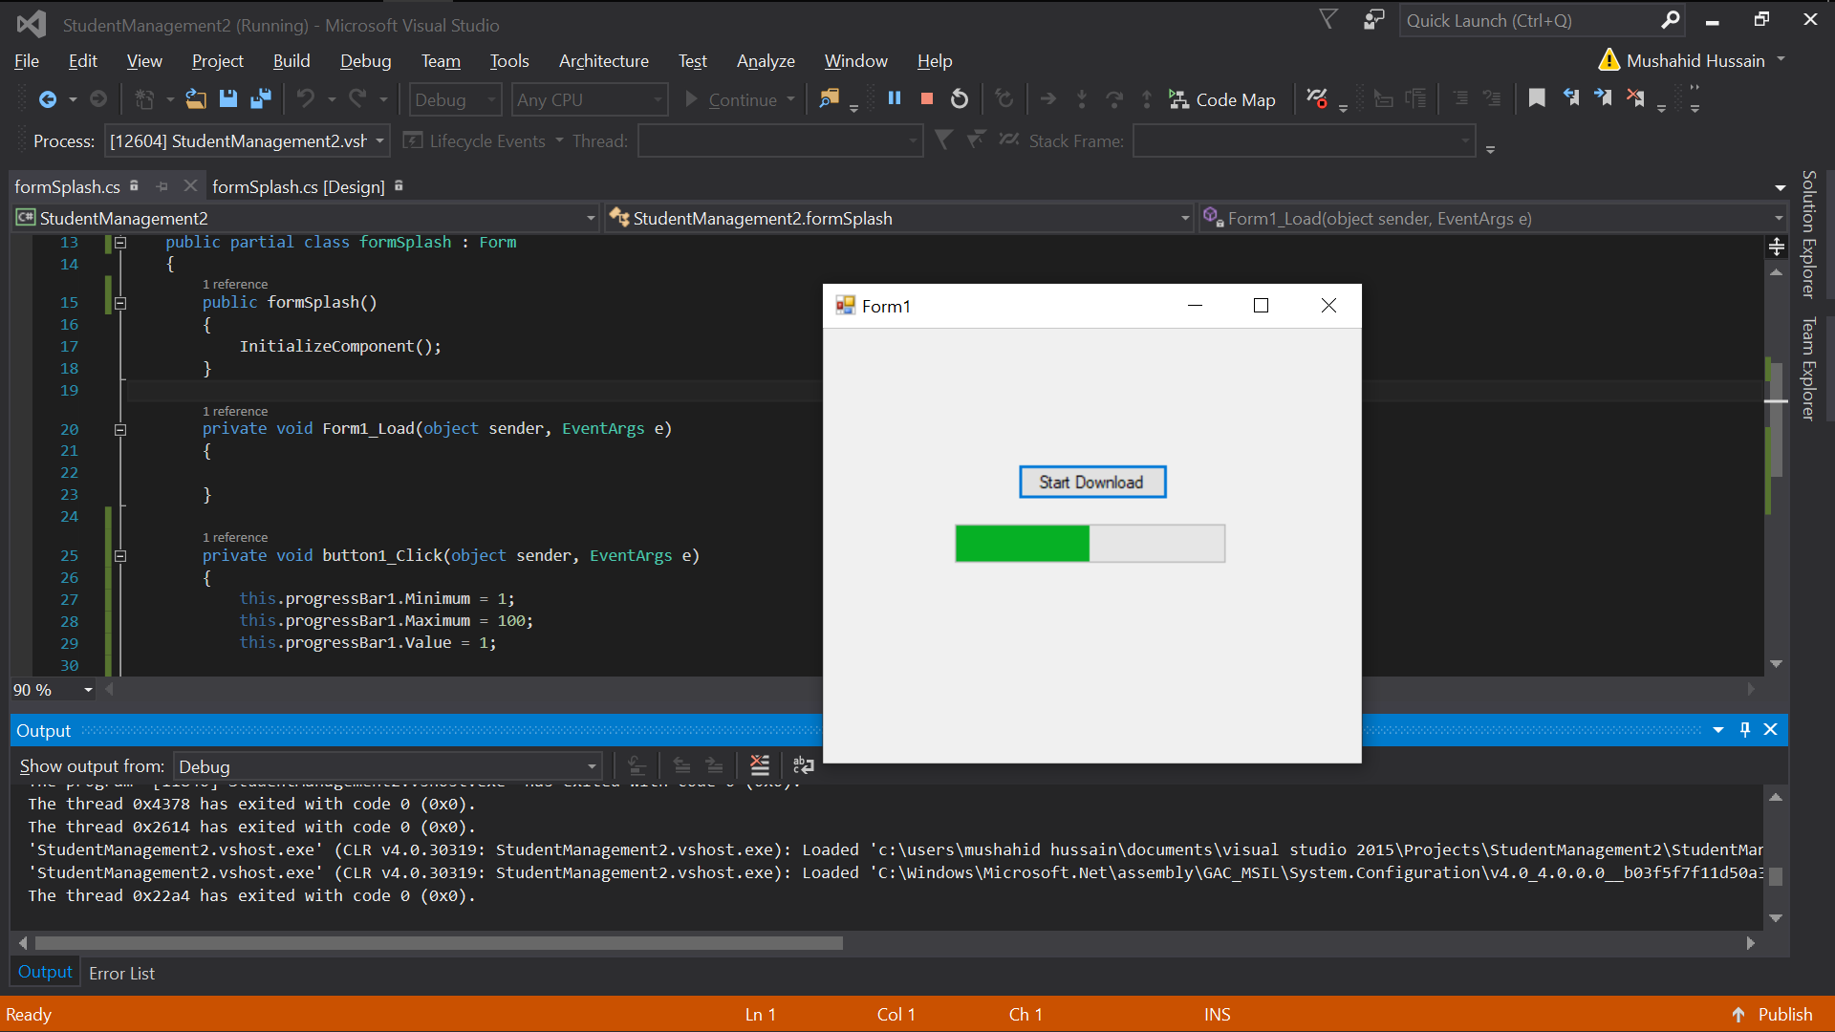

Acitivity2:

using System;

using System.Collections.Generic;

using System.ComponentModel;

using System.Data;

using System.Drawing;

using System.Linq;

using System.Text;

using System.Threading.Tasks;

using System.Windows.Forms;

namespace SplashScreen

{

public partial class frmSplashScreen : Form

{

public frmSplashScreen()

{

InitializeComponent();

}

private async void Form1_Load(object sender, EventArgs e)

{

this.label1.Text = "Wait a moment, Application is loading";

this.label1.Visible = true;

this.progressBar1.Minimum = 1;

this.progressBar1.Maximum = 100;

this.progressBar1.Value = 1;

for (int i=1; i<100; i++)

{

this.progressBar1.Value++;

}

await Task.Delay(1000);

this.Hide();

MessageBox.Show("Sorry, Error occured during loading");

this.Dispose();

}

}

}

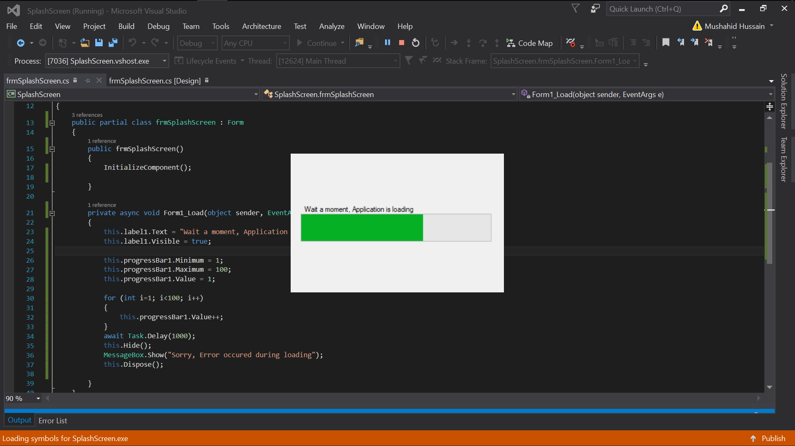

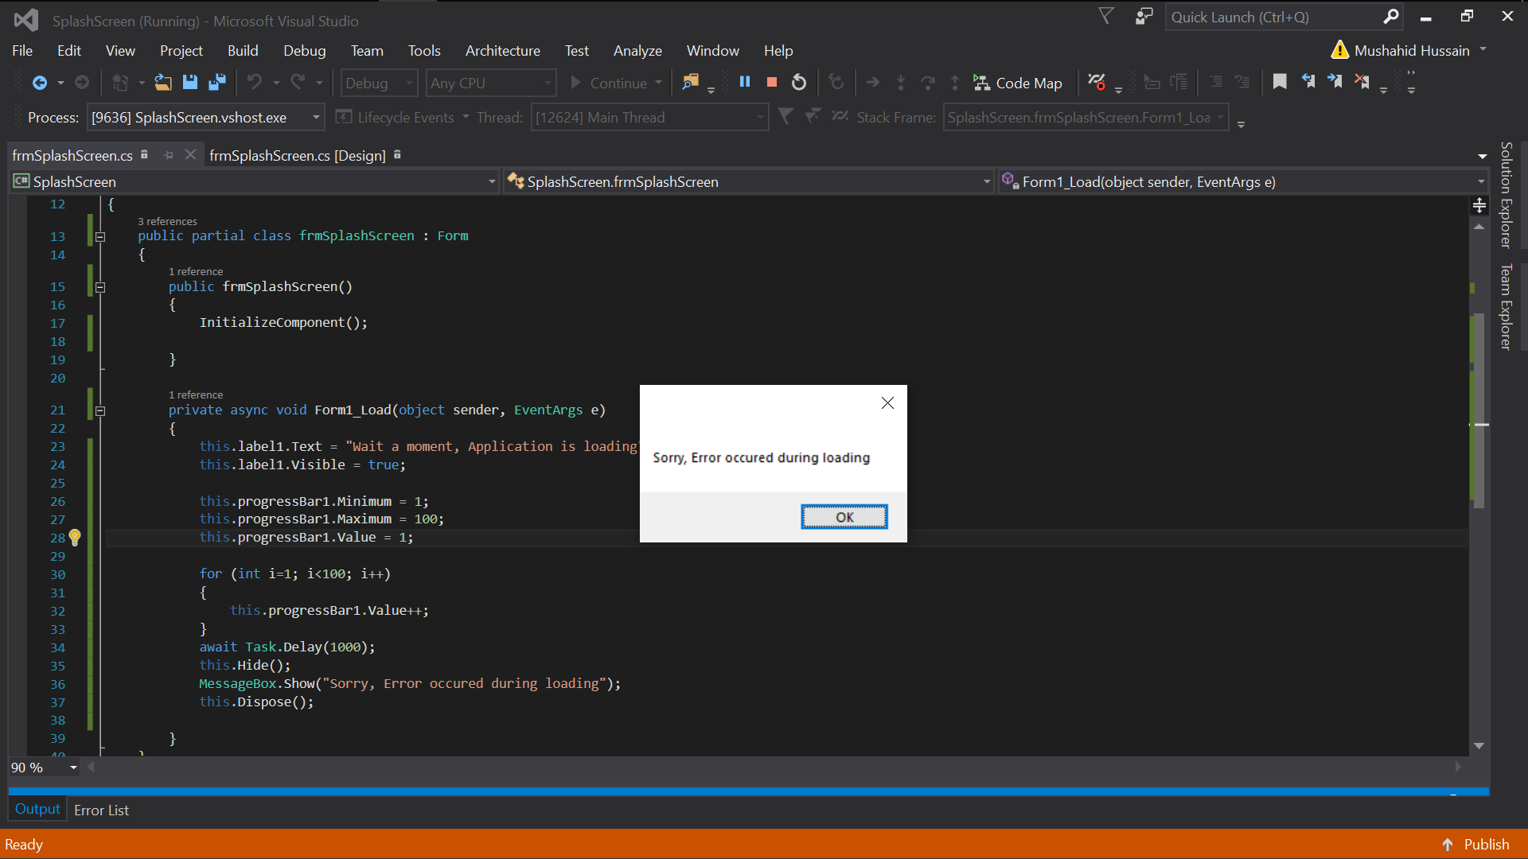

Activity 3:

using System;

using System.Collections.Generic;

using System.ComponentModel;

using System.Data;

using System.Drawing;

using System.Linq;

using System.Text;

using System.Threading.Tasks;

using System.Windows.Forms;

namespace SplashScreen

{

public partial class frmBuildPizza : Form

{

public frmBuildPizza()

{

InitializeComponent();

}

private void radioButton1_CheckedChanged(object sender, EventArgs e)

{

}

private void label1_Click(object sender, EventArgs e)

{

}

private void frmBuildPizza_Load(object sender, EventArgs e)

{

}

private void groupBox4_Enter(object sender, EventArgs e)

{

}

private void btnBuild_Click(object sender, EventArgs e)

{

string size=groupBox1.Controls.OfType<RadioButton>().FirstOrDefault(r => r.Checked).Text;

string topping = groupBox2.Controls.OfType<CheckBox>().FirstOrDefault(r => r.Checked).Text;

string crust= groupBox3.Controls.OfType<RadioButton>().FirstOrDefault(r => r.Checked).Text;

string place;

if (rbEatin.Checked)

place = rbEatin.Text;

else

place = rbEatout.Text;

MessageBox.Show($"Size: {size}\nToppings: {topping}\nCrust: {crust}\n{place}");

}

private void btnExit_Click(object sender, EventArgs e)

{

Application.Exit();

}

}

}

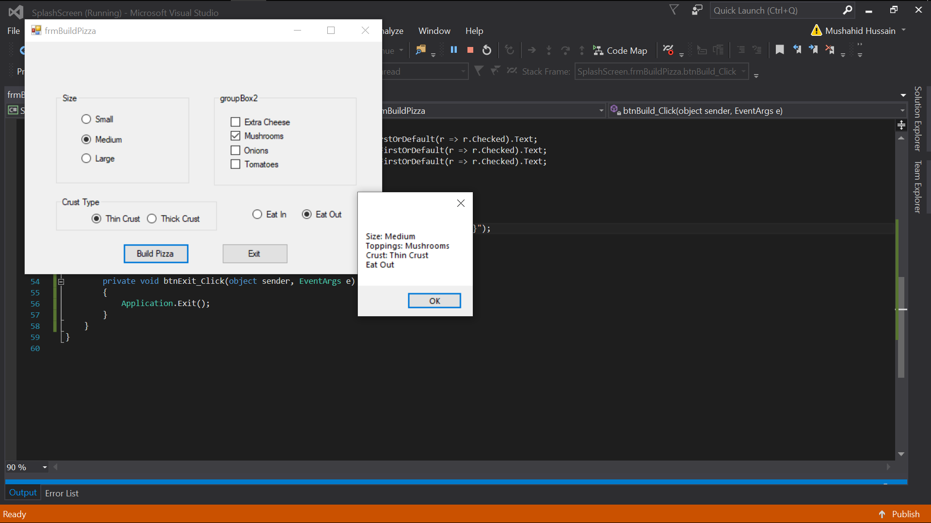

Activity 4:

using System;

using System.Collections.Generic;

using System.ComponentModel;

using System.Data;

using System.Drawing;

using System.Linq;

using System.Text;

using System.Threading.Tasks;

using System.Windows.Forms;

namespace SplashScreen

{

public partial class frmDynamicArray : Form

{

int i=0;

public frmDynamicArray()

{

InitializeComponent();

}

private void textBox1_Leave(object sender, EventArgs e)

{

if (textBox1.Text == "")

{

textBox1.Text = "Enter Student name";

}

}

private void textBox1_Enter(object sender, EventArgs e)

{

if (textBox1.Text!="")

{

textBox1.Text = "";

}

}

private void button1_Click(object sender, EventArgs e)

{

string name = textBox1.Text;

studentClass std = new studentClass(name,i++);

MessageBox.Show("Record Added");

label1.Text += "\n" + name;

}

}

class studentClass

{

public string[] stdentrecord = new string[50];

string firstname;

public studentClass(string firstname, int index)

{

this.firstname = firstname;

stdentrecord[index] = firstname;

}

}

}

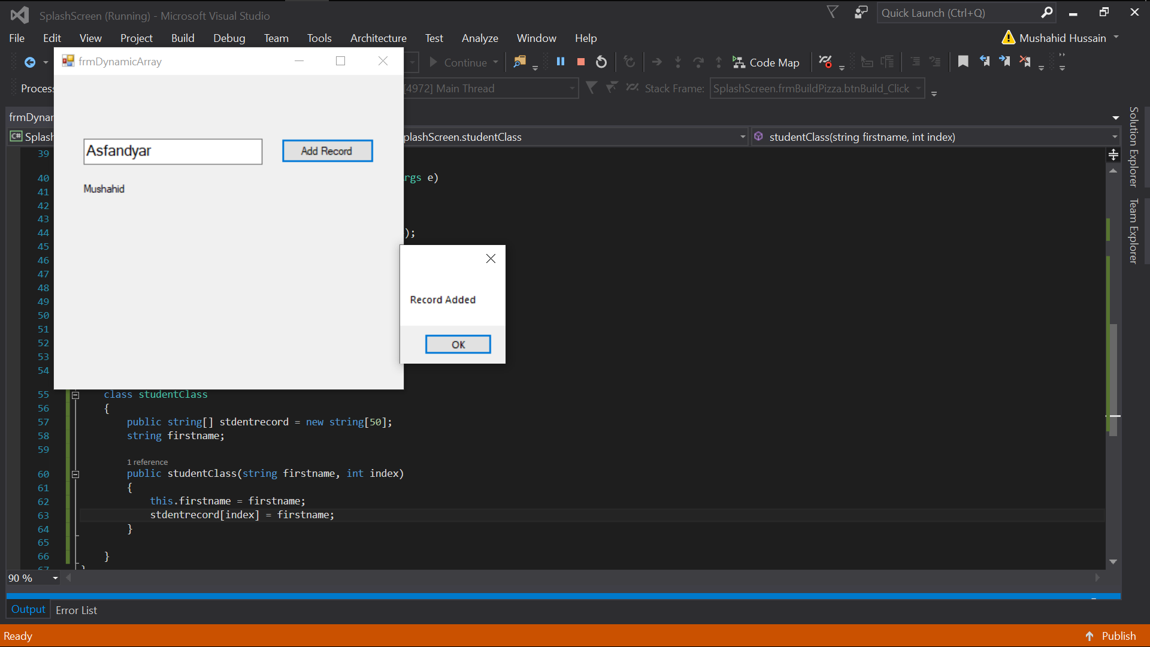

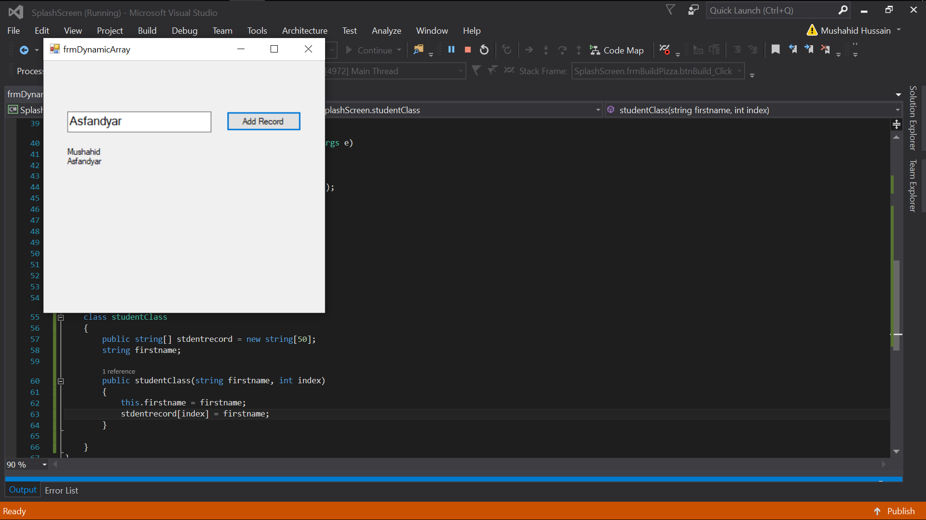

Activity 6: slideshowApp

using System;

using System.Collections.Generic;

using System.ComponentModel;

using System.Data;

using System.Drawing;

using System.Linq;

using System.Text;

using System.Threading.Tasks;

using System.Windows.Forms;

using System.IO;

namespace slideShowApp

{

public partial class frmSlideShow : Form

{

DriveInfo[] driveInfo;

DirectoryInfo[] dirs;

FileInfo[] files;

int picno = 0;

bool turn = false;

bool direction = true;

bool pause = false;

public frmSlideShow()

{

InitializeComponent();

}

private void Form1_Load(object sender, EventArgs e)

{

driveInfo = DriveInfo.GetDrives();

comboBox1.Text = "Select One";

foreach(DriveInfo d in driveInfo)

{

comboBox1.Items.Add(d);

}

}

private void comboBox1_SelectedIndexChanged(object sender, EventArgs e)

{

turn = true;

if (turn)

listBox1.Items.Clear();

String drive = comboBox1.SelectedItem.ToString();

DirectoryInfo directoryInfo = new DirectoryInfo(drive);

dirs = directoryInfo.GetDirectories();

foreach (DirectoryInfo d in dirs)

{

listBox1.Items.Add(d.Name);

}

}

private void listBox1_SelectedIndexChanged(object sender, EventArgs e)

{

String directory = listBox1.SelectedItem.ToString();

DirectoryInfo dd=null;

foreach (DirectoryInfo d in dirs)

if (directory == d.Name)

dd = d;

files = dd?.GetFiles("*.JPG");

if (files.Length > 0)

{

pictureBox1.ImageLocation = files[0].FullName;

}

else

{

MessageBox.Show("No pictures found");

}

}

private void button1_Click(object sender, EventArgs e)

{

direction = true;

if (picno >= files.Length-1)

{

picno = -1;

pictureBox1.ImageLocation = files[++picno].FullName;

}

else

pictureBox1.ImageLocation = files[++picno].FullName;

}

private void button2_Click(object sender, EventArgs e)

{

direction = false;

if (picno <= 0)

{

picno = files.Length;

pictureBox1.ImageLocation = files[--picno].FullName;

}

else

pictureBox1.ImageLocation = files[--picno].FullName;

}

private async void button3_Click(object sender, EventArgs e)

{

while (!pause)

{

foreach (FileInfo f in files)

{

if (pause)

{

goto comeout;

}

else

{

if (direction)

{

button1_Click(sender, e);

await Task.Delay(1000);

}

else

{

button2_Click(sender, e);

await Task.Delay(1000);

}

}

}

}

comeout: { pause = false; }

}

private void button4_Click(object sender, EventArgs e)

{

pause = true;

}

private void button5_Click(object sender, EventArgs e)

{

pictureBox1.ImageLocation = files[0].FullName;

}

private void button6_Click(object sender, EventArgs e)

{

pictureBox1.ImageLocation = files[files.Length-1].FullName;

}

}

}

