Activity 1:

using System;

using System.Collections.Generic;

using System.ComponentModel;

using System.Data;

using System.Drawing;

using System.Linq;

using System.Text;

using System.Threading.Tasks;

using System.Windows.Forms;

namespace EditorApp

{

public partial class frmEditor : Form

{

public frmEditor()

{

InitializeComponent();

}

private void undoToolStripMenuItem_Click(object sender, EventArgs e)

{

richTextBox1.Undo();

}

private void redoToolStripMenuItem_Click(object sender, EventArgs e)

{

richTextBox1.Redo();

}

private void cutToolStripMenuItem_Click(object sender, EventArgs e)

{

richTextBox1.Cut();

}

private void copyToolStripMenuItem_Click(object sender, EventArgs e)

{

richTextBox1.Copy();

}

private void pasteToolStripMenuItem_Click(object sender, EventArgs e)

{

richTextBox1.Paste();

}

private void selectAllToolStripMenuItem_Click(object sender, EventArgs e)

{

richTextBox1.SelectAll();

}

private void fontToolStripMenuItem_Click(object sender, EventArgs e)

{

FontDialog fd = new FontDialog();

if (fd.ShowDialog() == DialogResult.OK)

{

richTextBox1.SelectionFont = fd.Font;

}

}

private void colorToolStripMenuItem_Click(object sender, EventArgs e)

{

ColorDialog cd = new ColorDialog();

if (cd.ShowDialog() == DialogResult.OK)

{

richTextBox1.SelectionColor = cd.Color;

}

}

private void openToolStripMenuItem_Click(object sender, EventArgs e)

{

OpenFileDialog ofd = new OpenFileDialog();

if (ofd.ShowDialog() == DialogResult.OK)

{

richTextBox1.LoadFile(ofd.FileName);

}

}

private void saveToolStripMenuItem_Click(object sender, EventArgs e)

{

SaveFileDialog sfd = new SaveFileDialog();

if (sfd.ShowDialog() == DialogResult.OK)

{

richTextBox1.SaveFile(sfd.FileName);

}

}

private void frmEditor_Load(object sender, EventArgs e)

{

newToolStripMenuItem.ShortcutKeys = Keys.Control | Keys.N;

openToolStripMenuItem.ShortcutKeys = Keys.Control | Keys.O;

saveToolStripMenuItem.ShortcutKeys = Keys.Control | Keys.S;

undoToolStripMenuItem.ShortcutKeys = Keys.Control | Keys.Z;

redoToolStripMenuItem.ShortcutKeys = Keys.Control | Keys.Y;

cutToolStripMenuItem.ShortcutKeys = Keys.Control | Keys.X;

copyToolStripMenuItem.ShortcutKeys = Keys.Control | Keys.C;

pasteToolStripMenuItem.ShortcutKeys = Keys.Control | Keys.P;

selectAllToolStripMenuItem.ShortcutKeys = Keys.Control | Keys.A;

fontToolStripMenuItem.ShortcutKeys = Keys.Control | Keys.P;

colorToolStripMenuItem.ShortcutKeys = Keys.Control | Keys.A;

}

private void newToolStripMenuItem_Click(object sender, EventArgs e)

{

richTextBox1.Text = "";

}

}

}

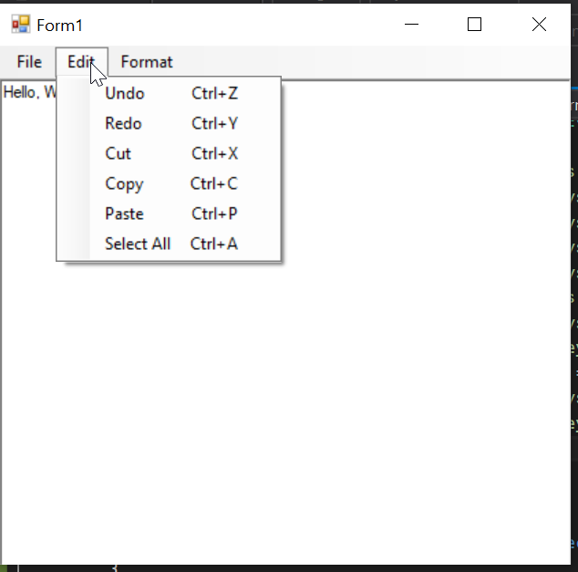

Activity 2:

using System;

using System.Collections.Generic;

using System.ComponentModel;

using System.Data;

using System.Data.SqlClient;

using System.Drawing;

using System.Linq;

using System.Text;

using System.Threading.Tasks;

using System.Windows.Forms;

namespace DatabaseApplication

{

public partial class frmConnectedAccess : Form

{

public frmConnectedAccess()

{

InitializeComponent();

}

private void button1_Click(object sender, EventArgs e)

{

string connectionString = @"Data Source=(localdb)\MSSQLLocalDB;Initial Catalog=ProjectDatabase;Integrated Security=True;";

try

{

SqlConnection sqlconncection = new SqlConnection();

sqlconncection.ConnectionString = connectionString;

SqlCommand sqlcmnd = new SqlCommand();

sqlcmnd.Connection = sqlconncection;

sqlcmnd.CommandText = @"SELECT * FROM [dbo].[Table]";

sqlconncection.Open();

lblinfo.Text = "";

SqlDataReader reader = sqlcmnd.ExecuteReader();

while (reader.Read())

{

lblinfo.Text += $"{reader.GetValue(0)}: {reader.GetValue(1)}: {reader.GetValue(2)}\n";

}

sqlconncection.Close();

}

catch (Exception)

{

Console.Write("Exception has occured");

}

}

}

}

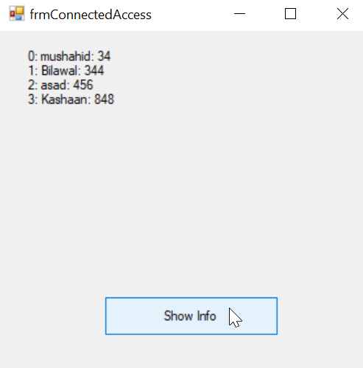

Acitivity 3:

using System;

using System.Collections.Generic;

using System.Linq;

using System.Text;

using System.Threading.Tasks;

namespace DatabaseApplication

{

class Person

{

String firstname, lastname, city;

public string FirstName

{

set;

get;

}

public string LastName

{

set;

get;

}

public string City

{

set;

get;

}

}

}

using System;

using System.Collections.Generic;

using System.ComponentModel;

using System.Data;

using System.Drawing;

using System.Linq;

using System.Text;

using System.Threading.Tasks;

using System.Windows.Forms;

namespace DatabaseApplication

{

public partial class frmGridView : Form

{

Person[] persons;

public frmGridView()

{

InitializeComponent();

}

private void button1_Click(object sender, EventArgs e)

{

dataGridView1.DataSource = persons;

}

private void frmGridView_Load(object sender, EventArgs e)

{

persons = new Person[5];

int i = 0;

Person person = new Person();

person.FirstName = "Mushahid";

person.LastName = "Hussain";

person.City = "Parachinar";

persons[i++] = person;

Person person2 = new Person();

person2.FirstName = "Bilawal";

person2.LastName = "Hussain";

person2.City = "Kohat";

persons[i++] = person2;

Person person3 = new Person();

person3.FirstName = "Yahya";

person3.LastName = "Malik";

person3.City = "Gilgit";

persons[i++] = person3;

Person person4 = new Person();

person4.FirstName = "Asfand";

person4.LastName = "khan";

person4.City = "Peshawar";

persons[i++] = person4;

Person person5 = new Person();

person5.FirstName = "Kashaan";

person5.LastName = "Hashim";

person5.City = "Punjab";

persons[i++] = person5;

}

}

}

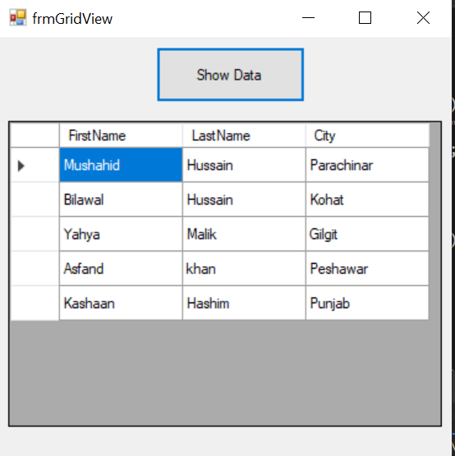

Activity 4

using System;

using System.Collections.Generic;

using System.ComponentModel;

using System.Data;

using System.Drawing;

using System.Linq;

using System.Text;

using System.Threading.Tasks;

using System.Windows.Forms;

namespace DatabaseApplication

{

public partial class frmBookStore : Form

{

public frmBookStore()

{

InitializeComponent();

}

private void frmBookStore_Load(object sender, EventArgs e)

{

}

private void comboBox1_SelectedIndexChanged(object sender, EventArgs e)

{

listBox1.Items.Clear();

BookDB bdb = new BookDB();

bdb.AddBooks(bdb);

if (comboBox1.SelectedItem == "Title")

{

foreach(Book b in bdb.list)

listBox1.Items.Add(b.getTitle());

}

else if (comboBox1.SelectedItem == "Author")

{

foreach (Book b in bdb.list)

{

listBox1.Items.Add(b.getAuthor());

}

}

else

{

}

}

}

}

using System;

using System.Collections;

using System.Collections.Generic;

using System.Linq;

using System.Text;

using System.Threading.Tasks;

namespace DatabaseApplication

{

public delegate string ProcessBookDelegate(Book b);

public struct Book

{

public string Title;

public string Author;

public decimal Price;

public bool Peperback;

public Book(string title, string author, decimal price, bool paperBack)

{

Title = title;

Author = author;

Price = price;

Peperback = paperBack;

}

public string getTitle()

{

return Title;

}

public string getAuthor()

{

return Author;

}

}

class BookDB

{

public ArrayList list = new ArrayList();

{

list.Add(new Book(title, author, price, paperBack));

}

public void ProcessPaperBackBooks(ProcessBookDelegate processBook)

{

foreach(Book b in list)

{

processBook(b);

}

}

public void AddBooks(BookDB bookdb)

{

bookdb.AddBook("The C porgramming Language", "Brain W.Kernighan and Dennis M. Ritchie", 19.95m, true);

bookdb.AddBook("The Unicode Standard 2.0", "The Unicode Consortium", 39.95m, true);

bookdb.AddBook("The MS-Dos Encyclopedia", "Ray Duncan", 129.95m, false);

bookdb.AddBook("Dogbert's Clues for the Clueless", "Scott adams", 12.00m, true);

}

}

}

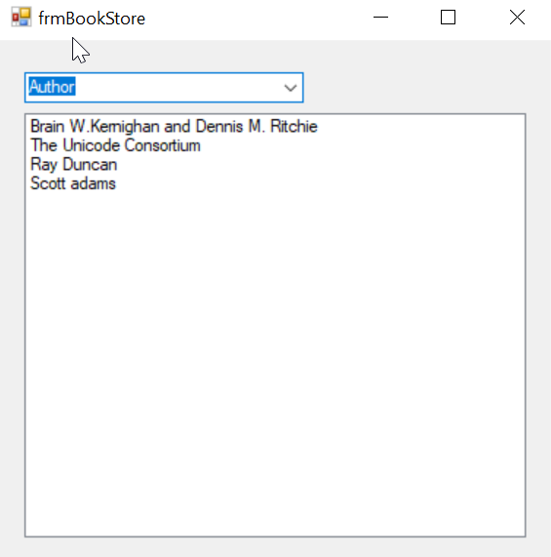

Activity 5

using System;

using System.Collections.Generic;

using System.ComponentModel;

using System.Data;

using System.Data.SqlClient;

using System.Drawing;

using System.Linq;

using System.Text;

using System.Threading.Tasks;

using System.Windows.Forms;

namespace studentManagementDB

{

public partial class Form1 : Form

{

int i = -1;

SqlConnection connection;

SqlCommand command;

string connectionString = @"Data Source=(localdb)\MSSQLLocalDB;Initial Catalog=ProjectDatabase;Integrated Security=True;";

public Form1()

{

InitializeComponent();

connection = new SqlConnection();

connection.ConnectionString = connectionString;

command = new SqlCommand();

command.Connection = connection;

}

private void Form1_Load(object sender, EventArgs e)

{

String query = "SELECT * FROM [dbo].[studentRecords]";

try

{

connection.Open();

command.CommandText = query;

SqlDataReader reader = command.ExecuteReader();

while (reader.Read())

{

listBox1.Items.Add(reader.GetValue(1));

}

connection.Close();

}

catch (Exception)

{

}

}

private void button1_Click(object sender, EventArgs e)

{

++i;

try

{

string commandtext = $@"INSERT INTO [dbo].[studentRecords]

VALUES ('{i}','{textBox1.Text}','{textBox2.Text}','{textBox3.Text}','{textBox4.Text}','{textBox5.Text}','{textBox6.Text}');";

connection.Open();

command.CommandText = commandtext;

command.ExecuteNonQuery();

listBox1.Items.Add(textBox1.Text);

MessageBox.Show("Record Added successfully");

connection.Close();

}

catch(Exception)

{

Console.Write("\n\nerror occured\n\n");

}

}

private void button2_Click(object sender, EventArgs e)

{

try

{

string commandtext = $@"DELETE FROM [dbo].[studentRecords] WHERE firstName= '{textBox1.Text}';";

connection.Open();

command.CommandText = commandtext;

command.ExecuteNonQuery();

listBox1.Items.Remove(textBox1.Text);

MessageBox.Show("Record deleted successfully");

connection.Close();

}

catch (Exception)

{

Console.Write("\n\nerror occured\n\n");

}

}

private void button4_Click(object sender, EventArgs e)

{

emptyTextboxes();

}

private void button3_Click(object sender, EventArgs e)

{

string commandtext = $@"UPDATE [dbo].[studentRecords]

SET firstName = '{textBox1.Text}', lastName = '{textBox2.Text}', city='{textBox3.Text}', state='{textBox4.Text}', country='{textBox5.Text}', Nationality='{textBox6.Text}'

WHERE firstName='{textBox1.Text}';";

connection.Open();

command.CommandText = commandtext;

command.ExecuteNonQuery();

MessageBox.Show("Updated successfully");

emptyTextboxes();

connection.Close();

}

private void emptyTextboxes()

{

this.textBox1.Text = "firstname";

this.textBox2.Text = "lastname";

this.textBox3.Text = "city";

this.textBox4.Text = "state";

this.textBox5.Text = "country";

this.textBox6.Text = "nationality";

}

private void listBox1_SelectedIndexChanged(object sender, EventArgs e)

{

string data=listBox1.SelectedItem.ToString();

String query = $"SELECT * FROM [dbo].[studentRecords] WHERE firstname='{data}'";

try

{

connection.Open();

command.CommandText = query;

SqlDataReader reader = command.ExecuteReader();

while (reader.Read())

{

this.textBox1.Text = reader.GetValue(1).ToString();

this.textBox2.Text = reader.GetValue(2).ToString();

this.textBox3.Text = reader.GetValue(3).ToString();

this.textBox4.Text = reader.GetValue(4).ToString();

this.textBox5.Text = reader.GetValue(5).ToString();

this.textBox6.Text = reader.GetValue(6).ToString();

}

connection.Close();

}

catch (Exception)

{

}

}

}

}

