Appendices to the Technical Report
Distributed Multi-Model Analytics for E-commerce Data · Godfrey Mushambo (101376) · A: reproduce · B: key scripts · C: evidence screenshots S1-S14

Appendix A - How to reproduce
Everything runs in Docker. From Windows PowerShell, in the project folder:
docker compose up -d --build # mongo :27017, hbase :9090 / UI :16010, app (Spark UI :4040)
docker compose exec -T app python wait_for_services.py
.\run_all.ps1 # whole pipeline (or .\run_all.ps1 -Scale 1.0)
.\evidence.ps1 # re-creates the evidence screenshots step by step
Step | Command (prefix each with docker compose exec -T app ) | Output
1 Generate data | python data_generation/dataset_generator.py --out data/raw --scale 0.1 | data/raw/*.json
2 MongoDB | python mongodb/load_mongodb.py --sessions-limit 50000; python mongodb/aggregations.py | 5 collections, indexes, output/mongo_*.csv
3 HBase | python hbase/load_hbase.py --recreate; python hbase/query_hbase.py | 2 tables; queries Q1-Q5
4 Spark clean | python spark/01_clean_normalize.py | data/clean/*.parquet, data_quality_report.csv
5 Spark analytics | python spark/02_recommendations.py; 03_cohort_analysis.py; 04_spark_sql_analytics.py | output/reco_, cohort_, sql_*.csv
6 Integration | python integration/clv_analysis.py --mongo mongo --hbase hbase; python integration/funnel_analysis.py --mongo mongo --hbase hbase | output/clv_.csv, funnel_.csv
7 Charts | python visualization/make_charts.py | report/figures/*.png
Shells | Get-Content mongodb\evidence.js | docker exec -i mongo mongosh ecommerce --quiet; Get-Content hbase\evidence.hbase | docker exec -i hbase hbase shell -n | S7, S8

Repository path | Purpose
data_generation/dataset_generator.py | Improved generator (original kept as dataset_generator_original.py)
mongodb/load_mongodb.py, aggregations.py, aggregations.js, evidence.js | Document model, bulk load, indexes, 4 pipelines
hbase/create_tables.hbase, load_hbase.py, query_hbase.py, sample_queries.hbase, hbase_client.py | Schema, loader, queries, Thrift client + local emulator
spark/spark_utils.py, 01-04 *.py | Explicit schemas, cleaning, recommendations, cohorts, Spark SQL
integration/sources.py, clv_analysis.py, funnel_analysis.py | Source-independent loaders (range scans) and the two integrated queries
visualization/make_charts.py, report/make_architecture_diagram.py | Charts and architecture diagram
Dockerfile, docker-compose.yml, run_all.ps1, run_all.sh, evidence.ps1, wait_for_services.py, README.md | Docker environment, orchestration, documentation

Appendix B - Key scripts

B.1 HBase schema creation (hbase/create_tables.hbase)
# create_tables.hbase - HBase schema (run with: hbase shell hbase/create_tables.hbase
# or docker exec -i hbase hbase shell < hbase/create_tables.hbase)
#
# ---------------------------------------------------------------------------
# TABLE 1: user_sessions - time-series browsing activity per user
# ---------------------------------------------------------------------------
# Row key : <user_id>|<reverse_ts>|<session_id>
# reverse_ts = 9999999999999 - start_time_epoch_millis (13 digits, zero padded)
# -> all sessions of a user are contiguous (one prefix scan)
# -> newest session sorts FIRST (no client-side sort for "recent activity")
# -> session_id suffix keeps keys unique if two sessions start in the same ms
#
# Column families (kept few and small, each stored in its own HFiles):
# info : session header - one cell per attribute (start, end, duration, device, geo, referrer,
# conversion_status, n_pages ...). Read by "list sessions" queries -> smallest I/O.
# pv : page views, one column per view: qualifier = 3-digit sequence ("000","001",...),
# value = "page_type|product_id|category_id|view_duration|timestamp".
# Sparse & variable width: a 3-page session stores 3 cells, a 15-page session 15.
# cart : one column per product in the cart: qualifier = product_id, value = "qty|unit_price".
# Most sessions have 0-2 cells here -> sparse storage costs nothing for empty cells.
#
# VERSIONS => 1 : events are immutable, no need for history
# COMPRESSION : SNAPPY (falls back to NONE if native libs are missing; change if needed)
# BLOOMFILTER ROW: speeds up point gets of a single session row
# TTL on pv : 180 days of raw click-stream (older detail can be archived to HDFS/parquet)
# SPLITS : pre-split on user-id ranges so the bulk load is spread over regions
create 'user_sessions',
{NAME => 'info', VERSIONS => 1, COMPRESSION => 'NONE', BLOOMFILTER => 'ROW'},
{NAME => 'pv', VERSIONS => 1, COMPRESSION => 'NONE', TTL => 15552000},
{NAME => 'cart', VERSIONS => 1, COMPRESSION => 'NONE'},
SPLITS => ['user_002', 'user_004', 'user_006', 'user_008']

# ---------------------------------------------------------------------------
# TABLE 2: product_metrics - daily performance per product
# ---------------------------------------------------------------------------
# Row key : <product_id>|<yyyymmdd>
# -> a product's whole history is one contiguous range;
# a date range is a bounded scan: STARTROW prod_x|20260901, STOPROW prod_x|20261001
# Column family m (metrics): views, cart_adds, purchases, units_sold, revenue_cents
# Batch loads write pre-aggregated values; a streaming job would use atomic counters:
# incr 'product_metrics', 'prod_00123|20261015', 'm:views', 1
create 'product_metrics',
{NAME => 'm', VERSIONS => 1, COMPRESSION => 'NONE', BLOOMFILTER => 'ROW'},
SPLITS => ['prod_01', 'prod_02', 'prod_03', 'prod_04']

list
describe 'user_sessions'
describe 'product_metrics'

B.2 HBase sample queries (hbase/sample_queries.hbase)
# sample_queries.hbase - HBase shell equivalents of query_hbase.py
# hbase shell hbase/sample_queries.hbase
# Row keys: user_sessions = user_id|reverse_ts|session_id (reverse_ts = 9999999999999 - epoch_ms)
# product_metrics = product_id|yyyymmdd

# Q1 - the 5 most recent sessions of a user (newest first thanks to the reversed timestamp),
# reading only the small 'info' family
scan 'user_sessions', {ROWPREFIXFILTER => 'user_000042|', COLUMNS => ['info'], LIMIT => 5}

# Q2 - a user's sessions that started in September 2026.
# newer bound -> STARTROW, older bound -> STOPROW (because the timestamp is reversed)
# reverse(2026-10-01T00:00:00Z - 1 ms) = 8209187200000 ; reverse(2026-09-01T00:00:00Z) = 8211779199999
scan 'user_sessions', {STARTROW => 'user_000042|8209187200000', STOPROW => 'user_000042|8211779199999~',
COLUMNS => ['info:start_time', 'info:conversion_status']}

# Q3 - complete click-stream (page views + cart) of a single session (point get by full row key;
# take a key returned by Q1)
get 'user_sessions', 'user_000042|8206766047273|sess_2817bd6893', {COLUMN => ['pv', 'cart']}

# Q3b - only the converted sessions of a user (server-side filter on a column value)
scan 'user_sessions', {ROWPREFIXFILTER => 'user_000042|',
FILTER => "SingleColumnValueFilter('info','conversion_status',=,'binary:converted',true,true)"}

# Q4 - number of sessions of a user (counts rows under the prefix)
count 'user_sessions', {ROWPREFIXFILTER => 'user_000042|', INTERVAL => 1000}

# Q5 - a product's daily performance during September 2026 (contiguous range scan)
scan 'product_metrics', {STARTROW => 'prod_00123|20260901', STOPROW => 'prod_00123|20261001'}

# Q5b - one metric for one day
get 'product_metrics', 'prod_00123|20260915', 'm:views'

# Streaming-style update: atomic counter increments (what a real-time click consumer would do)
incr 'product_metrics', 'prod_00123|20261101', 'm:views', 1
get_counter 'product_metrics', 'prod_00123|20261101', 'm:views'

B.3 MongoDB aggregation pipelines (mongodb/aggregations.js)
// aggregations.js - the same analytics pipelines as aggregations.py, for mongosh.
// Run: mongosh "mongodb://localhost:27017/ecommerce" mongodb/aggregations.js
// (or docker exec -i mongo mongosh ecommerce < mongodb/aggregations.js)

// ---------------------------------------------------------------- 1. Product popularity
print("\n=== 1. Top-selling products ===");
printjson(db.transactions.aggregate([
{ $match: { status: { $in: ["completed", "shipped", "delivered", "processing"] } } },
{ $unwind: "$items" },
{ $group: { _id: "$items.product_id", product_name: { $first: "$items.product_name" },
category_id: { $first: "$items.category_id" },
units_sold: { $sum: "$items.quantity" }, revenue: { $sum: "$items.subtotal" },
orders: { $sum: 1 } } },
{ $sort: { units_sold: -1, revenue: -1 } },
{ $limit: 10 },
{ $lookup: { from: "products", localField: "_id", foreignField: "_id", as: "product" } },
{ $unwind: "$product" },
{ $project: { _id: 0, product_id: "$_id", product_name: 1, category_id: 1, units_sold: 1, orders: 1,
revenue: { $round: ["$revenue", 2] }, current_stock: "$product.current_stock" } }
]).toArray());

// ---------------------------------------------------------------- 2. Revenue by category & month
print("\n=== 2. Revenue & estimated profit by category and month ===");
printjson(db.transactions.aggregate([
{ $unwind: "$items" },
{ $lookup: { from: "categories", localField: "items.category_id", foreignField: "_id", as: "cat" } },
{ $unwind: "$cat" },
{ $addFields: { sub: { $arrayElemAt: [ { $filter: { input: "$cat.subcategories", as: "s",
cond: { $eq: ["$$s.subcategory_id", "$items.subcategory_id"] } } }, 0 ] } } },
{ $group: { _id: { category: "$cat.name", month: { $dateToString: { format: "%Y-%m", date: "$timestamp" } } },
revenue: { $sum: "$items.subtotal" },
est_profit: { $sum: { $multiply: ["$items.subtotal", "$sub.profit_margin"] } },
units: { $sum: "$items.quantity" } } },
{ $sort: { "_id.month": 1, revenue: -1 } },
{ $limit: 30 }
], { allowDiskUse: true }).toArray());

// Same idea restricted to a time window (uses the {timestamp:1} index)
print("\n=== 2b. Revenue in October 2026 ===");
printjson(db.transactions.aggregate([
{ $match: { timestamp: { $gte: ISODate("2026-10-01"), $lt: ISODate("2026-11-01") } } },
{ $group: { _id: null, revenue: { $sum: "$total" }, orders: { $sum: 1 }, aov: { $avg: "$total" } } }
]).toArray());

// ---------------------------------------------------------------- 3. User segmentation
print("\n=== 3. User segmentation by purchase frequency and spend ===");
printjson(db.transactions.aggregate([
{ $group: { _id: "$user_id", orders: { $sum: 1 }, spent: { $sum: "$total" }, last_order: { $max: "$timestamp" } } },
{ $facet: {
by_frequency: [ { $bucket: { groupBy: "$orders", boundaries: [1, 3, 6, 10, 1000], default: "other",
output: { users: { $sum: 1 }, avg_spent: { $avg: "$spent" }, total_revenue: { $sum: "$spent" } } } } ],
by_spend: [ { $bucket: { groupBy: "$spent", boundaries: [0, 500, 1500, 3000, 6000, 1e9], default: "other",
output: { users: { $sum: 1 }, avg_orders: { $avg: "$orders" } } } } ],
top_customers: [ { $sort: { spent: -1 } }, { $limit: 5 } ]
} }
], { allowDiskUse: true }).toArray());

// Because users embed purchase_summary, the "top customers" question is a simple indexed find:
print("\n=== 3b. Top customers straight from the users collection ===");
printjson(db.users.find({}, { "purchase_summary.total_spent": 1, "purchase_summary.order_count": 1, geo_data: 1 })
.sort({ "purchase_summary.total_spent": -1 }).limit(5).toArray());

// ---------------------------------------------------------------- 4. Journey funnel (sessions sample)
print("\n=== 4. Session funnel by referrer ===");
printjson(db.sessions.aggregate([
{ $project: { referrer: 1, conversion_status: 1, pages: "$page_views.page_type" } },
{ $group: { _id: "$referrer", sessions: { $sum: 1 },
viewed_product: { $sum: { $cond: [{ $in: ["product_detail", "$pages"] }, 1, 0] } },
reached_cart: { $sum: { $cond: [{ $in: ["cart", "$pages"] }, 1, 0] } },
reached_checkout: { $sum: { $cond: [{ $in: ["checkout", "$pages"] }, 1, 0] } },
converted: { $sum: { $cond: [{ $eq: ["$conversion_status", "converted"] }, 1, 0] } } } },
{ $addFields: { conversion_rate: { $round: [{ $divide: ["$converted", "$sessions"] }, 4] } } },
{ $sort: { conversion_rate: -1 } }
]).toArray());

// Full journey of one user's most recent session - one document read, no joins
print("\n=== 5. Latest session journey for user_000042 ===");
printjson(db.sessions.find({ user_id: "user_000042" }).sort({ start_time: -1 }).limit(1).toArray());

B.4 Spark SQL over MongoDB-shaped and HBase-shaped data (excerpt)
WITH engagement AS ( -- HBase: user_sessions rows
SELECT SPLIT(rowkey, '\\|')[0] AS user_id,
COUNT(*) AS sessions,
ROUND(AVG(`info:duration`) / 60, 1) AS avg_session_min
FROM hbase_user_sessions GROUP BY 1
)
SELECT CASE WHEN e.sessions >= 25 THEN '25+ sessions' WHEN e.sessions >= 20 THEN '20-24'
WHEN e.sessions >= 15 THEN '15-19' ELSE '<15' END AS engagement_band,
COUNT(*) AS users,
ROUND(AVG(m.purchase_summary.order_count), 2) AS avg_orders, -- MongoDB: users document
ROUND(AVG(m.purchase_summary.total_spent), 2) AS avg_spent
FROM mongo_users m JOIN engagement e ON m._id = e.user_id
GROUP BY 1 ORDER BY 1;

B.5 CLV core computation (integration/clv_analysis.py, excerpt)
purchases = (items_m.groupBy("user_id").agg(
F.countDistinct("transaction_id").alias("orders"),
F.round(F.sum("net_revenue"), 2).alias("revenue"),
F.round(F.sum("profit"), 2).alias("gross_profit"),
F.max("txn_time").alias("last_purchase"))
.withColumn("aov", F.col("revenue") / F.col("orders"))
.withColumn("margin_pct", F.col("gross_profit") / F.col("revenue"))
.withColumn("orders_per_month", F.col("orders") / F.lit(window_months)))

lifetime_months = min(1 / (1 - retention), 36) # retention estimated from the data
clv = clv.withColumn("clv", F.col("aov") * F.col("orders_per_month")
* F.col("margin_pct") * F.lit(lifetime_months))

B.6 Robust HBase reader: row-key range scans with retry (integration/sources.py)
def _scan_in_ranges(source, table, columns, prefixes, batch_size=200, retries=4):
"""Scan an HBase table as many short row-key RANGE scans instead of one full-table scan.

A single full scan through the Thrift gateway keeps one scanner open for minutes, which a
single-node HBase in Docker can stall on (TimeoutError). Short range scans - the access path
the row-key design is built for - finish quickly, and a failed range is simply retried on a
fresh connection, so the job is robust. Yields (rowkey, cells).
"""
import time
conn = _hbase(source)
for i, start in enumerate(prefixes):
stop = prefixes[i + 1] if i + 1 < len(prefixes) else None
for attempt in range(1, retries + 1):
try:
rows = list(conn.table(table).scan(row_start=start.encode(),
row_stop=stop.encode() if stop else None,
columns=columns, batch_size=batch_size))
break
except Exception as e: # noqa: BLE001 - Thrift timeout / broken pipe
if attempt == retries:
raise
print(f" range {start}: {e.__class__.__name__}, retry {attempt}/{retries - 1}")
time.sleep(3 * attempt)
try:
conn.close()
except Exception: # noqa: BLE001
pass
conn = _hbase(source)
for row in rows:
yield row
if (i + 1) % 20 == 0:
print(f" {table}: {i + 1}/{len(prefixes)} key ranges scanned")

# user ids are user_000000..user_009999 -> 100 ranges of 100 users; products prod_00000..prod_04999
USER_RANGES = [f"user_{i:04d}" for i in range(100)]
PRODUCT_RANGES = [f"prod_{i:03d}" for i in range(50)]

B.7 Docker environment (docker-compose.yml)
# Whole project in Docker: docker compose up -d --build
# mongo - MongoDB 7 (localhost:27017)
# hbase - HBase standalone + Thrift (UI http://localhost:16010, Thrift 9090)
# app - Python 3.11 + Java 17 + PySpark (runs every script; Spark UI http://localhost:4040)
services:
mongo:
image: mongo:7
container_name: mongo
ports:
- "27017:27017"
volumes:
- mongo_data:/data/db

hbase:
image: dajobe/hbase
container_name: hbase
hostname: hbase
ports:
- "16010:16010" # HMaster web UI
- "9090:9090" # Thrift API (used by happybase)
- "9095:9095" # Thrift web UI
- "2181:2181" # ZooKeeper
volumes:
- hbase_data:/data

app:
build: .
container_name: app
depends_on:
- mongo
- hbase
environment:
MONGO_URI: mongodb://mongo:27017
HBASE_HOST: hbase
HBASE_PORT: "9090"
SPARK_DRIVER_MEMORY: 3g
ports:
- "4040:4040" # Spark UI while a job is running
volumes:
- .:/app # your project folder; results land in output/ and report/figures/ on Windows
working_dir: /app
command: sleep infinity

volumes:
mongo_data:
hbase_data:

Appendix C - Evidence screenshots (live Docker run)

C.1 Environment
S1 - Running containers
Command: docker compose ps
Comment: The three project containers - app (Python 3.11 + Java 17 + PySpark), hbase (HBase + Thrift) and mongo (MongoDB 7) - are up, with ports 4040, 9090/16010/2181 and 27017 published.
S2 - HBase master web UI
Command: http://localhost:16010
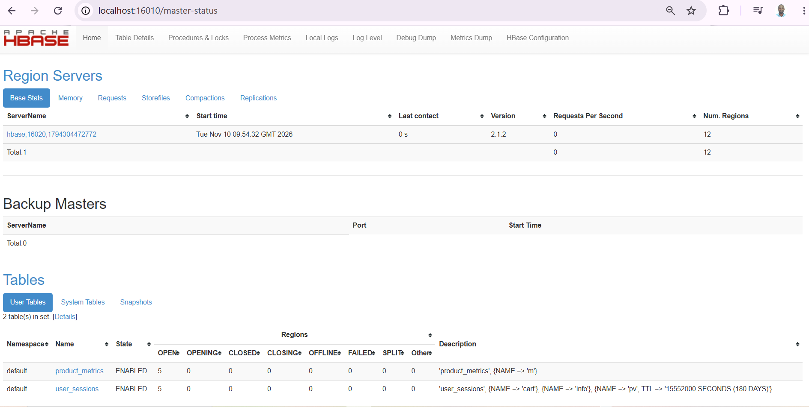
Comment: HBase 2.1.2 with one region server. Both user tables are ENABLED with 5 regions each, proving the 4 pre-split points took effect; the description lists the info, pv (TTL 180 days) and cart families.
S3 - Spark UI during the cleaning job
Command: http://localhost:4040
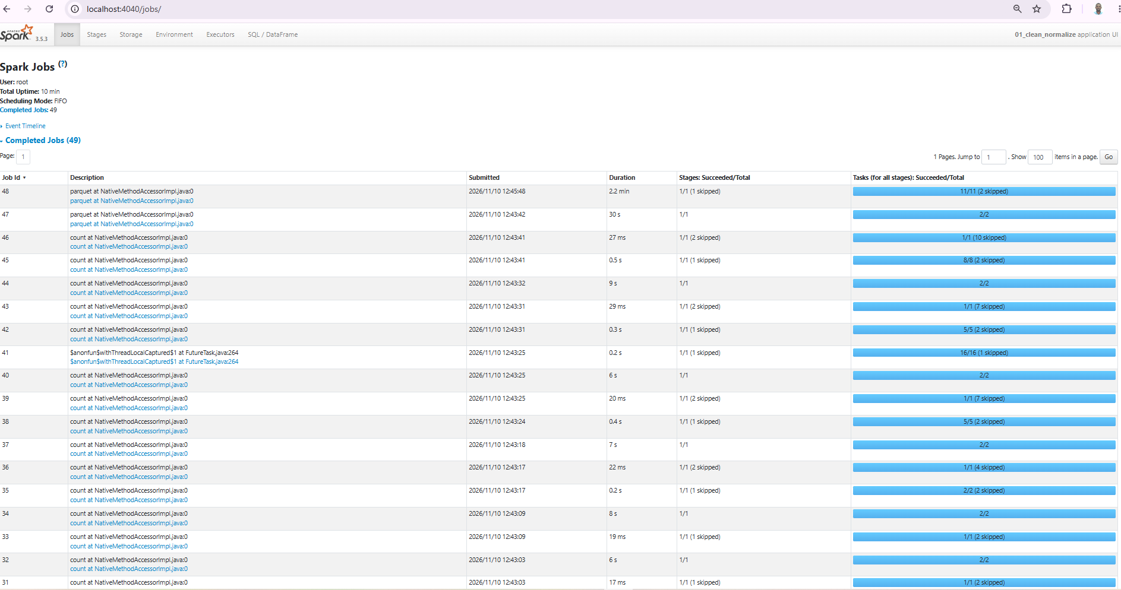
Comment: Spark 3.5.3 ran 49 jobs for 01_clean_normalize: Parquet writes (up to 2.2 min) and the short data-quality counts; skipped stages show cached data being reused.

C.2 Data generation
S4 - Dataset generation, scale 0.1
Command: python data_generation/dataset_generator.py --out data/raw --scale 0.1
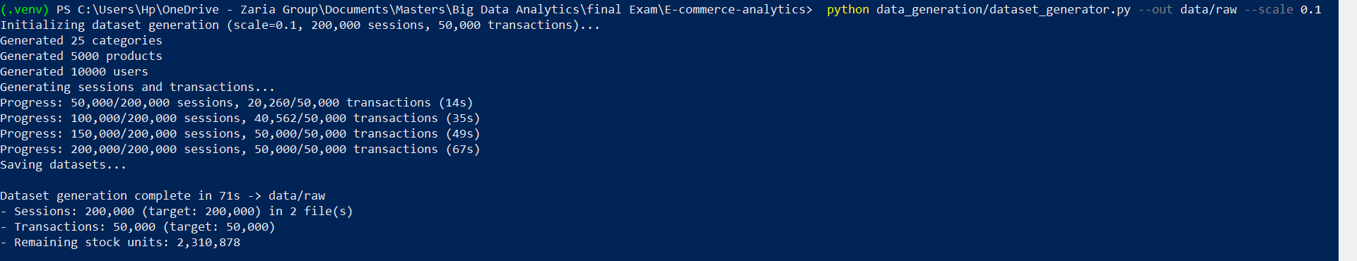
Comment: 200,000 sessions and 50,000 transactions in 2 files in 71 s. The transaction target is reached between 100,000 and 150,000 sessions; after that converted sessions create no orders - the source of the 15,552 gap.

C.3 Part 1 - MongoDB
S5 - Loading MongoDB
Command: python mongodb/load_mongodb.py --sessions-limit 50000
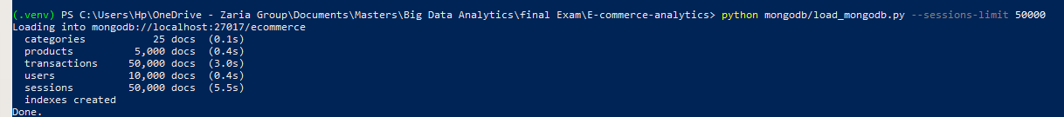
Comment: Five collections loaded with unordered batched inserts in ~10 s, then the indexes were created.
S6 - The four aggregation pipelines
Command: python mongodb/aggregations.py
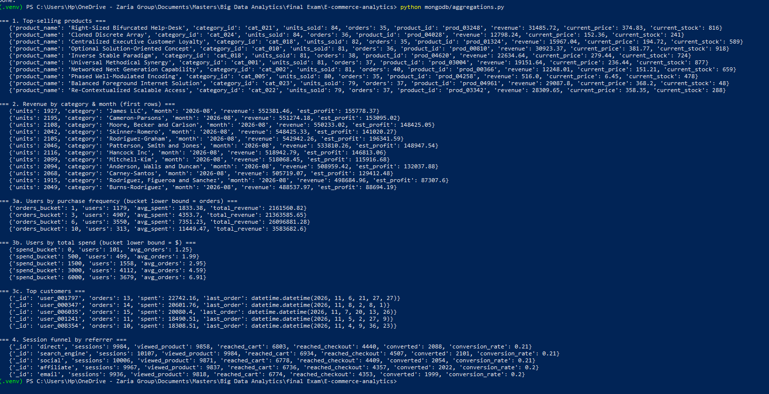
Comment: Top sellers (84 units for the leader); revenue and estimated profit per category and month; frequency and spend segments (313 users with 10+ orders average $11,449); top customers; journey funnel by referrer (20-21% flagged converted for every referrer).
S7 - mongosh: counts and pipeline 1
Command: Get-Content mongodb\evidence.js | docker exec -i mongo mongosh ecommerce --quiet
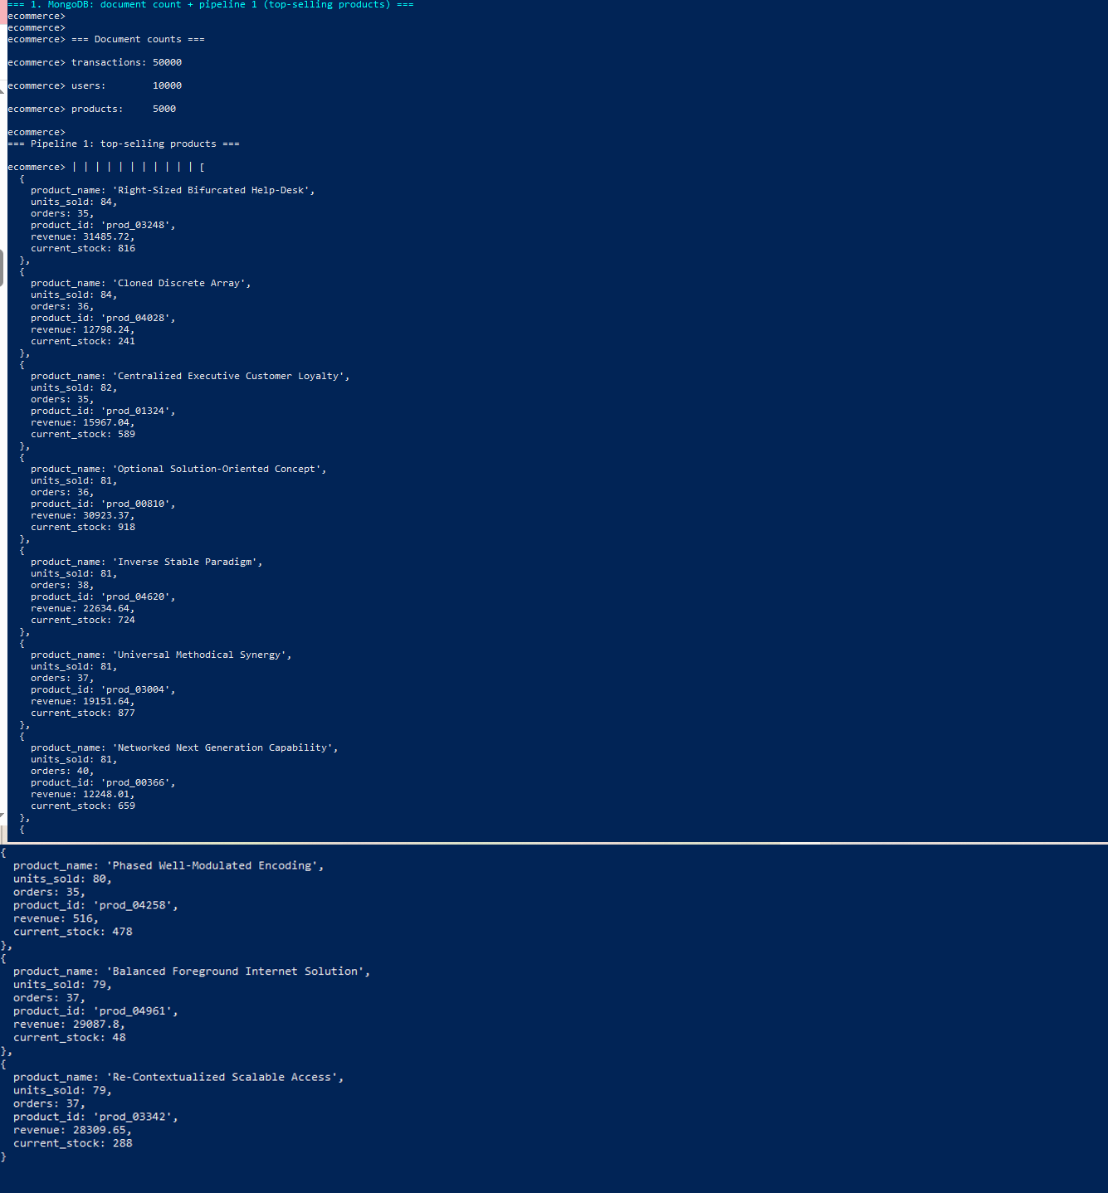
Comment: Run directly in the MongoDB shell: 50,000 transactions, 10,000 users, 5,000 products; the top-selling pipeline with $lookup to current stock returns the same units, orders and revenue as the Python run (S6).

C.4 Part 1 - HBase
S8 - HBase shell: list, describe and a user prefix scan
Command: Get-Content hbase\evidence.hbase | docker exec -i hbase hbase shell -n
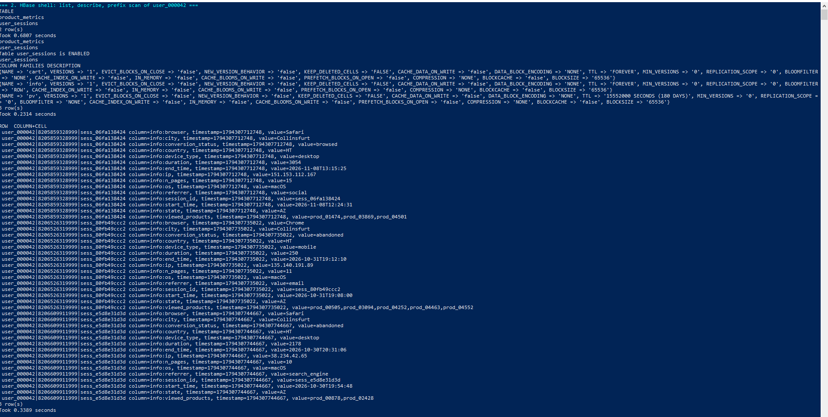
Comment: Both tables listed; describe shows VERSIONS 1, ROW bloom filters and the 180-day TTL on pv. The prefix scan of user_000042| returns the user's newest sessions first without sorting - the reversed timestamp in the row key at work.

C.5 Part 2 - Spark processing
S9 - Cleaning job and data-quality report
Command: docker compose exec -T app python spark/01_clean_normalize.py
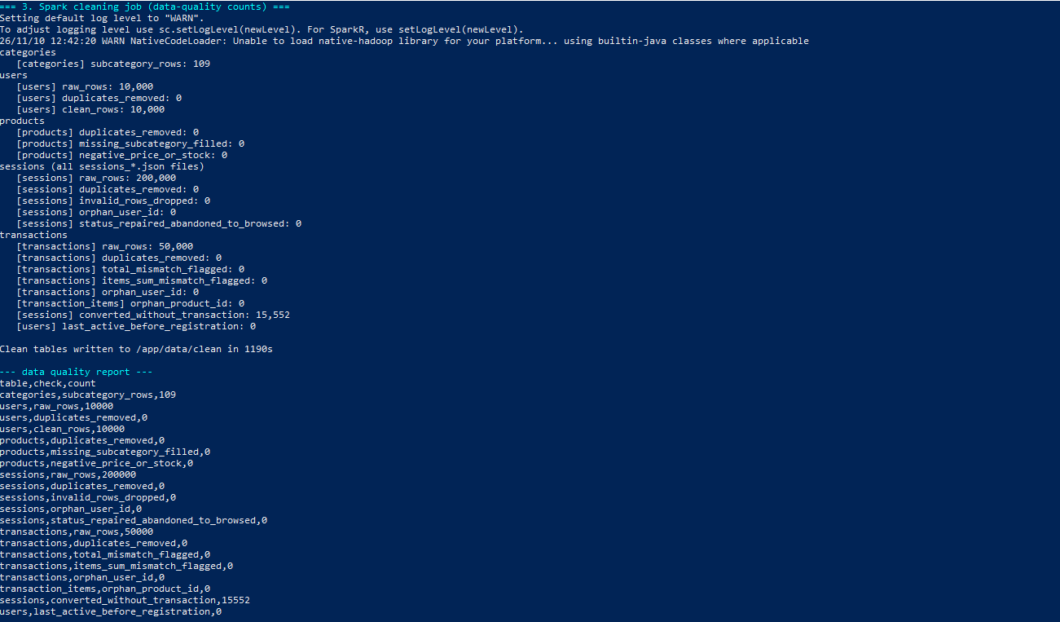
Comment: All 200,000 sessions, 50,000 transactions and 10,000 users validated: 0 duplicates, 0 invalid rows, 0 orphans, 0 total mismatches; 15,552 converted sessions without an order are flagged, not deleted. Runtime 1,190 s.
S10 - Recommendation indicators
Command: docker compose exec -T app python spark/02_recommendations.py
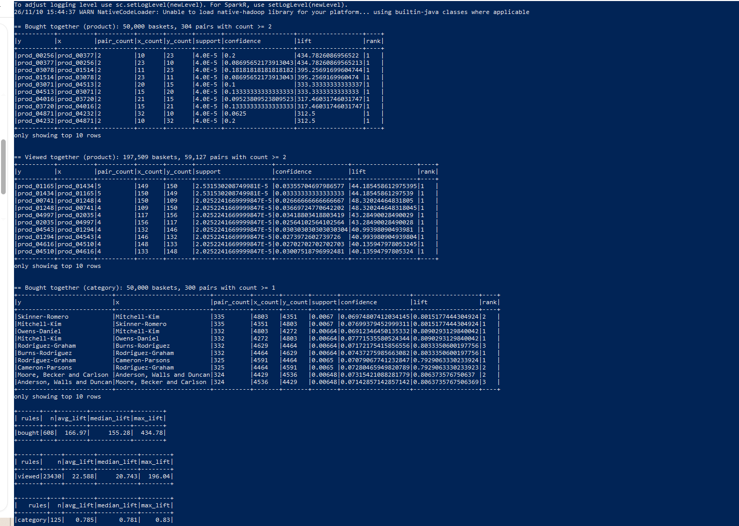
Comment: 304 product pairs occur twice or more in 50,000 baskets (lifts up to 435 from tiny counts); 59,127 viewed-together pairs; category lift ~0.79. Conclusion: no real affinity in random synthetic data - the method needs support thresholds on real data.
S11 - Cohort analysis
Command: docker compose exec -T app python spark/03_cohort_analysis.py
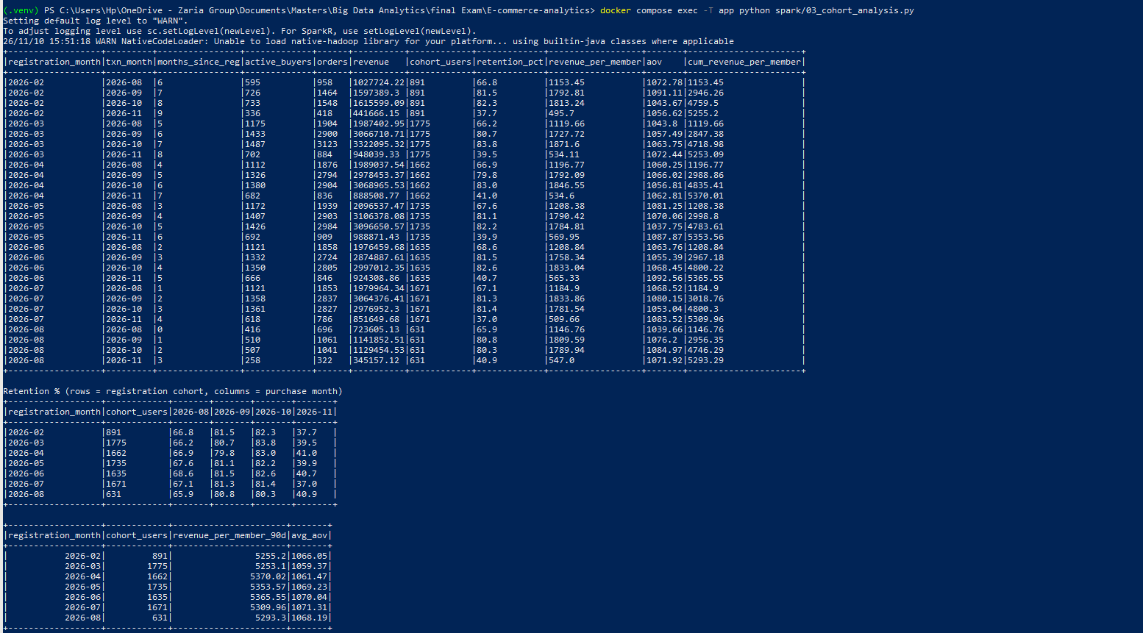
Comment: Seven registration cohorts; about 80-84% of each buys in each full month (Aug and Nov are partial); 90-day revenue per member is flat at $5,253-$5,370.
S12 - Spark SQL analytics
Command: docker compose exec -T app python spark/04_spark_sql_analytics.py
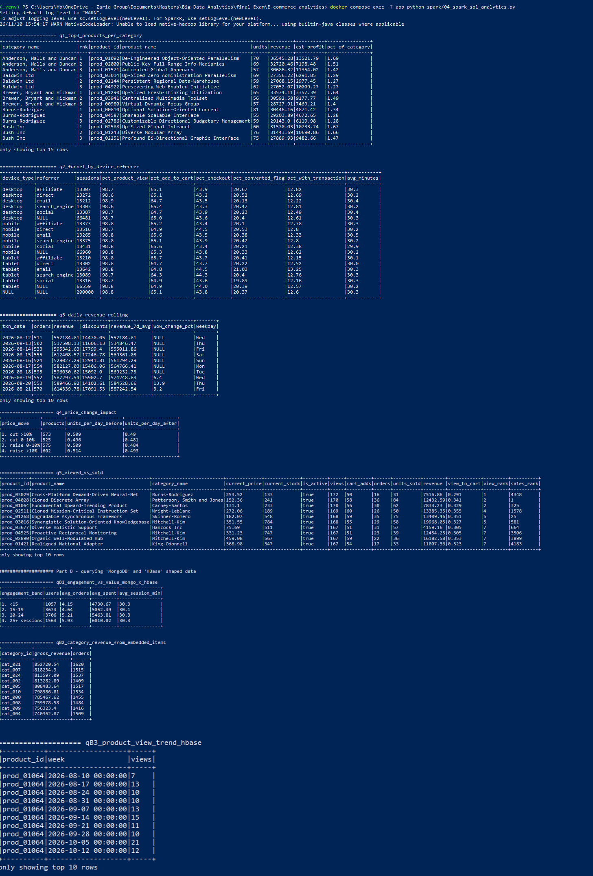
Comment: Part A: top-3 per category, ROLLUP funnel (12.6% of 200,000 sessions have an order), 7-day rolling revenue, price-change impact, viewed-vs-sold ranks. Part B: MongoDB-shaped users joined with HBase-shaped sessions - spend rises from $4,731 (<15 sessions) to $6,010 (25+).

C.6 Part 3 - Integrated analytics
S13 - Customer Lifetime Value (MongoDB + HBase via Spark)
Command: docker compose exec -T app python integration/clv_analysis.py --mongo mongo --hbase hbase
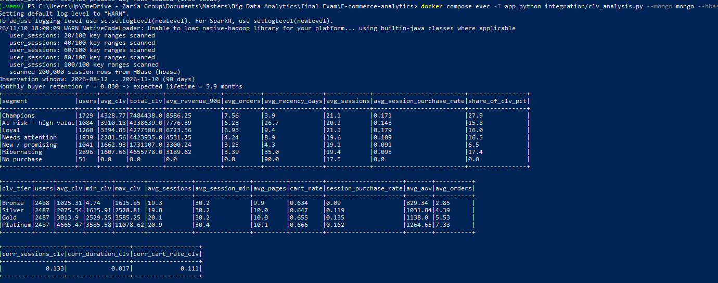
Comment: Spark read orders from MongoDB and all 200,000 sessions from HBase in 100 row-key ranges, estimated retention r = 0.830 (5.9-month lifetime) and produced the segment, tier and correlation tables of §5.1.
S14 - Funnel conversion (HBase journeys + MongoDB purchases)
Command: docker compose exec -T app python integration/funnel_analysis.py --mongo mongo --hbase hbase
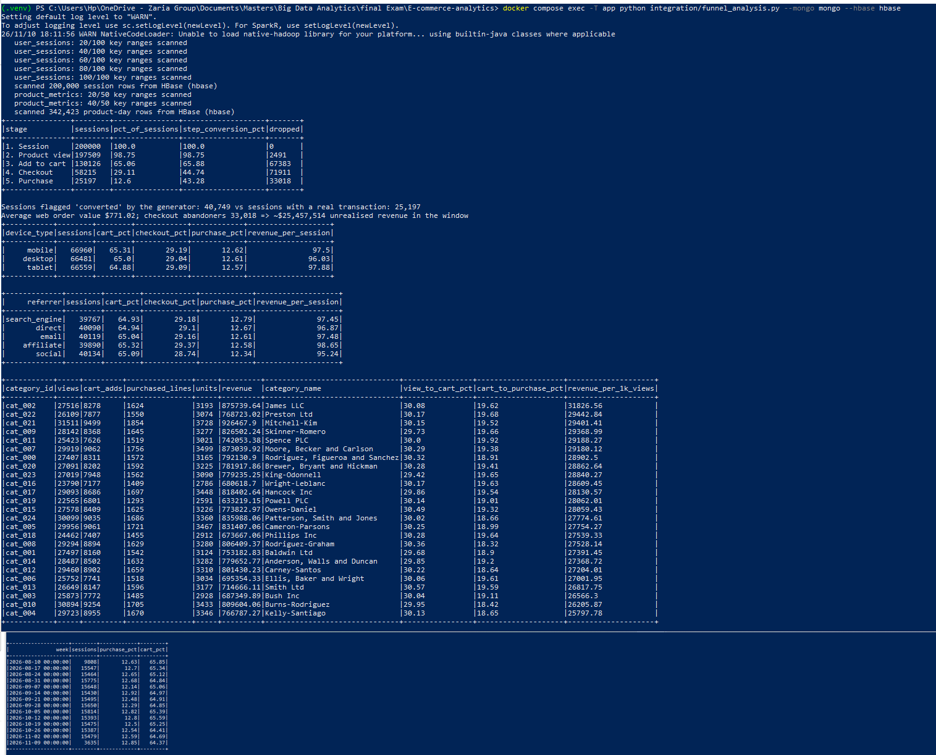
Comment: 200,000 sessions and 342,423 product-day rows read from HBase; funnel 200,000 → 197,509 → 130,126 → 58,215 → 25,197 (12.6%); 40,749 flagged vs 25,197 real orders; $25.5M unrealised at checkout; device, referrer, category and weekly breakdowns are all within ~1 point.

