Distributed Multi-Model Analytics for E-commerce Data
MongoDB · HBase · Apache Spark
Technical Report - AUCA Big Data Analytics, Final Project (October 2026)
Author: Godfrey Mushambo
Student ID: [enter your student ID]
Lecturer: [enter lecturer name]
GitHub repository: [paste your repository URL]
Submission date: [e.g. 11 November 2026]

Final checks before submission (delete this page)
Only the items below still need you. Each one is also ==highlighted in yellow== where it appears in the report. When done, remove the highlights (Home → Text Highlight Color → No Color) and delete this page.
# | Action | Where
1 | Fill in student ID, lecturer, GitHub URL and submission date. | Title page
2 | Reload HBase completely, then retake the funnel screenshot. Your HBase held 186,713 of 200,000 sessions and an empty product_metrics table (the load was interrupted), so S14 shows 186,713 sessions and an empty category table. Run docker compose exec -T app python hbase/load_hbase.py --recreate (wait for '200,000 rows' and the product_metrics line), then docker compose exec -T app python integration/funnel_analysis.py --mongo mongo --hbase hbase. Expected: 200,000 → 197,509 → 130,126 → 58,215 → 25,197 (verified on your raw data) and a filled category table. | Appendix C, S14; Section 5.2
3 | After the reload, rerun integration/clv_analysis.py and retake S13. Only the Sessions and Session→order columns can change slightly (CLV values do not depend on HBase). | Appendix C, S13; Section 5.1 table
4 | Retake S1 with docker compose ps: the current picture also shows an unrelated nginx container (my-web-server) and a command typed mid-output. | Appendix C, S1
5 | Update the table of contents (right-click → Update Field → Update entire table) and export to PDF (File → Save As → PDF). | Contents

What was cleaned up in this version: duplicated screenshots removed (run_all output duplicated the generator and MongoDB-load shots; two CLV and two cleaning runs; an older architecture diagram); the seven charts now appear once (Section 6), regenerated from your live Docker results; all numbers updated to the live run; every screenshot moved to Appendix C, grouped by project part, each with the command used and a comment; Appendix B updated to the final docker-compose.yml and the HBase range-scan reader.

Contents

1. Executive summary
This project builds a polyglot analytics platform for a synthetic e-commerce business. MongoDB stores the document-shaped business entities (catalogue, customers, orders), HBase stores the high-volume, time-ordered click-stream and daily product metrics, and Apache Spark cleans the raw data, runs the batch analytics and joins data across both stores. Everything runs in Docker (MongoDB 7, HBase 2.1.2, Spark 3.5.3 with Python 3.11). Results come from a live run on a 10% dataset (seed 42): 10,000 users, 5,000 products, 25 categories, 200,000 sessions and 50,000 transactions over 90 days (12 Aug - 10 Nov 2026).
Net revenue | Sessions ending in a purchase | Checkout abandonment | CLV held by top 17% of customers
$53.2M (50,000 orders, AOV $1,064) | 12.6% (25,197 of 200,000) | 57% of checkouts | 27.9% ('Champions')

- The funnel leaks after the cart, not before it. 98.8% of sessions view a product and 65% add to cart, but only 45% of carts reach checkout and 43% of checkouts become an order: 33,018 checkout abandoners, worth up to ~$25M at the $771 average web order.
- Stock-outs, not demand, drive the views-sales link. Across all products views and units sold correlate at r = 0.69, but among in-stock products only r = 0.12; the 209 products that sold out averaged 52 page views against 132 for in-stock products (-60%).
- Value is concentrated and partly at risk. RFM segmentation finds 1,729 'Champions' holding 27.9% of estimated lifetime value and 1,084 high-value customers who have not bought for ~27 days (15.8% of CLV, $4.2M).
- Revenue is flat; profit is not. Daily revenue is stable (~$592k/day, s.d. $31k) and category revenue stays within -17% / +15% of the mean, but subcategory margins range from 18% to 36%, so category profit differs about two-fold.
- Cross-system reconciliation finds data issues. 15,552 of the 40,749 sessions flagged 'converted' (38%) have no matching transaction - visible only by joining HBase sessions with MongoDB orders.

2. System architecture
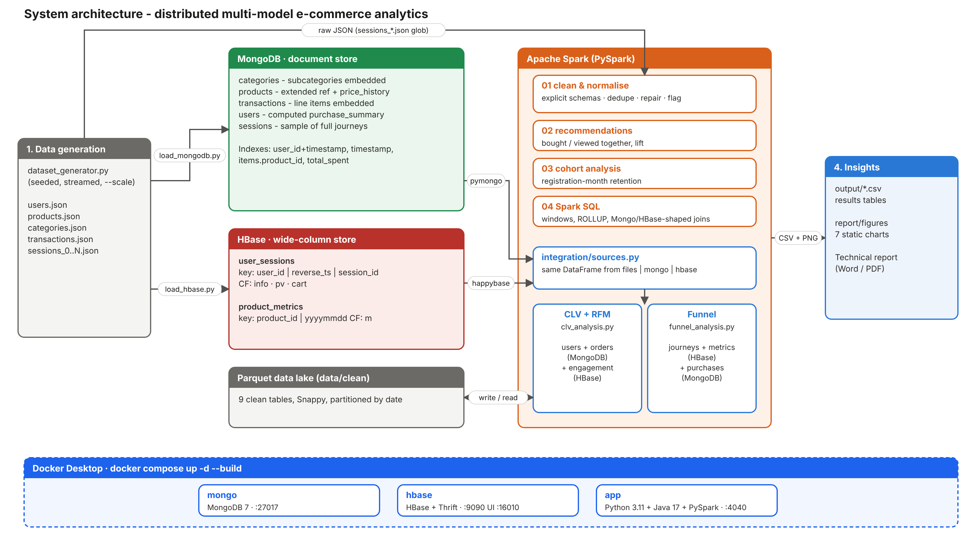
Figure 1 - System architecture: the generator feeds MongoDB, HBase and Spark; Spark joins all sources for the integrated analytics; all services run as Docker containers.
Layer | Component | Role in the solution
Source | dataset_generator.py | Generates users, products, categories, sessions_N.json and transactions (JSON arrays)
Document store | MongoDB 7 | categories, products, users (+ purchase_summary), transactions (+ embedded items), sessions sample; 4 aggregation pipelines
Wide-column store | HBase 2.1.2 | user_sessions (key user|reverse_ts|session) and product_metrics (key product|yyyymmdd)
Processing | Apache Spark 3.5.3 | Cleaning → Parquet lake; recommendations; cohorts; Spark SQL; integrated CLV and funnel jobs
Access layer | integration/sources.py | Returns the same DataFrame from Parquet, MongoDB (pipeline pushed down) or HBase (row-key range scans)
Deployment | Docker Compose | Three containers: mongo (:27017), hbase (:9090 Thrift, :16010 UI), app (Python + Java + PySpark, :4040 Spark UI)

Raw JSON is loaded into the two operational stores by Python loaders and, in parallel, read by Spark, which writes a clean Parquet 'lake'. The analytical jobs read through one access layer, so the analysis code does not depend on where data is stored; the same code runs against live databases or, for development, against an in-memory MongoDB substitute and a SQLite-backed HBase emulator that keeps HBase's sorted row-key behaviour. Evidence that the three containers ran is in Appendix C (S1-S3).

2.1 Dataset and generator
The course generator's simulation logic (page-flow probabilities, 30% add-to-cart, 70% checkout completion, stock checks, discounts) is unchanged. Four engineering fixes were made: (1) products receive the subcategory_id shown in the brief's data dictionary but never assigned by the original; (2) sessions are streamed to sessions_N.json in 100,000-record chunks instead of being kept in memory (the original needs >10 GB RAM at 2M sessions); (3) IDs come from the seeded random generator instead of uuid4, making runs reproducible; (4) a --scale option. The 10% dataset generated in 71-106 s (S4).

3. Data modelling and storage (Part 1)

3.1 MongoDB document model
Collection | Document shape | Pattern and justification
categories | category + subcategories[] (3-5) with profit_margin | Embedding: small, bounded, always read together - one read returns the whole hierarchy.
products | product + category{id,name} + subcategory{id,name,profit_margin} + price_history[] | Extended reference: copies rarely-changing names and margin, so catalogue pages and margin maths need no $lookup. Price history is bounded (1-3 points), so it is embedded.
transactions | order header + items[] (each with product_name, category_id, subcategory_id); timestamp as BSON Date | Line items live and die with the order (atomic single-document write). Denormalised category ids make revenue-by-category a pure $unwind/$group.
users | profile + geo + purchase_summary{total_spent, order_count, avg_order_value, favorite_category, recent_orders[5]} | Computed + subset pattern: the most-requested facts are pre-aggregated; the full history stays in transactions, avoiding unbounded arrays.
sessions (50k sample) | full journey with page_views[] and cart_contents[] | Shows the 'whole journey in one document' query; the complete click-stream lives in HBase.

Indexes back each query pattern: {user_id:1, timestamp:-1} (order history), {timestamp:1} (period revenue), multikey {items.product_id:1} (product sales), {purchase_summary.total_spent:-1} (top customers), {category.category_id:1, is_active:1} (catalogue browsing). The loader inserted 25 categories, 5,000 products, 50,000 transactions, 10,000 users and 50,000 sessions in about 10 s (S5). Four aggregation pipelines are implemented (mongodb/aggregations.py and .js, Appendix B.3; output in S6-S7):
- Product popularity - $match → $unwind → $group → $sort → $lookup (current stock): the top product sold 84 units in 35 orders.
- Revenue analytics - revenue and estimated profit per category per month; each item is matched to its embedded subcategory margin with $filter.
- User segmentation - purchase-frequency and spend buckets with $facet + $bucket in one round trip: 1,179 users with 1-2 orders spend $1,833 on average, 3,550 users with 6-9 orders spend $7,351, and 313 users with 10+ orders spend $11,449.
- Journey funnel over the embedded page_views array, by referrer (about 20-21% of sessions per referrer are flagged converted).

3.2 HBase wide-column model
Table | Row key | Column families | Access patterns served
user_sessions | user_id|reverse_ts|session_id (reverse_ts = 9999999999999 - epoch_ms) | info: session header (15 cells); pv: one column per page view (000..015); cart: qualifier = product_id, value qty|price | Latest N sessions of a user = prefix scan, newest first; a time window = bounded STARTROW/STOPROW scan; one session = point get.
product_metrics | product_id|yyyymmdd | m: views, cart_adds, purchases, units_sold, revenue_cents | A product's daily history or a date range is one contiguous scan; streaming updates use atomic incr counters.

Why this design. Putting user_id first stores a user's activity contiguously; reversing the timestamp returns the most recent session first, so no sort is needed. Column families follow access patterns: listing sessions reads only the small info family, while the variable-width pv family (3-15 cells) is read only when a journey is drilled into. Sparse columns cost nothing - most sessions have 0-2 cart cells. VERSIONS=1 (events are immutable), a ROW bloom filter for point gets, a 180-day TTL on pv, and four pre-split points complete the schema; the HBase UI confirms 5 regions per table (S2). Example queries (all in Appendix B.2; live output in S8 and in Q1-Q5 of hbase/query_hbase.py):
scan 'user_sessions', {ROWPREFIXFILTER => 'user_000042|', COLUMNS => ['info'], LIMIT => 5} # latest sessions
scan 'user_sessions', {STARTROW => 'user_000042|8209187200000',
STOPROW => 'user_000042|8211779199999~'} # September 2026
scan 'product_metrics', {STARTROW => 'prod_00123|20260901', STOPROW => 'prod_00123|20261001'}

3.3 Why data was placed in MongoDB or HBase
Criterion | MongoDB | HBase
Data | Entities with rich nested structure and modest volume (catalogue, customers, orders) | Append-only events at very high volume (2M sessions, ~20M page views at full scale), daily counters
Queries | Ad-hoc filters, secondary indexes, aggregation framework, $lookup | Known access path by key: per-user timelines, per-product time ranges
Schema | Flexible documents, validation per collection | Sparse, variable columns per row; the row-key design is the 'index'
Writes | Atomic per document (an order and its items together) | Very high write throughput, atomic counters, automatic region sharding

4. Data processing with Apache Spark (Part 2)

4.1 Cleaning and normalisation (01_clean_normalize.py)
The job reads every JSON file (sessions via the glob sessions_*.json) with explicit schemas - avoiding a second inference pass over the large session files and type drift - and writes nine Parquet tables: users, categories (hierarchy flattened to one row per subcategory), products (joined with margin), price_history, sessions (partitioned by date, with funnel flags), page_views (exploded with posexplode, partitioned by date), cart_items (the cart_contents object read as a MapType and exploded), transactions (with reconciliation flags) and transaction_items (discount pro-rated per line, enriched with category and margin through a broadcast join).
Cleaning rules: de-duplicate on keys; drop rows with missing keys or unparseable timestamps; trim and case-normalise enums and geo codes; clamp negatives; fill missing descriptive values; repair conversion_status ('abandoned' with an empty cart → 'browsed'); and flag - not drop - logical inconsistencies. Every check is counted in output/data_quality_report.csv (S9). The data was structurally clean (0 duplicates, 0 invalid rows, 0 orphan ids, 0 total mismatches); the one material issue is 15,552 converted sessions without an order, explained in Section 9.

4.2 Product recommendation indicators (02_recommendations.py)
Association rules (support, confidence, lift; top-5 per product with a window function) for 'bought together' (self-join on transaction id with x < y) and 'viewed together' (pairs built inside each session's viewed_products array with the higher-order functions transform/filter, which avoids a shuffle-heavy join), plus category-level affinity. Result (S10): only 304 product pairs occur in 2 or more of the 50,000 baskets, and their lifts (median 155, max 435) are inflated by tiny counts; 'viewed together' gives 59,127 pairs (median lift 20.7); category lift is ~0.79 - i.e. no genuine affinity in this synthetic data, a useful null-model check of the method.

4.3 Cohort analysis (03_cohort_analysis.py)
Users are grouped by registration month (Feb-Aug 2026) and followed by months since registration: active buyers, retention %, revenue, AOV and cumulative revenue per member (S11). In each full month (September, October) about 80-84% of every cohort buys; the first (from 12 Aug) and last (10 days of November) months are partial. Revenue per member over the 90 days is flat across cohorts ($5,253-$5,370), so cohort age has no effect - another sign of uniform synthetic behaviour.

4.4 Spark SQL analytics (04_spark_sql_analytics.py)
Part A runs five complex queries on the DataFrames (S12): top-3 products per category (CTE + RANK); funnel by device and referrer with ROLLUP; daily revenue with a 7-day RANGE window and week-over-week LAG; price-change impact using MAX_BY over exploded price history (units per day fall from ~0.51 to ~0.49 after every type of price move, cuts and raises alike - no measurable price elasticity); and viewed-vs-sold ranks. Part B shows how Spark SQL queries data that notionally lives in the two stores: views shaped like MongoDB documents (mongo_users with nested purchase_summary; mongo_transactions with an items array queried through LATERAL VIEW explode - Spark's equivalent of $unwind) and like HBase rows (rowkey + info:* columns, user id parsed with SPLIT) are joined in SQL (Appendix B.4).

4.5 Optimisations
Explicit schemas; Parquet + Snappy with date partitioning (partition pruning for time ranges); broadcast joins for the 5,000-product and 109-subcategory dimensions; adaptive query execution; cache() only for reused DataFrames; array functions instead of joins for co-occurrence; a minimum pair count before ranking; reduced shuffle partitions for a single machine. On the laptop, cleaning took ~20 min (1,190 s, S9), dominated by multi-line JSON parsing - such files cannot be split across tasks, so at scale the generator should write JSON Lines.

5. Integrated analytics (Part 3)

5.1 Customer Lifetime Value (integration/clv_analysis.py)
Business question: which customers are worth most over their expected lifetime, how engaged are they, and which segment should receive retention spend?
Data sources: user profiles and orders from MongoDB ($unwind and discount pro-ration pushed into the aggregation pipeline, so only line-item rows cross the network); engagement from HBase user_sessions (session count, duration, pages, cart rate); margins from the category dimension.
Spark steps: per-user purchase facts → per-user engagement facts → monthly buyer retention estimated from the data (r = 0.830 ⇒ expected lifetime 1/(1-r) = 5.9 months) → CLV = AOV × orders per month × gross-margin % × lifetime → RFM quintiles (NTILE) mapped to named segments and CLV tiers. Output in S13:
Segment | Users | Avg CLV | Share of CLV | Recency (days) | Sessions* | Session→order*
Champions | 1,729 | $4,329 | 27.9% | 3.9 | 19.8 | 18.3%
At risk - high value | 1,084 | $3,910 | 15.8% | 26.7 | 18.8 | 15.3%
Loyal | 1,260 | $3,395 | 16.0% | 9.4 | 19.8 | 19.1%
Needs attention | 1,939 | $2,282 | 16.5% | 8.9 | 18.2 | 11.7%
New / promising | 1,041 | $1,663 | 6.5% | 4.3 | 17.8 | 9.8%
Hibernating | 2,896 | $1,608 | 17.4% | 35.0 | 18.1 | 10.3%
*Columns read from HBase; recheck after the full HBase reload (final-checks item 3).
Platinum customers (top CLV quartile) average 19.5 sessions and a 17.3% session-to-order rate, against 17.9 and 9.7% for Bronze: value is driven by conversion efficiency far more than by browsing time (correlation of CLV with session duration 0.02, with session count 0.14, with cart rate 0.11).

5.2 Funnel conversion (integration/funnel_analysis.py)
Business question: where are shoppers lost, does it differ by device, traffic source or category, and what is the leak worth?
Data sources: journey stages from HBase user_sessions (pv and cart families); category views and cart adds from HBase product_metrics; purchases from MongoDB transactions as the source of truth for the last stage.
Spark steps: range scans → per-session stage flags → left join to orders on session_id → stage counts and step conversion; repeated by device, referrer, category (HBase views × MongoDB web purchases) and week. Over the 200,000 sessions: 98.8% view a product, 65.1% add to cart, 29.1% reach checkout with a cart, 12.6% buy (Figure 4). Device purchase rates differ by less than 0.1 point (12.57-12.62%) and device × referrer cells stay within 12.2-13.3%: the leak is a process problem at checkout, not a channel problem. The generator flags 40,749 sessions as converted, but only 25,197 have a real order - MongoDB is therefore used as the source of truth. S14 must be retaken after the full HBase reload (final-checks item 2).

5.3 Why these technologies, and performance
MongoDB answers the order and profile side with pushed-down aggregation; HBase answers the per-user, time-ordered event side with key-range scans; Spark does what neither store does well - large joins across the two and window/statistical computation. Reading the whole user_sessions table as one Thrift scan timed out on the single-node HBase, so the reader scans 100 user-id key ranges (and 50 product ranges), retrying a failed range on a fresh connection (Appendix B.6). At full scale, the hbase-spark connector or a snapshot export would let executors read regions in parallel, and the MongoDB Spark connector would partition reads by _id; joins are on high-cardinality keys with dimension tables broadcast.

6. Visualisations and insights (Part 4)
All charts were produced with python visualization/make_charts.py (matplotlib) from the result tables of the live run.
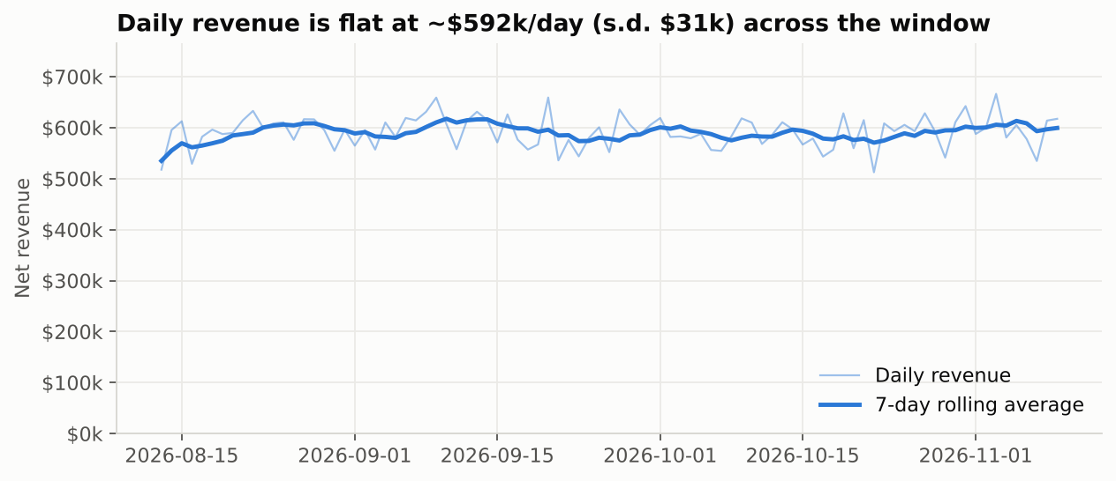
Figure 2 - Sales performance over time: daily net revenue with a 7-day rolling average (Spark SQL window query).
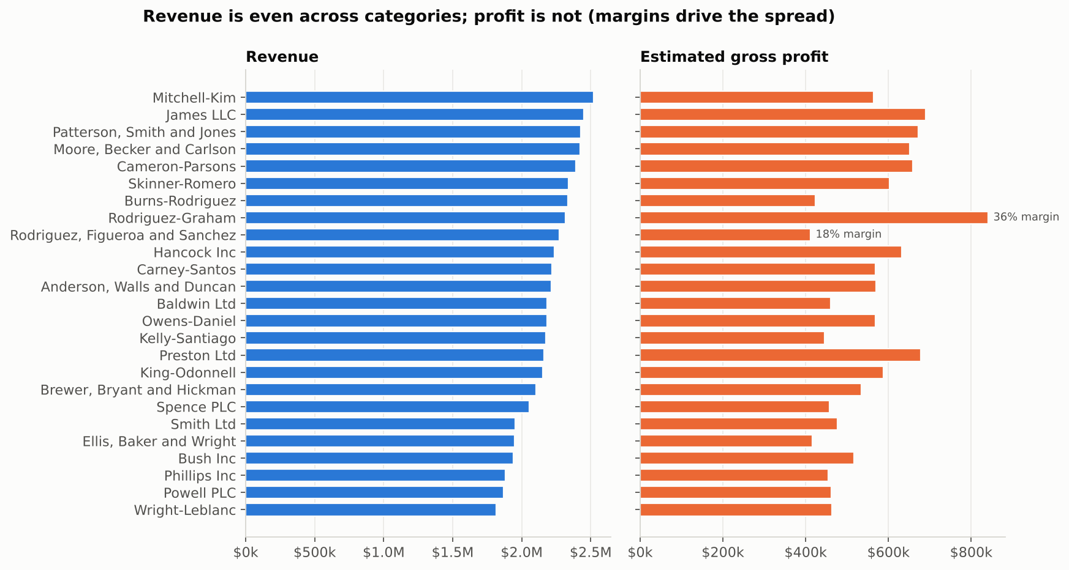
Figure 3 - Sales by category: revenue and estimated gross profit (MongoDB pipeline 2). Margins range from 18% to 36%.
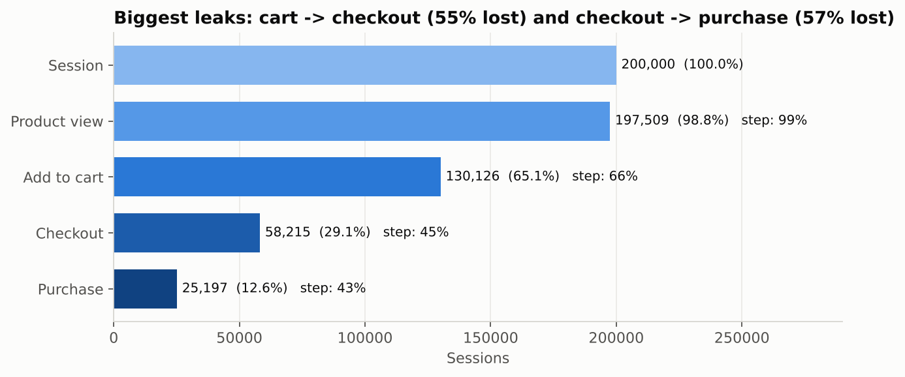
Figure 4 - Conversion funnel over 200,000 sessions (HBase journeys × MongoDB orders). Step % = conversion from the previous stage.
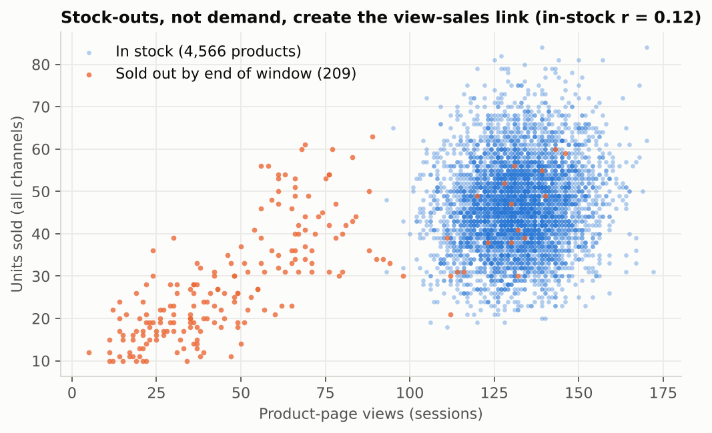
Figure 5 - Product performance, most-viewed vs top-selling: each dot is a product; sold-out products lose page views.
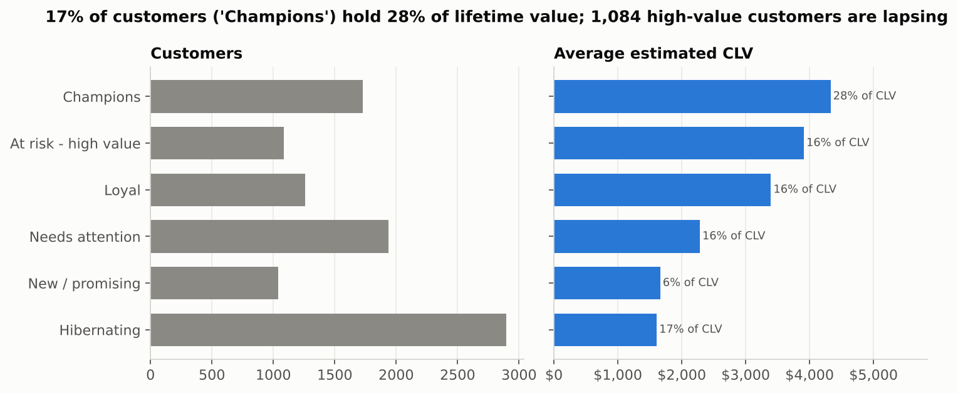
Figure 6 - Customer segmentation: RFM segments by size (left) and average estimated CLV with share of total CLV (right).
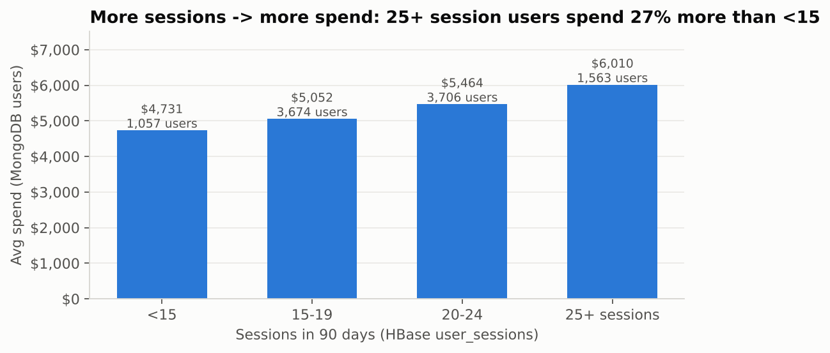
Figure 7 - Engagement vs value: average spend (MongoDB) by session-count band (HBase).
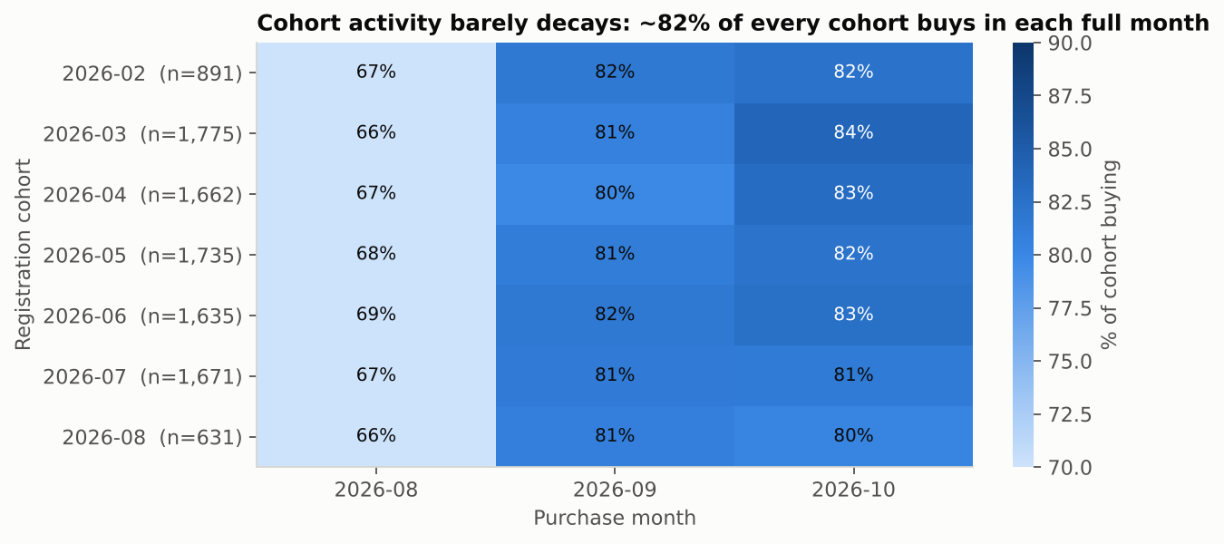
Figure 8 - Cohort analysis: share of each registration cohort buying per month (August starts on the 12th; November omitted, 10 days).

6.1 Key findings and recommended actions
- Fix checkout first. Checkout-to-order is the largest controllable loss (33,018 sessions). Test guest checkout, saved payment methods and cart-recovery e-mails; a 5-point lift adds ~2,900 orders (~$2.2M) per 90 days at current traffic.
- Replenish before stock-out. Use product_metrics daily views and units to trigger re-orders; sold-out items lose ~60% of their visibility.
- Win back the 'At risk - high value' segment (1,084 customers, $4.2M estimated CLV) before they become 'Hibernating'.
- Steer merchandising by margin, not revenue: promote the 30-36% margin subcategories; revenue alone hides a two-fold profit spread.
- Reward engagement: users with 25+ sessions spend 27% more than those with fewer than 15 (Figure 7), so re-engagement campaigns have a measurable value.

7. Methodology for key analyses
- Funnel: a session reaches a stage if its page sequence contains it; 'Checkout' also requires a non-empty cart; 'Purchase' requires a MongoDB transaction with that session_id.
- CLV: retention-based model; partial first/last months are excluded when estimating retention; lifetime capped at 36 months; margin from the item's subcategory.
- RFM: quintiles over buyers only, mapped to six named segments. Recommendations: lift = confidence / P(consequent), minimum pair count 2. Cohorts: calendar-month differences between registration and purchase.

8. Scalability and technology selection
Analytical task | Technology | Why | Scaling path
Catalogue, customer profile, order look-ups and aggregations | MongoDB | Nested documents, secondary indexes, aggregation framework | Shard transactions on {user_id: 'hashed'}; replica sets for reads
Click-stream, user timelines, product time series | HBase | Key-ordered storage, sparse wide rows, very high write rate, counters | Automatic region splits; pre-split; salt keys with hash(user_id) % N if hot-spots appear
Cleaning, co-occurrence, cohorts, CLV, cross-store joins | Spark | Distributed, in-memory, SQL + DataFrame APIs, reads all sources | YARN/Kubernetes cluster; Parquet partitioning; parallel connectors; Structured Streaming

The pipeline scales linearly with data volume: the full dataset (10×) is ~4 GB of JSON and needs only more shuffle partitions. Pair generation is the only super-linear step (O(k²) per basket/session) and is bounded by the 15-page session cap. In production, session events would arrive through Kafka, be written to HBase with counter increments by a Spark Structured Streaming job, and be compacted nightly into Parquet.

9. Limitations and future work
- Synthetic data has little behavioural signal: devices, referrers and categories are sampled uniformly, cohorts do not decay and prices do not change demand; product-level rules suffer from small counts. Real data would need minimum-support thresholds, significance tests or collaborative filtering (Spark ALS).
- Generator artefacts: once its transaction target is reached, converted sessions stop producing orders (the 15,552 gap); half the orders have no session ('offline/app'); there are no demographics (age), so segmentation is behavioural.
- Infrastructure: MongoDB 7, HBase 2.1.2 and Spark 3.5.3 ran as Docker containers on one laptop. Single-node HBase was the weak point - it stopped once under memory pressure and stalled on long full-table scans - which led to the range-scan reader. Cleaning took ~20 minutes because multi-line JSON cannot be split.
- Future work: JSON Lines input, Spark ALS recommendations, Structured Streaming into HBase counters, probabilistic (BG/NBD) CLV, and an interactive dashboard.

Appendix A - How to reproduce
All components run in Docker. From Windows PowerShell, in the project folder:
docker compose up -d --build # mongo :27017, hbase :9090 / UI :16010, app (Spark UI :4040)
docker compose exec -T app python wait_for_services.py
.\run_all.ps1 # whole pipeline (or .\run_all.ps1 -Scale 1.0)
.\evidence.ps1 # re-creates the evidence screenshots step by step
Step | Command (prefix each with docker compose exec -T app ) | Output
1 Generate data | python data_generation/dataset_generator.py --out data/raw --scale 0.1 | data/raw/*.json
2 MongoDB | python mongodb/load_mongodb.py --sessions-limit 50000 then python mongodb/aggregations.py | 5 collections + indexes; output/mongo_*.csv
3 HBase | python hbase/load_hbase.py --recreate then python hbase/query_hbase.py | 2 tables; Q1-Q5 results
4 Spark clean | python spark/01_clean_normalize.py | data/clean/*.parquet; data_quality_report.csv
5 Spark analytics | python spark/02_recommendations.py, 03_cohort_analysis.py, 04_spark_sql_analytics.py | output/reco_, cohort_, sql_*.csv
6 Integration | python integration/clv_analysis.py --mongo mongo --hbase hbase; python integration/funnel_analysis.py --mongo mongo --hbase hbase | output/clv_.csv, funnel_.csv
7 Charts | python visualization/make_charts.py | report/figures/*.png
Shells | Get-Content mongodb\evidence.js | docker exec -i mongo mongosh ecommerce --quiet; Get-Content hbase\evidence.hbase | docker exec -i hbase hbase shell -n | S7, S8

Repository path | Purpose
data_generation/dataset_generator.py | Improved generator (original kept as dataset_generator_original.py)
mongodb/load_mongodb.py, aggregations.py, aggregations.js, evidence.js | Document model, bulk load, indexes, 4 pipelines
hbase/create_tables.hbase, load_hbase.py, query_hbase.py, sample_queries.hbase, hbase_client.py | Schema, loader, queries, Thrift client + emulator
spark/spark_utils.py, 01-04 *.py | Explicit schemas, cleaning, recommendations, cohorts, Spark SQL
integration/sources.py, clv_analysis.py, funnel_analysis.py | Source-independent loaders (range scans) and the two integrated queries
visualization/make_charts.py; report/make_architecture_diagram.py | The charts and the architecture diagram
Dockerfile, docker-compose.yml, run_all.ps1, run_all.sh, evidence.ps1, wait_for_services.py, README.md | Docker environment, orchestration, documentation

Appendix B - Key scripts
The complete, commented source code is in the repository; these are the parts the brief asks to see.

B.1 HBase schema (hbase/create_tables.hbase)
# create_tables.hbase - HBase schema (run with: hbase shell hbase/create_tables.hbase
# or docker exec -i hbase hbase shell < hbase/create_tables.hbase)
#
# ---------------------------------------------------------------------------
# TABLE 1: user_sessions - time-series browsing activity per user
# ---------------------------------------------------------------------------
# Row key : <user_id>|<reverse_ts>|<session_id>
# reverse_ts = 9999999999999 - start_time_epoch_millis (13 digits, zero padded)
# -> all sessions of a user are contiguous (one prefix scan)
# -> newest session sorts FIRST (no client-side sort for "recent activity")
# -> session_id suffix keeps keys unique if two sessions start in the same ms
#
# Column families (kept few and small, each stored in its own HFiles):
# info : session header - one cell per attribute (start, end, duration, device, geo, referrer,
# conversion_status, n_pages ...). Read by "list sessions" queries -> smallest I/O.
# pv : page views, one column per view: qualifier = 3-digit sequence ("000","001",...),
# value = "page_type|product_id|category_id|view_duration|timestamp".
# Sparse & variable width: a 3-page session stores 3 cells, a 15-page session 15.
# cart : one column per product in the cart: qualifier = product_id, value = "qty|unit_price".
# Most sessions have 0-2 cells here -> sparse storage costs nothing for empty cells.
#
# VERSIONS => 1 : events are immutable, no need for history
# COMPRESSION : SNAPPY (falls back to NONE if native libs are missing; change if needed)
# BLOOMFILTER ROW: speeds up point gets of a single session row
# TTL on pv : 180 days of raw click-stream (older detail can be archived to HDFS/parquet)
# SPLITS : pre-split on user-id ranges so the bulk load is spread over regions
create 'user_sessions',
{NAME => 'info', VERSIONS => 1, COMPRESSION => 'NONE', BLOOMFILTER => 'ROW'},
{NAME => 'pv', VERSIONS => 1, COMPRESSION => 'NONE', TTL => 15552000},
{NAME => 'cart', VERSIONS => 1, COMPRESSION => 'NONE'},
SPLITS => ['user_002', 'user_004', 'user_006', 'user_008']

# ---------------------------------------------------------------------------
# TABLE 2: product_metrics - daily performance per product
# ---------------------------------------------------------------------------
# Row key : <product_id>|<yyyymmdd>
# -> a product's whole history is one contiguous range;
# a date range is a bounded scan: STARTROW prod_x|20260901, STOPROW prod_x|20261001
# Column family m (metrics): views, cart_adds, purchases, units_sold, revenue_cents
# Batch loads write pre-aggregated values; a streaming job would use atomic counters:
# incr 'product_metrics', 'prod_00123|20261015', 'm:views', 1
create 'product_metrics',
{NAME => 'm', VERSIONS => 1, COMPRESSION => 'NONE', BLOOMFILTER => 'ROW'},
SPLITS => ['prod_01', 'prod_02', 'prod_03', 'prod_04']

list
describe 'user_sessions'
describe 'product_metrics'

B.2 HBase sample queries (hbase/sample_queries.hbase)
# sample_queries.hbase - HBase shell equivalents of query_hbase.py
# hbase shell hbase/sample_queries.hbase
# Row keys: user_sessions = user_id|reverse_ts|session_id (reverse_ts = 9999999999999 - epoch_ms)
# product_metrics = product_id|yyyymmdd

# Q1 - the 5 most recent sessions of a user (newest first thanks to the reversed timestamp),
# reading only the small 'info' family
scan 'user_sessions', {ROWPREFIXFILTER => 'user_000042|', COLUMNS => ['info'], LIMIT => 5}

# Q2 - a user's sessions that started in September 2026.
# newer bound -> STARTROW, older bound -> STOPROW (because the timestamp is reversed)
# reverse(2026-10-01T00:00:00Z - 1 ms) = 8209187200000 ; reverse(2026-09-01T00:00:00Z) = 8211779199999
scan 'user_sessions', {STARTROW => 'user_000042|8209187200000', STOPROW => 'user_000042|8211779199999~',
COLUMNS => ['info:start_time', 'info:conversion_status']}

# Q3 - complete click-stream (page views + cart) of a single session (point get by full row key;
# take a key returned by Q1)
get 'user_sessions', 'user_000042|8206766047273|sess_2817bd6893', {COLUMN => ['pv', 'cart']}

# Q3b - only the converted sessions of a user (server-side filter on a column value)
scan 'user_sessions', {ROWPREFIXFILTER => 'user_000042|',
FILTER => "SingleColumnValueFilter('info','conversion_status',=,'binary:converted',true,true)"}

# Q4 - number of sessions of a user (counts rows under the prefix)
count 'user_sessions', {ROWPREFIXFILTER => 'user_000042|', INTERVAL => 1000}

# Q5 - a product's daily performance during September 2026 (contiguous range scan)
scan 'product_metrics', {STARTROW => 'prod_00123|20260901', STOPROW => 'prod_00123|20261001'}

# Q5b - one metric for one day
get 'product_metrics', 'prod_00123|20260915', 'm:views'

# Streaming-style update: atomic counter increments (what a real-time click consumer would do)
incr 'product_metrics', 'prod_00123|20261101', 'm:views', 1
get_counter 'product_metrics', 'prod_00123|20261101', 'm:views'

B.3 MongoDB aggregation pipelines (mongodb/aggregations.js)
// aggregations.js - the same analytics pipelines as aggregations.py, for mongosh.
// Run: mongosh "mongodb://localhost:27017/ecommerce" mongodb/aggregations.js
// (or docker exec -i mongo mongosh ecommerce < mongodb/aggregations.js)

// ---------------------------------------------------------------- 1. Product popularity
print("\n=== 1. Top-selling products ===");
printjson(db.transactions.aggregate([
{ $match: { status: { $in: ["completed", "shipped", "delivered", "processing"] } } },
{ $unwind: "$items" },
{ $group: { _id: "$items.product_id", product_name: { $first: "$items.product_name" },
category_id: { $first: "$items.category_id" },
units_sold: { $sum: "$items.quantity" }, revenue: { $sum: "$items.subtotal" },
orders: { $sum: 1 } } },
{ $sort: { units_sold: -1, revenue: -1 } },
{ $limit: 10 },
{ $lookup: { from: "products", localField: "_id", foreignField: "_id", as: "product" } },
{ $unwind: "$product" },
{ $project: { _id: 0, product_id: "$_id", product_name: 1, category_id: 1, units_sold: 1, orders: 1,
revenue: { $round: ["$revenue", 2] }, current_stock: "$product.current_stock" } }
]).toArray());

// ---------------------------------------------------------------- 2. Revenue by category & month
print("\n=== 2. Revenue & estimated profit by category and month ===");
printjson(db.transactions.aggregate([
{ $unwind: "$items" },
{ $lookup: { from: "categories", localField: "items.category_id", foreignField: "_id", as: "cat" } },
{ $unwind: "$cat" },
{ $addFields: { sub: { $arrayElemAt: [ { $filter: { input: "$cat.subcategories", as: "s",
cond: { $eq: ["$$s.subcategory_id", "$items.subcategory_id"] } } }, 0 ] } } },
{ $group: { _id: { category: "$cat.name", month: { $dateToString: { format: "%Y-%m", date: "$timestamp" } } },
revenue: { $sum: "$items.subtotal" },
est_profit: { $sum: { $multiply: ["$items.subtotal", "$sub.profit_margin"] } },
units: { $sum: "$items.quantity" } } },
{ $sort: { "_id.month": 1, revenue: -1 } },
{ $limit: 30 }
], { allowDiskUse: true }).toArray());

// Same idea restricted to a time window (uses the {timestamp:1} index)
print("\n=== 2b. Revenue in October 2026 ===");
printjson(db.transactions.aggregate([
{ $match: { timestamp: { $gte: ISODate("2026-10-01"), $lt: ISODate("2026-11-01") } } },
{ $group: { _id: null, revenue: { $sum: "$total" }, orders: { $sum: 1 }, aov: { $avg: "$total" } } }
]).toArray());

// ---------------------------------------------------------------- 3. User segmentation
print("\n=== 3. User segmentation by purchase frequency and spend ===");
printjson(db.transactions.aggregate([
{ $group: { _id: "$user_id", orders: { $sum: 1 }, spent: { $sum: "$total" }, last_order: { $max: "$timestamp" } } },
{ $facet: {
by_frequency: [ { $bucket: { groupBy: "$orders", boundaries: [1, 3, 6, 10, 1000], default: "other",
output: { users: { $sum: 1 }, avg_spent: { $avg: "$spent" }, total_revenue: { $sum: "$spent" } } } } ],
by_spend: [ { $bucket: { groupBy: "$spent", boundaries: [0, 500, 1500, 3000, 6000, 1e9], default: "other",
output: { users: { $sum: 1 }, avg_orders: { $avg: "$orders" } } } } ],
top_customers: [ { $sort: { spent: -1 } }, { $limit: 5 } ]
} }
], { allowDiskUse: true }).toArray());

// Because users embed purchase_summary, the "top customers" question is a simple indexed find:
print("\n=== 3b. Top customers straight from the users collection ===");
printjson(db.users.find({}, { "purchase_summary.total_spent": 1, "purchase_summary.order_count": 1, geo_data: 1 })
.sort({ "purchase_summary.total_spent": -1 }).limit(5).toArray());

// ---------------------------------------------------------------- 4. Journey funnel (sessions sample)
print("\n=== 4. Session funnel by referrer ===");
printjson(db.sessions.aggregate([
{ $project: { referrer: 1, conversion_status: 1, pages: "$page_views.page_type" } },
{ $group: { _id: "$referrer", sessions: { $sum: 1 },
viewed_product: { $sum: { $cond: [{ $in: ["product_detail", "$pages"] }, 1, 0] } },
reached_cart: { $sum: { $cond: [{ $in: ["cart", "$pages"] }, 1, 0] } },
reached_checkout: { $sum: { $cond: [{ $in: ["checkout", "$pages"] }, 1, 0] } },
converted: { $sum: { $cond: [{ $eq: ["$conversion_status", "converted"] }, 1, 0] } } } },
{ $addFields: { conversion_rate: { $round: [{ $divide: ["$converted", "$sessions"] }, 4] } } },
{ $sort: { conversion_rate: -1 } }
]).toArray());

// Full journey of one user's most recent session - one document read, no joins
print("\n=== 5. Latest session journey for user_000042 ===");
printjson(db.sessions.find({ user_id: "user_000042" }).sort({ start_time: -1 }).limit(1).toArray());

B.4 Spark SQL joining MongoDB-shaped and HBase-shaped data
WITH engagement AS ( -- HBase: user_sessions rows
SELECT SPLIT(rowkey, '\\|')[0] AS user_id,
COUNT(*) AS sessions,
ROUND(AVG(`info:duration`) / 60, 1) AS avg_session_min
FROM hbase_user_sessions GROUP BY 1
)
SELECT CASE WHEN e.sessions >= 25 THEN '25+ sessions' WHEN e.sessions >= 20 THEN '20-24'
WHEN e.sessions >= 15 THEN '15-19' ELSE '<15' END AS engagement_band,
COUNT(*) AS users,
ROUND(AVG(m.purchase_summary.order_count), 2) AS avg_orders, -- MongoDB: users document
ROUND(AVG(m.purchase_summary.total_spent), 2) AS avg_spent
FROM mongo_users m JOIN engagement e ON m._id = e.user_id
GROUP BY 1 ORDER BY 1;

B.5 CLV core computation (integration/clv_analysis.py, excerpt)
purchases = (items_m.groupBy("user_id").agg(
F.countDistinct("transaction_id").alias("orders"),
F.round(F.sum("net_revenue"), 2).alias("revenue"),
F.round(F.sum("profit"), 2).alias("gross_profit"),
F.max("txn_time").alias("last_purchase"))
.withColumn("aov", F.col("revenue") / F.col("orders"))
.withColumn("margin_pct", F.col("gross_profit") / F.col("revenue"))
.withColumn("orders_per_month", F.col("orders") / F.lit(window_months)))

lifetime_months = min(1 / (1 - retention), 36) # retention estimated from the data
clv = clv.withColumn("clv", F.col("aov") * F.col("orders_per_month")
* F.col("margin_pct") * F.lit(lifetime_months))

B.6 Robust HBase reader - row-key range scans with retry (integration/sources.py)
def _scan_in_ranges(source, table, columns, prefixes, batch_size=200, retries=4):
"""Scan an HBase table as many short row-key RANGE scans instead of one full-table scan.

A single full scan through the Thrift gateway keeps one scanner open for minutes, which a
single-node HBase in Docker can stall on (TimeoutError). Short range scans - the access path
the row-key design is built for - finish quickly, and a failed range is simply retried on a
fresh connection, so the job is robust. Yields (rowkey, cells).
"""
import time
conn = _hbase(source)
for i, start in enumerate(prefixes):
stop = prefixes[i + 1] if i + 1 < len(prefixes) else None
for attempt in range(1, retries + 1):
try:
rows = list(conn.table(table).scan(row_start=start.encode(),
row_stop=stop.encode() if stop else None,
columns=columns, batch_size=batch_size))
break
except Exception as e: # noqa: BLE001 - Thrift timeout / broken pipe
if attempt == retries:
raise
print(f" range {start}: {e.__class__.__name__}, retry {attempt}/{retries - 1}")
time.sleep(3 * attempt)
try:
conn.close()
except Exception: # noqa: BLE001
pass
conn = _hbase(source)
for row in rows:
yield row
if (i + 1) % 20 == 0:
print(f" {table}: {i + 1}/{len(prefixes)} key ranges scanned")

# user ids are user_000000..user_009999 -> 100 ranges of 100 users; products prod_00000..prod_04999
USER_RANGES = [f"user_{i:04d}" for i in range(100)]
PRODUCT_RANGES = [f"prod_{i:03d}" for i in range(50)]

B.7 Docker environment (docker-compose.yml)
# Whole project in Docker: docker compose up -d --build
# mongo - MongoDB 7 (localhost:27017)
# hbase - HBase standalone + Thrift (UI http://localhost:16010, Thrift 9090)
# app - Python 3.11 + Java 17 + PySpark (runs every script; Spark UI http://localhost:4040)
services:
mongo:
image: mongo:7
container_name: mongo
ports:
- "27017:27017"
volumes:
- mongo_data:/data/db

hbase:
image: dajobe/hbase
container_name: hbase
hostname: hbase
ports:
- "16010:16010" # HMaster web UI
- "9090:9090" # Thrift API (used by happybase)
- "9095:9095" # Thrift web UI
- "2181:2181" # ZooKeeper
volumes:
- hbase_data:/data

app:
build: .
container_name: app
depends_on:
- mongo
- hbase
environment:
MONGO_URI: mongodb://mongo:27017
HBASE_HOST: hbase
HBASE_PORT: "9090"
SPARK_DRIVER_MEMORY: 3g
ports:
- "4040:4040" # Spark UI while a job is running
volumes:
- .:/app # your project folder; results land in output/ and report/figures/ on Windows
working_dir: /app
command: sleep infinity

volumes:
mongo_data:
hbase_data:

Appendix C - Evidence screenshots
Screenshots from the live Docker run, grouped by project part. Each shows the command used and a short comment on what it proves.

C.1 Environment
Screenshot S1 - Running containers
Command: docker compose ps
Comment: The three project containers - app (Python + Java + PySpark), mongo (MongoDB 7) and hbase (HBase + Thrift) - are up, with ports 27017, 9090/16010 and 4040 published. Retake with `docker compose ps`: this image also shows an unrelated nginx container (my-web-server) and a command typed mid-output.
Screenshot S2 - HBase master web UI
Command: http://localhost:16010
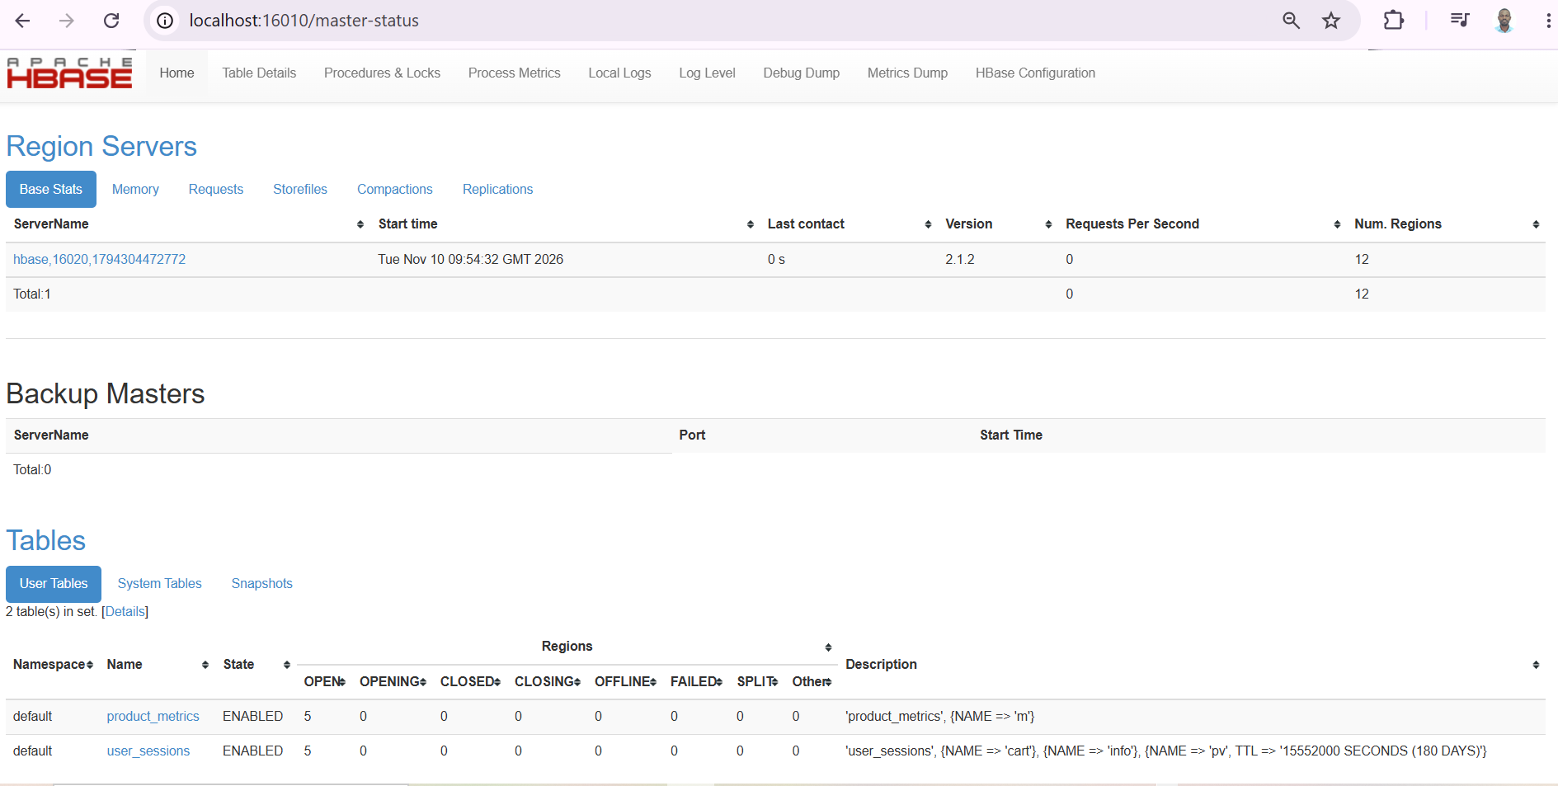
Comment: HBase 2.1.2 runs with one region server. Both user tables, user_sessions and product_metrics, are ENABLED with 5 regions each - the 4 split points of the schema took effect - and the description confirms the info, pv (TTL 180 days) and cart families.
Screenshot S3 - Spark UI during the cleaning job
Command: http://localhost:4040
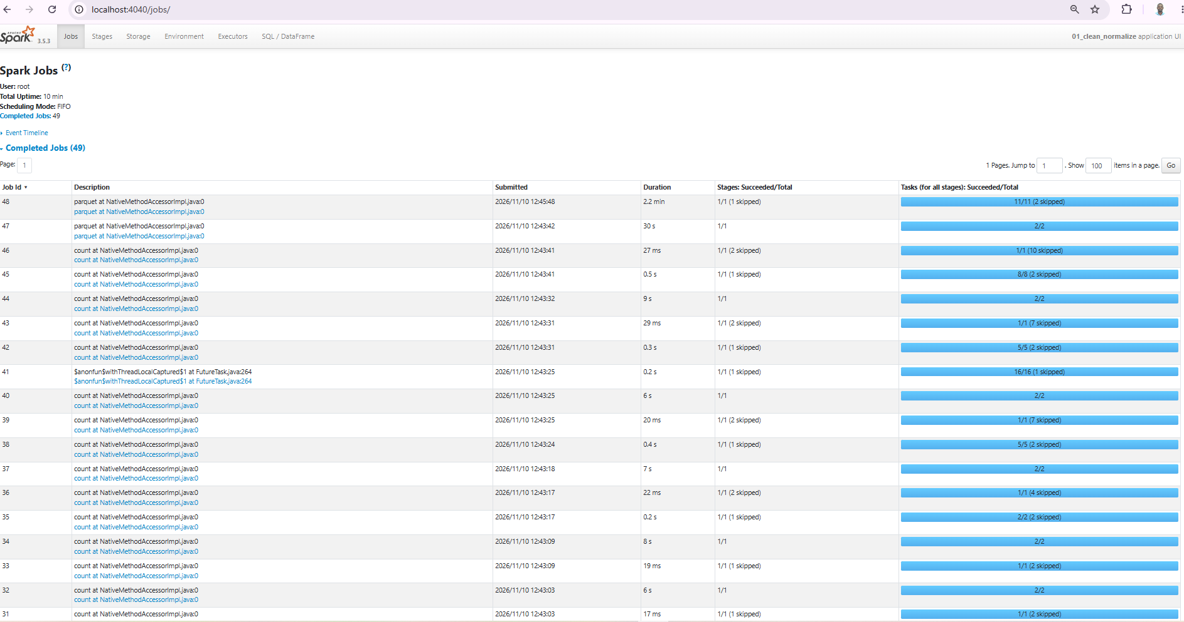
Comment: Spark 3.5.3 executed 49 jobs for 01_clean_normalize; the final jobs are the Parquet writes (up to 2.2 min) and the many short jobs are the data-quality counts. This is where stage times and skipped (cached) stages can be inspected.

C.2 Data generation
Screenshot S4 - Dataset generation (scale 0.1)
Command: python data_generation/dataset_generator.py --out data/raw --scale 0.1
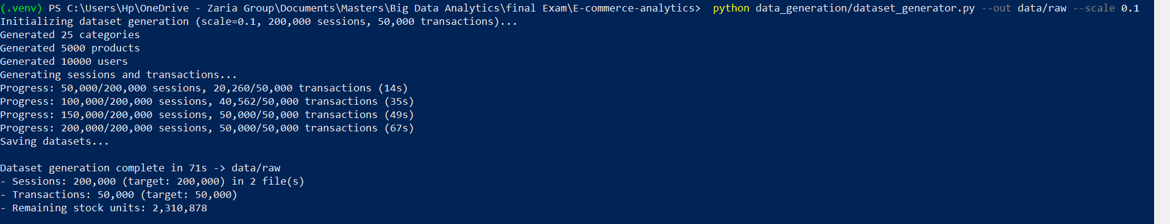
Comment: 200,000 sessions and 50,000 transactions were generated in 2 files in 71 s. The transaction target is reached between 100,000 and 150,000 sessions; after that, converted sessions no longer create orders - the root cause of the 15,552 gap reported in S9.

C.3 Part 1 - MongoDB
Screenshot S5 - Loading MongoDB
Command: python mongodb/load_mongodb.py --sessions-limit 50000
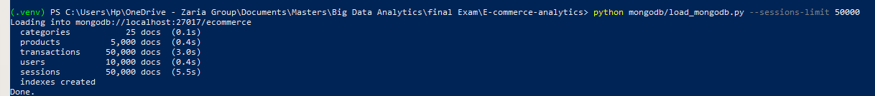
Comment: All five collections loaded with batched insert_many (unordered) in about 10 s, and the indexes were created.
Screenshot S6 - The four aggregation pipelines
Command: python mongodb/aggregations.py
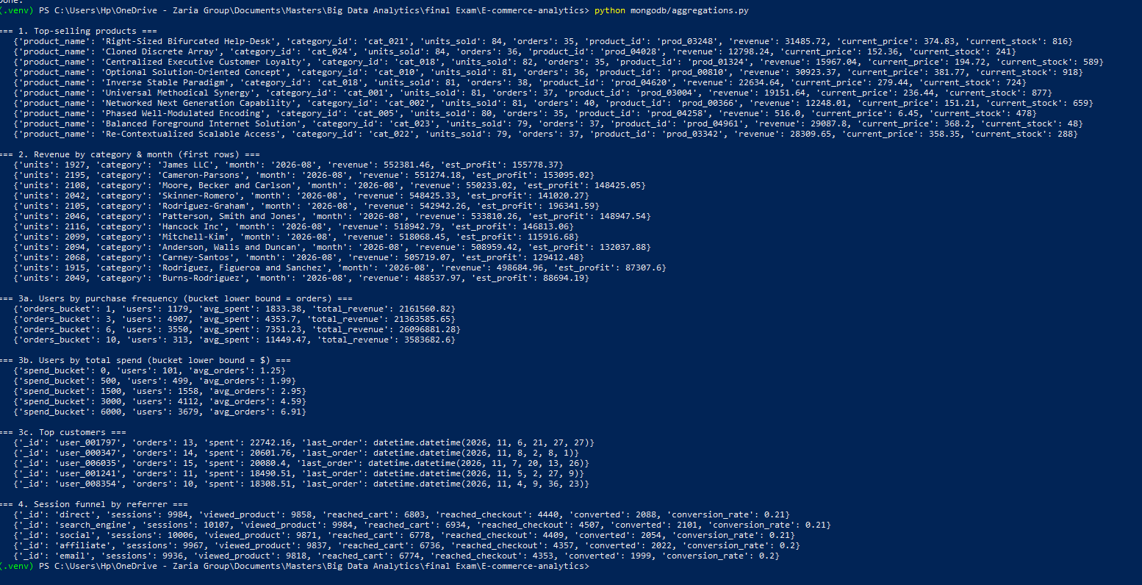
Comment: One run shows all pipelines: (1) top sellers - 84 units for the best product; (2) revenue and estimated profit per category per month; (3a/3b) frequency and spend buckets - 313 users with 10+ orders average $11,449; (3c) top customers; (4) session funnel by referrer - about 20-21% of sessions flagged converted for every referrer.
Screenshot S7 - mongosh: document counts and pipeline 1
Command: Get-Content mongodb\evidence.js | docker exec -i mongo mongosh ecommerce --quiet
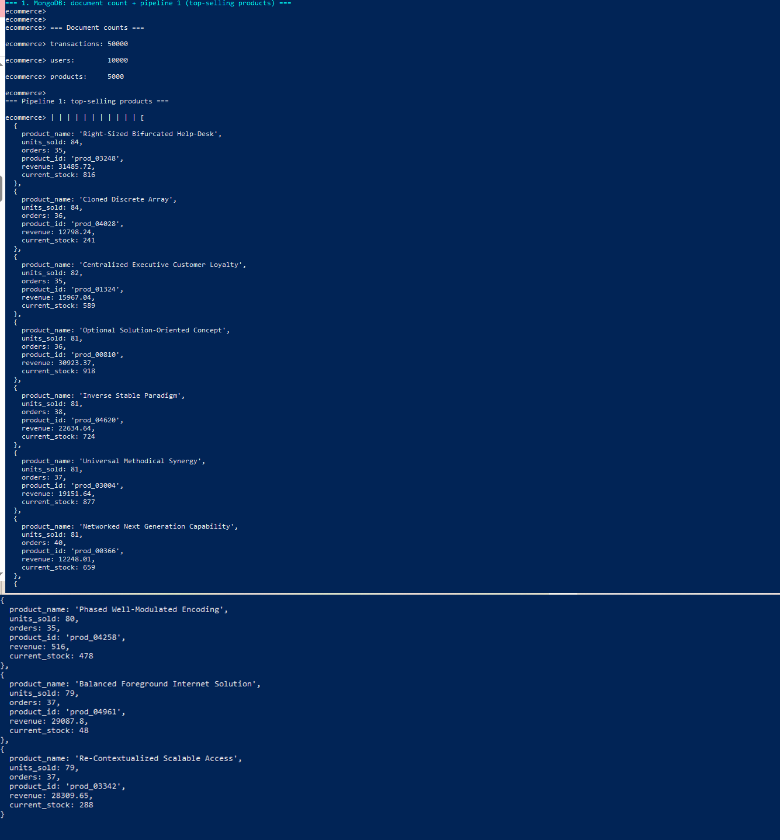
Comment: The same data queried directly in the MongoDB shell: 50,000 transactions, 10,000 users and 5,000 products, and the top-selling products pipeline with $lookup to current stock. Units, orders and revenue match the Python run (S6), proving the pipeline is identical in both clients.

C.4 Part 1 - HBase
Screenshot S8 - HBase shell: list, describe and a user prefix scan
Command: Get-Content hbase\evidence.hbase | docker exec -i hbase hbase shell -n
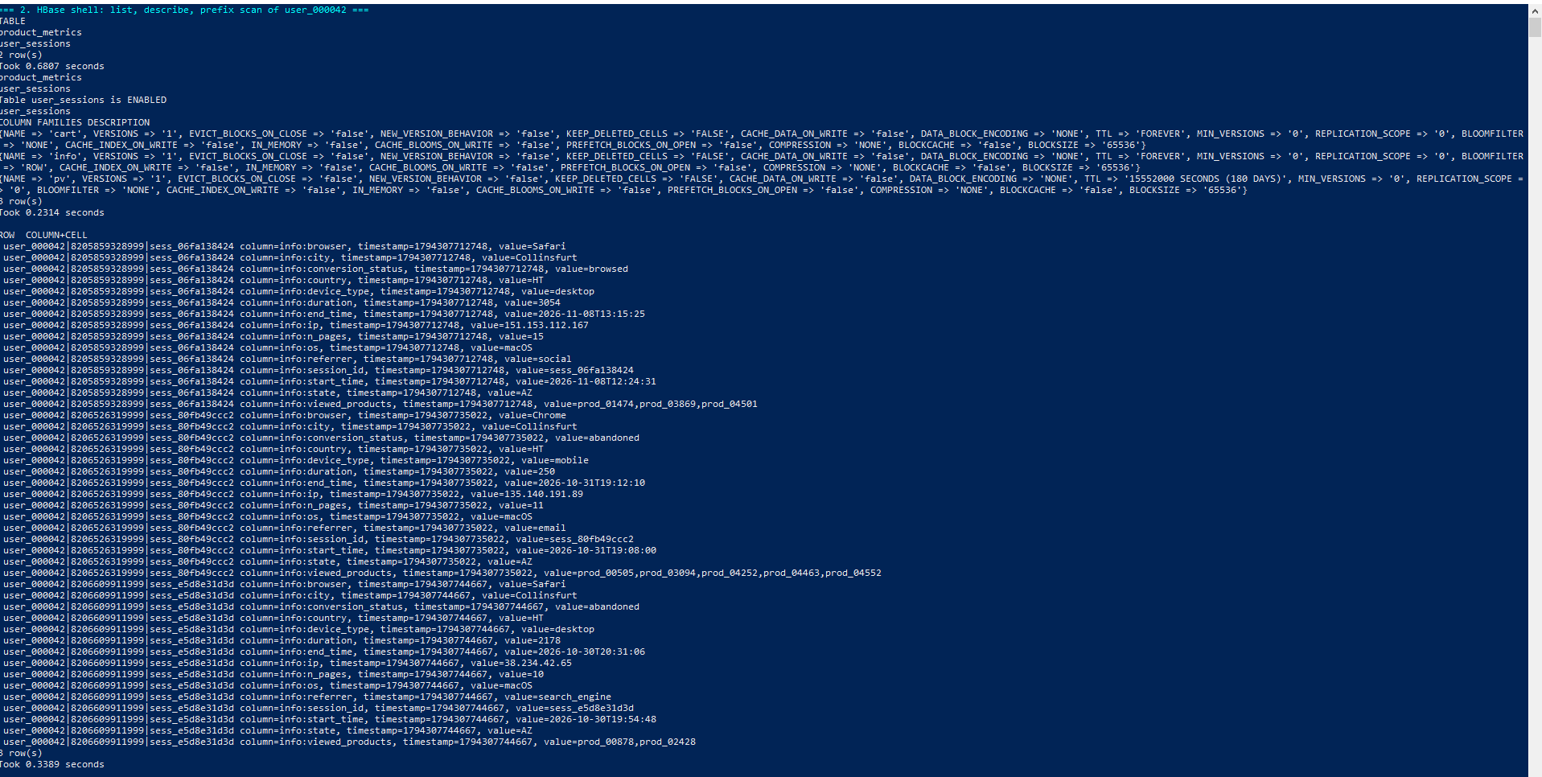
Comment: list shows both tables; describe shows the column families with VERSIONS 1, ROW bloom filter and the 180-day TTL on pv. The prefix scan of user_000042| returns that user's 3 most recent sessions first, without any sort - the reversed timestamp in the row key at work; info holds one cell per attribute.

C.5 Part 2 - Spark processing
Screenshot S9 - Cleaning job and data-quality report
Command: docker compose exec -T app python spark/01_clean_normalize.py
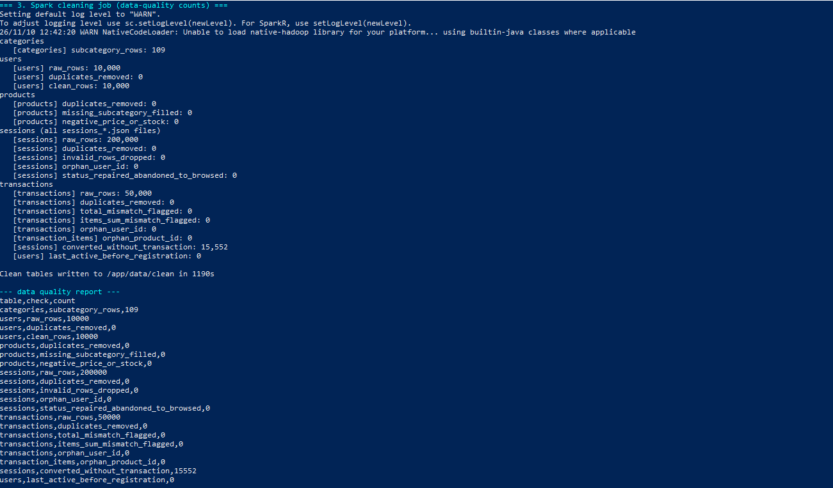
Comment: All 200,000 sessions, 50,000 transactions and 10,000 users passed validation: 0 duplicates, 0 invalid rows, 0 orphan ids and 0 total mismatches. The one material issue - 15,552 converted sessions without a transaction - is flagged rather than deleted. Runtime 1,190 s, mostly multi-line JSON parsing.
Screenshot S10 - Recommendation indicators
Command: docker compose exec -T app python spark/02_recommendations.py
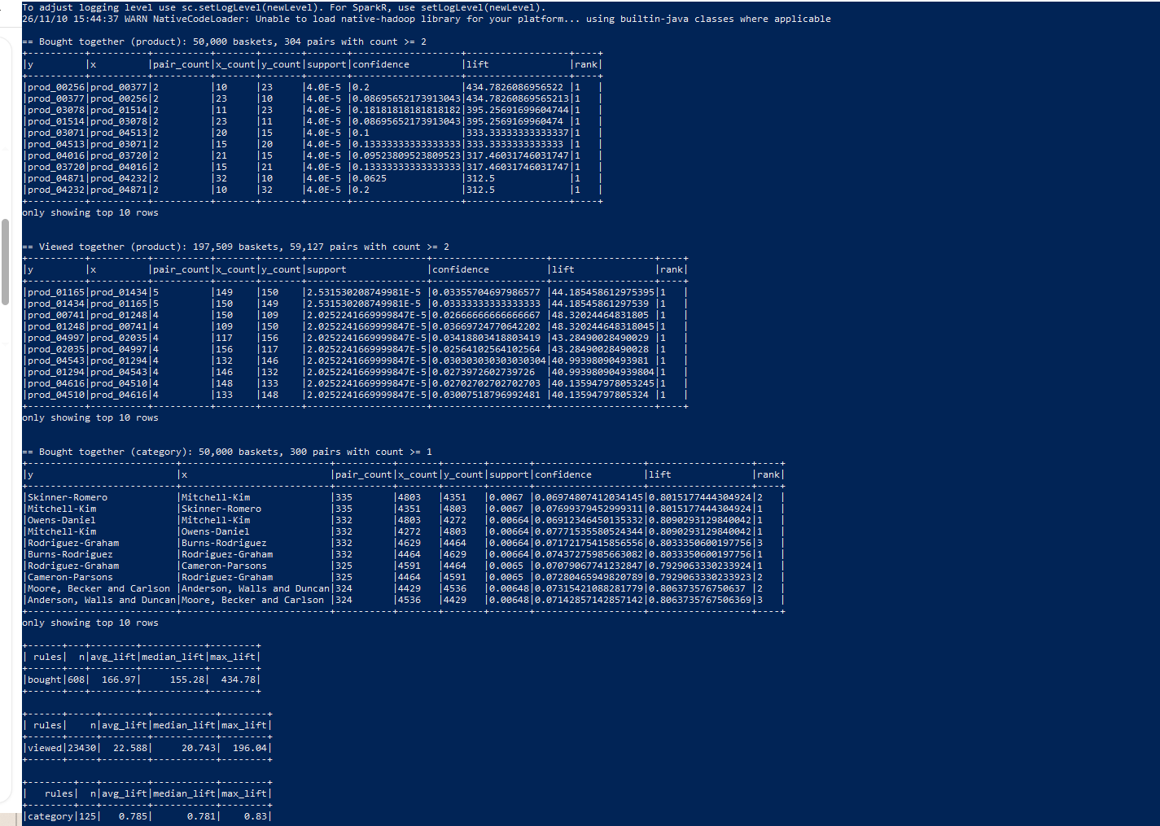
Comment: Bought-together: only 304 product pairs occur twice or more in 50,000 baskets, and their very high lifts (up to 435) come from tiny counts. Viewed-together: 59,127 pairs. Category lift ~0.79 (< 1). Together these show the random synthetic data contains no real affinity - the method is sound but needs support thresholds on real data.
Screenshot S11 - Cohort analysis
Command: docker compose exec -T app python spark/03_cohort_analysis.py
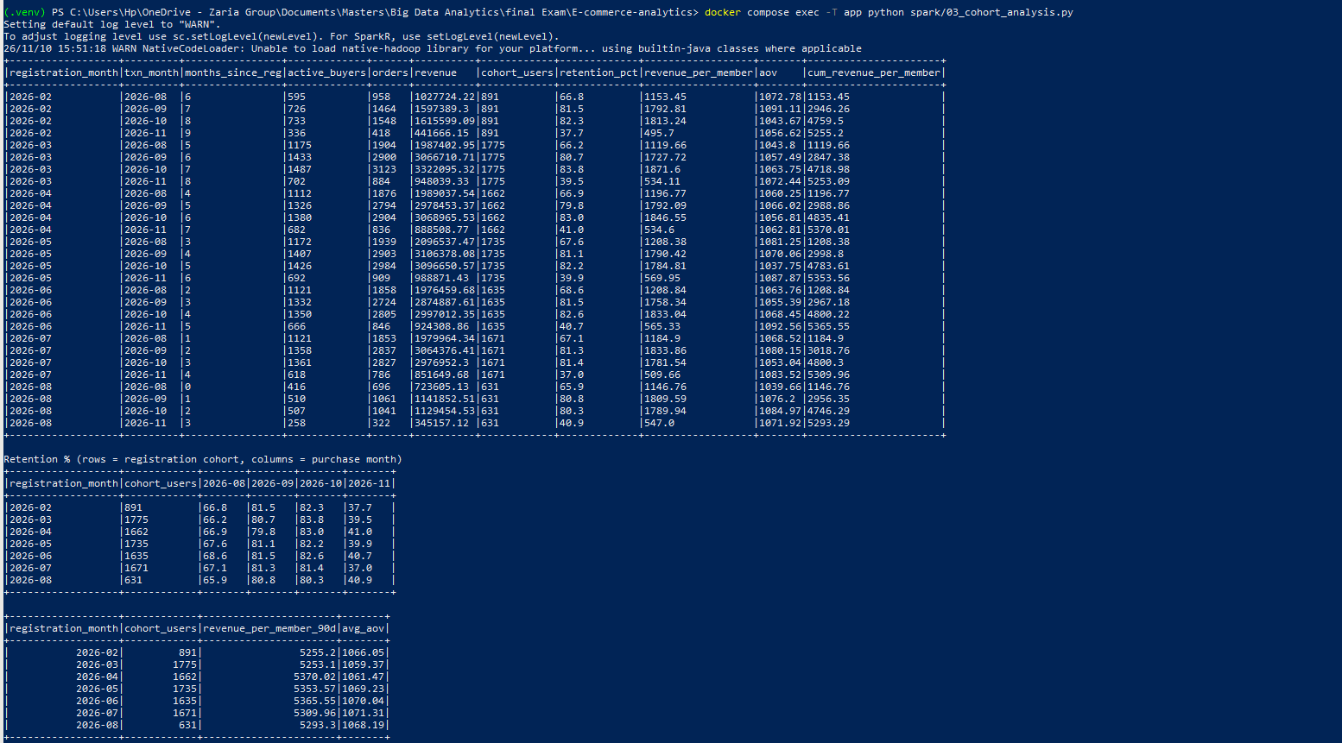
Comment: Seven registration cohorts (Feb-Aug 2026): about 80-84% of each cohort buys in each full month (September, October); August and November are partial months. Revenue per member over 90 days is flat ($5,253-$5,370), so cohort age makes no difference.
Screenshot S12 - Spark SQL analytics
Command: docker compose exec -T app python spark/04_spark_sql_analytics.py
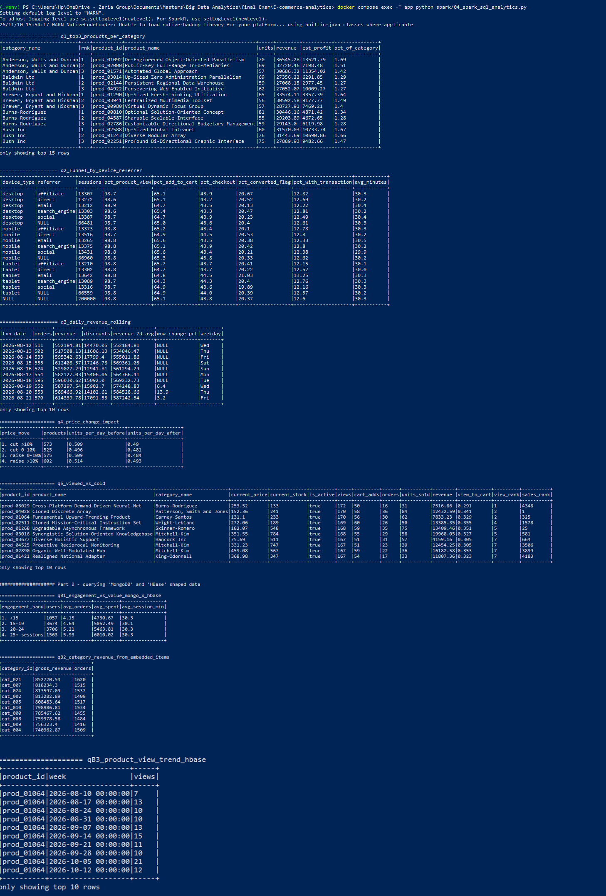
Comment: Part A: top-3 products per category (RANK), funnel by device/referrer with ROLLUP (12.6% of all 200,000 sessions have an order), 7-day rolling revenue, price-change impact (≈0.51 → ≈0.49 units/day for every price move) and viewed-vs-sold ranks. Part B: MongoDB-shaped users joined with HBase-shaped sessions - spend rises from $4,731 (<15 sessions) to $6,010 (25+).

C.6 Part 3 - Integrated analytics
Screenshot S13 - Customer Lifetime Value (MongoDB + HBase via Spark)
Command: docker compose exec -T app python integration/clv_analysis.py --mongo mongo --hbase hbase
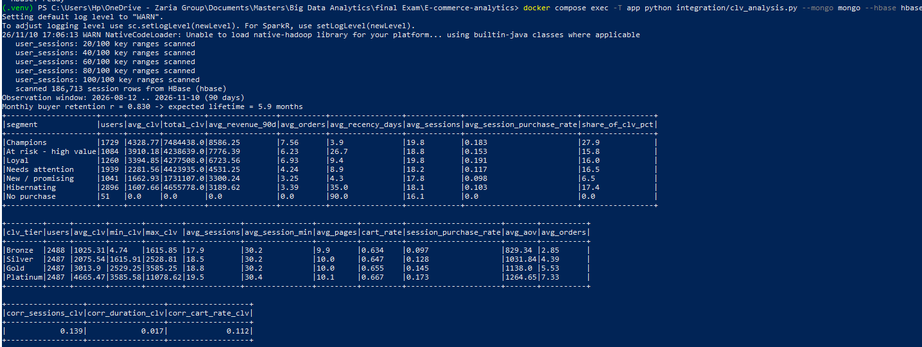
Comment: Spark read users and orders from MongoDB and sessions from HBase in 100 row-key ranges, estimated retention r = 0.830 (5.9-month lifetime) and produced the segment, tier and correlation tables of Section 5.1. It scanned 186,713 sessions because HBase was only partly loaded; retake after the full reload (expect 200,000).
Screenshot S14 - Funnel conversion (HBase journeys + MongoDB purchases)
Command: docker compose exec -T app python integration/funnel_analysis.py --mongo mongo --hbase hbase
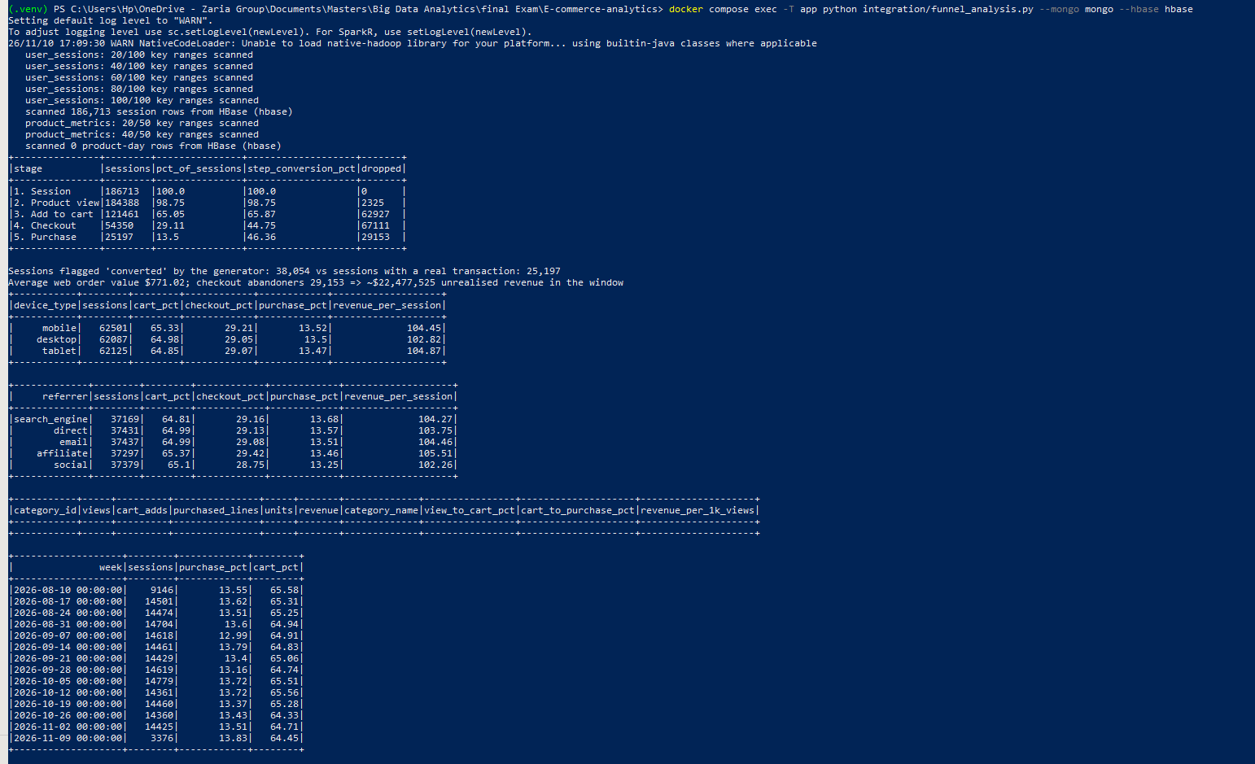
Comment: Stage counts, device, referrer and weekly funnels, and the generator-vs-MongoDB reconciliation (38,054 flagged vs 25,197 real orders). Retake after the full HBase reload: this run saw 186,713 sessions and 0 product_metrics rows, so the category table is empty. Expected: 200,000 sessions, 40,749 flagged vs 25,197 purchases (12.6%) and a filled category table.

