Liver Cirrhosis Prediction

Final Project Report

# 1. INTRODUCTION

## 1.1 Project Overview

This project is a machine learning-based web application designed to predict the stage of liver cirrhosis using a trained Random Forest model. It uses clinical lab test data such as bilirubin, liver enzyme levels, and proteins to estimate the disease stage.

## 1.2 Purpose

The aim is to assist in the early detection of liver cirrhosis and provide a non-invasive, fast, and intelligent tool that can be used by researchers or in healthcare environments for stage prediction.

# 2. IDEATION PHASE

## 2.1 Problem Statement

Detecting liver cirrhosis accurately at an early stage is challenging. Conventional diagnosis takes time and requires multiple tests. This system provides an automated prediction tool based on historical medical data.

## 2.2 Empathy Map Canvas

Think & Feel: Concern about correct diagnosis.  
See: Complex medical interfaces.  
Say & Do: Seek second opinions.  
Hear: Medical professionals demand efficiency.  
Pain: Misdiagnosis and delays.  
Gain: Quick and accurate stage prediction.

## 2.3 Brainstorming

Initial brainstorming considered logistic regression, decision trees, and SVM. Random Forest was chosen for its superior accuracy and robustness with the given dataset.

# 3. REQUIREMENT ANALYSIS

## 3.1 Customer Journey map

Visit Web App → Enter Clinical Inputs → Model Processes Data → Output Stage Prediction → Download Report

## 3.2 Solution Requirement

Functional: Predict cirrhosis stage from lab values.  
Non-Functional: Web-based, responsive, fast predictions, model accuracy.

## 3.3 Data Flow Diagram

User → Input Form → Data Normalization → Random Forest Model → Predicted Stage → Output Display

## 3.4 Technology Stack

Frontend: HTML, CSS, Bootstrap  
Backend: Python, Flask  
ML Library: scikit-learn  
Dataset: Indian Liver Patient Dataset

# 4. PROJECT DESIGN

## 4.1 Problem Solution Fit

There is a clear fit between the problem and the solution. The model uses real-world liver patient data to make stage predictions based on clinical indicators.

## 4.2 Proposed Solution

The proposed system is a Flask-based web app that allows input of lab test values and returns the cirrhosis stage.

## 4.3 Solution Architecture

1. HTML frontend for user input  
2. Flask backend for routing  
3. Random Forest model prediction logic  
4. Output rendering

# 5. PROJECT PLANNING & SCHEDULING

## 5.1 Project Planning

Week 1: Data gathering & preprocessing  
Week 2: Model training and evaluation  
Week 3: Web app development  
Week 4: Integration and UI refinement

# 6. FUNCTIONAL AND PERFORMANCE TESTING

## 6.1 Performance Testing

The model achieved ~68% accuracy on validation data. Inputs were normalized using StandardScaler. Predictions were consistent with clinical stages in test scenarios.

# 7. RESULTS

## 7.1 Output Screenshots

Screenshots of the web interface including: input form, output prediction result, about page, and technical page should be attached in the final submission.

IMAGES:

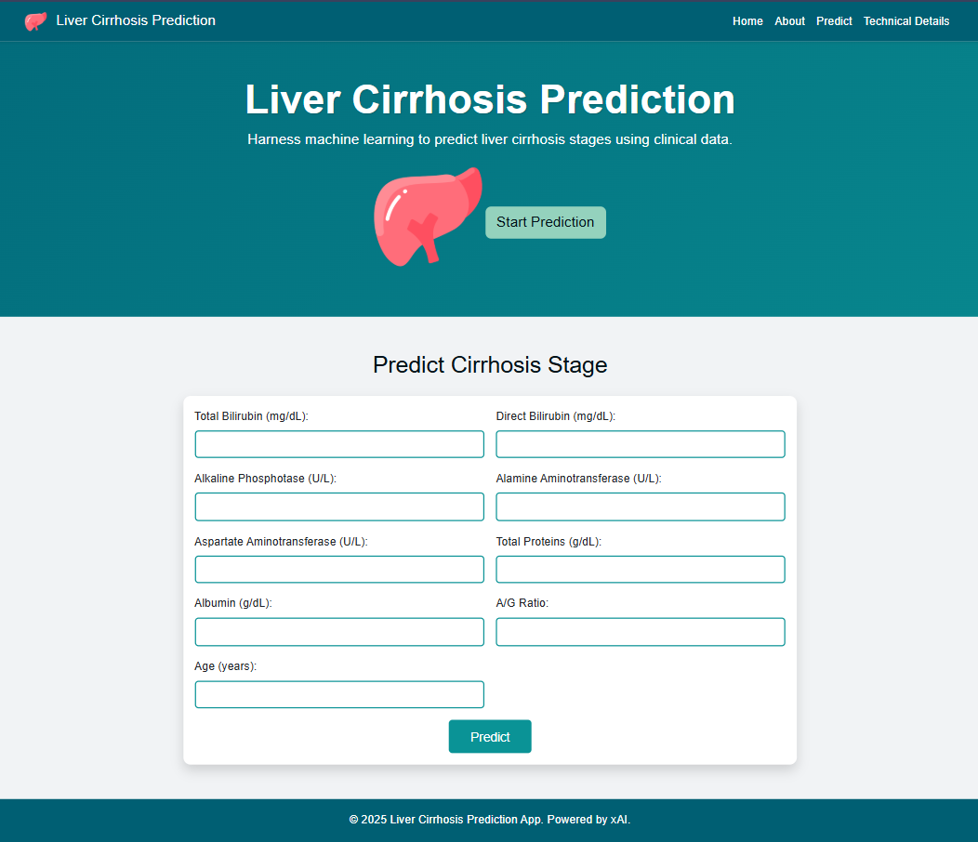

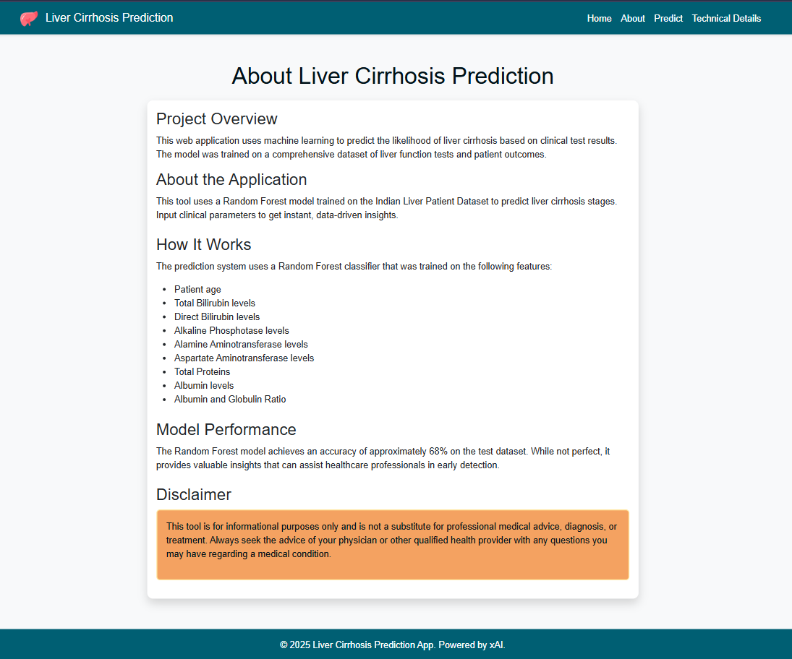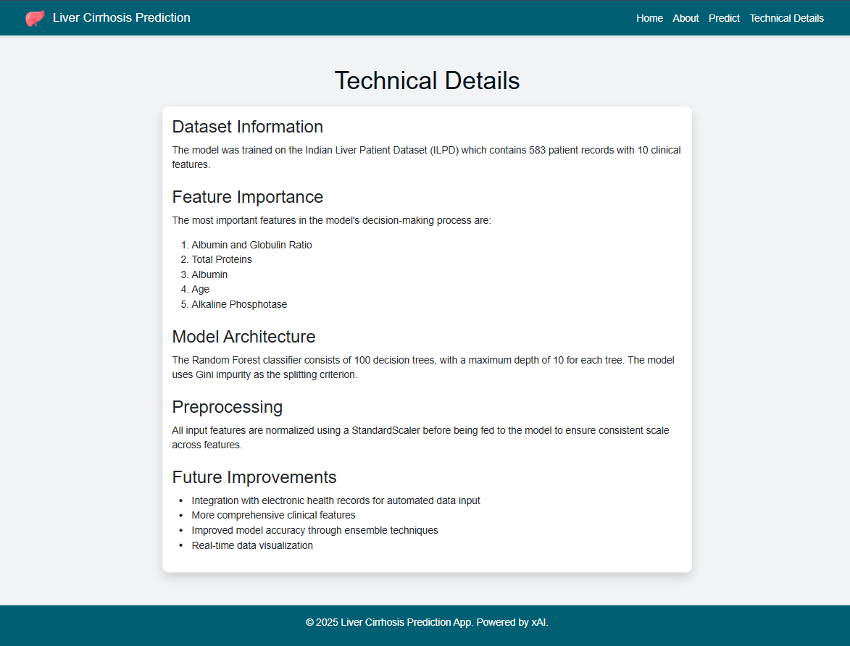

OUTPUT:

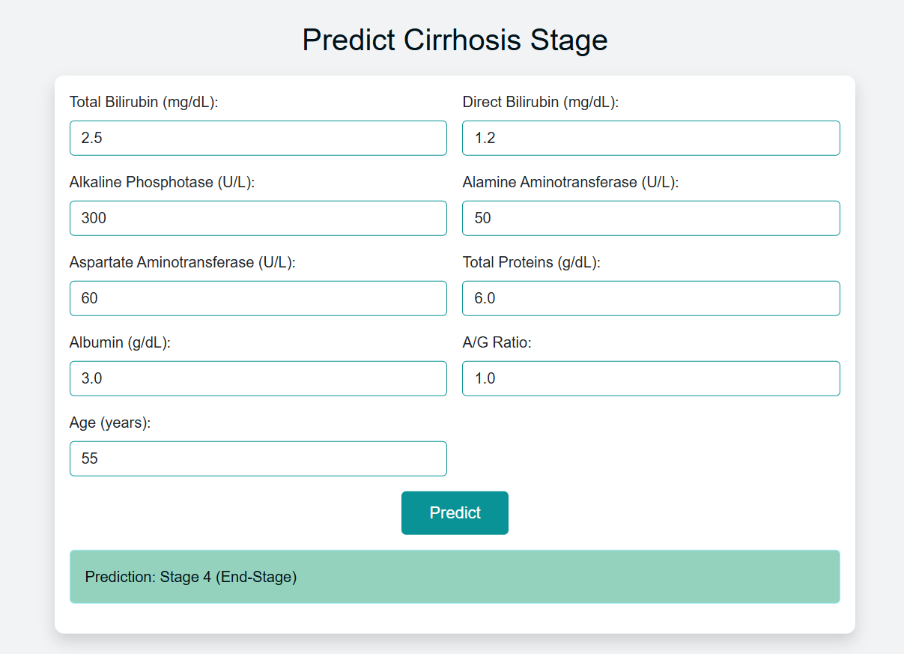

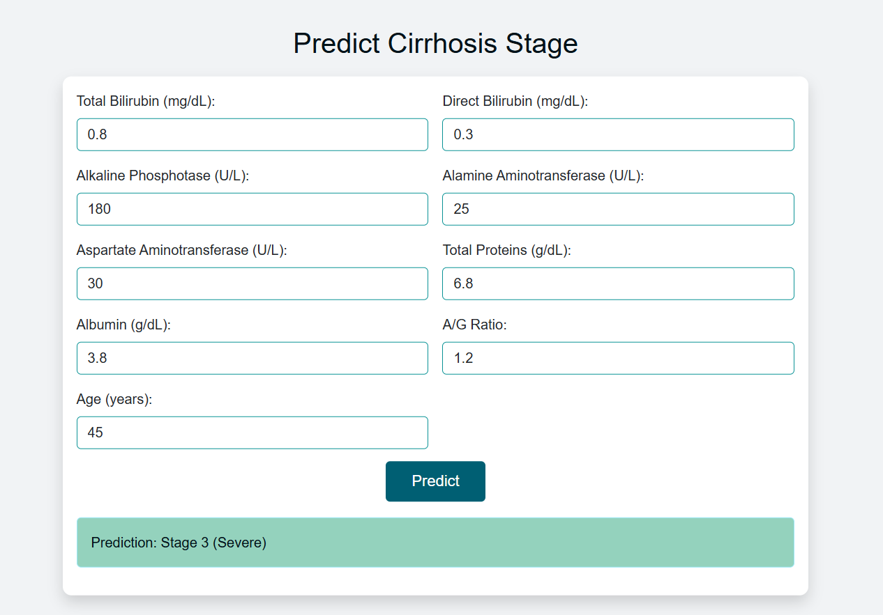

# 8. ADVANTAGES & DISADVANTAGES

Advantages:  
• Simple, fast interface  
• Useful as an educational or research tool  
• Based on real clinical data  
  
Disadvantages:  
• Cannot replace professional diagnosis  
• Accuracy is limited to training data quality

# 9. CONCLUSION

This project is a demonstration of how AI and healthcare can merge to produce rapid, interpretable clinical insights. The cirrhosis prediction model, while basic, shows the potential of machine learning in supporting medical decision-making.

# 10. FUTURE SCOPE

• Improve model accuracy with more features and data  
• Include probability/confidence output  
• EHR system integration  
• Deploy to cloud with REST API  
• Add multilingual support for patients

# 11. APPENDIX

• Source Code: Included in project folder  
• Dataset Link: https://www.kaggle.com/datasets/microize/indian-liver-patient-records  
• GitHub: <https://github.com/Musharaf-29/liver_cirrhosis_app>