**Version Control System**

1. Create a html file at local drive to push on Github.

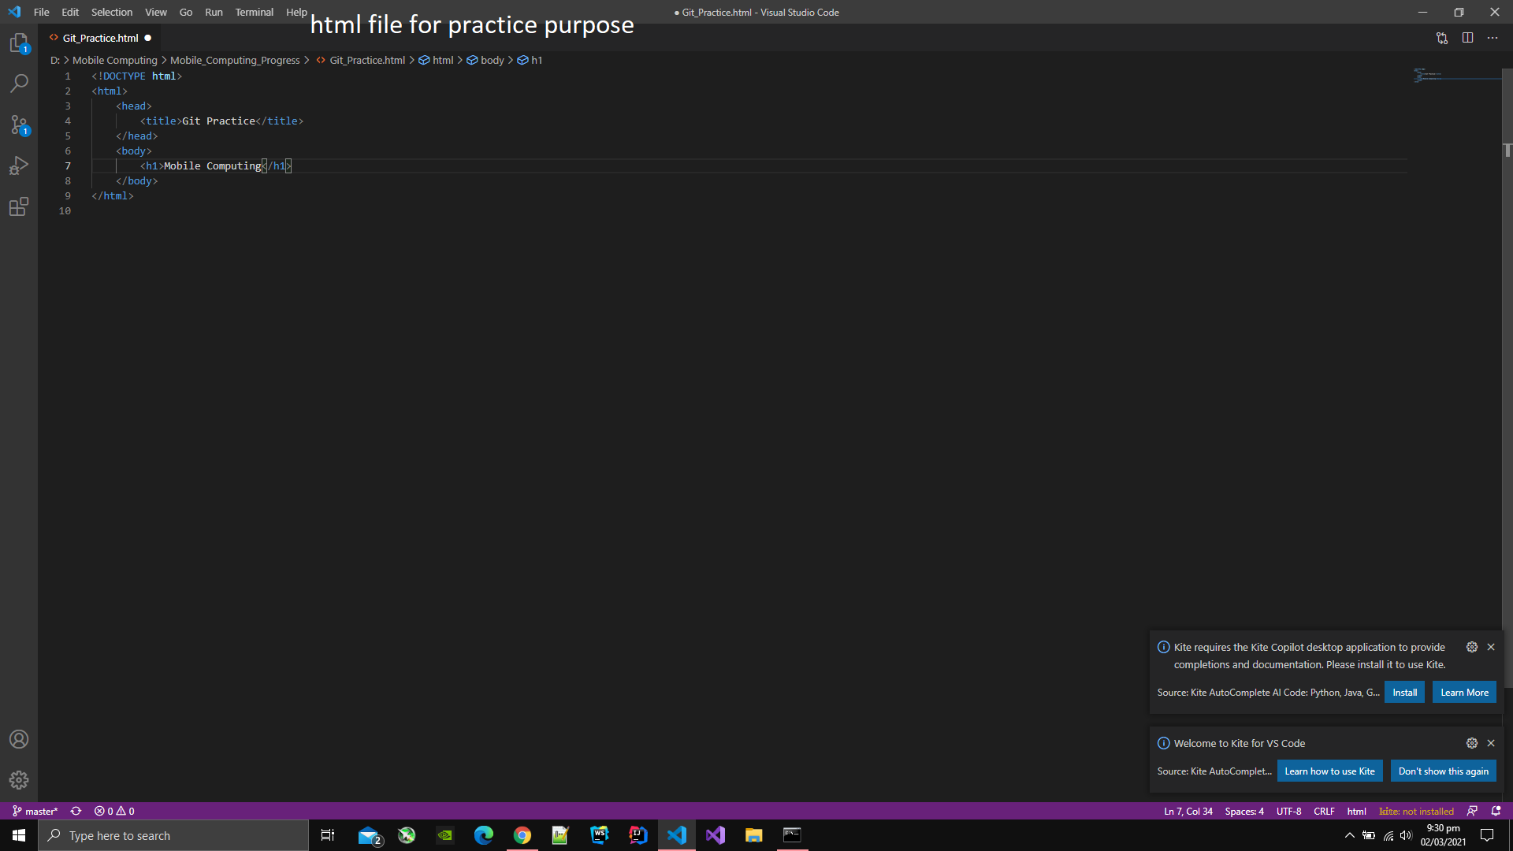

1. Open command line.
2. Move to the the directory where html file is created.
3. Type git clone [url of repository ].

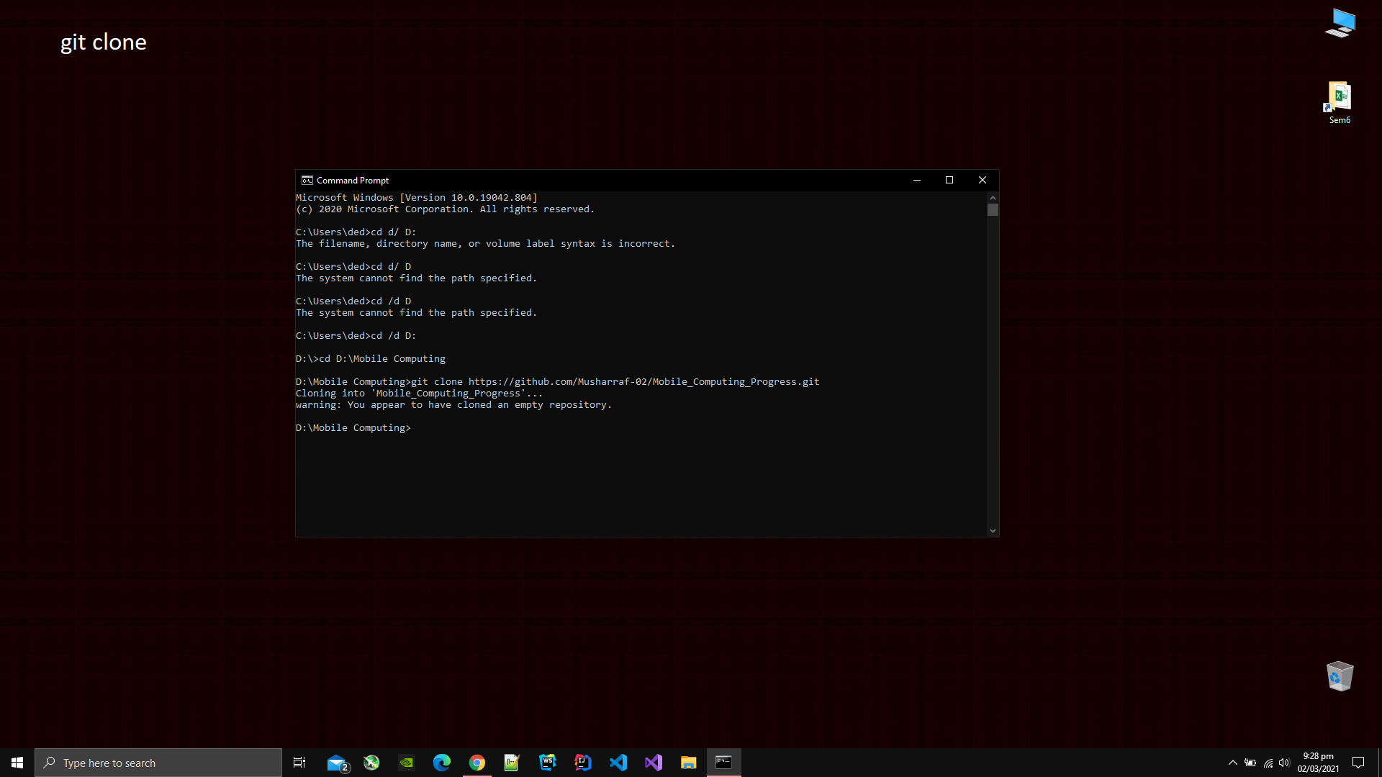

1. Type git add [name of file or folder] to add that file or folder on the git hub.

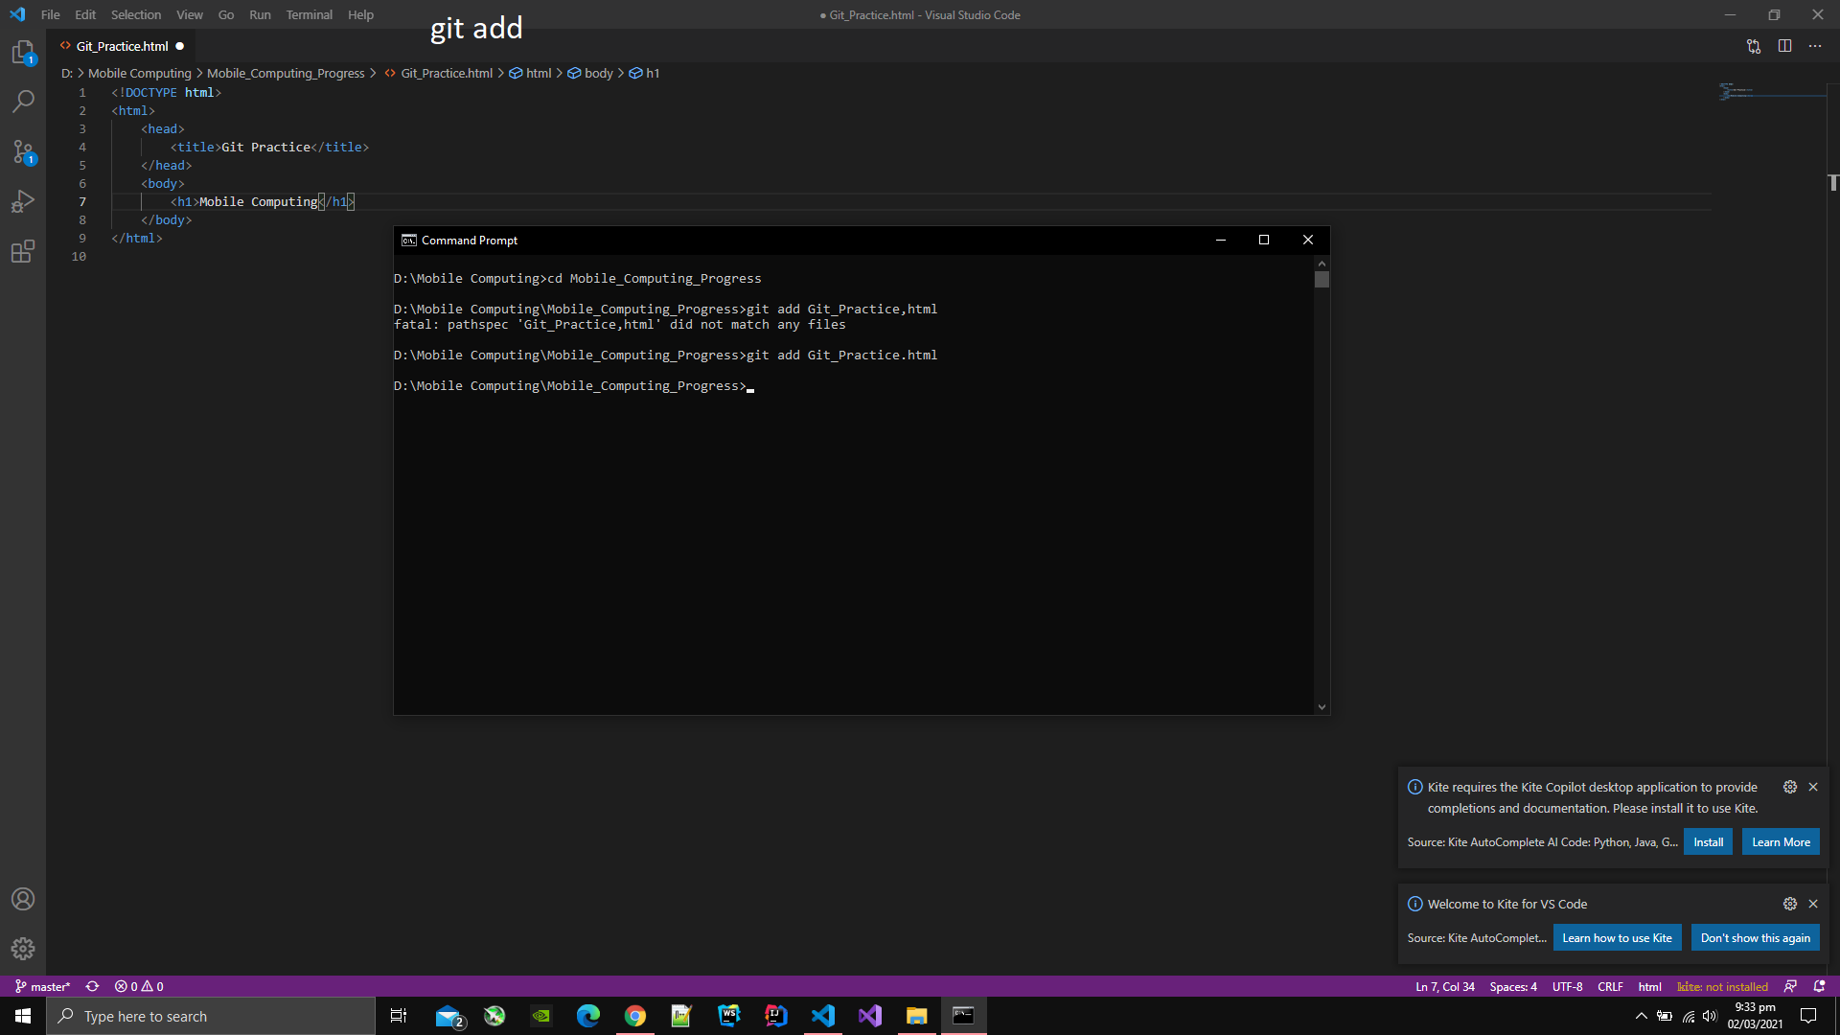

1. Type git commit -m [message for the commit].

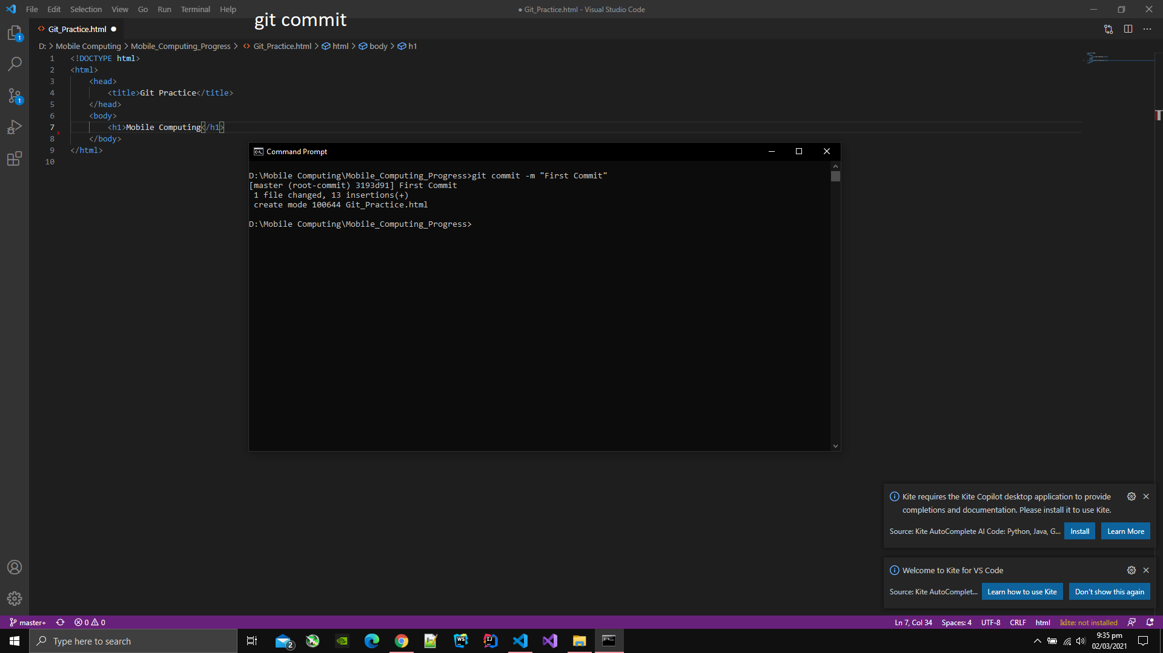

1. Type git push to push the file or directory on the Github repository that was added.

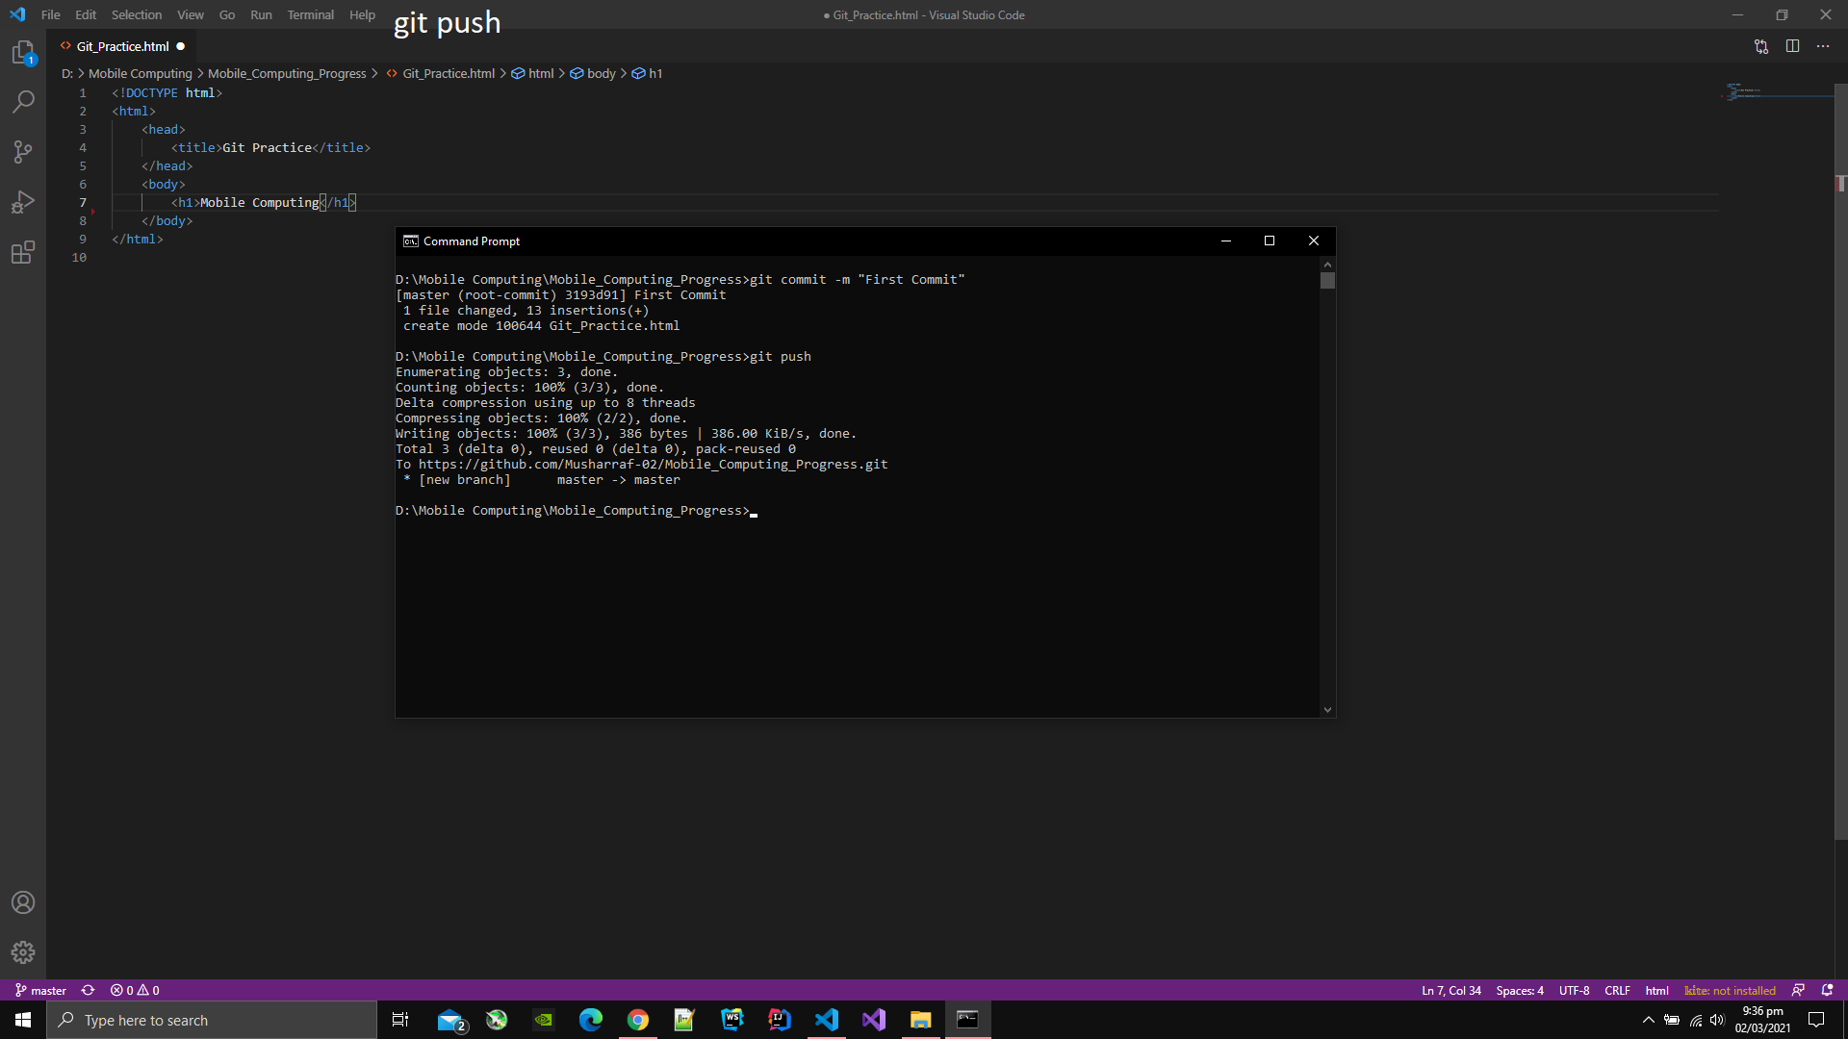

1. You can see the message on the site that was typed in the command git commit -m [message].

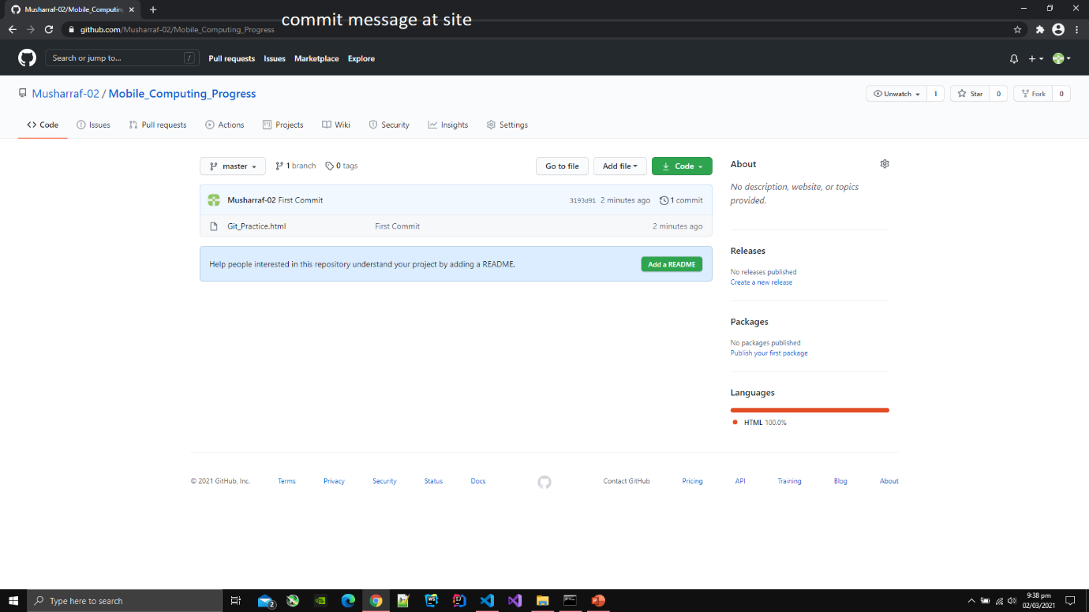

1. You can also see the content of file at Github via clicking on the file.

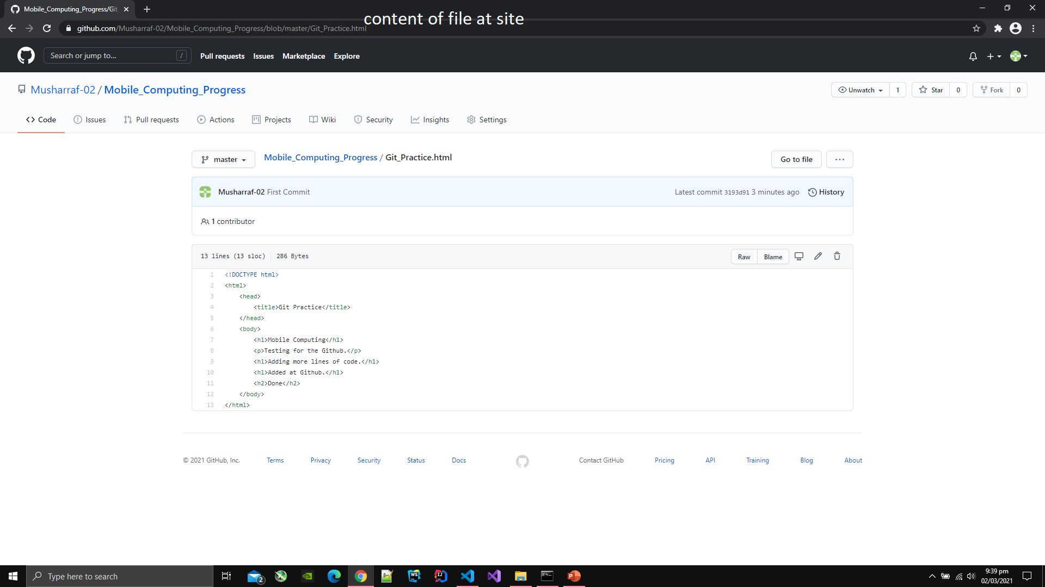

1. Now changing file content at editor.

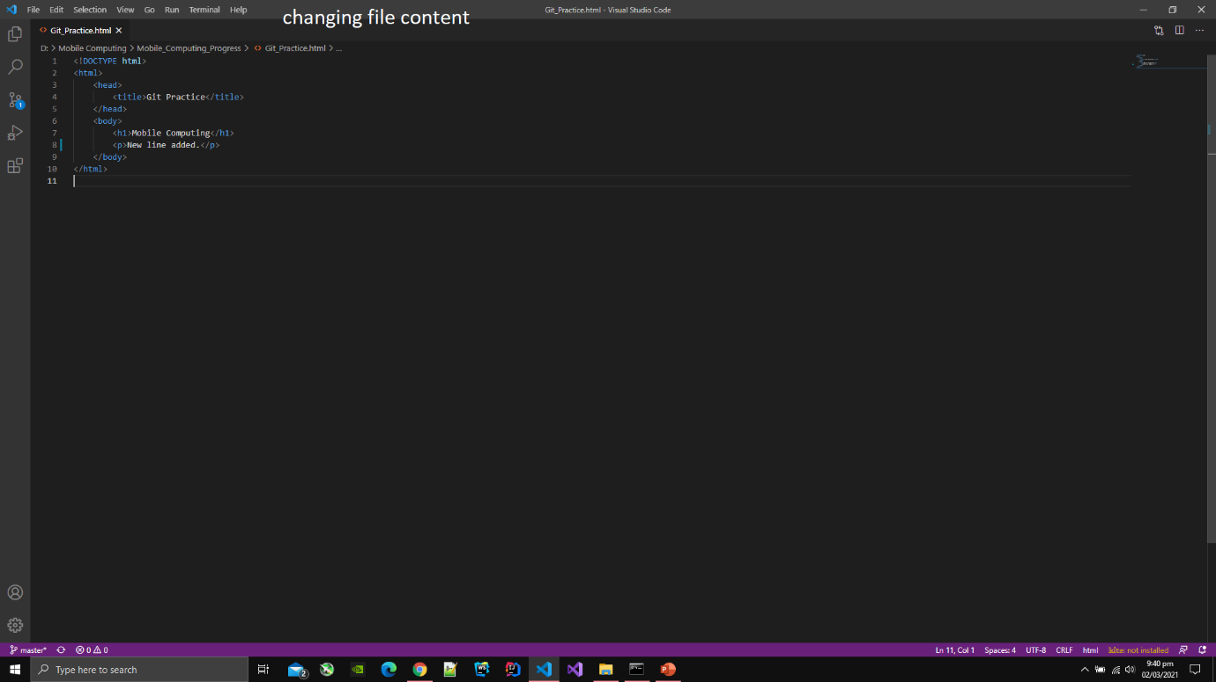

1. Again adding the file and commiting at the same time by typing command git commit -am [message].

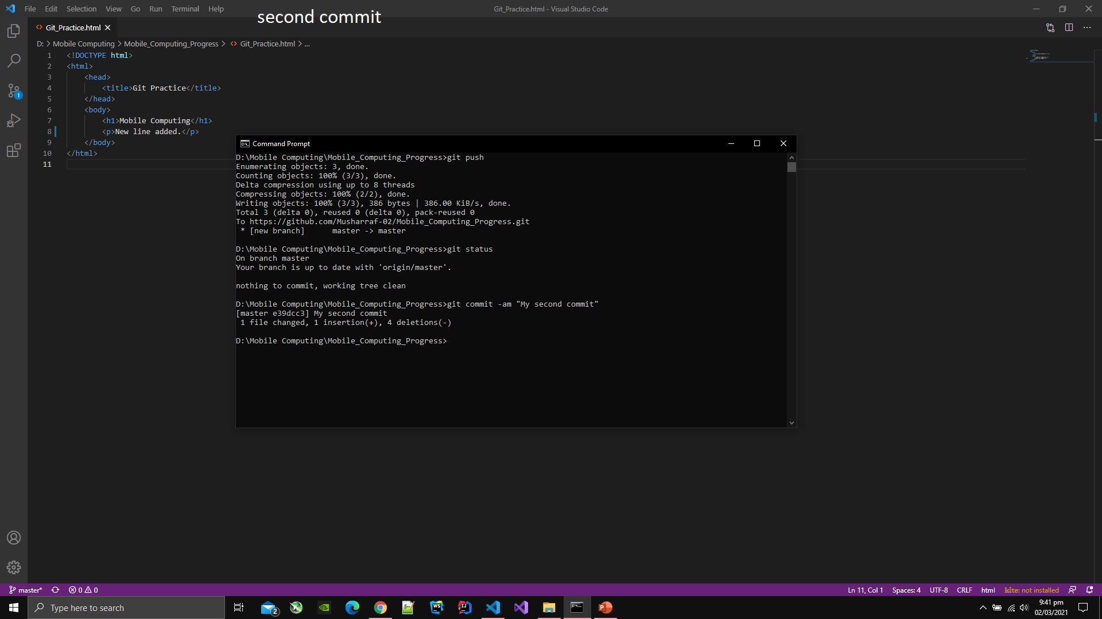

1. Type git push to add the file or directory on Github that was added before.

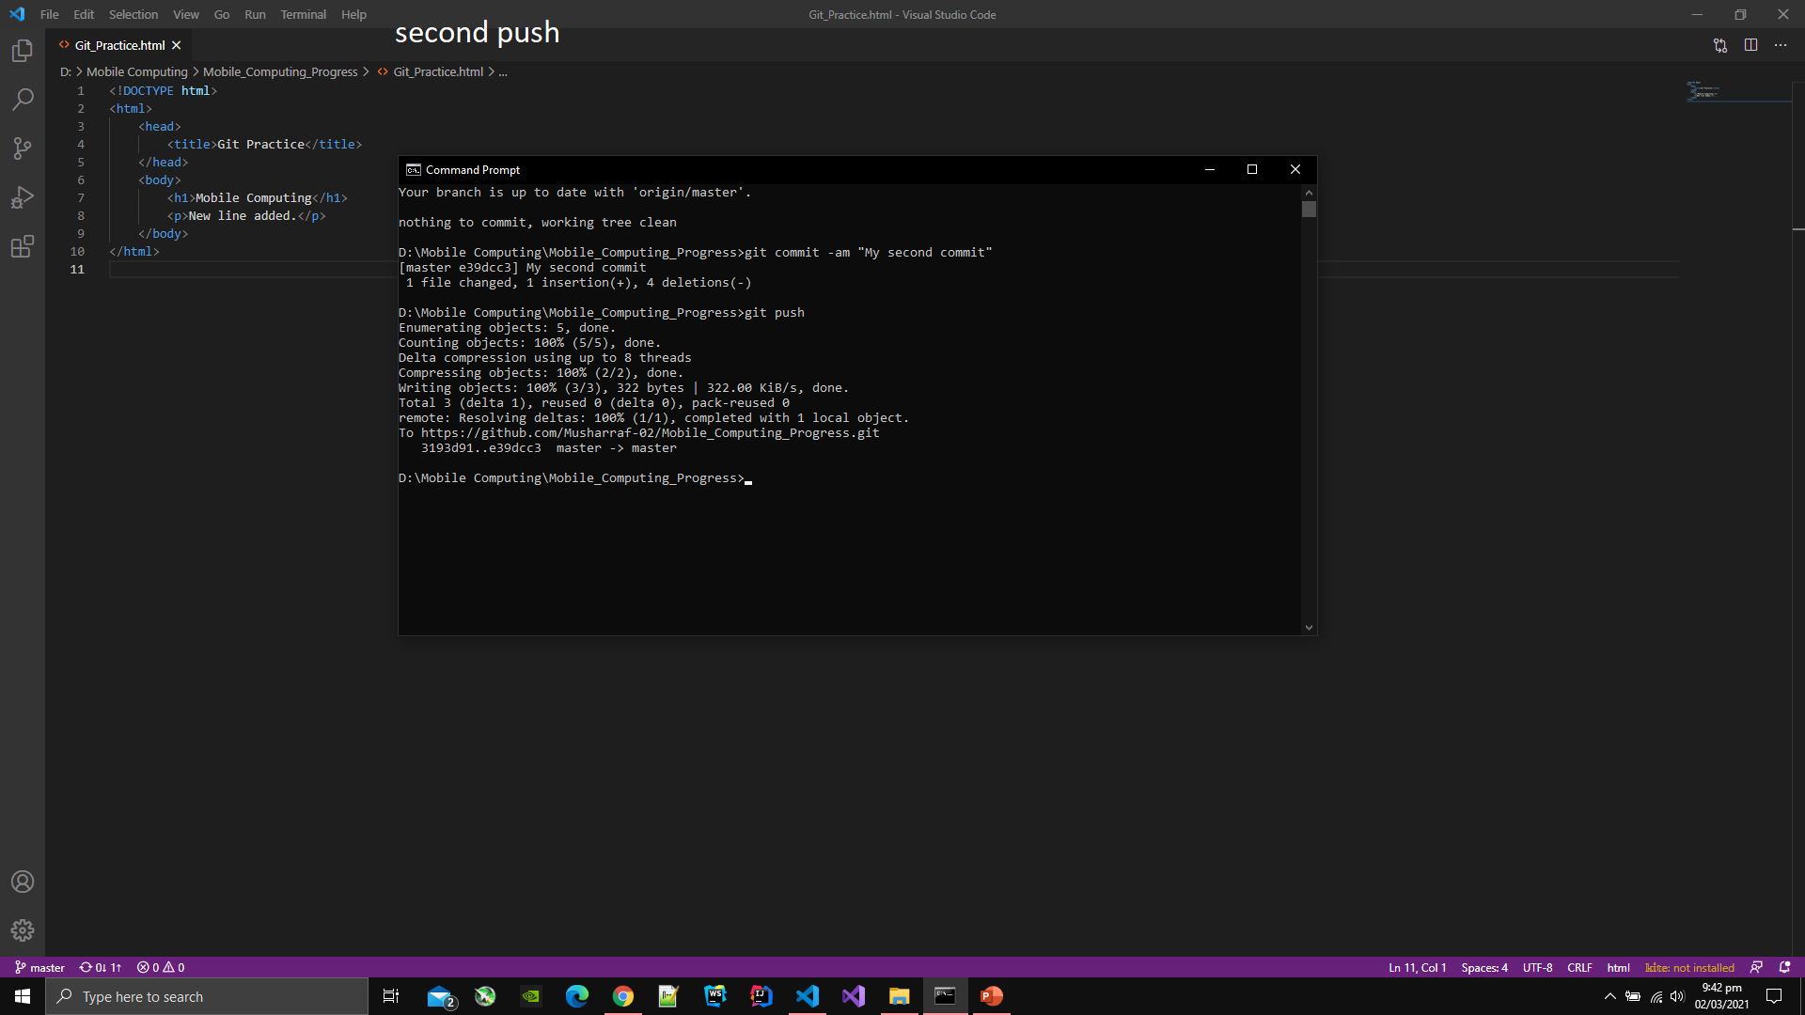

1. You can see the status of branch via typing git status.

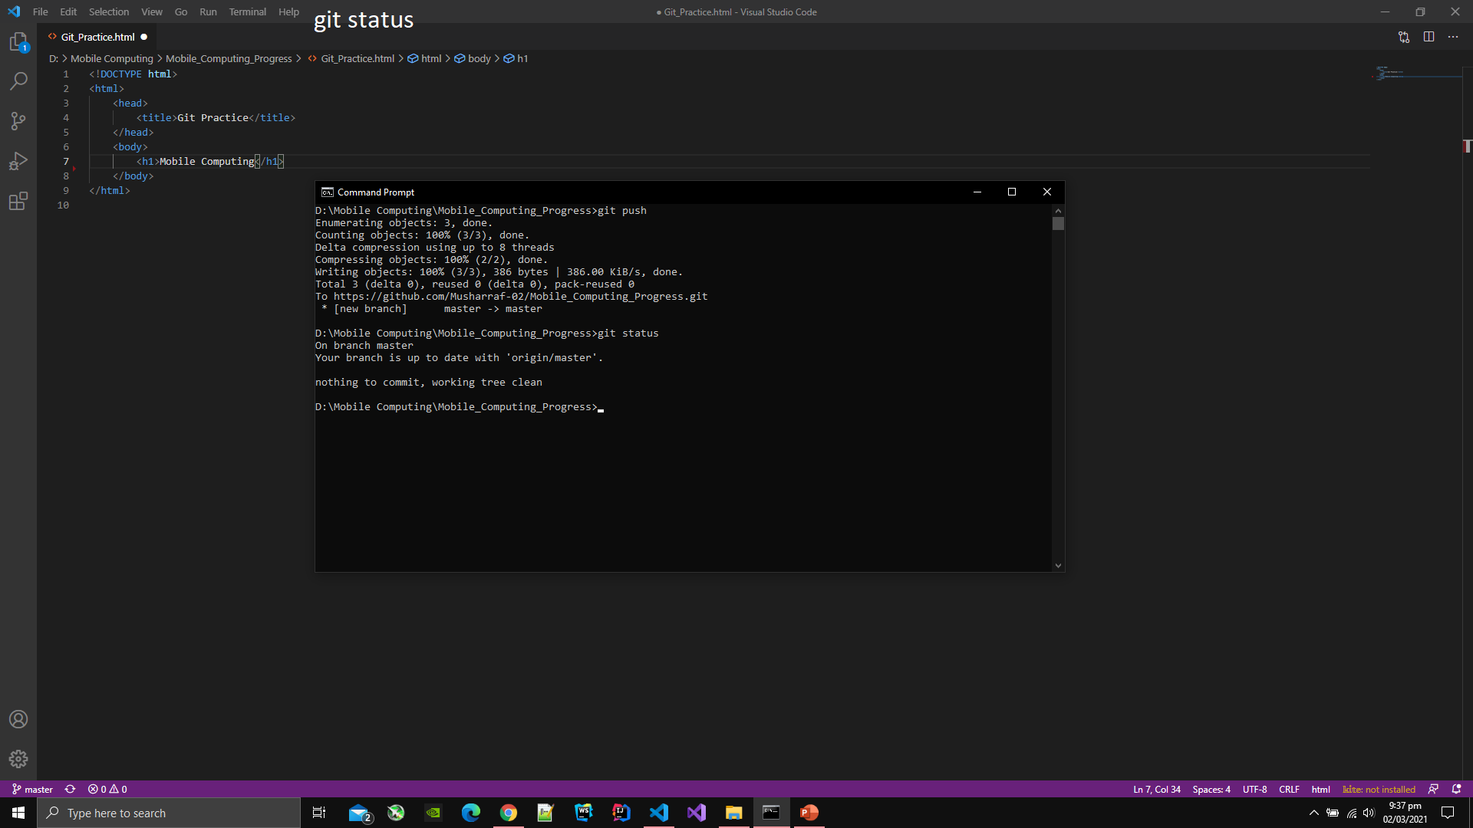

1. You can see the message at the site that was typed in the commit command.

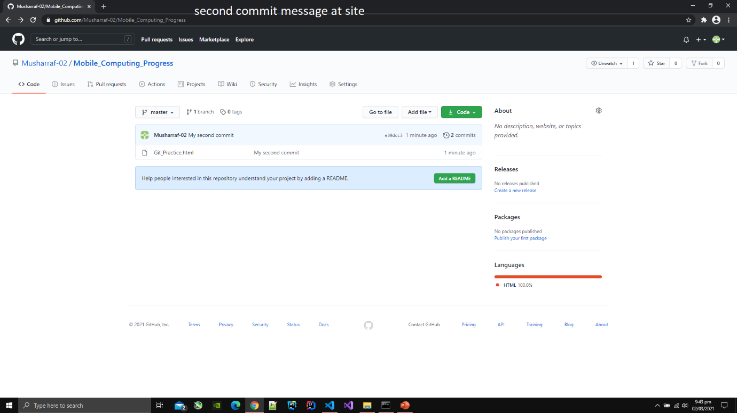

1. You can also change the content of file at the Github site.
2. Click on the pencil icon then the file will open in the online editor.
3. Then you can edit the content of file at the site.

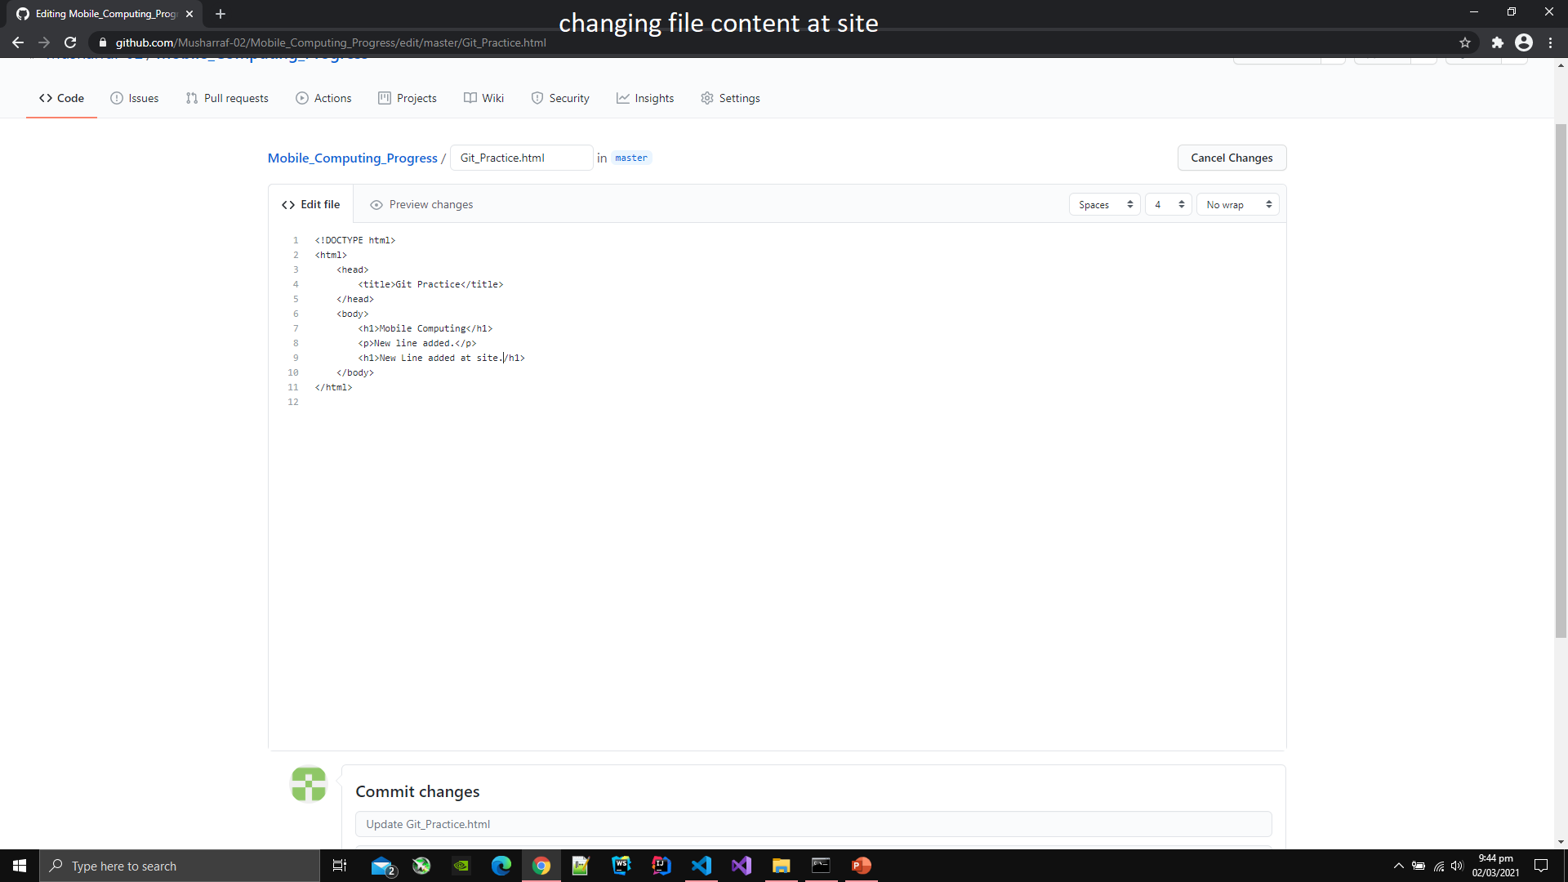

1. After editing file at the site you have to commit changes at the site.
2. To commit changes at the site press the button Commit Changes.

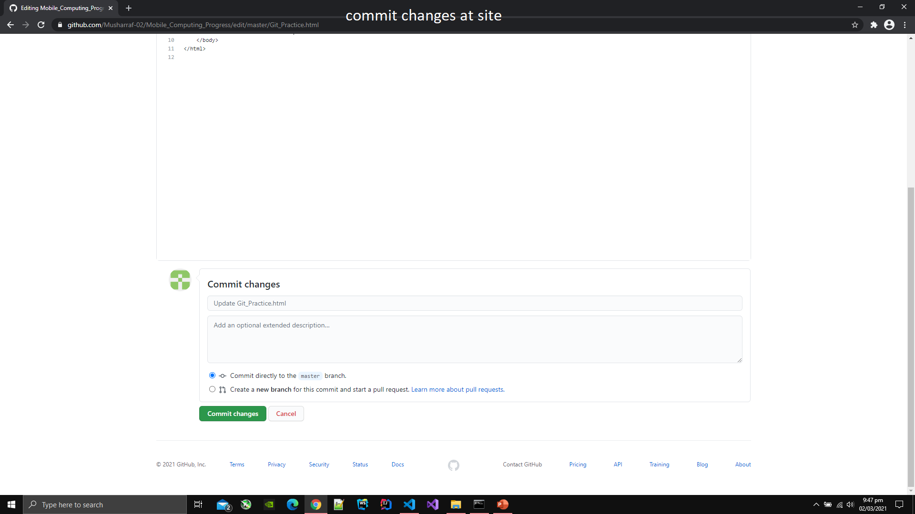

1. After pressing the button you can see the commit message as Update [file name].

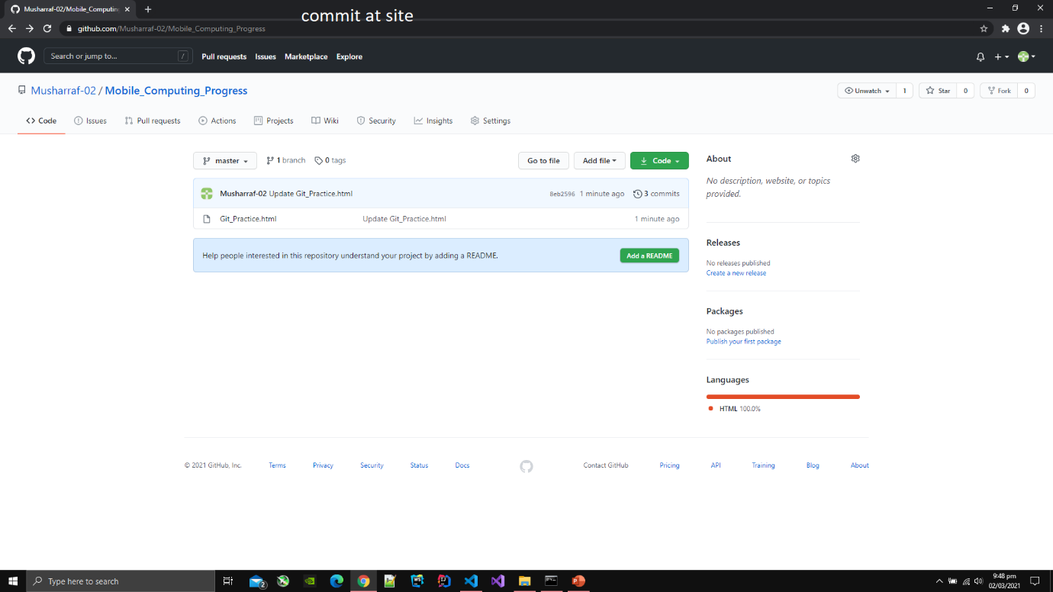

1. You can also see the version hierarchy at the site.
2. Click on the number like e39cc3 that is assinged by Github than all the changes that were made will be highlighted.

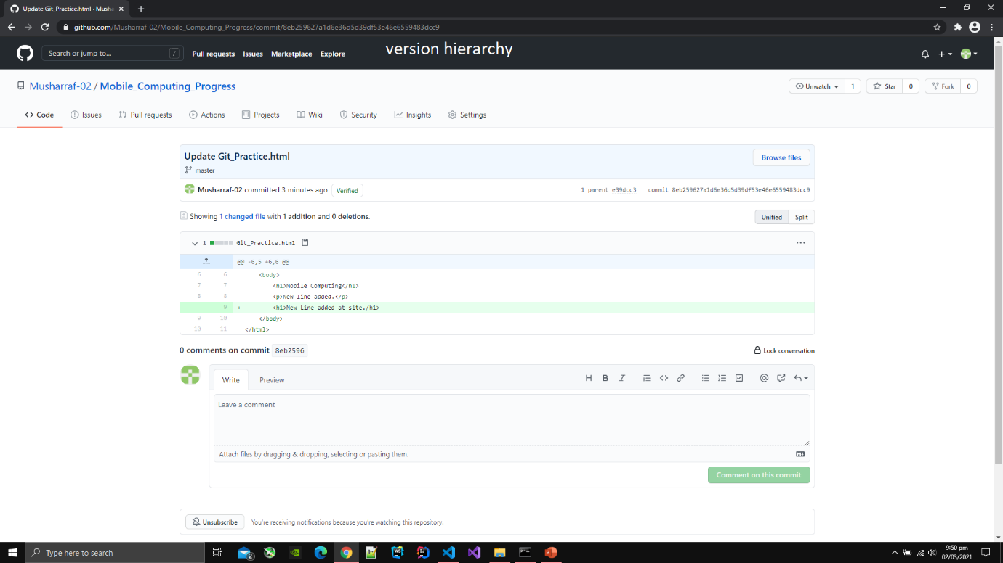

1. To get the data from the Github repository type git pull in the command line
2. After typing the data will br downloaded at the specified directory.

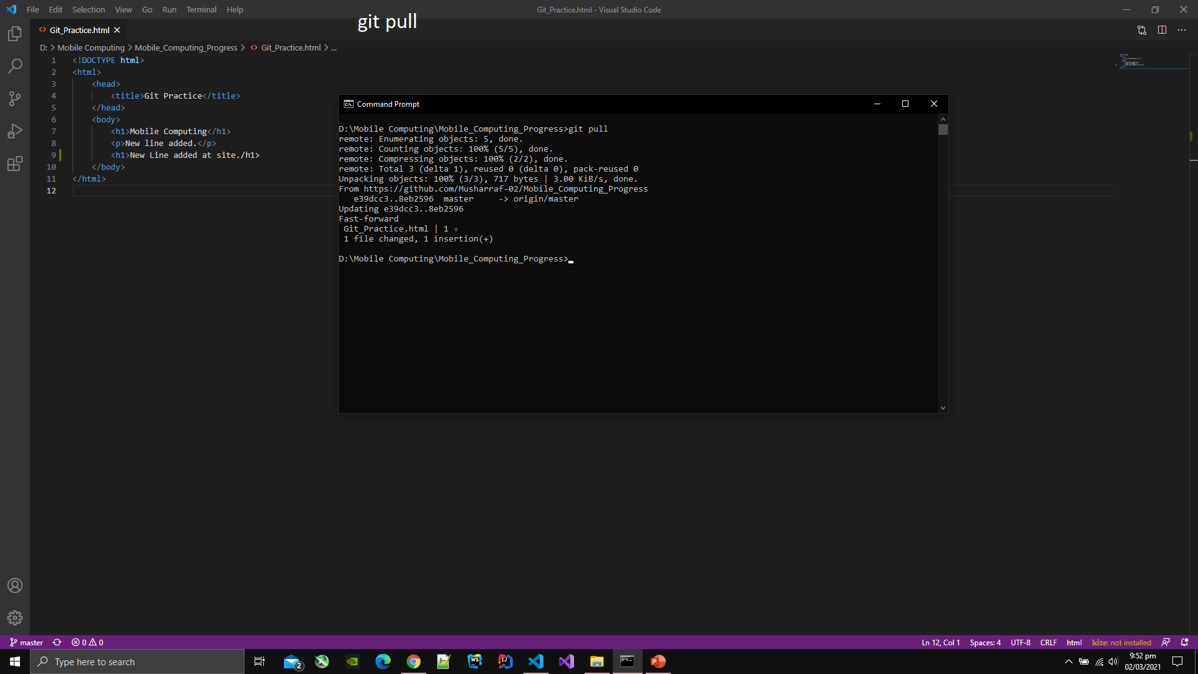

1. Merge Conflict can also occur if you have recently updated file at the site and have not used pull command and then you edit file at the editor and then you add the file and then push the edited file.
2. To solve the merge conflict select the file content form the prompt that is showed in the editor in which file is open.

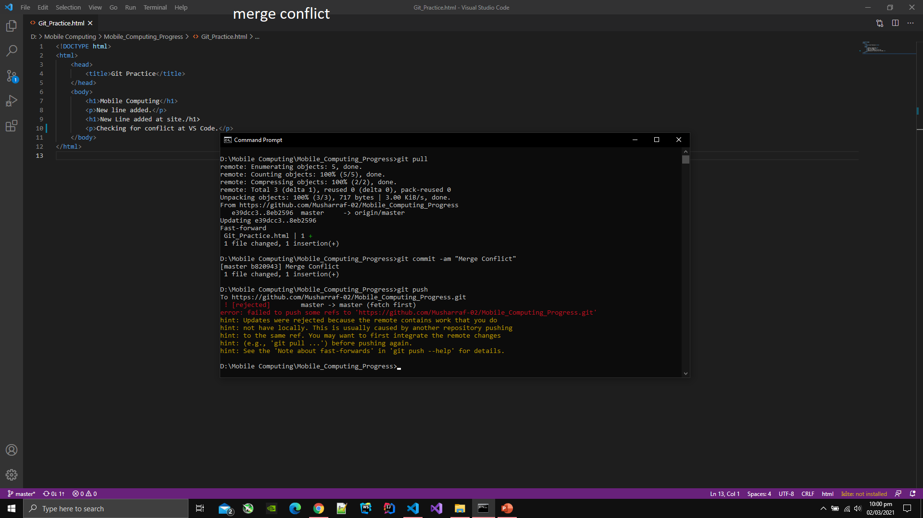

1. To see the log of all the commits and push that were made type git log in the command line then the log will display in command line.

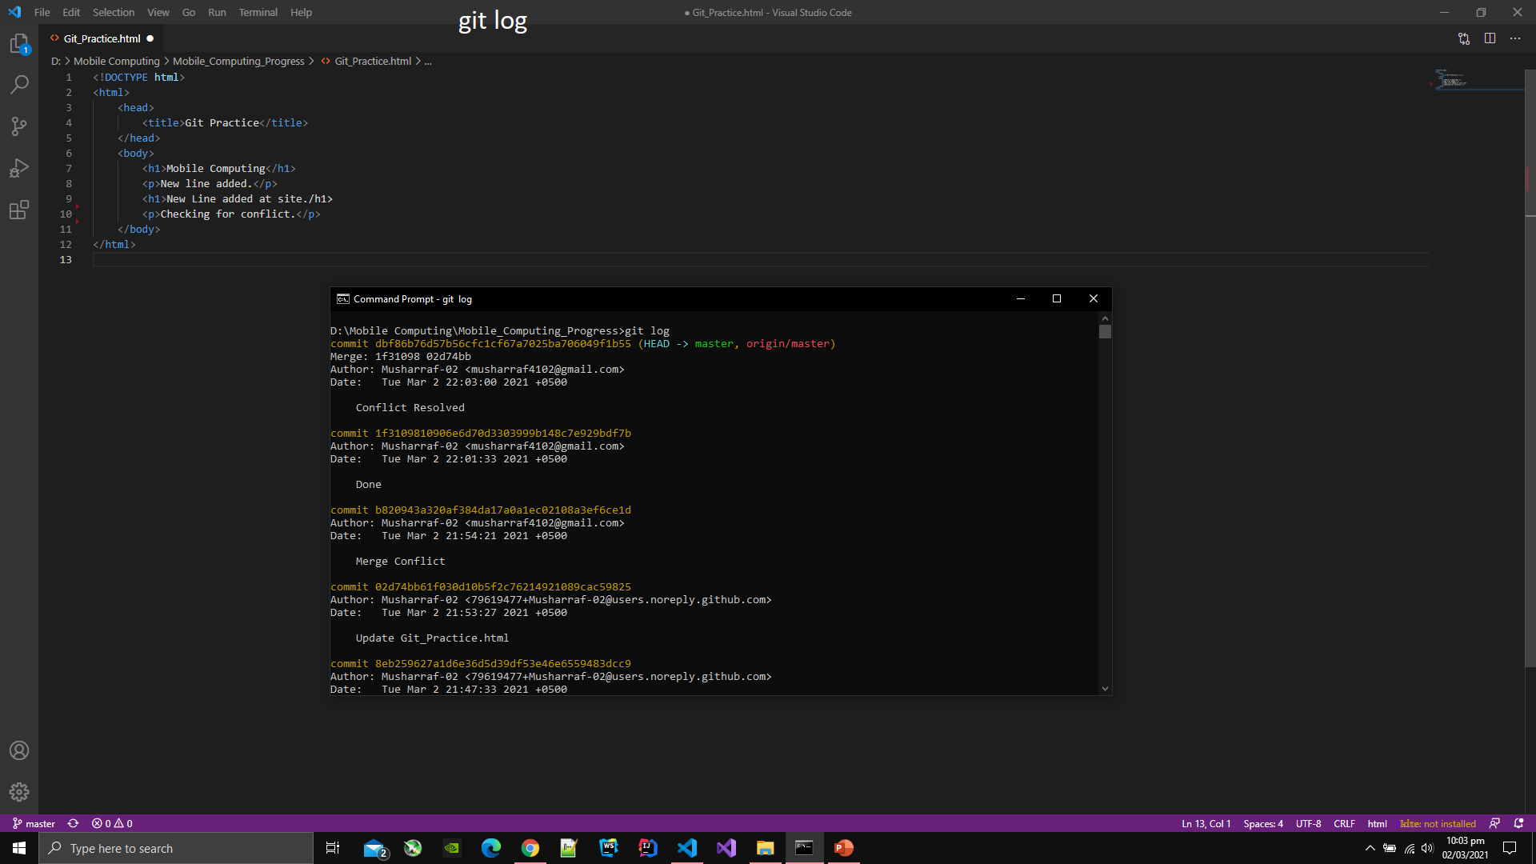

1. Type git branch to see the branch name of project on which you are currently working.

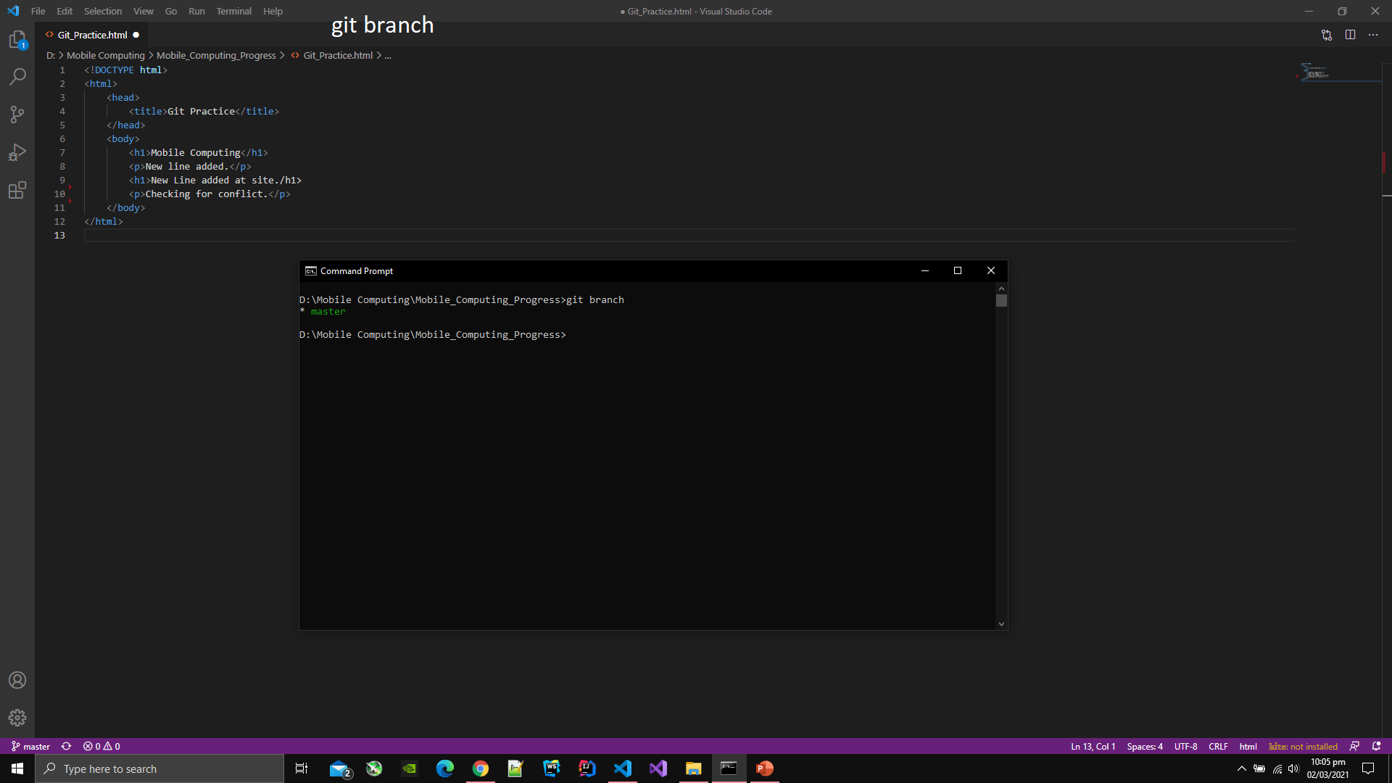

1. Make a branch of currently working project by typing git checkout -b [branch name].
2. After typing above command, the files in the editor will automatilcally switch to the files of new branch.

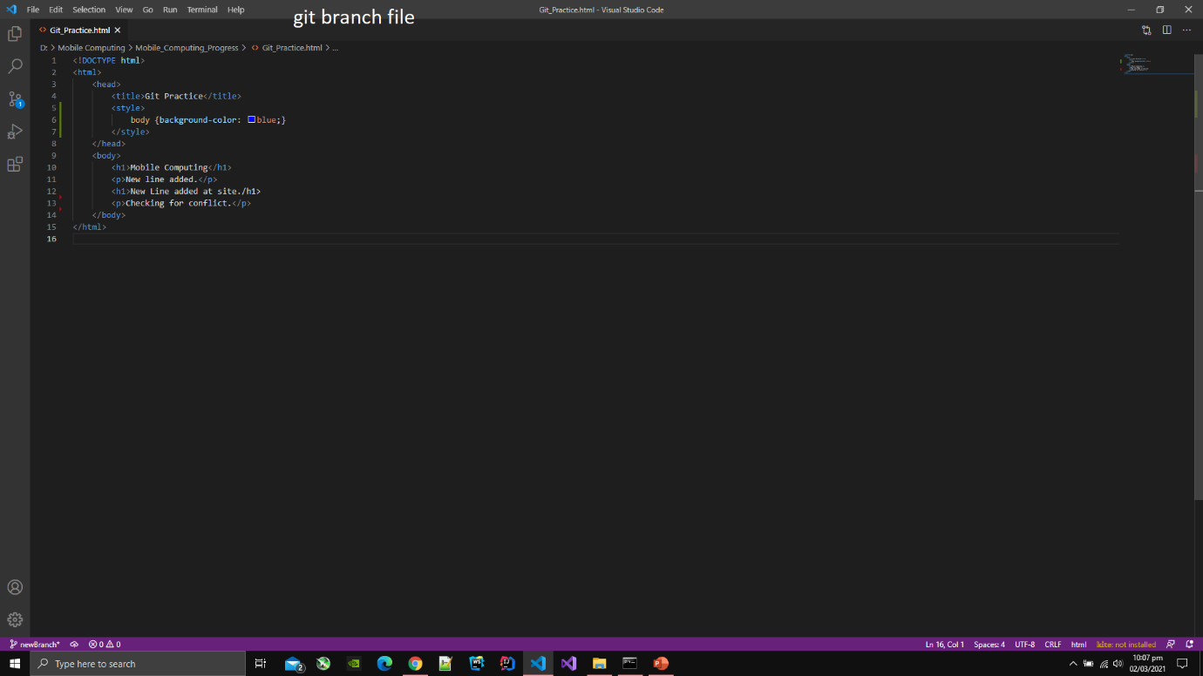

1. To switch back to master branch type git checkout master.
2. All the files in the editor will be switched to the files of master branch after typing the above command.

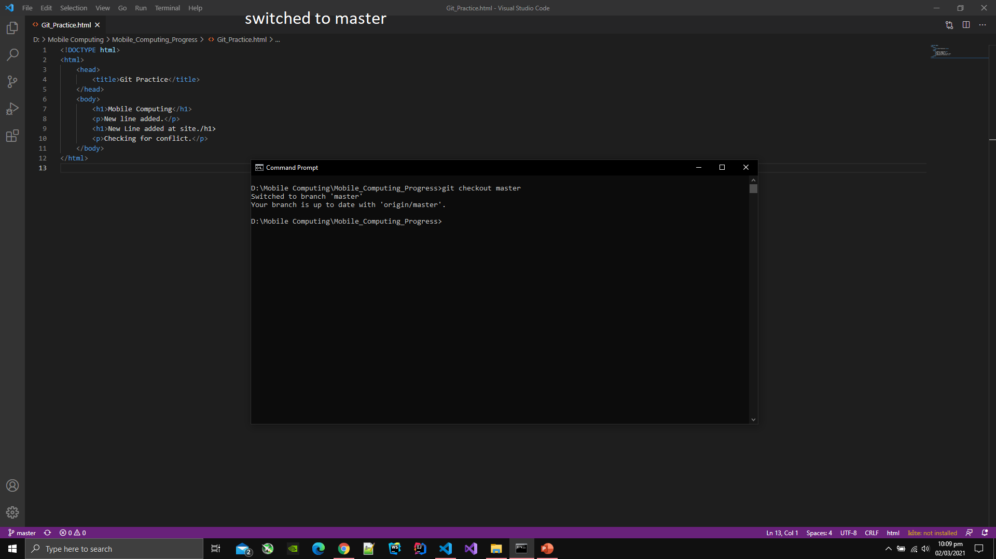

1. Below is the content of master branch file after switching back to master branch.

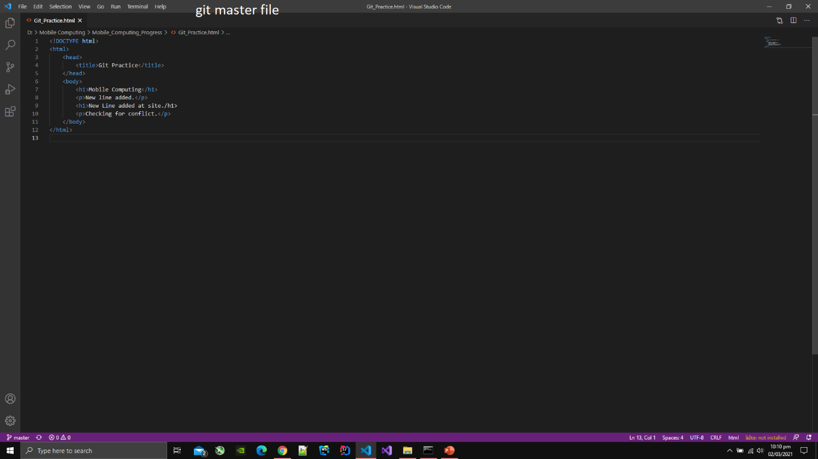

1. After trying new features in the other branch, you can merge the content of new branch and master branch.
2. To merge the content of other branch with master branch type git merge [branch name] in the command line.

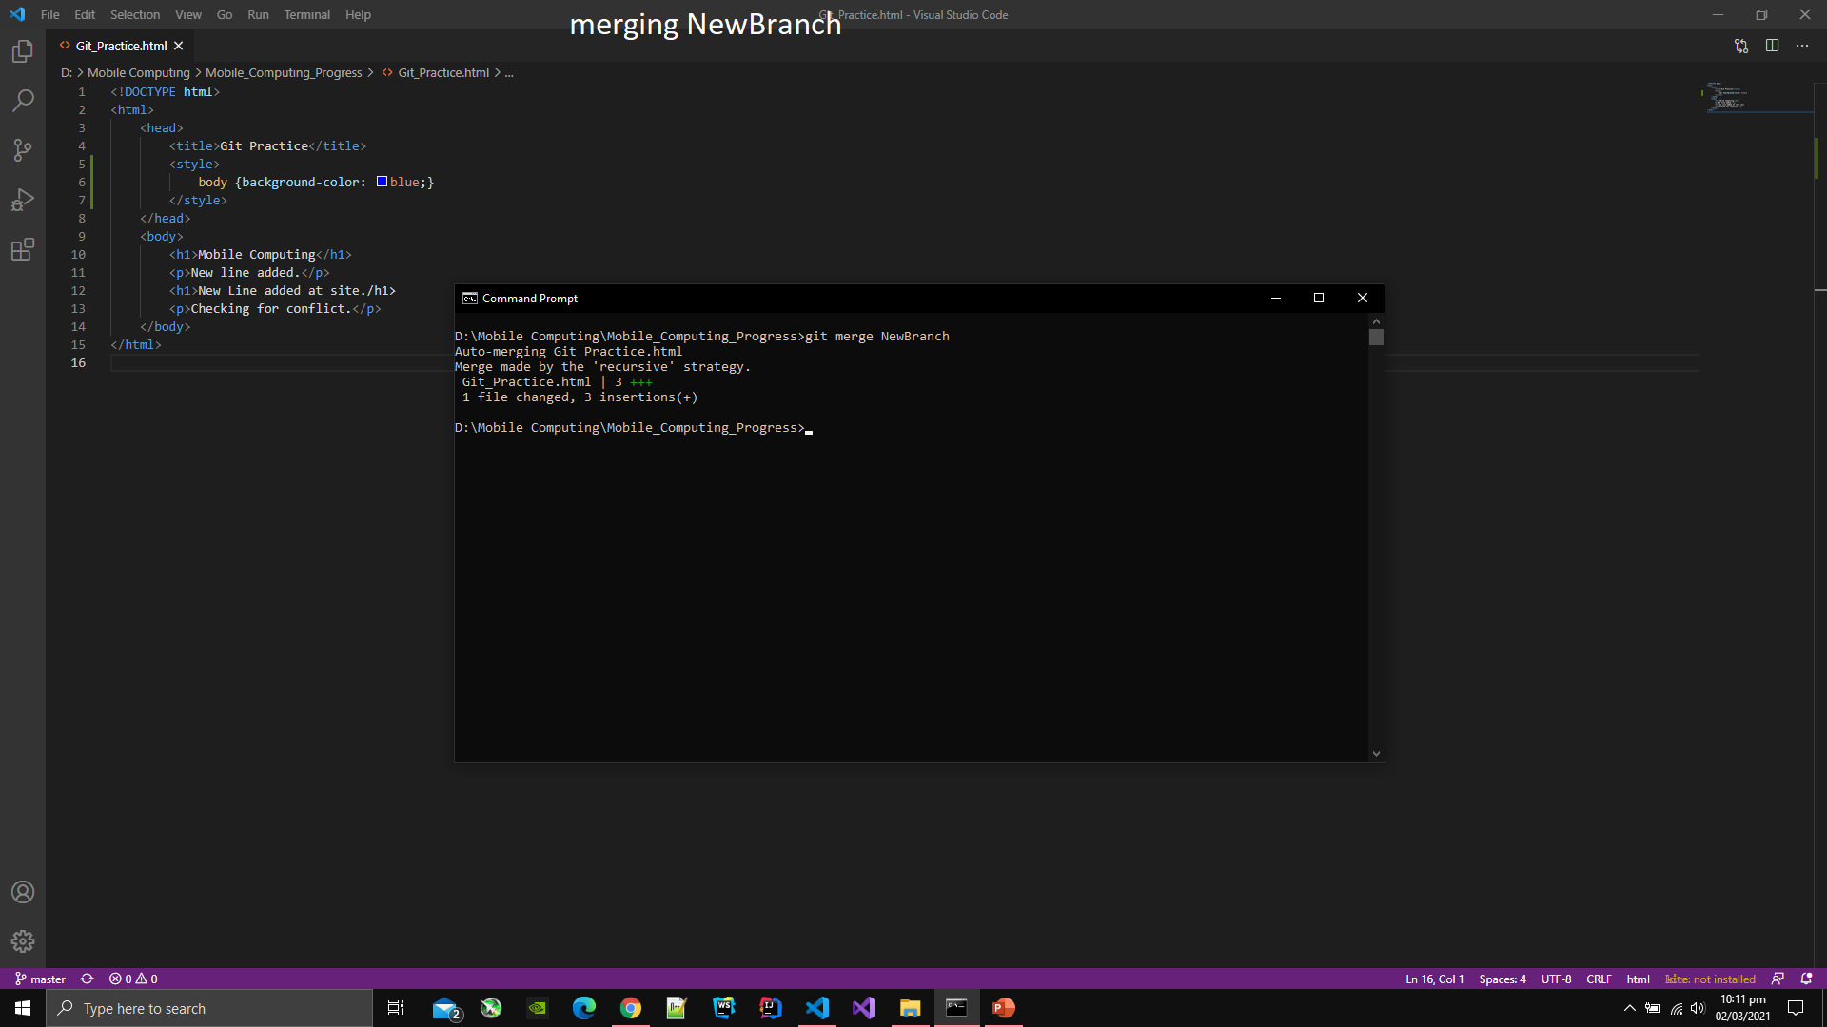

1. After merging the branch with master branch the content of the file will be as follows:

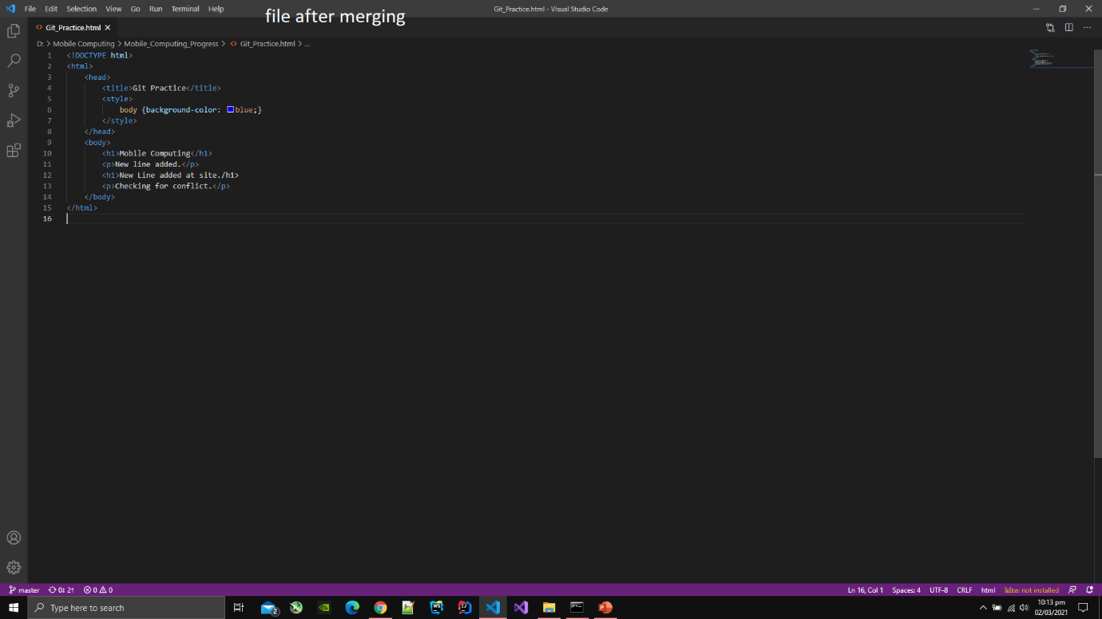

1. To delete the branch type git branch -D [branch name] in the command line.

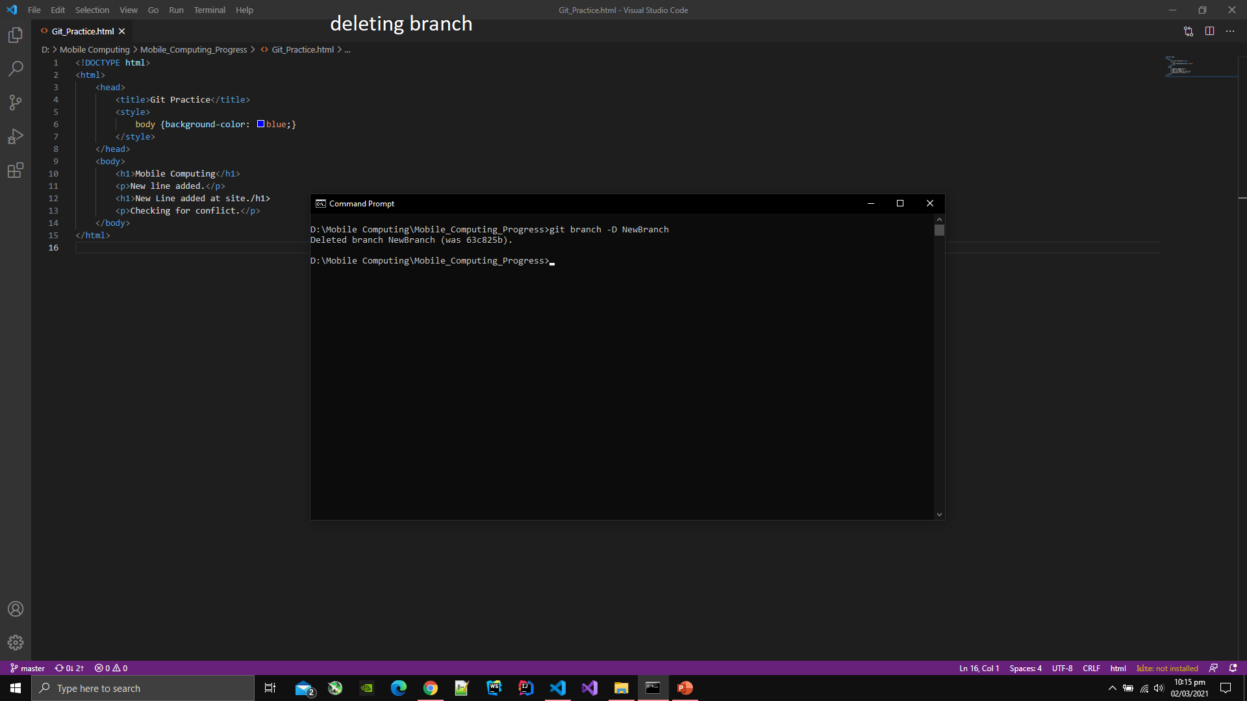

**Android Screens**

1. Download Android Studio.
2. After downlaing Android Studio, open it.
3. Then click on the create new project.
4. Select Empty Activity template from the list of different templates.
5. After selecting template, type the name of project and select directory where you want to create project.
6. After the project is created, go to activity_main.xml and switch to design view.
7. There you can drag and drop different elements and change their attributes like colors, background, gradient, position, font size and many more
8. After creating the screen, select on the play button then select the device where you want to run the project.

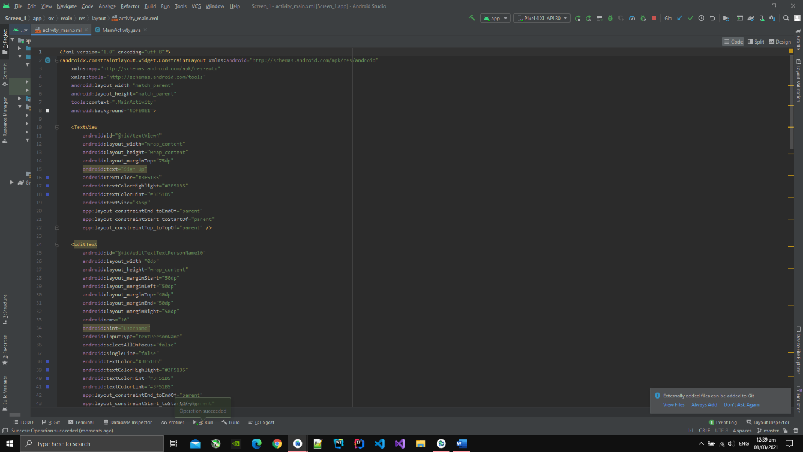

**Screen 1**

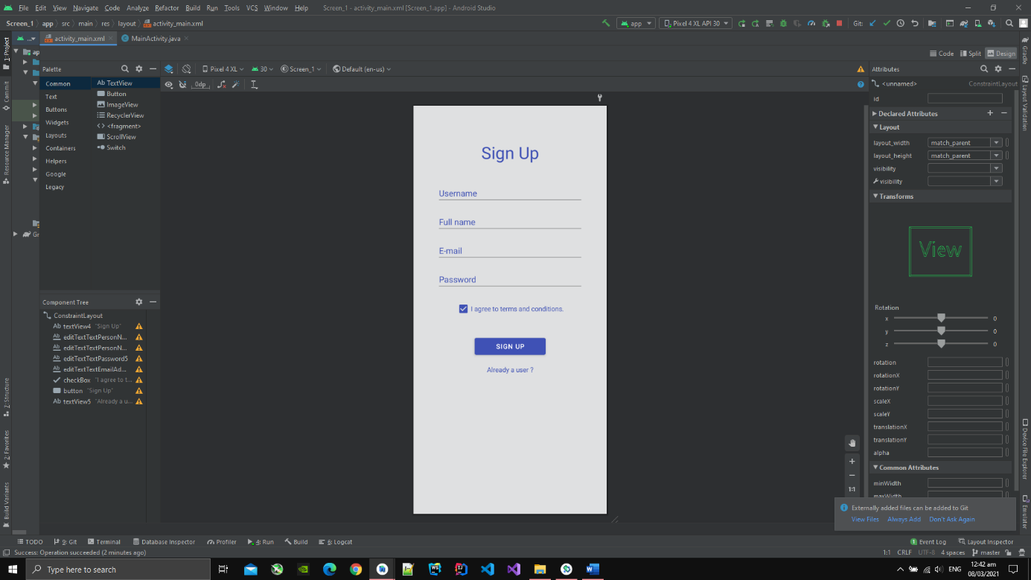

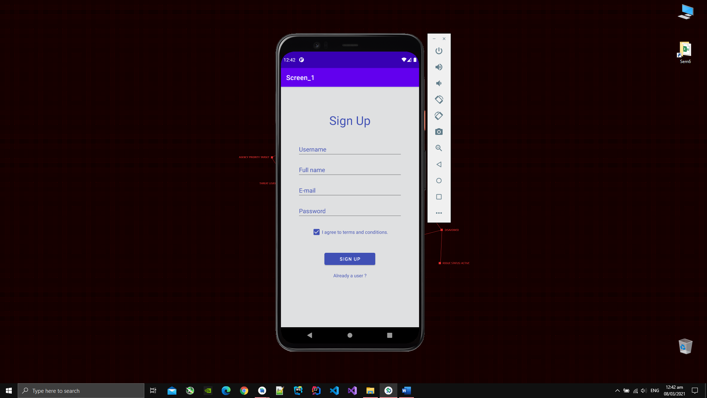

**Screen 2**

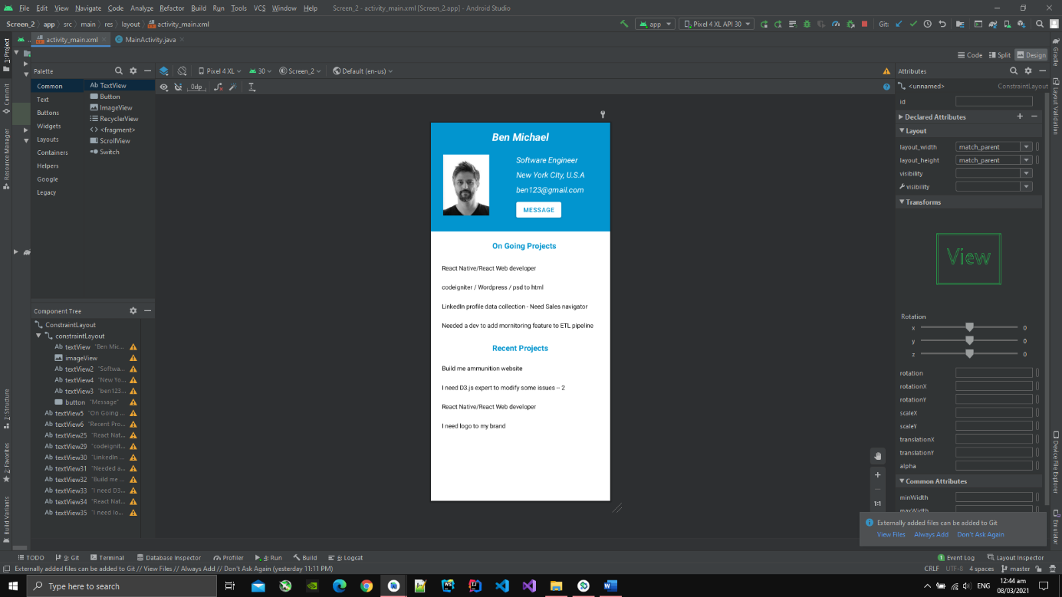

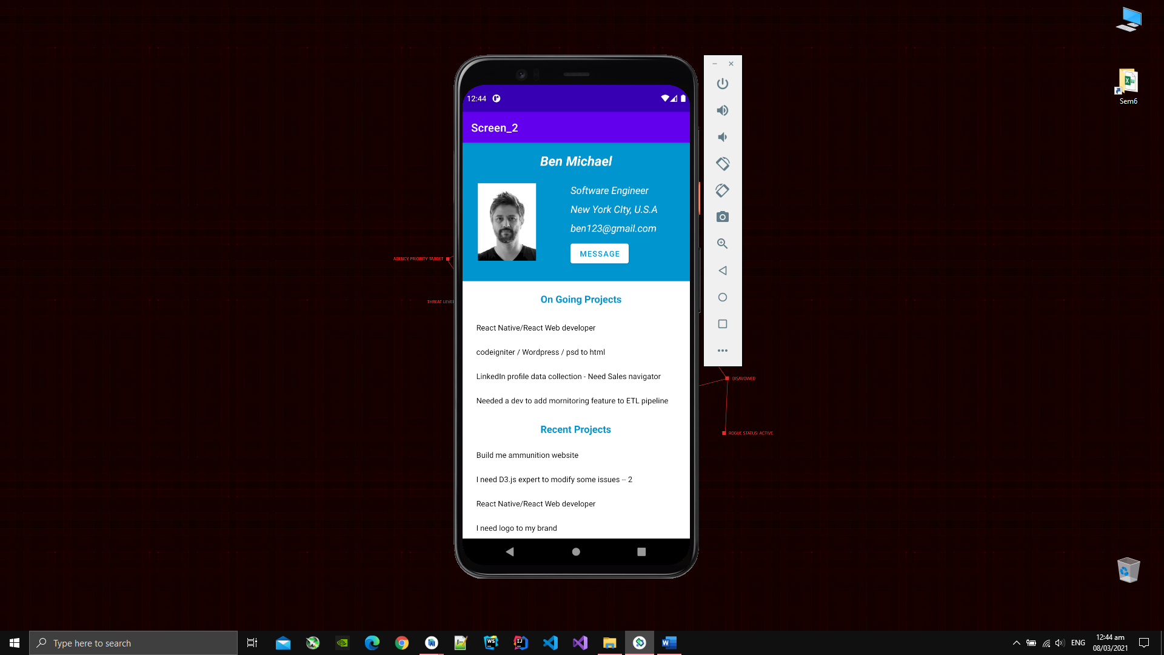

**Screen 3**

