Formula 1 Azure Lakehouse Pipeline
Enterprise Data Engineering Capstone Project

Submitted to:
BharatSkillz
Submission Email:
support@bharatskillz.com
Submission Deadline:
30 September 2026

Internship:
Cloud Computing Internship
Technology Stack:
Azure Databricks • PySpark • SQL • Delta Lake • Unity Catalog • Power BI

Table of Contents

- Project Overview
- Project Objectives
- Technology Stack
- Data Architecture
- Data Sources
- Bronze Layer — Data Ingestion
- Silver Layer — Data Transformation
- Gold Layer — Presentation
- Data Analysis
- Power BI Dashboard
- Implementation Using Databricks Free Edition
- Project Limitations and Adaptations
- Project Results
- Conclusion
- Submission Evidence

Project Overview

The Formula 1 Azure Lakehouse Pipeline is an end-to-end data engineering project designed to demonstrate the ingestion, transformation, storage, analysis, and visualization of Formula 1 racing data.
The project follows a modern Medallion Lakehouse architecture, consisting of Bronze, Silver, and Gold layers. Formula 1 source data is ingested into the Bronze layer, transformed and cleaned in the Silver layer, and prepared for analytics in the Gold layer.
The implementation uses Databricks, PySpark, SQL, Delta Lake, Unity Catalog, and Power BI. The Databricks environment is used to implement the data engineering pipeline, while Power BI is used to create analytical dashboards.
The project was implemented using Databricks Free Edition to maintain a zero-cost development environment. Where the original project architecture required paid Azure resources, equivalent free-platform approaches were used while preserving the core data engineering concepts and Bronze → Silver → Gold workflow.

Project Objectives
The main objectives of the Formula 1 Lakehouse project are:
To build an end-to-end Formula 1 data engineering pipeline.
To ingest Formula 1 datasets into a centralized Bronze layer.
To transform and clean raw data using PySpark and Spark SQL.
To implement a Medallion architecture consisting of Bronze, Silver, and Gold layers.
To store transformed datasets using Delta Lake tables.
To organize and govern data using Unity Catalog.
To create analysis-ready datasets for Formula 1 performance analysis.
To connect the curated Gold-layer data with Power BI.
To develop interactive dashboards for driver, constructor, and race-level analysis.
To demonstrate practical data engineering concepts using a zero-cost development environment.

Technology Stack
The project uses the following technologies and tools:

Technology / Tool | Purpose
Databricks Free Edition | Data engineering and Spark processing
PySpark | Data ingestion and transformation
Spark SQL / SQL | Data querying and analysis
Delta Lake | Reliable table storage and processing
Unity Catalog | Data organization and table management
Power BI Desktop | Data visualization and dashboard development
Jolpica-F1 API | Formula 1 data source used as the successor to the discontinued Ergast API
Microsoft Word | Project documentation

Data Architecture
The project follows a Medallion Lakehouse architecture consisting of Bronze, Silver, and Gold layers. Formula 1 data is first collected from the Jolpica-F1 data source and stored in the Bronze layer. The Bronze layer preserves the ingested source data in its raw form.
The Bronze data is then processed using PySpark and Spark SQL to create structured and cleaned Silver-layer Delta tables. These tables contain standardized fields, appropriate data types, flattened nested structures, and calculated metrics required for further processing.
The Silver layer feeds the Gold layer, where presentation-ready datasets are created for analytical queries and reporting. Databricks analysis notebooks use the Gold datasets to perform driver, constructor, and race-level analysis. Selected Gold-layer tables are then connected to Power BI Desktop to create interactive dashboards.
The original capstone architecture was designed around Azure Data Lake Storage Gen2, Azure Databricks, and Azure Data Factory. Because this implementation was completed with a zero-cost requirement, Databricks Free Edition was used as the development platform while preserving the core Bronze → Silver → Gold data engineering workflow.

Data Sources
The project uses Formula 1 racing data covering circuits, races, constructors, drivers, race results, pit stops, lap times, and qualifying results. The original capstone documentation specified the Ergast Formula 1 API as the primary data source. Since the Ergast API was discontinued, the implementation used the Jolpica-F1 API as its successor.
The source data was prepared as CSV and JSON files and ingested into the Bronze layer. The datasets used in the project are:
Circuits — Formula 1 circuit information.
Races — Race and season information.
Constructors — Formula 1 constructor/team information.
Drivers — Driver information.
Results — Race results and driver performance.
Pit Stops — Pit stop information.
Lap Times — Driver lap-time information.
Qualifying — Qualifying session results.
The datasets were used to demonstrate the complete data engineering workflow from raw ingestion through transformation, analysis, and visualization

Bronze Layer — Data Ingestion
The Bronze layer is the first stage of the Formula 1 Lakehouse pipeline. Its purpose is to ingest and preserve the source datasets before applying business transformations.
In this implementation, the source CSV and JSON files were uploaded to a Databricks Volume. The files were organized under the Bronze storage area and processed using PySpark notebooks.
Eight Formula 1 datasets were ingested into the Bronze layer:
circuits.csv
races.csv
constructors.json
drivers.json
results.json
pit_stops.json
laptimes.csv
qualifying.json
The ingestion notebooks read the source files, applied the required initial schema handling, and stored the resulting datasets as Delta tables in the workspace.f1_processed schema.
The Bronze ingestion stage successfully created the following processed tables:
circuits
races
constructors
drivers
results
pit_stops
laptimes
qualifying
This layer provides the foundation for the subsequent Silver-layer transformation process.
Silver Layer — Data Transformation
The Silver layer is responsible for converting the ingested Bronze data into clean, structured, and analysis-ready datasets. PySpark was used to read the Bronze Delta tables, flatten nested fields, standardize column names, cast columns to appropriate data types, and calculate analytical metrics.
The main Silver-layer transformations produced the following tables:
race_results — Structured race results containing driver, constructor, race, position, points, grid, laps, and race-time information.
driver_standings — Aggregated driver performance including total points, races entered, wins, and podiums.
constructor_standings — Aggregated constructor performance including total points, races entered, wins, and podiums.
calculated_race_results — Race-level calculated metrics such as total drivers, total points awarded, winner count, fastest race time, average driver points, and highest driver points.
The transformed datasets were stored as Delta tables in the workspace.f1_processed schema. Delta Lake provides reliable table storage and supports efficient querying and further processing.
This layer separates raw ingestion from analytical processing and prepares the data for the Gold presentation layer.

Gold Layer — Presentation
The Gold layer contains curated, presentation-ready datasets designed for analytical queries and reporting. The Gold tables were created from the transformed Silver-layer data using PySpark and Delta Lake.
The following Gold tables were created in the workspace.f1_presentation schema:
race_results — Curated race-level and driver-level result information.
driver_standings — Driver championship performance, including points, wins, podiums, and races entered.
constructor_standings — Constructor championship performance, including points, wins, podiums, and races entered.
calculated_race_results — Race-level analytical metrics used for detailed race analysis.
The Gold layer provides a clean interface between the data engineering pipeline and the reporting layer. The curated tables were connected to Power BI Desktop and used to create Formula 1 performance dashboards.
The Gold layer therefore completes the Bronze → Silver → Gold processing workflow and provides analysis-ready data for business intelligence and visualization.

Data Analysis
The Gold-layer datasets were used for analytical processing in Databricks. The analysis focused on Formula 1 driver performance, constructor performance, and race-level statistics.
The analysis notebooks included:
Dominant Drivers Analysis — used driver championship data to examine driver performance based on points, wins, and podiums.
Dominant Teams Analysis — used constructor championship data to examine team performance.
Driver Visualization Analysis — prepared driver-level data for visualization.
Team Visualization Analysis — prepared constructor-level data for visualization.
The analysis demonstrated how curated Delta tables can be queried using Spark SQL and PySpark to generate meaningful performance metrics. These results were subsequently used as the basis for the Power BI reporting layer.
The analysis stage connects the data engineering pipeline with business intelligence by converting structured Formula 1 data into information that can be used for performance reporting and comparison.

Power BI Dashboard
Power BI Desktop was used to create the reporting and visualization layer of the project. The curated Gold-layer tables from Databricks were connected to Power BI and used to develop interactive Formula 1 dashboards.
The Power BI report contains three dashboard pages:
F1 Championship Overview
This page contains four visuals:
Driver Championship Points
Constructor Championship Points
Driver Race Wins
Constructor Race Wins
F1 Detailed Analysis
This page contains three race-level visuals:
Total Points Awarded by Race
Average Driver Points by Race
Highest Driver Points by Race
F1 Performance Analysis
This page contains two detailed table visuals:
Driver Performance Summary
Constructor Performance Summary
The dashboards provide a visual representation of driver, constructor, and race performance and demonstrate how the curated Gold-layer data can be consumed by a business intelligence tool.

Implementation Using Databricks Free Edition
The project was implemented using Databricks Free Edition to maintain a zero-cost development environment. The implementation preserved the main data engineering concepts of the original Azure-based capstone while adapting the infrastructure to the capabilities available in the free platform.
The Databricks project was organized into the following folders:
01_Setup — project configuration and initial setup.
02_Bronze — source-file ingestion.
03_Silver — data transformation and cleansing.
04_Gold — presentation and analytical tables.
05_Analysis — driver, constructor, and race analysis.
06_Dashboard — dashboard-related project organization.
Unity Catalog was used to organize the data using the workspace catalog. The processed datasets were stored in the f1_processed schema, while the presentation-ready datasets were stored in the f1_presentation schema.
PySpark and Spark SQL were used for data processing, while Delta tables were used for reliable structured storage. Power BI Desktop was used separately for the final reporting and visualization stage.
This implementation demonstrates the core functionality of a Lakehouse data engineering pipeline without requiring paid cloud infrastructure.

Project Limitations and Adaptations
The original capstone architecture was designed for Azure cloud infrastructure, including Azure Data Lake Storage Gen2, Azure Databricks, Azure Data Factory, networking components, and service-principal-based authentication. These services were not deployed in this implementation because the project was required to be completed with a zero-cost budget and no active paid Azure subscription was available.
To overcome this limitation, Databricks Free Edition was used as the primary data engineering environment. Databricks Volumes were used for source-file storage, while Unity Catalog and Delta tables were used for data organization and structured storage.
The original capstone documentation referenced the Ergast Formula 1 API. Since the Ergast API was discontinued, the Jolpica-F1 API was used as its successor. The required datasets were prepared as CSV and JSON files for ingestion into the Bronze layer.
The project therefore represents a functional, zero-cost adaptation of the original Azure Lakehouse architecture. The core concepts of data ingestion, Bronze → Silver → Gold processing, Delta Lake storage, analysis, and Power BI reporting were retained, while the cloud infrastructure was adapted to the available free environment.
These adaptations should be considered when comparing this implementation with a production deployment using the full Azure architecture.

Project Results
The project successfully implemented an end-to-end Formula 1 data engineering workflow using a Medallion Lakehouse architecture.
The Bronze layer successfully ingested eight Formula 1 datasets covering circuits, races, constructors, drivers, results, pit stops, lap times, and qualifying.
The Silver layer transformed the ingested data into structured Delta tables for race results, driver standings, constructor standings, and calculated race metrics.
The Gold layer produced presentation-ready datasets in the workspace.f1_presentation schema. These datasets were successfully connected to Power BI Desktop.
The Power BI report contains three dashboard pages with a total of nine analytical visuals covering championship points, race wins, race-level statistics, driver performance, and constructor performance.
The completed implementation demonstrates practical skills in PySpark, Spark SQL, Delta Lake, Unity Catalog, data transformation, analytical processing, and Power BI reporting while maintaining a zero-cost development environment.

Conclusion
The Formula 1 Azure Lakehouse Pipeline demonstrates an end-to-end data engineering workflow covering data ingestion, transformation, storage, analysis, and visualization.
The project successfully implemented a Medallion architecture using Bronze, Silver, and Gold layers. Formula 1 datasets were ingested and processed using PySpark and Spark SQL, stored as Delta tables, organized through Unity Catalog, and transformed into analysis-ready datasets.
The resulting Gold-layer data was connected to Power BI Desktop to create dashboards covering driver performance, constructor performance, and race-level statistics.
Although the original capstone architecture was designed for Azure cloud services, the project was adapted to Databricks Free Edition to satisfy the zero-cost requirement. This adaptation retained the essential data engineering concepts while avoiding paid cloud infrastructure.
Overall, the project provided practical experience in modern data engineering, Lakehouse architecture, Delta Lake, Spark processing, data analysis, and business intelligence reporting.

Submission Evidence
The following evidence is included as part of the project submission to demonstrate the implementation and final results:
Databricks Project Structure — Screenshot showing the Formula1_Azure_Lakehouse project folders and organization.
Bronze Layer Evidence — Screenshots showing the ingested Formula 1 datasets and Bronze processing notebooks.
Silver Layer Evidence — Screenshots showing the transformed Delta tables and Silver-layer notebooks.
Gold Layer Evidence — Screenshots showing the presentation tables in the workspace.f1_presentation schema.
Databricks Analysis Evidence — Screenshots showing the analysis notebooks and analytical queries.
Power BI Dashboard Evidence — Screenshots of the three completed dashboard pages.
Power BI Project File — Formula1_Azure_Lakehouse.pbix
Project Documentation — This project report and the accompanying project README.
These materials provide evidence of the complete workflow from data ingestion through transformation, analysis, and final visualization.

Figure 1 : Databricks Project Structure
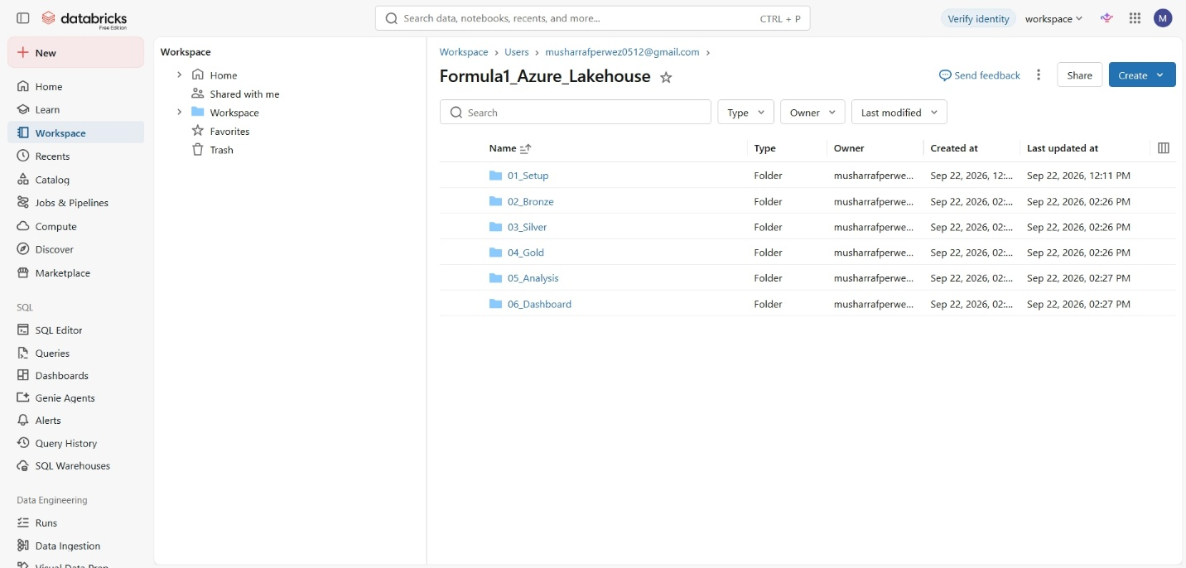

Figure 2 : Bronze Layer
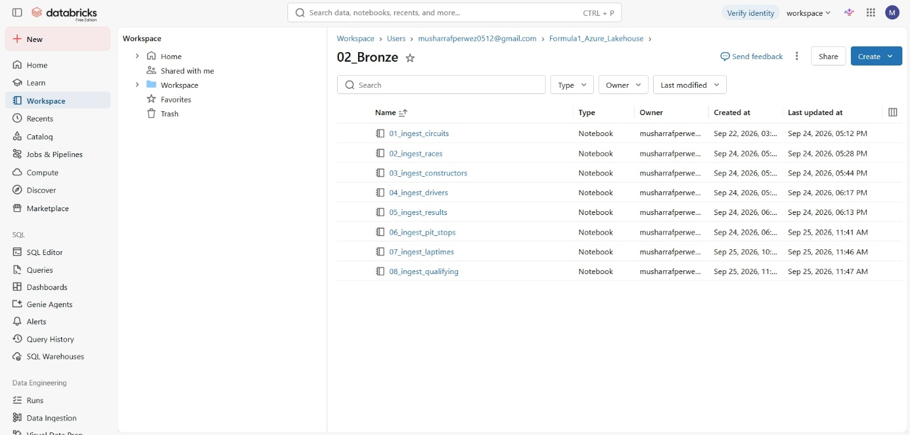

Figure 3 : Silver Layer
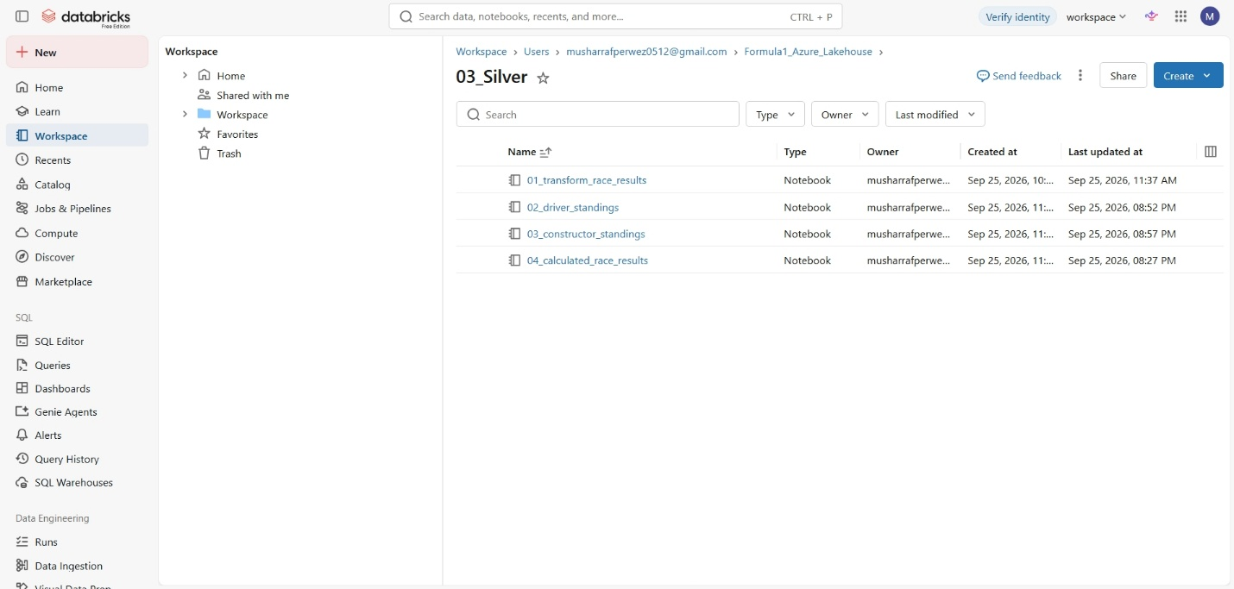

Figure 4 : Gold Layer
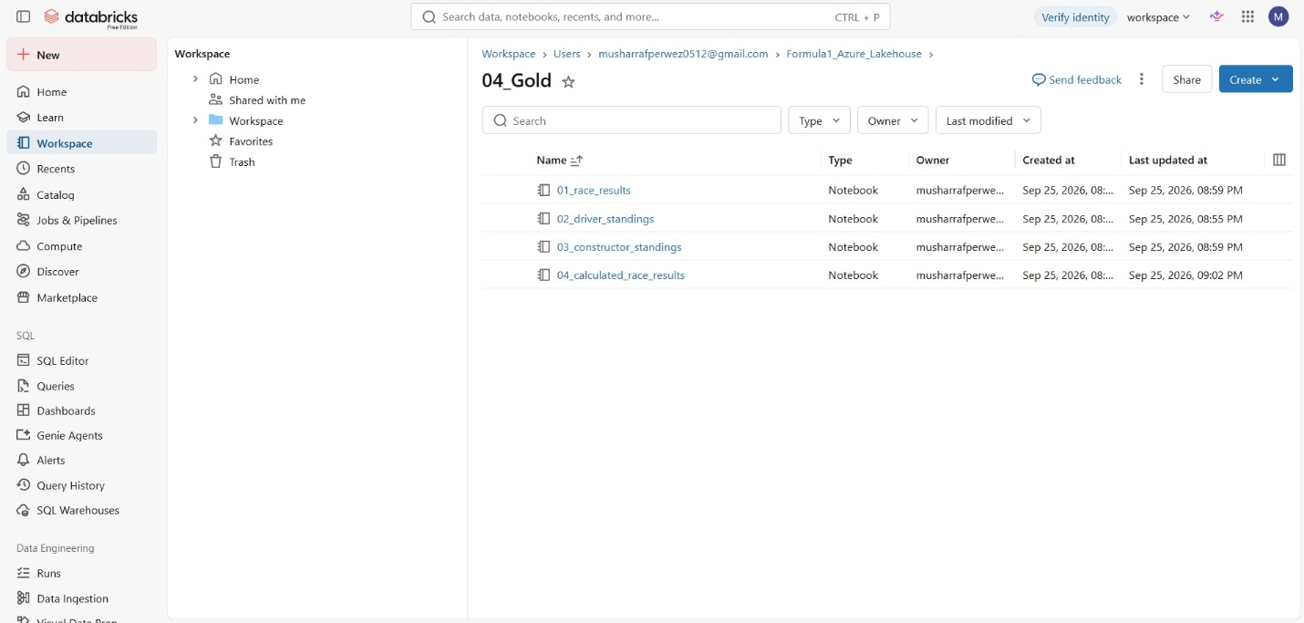

Figure 5 : Analysis Layer
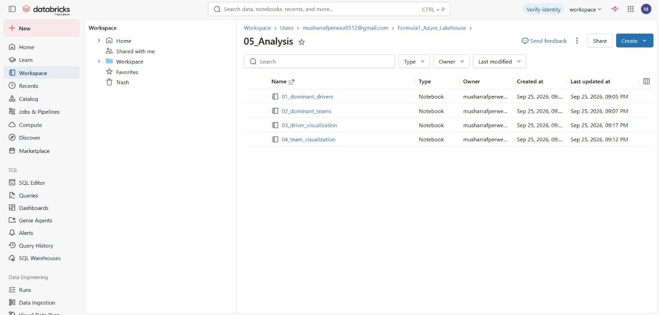

Figure 6 : PowerBI Championship Overview
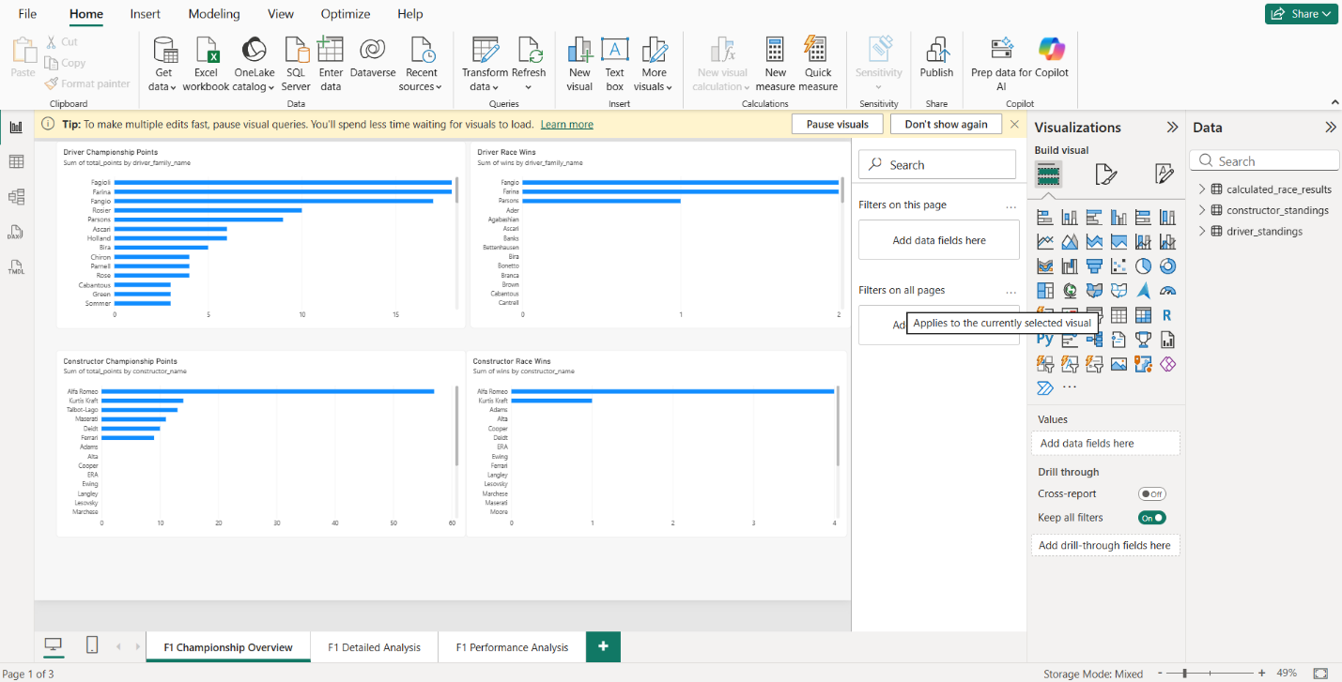

Figure 7 : PowerBI Detailed Analysis
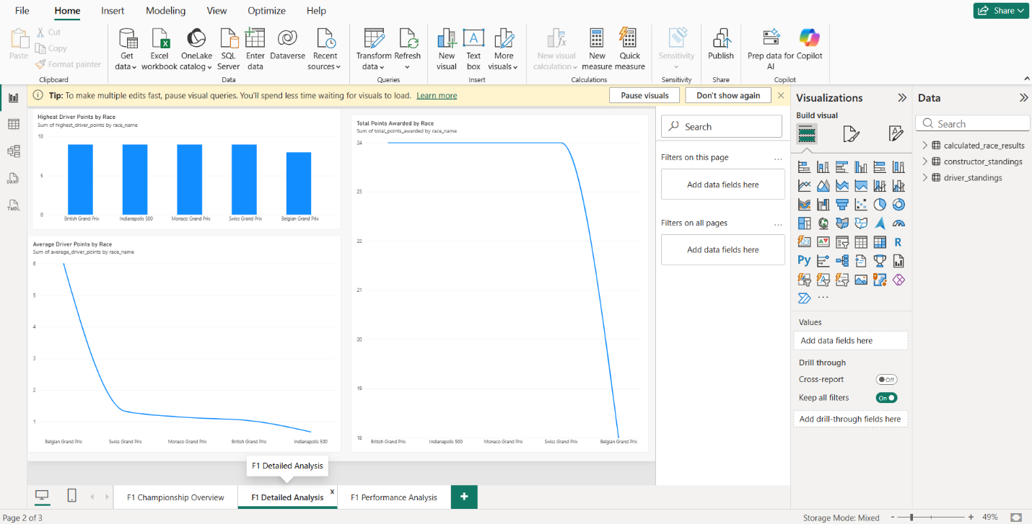

Figure 8 : PowerBI Performance Analysis
