

*Green University of Bangladesh*

*Department of Computer Science and Engineering (CSE) Semester: (Fall, Year: 2025), B.Sc. in CSE (Day)*

LAB Performance NO - 2

*Course Title:* *Artificial Intelligence Lab*

*Course Code: CSE-201*

*Section: 221-D14*

Students Details

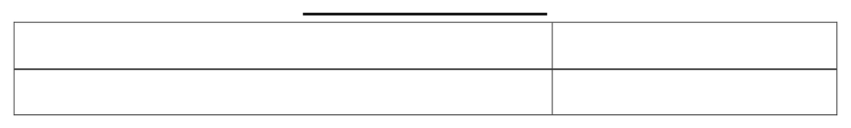

Name

Mushfikur Rahman



ID



221902023

*Submission Date: 02.11.2025*

*Course Teacher’s Name: Md. Sabbir Hosen Mamun*

[For teachers use only: Don’t write anything inside this box]



Marks:



Comments:



Lab Report Status



Signature:



Date:



I already uploaded my work in github and also write readme.md file where i write problems and showed my output results. [Click here to see](https://github.com/Mushfikur007/Artificia_lntelligence_Lab/tree/main/Lab_1)

1. Given a list of numbers, remove duplicates and sort in ascending order.

num = [5, 2, 8, 3, 2, 9, 5, 1]

unique = sorted(set(num))

print(unique)

**Output:**



1. Find the common elements between two lists using sets.

list1 = {1, 2, 3, 4, 5}

list2 = {3, 4, 5, 6, 7}

common_elements = list1 & list2

print(common_elements)

**Output:**



1. Create a tuple of student records (name, age, grade) and sort by grade.

students = [("Rahim", 20, 85), ("Korim", 22, 90), ("Sofik", 21, 88)]

sorted_students = sorted(students, key=lambda x: x[2])

print(sorted_students)

Output:



1. Count word occurrences in a given text and store them in a dictionary.

text = "hello world hello everyone"

word_counts = {}

for word in text.split():

    word_counts[word] = word_counts.get(word, 0) + 1

print(word_counts)

Output:



1. Generate a 5x5 matrix of random integers and compute row-wise sums.

import numpy as np

matrix = np.random.randint(1, 100, (5, 5))

row_sums = matrix.sum(axis=1)

print(matrix)

print("Row-wise sums:", row_sums)

Ouput:

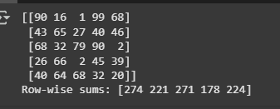

1. Create an array of 100 random values and normalize them between 0 and 1.

random_values = np.random.rand(100)

normalized_values = (random_values - random_values.min()) / (random_values.max() - random_values.min())

print(normalized_values)

Output:

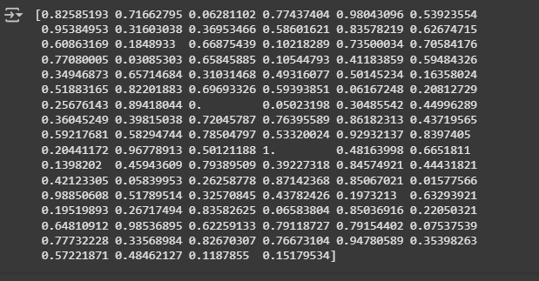

1. Plot a line graph showing temperature variations over a week.

import matplotlib.pyplot as plt

days = ["Mon", "Tue", "Wed", "Thu", "Fri", "Sat", "Sun"]

temperatures = [30, 32, 31, 29, 28, 27, 26]

plt.plot(days, temperatures, marker='o', linestyle='-')

plt.xlabel("Days")

plt.ylabel("Temperature (°C)")

plt.title("Temperature Variations Over a Week")

plt.show()

Output:

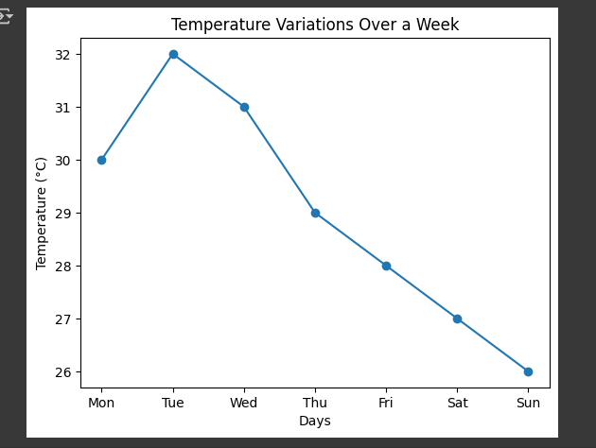

1. Create a bar chart comparing sales revenue across different regions.

regions = ["North", "South", "East", "West"]

sales_revenue = [50000, 60000, 45000, 70000]

plt.bar(regions, sales_revenue, color=['blue', 'red', 'green', 'purple'])

plt.xlabel("Regions")

plt.ylabel("Sales Revenue")

plt.title("Sales Revenue Comparison")

plt.show()

output:

