Assignment 3: Randomized Quicksort and Hashing with Chaining
Muhtadin Mushfiq
Id: 005059360
Course: Algorithms and Data Structures (MSCS-532-M70)

About this report
This report analyzes and compares two algorithms: Randomized Quicksort (Part 1) and a hash table with chaining (Part 2). For each one it gives the implementation, a theoretical analysis, and experiments that test the theory.
All code is in the src/ folder of the GitHub repository, every number below comes from benchmark.py, and the raw data is in the results/ folder. Test machine: Python 3.11.15, Linux x86-64. Each timing is the median of 3 runs (5 runs for the comparison counts).
Contents
- Part 1: Randomized Quicksort — 1.1 Implementation · 1.2 Analysis · 1.3 Empirical comparison
- Part 2: Hashing with Chaining — 2.1 Implementation · 2.2 Analysis · 2.3 Load factor · 2.4 Keeping the load factor low
- Conclusions and References

Part 1: Randomized Quicksort

1.1 Implementation
File: src/quicksort.py
Quicksort is a divide-and-conquer algorithm:
- Pick a pivot element from the subarray.
- Partition: rearrange the subarray so that smaller elements come before the pivot and larger elements come after it.
- Recurse on the two sides. Nothing needs to be combined afterwards because the pivot is already in its final position.
The implementation contains two main functions:
Function | Pivot rule | Partition scheme
randomized_quicksort | chosen uniformly at random from a[lo..hi] using random.randint(lo, hi) | 3-way: < pivot, == pivot, > pivot
deterministic_quicksort (baseline) | always the first element a[lo] | Lomuto 2-way (textbook CLRS version)
A third function, randomized_quicksort_2way (random pivot with the ordinary 2-way partition), is included only for an experiment in Section 1.3 that separates the effect of the pivot rule from the effect of the partition scheme.

How the edge cases are handled
Edge case | How the implementation handles it
Empty array / one element | Returned immediately (if n < 2: return arr).
Repeated elements | The 3-way partition groups all copies of the pivot in the middle and never recurses into that group. An array of 20,000 identical values is therefore sorted in one pass of 19,999 comparisons (checked in tests/test_all.py).
Already sorted / reverse sorted | The random pivot means the input order does not matter (see Section 1.2).
Deep recursion | Both versions recurse on the smaller side and loop over the larger side. The smaller side has at most half the elements, so the call stack is at most log₂ n frames deep, even in the deterministic version’s O(n²) worst case. Sorting 8,000 already-sorted numbers deterministically is slow but never raises RecursionError.
Non-numeric keys | Only < and > are used, so strings, floats, tuples and any other comparable type work.
The sort is in place (it only swaps entries), and the function also returns the list for convenience.

1.2 Analysis: why the average case is O(n log n)
This section builds the argument one step at a time. It gives the intuition first, then a rigorous proof with indicator random variables, then a second proof with a recurrence relation.
Throughout, n is the number of elements, and we count comparisons between an element and a pivot. Comparisons are the right thing to count because every other operation (swaps, index updates) happens at most a constant number of times per comparison. So if the comparisons are O(n log n), the whole running time is O(n log n).
To keep the proofs clean we assume the keys are distinct. Repeated keys only make the 3-way version faster, because equal keys are removed from further work.

Step 1: What does one partition cost?
Partitioning a subarray of size m compares each of the other m − 1 elements with the pivot once. So a partition costs Θ(m).

Step 2: The best case and the worst case
- Best case (perfect splits). If the pivot always lands exactly in the middle, every level of recursion does about n work in total, and the array can be halved only log₂ n times before the pieces have size 1. Total ≈ n log₂ n.
level 0: [ n ] work ≈ n
level 1: [ n/2 ][ n/2 ] work ≈ n
level 2: [n/4][n/4 ][n/4 ][n/4 ] work ≈ n
... (log₂ n levels in total)
- Worst case (terrible splits). If the pivot is always the smallest or largest element, one side is empty and the other has m − 1 elements. The work is (n−1) + (n−2) + … + 1 = n(n−1)/2 = Θ(n²). Deterministic “first element” Quicksort does exactly this on sorted and reverse-sorted input, because the first element is the smallest (or largest).

Step 3: Why a random pivot is almost never terrible
Call a pivot good if it lands in the middle half of the sorted order, i.e. between the 25th and 75th percentile. A uniformly random pivot is good with probability 1/2.
After a good pivot, both sides have at most ¾ of the elements. Any element can only be in a subarray that shrinks by a factor of ¾ at most log_{4/3} n ≈ 2.4 log₂ n times before the subarray has size 1. Since only half the pivots are good, each element takes part in about twice that many partitions, which is still O(log n). Each element is compared about O(log n) times, so all n elements together give O(n log n).
That is the intuition. The next two steps make it precise.

Step 4: Rigorous proof with indicator random variables
Setup. Name the elements by their position in the final sorted order:
$$z_{1}<z_{2}<z_{3}<…<z_{n}$$
Fact A: any two elements are compared at most once. Elements are only compared with the pivot, and after a partition the pivot is never touched again. So zᵢ and zⱼ can meet at most once.
The indicator variables. For every pair i < j define
$$X_{ij}=1 \text{ if }z_{i}\text{ is ever compared with }z_{j}, \text{and }X_{ij}=0\text{ otherwise.}$$
By Fact A, the total number of comparisons is
$$X=\sum_{i=1}^{n-1}{\sum_{j=i+1}^{n}{X_{ij}}}$$
Linearity of expectation. The expected value of a sum is the sum of the expected values, even when the variables are dependent. For an indicator variable, the expected value is just the probability that it equals 1:
$$E\left[X\right]=\sum_{i=1}^{n-1}{\sum_{j=i+1}^{n}{Pr\left[z_{i}\text{ is compared with }z_{j}\right]}}$$
So everything reduces to one question: what is the probability that two particular elements are ever compared?
Fact B: Pr[zᵢ and zⱼ are compared] = 2 / (j − i + 1).
Look at the block of values Zᵢⱼ = {zᵢ, zᵢ₊₁, …, zⱼ}. It contains j − i + 1 elements.
- As long as no element of Zᵢⱼ has been chosen as a pivot, the whole block stays together in the same subarray, because every pivot so far was either smaller than all of it or larger than all of it.
- At some point, a pivot from inside Zᵢⱼ is chosen for the first time. Call it x.
  - If x = zᵢ or x = zⱼ, then zᵢ and zⱼ are compared (the pivot is compared with everything in its subarray).
  - If x is strictly between them, then zᵢ goes to the left side and zⱼ goes to the right side. They are in different subarrays from now on, so they are never compared.
- The pivot is uniform over its subarray, so every element of Zᵢⱼ is equally likely to be that first pivot x. Two of the j − i + 1 choices (zᵢ and zⱼ) lead to a comparison.
Therefore
$$Pr\left[X_{ij}=1\right]=\frac{2}{j-i+1}$$
Example: for 1, 2, 3, 4, 5, the values 1 and 5 are compared only if 1 or 5 is the first of {1, 2, 3, 4, 5} to be picked as a pivot, which has probability 2/5. The neighbours 2 and 3 are always compared (probability 2/2 = 1), since nothing lies between them that could separate them.
Adding it up. Substitute k = j − i, the distance between the two elements:
$$E\left[X\right]=\sum_{i=1}^{n-1}{\sum_{k=1}^{n-i}{\frac{2}{k+1}}} < \sum_{i=1}^{n}{\sum_{k=1}^{n}{\frac{2}{k}}} = 2nH_{n}$$
where Hₙ = 1 + 1/2 + 1/3 + … + 1/n is the n-th harmonic number. A standard fact is that Hₙ ≈ ln n (more precisely, ln n < Hₙ ≤ ln n + 1). So
$$E\left[X\right]<2nH_{n}≈2nlnn≈1.39 n\log_{2}n=O\left(nlogn\right)$$
Doing the sum exactly gives E[X] = 2(n+1)Hₙ − 4n, which is the curve we test against in Section 1.3.
Why this holds for every input. The only randomness used in the proof is the algorithm’s own pivot choice. Nothing was assumed about the input order. So the bound applies to sorted, reverse-sorted, adversarial, and random inputs alike. “Average case” here means averaged over the algorithm’s coin flips, not over some lucky distribution of inputs. This is the key difference from deterministic Quicksort, whose O(n log n) average does depend on the input being randomly ordered.

Step 5: The same result with a recurrence relation
Let T(n) be the expected number of comparisons on n elements. The pivot is equally likely to be the 1st, 2nd, …, or n-th smallest (probability 1/n each). If it is the (q+1)-th smallest, the two sides have q and n − 1 − q elements. Partitioning costs n − 1 comparisons, so
$$T\left(n\right)=\left(n-1\right)+\frac{1}{n}\sum_{q=0}^{n-1}{\left[T\left(q\right)+T\left(n-1-q\right)\right]}$$
which simplifies (the two sums contain the same terms) to
$$T\left(n\right)=\left(n-1\right)+\frac{2}{n}\sum_{q=0}^{n-1}{T}\left(q\right), T\left(0\right)=T\left(1\right)=0.$$
Solving it (step by step):
- Multiply by $n$: $nT\left(n\right)=n\left(n-1\right)+2\sum_{q=0}^{n-1}{T}\left(q\right)$.
- Write the same equation for $n-1$: $\left(n-1\right)T\left(n-1\right)=\left(n-1\right)\left(n-2\right)+2\sum_{q=0}^{n-2}{T}\left(q\right)$.
- Subtract the second equation from the first. Most of the sum cancels: $nT\left(n\right)-\left(n-1\right)T\left(n-1\right)=2\left(n-1\right)+2T\left(n-1\right)$, so $nT\left(n\right)=\left(n+1\right) T\left(n-1\right)+2\left(n-1\right)$.
- Divide both sides by $n\left(n+1\right)$: $\frac{T\left(n\right)}{n+1}=\frac{T\left(n-1\right)}{n}+\frac{2\left(n-1\right)}{n\left(n+1\right)}$.
- Put $S\left(n\right)=\frac{T\left(n\right)}{n+1}$. Then $S\left(n\right)=S\left(n-1\right)+\frac{2\left(n-1\right)}{n\left(n+1\right)}≤S\left(n-1\right)+\frac{2}{n}$.
- Unroll it: $S\left(n\right)≤2\left(1/2+1/3+…+1/n\right)<2H_{n}$.
- So $T\left(n\right)=\left(n+1\right) S\left(n\right)<2\left(n+1\right)H_{n}=O\left(nlogn\right)$.
Both methods give the same answer: about 2n ln n ≈ 1.39 n log₂ n comparisons on average.

Step 6: Summary table
 | Deterministic (first pivot) | Randomized
Best case | Θ(n log n) | Θ(n log n)
Expected / average | Θ(n log n) if the input is randomly ordered | Θ(n log n) for every input
Worst case | Θ(n²) on sorted, reverse, all-equal input | Θ(n²), but with vanishingly small probability on any input
Extra space (this implementation) | O(log n) | O(log n)
A note on the randomized worst case: to take Θ(n²) time, the algorithm has to pick a near-extreme pivot over and over. The probability of this drops exponentially, and for n in the thousands it will not happen in practice.

1.3 Empirical comparison with Deterministic Quicksort

Setup
- Sizes n = 500, 1,000, 2,000, 4,000, 8,000.
- Four input distributions:
  - random: uniform integers in [0, 10n];
  - sorted: 0, 1, …, n−1;
  - reverse: n, n−1, …, 1;
  - repeated: uniform integers in [0, 9], so only 10 distinct values and each appears about n/10 times.
- Each algorithm sorts a fresh copy of the same array. The reported time is the median of 3 runs.
- Raw data: results/quicksort_times.csv.
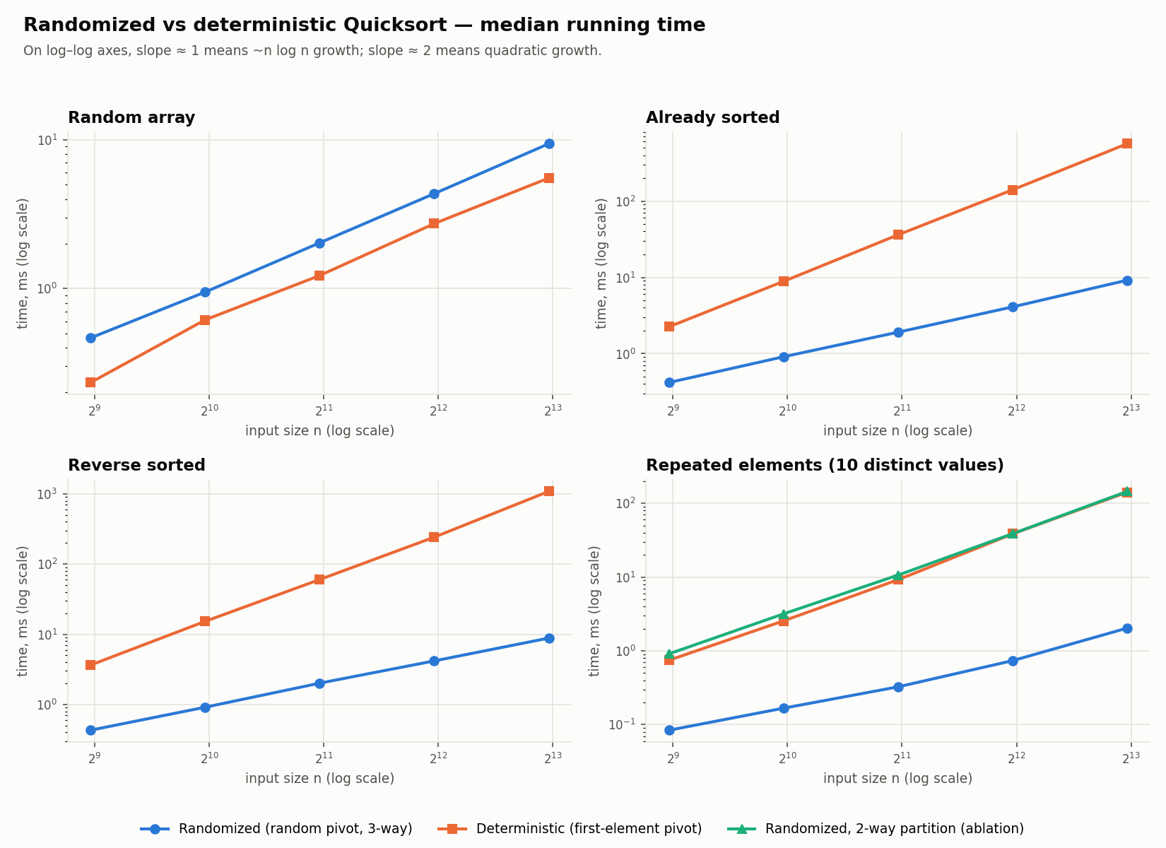
Figure 1. Median running time of randomized vs deterministic Quicksort on four input distributions (log–log axes).

Results (milliseconds)
n | random: rand | random: det | sorted: rand | sorted: det | reverse: rand | reverse: det | repeated: rand | repeated: det
500 | 0.46 | 0.23 | 0.42 | 2.26 | 0.43 | 3.65 | 0.08 | 0.75
1,000 | 0.95 | 0.62 | 0.91 | 8.87 | 0.91 | 15.28 | 0.17 | 2.55
2,000 | 2.03 | 1.22 | 1.91 | 36.12 | 2.01 | 60.24 | 0.32 | 9.20
4,000 | 4.34 | 2.73 | 4.10 | 140.52 | 4.17 | 241.78 | 0.74 | 38.46
8,000 | 9.40 | 5.53 | 9.18 | 563.99 | 8.82 | 1,084.70 | 2.03 | 141.15
Growth when n doubles from 4,000 to 8,000 (n log n predicts about ×2.2, n² predicts ×4):
 | random | sorted | reverse | repeated
Randomized | ×2.2 | ×2.2 | ×2.1 | ×2.7
Deterministic | ×2.0 | ×4.0 | ×4.5 | ×3.7

Observations and how they relate to the theory
1. Sorted and reverse-sorted input: the theory is confirmed exactly. Deterministic Quicksort’s time grows by ×4 each time n doubles, which is the signature of Θ(n²). On the log–log plot its line has slope ≈ 2. At n = 8,000 it is 61× slower than the randomized version on sorted input and 123× slower on reverse-sorted input. The randomized version takes the same ~9 ms on random, sorted and reverse-sorted input. This is the “O(n log n) for every input” guarantee from Section 1.2 showing up in practice: input order is invisible to an algorithm that chooses pivots with its own coin flips.
Reverse-sorted is about 2× worse than sorted for the deterministic version, even though both are Θ(n²). With Lomuto partitioning on reverse input, every comparison succeeds (a[j] <= pivot), so every comparison also causes a swap. On sorted input, almost every comparison fails and no swap happens. The number of comparisons is the same; the number of swaps is not. The constant factor differs while the growth rate matches.
2. Random input: deterministic is ~1.5–2× faster. This is not a contradiction. On randomly ordered input, the first element is itself a random pivot. So both algorithms perform about 2n ln n comparisons, and theory predicts the same Θ(n log n) growth for both. The measurements agree: both grow about ×2.1 per doubling, and the lines on the plot are parallel. The gap is only a constant factor:
- random.randint is a relatively expensive Python call, and the randomized version pays it once per partition.
- The 3-way partition does up to two comparisons per element (< then >), while Lomuto does one.
Big-O notation hides constant factors on purpose. A small constant penalty is the price of insurance against the ×60–×120 slowdowns above. In a compiled language, the relative overhead of the random-number call would be much smaller.
3. Repeated elements: the partition scheme matters as much as the pivot. With only 10 distinct values, the randomized 3-way version is the fastest case of all (2 ms at n = 8,000). After at most about 10 partitions, each group of equal values is finished and never touched again. This is even better than n log n.
The deterministic version grows ~×3.7 per doubling, which is close to quadratic. Its 2-way partition sends every element equal to the pivot to the same side. Once a subarray contains only one value (roughly n/10 copies), every split is (m−1, 0), which is the worst case again.
The ablation (green line, randomized_quicksort_2way) makes the cause clear. A random pivot with a 2-way partition is just as slow as the deterministic version (144.7 ms vs 141.2 ms). When all keys in a subarray are equal, every choice of pivot is equally bad, so randomness cannot help. The proof in Section 1.2 assumed distinct keys, and this experiment shows why that assumption matters. The fix is the 3-way partition, and this is why the main implementation uses it.
4. Counting comparisons matches the formula almost exactly. To remove timing noise, the benchmark also counts pivot comparisons for randomized Quicksort on arrays of distinct floats, averaged over 5 runs (results/quicksort_comparisons.csv):
n | measured comparisons | theory 2(n+1)Hₙ − 4n | difference
1,000 | 10,680 | 10,986 | −2.8%
4,000 | 55,300 | 54,989 | +0.6%
16,000 | 265,142 | 264,263 | +0.3%
64,000 | 1,242,645 | 1,234,438 | +0.7%
256,000 | 5,525,279 | 5,647,463 | −2.2%
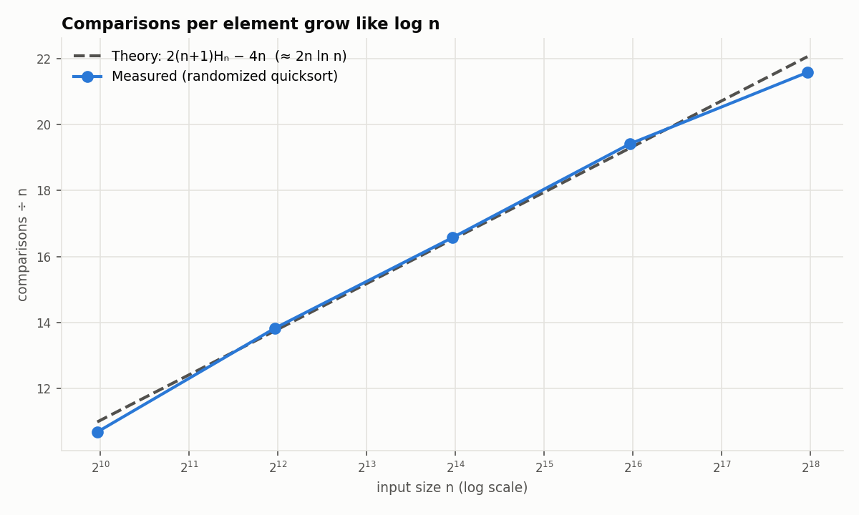
Figure 2. Comparisons per element for randomized Quicksort, measured vs the exact expected value 2(n+1)Hₙ − 4n.
Comparisons divided by n rise in a straight line on a log-scale x-axis. That straight line is what “a constant times n log n” looks like on this plot. The small differences are random variation: the formula is an expected value, and any single run lands a few percent above or below it.

Remaining discrepancies between theory and measurement
- Constant factors. Big-O ignores the cost of each step. Python’s interpreter overhead, the randint call, and extra comparisons in the 3-way partition set the constants, which is why deterministic wins on random input.
- Growth slightly above ×2 per doubling. n log n predicts ×2 × log(2n)/log n ≈ ×2.17 for n = 4,000 → 8,000. The randomized version measured ×2.1–2.2. The repeated-elements case measured ×2.7, but its absolute times are so small (0.7 → 2.0 ms) that timer noise and memory effects dominate.
- The deterministic worst case is not exactly ×4. Measured ×4.0 and ×4.5. Larger arrays fit less well in the CPU caches, which adds a little on top of the pure n² growth.
Part 2: Hashing with Chaining

2.1 Implementation
File: src/hash_table.py, class HashTableChaining.
Structure. The table is an array of m buckets (slots). Each bucket holds a chain, a Python list of [key, value] pairs. When two keys hash to the same slot (a collision), they share that slot’s chain.
slot 0: → [k7, v7]
slot 1: (empty)
slot 2: → [k2, v2] → [k9, v9] → [k4, v4] ← three keys collided here
slot 3: → [k1, v1]
...
Hash function: a universal family.
$$h_{a,b}\left(k\right)=\left(\left(a⋅k+b\right) mod p\right) mod m$$
- p = 2⁶¹ − 1, a Mersenne prime.
- a is chosen uniformly at random from {1, …, p−1}; b is chosen uniformly from {0, …, p−1}.
- Non-integer keys (strings, tuples, floats) are first converted to an integer with Python’s hash(), and that integer is then fed into h_{a,b}.
- Guarantee (Carter & Wegman): for any two different keys x ≠ y, Pr[h(x) = h(y)] ≤ 1/m, where the probability is over the random choice of a and b. The guarantee holds for every set of keys, including keys chosen by an adversary. This is the same idea as the random pivot in Quicksort: randomness in the algorithm removes the dependence on the input.
- A new (a, b) is chosen every time the table is resized.
Operations.
Operation | What it does
insert(key, value) | Hash to a slot and scan that chain. If the key is already there, overwrite its value; otherwise append the pair. Grow the table if the load factor would go above 1.
search(key) | Hash to a slot, scan that chain, and return the value (or None / a supplied default if the key is absent).
delete(key) | Hash to a slot and scan that chain. Remove the pair by swapping it with the chain’s last element and popping (O(1) removal). Shrink the table if the load factor falls below ¼. Returns True if a key was removed.
The class also supports t[key], t[key] = v, del t[key], key in t and len(t). Its correctness is checked against Python’s dict over 20,000 random operations in tests/test_all.py.

2.2 Analysis under simple uniform hashing
The assumption. Simple uniform hashing means every key is equally likely to hash to any of the m slots, independently of where the other keys went.
Definitions. n = number of stored keys, m = number of slots, and the load factor is
$$α=\frac{n}{m}$$
which is the average chain length.
Computing h(k) and jumping to the slot always takes O(1). The rest of the cost is the scan along one chain.

Unsuccessful search (the key is not in the table): Θ(1 + α)
The missing key hashes to a random slot. Under simple uniform hashing, the expected length of that slot’s chain is n/m = α. We must scan the whole chain to be sure the key is absent.
$$\text{Expected time}=\underset{\text{hash}}{\underset{⏟}{O\left(1\right)}}+\underset{\text{scan chain}}{\underset{⏟}{α}}=Θ\left(1+α\right)$$

Successful search (the key is in the table): Θ(1 + α)
Suppose we look for a key x that was the i-th key inserted, and new keys are appended to the end of the chain. The elements examined are x itself plus any keys inserted before x into x’s slot, because those come earlier in the chain. Each of the i − 1 earlier keys landed in x’s slot with probability 1/m, so we expect (i − 1)/m of them. Averaging over all n keys:
$$E\left[\text{examined}\right]=\frac{1}{n}\sum_{i=1}^{n}{\left(1+\frac{i-1}{m}\right)}=1+\frac{n-1}{2m}=1+\frac{α}{2}-\frac{α}{2n}=Θ\left(1+α\right)$$
On average we scan about half of a chain before finding the key.

Insert: Θ(1 + α)
Appending a new pair is O(1). This implementation first checks whether the key is already present (so a key is never stored twice), which costs the same as a search, Θ(1 + α). If duplicates were known to be impossible, insertion could skip the check and would be O(1) in the worst case.

Delete: Θ(1 + α)
We first have to find the key (a successful search, Θ(1 + α)). The removal itself is O(1): swap with the last element of the chain, then pop.

Summary
Operation | Expected time | If α = O(1)
Search, key absent | Θ(1 + α) | O(1)
Search, key present | Θ(1 + α/2) | O(1)
Insert | Θ(1 + α) (O(1) without the duplicate check) | O(1)
Delete | Θ(1 + α) | O(1)
Any operation, worst case | Θ(n), when every key lands in one chain
The key takeaway: if the number of slots grows in proportion to the number of keys (m = Θ(n)), then α is bounded by a constant and every operation takes O(1) expected time.

2.3 How the load factor affects performance
Experiment. m = 4,096 slots is held fixed with resizing turned off. We insert n = α·m random keys for α ∈ {0.25, 0.5, 1, 2, 4, 8, 16}, then run 20,000 successful and 20,000 unsuccessful searches. Data: results/hash_load_factor.csv.
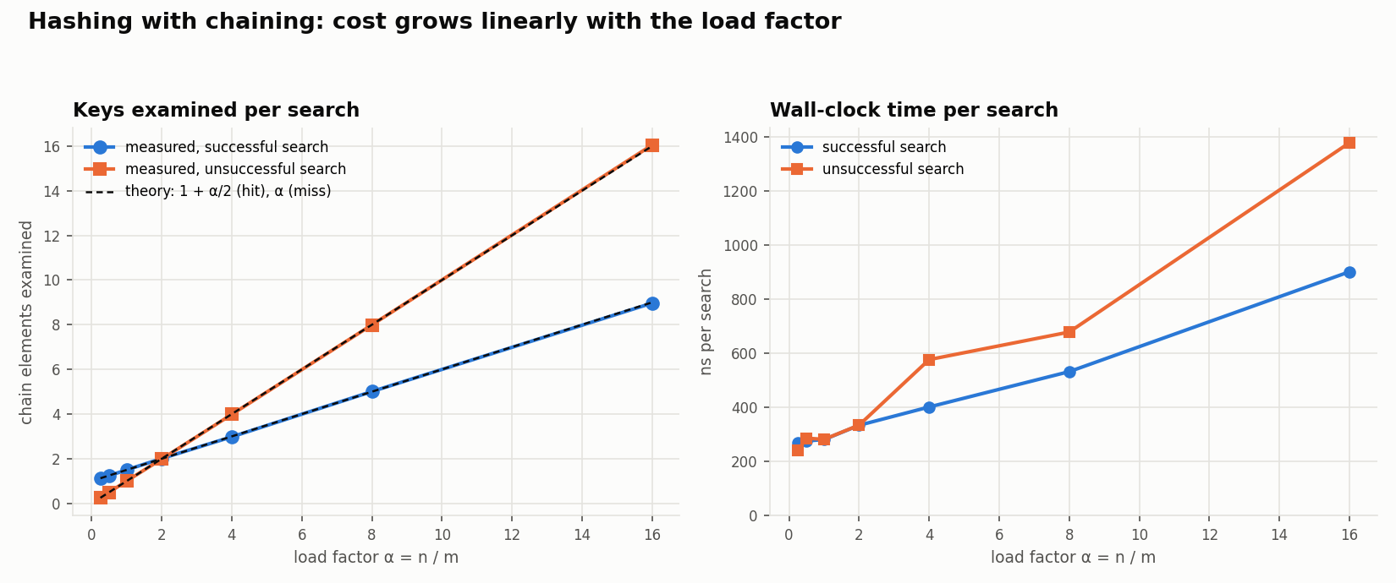
Figure 3. Hash table search cost as the load factor α grows (m = 4,096 slots, resizing off).
α | keys examined, hit (measured) | theory 1 + α/2 | keys examined, miss (measured) | theory α | ns per hit | ns per miss | longest chain
0.25 | 1.13 | 1.12 | 0.25 | 0.25 | 270 | 241 | 4
0.5 | 1.24 | 1.25 | 0.50 | 0.50 | 276 | 286 | 4
1 | 1.50 | 1.50 | 1.00 | 1.00 | 281 | 282 | 5
2 | 2.01 | 2.00 | 1.98 | 2.00 | 334 | 334 | 9
4 | 2.98 | 3.00 | 3.98 | 4.00 | 401 | 577 | 12
8 | 5.01 | 5.00 | 7.99 | 8.00 | 532 | 678 | 18
16 | 8.97 | 9.00 | 16.05 | 16.00 | 901 | 1,378 | 30
(Keys-examined counts are exact and repeatable; nanosecond timings vary by roughly ±10% between runs.)
What this shows:
- The formulas are confirmed almost exactly. The measured keys-examined values match 1 + α/2 (hits) and α (misses) to within 1%. The universal hash function behaves like the idealized “simple uniform hashing” assumption.
- Cost is linear in α. Doubling the load factor roughly doubles the chain-scanning part of the cost.
- Misses become more expensive than hits once α > 2. A miss scans the whole chain (α keys), while a hit stops halfway on average (≈ α/2 keys). For α < 2 the order is reversed: an empty slot ends a miss immediately (with α = 0.25, 78% of slots are empty), while a hit always examines at least one key.
- For α ≤ 1, time is almost flat (≈ 240–290 ns). It is dominated by the fixed O(1) part: computing the hash (big-integer arithmetic modulo 2⁶¹ − 1) and Python’s function-call overhead. This is the “1” in Θ(1 + α).
- The longest chain grows more slowly than α (5 at α = 1, 30 at α = 16). The expected cost stays low even though a few chains are longer than average.

2.4 Keeping the load factor low and collisions rare

Strategy 1: Dynamic resizing (implemented)
- Grow: when inserting would make α > 1, allocate 2m slots, pick a new hash function, and re-insert (rehash) every key.
- Shrink: when deleting makes α < ¼, halve the table (never below the initial capacity) and rehash.
Why doubling gives O(1) amortized insertion. A single resize costs Θ(n), since every key must be moved. But resizes happen only at sizes 8, 16, 32, …, n, so the total rehashing work over n insertions is at most
$$8+16+32+…+n<2n$$
Spread across n insertions, that is less than 2 extra moves per insertion: O(1) amortized. Growing by a fixed number of slots (m + 100, say) would instead cause about n/100 resizes, each costing Θ(n), for Θ(n²) total. That is why the table doubles rather than adding a constant.
Why the shrink threshold is ¼, not ½. If the table grew above α = 1 and shrank below α = ½, then a table with 2m slots and m keys that alternates insert, delete, insert, delete could shrink and grow on every operation, costing Θ(n) each time. With a ¼ threshold, after any resize α is exactly ½, and at least Θ(m) operations must happen before the next resize. Those operations pay for it, so deletions are also O(1) amortized.
Experiment. We insert n random keys into (a) a dynamically resizing table starting from 8 slots, and (b) a fixed table of 1,024 slots, then time random searches and deletes. Data: results/hash_resizing.csv.
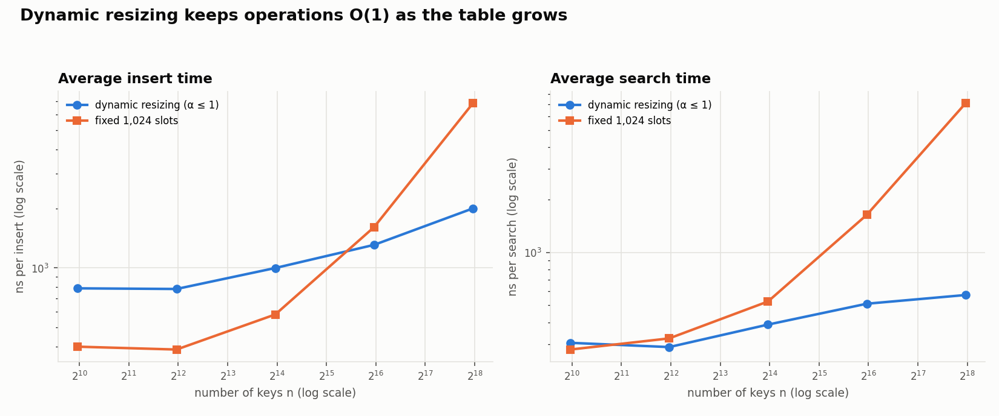
Figure 4. Average insert and search time with dynamic resizing vs a fixed table of 1,024 slots.
n | dynamic: final α | dynamic: insert / search (ns) | fixed: final α | fixed: insert / search (ns)
1,000 | 0.98 | 788 / 305 | 0.98 | 399 / 280
16,000 | 0.98 | 1,000 / 388 | 15.6 | 581 / 526
64,000 | 0.98 | 1,310 / 511 | 62.5 | 1,612 / 1,642
256,000 | 0.98 | 2,005 / 573 | 250 | 6,851 / 7,117
- With resizing, α always stays below 1, so search cost stays in the few-hundred-nanosecond range as the table grows 256-fold.
- Without resizing, α grows with n, so every operation becomes Θ(n/m). At n = 256,000, search is 12× slower and delete is 14× slower than with resizing.
- For small n the fixed table inserts faster. It was already big enough and never had to rehash, while the dynamic table paid for 7 doublings starting from 8 slots. This is the amortized rehashing cost from above: a constant factor, not a change in growth rate. When the final size is known in advance, pre-sizing the table (HashTableChaining(capacity=...)) avoids it.
- The dynamic table’s time per operation still creeps up (≈ 300 → 570 ns for search) even though α is fixed. This is a memory effect that the RAM model behind Big-O ignores: a 262,144-slot table of Python lists no longer fits in the CPU cache, so each slot lookup is more likely to go to main memory.

Strategy 2: A good hash function, ideally universal (implemented)
Resizing controls the average chain length, but if the hash function puts many keys in the same slot, some chains become long anyway. The hash function decides how evenly keys are spread.
Experiment: adversarial keys. We insert 1,024 keys that are all multiples of m = 1,024 (0, 1024, 2048, …). Such keys come up in practice with aligned memory addresses, IDs that step by a fixed amount, or timestamps rounded to a fixed interval. Data: results/hash_adversarial.csv.
Hash function | longest chain | non-empty slots (of 1,024)
Division method, h(k) = k mod m | 1,024 | 1
Universal, ((a·k + b) mod p) mod m | 2 | 757
With the naive division method, every key lands in slot 0. The table becomes a linked list and every operation is Θ(n). The universal function spreads the same keys at least as well as a random assignment would: with truly random placement about 1 − 1/e ≈ 63% of slots are non-empty at α = 1, and we measured 74% (757 slots), with no chain longer than 2. (A linear function maps evenly spaced keys to evenly spaced values mod p, which spreads them slightly more evenly than random.)
Guidelines for choosing a hash function:
- Use a universal family with a random seed. No fixed input can be bad for it, and choosing a new seed on each resize means an attacker cannot build a set of colliding keys in advance. This matters for hash-flooding denial-of-service attacks on web servers, which is why Python randomizes str hashing per process.
- If you use the division method, make m a prime not close to a power of 2, so that patterns in the key’s low-order bits do not all map to the same slot.
- The hash must use every part of the key (all characters of a string, all fields of a tuple).

Other strategies
- Choose the threshold for the workload. A max load of ≤ 1 is common for chaining. Lower thresholds (like 0.75, which Java’s HashMap uses) trade memory for shorter chains.
- Pre-size the table when the number of keys is known in advance, to skip the intermediate resizes.
- Incremental rehashing: move a few buckets per operation instead of all at once. This removes the occasional Θ(n) pause at the cost of a more complex implementation, and is used in systems like Redis.
- Balanced trees for long chains: Java 8’s HashMap turns a chain into a red-black tree once it holds 8 or more entries, capping the worst case at O(log n) per operation instead of O(n).

Conclusions
- Randomization turns a worst-case risk into a guarantee. The expected O(n log n) for Randomized Quicksort holds for every input because the randomness is in the algorithm, not in the data. The experiments confirmed this: the time stayed at ~9 ms for n = 8,000 regardless of input order, while deterministic Quicksort degraded quadratically, becoming 61× slower on sorted and 123× slower on reverse-sorted input.
- Asymptotic analysis and constant factors are both needed. Deterministic Quicksort was 1.5–2× faster on random input and a fixed-size hash table inserted faster for small n. Neither contradicts the theory, because Big-O describes how cost grows, not how large it is at a single size.
- Assumptions matter. The O(n log n) proof assumes distinct keys. The repeated-keys experiment showed that a random pivot alone does not help when keys repeat, and that the 3-way partition is what fixes it.
- For hash tables, the load factor is the key quantity. Measured costs matched 1 + α/2 and α almost exactly. Keeping α ≤ 1 with doubling resizes and a universal hash function gives O(1) expected time per operation, as the fixed-size and adversarial-key experiments show when these are left out.

References
- T. H. Cormen, C. E. Leiserson, R. L. Rivest, C. Stein. Introduction to Algorithms, 4th ed., MIT Press, 2022. Chapter 7 (Quicksort), Chapter 11 (Hash Tables), Chapter 16 (Amortized Analysis).
- J. L. Carter, M. N. Wegman. “Universal classes of hash functions.” Journal of Computer and System Sciences 18(2), 1979.
- R. Sedgewick, K. Wayne. Algorithms, 4th ed., Addison-Wesley, 2011. §2.3 (3-way partitioning).
- Claude ai. (used ai to organize).

