External Design Document – MyNutritionTracker

Team: CodeMonkeys
Names: | Student Number:
Mushfiqa | 301493764
Anton | 301452511
JD
Sienna

Team logo:
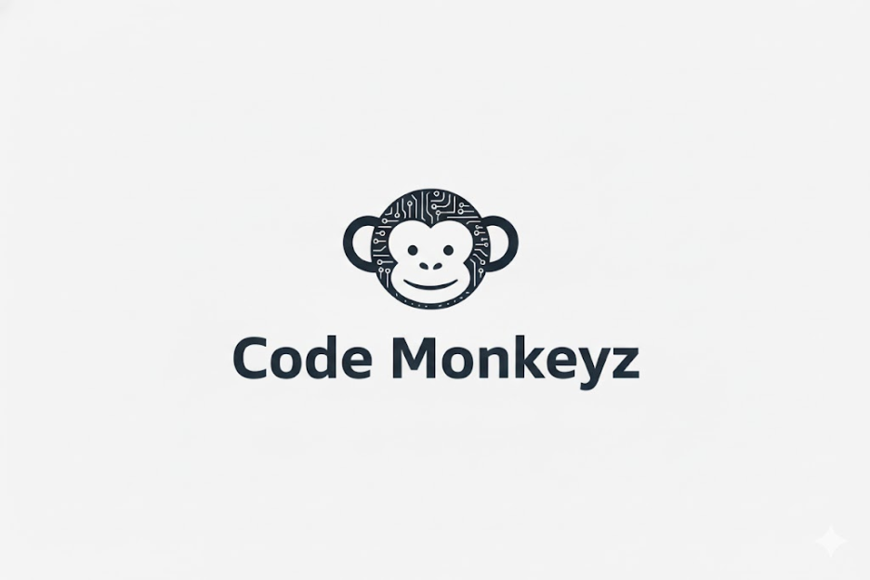

Github backend link : https://github.com/Mushfiqa1/MyNutritionTracker.git and snapshot for commit proof:
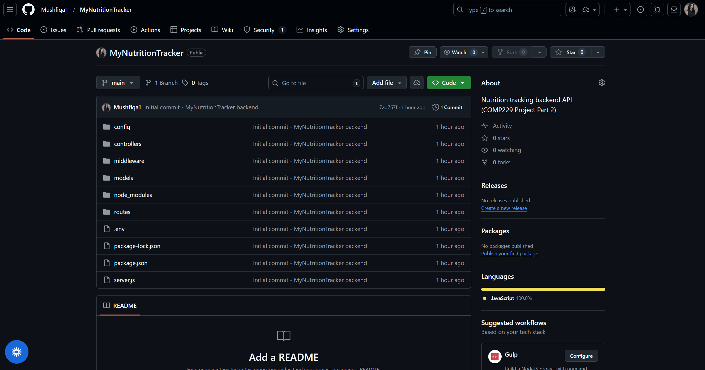

Wireframes Explanation:
Wireframes are simple visual sketches of each screen in your app. They show layout and structure, not colors or styling. They help demonstrate how users move through the system.
Included Wireframes
Landing Page
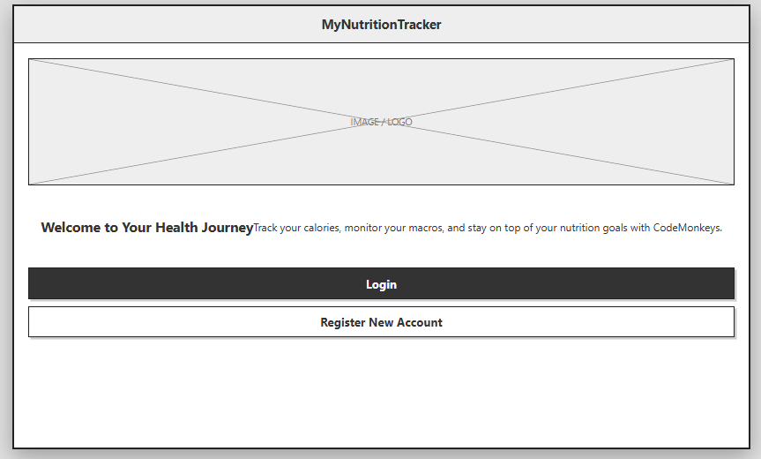
Registration Page
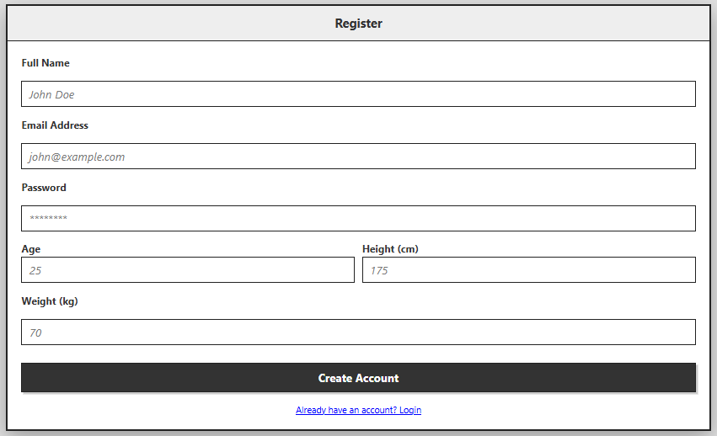
Login Page
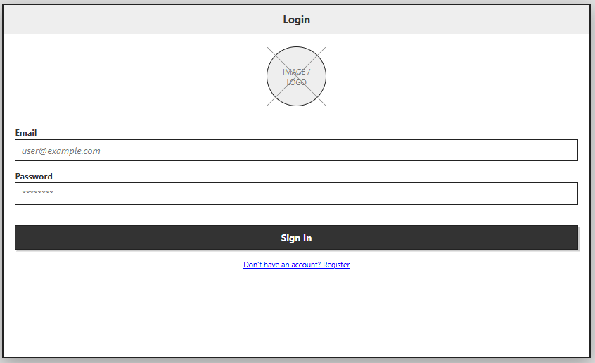

Dashboard – List of Nutrition Entries
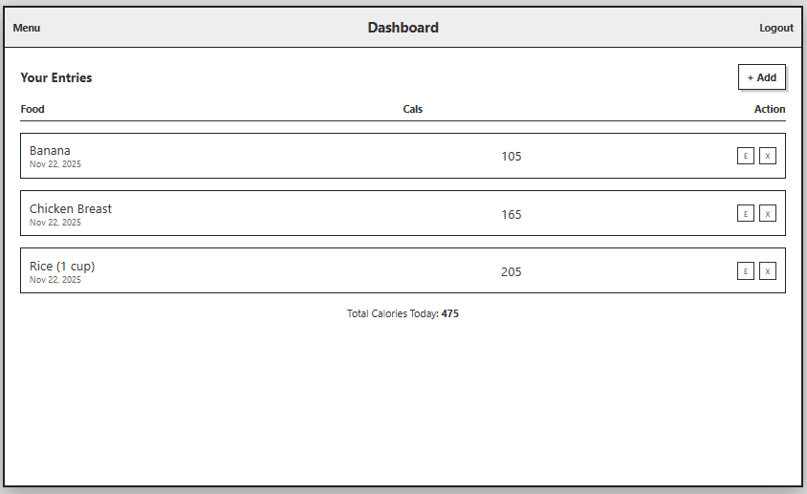
Add Entry Page
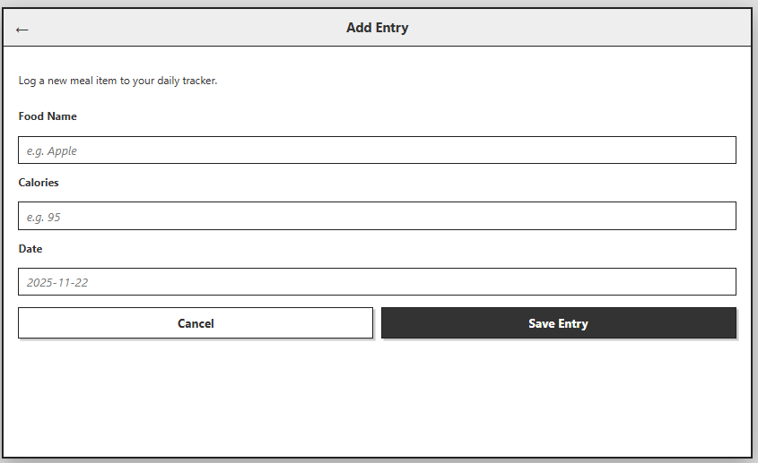
Edit Entry Page
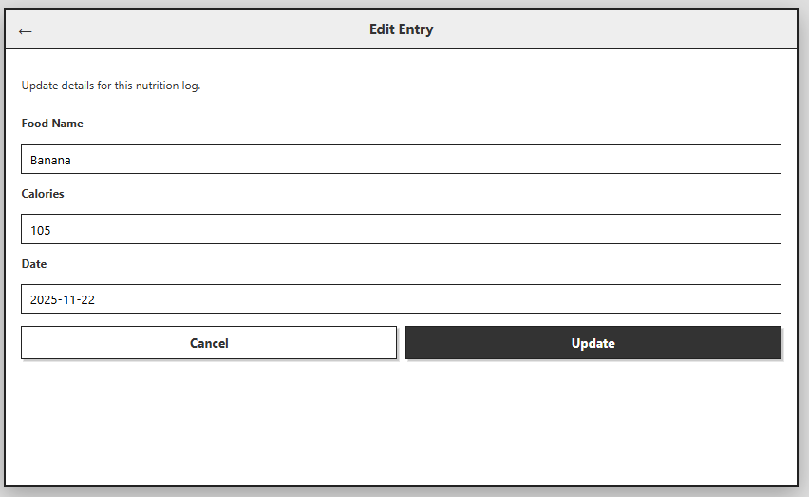
These wireframes outline the navigation flow and overall interface design for MyNutritionTracker

Agile Development Approach
Our team (Code Monkeys) followed an Agile-based workflow to guide the development of MyNutritionTracker. We used an iterative, collaborative approach with short development cycles, continuous communication, and frequent updates to ensure progress and alignment with project requirements.
Sprint Structure: We organized our work into two sprints
Sprint 1 – Backend Foundation
- User authentication (register, login)
- Nutrition CRUD API
- MongoDB models and routing
- Postman testing for all endpoints
Sprint 2 – Frontend & Integration
- Basic UI layout of “My Nutrition Tracker”
- API integration for login + nutrition entries
- Error handling & validation
- Final testing and deployment to GitHub
User Stories: We identified the core user needs as user stories
- As a user, I want to register an account so that I can securely log in.
- As a user, I want to log in so the system knows which entries belong to me.
- As a user, I want to add nutrition entries so I can track what I eat.
- As a user, I want to edit or delete entries so I can manage my daily intake.
- a user, I want a clear interface so I can easily navigate the app.
Team Roles (Scrum Model)
- Mushfiqa – Backend lead, API testing, documentation
- Anton – Database modeling, routes, testing
- an Daniel – Frontend UI structure, API integration
- Siena – Wireframes, design decisions, documentation support
Agile Tools & Communication
- GitHub for version control and commits
- VS Code as the development environment
- Postman for API testing
- Weekly meetings (simulated) to track progress and assign tasks
Review + Retrospective
- After each sprint, we performed a review of completed features and a retrospective discussing:
- What went well (solid API structure, successful CRUD functions)
- What could be improved (more time for UI polish)
- What to do next (future enhancements like calorie charts)

Screenshot of our agile method : Trello

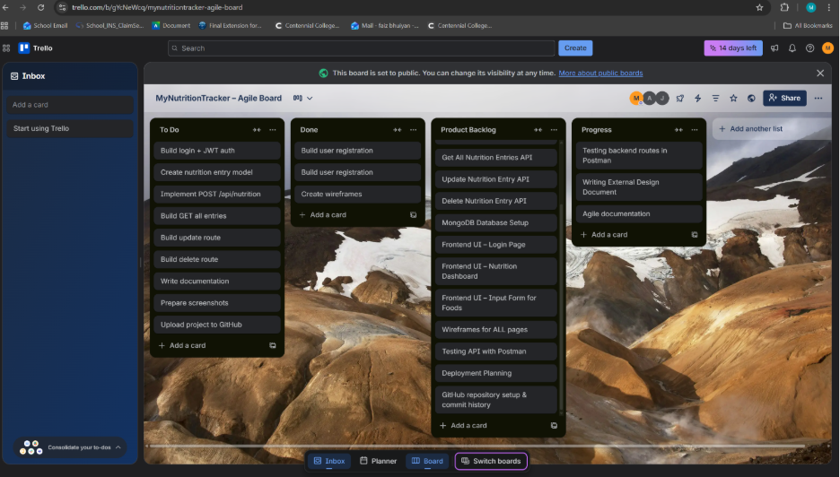

POSTMAN
Screenshot #1: Register (POST) success response
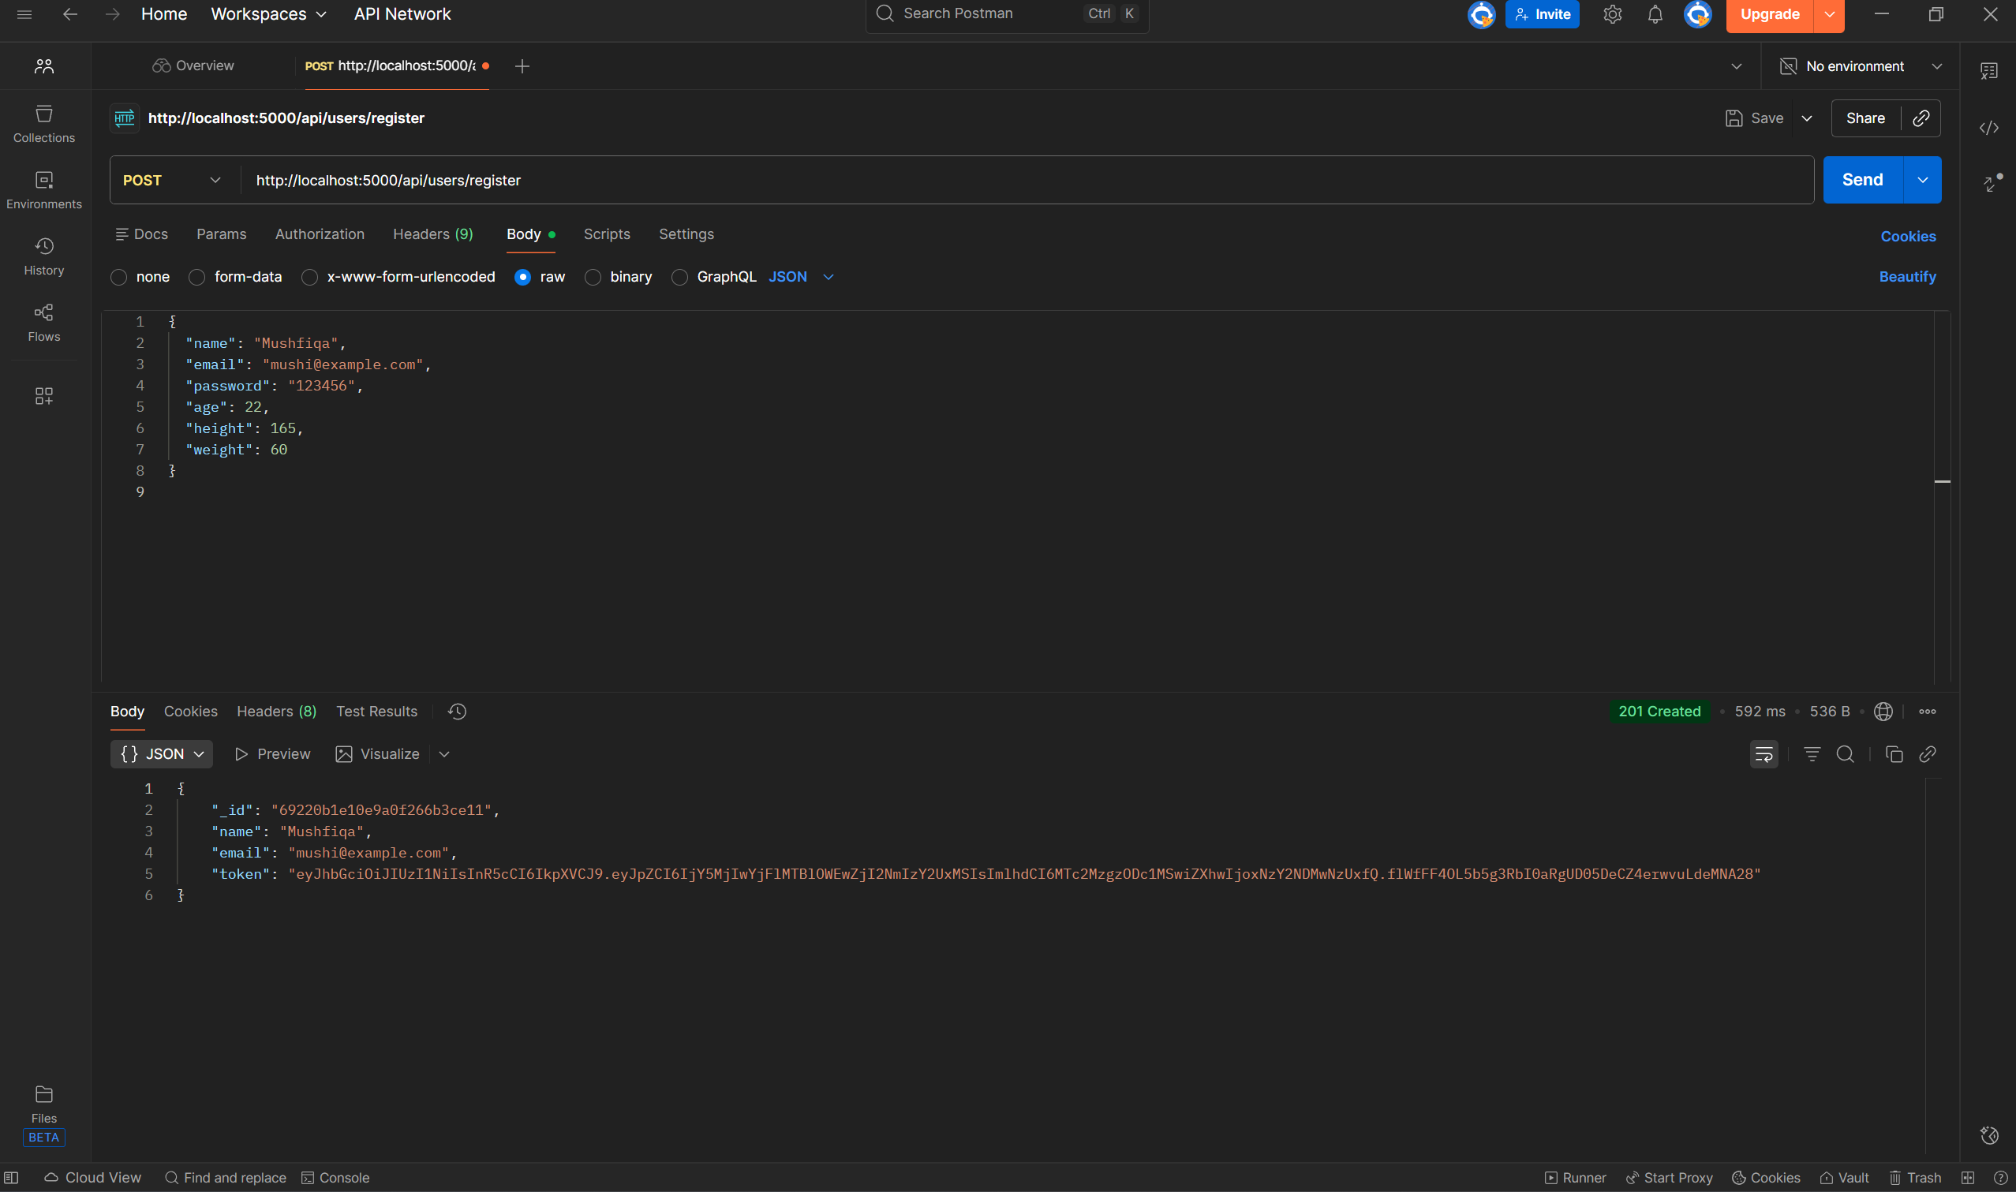
The screenshot shows a successful test of the POST /api/users/register endpoint using Postman. A new user account was created by sending JSON data (name, email, password, age, height, weight) to the backend. The server responded with HTTP 201 Created, confirming the user was registered in the MongoDB database. The response also includes the user’s _id, name, email, and a generated JWT authentication token, proving that both registration and token generation are working correctly.
Screenshot #2 Login API Test
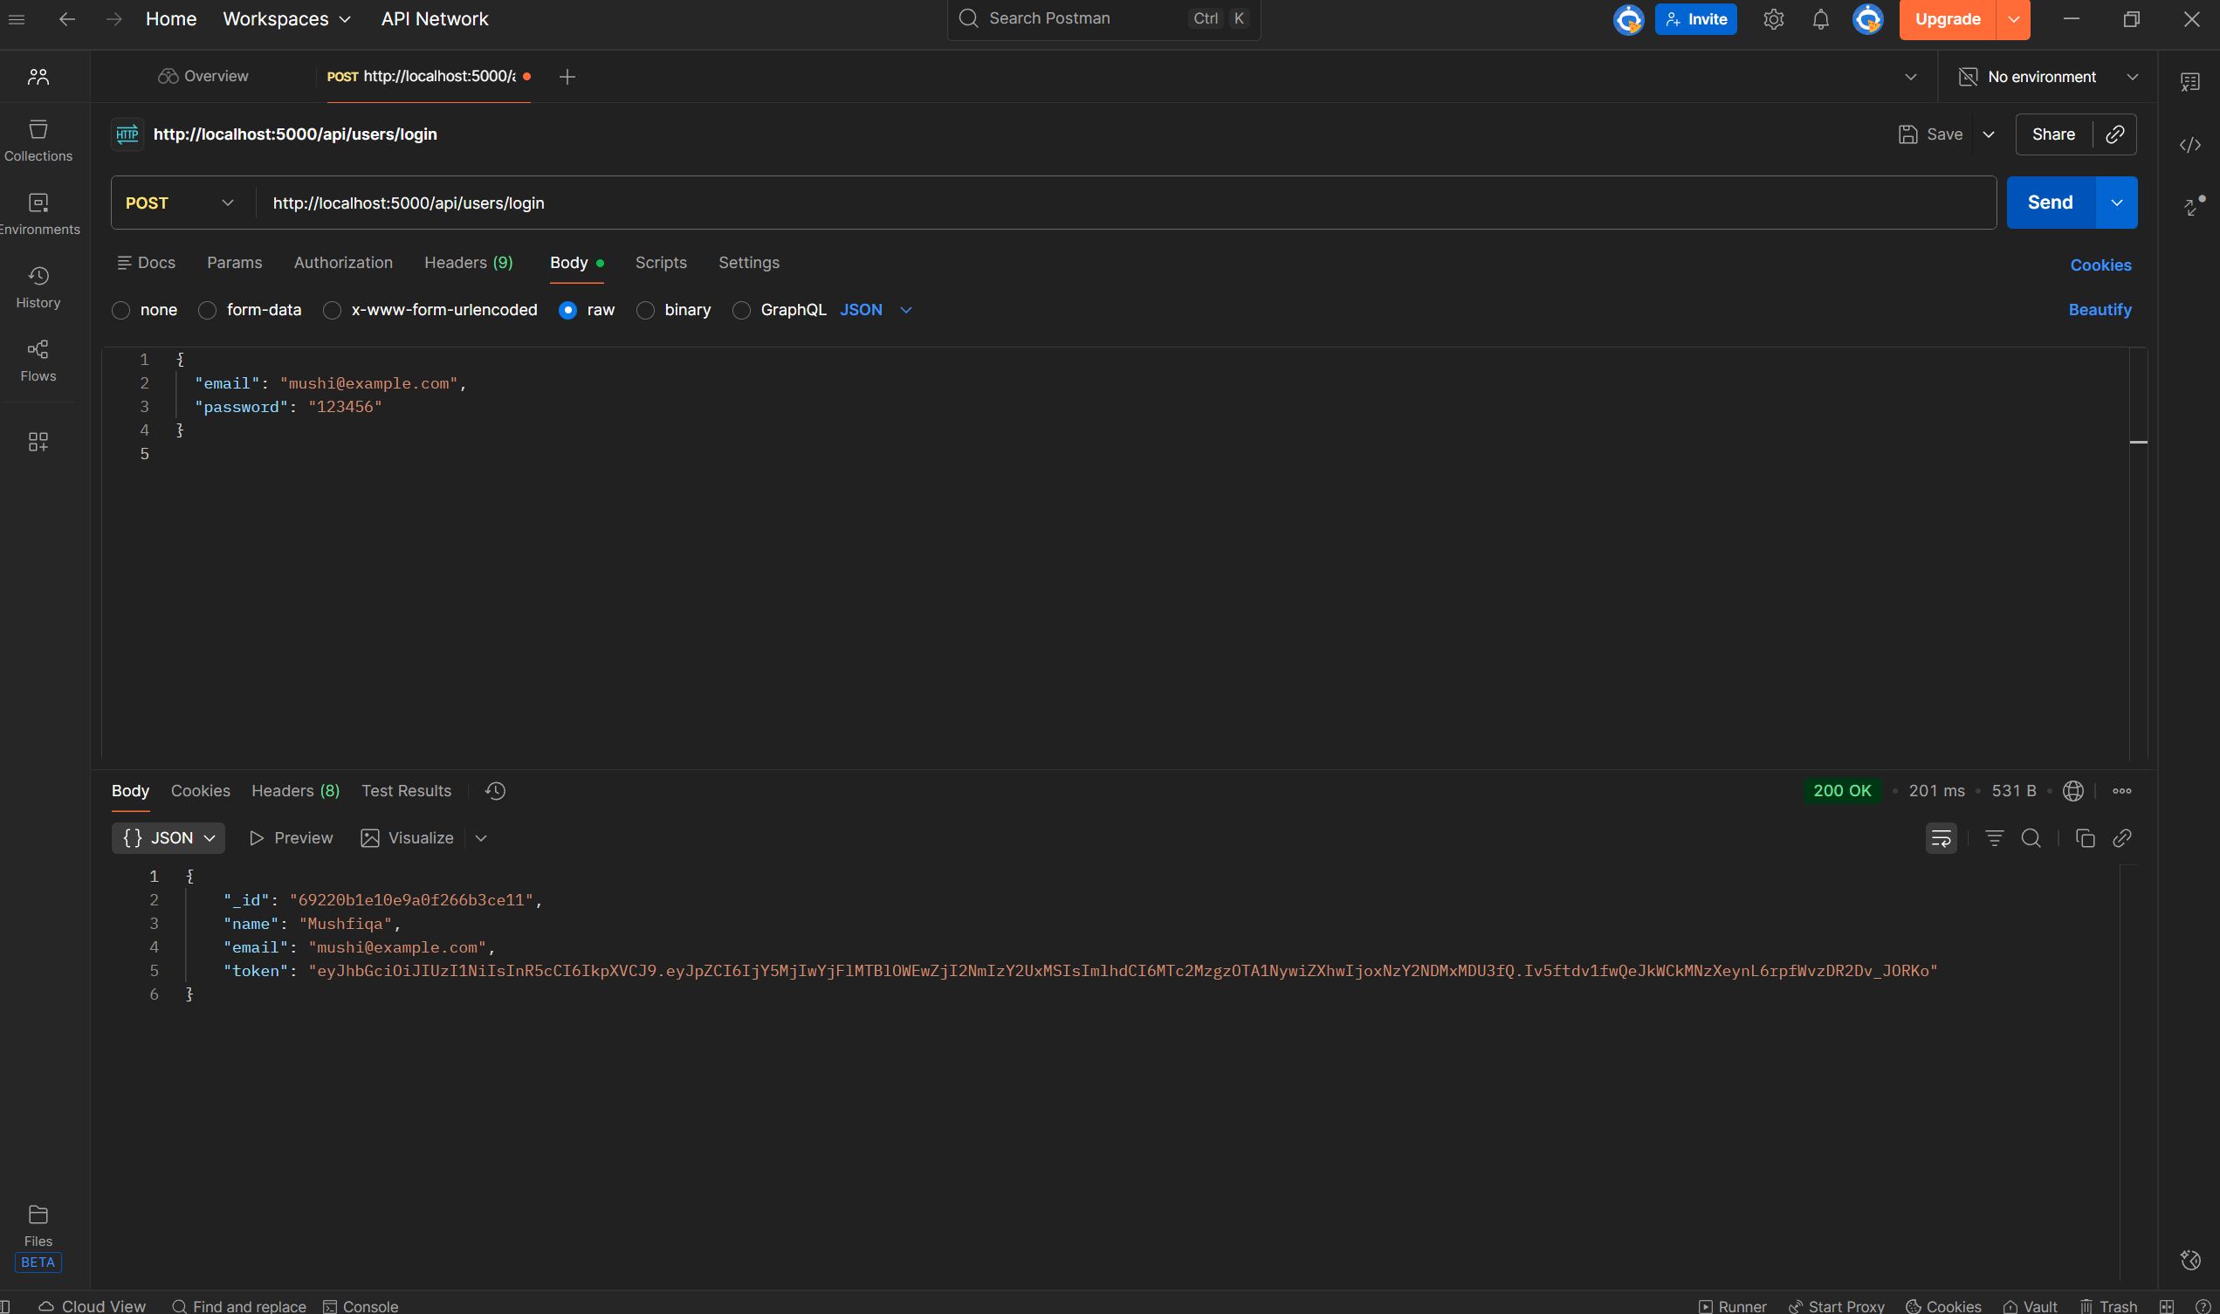
This screenshot shows a successful test of the login endpoint. A POST request was sent to http://localhost:5000/api/users/login with a valid email and password. The server responded with 200 OK, confirming the login worked. The response includes the user’s ID, name, email, and a newly generated JWT token, proving that authentication and token creation are functioning correctly.
Screenshot #3: POST http://localhost:5000/api/nutrition/
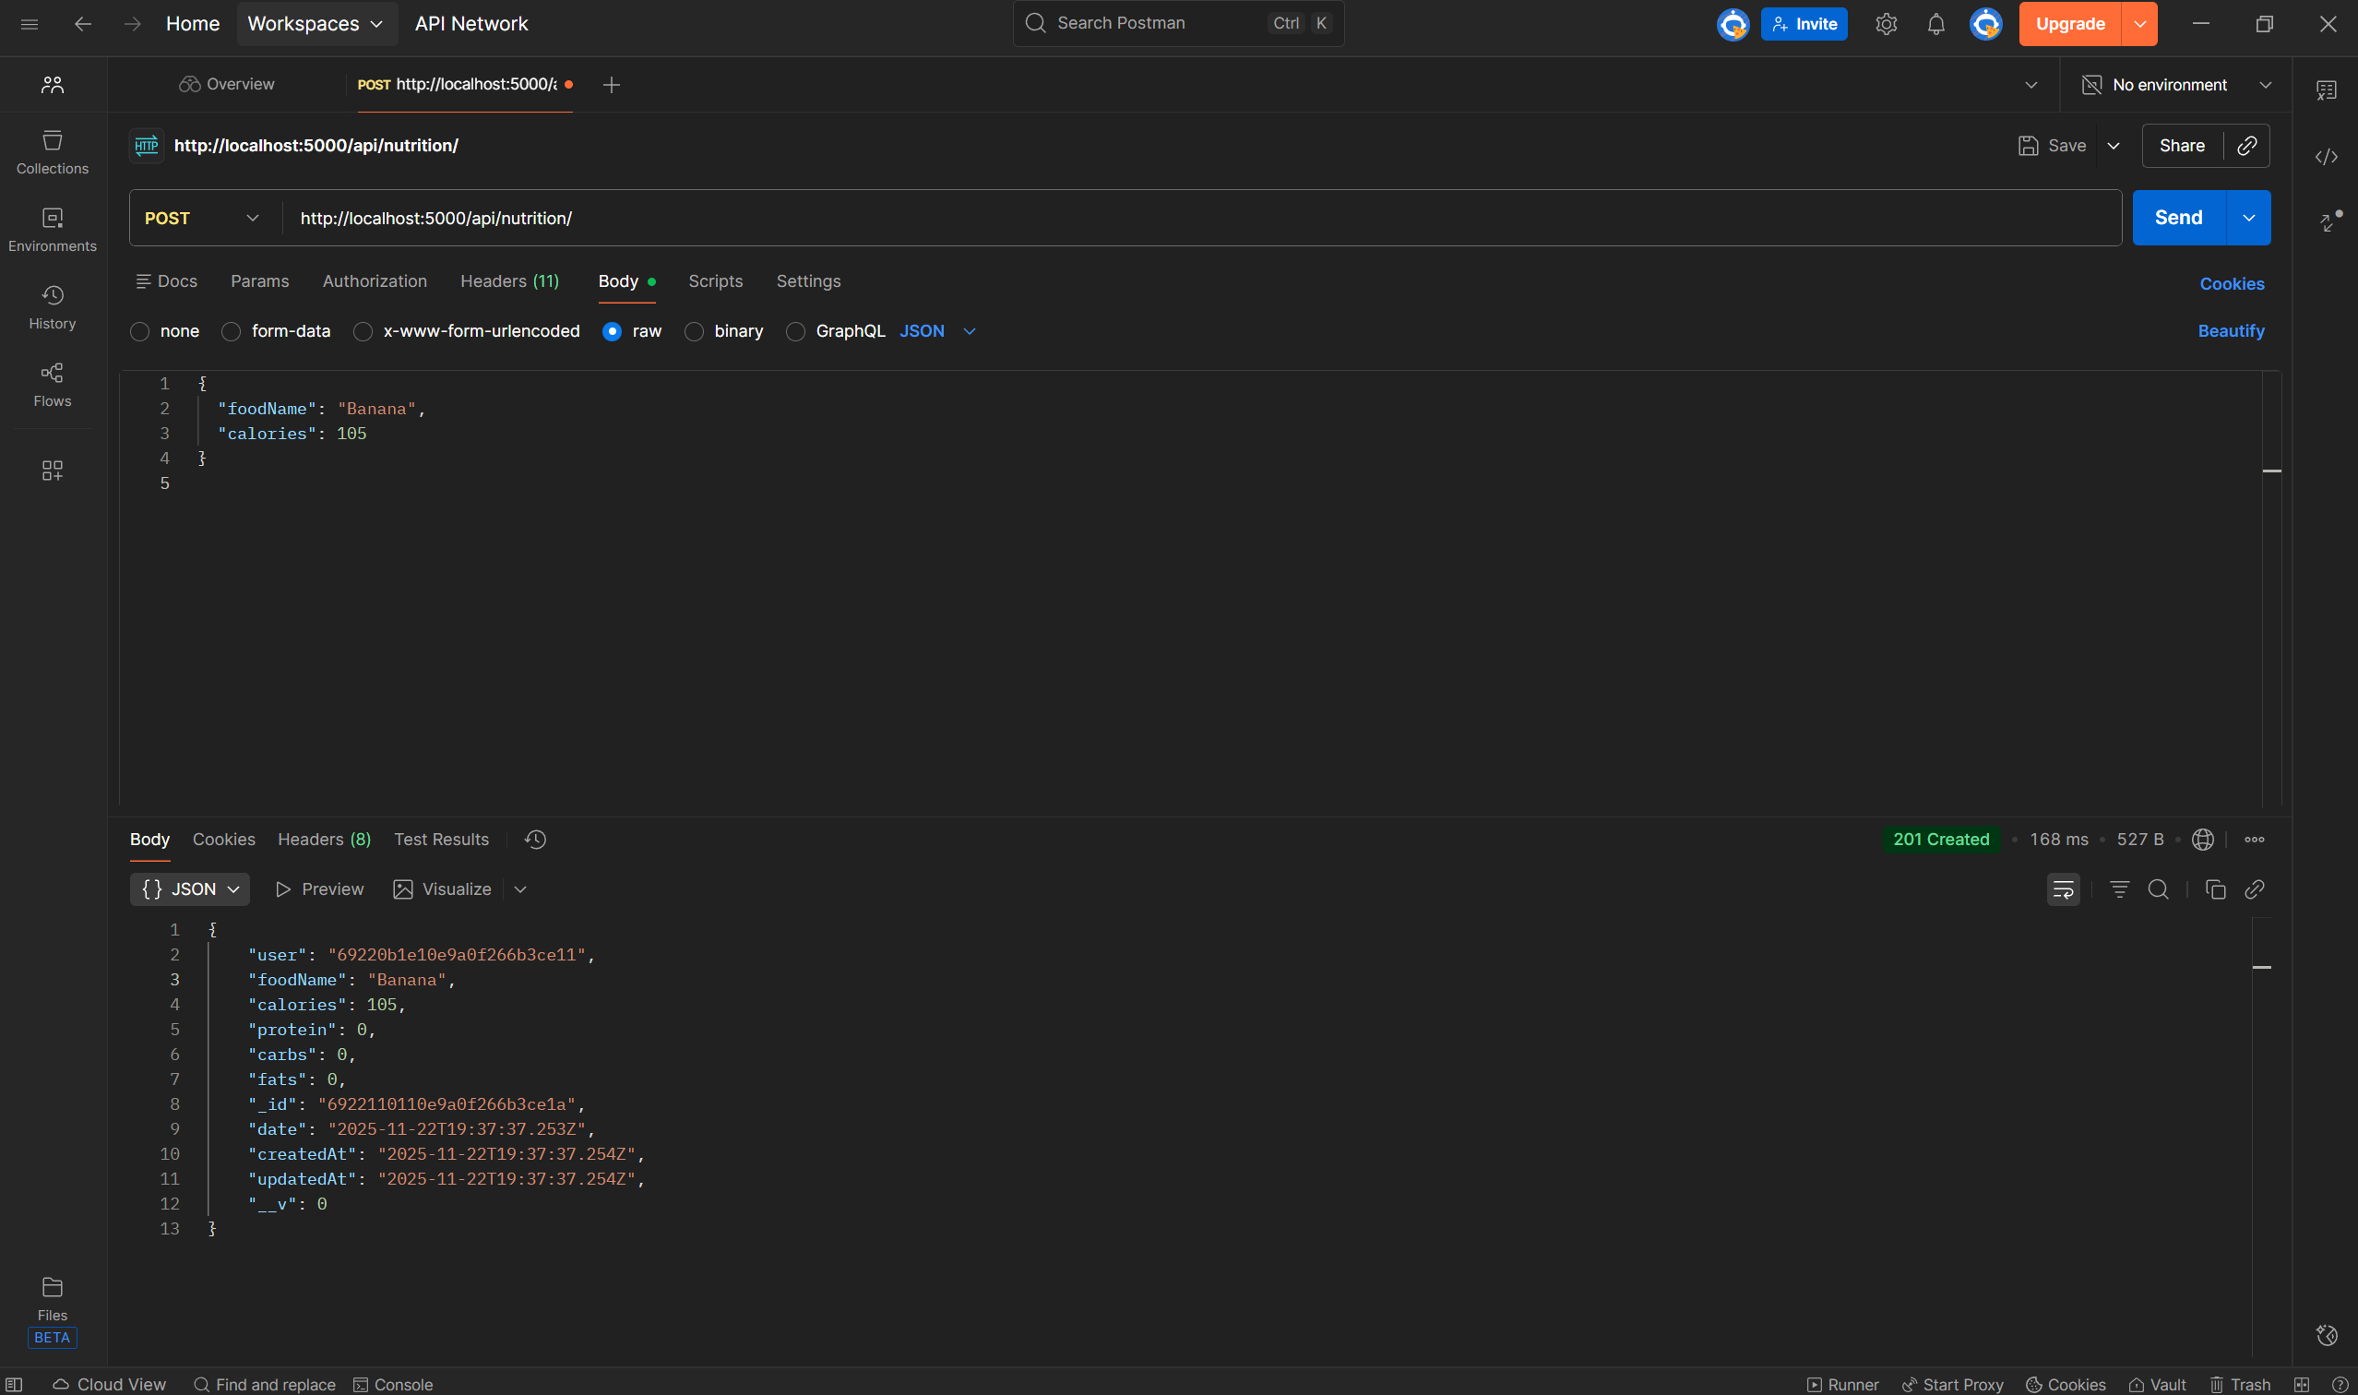
The screenshot shows a successful POST request to the /api/nutrition endpoint using a valid JWT token in the Authorization header. The request body contained a food entry with foodName: "Banana" and calories: 105, and the server responded with status 201 Created. The response confirms that the entry was saved in the database under the correct authenticated user, and includes the stored fields along with automatically generated timestamps and the entry’s unique ID. This demonstrates that authentication is working properly and the nutrition entry creation feature is functioning as intended.
Screenshot#4 GET request
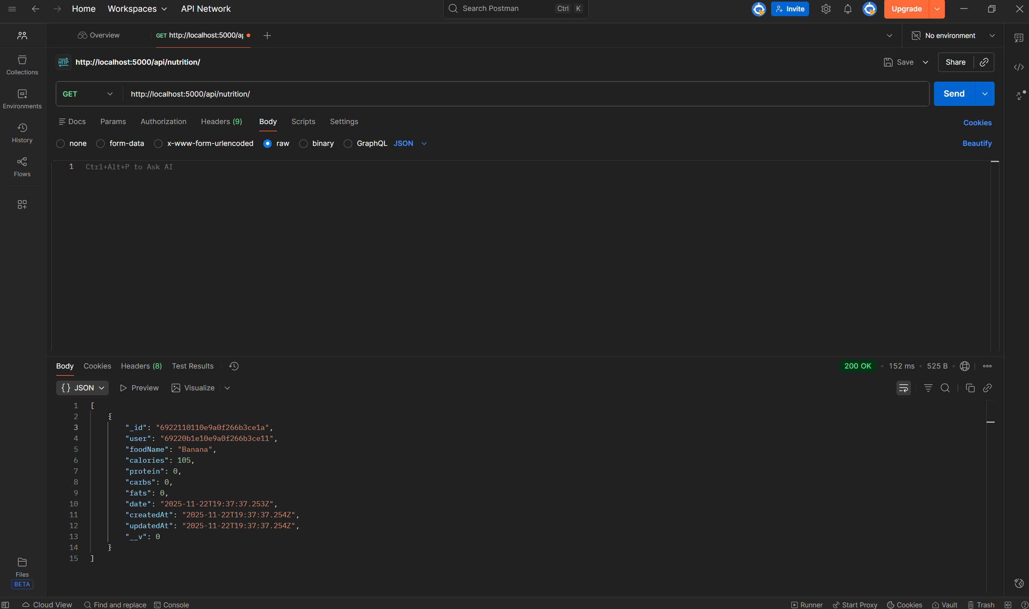
The screenshot shows a successful GET request to http://localhost:5000/api/nutrition/ in Postman. No body was required for the request; only the Authorization Bearer token header was used. The server returned a 200 OK response, displaying all nutrition entries stored for the authenticated user. The response includes one saved entry (“Banana”, 105 calories) along with metadata such as the entry’s _id, user ID, timestamps, and default macro values.
Screenshot #5 PUT request
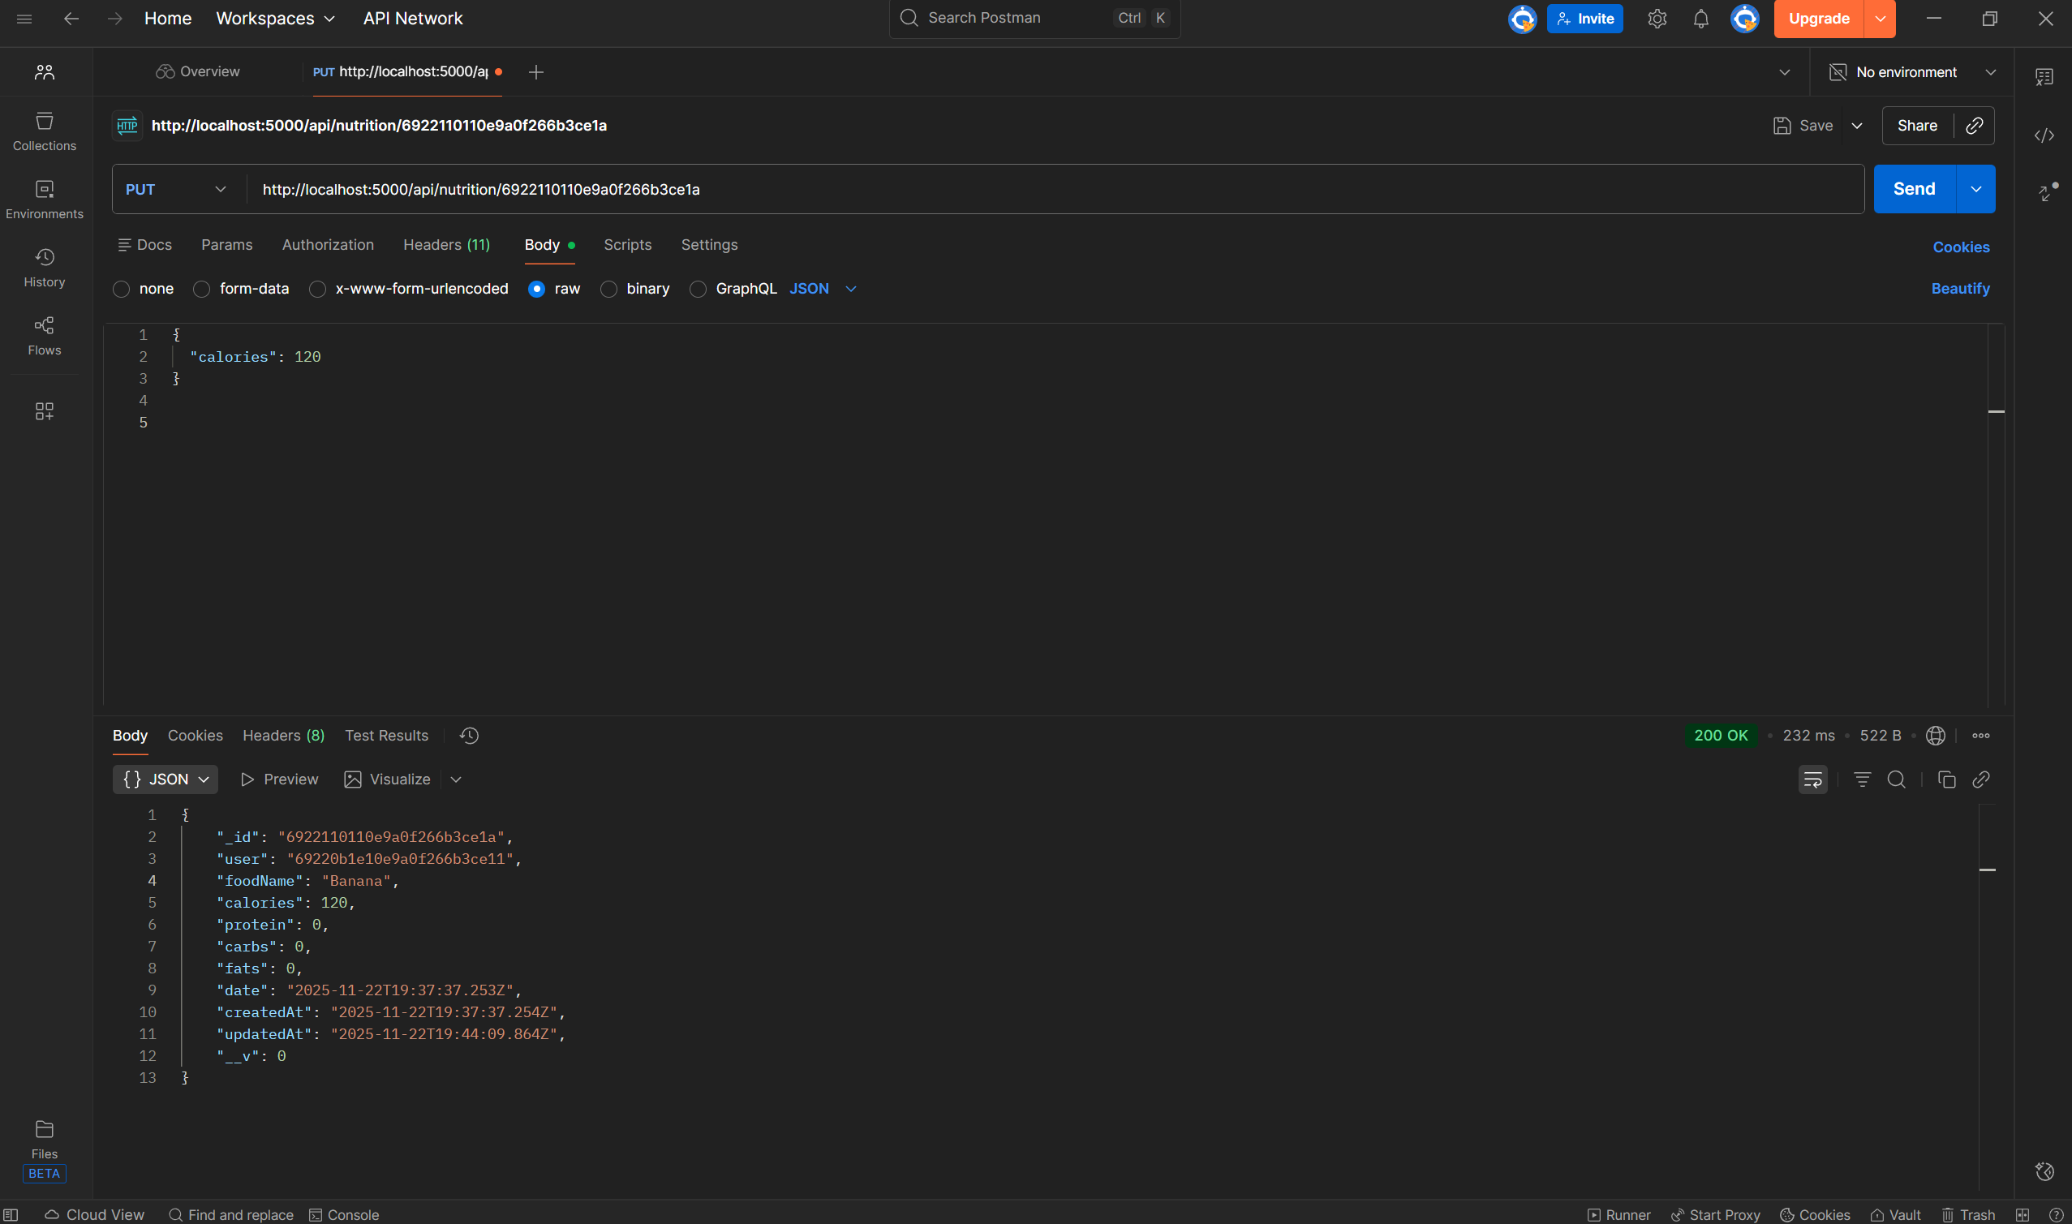
The screenshot shows a successful PUT request to the endpoint http://localhost:5000/api/nutrition/692210110e9a0f266b3ce1a, updating the nutrition entry’s calories. In the request body, you changed "calories": 120, and the server responded with 200 OK, returning the updated entry. The response confirms the change by showing "calories": 120" and an updated "updatedAt" timestamp, proving the update operation is functioning correctly through authenticated access.
Screenshot#6 DELETE request
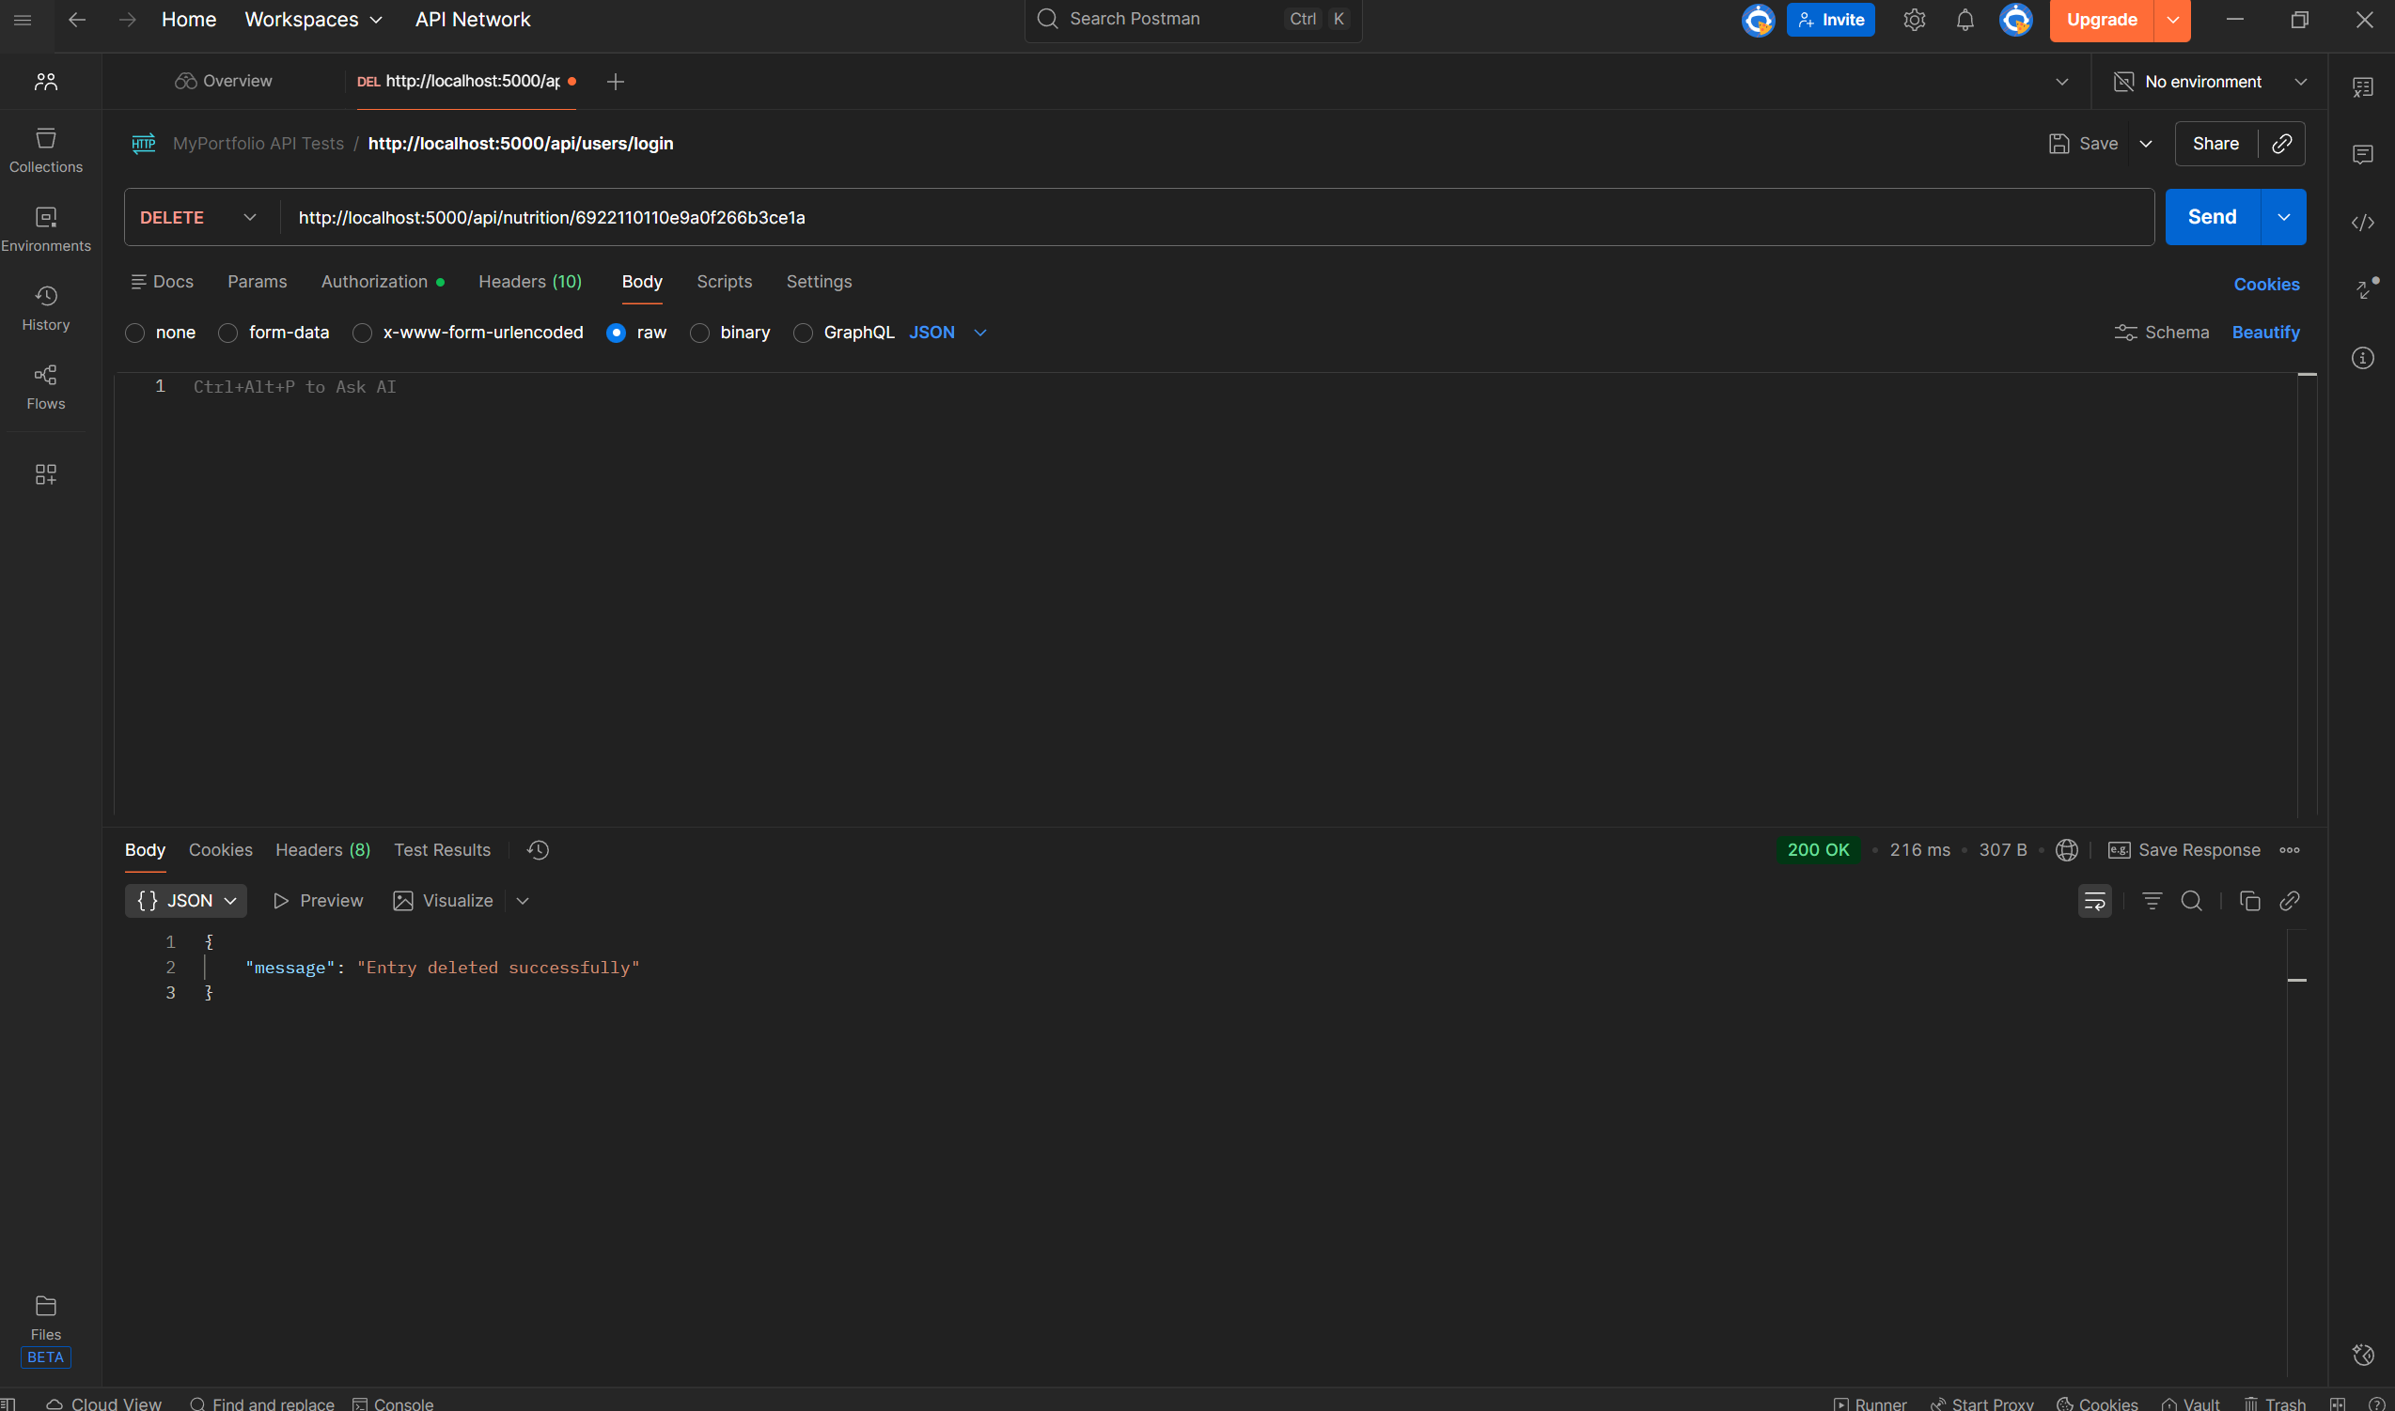
The DELETE request to /api/nutrition/692210110e9a0f266b3ce1a was successful. Postman shows a 200 OK response, confirming that the nutrition entry was deleted. The backend returned the message “Entry deleted successfully”, meaning the ID was valid, the token was correct, and the authentication middleware worked properly. This completes the final step of testing the DELETE endpoint.

DEMO VIDEO LINK: https://www.youtube.com/watch?v=sOqW_kBONhg

