**Project Title:**

Library Management System

**Project Abstract:**

The main of Library Management application is to keep the book in the proper format with its complete details including Author and the person who is issuing this book. Everything is managed from the database. We need to maintain the book and to check whether the books are available on the library or not.

**Description on Project Working:**

This project is about the management of a library. It is a desktop based application. The project consists of two panels, which are user panel and admin panel.

Admin can insert, delete and update data. User can be the member of the library by providing necessary information. If the member wants to issue a book, he can get a notification whether the book is available or not.

User can issue the book for the return date and after they have to pay the fine per day 10 taka. If the student lost the book he has to purchase the same book and submit to the library.

|  |
| --- |
|  |

The computers used in the library must be connected to each other via LAN at the speed of 10 MB per seconds. The student needs to enter his roll no and the details of the book. After they just need to enter the book number and their roll no and the book will be issued.

**Hardware and Software Requirements:**

**Hardware requirement:**

* Operating System: Window 10
* Hard Drive: 40GB
* RAM: 256 MB

**Software requirement:**

* JDK 8
* Net beans IDE 8.2
* MS SQL server 2017
* XAMPP v3.2.2

**Design:**

* Front End Design: Graphical User Interface
* Back End Design: Java Language
* Database: SQL Queries

**Other Requirements:**

* Sources: Books, Internet
* Books:
  1. Java The Complete Reference by Schildt.
  2. SQL: The Complete Reference by Schildt.

**Panels:**

* User Panel
* Admin Panel

**Features:**

1. **Admin Panel:** 
   * 1. **Admin Login:**

Admin must log in first to continue his activities. If he has no account. He must create his account by signing up.

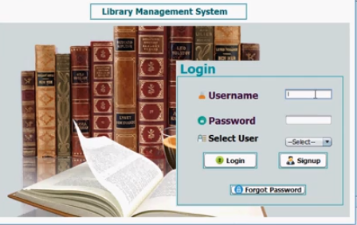

**Figure:** Admin Login

* + 1. **Book Management:**

Admin can add, delete, update and search books from here.

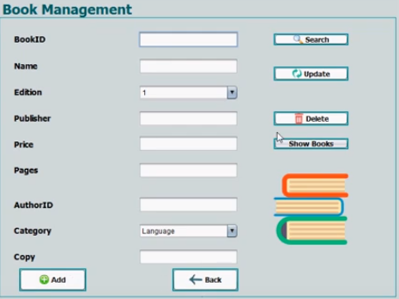

**Figure:** Book Management

* + 1. **Member Management:**

Admin can add, delete, update and search members from here.

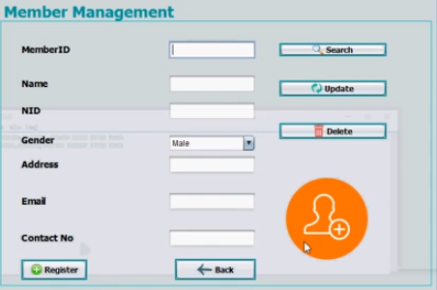

**Figure:** Member Management

* + 1. **Author Management :**

By the first panel, admin can add new author. By the second panel, admin can add multiple authors for the same book.

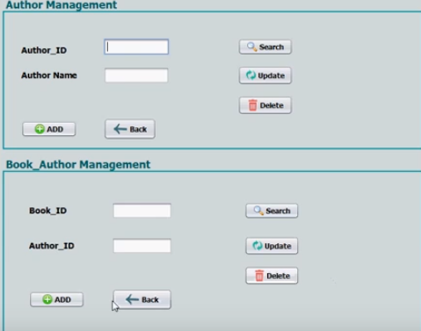

**Figure:** Author Management

* + 1. **Book and Member Details:**

From dashboard, admin can see book, member and issue & return details and send email to him/her who are late.

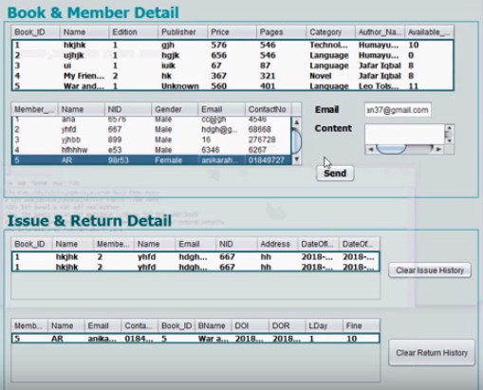

**Figure:** Book and Member Details

* + 1. **Most Issued Books:**

This table shows most issued book id, title and issue times. First table shows most issued member id, name and issue times. Second table shows the member who issued same book more than once.

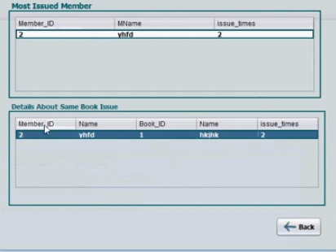

**Figure:** Most Issued Books

* + 1. **Fine Details:**

This table shows member id, name along with late days and fine.

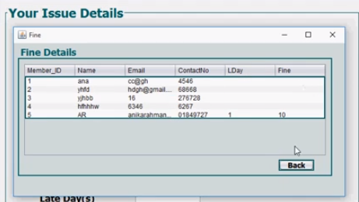

**Figure:** Fine Details

* + 1. **Book Issue:**

Admin can search by book id, member id and gets all information and inserts issue and return date.

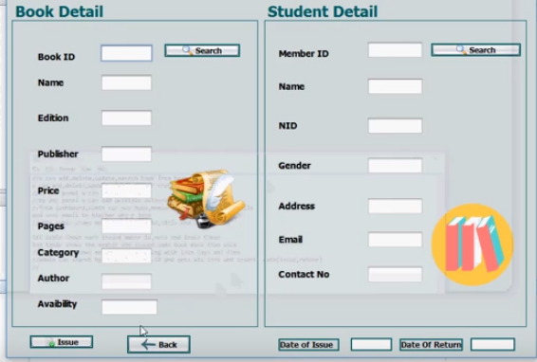

**Figure:** Book Issue

* + 1. **Return Panel:**

Admin can know the members fine and confirm their book returns by this feature.

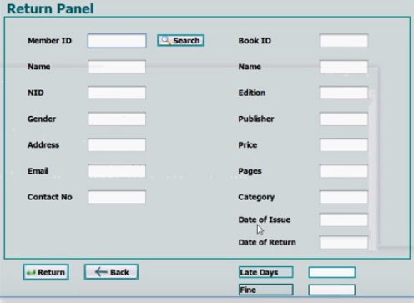

**Figure:** Return Panel

* + 1. **Book and Member Availability:**

Admin can know the availability of books by this feature.



**Figure:** Book and Member Availability

1. **User Panel:**
   1. **Member Login:**

Member must log in first to continue his activities. If he has no account. He must create his account by signing up.

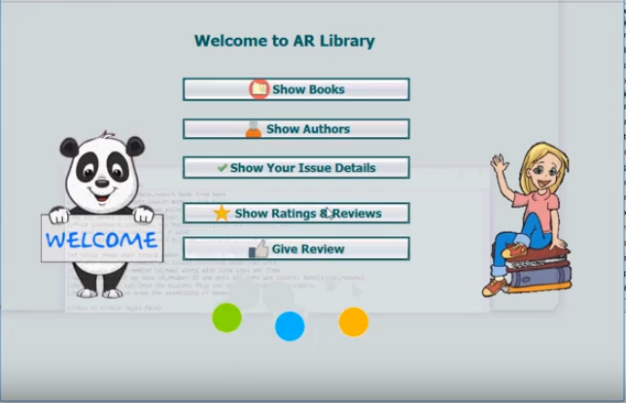

**Figure:** Member Login

* 1. **Show Books:**

Members can see the books in this feature.

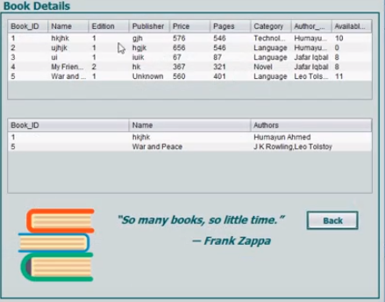

**Figure:** Show Books

* 1. **Show Authors:**

Members can see the authors in this feature.

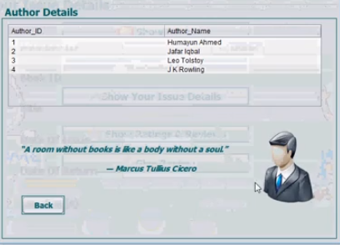

**Figure:** Show Authors

* 1. **Show Issue Details:**

Members can see the issue details in this feature.

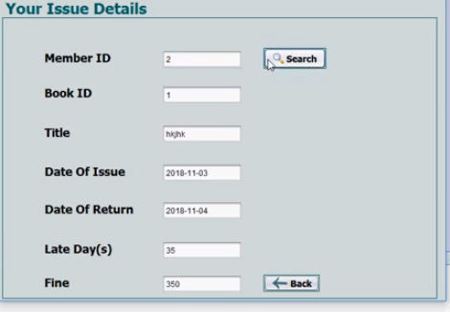

**Figure:** Show Issue Details

* 1. **Ratings and Reviews:**

Members can see the ratings and reviews in this feature.

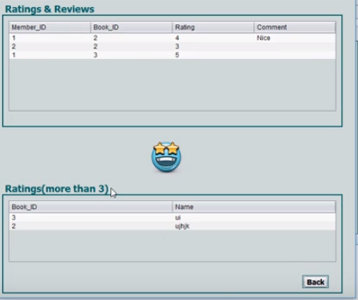

**Figure:** Ratings and Reviews

* 1. **Give Review:**

Members can give reviews by this feature.

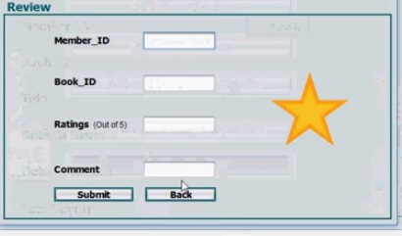

**Figure:** Give Review

**Other Features:**

1. **Log out:**

User and Admin can log out after completing his activities.

1. **Forgot Password:**

If the user or admin forgets his password, he can retrieve his password by answering security questions.

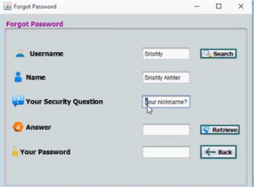

**Figure:** Forgot Password

**SQL Operations:**

There are some SQL operations in our project. They are given below:

* Data Insert, Update and Delete
* Data Comparison (Ascending and Descending order)
* Data Search
* Mathematical Operation such as Multiplication
* Aggregate Function AVG is used
* Four types of Join: Inner Join, Outer Join, Left Join and Right Join
* Six types of Subqueries

**Limitation:**

There are some limitations in our project. They are given below:

* Not more than six types of Subqueries
* No Self Join operation
* Other Aggregate Functions (MIN, MAX, COUNT, GROUPING etc) are not used except AVG
* No View

**Future work:**

Our future work is to complete all the limitations or incomplete SQL operations as possible as we can.

**Conclusion:**

We have done our project so far, Library Management System as possible as we can. We will add more features and SQL operations in our further update.