|  |  |
| --- | --- |
| Exam Number: | B177407 |
| Course Name: | Bioinformatics 1 |
| Coursework Number: | CW2 |
| Tutor’s Name: | Ian Simpson |

|  |  |  |  |
| --- | --- | --- | --- |
| Date: |  | Signature: |  |

Please fill in the information below, in relation to the coursework you are submitting.

Informatics Coursework Cover Sheet

2020/21

#### Introduction

SFARI Gene is an evolving database for the autism research community. The database assigns every gene with a score reflecting the strength of the evidence linking it to the development of autism.[1]

This report is about a research on Autism literature, genes and gene network using the genes from SFARI database with the gene score 1 to 3.

#### **Data & Methods**

The main data used in this report is from Data set: *SFARI-Gene_genes_10-29-2020release_11-22-2020export.csv* which was provided from the course website, NCBI Entrez Database[2] and NCBI gene2go file[3].

Most of the works are done by using Python(Bio, pandas, ul, seaborn). Some tools also used in this report are: the PantherDB tool[4] and the STRING website[5].

#### **Results**

##### Part 1 - Autism Literature

###### Task 1

In this task, I used the pandas value_counts() function to count for each gene-score. The bar chart below shows the number of genes in each gene-score group:

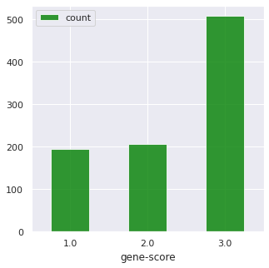

*Figure 1: number of genes by different gene-score*

###### Task 2

In this task, I just sorted the number of report and the top 5 SFARI genes with the most ‘number-of-reports’ ranked by different gene score is shown in table 1:

|  |  |
| --- | --- |
| **Gene Symbol** | **Number of Reports** |
| SHANK3 | 88 |
| NRXN1 | 88 |
| MECP2 | 87 |
| SCN2A | 71 |
| SCN1A | 67 |

*Table 1: top 5 SFARI genes with the most number of reports*

###### Task 3

In this part, I retrieved data from PubMed using Entrez from Bio package.

The Medical Subject Headings (MeSH) thesaurus is a controlled and hierarchically-organized vocabulary produced by the National Library of Medicine.[6] Using the MeSH Major Topic is not just picking up papers that have autism as a wordnecessarily in it. It's picking up any paper that has been annotated with the mesh keywords that live within that part of the mesh annotation table.

So in this case, the keywords were set to *autism[MAJR] AND ("gene symbol" OR "gene name")* in which the [MAJR] represents MeSH Major Topic. Notice that I also included not only the gene symbol but also the gene name because some articles refer to the gene as their name while others as their symbols.

The results are shown as follow:

|  |  |
| --- | --- |
| **Gene Symbol** | **Number of Articles** |
| SHANK3 | 65 |
| NRXN1 | 37 |
| MECP2 | 80 |
| SCN2A | 12 |
| SCN1A | 11 |

*Table 2: Number of Articles of each top 5 genes*

###### Task 4

In this task, I used the keywords: *autism[MAJR] AND ("gene symbol" OR "gene name") AND "year"[DCOM]* in which the year ranges from 2000 to 2010 since these are the earliest and latest year of the appearance of articles about autism relating to the top 5 genes. As was discussed in the discussion forum, some paper may have different version or last for more than one year. To solve this problem, I just changed [DP] to [DCOM] which means the Completion Date pf the paper so that one paper only be counted for only once. The sum of papers on each gene matches the total number of papers which can approve it.

|  |  |  |  |  |  |  |  |  |  |  |  |
| --- | --- | --- | --- | --- | --- | --- | --- | --- | --- | --- | --- |
| **Gene Symbol** | **2000** | **2001** | **2002** | **2003** | **2004** | **2005** | **2006** | **2007** | **2008** | **2009** | **2010** |
| *SHANK3* | 0 | 0 | 0 | 0 | 0 | 0 | 0 | 2 | 5 | 9 | 0 |
| *NRXN1* | 0 | 0 | 0 | 0 | 1 | 0 | 0 | 0 | 4 | 5 | 1 |
| *MECP2* | 0 | 2 | 1 | 4 | 2 | 7 | 2 | 3 | 7 | 7 | 8 |
| *SCN2A* | 0 | 0 | 0 | 1 | 0 | 1 | 0 | 0 | 2 | 0 | 1 |
| *SCN1A* | 0 | 0 | 0 | 1 | 0 | 2 | 0 | 0 | 1 | 1 | 0 |

|  |  |  |  |  |  |  |  |  |  |  |
| --- | --- | --- | --- | --- | --- | --- | --- | --- | --- | --- |
| **Gene Symbol** | **2011** | **2012** | **2013** | **2014** | **2015** | **2016** | **2017** | **2018** | **2019** | **2020** |
| *SHANK3* | 5 | 8 | 4 | 1 | 1 | 4 | 6 | 6 | 9 | 5 |
| *NRXN1* | 1 | 4 | 3 | 4 | 6 | 1 | 2 | 1 | 2 | 2 |
| *MECP2* | 2 | 5 | 5 | 5 | 2 | 7 | 5 | 5 | 0 | 1 |
| *SCN2A* | 0 | 1 | 1 | 1 | 0 | 1 | 0 | 0 | 3 | 0 |
| *SCN1A* | 0 | 2 | 1 | 0 | 0 | 0 | 1 | 0 | 1 | 1 |

*Table 3: Number of Articles counted by year*

###### Task 5

The single stacked histogram displaying the data from the table is shown below(Figure 2) as well as another single stacked bar chart(Figure 3) which will demonstrate the data clearer. The methods used were DataFrame.plot.hist() and DataFrame.plot.bar().

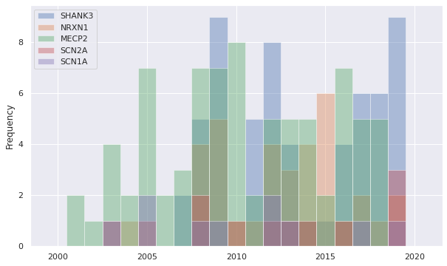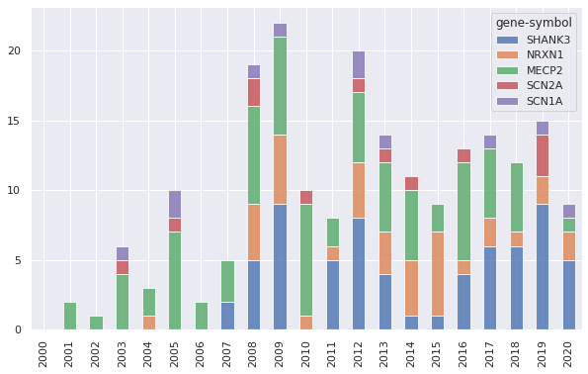

*Figure 2: Number of Articles counted by year - histogram Figure 3: Number of Articles counted by year - bar chart*

###### **Additional Analysis**

In this section, I did the PubMed search with the same key words as *autism[MAJR] AND ("gene symbol" OR "gene name") AND 0:2000[DCOM]* for all the SFARI genes in order to find those articles related to the genes which were published before 2000 which is the earliest year of the top 5 genes. Here are some significant results:

|  |  |  |  |
| --- | --- | --- | --- |
| **Gene Symbol** | **Number of Articles** | **Gene Symbol** | **Number of Articles** |
| FMR1 | 7 | TEK | 3 |
| GABRB3 | 7 | SON | 38 |
| HRAS | 3 | ADSL | 8 |
| UBE3A | 3 | GFAP | 3 |

*Table 4: Number of Articles before 2000*

I also did the PubMed search for every genes for the articles published recently: on 2019 and 2020. And here are some significant results:

|  |  |  |
| --- | --- | --- |
| **Gene Symbol** | **Counts 2019** | **Counts 2020** |
| SHANK3 | 5 | 3 |
| FMR1 | 5 | 2 |
| CACNA1C | 5 | 0 |
| NRXN1 | 4 | 0 |
| PTEN | 2 | 3 |
| NLGN3 | 2 | 1 |

*Table 5: Number of Articles in 2019 and 2020*

##### **Part 2 - Autism Genes**

###### **Task 1**

In this task, I used the ul package in python to retrieve the gene information of Homo Sapiens in order to link the gene symbols to the gene IDs. However, while doing so, there are some genes that are in the SFARI-Gene file but not in the gene-info file. Since there are only a few of them, after printing them out and searched manually, there are mainly 3 reasons:

1. . The gene symbols in the SFARI-Gene file are sometimes aliases(pseudonym), for example: gene FAM92B(alias) is recorded as CIBAR2 in NCBI database;
2. . The gene symbols in the SFARI-Gene file actually refer to a group of genes, for example: gene NOTCH2NL is an alias for NOTCH2NLA, NOTCH2NLB and NOTCH2NLC;
3. . The gene symbols in the SFARI-Gene file are too specific, for example: gene RP11-1407O15.2 is recorded as RP11 in NCBI database.

There is also a duplicated gene symbol in the data set: MEMO1. And after searching it on the NCBI website, there are indeed 2 IDs for this gene symbol. So I decided to keep both of them.

Finally, the total number of gene IDs mapped to the SFARI genes are 993.

###### **Task 2**

In this task, the same method was used to retrieve the file *gene2go.gz*. After merging gene2go file and the IDs of all the SFARI genes, a total 26969 hits are obtained.

However, there were 3304 rows that were fond duplicated: same GeneIDs with same GO_IDs.

After checking the gene2go file, I fond that this is because that there are many genes that hit the same GO term with different **evidences.** As a result, I decided to remove the duplicated rows since there should be only one hit of the same GO terms from one gene. After cleaning up the data, there are now 23665 hits.

###### **Task 3**

In this task, I split the genes with different gene-scores using groupby() and get_goup() methods in pandas.

###### **Task 4**

After merging the gene2go file and the geneIDs, the 3 tables with GO term ID, GO term Description and Go term count of each gene list are shown as table 6, 7 and 8 separately.

|  |  |  |
| --- | --- | --- |
| **GO_ID** | **GO_term** | **GO_term_count** |
| GO:0005515 | protein binding | 150 |
| GO:0005634 | nucleus | 106 |
| GO:0005654 | nucleoplasm | 84 |
| GO:0005829 | cytosol | 66 |
| GO:0005886 | plasma membrane | 58 |
| GO:0005737 | cytoplasm | 55 |
| GO:0006357 | regulation of transcription by RNA polymerase II | 45 |
| GO:0046872 | metal ion binding | 42 |
| GO:0045944 | positive regulation of transcription by RNA polymerase II | 38 |
| GO:0000785 | chromatin | 38 |

*Table 6: table of GO term counts with gene score 1*

|  |  |  |
| --- | --- | --- |
| **GO_ID** | **GO_term** | **GO_term_count** |
| GO:0005515 | protein binding | 137 |
| GO:0005886 | plasma membrane | 76 |
| GO:0005634 | nucleus | 71 |
| GO:0005829 | cytosol | 68 |
| GO:0005737 | cytoplasm | 62 |
| GO:0005654 | nucleoplasm | 56 |
| GO:0016021 | integral component of membrane | 33 |
| GO:0016020 | membrane | 32 |
| GO:0005887 | integral component of plasma membrane | 31 |
| GO:0070062 | extracellular exosome | 27 |

*Table 7: table of GO term counts with gene score 2*

|  |  |  |
| --- | --- | --- |
| **GO_ID** | **GO_term** | **GO_term_count** |
| GO:0005515 | protein binding | 333 |
| GO:0005886 | plasma membrane | 179 |
| GO:0005829 | cytosol | 141 |
| GO:0005634 | nucleus | 126 |
| GO:0005737 | cytoplasm | 122 |
| GO:0005654 | nucleoplasm | 103 |
| GO:0016021 | integral component of membrane | 89 |
| GO:0005887 | integral component of plasma membrane | 82 |
| GO:0016020 | membrane | 67 |
| GO:0046872 | metal ion binding | 67 |

*Table 8: table of GO term counts with gene score 3*

###### **Task 5**

In this task, I obtained the bar chart data sets from the PantherDB tool[3] using the tab-delimited file with ID list as the first column, selected the organism Homo Sapiens, and then plotted the bar chart using seaborn package in python. The graphs that are exactly the same as shown on the Panther website are as follow(Figure 4, 5 and 6):

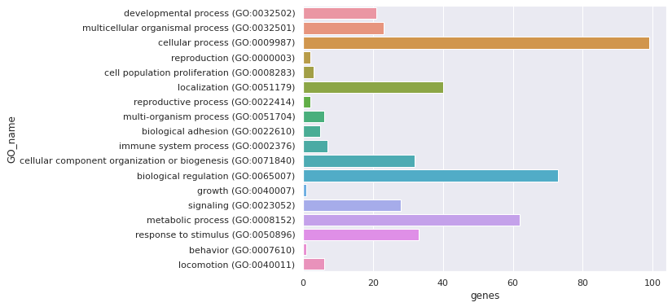

*Figure 4: Hits of GO terms of genes with gene-score 1*

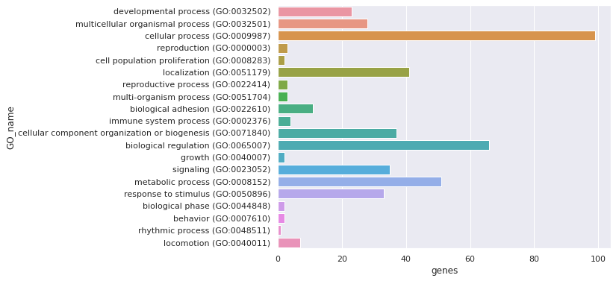

*Figure 5: Hits of GO terms of genes with gene-score 2*

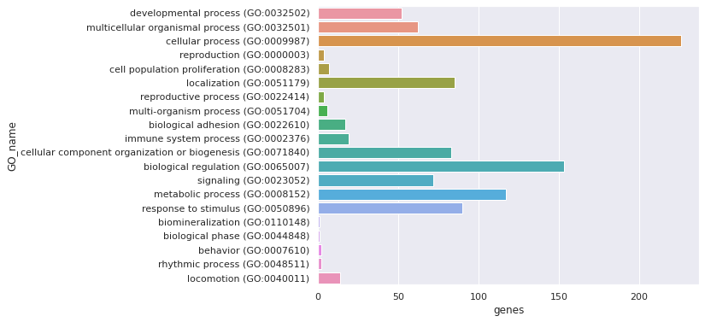

*Figure 6: Hits of GO terms of genes with gene-score 3*

And I also plotted some other graphs showing and comparing the percentage of hits against total genes and total process hits(Figure 7, 8 and 9).

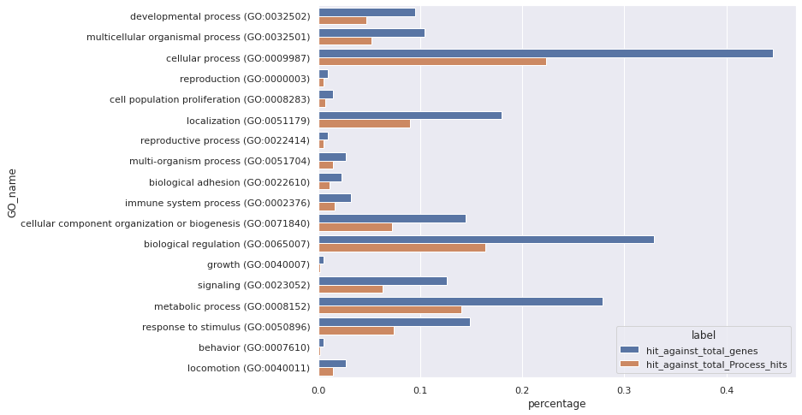

*Figure 7: Percentage of hits of genes with gene-score 1*

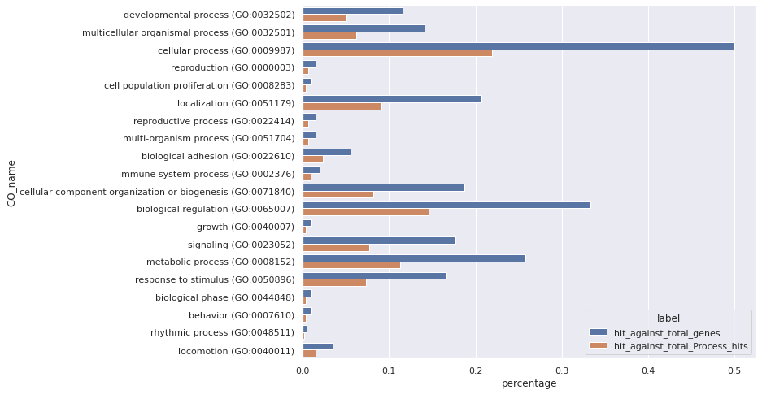

*Figure 8: Percentage of hits of genes with gene-score 2*

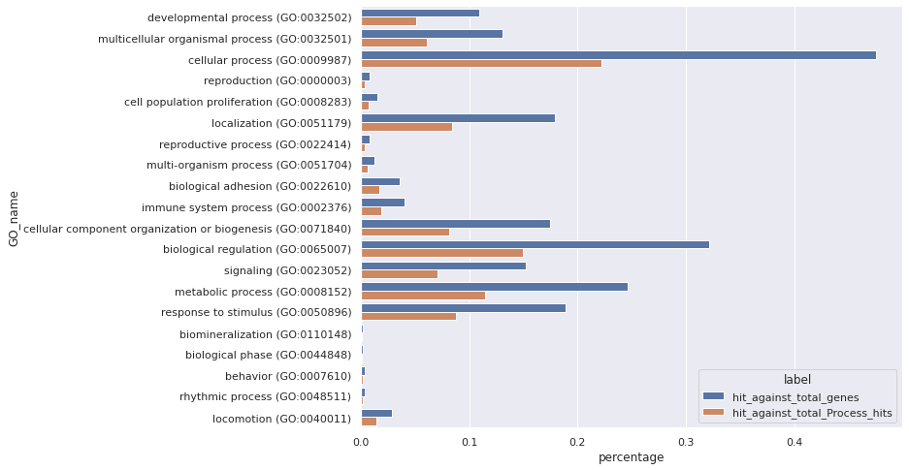

*Figure 9: Percentage of hits of genes with gene-score 3*

##### **Part 3 - Autism Gene Networks**

###### Task 1

Using the STRING website, the statistics of gene-score 1 list are shown as below:

|  |  |  |
| --- | --- | --- |
| Number of nodes | Number of edges | Average node degree |
| 193 | 990 | 10.3 |

*Table 6: Statistics of gene score 2 list*

###### Task 2

After downloading the tsv file and analyzed using python, the two biggest clusters are fond as cluster 1 and 2 both with 22 proteins.

Using the same way in part 2, the gene symbols in each cluster were mapped with the corresponding gene IDs, and the graphs were shown below:

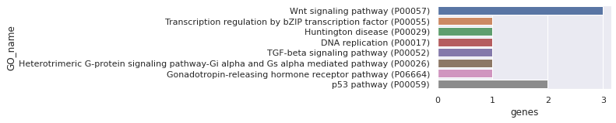

*Figure 10: Hits of GO terms of cluster 1*

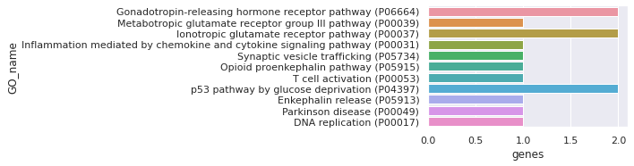

*Figure 11: Hits of GO terms of cluster 2*

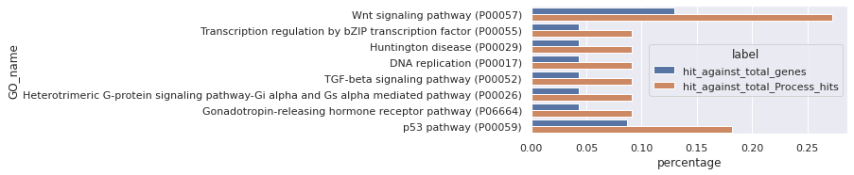

*Figure 12: Percentage of hits of genes of cluster 1*

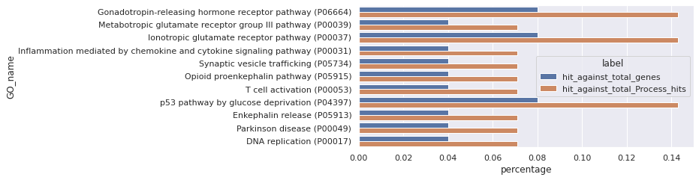

*Figure 12: Percentage of hits of genes of cluster 2*

###### Task 3

The bitmap image of this task is shown below. It is impossible to show the graph clearly with out occupying one page so the image here is just to show the finish of the task.

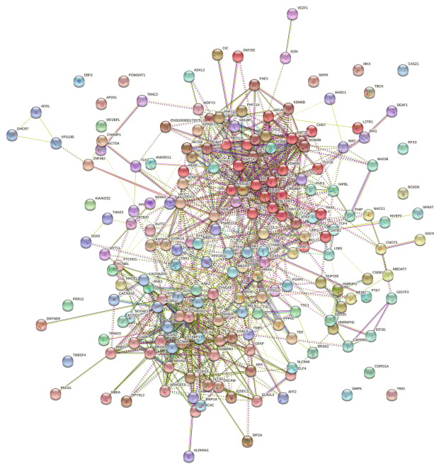

*Figure 13: Bitmap image*

###### Additional **Analysis**

After repeating the same process above for the other 2 gene score lists, it was fond that the number of genes in the biggest clusters of gene score 2(which are 14 and 9) and 3(which are 15 and 12) are much less than that of gene score 1(22 and 22).

The pathway GO terms hits of 3 gene score lists however, varies a lot while the other ontologies are basically the same except with different hit rates.

#### **Discussion**

##### **Part 1 - Autism Literature**

Among the top 5 genes, though it does not have the largest number of papers, *MECP2* appeared the earliest . But the number of papers related to this gene is not very significant since 2019. *SCN1A* also appeared early but the number of papers stayed low over the years and so did gene *SCN2A*. As for *NRXN1* and *SHANK3*, which are the top 2 SFARI genes, the number of papers increased from 2007 and are still very significant.

The genes are **fairly representative**. Since they inclde the genes that is related to the largest numbers of papers about autism which means they are most likely to be crucial to autism. And the time covered the most period of the history of the research about the relationship of autism and genes.[7]

However, it is still **not sufficient**. Firstly, there are still some genes with a raletively large numbers of papers for example, *PTEN* has 63 results which is just 4 papers less than *SCN1A*. Secondly, there are also many genes that is discovered to be related to autism siince a very early time such as *PTEN* and *RELN*. In fact, from additional analysis(3.1.6), there are 10 genes that have papers related to autism before 2000 which is earlier than the most earliest paper of the top 5 genes, and there are even genes with papers in 1990s: *FMR1* which is far earlier than the earliest time these 5 genes covered. What's more, from additional piece of analysis 2, there are still many genes beyond top 5 genes that have pepers related to autism in more recent years such as 2020 or 2019. The gene *CACNA1C* has though much less papers related to autism, the number of papers is increasing year by year which may be an avidence of relationship to autism.

##### **Part 2 - Autism Genes**

Firstly, as was discussed in 3.2.1, there are genes that can not be mapped from the gene-info file using the gene symbols. Since each gene has only one unique UID, and many genes have aliases of pseudonyms, it is better to use UIDs instead of gene names and symbols.

Secondly, as can tell from the results in 3.2.4 and 3.2.5, and also mentioned in the discuss forum, the GO terms in task 5 don't match the ones found in task 4. The ones in task 4 are much more granular whereas the pantherDB terms are quite broad. It is because that those terms fond in task 5 are actually the parent terms of those in task 4 and if you click on the graph on the website, you will be able to get the children terms.

From task 4 and 5 in this part, the GO terms of each gene score are quit similar except with slightly different number of hits. The genes with a score 1 has the most hit rate, then follows gene score 2 while the genes with a score 3 has the least considering from 3.2.3 that the number of genes in gene score 3 list is 2.5 times as large as that of gene score 1 and 2. And the percentage of the gene hits against the total gene list is always about half the percentage of gene hits against the total process.

It can also tell that, the genes related to Autism are probably also related to **cellular process, biological regulation and metabolic process** since these terms has much more hits in all 3 gene score categories.

Another finding is that, while submitting the gene lists in the website, the total genes shown on the website was always larger than the number of genes in the file. After some searching and testing, It is clear that: “If for the biological process more genes are observed in the test list than expected, you have an over-representation of genes involved in induction of apoptosis. If fewer genes are observed than expected, you have an under-representation.”[8]

##### **Part 3 - Autism Gene Networks**

From the results in part 3, on the contrast to part 2, the 2 clusters have very different GO term hits. The first cluster is mainly about signaling and transcription and the second cluster is mainly about receptor. This shows that there are also several different clusters of genes in one gene score category. And Autism may be related not only to a special function but to a **combination** of different genes.

From the additional analysis, it is shown that the number of genes in the biggest clusters of gene score 2 and 3 are much less than that of gene score 1 which means that the connections between genes of score 1 are closer to that of genes of score 2 and 3.

The pathway GO terms hits of 3 gene score lists however, varies a lot while the other ontologies are basically the same except with different hit rates.

#### **References**

1. SFARI Gene, <https://gene.sfari.org/>
2. NCBI Entrez Database, Homo_sapiens gene info, <https://ftp.ncbi.nlm.nih.gov/gene/DATA/GENE_INFO/Mammalia/Homo_sapiens.gene_info.gz>
3. NCBI gene2go file, <https://ftp.ncbi.nlm.nih.gov/gene/DATA/gene2go.gz>
4. PantherDB tool, <http://pantherdb.org/>
5. the STRING website, <https://string-db.org/>
6. Medical Subject Heading, NIH, <https://www.nlm.nih.gov/mesh/meshhome.html>
7. Rylaarsdam, Lauren & Guemez-Gamboa, Alicia, 2019. Genetic Causes and Modifiers of Autism Spectrum Disorder. Frontiers in cellular neuroscience, 13, p.385.
8. Mi, Huaiyu et al., 2013. Large-scale gene function analysis with the PANTHER classification system. Nature protocols, 8(8), pp.1551–1566. <https://www.ncbi.nlm.nih.gov/pmc/articles/PMC6519453/>