Chapter 1: Program Design (Task A)
1.1. Introduction
This CPT204 Coursework 3 project is a US road trip planning application designed to calculate and display the shortest optimized route based on user inputs (start, end, optional POIs). The coursework focuses on practicing Object-Oriented Programming (OOP), utilizing advanced data structures, and enhancing comprehensive skills in problem-solving, team cooperation, and EDI principles. An overview of Tasks A and B structure follows:
- System Design and Core Components: Explanation of the application's modular decomposition, as well as to introduce the class design and internal data structures for key entities to support efficient data processing and algorithmic requirements.
- Workflow and Interactions of Key Classes: Description of core class functions and their collaboration methods to accomplish data loading, graph construction, input processing, and preparation for path computation.
- Application of Design Principles: Discussion on how basic OOP principles is applied in the design to build a comprehensive and understandable system.
1.2. System Design and Core Components
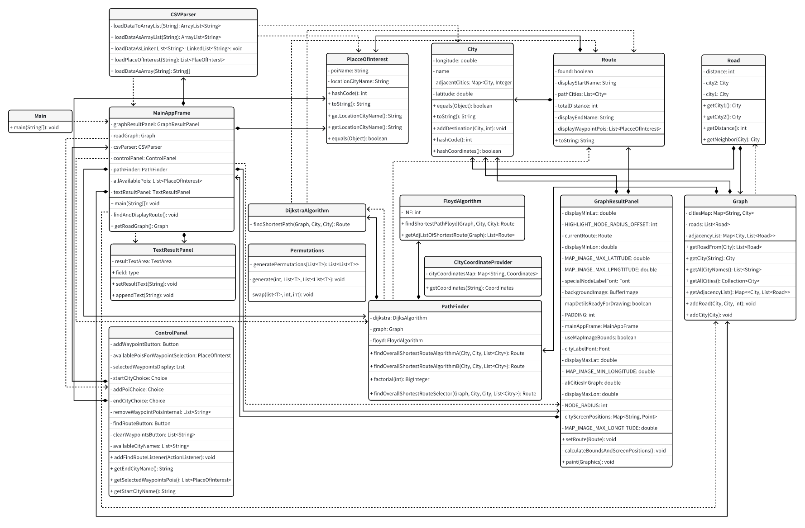
Fig 1. Task A & Task B’s Class Diagram
Our Program employs a modular, Object-Oriented design to ensure maintainability and scalability. Functionality is partitioned into distinct Java packages with clear responsibilities, establishing a layered architecture that minimizes inter-module coupling. The following details the application's core modules, their key classes, data structures, and functionalities.
- com.roadtrip (Main Program Entry)
Main.java initiates the application, launching the MainAppFrame to ensure successful UI operations on the Swing/AWT framework.
- com.roadtrip.model (Data Models) This package defines the core entities for the road network.
  - City.java: models an image node, holding its name and graph coordinates. PlaceOfInterest.java links a POI's name to its host city, bridging GUI selections with graph nodes. Road.java represents a connection between two City instances, carrying travel distance.
  - Graph.java: represents the road network topology. It employs a Map<String, City> for efficient City object retrieval and uniqueness, alongside an adjacency list (Map<City, List<Road>>) to manage graph connectivity by associating each City with its directly adjoining Road objects. Key graph operation methods are encapsulated within public methods.
  - Route.java: serves as a Data Transfer Object, packaging pathfinding outcomes, including the city sequence (List<City>), total distance, and success status. It is versatile enough to hold raw algorithm output or be augmented by MainAppFrame.findAndDisplayRoute() with comprehensive graph display context.
- com.roadtrip.parser (Data Parser) Tasks with data from CSV files.
  - CSVParser.java: transforms raw text into the application's internal object model. Its loadPlacesOfInterest() method processes attractions.csv into PlaceOfInterest objects. The populateGraphWithCitiesAndRoads() method handles roads.csv, ensuring City objects exist in the Graph object before establishing Road connections via Graph.addRoad().
- com.roadtrip.algorithm (Core Path Planning Algorithms) This package houses the computational logic for path discovery.
  - DijkstraAlgorithm.java: implements Dijkstra's algorithm for single shortest path calculations between two cities, returning a Route and utilizing a PriorityQueue for efficiency.
  - FloydAlgorithm.java: provides the Floyd-Warshall algorithm for all-pairs shortest paths, with getAdjListOfShortestRoutes() offering a Map<City, List<Route>> of pre-calculated routes.
  - PathFinder.java: arranges complex pathfinding, especially with waypoints. It integrates DijkstraAlgorithm and FloydAlgorithm through strategies like findOverallShortestRouteAlogrithmA (waypoint permutations with Dijkstra segments) and findOverallShortestRouteAlogrithm. A selector method, findOverallShortestRouteSelector(), aims to choose the optimal strategy based on input complexity.
- com.roadtrip.util (Common Assisted Utilities) his package furnishes reusable, general-purpose functionalities.
  - Permutations.java: offers a static generic generatePermutations() method by using Heap's algorithm for PathFinder to enumerate all waypoint visiting sequences.
  - CityCoordinateProvider.java, via its static getCoordinates(), supplies pre-set display coordinates for cities from an internal HashMap, vital for MainAppFrame initialization and GraphResultPanel's map rendering.
- com.roadtrip.panel (User Interface Design) Constructed with Java AWT/Swing the GUI offers an intuitive path planning tool.
  - MainAppFrame.java (extends java.awt.Frame): is the top-level GUI controller, organizing sub-panels, coordinating data loading, path planning invocation, and result dispatch.
  - ControlPanel.java (extends java.awt.Panel): manages user input for path parameters. TextResultPanel.java displays textual path details from the Route object. GraphResultPanel.java is the visualization engine, rendering paths on a map image by accurately mapping city coordinates and using the returned Graph object to display the path information.
1.3. Workflow and Interactions of Key Classes
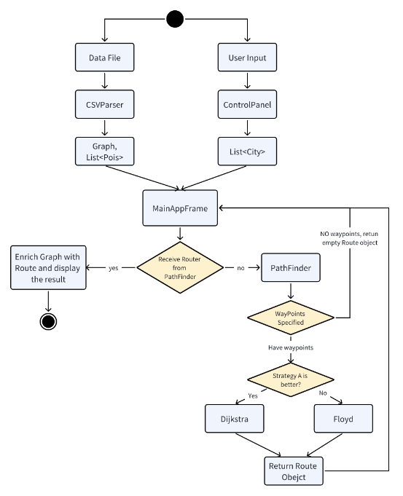
Fig. 2: The Overall Workflow of Task A & Task B
1.3.1. Application Launch and Initialization
During the application startup and data preparation phase, the main() method of the Main class launches and displays the main window. MainAppFrame class then coordinates data preparation: it directs parser.CSVParser to load the list of points of interest by method loadPlacesOfInterest(String attractionFilePath) and to construct the road network graph by populateGraphWithCitiesAndRoads(Graph graph, String roadsFilePath) that contain City and Road objects. Afterwards, MainAppFrame calls util.CityCoordinateProvider to supplement City objects in the graph with pre-set image coordinates. At the end of this phase, the prepared data is used to initialize fields in panel.ControlPanel and to create an instance of algorithm.PathFinder.
1.3.2. User Input Handling
In the user input and request processing phase, the user specifies the start city, end city, and optional intermediate points of interest via ControlPanel. When a path planning request is initiated, MainAppFrame retrieves these raw inputs from ControlPanel, queries the Graph object to convert the textual and PlaceOfInterest into a list of City objects, as well as performs validity checks. If there is no preset coordination in the data file, the points on the panel graph will be displayed according to the random points obtained after the hash of the city name.
1.3.3. Path Planning Request Processing
The core pathfinding execution begins when MainAppFrame passes validated City objects to PathFinder's findOverallShortestRouteSelector() method. This selector is responsible for choosing and then executing the most suitable pathfinding algorithm (Dijkstra or Floyd) based on an internal estimation of computational complexity.
- No Waypoints: If no waypoints are specified, the pathfinding task simplifies to a direct two-point calculation. The selected strategy will invoke DijkstraAlgorithm.findShortestPath(). This method utilizes its PriorityQueue-optimized search to compute and return a Route object detailing the shortest path and distance between the start and end cities.
- With Waypoints: On the other hand, routes involving waypoints, the findOverallShortestRouteSelector() first estimates the complexities of two distinct strategies, findOverallShortestRouteAlogrithmA and findOverallShortestRouteAlogrithmB, and then executes which one could be more efficient for the given input nodes
  - findOverallShortestRouteAlogrithmA: If chosen, this strategy generates all possible visiting orders of the distinct waypoint cities using Permutations. For each permutation, it calculates the path for individual segments by repeatedly calling DijkstraAlgorithm.findShortestPath(). The total distances of these segments are summed for each permutation, and the overall shortest route is determined by comparing these totals.
  - findOverallShortestRouteAlogrithmB: If selected, this strategy first invokes FloydAlgorithm.getAdjListOfShortestRoutes() to obtain pre-computed all-pairs shortest paths data for the entire graph. With this information, it then performs a recursive Depth-First Search (DFS), utilizing these pre-calculated path segments and applying pruning (if newCost >= bestCost[0]) to efficiently find the optimal sequence for visiting all waypoints and the corresponding total distance.
1.3.4. Result Encapsulation and Multimodal Display
Finally, in the result processing and display phase, MainAppFrame receives the Route object returned by PathFinder. For user readability, this Route object will be enriched with additional contextual information that is calculated during path searching, is passed to a new instance TextResultPanel for a textual summary display and to another instance GraphResultPanel for a concise graphical rendering of the path on the map.
1.4. Application of Design Principles
The pathfinding system strongly adheres to OOP principles. Model classes like City and Graph encapsulate data and behavior. Algorithm classes such as DijkstraAlgorithm and FloydAlgorithm abstract complex calculations, each with a distinct responsibility. PathFinder composes these algorithms to a higher-level strategy for route determination with waypoints, demonstrating clear modularity and separation of concerns for a more comprehensive design.
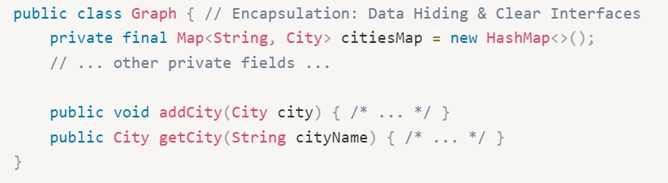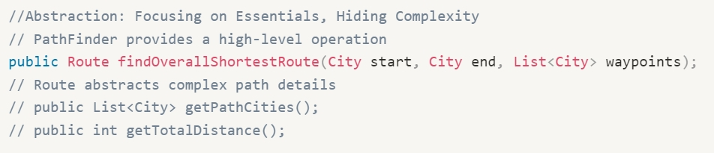
Fig. 3, 4: Example of Encapsulation (Graph.java); Abstraction (PathFinder.java)
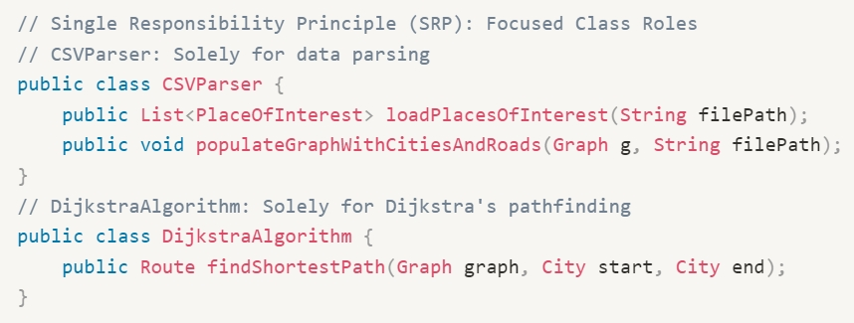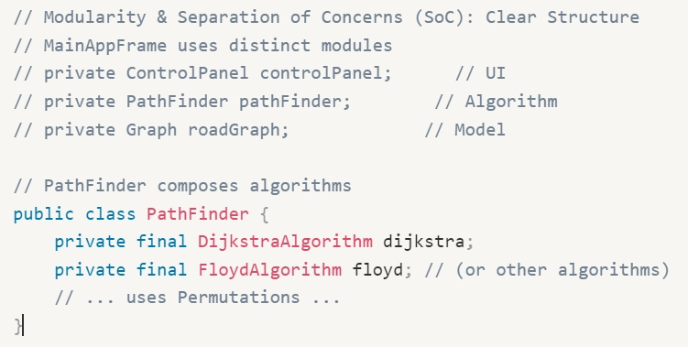
Fig. 5, 6: Example of Single Responsibility Principle (CSVParser.java); Modularity (PathFinder.java)
Chapter 2: Graph Algorithm (Task B)
2.1 Problem Analysis and Algorithm Selection
The problem's core is planning a shortest path in the US road network from a start to an end point, passing through all user-specified points of interest (POIs), with repeated paths or vertices allowed. Graph-theoretically, this is a constrained shortest path optimization, essentially a variant of the Traveling Salesperson Problem (TSP) or Hamiltonian path search, with these key features:
- NP-Hard Property: Treating POIs as mandatory intermediate nodes equates the problem to finding a Hamiltonian path that includes all POIs, which is NP-complete. For v POIs, the v! possible path permutations result in factorial computational complexity, unsolvable in polynomial time.
- Subproblem Decomposability: While the overall problem is NP-Hard, its subproblem—finding the shortest path between two points—is efficiently solvable by algorithms like Dijkstra's or Floyd-Warshall, offering a basis for optimization.
- Map Properties: Real-world road networks are typically sparse graphs, distances satisfy the triangle inequality, and edge weights often show geographical clustering. These characteristics allow for potential optimizations through heuristic pruning and preprocessing.
2.2. Algorithm Structure and Time Complexity Analysis
2.2.1. Algorithm A: Violent scheme based on Dijkstra’s algorithm
When v waypoints (POIs) are involved, this algorithm first generates all v! permutations of these waypoints. For each permutation, it sequentially calculates the shortest paths for the v+1 segments. The path corresponding to the permutation with the minimum accumulated segment distances is chosen as the final optimized route. The shortest path for each individual segment is determined using Dijkstra's algorithm. While the traditional matrix-based Dijkstra's algorithm has a time complexity of θ(n²), optimizing it with a priority queue can reduce this to approximately θ(nlogn), where n is the number of vertices in the graph. Consequently, the overall time complexity for handling multiple waypoints is about O(v!*(v+1)n²) or O(v!(v+1)*n log n). Space complexity is primarily for storing the graph's adjacency matrix (O(n²)) and the iteration stack (O(n)). This strategy is relatively simple to implement and performs efficiently when the number of waypoints is small (v < 4)
DijkstraAlgorithm.java uses Dijkstra's algorithm and iteratively expands from the start, prioritizing updates to and visits of the nearest nodes until the shortest path to the end city is determined.. The calculation process are as follows:
Initialization:
- A distances map (Map<City, Integer>) is created to store the shortest known distance from startCity to every other city, initialized to Integer.MAX_VALUE for all cities except for startCity itself, which is set to 0.
- A predecessors map (Map<City, City>) is created to store the city that precedes a given city on its shortest path from startCity, crucial for path reconstruction.
- A PriorityQueue<CityDistancePair> (pq) is initialized, ordered by distance. The CityDistancePair is a helper class bundling a City with its current distance from the source. startCity (with distance 0) is added to pq.
Iterative Path Discovering
- The algorithm enters a loop that continues as long as pq is not empty. In each iteration, the CityDistancePair with the smallest distance is extracted from pq. An optimization check ensures that if a shorter path to u has already been found and processed (currentPair.getDistance() > distances.get(u)), the current pair is skipped. Eventually, if u is the endCity, the shortest path has been found, and the loop terminates.
Neighbor Relaxation
- For each neighbor v of city u (graph.getRoadsFrom(u)), the algorithm calculates the distance from startCity to v through u. If this newly calculated distance is shorter than the previously recorded distance to v which is stored in the distances map, the distance to v is updated, u is set as v's predecessor in the predecessors map, and a new CityDistancePair for v (with the updated distance) is added to pq.
Path Reconstruction
- After the loop, if the distance to endCity remains Integer.MAX_VALUE, no path exists. Otherwise, the path is reconstructed by starting from endCity and backtracking using the predecessors map until startCity is reached. The collected cities are then reversed to get the correct path sequence. Finally, a Route object containing the path cities and total distance will be returned.
Time Complexity:
- A The initialization of the distances map for all V cities takes O(V) time. Adding the start city to the PriorityQueue takes O(log V).
- The while loop can iterate at most V times in the best case (each city extracted once). Extracting the minimum element from the PriorityQueue (pq.poll()) takes O(log V) time. So, all poll operations sum to O(V log V).
- Each road (edge E) is considered at most twice during the relaxation process. When a distance is updated, adding an element to the PriorityQueue (pq.add()) takes O(log V). In the worst case, many edges might lead to updates and additions to the priority queue. The total time spent on relaxation and priority queue additions related to edges is O(E log V).
- When PathFinder's findOverallShortestRouteAlogrithmA strategy employs this Dijkstra's algorithm for a route with v waypoints, it generates v! permutations. Therefore, the eventual time complexity would be O(V!·(V+E)·log V) (or O(V!·(V+1)··V^2) using plain algorithm).
2.2.2 Algorithm B based on Floyd-Warshall Algorithm
To ensure an optimal solution for paths involving multiple points of interest (POIs), thereby avoiding the limitations of greedy or purely heuristic methods, we adopted a strategy inspired by Traveling Salesperson Problem (TSP) solutions, combining Floyd-Warshall algorithm preprocessing with a Branch-and-Bound search.
Initially, the Floyd-Warshall algorithm, with a time complexity of O(n³) and space complexity of θ(n²), pre-calculates the shortest paths and distances between all pairs of cities. This step transforms the complex full graph information into a concise distance matrix where the shortest path between any two points can be queried in O(1) time. Consequently, subsequent processing focuses only on the user-specified start, end, and mandatory POIs, effectively simplifying the problem to finding an optimal order among these key points (akin to a Hamiltonian circuit).
Subsequently, the Branch-and-Bound method is applied for the search: a state is defined by the current city and the set of visited waypoints. A Depth-First Search enumerates the next unvisited waypoint. During the search, the algorithm accumulates the cost of the current path and compares it against the cost (upper bound) of the best solution found so far; pruning occurs if the "cumulative cost ≥ upper bound," avoiding unnecessary computations. By traversing all potentially valid path combinations in this manner, the global optimal solution is retained. Although the worst-case time complexity for Branch-and-Bound remains O(v!) (where v is the number of waypoints) with O(n²) space complexity, the pruning, facilitated by real-world road network properties (e.g., paths satisfying the triangle inequality), often significantly reduces actual computational effort. In contrast, traditional dynamic programming for such problems typically has a time complexity of O(v² * 2ᵛ). When the number of waypoints is large but the total number of cities is manageable, Branch-and-Bound can be more advantageous due to its effective pruning, achieving an optimal solution with relatively lower resource consumption.
FloydAlgorithm.java implements Floyd-Warshall algorithm that iteratively updates and finds all-pairs shortest paths by considering each city as an intermediary.
Initialization:
- A list of all City objects from the graph is created, and a Map<City, Integer> (idx) is established to map each City object to a unique integer index from 0 to V-1 (where V is the total number of cities). This allows the use of 2 dimensional arrays for distance and path information.
- A distance matrix dist[V][V] is initialized. dist[i][i] is set to 0, direct connections (i, j) are set to their road distance, and all other pairs are set to a representation of infinity (INF, defined as Integer.MAX_VALUE / 2).
- A successor matrix next[V][V] is initialized. next[i][j] will store the index of the next city on the shortest path from city i to city j. It's initialized such that next[i][i] = i, and for direct roads from i to j, next[i][j] = j; other entries are marked as invalid.
Core Floyd-Warshall Logic
- The algorithm employs three nested loops, with iterators k, i, and j, each running from 0 to V-1. In the innermost loop, it checks if the path from city i to city j can be shortened by passing through city k. That is, if dist[i][k] + dist[k][j] < dist[i][j]. If a shorter path is found, dist[i][j] is updated to dist[i][k] + dist[k][j], and crucially, next[i][j] is updated to next[i][k]. This means the shortest path from i to j now starts by following the shortest path from i to k.
Path Reconstruction and Result Packaging:
- After the triple loops, the dist matrix contains all-pairs shortest distances.
  - For findShortestPathFloyd(startCity, endCity): The path from startCity to endCity is reconstructed using the next matrix by starting at startCity's index and repeatedly moving to next[currentIndex][endCityIndex] until endCityIndex is reached. The cities corresponding to these indices are collected. And the corresponding information will be encapsulated into a Route and returned.
  - For getAdjListOfShortestRoutes(graph): This method iterates through all possible source cities src and destination cities dst. For each pair, if a path exists (next[iSrc][iDst] is valid and dist[iSrc][iDst] is not INF), it reconstructs the path as described above and creates a Route object. All Route objects originating from src node are collected into a list, and finally, a Map<City, List<Route>> will be returned.
Time Complexity
- Running Floyd-Warshall and converting to an adjacency table has a time complexity of O(n³) (triple-loop relaxation of all vertex pairs).
- The algorithm performs a depth-first search on w waypoints, essentially enumerating all possible access orders in the worst case, i.e., w! permutations. For each branch, the algorithm needs to first find the shortest segment from the fullAdj from the current city to the next waypoint (assuming hash table lookup + list scan is O(d), where the worst case can be considered as O(w)) followed by a constant number of sums and boundary pruning checks (O(1)). Thus, the worst time complexity of the branch-and-bound part is O(w!×(w)).
- Although pruning (if (newCost >= bestCost[0]) continue;) can significantly reduce the search volume in practice, especially in the current scenario, where the road network is usually a sparse graph and the inter-city distances satisfy the triangular inequality.
- Ultimately the worst-case time complexity is the sum of the complexity of the two steps O(n³+w!w) and the space complexity is only O(n²+V²).
Summary: We have combined the above two methods to make our software more efficient in each case.
2.3 Algorithm implementation
2.3.1 Program Workflow
- Input parsing: the program reads the map data, the start points, end point and the list of waypoints.
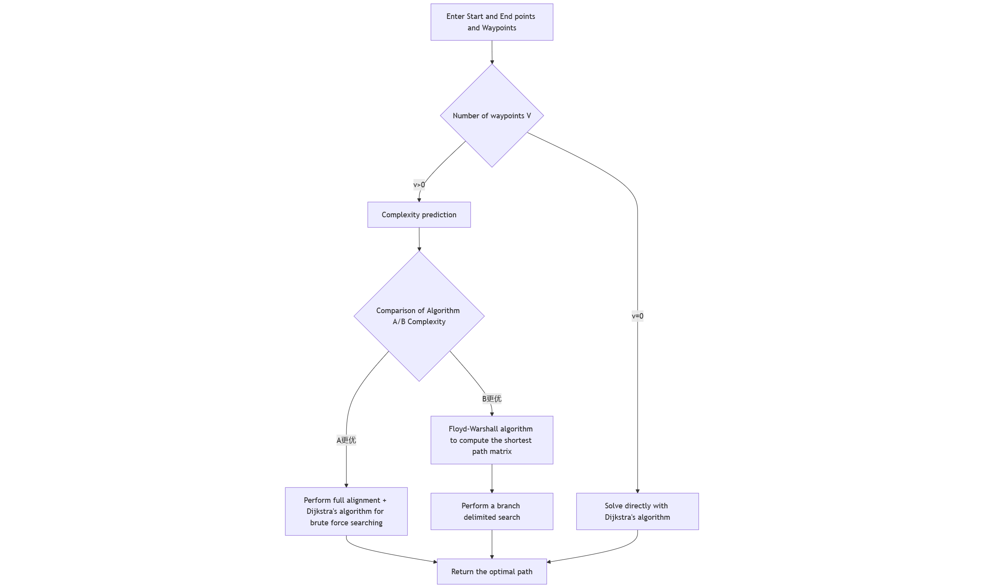
- Complexity Estimation: Calculate the theoretical complexity of the two algorithms based on n (the total number of cities) and v (the number of passing points).
- Algorithm Selection: Automatically compare the order of magnitude of O(v!-(v+1)-n²) and O(n³ + pruning cost), and select the lower one.
- Path computation: Algorithm A enumerates sequence by sequence and calls Dijkstra, Algorithm B starts with Floyd-Warshall and then use Branch and Bound.
- Output: return the shortest path sequence and total distance, and display the list of cities along the route in the interface.
2.3.2 Evaluation of two algorithms in terms of time and space complexity
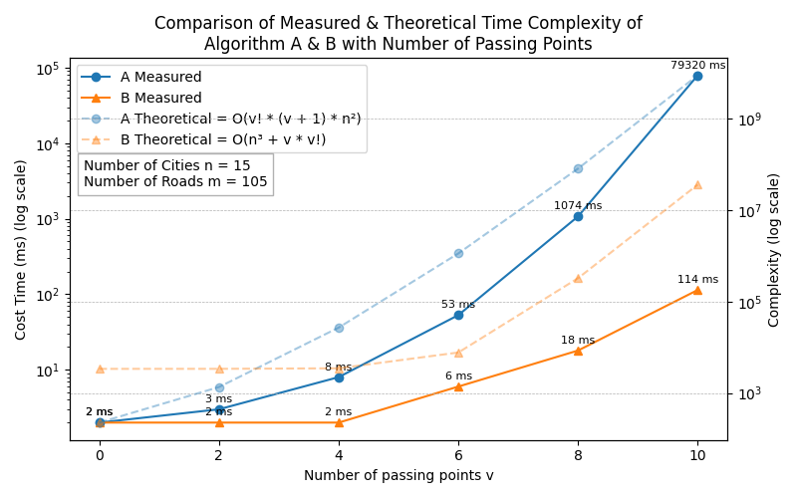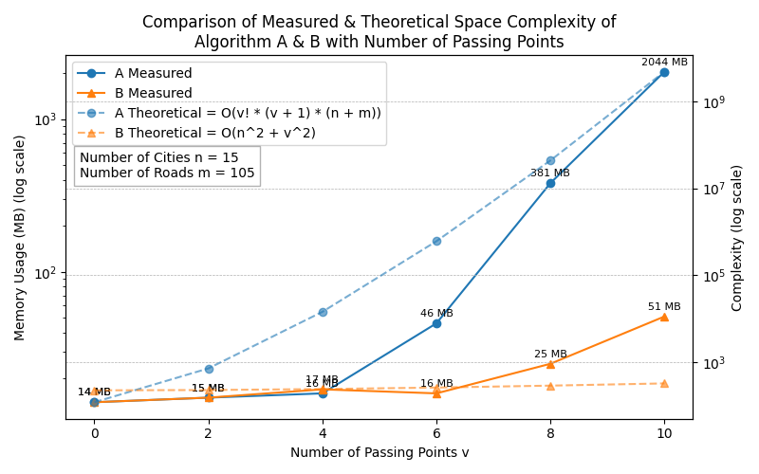
Fig.5 Comparison of Algo A & B of Measured/Theoretical Time/Space Complexity.
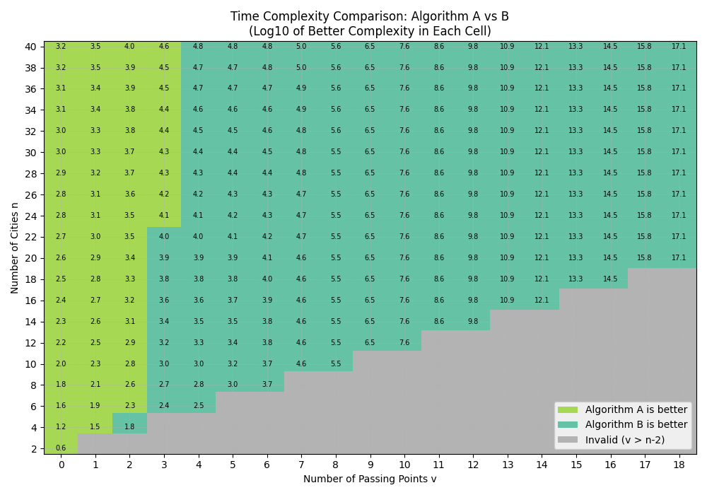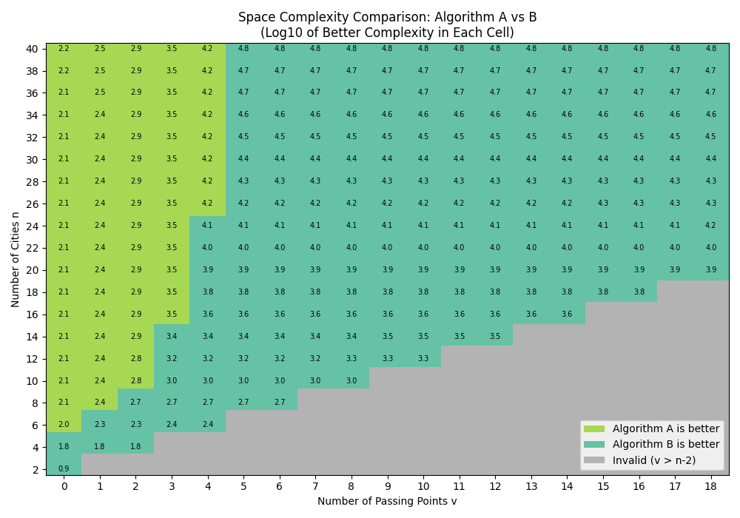
Fig.6 Visualization of the advantages of Algo A & B under different conditions.
The visualization data indicate that Algorithm A is more efficient in more cities with fewer passing points while Algorithm B is more efficient in fewer cities with more passing points.
2.3.3 Demonstration of Panel
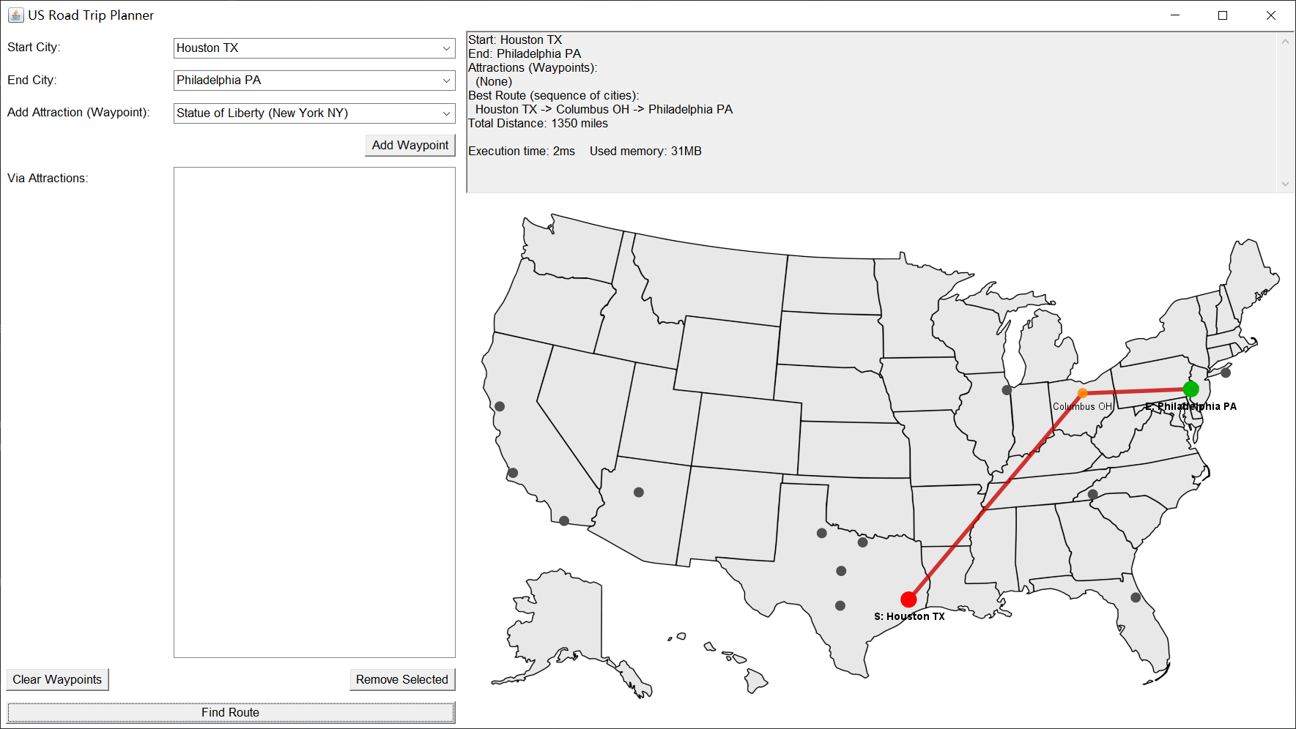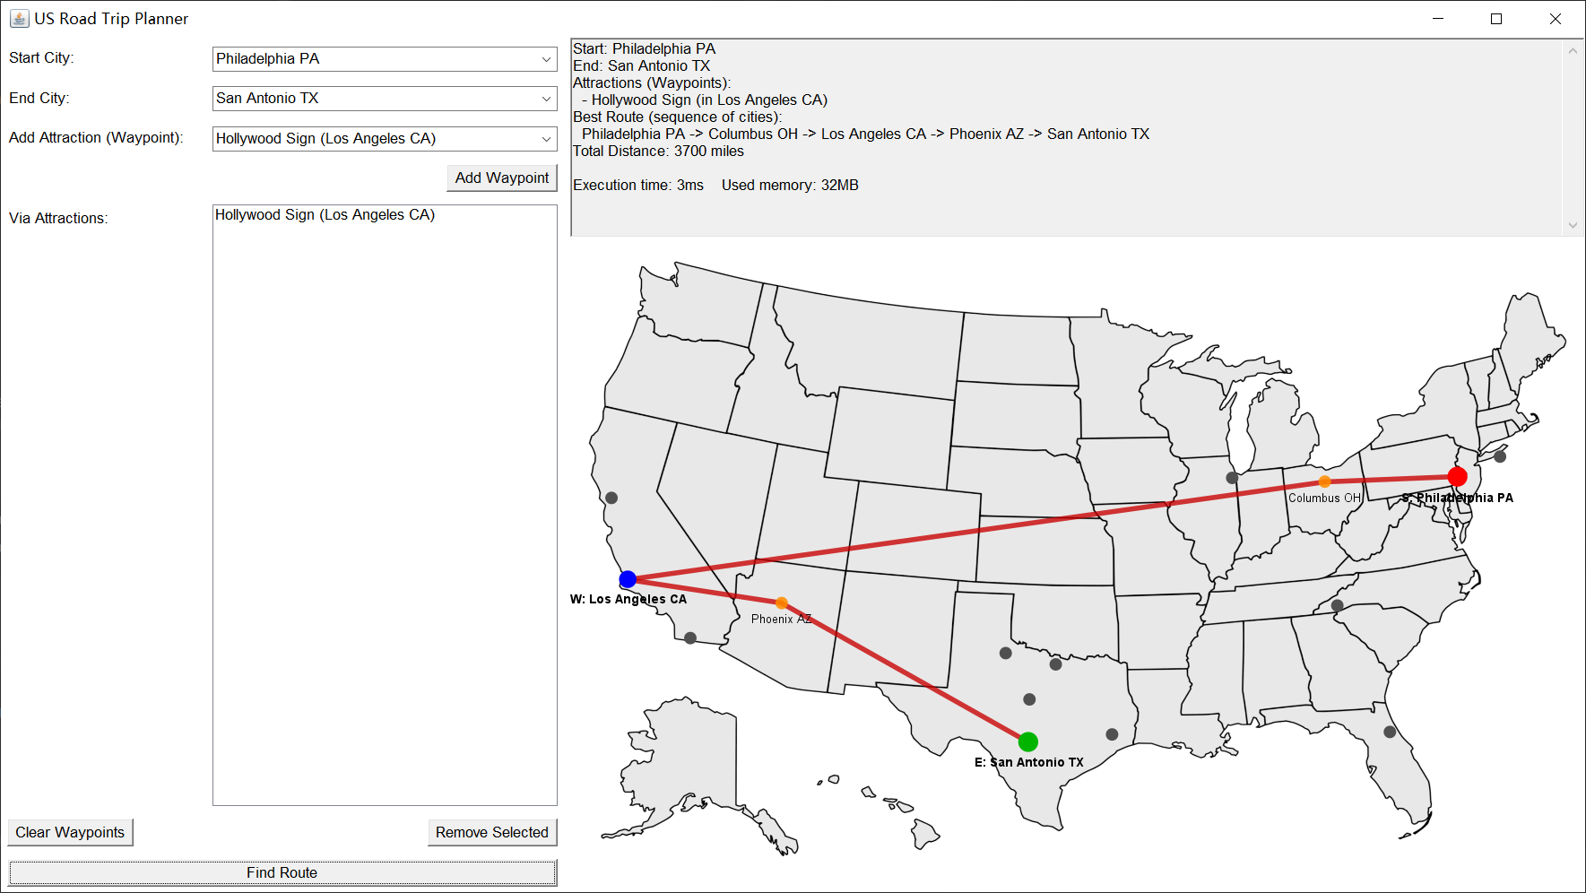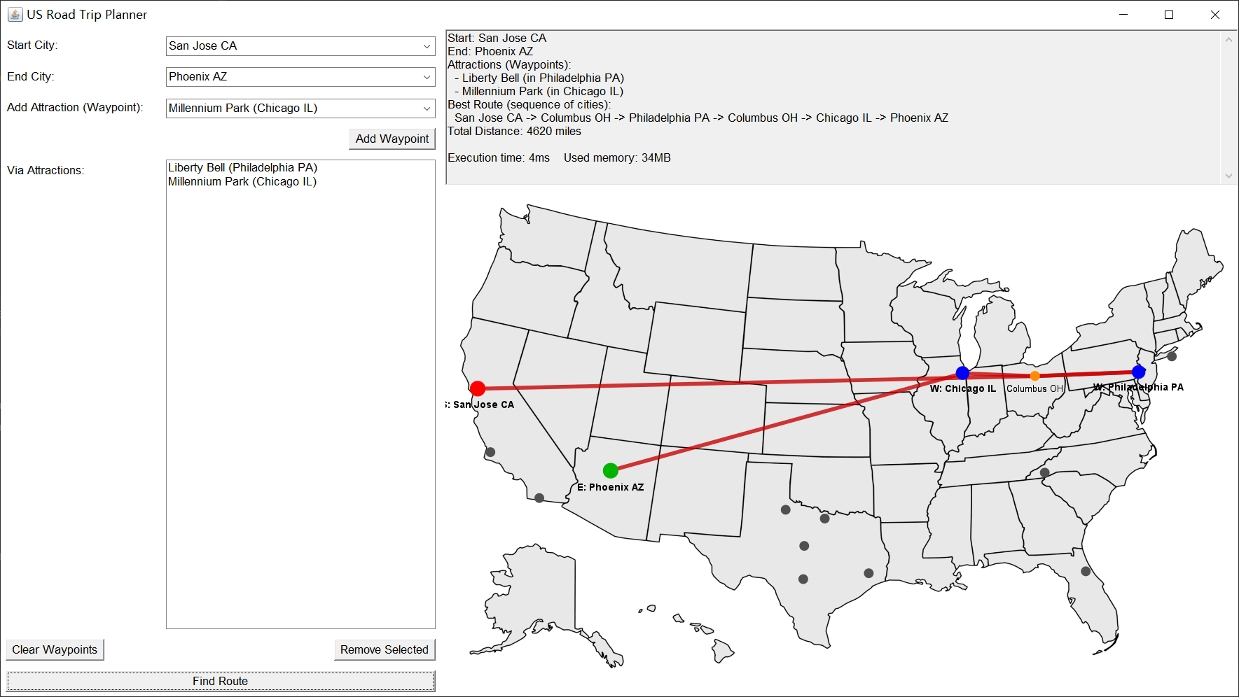
Fig.7 (a)Houston TX to Philadelphia PA via no place of interest (b) Philadelphia PA to San Antonio TX via Hollywood Sign (c) San Jose CA to Phoenix AZ via Liberty Bell and Millennium Park. Where the Red point is Start city, Blue point is waypoint, Orange point is pass by city, Green point is End city.
2.4. Better alternative
Coordinate-Based Heuristics: When each city comes with additional planar coordinate information, we can use Euclidean distance as an admissible A* heuristic reduces node expansions while ensuring optimality. Local search (e.g., 2-opt, 3-opt) can further improve A* results efficiently.
Machine Learning: GNNs learn to predict edge selection probabilities, achieving near-optimal solutions on 50- and 100-node instances (0.01% and 1.39% gaps, respectively) [1]. Unsupervised and RL-based models like H-TSP scale well to large graphs [2].
Hierarchical Clustering: Partitioning large graphs into clusters allows solving intra-cluster TSPs first, then optimizing inter-cluster routes. This divide-and-conquer approach yields ~2–3% deviation from optimal with near-linear runtime [3].
Chapter 3: Sorting Algorithm (Task C)
3.1. Introduction
This chapter focuses on Task C, a comparative study of three fundamental sorting algorithms: Insertion Sort, Quick Sort, and Merge Sort. Beyond performance comparison, we also explore the significant impact of different Java data containers (String[], ArrayList, LinkedList) on their efficiency and evaluate three pivot selection strategies for Quick Sort. All assessments are based on execution time (ms) when sorting city name datasets of varying scales and initial orderings.
3.2. Implementation Details and Adjusting Process
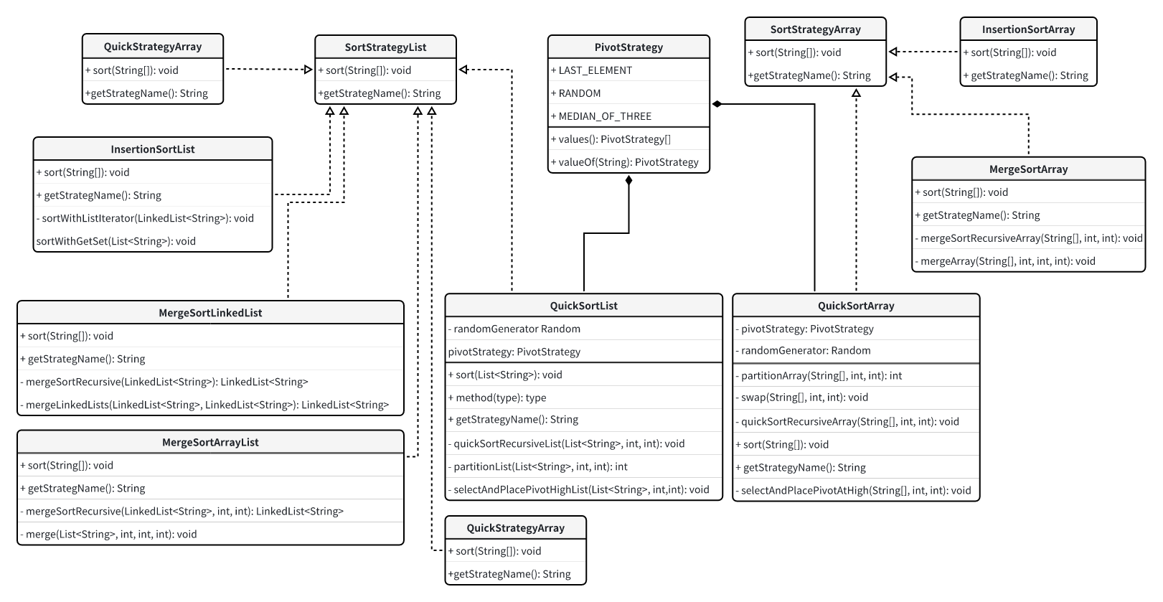
Fig. : Task C’s Class Diagram
3.2.1 Object-Oriented Testing Framework:
The testing framework was built using the Strategy design pattern to decouple sorting algorithms from the core testing logic, enhancing modularity and extensibility.
- Strategy Interfaces: Two interfaces, SortStrategyArray and SortStrategyList, define the contract for sorting algorithms operating on String[] arrays and List<String> implementations, includes ArrayList and LinkedList, respectively. Each mandates sort() and getStrategyName() methods.
- Concrete Strategy Implementations: Each sorting algorithm, including its variants, is encapsulated in a separate class implementing the appropriate interface. For Quick Sort, three pivot selection strategies: LAST_ELEMENT, MEDIAN_OF_THREE (Take the left, middle and right three numbers, and then sort them, taking the middle number as the pivot value), and RANDOM, were implemented, managed by a PivotStrategy enum.
3.2.2 Data Handling
A unified CSVParser class, also used in Tasks A and B, handles loading city names from the four targeted CSV files. It reads data into an ArrayList first, then provides methods (loadDataAsArray, loadDataAsArrayList, loadDataAsLinkedList) to convert this to the specific container type required for each test. This loading phase is not timed as part of the sort performance.
3.2.3 Sorting Algorithm Implementation Highlights:
- Insertion Sort:
  - InsertionSortArray.java: Standard array-based implementation.
  - InsertionSortList.java: Employs a dynamic internal dispatch: for ArrayList, it uses a classic get()/set() approach; for LinkedList, it switches to a ListIterator-based implementation to better suit its node-based structure and mitigate severe performance issues that would arise from direct indexed access from preliminarily observed.
- Merge Sort:
  - MergeSortArray.java and MergeSortArrayList.java: Standard recursive implementations using arrays/lists for merging.
  - MergeSortLinkedList.java: Design for LinkedList, and using pollFirst(), addLast() for specific operation.
- Quick Sort and Pivot Strategy Tuning:
  - A PivotStrategy enum (LAST_ELEMENT, MEDIAN_OF_THREE (), RANDOM) defines the pivot selection techniques.
  - QuickSortArray.java and QuickSortList.java strategies accept a PivotStrategy in their constructor, and their partition methods dynamically apply the chosen logic.
  - For LinkedLists, a QuickSortLinkedList.java will directly acknowledging the fundamental unsuitability of standard Quick Sort for LinkedList due to its reliance on efficient random access.
3.3. Measurement Methodology
Performance tests were conducted using Java SE Development Kit 17.0.8. Execution times for each sorting configuration were precisely measured in nanoseconds (ns) (use ms in tables for concise). To ensure result reliability and mitigate an JIT or caching initial overheads, a warm-up phase of 5 iterations preceded 10 timed measurement iterations for every test case. Fresh data copies were used for each of these 10 measurements runs. The final reported performance figures are the arithmetic mean of these 10 timed iterations. Additionally, standard deviation was calculated from these runs to quantify performance variability (time span). An explicit garbage collection suggestion (System.gc()) was employed between tests of different container types for a given file to minimize GC interference.
3.4. In-depth Analysis
3.4.1 Algorithmic Performance and Complexity Validation:
- Insertion Sort: Demonstrated its O(n) best-case efficiency on pre-sorted String[] and ArrayList<String> (N=10000 sorted String[] avg. ~0.16ms; ArrayList avg. ~0.25). However, on random data, its performance aligned with O(n^2) complexity (N=10000 random String[] avg. ~62.7ms). The InsertionSortList strategy, when applied to LinkedList using sortWithListIterator(), also exhibited O(n^2) behavior (N=10000 random avg. ~177.1ms), as iterator positioning or equivalent access still incurred significant costs on LinkedList form.
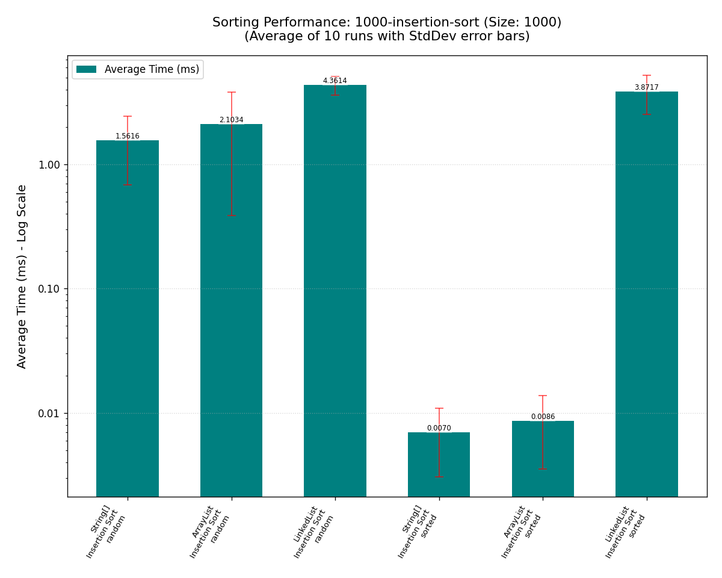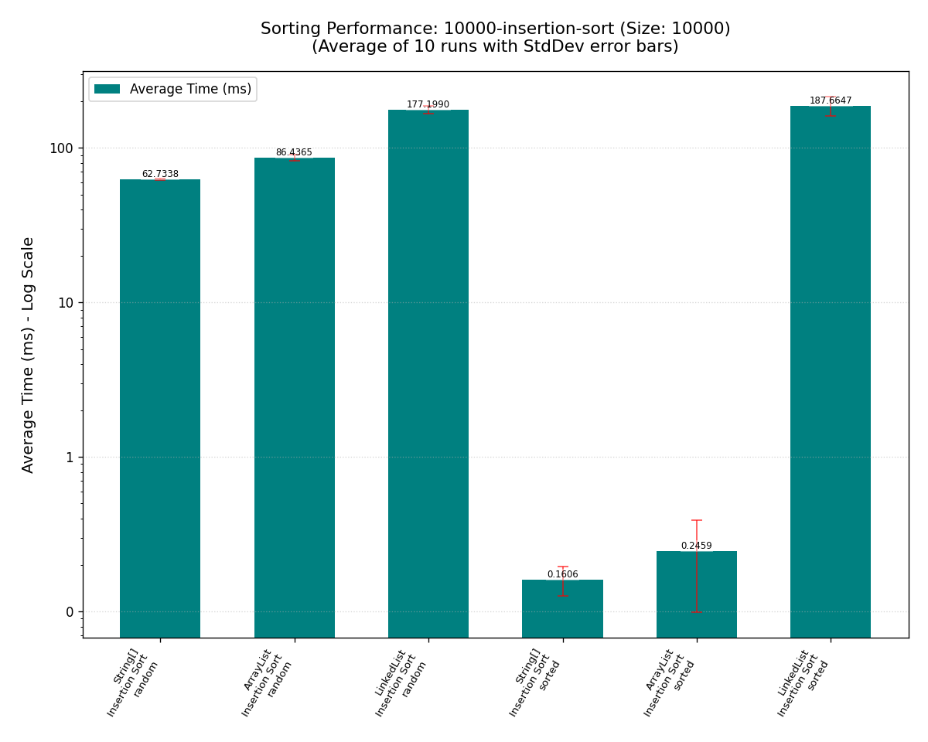
Fig. : 1000-cities-insertion-sort-summary; 10000-cities-insertion-sort-summary
- Quick Sort:
  - On random data, all pivot strategies generally yielded O(nlogn) performance on String[] and ArrayList (N=10000 random String[] with Median-of-Three pivot avg. ~1.87ms). Optimized pivots (Median-of-Three, Random) were typically the most competitive due to their higher probability of achieving balanced partitions.
  - The "Last Element" pivot showed O(n^2) degradation on sorted data (N=10000 sorted String[] avg. ~84.1ms).
  - Pivot tuning with "Median-of-Three" and "Random" strategies effectively restored O(nlogn) performance on sorted data (N=10000 sorted String[] with Median-of-Three avg. ~0.77ms), highlighting their critical role in ensuring Quick Sort's performance.
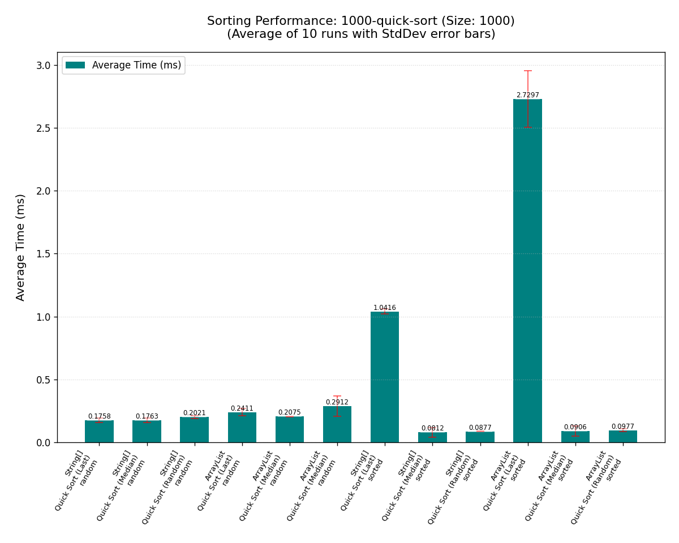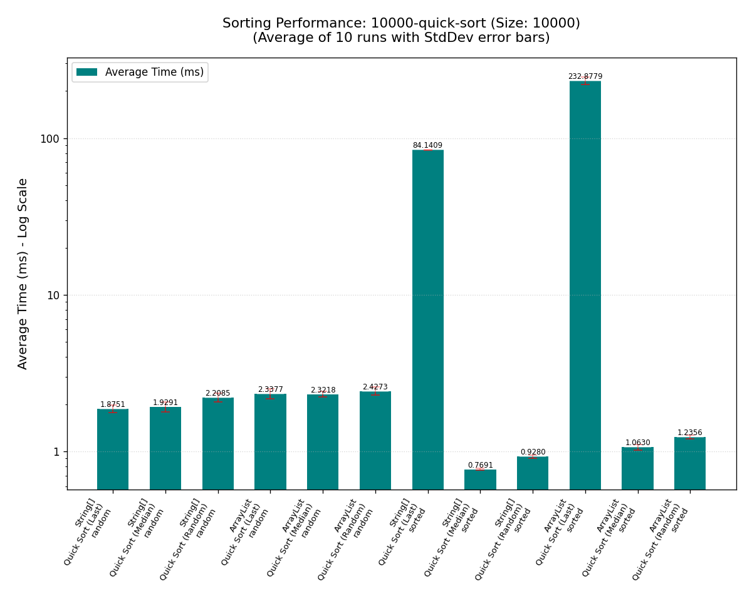
Fig. : 1000-cities-quick-sort-summary; 10000-cities-quick-sort-summary
- Merge Sort: Consistently demonstrated stable O(nlogn) performance across all conditions. While sometimes slightly slower than tuned Quick Sort on random array-based data (N=10000 random ArrayList avg. ~2.08ms vs. N=10000 random ArrayList with Median-of-Three avg. ~1.06ms), it can guarantee even worst-case performance can still maintain a acceptable complexity.
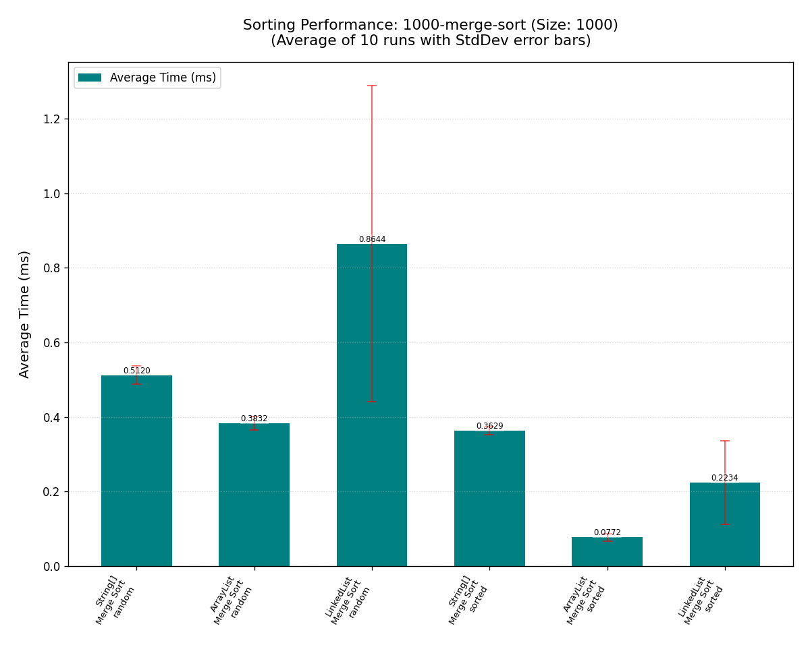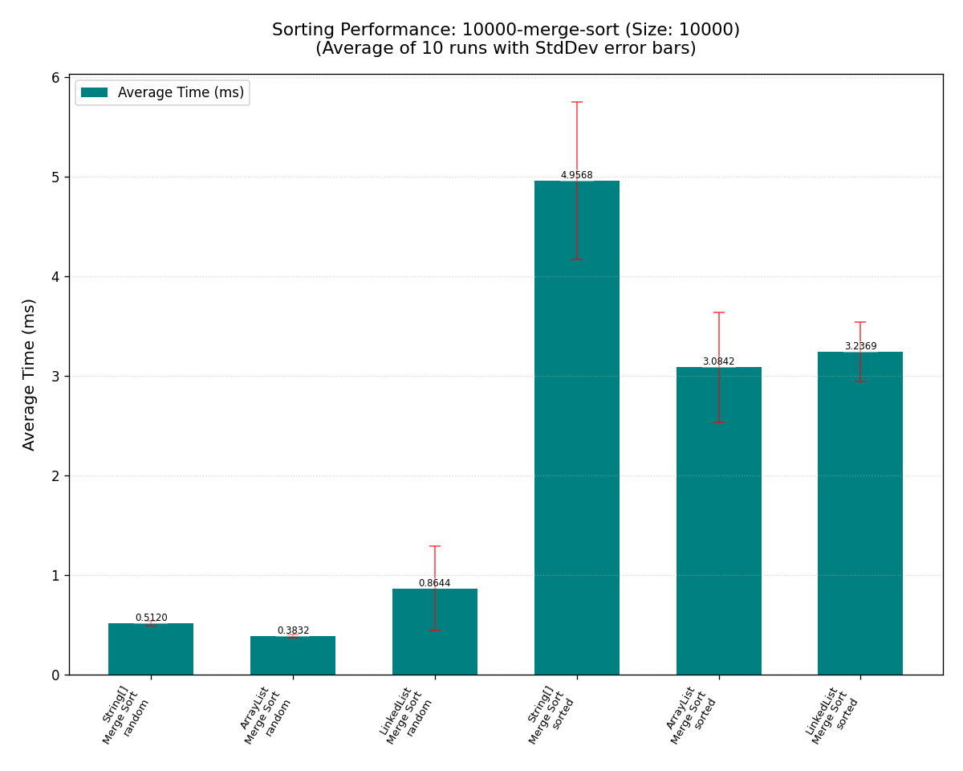
Fig. : 1000-cities-merge-sort-summary; 10000-cities-merge-sort-summary
3.4.2 Impact of Data Containers and Pivot Strategies:
- Container Choice:
  - String[] (native arrays) generally offered the best raw performance due to direct memory access and minimal overhead, excelling with random-access-dependent algorithms.
  - ArrayList<String> performed very closely to native arrays, proving to be a highly efficient and flexible general-purpose container for these sorting tasks.
  - LinkedList<String> posed significant challenges. InsertionSortList (with ListIterator) remained O(n^2) due to inherent traversal/positioning costs. Attempting standard Quick Sort would be catastrophically slow. Only the specialized MergeSortLinkedList achieved reasonable O(nlogn) performance on this container, though still generally slower than its array/ArrayList counterparts. This underscores that algorithm-container pairing is critical.
- Quick Sort Pivot Tuning Effectiveness:
  - The "Last Element" pivot's vulnerability to sorted data O(n^2) was clearly confirmed.
  - "Median-of-Three" and "Random" pivot strategies effectively mitigated this, restoring O(nlogn) performance on sorted data and maintaining strong performance on random data. For general use where input characteristics are unknown, these optimized pivot strategies are essential for Quick Sort performance.
3.4.3 Performance Variability:
Analysis of the 10 iteration times indicated that while averaging provides a stable measure, some configurations, particularly those involving LinkedList or algorithms with inherent randomness, exhibited greater run-to-run variability. This can be attributed to factors, such as GC activity and system-level noise, highlighting the complexities of micro-benchmarking.
Chapter 4: Project Reflection (Task D)
4.1. Summary of Project Achievements
4.1.1. Achievements in Program Design (Task A)
This project successfully constructed a modular Java application, designed following core Object-Oriented Programming (OOP) principles such as encapsulation, abstraction, and single responsibility. The system achieved high cohesion and low coupling through a clear package structure, laying a solid foundation for subsequent functional implementation and algorithm integration.
4.1.2. Achievements in Graph Algorithm and Path Planning (Task B)
For the core route planning functionality, we implemented optimized route calculations through the PathFinder module, capable of handling origin cities, destination cities, and multiple points of interest (POIs). The module integrates segmentation-based path computation using the Dijkstra algorithm or utilizes Floyd-Warshall to select the appropriate answer from the shortest path.
4.1.3 Achievements in Sorting Algorithm Analysis (Task C)
For Task C, we successfully implemented and evaluated three classic sorting algorithms: Insertion Sort, Quick Sort, and Merge Sort. By conducting performance tests on datasets of varying sizes 1000, 10000 elements) and initial states (random order, sorted order), we collected key metrics including execution time. Based on this experimental data, we analyzed and compared the actual performance of the three algorithms, deepening our understanding of their theoretical characteristics versus practical performance, and explored the impact of different data characteristics on algorithm efficiency.
4.2 Application of AI-Assisted Tools
In this project, while adhering to the course's requirement for independent core design completion, AI tools like ChatGPT and DeepSeek provided beneficial assistance. As Java AWT/Swing was not extensively covered in the curriculum, AI offered valuable suggestions on API usage, layout, and debugging during the GUI design phase, particularly for graphics drawing in GraphResultPanel, where its examples significantly accelerated our understanding of basic drawing techniques. Furthermore, in the algorithm ideation phase, AI facilitated brainstorming, inspiring approaches for specific problems such as handling multi-waypoint permutations and deepening our comprehension of complex algorithms, thus aiding our design choices rather than directly generating code.
4.3 Consideration of Equality, Diversity, and Inclusion (EDI) Principles
We actively considered incorporating EDI principles into the project. Currently, the application preliminarily addresses diverse user preferences by offering both textual (TextResultPanel) and graphical (GraphResultPanel) displays for path results. Looking ahead, to enhance accessibility and inclusivity, we envision:
- Integrating a Text-to-Speech (TTS) voice assistant to narrate path results for visually impaired users or those with reading difficulties; and
- Implementing internationalization (i18n) by localizing interface texts and data to support users of different languages, thereby serving a broader community.
4.4 Personal Growth and Takeaways
This project significantly enhanced our capabilities in multiple areas.
Regarding teamwork and project management, as a two-person team, clear task division and effective communication were established early on. We proficiently used Git for version control including branching, commits, merging, and conflict resolution, ensuring code consistency and collaborative efficiency. Concurrently, using Markdown for documenting the design and development process fostered good documentation habits and promoted knowledge sharing.
In terms of technical and self-directed learning skills, the project strengthened our comprehensive application of Java OOP, advanced data structure, and algorithm design. Notably, for the GUI implementation, which was not a primary course focus, we relied mainly on self-study of Java AWT/Swing by consulting development manuals and online resources. This process greatly improved our ability to independently solve problems and quickly learn new skills. Continuous debugging and refactoring also heightened our awareness of coding standards.

Chapter 5: Program Code
com.roadtrip.algorithm.DijkstraAlgorithm.java
package algorithm;

import model.City;
import model.Graph;
import model.Road;
import model.Route;

import java.util.*;

// Dijkstra Algorithm
public class DijkstraAlgorithm {

// Route now contains List<City>
public Route findShortestPath(Graph graph, City startCity, City endCity) {
if (startCity == null || endCity == null) {
return new Route(Collections.emptyList(), 0, false);
}
if (startCity.equals(endCity)) {
return new Route(Collections.singletonList(startCity), 0, true);
}

Map<City, Integer> distances = new HashMap<>();
Map<City, City> predecessors = new HashMap<>();
// AttractionDistancePair needs to become CityDistancePair
PriorityQueue<CityDistancePair> pq = new PriorityQueue<>(Comparator.comparingInt(CityDistancePair::getDistance));

// set all distances to infinity
for (City city : graph.getAllCities()) {
distances.put(city, Integer.MAX_VALUE);
}
distances.put(startCity, 0);
pq.add(new CityDistancePair(startCity, 0));

while (!pq.isEmpty()) {
CityDistancePair currentPair = pq.poll();
City u = currentPair.getCity();

if (currentPair.getDistance() > distances.get(u)) {
continue;
}
if (u.equals(endCity)) {
break;
}

for (Road road : graph.getRoadsFrom(u)) {
City v = road.getNeighbor(u);
if (v == null) continue;

int weight = road.getDistance();
if (distances.get(u) != Integer.MAX_VALUE && distances.get(u) + weight < distances.get(v)) {
distances.put(v, distances.get(u) + weight);
predecessors.put(v, u);
pq.add(new CityDistancePair(v, distances.get(v)));
}
}
}

List<City> path = new ArrayList<>(); // Changed
City current = endCity; // Changed
if (distances.get(endCity) == Integer.MAX_VALUE) {
return new Route(Collections.emptyList(), 0, false);
}

while (current != null) {
path.add(current);
if (current.equals(startCity)) break;
current = predecessors.get(current);
if (current == null && !path.contains(startCity)) {
return new Route(Collections.emptyList(), 0, false);
}
}
Collections.reverse(path);

if (!path.isEmpty() && path.get(0).equals(startCity)) {
return new Route(path, distances.get(endCity), true);
} else {
return new Route(Collections.emptyList(), 0, false);
}
}

// Helper class for Priority Queue, renamed
private static class CityDistancePair {
City city;
int distance;

public CityDistancePair(City city, int distance) {
this.city = city;
this.distance = distance;
}

public City getCity() {
return city;
}

public int getDistance() {
return distance;
}
}
}

com.roadtrip.algorithm.DijkstraAlgorithm.java
package algorithm;
import java.util.*;

import model.City;
import model.Graph;
import model.Road;
import model.Route;

/**
* The Freud–Wascher algorithm calculates the shortest path and distance between *any two cities
*/
public class FloydAlgorithm {

private static final int INF = Integer.MAX_VALUE / 2;

public Route findShortestPathFloyd(Graph graph, City startCity, City endCity) {
if (startCity == null || endCity == null) {
return new Route(Collections.emptyList(), 0, false);
}
if (startCity.equals(endCity)) {
return new Route(Collections.singletonList(startCity), 0, true);
}

// 1. List all cities and create City -> index map
List<City> cities = new ArrayList<>(graph.getAllCities());
int n = cities.size();
Map<City, Integer> idx = new HashMap<>(n);
for (int i = 0; i < n; i++) {
idx.put(cities.get(i), i);
}

// 2. Construct the distance matrix dist and the next node matrix next
int[][] dist = new int[n][n];
int[][] next = new int[n][n];

// 初始化
for (int i = 0; i < n; i++) {
Arrays.fill(dist[i], INF);
for (int j = 0; j < n; j++) {
next[i][j] = -1;
}
dist[i][i] = 0;
next[i][i] = i;
}

// fill road
for (City u : cities) {
int iu = idx.get(u);
for (Road road : graph.getRoadsFrom(u)) {
City v = road.getNeighbor(u);
if (v == null) continue;
int iv = idx.get(v);
int d = road.getDistance();
if (d < dist[iu][iv]) {
dist[iu][iv] = d;
next[iu][iv] = iv;
}
if (d < dist[iv][iu]) {
dist[iv][iu] = d;
next[iv][iu] = iu;
}
}
}

for (int k = 0; k < n; k++) {
for (int i = 0; i < n; i++) {
for (int j = 0; j < n; j++) {
if (dist[i][k] + dist[k][j] < dist[i][j]) {
dist[i][j] = dist[i][k] + dist[k][j];
next[i][j] = next[i][k];
}
}
}
}

Integer iStart = idx.get(startCity);
Integer iEnd = idx.get(endCity);
if (iStart == null || iEnd == null || next[iStart][iEnd] == -1) {
return new Route(Collections.emptyList(), 0, false);
}

List<City> path = new ArrayList<>();
int u = iStart;
while (u != iEnd) {
path.add(cities.get(u));
u = next[u][iEnd];
if (u < 0) {
return new Route(Collections.emptyList(), 0, false);
}
}
path.add(cities.get(iEnd));

int distance = dist[iStart][iEnd] >= INF ? -1 : dist[iStart][iEnd];
boolean reachable = distance >= 0 && !path.isEmpty();

return new Route(path, distance, reachable);
}

public Map<City, List<Route>> getAdjListOfShortestRoutes(Graph graph) {
// 1. List all cities and establish subscript mappings
List<City> cities = new ArrayList<>(graph.getAllCities());
int n = cities.size();
Map<City, Integer> idx = new HashMap<>(n);
for (int i = 0; i < n; i++) {
idx.put(cities.get(i), i);
}

// 2. Initialize the dist and next matrices
int[][] dist = new int[n][n];
int[][] next = new int[n][n];
for (int i = 0; i < n; i++) {
Arrays.fill(dist[i], INF);
for (int j = 0; j < n; j++) {
next[i][j] = -1;
}
dist[i][i] = 0;
next[i][i] = i;
}

// 3. Fill in initial edge rights
for (City u : cities) {
int iu = idx.get(u);
for (Road road : graph.getRoadsFrom(u)) {
City v = road.getNeighbor(u);
if (v == null) continue;
int iv = idx.get(v);
int w = road.getDistance();
if (w < dist[iu][iv]) {
dist[iu][iv] = w;
next[iu][iv] = iv;
}
if (w < dist[iv][iu]) {
dist[iv][iu] = w;
next[iv][iu] = iu;
}
}
}

// 4. Freud Wasser core triple cycle
for (int k = 0; k < n; k++) {
for (int i = 0; i < n; i++) {
for (int j = 0; j < n; j++) {
if (dist[i][k] + dist[k][j] < dist[i][j]) {
dist[i][j] = dist[i][k] + dist[k][j];
next[i][j] = next[i][k];
}
}
}
}

// 5. Refactor all shortest paths and fill them into the adjacency table
Map<City, List<Route>> adjacency = new HashMap<>();
for (City src : cities) {
int iSrc = idx.get(src);
List<Route> routesFromSrc = new ArrayList<>();
for (City dst : cities) {
int iDst = idx.get(dst);
if (iSrc == iDst || next[iSrc][iDst] == -1) {
// 同一个城市或不可达，不加入
continue;
}
List<City> path = new ArrayList<>();
int u = iSrc;
while (u != iDst) {
path.add(cities.get(u));
u = next[u][iDst];
}
path.add(cities.get(iDst));

int totalDist = dist[iSrc][iDst] >= INF ? -1 : dist[iSrc][iDst];
boolean reachable = totalDist >= 0;

routesFromSrc.add(new Route(path, totalDist, reachable));
}
adjacency.put(src, routesFromSrc);
}

return adjacency;
}
}

com.roadtrip.algorithm.PathFinder.java
package algorithm;

import model.City;
import model.Graph;
import model.PlaceOfInterest;
import model.Route;
import util.Permutations;

import java.math.BigDecimal;
import java.math.BigInteger;
import java.util.*;
import java.util.stream.Collectors;

public class PathFinder {
private final Graph graph;
private final DijkstraAlgorithm dijkstra;
private final FloydAlgorithm floyd;

public PathFinder(Graph graph) {
this.graph = graph;
this.dijkstra = new DijkstraAlgorithm();
this.floyd = new FloydAlgorithm();
}

// Signature now takes City objects directly
public Route findOverallShortestRouteAlogrithmA(
City startCity,
City endCity,
List<City> waypointCities) {

if (startCity == null || endCity == null) {
return new Route(Collections.emptyList(), 0, false); // Basic route object
}
// Ensure waypointCities is not null for stream operations
List<City> actualWaypointCities = (waypointCities != null) ? waypointCities : Collections.emptyList();

if (actualWaypointCities.isEmpty()) {
// Dijkstra returns a basic Route (pathCities, distance, found)
return dijkstra.findShortestPath(graph, startCity, endCity);
}

List<City> distinctWaypointCities = actualWaypointCities.stream().distinct().collect(Collectors.toList());

if (distinctWaypointCities.isEmpty()) { // e.g. original list had only duplicates, or was empty
return dijkstra.findShortestPath(graph, startCity, endCity);
}

// 穷举,生成所有航路点的可能排序的表
List<List<City>> waypointPermutations = Permutations.generatePermutations(distinctWaypointCities);

Route bestOverallRoute = null; // This will be a basic Route
int minOverallDistance = Integer.MAX_VALUE;

for (List<City> currentPermutationOfWaypoints : waypointPermutations) {// 对每一种可能排列
List<City> currentFullPathCities = new ArrayList<>();
int currentTotalDistance = 0;
boolean possiblePathThisPermutation = true;

City currentPathStartNode = startCity; // Start node for the current segment calculation
Route segment;

// Path from startCity to the first waypoint in the current permutation 计算初始点到第一个途经点距离
segment = dijkstra.findShortestPath(graph, currentPathStartNode, currentPermutationOfWaypoints.get(0));

if (!segment.isFound()) {
possiblePathThisPermutation = false;
} else {
currentFullPathCities.addAll(segment.getPathCities());
currentTotalDistance += segment.getTotalDistance();
currentPathStartNode = currentPermutationOfWaypoints.get(0);
}

// Path between waypoints in the current permutation 计算当前排列的距离
if (possiblePathThisPermutation) {
for (int i = 0; i < currentPermutationOfWaypoints.size() - 1; i++) {
City nextWaypointInPermutation = currentPermutationOfWaypoints.get(i + 1);
segment = dijkstra.findShortestPath(graph, currentPathStartNode, nextWaypointInPermutation);

if (!segment.isFound()) {
possiblePathThisPermutation = false;
break;
} else {// 如果找到了
List<City> segmentCities = segment.getPathCities();
if (segmentCities.size() > 1 && !currentFullPathCities.isEmpty() &&
currentFullPathCities.get(currentFullPathCities.size() - 1).equals(segmentCities.get(0))) {
currentFullPathCities.addAll(segmentCities.subList(1, segmentCities.size()));
} else if (!segmentCities.isEmpty()){
if (currentFullPathCities.isEmpty() || !currentFullPathCities.get(currentFullPathCities.size()-1).equals(segmentCities.get(0))) {
currentFullPathCities.addAll(segmentCities);
} else if (segmentCities.size() > 1) { // handles adding rest if first was duplicate
currentFullPathCities.addAll(segmentCities.subList(1, segmentCities.size()));
}
}
currentTotalDistance += segment.getTotalDistance();
currentPathStartNode = nextWaypointInPermutation;
}
}
}

// Path from the last waypoint in the permutation to endCity
if (possiblePathThisPermutation) {
segment = dijkstra.findShortestPath(graph, currentPathStartNode, endCity);
if (!segment.isFound()) {
possiblePathThisPermutation = false;
} else {
List<City> segmentCities = segment.getPathCities();
if (segmentCities.size() > 1 && !currentFullPathCities.isEmpty() &&
currentFullPathCities.get(currentFullPathCities.size() - 1).equals(segmentCities.get(0))) {
currentFullPathCities.addAll(segmentCities.subList(1, segmentCities.size()));
} else if (!segmentCities.isEmpty()){
if (currentFullPathCities.isEmpty() || !currentFullPathCities.get(currentFullPathCities.size()-1).equals(segmentCities.get(0))) {
currentFullPathCities.addAll(segmentCities);
} else if (segmentCities.size() > 1) {
currentFullPathCities.addAll(segmentCities.subList(1, segmentCities.size()));
}
}
currentTotalDistance += segment.getTotalDistance();
}
}

if (possiblePathThisPermutation && currentTotalDistance < minOverallDistance) {
minOverallDistance = currentTotalDistance;
// Store the basic route information; MainAppFrame will add display context
bestOverallRoute = new Route(currentFullPathCities, minOverallDistance, true);
}
}

return bestOverallRoute != null ? bestOverallRoute : new Route(Collections.emptyList(), 0, false);
}

public Route findOverallShortestRouteAlogrithmB(
City startCity,
City endCity,
List<City> waypointCities) {

if (startCity == null || endCity == null) {
return new Route(Collections.emptyList(), 0, false); // Basic route object
}
// Ensure waypointCities is not null for stream operations
List<City> actualWaypointCities = (waypointCities != null) ? waypointCities : Collections.emptyList();

if (actualWaypointCities.isEmpty()) {
// Dijkstra returns a basic Route (pathCities, distance, found)
return dijkstra.findShortestPath(graph, startCity, endCity);
}
List<City> distinctWaypointCities = actualWaypointCities.stream().distinct().collect(Collectors.toList());
if (distinctWaypointCities.isEmpty()) { // e.g. original list had only duplicates, or was empty
return dijkstra.findShortestPath(graph, startCity, endCity);
}

Map<City, List<Route>> fullAdj = floyd.getAdjListOfShortestRoutes(graph);

final Set<City> required = new HashSet<>(actualWaypointCities);
final List<Route> bestLegs = new ArrayList<>();
final int[] bestCost = { Integer.MAX_VALUE };

class DFS {
void run(City current,
Set<City> visited,
List<Route> legsSoFar,
int costSoFar) {
if (visited.size() == required.size()) {
Route lastLeg = fullAdj.getOrDefault(current, Collections.emptyList())
.stream()
.filter(r -> r.getLastCity().equals(endCity))
.findFirst()
.orElse(null);
if (lastLeg == null) return;

int total = costSoFar + lastLeg.getTotalDistance();
if (total < bestCost[0]) {
bestCost[0] = total;
bestLegs.clear();
bestLegs.addAll(legsSoFar);
bestLegs.add(lastLeg);
}
return;
}

for (City nextWp : required) {
if (visited.contains(nextWp)) continue;
Route leg = fullAdj.getOrDefault(current, Collections.emptyList())
.stream()
.filter(r -> r.getLastCity().equals(nextWp))
.findFirst()
.orElse(null);
if (leg == null) continue;

int newCost = costSoFar + leg.getTotalDistance();
if (newCost >= bestCost[0]) continue;

visited.add(nextWp);
legsSoFar.add(leg);

run(nextWp, visited, legsSoFar, newCost);

legsSoFar.remove(legsSoFar.size() - 1);
visited.remove(nextWp);
}
}
}

new DFS().run(startCity, new HashSet<>(), new ArrayList<>(), 0);

if (bestCost[0] == Integer.MAX_VALUE) {
return new Route(Collections.emptyList(), 0, false);
}

List<City> bestPath = new ArrayList<>();
for (int i = 0; i < bestLegs.size(); i++) {
Route leg = bestLegs.get(i);
List<City> cities = leg.getPathCities();
if (i == 0) {
bestPath.addAll(cities);
} else {
bestPath.addAll(cities.subList(1, cities.size()));
}
}

return new Route(bestPath, bestCost[0], true);
}

public static BigInteger factorial(int number) {
BigInteger result = BigInteger.ONE;
for (int i = 2; i <= number; i++) {
result = result.multiply(BigInteger.valueOf(i));
}
return result;
}

public Route findOverallShortestRouteSelector(
Graph graph,
City startCity,
City endCity,
List<City> waypointCities) {
int cityNumber = graph.getAllCities().size();
int waypointNumber = waypointCities.size();
BigInteger complexityOfAlgorithmA = factorial(waypointNumber).multiply(BigInteger.valueOf(waypointNumber + 1)).multiply(BigInteger.valueOf(cityNumber).pow(2));
BigInteger complexityOfAlgorithmB = BigInteger.valueOf(cityNumber).pow(3).add(BigInteger.valueOf(waypointNumber).multiply(factorial(waypointNumber)));

return (complexityOfAlgorithmA.compareTo(complexityOfAlgorithmB) < 0) ?
findOverallShortestRouteAlogrithmA(startCity, endCity, waypointCities) :
findOverallShortestRouteAlogrithmB(startCity, endCity, waypointCities);
}
}

com.roadtrip.modal.City.java
package model;

import java.awt.Point;
import java.util.HashMap;
import java.util.Map;
import java.util.Objects;
import java.util.Random;

public class City {
private String name;

private double latitude = Double.NaN;
private double longitude = Double.NaN;
private Point screenCoordinates;
private boolean usesGeographicData = false;

private Map<City, Integer> adjacentCities = new HashMap<>();

public City(String name) {
this.name = name;
}

public String getName() {
return name;
}

// --- 地理坐标相关 ---
public double getLatitude() {
return latitude;
}

public void setLatitude(double latitude) {
this.latitude = latitude;
}

public double getLongitude() {
return longitude;
}

public void setLongitude(double longitude) {
this.longitude = longitude;
}

public boolean hasValidGeographicCoordinates() {
return !Double.isNaN(this.latitude) && !Double.isNaN(this.longitude);
}

public void setUsesGeographicData(boolean usesGeo) {
this.usesGeographicData = usesGeo;
}

public boolean usesGeographicCoordinates() {
return this.usesGeographicData;
}

public void setScreenCoordinates(Point p) {
this.screenCoordinates = p;
}

public void generateRandomScreenCoordinates(int panelWidth, int panelHeight, int padding) {
Random rand = new Random(name.hashCode());
int xRange = panelWidth - 2 * padding;
int yRange = panelHeight - 2 * padding;
int x = padding + rand.nextInt(Math.max(1, xRange <= 0 ? 1 : xRange));
int y = padding + rand.nextInt(Math.max(1, yRange <= 0 ? 1 : yRange));
this.screenCoordinates = new Point(x, y);
}

public Point getScreenCoordinates() {
if (this.screenCoordinates == null) {
return new Point(-1, -1);
}
return this.screenCoordinates;
}

public void addDestination(City destination, int distance) {
this.adjacentCities.put(destination, distance);
}

public Map<City, Integer> getAdjacentCities() {
return this.adjacentCities;
}

@Override
public boolean equals(Object o) {
if (this == o) return true;
if (o == null || getClass() != o.getClass()) return false;
City city = (City) o;
return Objects.equals(name, city.name);
}

@Override
public int hashCode() {
return Objects.hash(name);
}

@Override
public String toString() {
return name;
}
}

com.roadtrip.modal.Graph.java
package model;

import java.util.*;
import java.util.stream.Collectors;

// 模拟问题中的路网
public class Graph {
// Stores City objects, keyed by city name for quick lookup
private final Map<String, City> citiesMap = new HashMap<>();

private final List<Road> roads = new ArrayList<>(); // Keep a list of all roads if needed

// Adjacency list: maps a City object to a list of Roads connected to it
private final Map<City, List<Road>> adjacencyList = new HashMap<>();

public void addCity(City city) {
// 判断是否重复
citiesMap.putIfAbsent(city.getName(), city); //这里可以说原来使用set来确保唯一性，但由于效率问题换成map
adjacencyList.putIfAbsent(city, new ArrayList<>());
}

public City getCity(String cityName) {
return citiesMap.get(cityName);
}

public Collection<City> getAllCities() {
return citiesMap.values();
}

public List<String> getAllCityNames() {
return citiesMap.keySet().stream().sorted().collect(Collectors.toList());
}

public void addRoad(City city1, City city2, int distance) {
if (city1 == null || city2 == null) {
System.err.println("Attempted to add road with null city object.");
return;
}
// Ensure cities are in the graph (they should be if getCity was used to fetch them)
this.addCity(city1); // Safe to call, won't duplicate
this.addCity(city2);

Road road = new Road(city1, city2, distance);
roads.add(road);

adjacencyList.get(city1).add(road);
adjacencyList.get(city2).add(road); // For undirected graph
}

public List<Road> getRoadsFrom(City city) {
return adjacencyList.getOrDefault(city, Collections.emptyList());
}

public Map<City, List<Road>> getAdjacencyList() { // For Dijkstra or other algorithms
return adjacencyList;
}
}

com.roadtrip.mmodal.PlaceOfInterest.java
package model;

import java.util.Objects;

public class PlaceOfInterest {

private String poiName;

private String locationCityName;

public PlaceOfInterest(String poiName, String locationCityName) {
this.poiName = poiName;
this.locationCityName = locationCityName;
}

public String getPoiName() {
return poiName;
}

public String getLocationCityName() {
return locationCityName;
}

@Override
public String toString() {

return poiName + " (" + locationCityName + ")";
}

@Override
public boolean equals(Object o) {
if (this == o) return true;
if (o == null || getClass() != o.getClass()) return false;
PlaceOfInterest that = (PlaceOfInterest) o;
return Objects.equals(poiName, that.poiName) &&
Objects.equals(locationCityName, that.locationCityName);
}

@Override
public int hashCode() {
return Objects.hash(poiName, locationCityName);
}
}

com.roadtrip.algorithm.PathFinder.java
package model;
public class Road {
private City city1;
private City city2;
private int distance;
public Road(City city1, City city2, int distance) {
this.city1 = city1;
this.city2 = city2;
this.distance = distance;
}

public City getCity1() {
return city1;
}

public City getCity2() {
return city2;
}

public int getDistance() {
return distance;
}

public City getNeighbor(City current) {
if (current.equals(city1)) {
return city2;
} else if (current.equals(city2)) {
return city1;
}
return null;
}
}

com.roadtrip.modal.Route.java
package model;
import java.util.Collections;
import java.util.List;
public class Route {
private final List<City> pathCities;
private final int totalDistance;
private final boolean found;
private String displayStartName;
private String displayEndName;
private List<PlaceOfInterest> displayWaypointPois;
public Route(List<City> pathCities, int totalDistance, boolean found) {
this.pathCities = (pathCities != null) ? pathCities : Collections.emptyList();
this.totalDistance = totalDistance;
this.found = found;
if (found && !this.pathCities.isEmpty()) {
this.displayStartName = this.pathCities.get(0).getName();
this.displayEndName = this.pathCities.get(this.pathCities.size() - 1).getName();
}
this.displayWaypointPois = Collections.emptyList();
}
public Route(List<City> pathCities, int totalDistance, boolean found,
String displayStartName, String displayEndName, List<PlaceOfInterest> displayWaypointPois) {
this.pathCities = (pathCities != null) ? pathCities : Collections.emptyList();
this.totalDistance = totalDistance;
this.found = found;
this.displayStartName = displayStartName;
this.displayEndName = displayEndName;
this.displayWaypointPois = (displayWaypointPois != null) ? displayWaypointPois : Collections.emptyList();
}
public List<City> getPathCities() {
return pathCities;
}
public City getFirstCity(){
return pathCities.get(0);
}
public City getLastCity(){
return pathCities.get(pathCities.size()-1);
}
public int getTotalDistance() {
return totalDistance;
}
public boolean isFound() {
return found;
}
public String getDisplayStartName() {
return displayStartName;
}
public String getDisplayEndName() {
return displayEndName;
}
public List<PlaceOfInterest> getDisplayWaypointPois() {
return displayWaypointPois;
}
@Override
public String toString() {
if (!found) {
return "No path found that satisfies all conditions.";
}
StringBuilder sb = new StringBuilder();
sb.append("Start: ").append(displayStartName != null ? displayStartName : "N/A").append("\n");
sb.append("End: ").append(displayEndName != null ? displayEndName : "N/A").append("\n");
sb.append("Attractions (Waypoints):\n");
if (displayWaypointPois.isEmpty()) {
sb.append(" (None)\n");
} else {
for (PlaceOfInterest poi : displayWaypointPois) {
sb.append(" - ").append(poi.getPoiName()).append(" (in ").append(poi.getLocationCityName()).append(")\n");
}
}
sb.append("Best Route (sequence of cities):\n");
if (pathCities.isEmpty()) {
sb.append(" (No route segments)\n");
} else {
sb.append(" ");
for (int i = 0; i < pathCities.size(); i++) {
sb.append(pathCities.get(i).getName());
if (i < pathCities.size() - 1) {
sb.append(" -> ");
}
}
sb.append("\n");
}
sb.append("Total Distance: ").append(totalDistance).append(" units\n");
return sb.toString();
}
}

com.roadtrip.panel.ControlPanel.java
package panel;
import model.PlaceOfInterest;
import java.awt.Button;
import java.awt.Choice;
import java.awt.GridBagConstraints;
import java.awt.GridBagLayout;
import java.awt.Insets;
import java.awt.Label;
import java.awt.Panel;
import java.awt.event.ActionListener;
import java.awt.List;
import java.util.ArrayList;
import java.util.Collections;
public class ControlPanel extends Panel {
private Choice startCityChoice;
private Choice endCityChoice;
private java.awt.List selectedWaypointsDisplay;
private Choice addPoiChoice;
private Button addWaypointButton;
private Button removeWaypointButton;
private Button findRouteButton;
private Button clearWaypointsButton;
private java.util.List<PlaceOfInterest> selectedWaypointPoisInternal;
private java.util.List<PlaceOfInterest> availablePoisForWaypointSelection;
private java.util.List<String> availableCityNames;
public ControlPanel(java.util.List<String> cityNames, java.util.List<PlaceOfInterest> allPois) {
this.availableCityNames = (cityNames != null) ? new ArrayList<>(cityNames) : Collections.emptyList();
this.availablePoisForWaypointSelection = (allPois != null) ? new ArrayList<>(allPois) : Collections.emptyList();
this.selectedWaypointPoisInternal = new ArrayList<>();
setLayout(new GridBagLayout());
GridBagConstraints gbc = new GridBagConstraints();
gbc.insets = new Insets(5, 5, 5, 5);
gbc.fill = GridBagConstraints.HORIZONTAL;
gbc.weightx = 1.0;
// Start City
gbc.gridx = 0; gbc.gridy = 0; gbc.weightx = 0.2; add(new Label("Start City:"), gbc);
startCityChoice = new Choice();
this.availableCityNames.forEach(startCityChoice::add);
gbc.gridx = 1; gbc.gridy = 0; gbc.weightx = 0.8; add(startCityChoice, gbc);
// End City
gbc.gridx = 0; gbc.gridy = 1; gbc.weightx = 0.2; add(new Label("End City:"), gbc);
endCityChoice = new Choice();
this.availableCityNames.forEach(endCityChoice::add);
if (!this.availableCityNames.isEmpty()) {
if (this.availableCityNames.size() > 1) endCityChoice.select(1);
else endCityChoice.select(0);
}
gbc.gridx = 1; gbc.gridy = 1; gbc.weightx = 0.8; add(endCityChoice, gbc);
gbc.gridx = 0; gbc.gridy = 2; gbc.weightx = 0.2; add(new Label("Add Attraction (Waypoint):"), gbc);
addPoiChoice = new Choice();
this.availablePoisForWaypointSelection.forEach(poi -> addPoiChoice.add(poi.toString()));
gbc.gridx = 1; gbc.gridy = 2; gbc.weightx = 0.8; add(addPoiChoice, gbc);
addWaypointButton = new Button("Add Waypoint");
gbc.gridx = 1; gbc.gridy = 3; gbc.anchor = GridBagConstraints.EAST; gbc.fill = GridBagConstraints.NONE; gbc.weightx = 0;
add(addWaypointButton, gbc);
// Selected Waypoints Display
gbc.gridx = 0; gbc.gridy = 4; gbc.weightx = 0.2; gbc.anchor = GridBagConstraints.NORTHWEST; add(new Label("Via Attractions:"), gbc);
selectedWaypointsDisplay = new java.awt.List(4, false);
gbc.gridx = 1; gbc.gridy = 4; gbc.gridheight = 2; gbc.weightx = 0.8; gbc.weighty = 1.0; gbc.fill = GridBagConstraints.BOTH;
add(selectedWaypointsDisplay, gbc);
gbc.gridheight = 1; gbc.weighty = 0; gbc.fill = GridBagConstraints.HORIZONTAL;
removeWaypointButton = new Button("Remove Selected");
gbc.gridx = 1; gbc.gridy = 6; gbc.anchor = GridBagConstraints.NORTHEAST; gbc.fill = GridBagConstraints.NONE; gbc.weightx = 0;
add(removeWaypointButton, gbc);
clearWaypointsButton = new Button("Clear Waypoints");
gbc.gridx = 0; gbc.gridy = 6; gbc.anchor = GridBagConstraints.NORTHWEST; gbc.fill = GridBagConstraints.NONE;
add(clearWaypointsButton, gbc);
findRouteButton = new Button("Find Route");
gbc.gridx = 0; gbc.gridy = 7; gbc.gridwidth = 2; gbc.fill = GridBagConstraints.HORIZONTAL; gbc.anchor = GridBagConstraints.CENTER; gbc.weightx = 1.0;
add(findRouteButton, gbc);
// Action Listeners
addWaypointButton.addActionListener(e -> {
int selectedIndexInChoice = addPoiChoice.getSelectedIndex();
if (selectedIndexInChoice != -1 && selectedIndexInChoice < this.availablePoisForWaypointSelection.size()) {
PlaceOfInterest selectedPoi = this.availablePoisForWaypointSelection.get(selectedIndexInChoice);
if (!this.selectedWaypointPoisInternal.contains(selectedPoi)) {
this.selectedWaypointPoisInternal.add(selectedPoi);
this.selectedWaypointsDisplay.add(selectedPoi.toString());
}
}
});
removeWaypointButton.addActionListener(e -> {
int displayIndexToRemove = selectedWaypointsDisplay.getSelectedIndex();
if (displayIndexToRemove != -1 && displayIndexToRemove < this.selectedWaypointPoisInternal.size()) {
this.selectedWaypointPoisInternal.remove(displayIndexToRemove);
this.selectedWaypointsDisplay.remove(displayIndexToRemove);
}
});
clearWaypointsButton.addActionListener(e -> {
this.selectedWaypointsDisplay.removeAll();
this.selectedWaypointPoisInternal.clear();
});
}
// Getters for selected values
public String getStartCityName() {
return startCityChoice.getSelectedItem();
}
public String getEndCityName() {
return endCityChoice.getSelectedItem();
}
public java.util.List<PlaceOfInterest> getSelectedWaypointPois() {
return new ArrayList<>(this.selectedWaypointPoisInternal); // Return a copy
}
public void addFindRouteListener(ActionListener listener) {
findRouteButton.addActionListener(listener);
}}

com.roadtrip.panel.GraphResultPanel.java
package panel;

import model.City;
import model.Graph;
import model.PlaceOfInterest;
import model.Route;

import javax.imageio.ImageIO;
import java.awt.*;
import java.awt.event.ComponentAdapter;
import java.awt.event.ComponentEvent;
import java.awt.image.BufferedImage;
import java.io.IOException;
import java.io.InputStream;
import java.util.HashMap;
import java.util.List;
import java.util.Map;

public class GraphResultPanel extends Panel {
private List<City> allCitiesInGraph;
private Route currentRoute;
private MainAppFrame mainAppFrame;

private Map<String, Point> cityScreenPositionsToDraw;

private static final double MAP_IMAGE_MIN_LATITUDE = 24.0;
private static final double MAP_IMAGE_MAX_LATITUDE = 50.0;
private static final double MAP_IMAGE_MIN_LONGITUDE = -125.0;
private static final double MAP_IMAGE_MAX_LONGITUDE = -66.0;
private boolean useGeographicDisplay;

private double geoDisplayMinLat, geoDisplayMaxLat, geoDisplayMinLon, geoDisplayMaxLon;
private boolean visualDataReady = false;

public static final int PADDING = 30;
private static final int NODE_RADIUS = 5;
private static final int HIGHLIGHT_NODE_RADIUS_OFFSET = 3;

private final Font cityLabelFont = new Font(Font.SANS_SERIF, Font.PLAIN, 9);
private final Font specialNodeLabelFont = new Font(Font.SANS_SERIF, Font.BOLD, 10);
private BufferedImage backgroundImage;

private final Color labelBackgroundColor = new Color(255, 255, 255, 200);
private final int labelPadding = 2;

public GraphResultPanel(List<City> cities, MainAppFrame mainAppFrame, boolean shouldUseGeoDisplayMode) {
this.allCitiesInGraph = cities;
this.mainAppFrame = mainAppFrame;
this.useGeographicDisplay = shouldUseGeoDisplayMode;
this.cityScreenPositionsToDraw = new HashMap<>();
setPreferredSize(new Dimension(700, 500));
setBackground(Color.LIGHT_GRAY);

if (this.useGeographicDisplay) {
try {
InputStream imgStream = getClass().getResourceAsStream("/US_Map.png");
if (imgStream != null) {
this.backgroundImage = ImageIO.read(imgStream);
System.out.println("背景图片 US_Map.png 加载成功 (地理模式)。");
} else {
System.err.println("无法找到背景图片 /US_Map.png。");
this.backgroundImage = null;
}
} catch (IOException e) {
System.err.println("加载背景图片时发生IO错误: " + e.getMessage());
this.backgroundImage = null;
}
} else {
System.out.println("当前为非地理（随机点位）显示模式，不加载背景地图。");
this.backgroundImage = null;
}

addComponentListener(new ComponentAdapter() {
@Override
public void componentResized(ComponentEvent e) {
prepareOrUpdateVisualData();
repaint();
}
});
}

public void setRoute(Route route) {
this.currentRoute = route;
repaint();
}

private void prepareOrUpdateVisualData() {
visualDataReady = false;
cityScreenPositionsToDraw.clear();

if (allCitiesInGraph == null || allCitiesInGraph.isEmpty()) return;

int panelWidth = getWidth();
int panelHeight = getHeight();
if (panelWidth <= (2 * PADDING) || panelHeight <= (2 * PADDING)) return;

if (useGeographicDisplay) {
this.geoDisplayMinLat = MAP_IMAGE_MIN_LATITUDE;
this.geoDisplayMaxLat = MAP_IMAGE_MAX_LATITUDE;
this.geoDisplayMinLon = MAP_IMAGE_MIN_LONGITUDE;
this.geoDisplayMaxLon = MAP_IMAGE_MAX_LONGITUDE;

double effectivePanelWidth = panelWidth - 2.0 * PADDING;
double effectivePanelHeight = panelHeight - 2.0 * PADDING;
double lonRange = this.geoDisplayMaxLon - this.geoDisplayMinLon;
double latRange = this.geoDisplayMaxLat - this.geoDisplayMinLat;

if (Math.abs(lonRange) < 1e-6) lonRange = 1.0;
if (Math.abs(latRange) < 1e-6) latRange = 1.0;

double scaleX = effectivePanelWidth / lonRange;
double scaleY = effectivePanelHeight / latRange;

int citiesPlotted = 0;
for (City city : allCitiesInGraph) {
if (city.usesGeographicCoordinates() && city.hasValidGeographicCoordinates()) {
double cityLon = city.getLongitude();
double cityLat = city.getLatitude();
int screenX = PADDING + (int) ((cityLon - this.geoDisplayMinLon) * scaleX);
int screenY = PADDING + (int) ((this.geoDisplayMaxLat - cityLat) * scaleY);
Point finalPoint = new Point(screenX, screenY);
city.setScreenCoordinates(finalPoint);
cityScreenPositionsToDraw.put(city.getName(), finalPoint);
citiesPlotted++;
}
}
if (backgroundImage != null || citiesPlotted > 0) {
visualDataReady = true;
}
} else {
int citiesPlotted = 0;
for (City city : allCitiesInGraph) {
Point screenPoint = city.getScreenCoordinates();
if (screenPoint != null && screenPoint.x != -1) {
cityScreenPositionsToDraw.put(city.getName(), screenPoint);
citiesPlotted++;
}
}
if (citiesPlotted > 0) {
visualDataReady = true;
}
}
}

@Override
public void paint(Graphics g) {
super.paint(g);
Graphics2D g2d = (Graphics2D) g;
g2d.setRenderingHint(RenderingHints.KEY_ANTIALIASING, RenderingHints.VALUE_ANTIALIAS_ON);
g2d.setRenderingHint(RenderingHints.KEY_TEXT_ANTIALIASING, RenderingHints.VALUE_TEXT_ANTIALIAS_ON);

if (!visualDataReady && (getWidth() > 0 && getHeight() > 0)) {
prepareOrUpdateVisualData();
}

// 绘制背景
if (useGeographicDisplay && backgroundImage != null) {
g2d.setRenderingHint(RenderingHints.KEY_INTERPOLATION, RenderingHints.VALUE_INTERPOLATION_BILINEAR);
g2d.setRenderingHint(RenderingHints.KEY_RENDERING, RenderingHints.VALUE_RENDER_QUALITY);
g2d.drawImage(backgroundImage, 0, 0, getWidth(), getHeight(), null);
} else {
g2d.setColor(new Color(235, 235, 235));
g2d.fillRect(0, 0, getWidth(), getHeight());
if (useGeographicDisplay && backgroundImage == null) {
g2d.setColor(Color.DARK_GRAY);
String msg = "背景地图资源未找到";
FontMetrics fm = g2d.getFontMetrics();
g2d.drawString(msg, getWidth()/2 - fm.stringWidth(msg)/2, getHeight()/2 - fm.getHeight());
}
}

if (!visualDataReady) {
String message = "等待城市数据或面板尺寸就绪...";
if (allCitiesInGraph == null || allCitiesInGraph.isEmpty()){
message = "No City";
} else if (cityScreenPositionsToDraw.isEmpty() && allCitiesInGraph != null && !allCitiesInGraph.isEmpty()){
message = "No city has coordinates that can be drawn. Please check the coordinate provider and mode settings.。";
}
FontMetrics fm = g.getFontMetrics();
int stringWidth = fm.stringWidth(message);
g.setColor(Color.RED);
g.drawString(message, (getWidth() - stringWidth) / 2, getHeight() / 2);
return;
}

g2d.setColor(useGeographicDisplay ? new Color(100,100,100,170) : new Color(150,150,150));
g2d.setStroke(new BasicStroke(useGeographicDisplay ? 1.6f : 1.3f));
if (mainAppFrame != null && mainAppFrame.getRoadGraph() != null) {
Graph graph = mainAppFrame.getRoadGraph();
if (graph.getAllCities() != null) {
for (City city1 : graph.getAllCities()) {
Point p1 = cityScreenPositionsToDraw.get(city1.getName());
if (p1 != null && city1.getAdjacentCities() != null) {
for (Map.Entry<City, Integer> entry : city1.getAdjacentCities().entrySet()) {
City city2 = entry.getKey();
Point p2 = cityScreenPositionsToDraw.get(city2.getName());
if (p2 != null) {
g2d.drawLine(p1.x, p1.y, p2.x, p2.y);
}
}
}
}
}
}

for (String cityNameKey : cityScreenPositionsToDraw.keySet()) {
Point p = cityScreenPositionsToDraw.get(cityNameKey);
if (p == null) continue;

boolean partOfDisplayedRoute = false;
if (currentRoute != null && currentRoute.isFound() && currentRoute.getPathCities() != null) {
City cityObj = mainAppFrame.getRoadGraph().getCity(cityNameKey);
if (cityObj != null && currentRoute.getPathCities().contains(cityObj)) {
partOfDisplayedRoute = true;
}
}

if (!partOfDisplayedRoute) {
g2d.setColor(new Color(90, 90, 90));
g2d.fillOval(p.x - NODE_RADIUS, p.y - NODE_RADIUS, 2 * NODE_RADIUS, 2 * NODE_RADIUS);
}

if (currentRoute == null || !currentRoute.isFound()) {
drawNodeLabelWithBackground(g2d, cityNameKey, p, this.cityLabelFont, NODE_RADIUS, 0);
}
}

if (currentRoute != null && currentRoute.isFound() && currentRoute.getPathCities() != null) {
List<City> pathCities = currentRoute.getPathCities();
boolean shouldDrawPathVisuals = !pathCities.isEmpty() ||
(currentRoute.getDisplayStartName() != null &&
currentRoute.getDisplayStartName().equals(currentRoute.getDisplayEndName()) &&
(currentRoute.getDisplayWaypointPois() == null || currentRoute.getDisplayWaypointPois().isEmpty()));

if (shouldDrawPathVisuals) {

g2d.setColor(new Color(220, 20, 60, 210));
g2d.setStroke(new BasicStroke(4.0f, BasicStroke.CAP_ROUND, BasicStroke.JOIN_ROUND));
for (int i = 0; i < pathCities.size() - 1; i++) {
Point p1 = cityScreenPositionsToDraw.get(pathCities.get(i).getName());
Point p2 = cityScreenPositionsToDraw.get(pathCities.get(i + 1).getName());
if (p1 != null && p2 != null) {
g2d.drawLine(p1.x, p1.y, p2.x, p2.y);
}
}

Graph graph = mainAppFrame.getRoadGraph();
City startCityObj = graph.getCity(currentRoute.getDisplayStartName());
City endCityObj = graph.getCity(currentRoute.getDisplayEndName());

for (City pathNodeCity : pathCities) {
Point pNode = cityScreenPositionsToDraw.get(pathNodeCity.getName());
if (pNode == null) continue;

boolean isStart = (startCityObj != null && pathNodeCity.equals(startCityObj));
boolean isEnd = (endCityObj != null && pathNodeCity.equals(endCityObj));
boolean isWaypoint = currentRoute.getDisplayWaypointPois().stream()
.anyMatch(poi -> poi.getLocationCityName().equals(pathNodeCity.getName()) &&
!isStart && !isEnd
);
String labelText;
Color nodeColor;
Font currentFont;
int currentHighlightOffset = 0;
int nodeDrawRadius = NODE_RADIUS;

if (isStart) {
nodeColor = Color.RED;
labelText = "S: " + pathNodeCity.getName();
currentFont = this.specialNodeLabelFont;
currentHighlightOffset = HIGHLIGHT_NODE_RADIUS_OFFSET;
} else if (isEnd) {
nodeColor = new Color(0, 180, 0); // 深绿色
labelText = "E: " + pathNodeCity.getName();
currentFont = this.specialNodeLabelFont;
currentHighlightOffset = HIGHLIGHT_NODE_RADIUS_OFFSET;
} else if (isWaypoint) {
nodeColor = Color.BLUE;
labelText = "W: " + pathNodeCity.getName();
currentFont = this.specialNodeLabelFont;
currentHighlightOffset = HIGHLIGHT_NODE_RADIUS_OFFSET - 1;
} else {

nodeColor = new Color(255, 140, 0, 220);
labelText = pathNodeCity.getName();
currentFont = this.cityLabelFont;

}

nodeDrawRadius += currentHighlightOffset;

g2d.setColor(nodeColor);
g2d.fillOval(pNode.x - nodeDrawRadius, pNode.y - nodeDrawRadius, 2 * nodeDrawRadius, 2 * nodeDrawRadius);

// 绘制带背景的标签
drawNodeLabelWithBackground(g2d, labelText, pNode, currentFont, nodeDrawRadius, 0);
}
}
} else if (currentRoute != null && !currentRoute.isFound()) {
g.setColor(Color.RED);
String msg = "No satisfies city";
FontMetrics fm = g.getFontMetrics();
int msgWidth = fm.stringWidth(msg);
g.drawString(msg, (getWidth() - msgWidth) / 2, getHeight() / 2);
} else if (currentRoute == null) {
g.setColor(Color.DARK_GRAY);
String msg = "Please Select cities";
FontMetrics fm = g.getFontMetrics();
int msgWidth = fm.stringWidth(msg);
g.drawString(msg, (getWidth() - msgWidth) / 2, getHeight() / 2);
}
}

private void drawNodeLabelWithBackground(Graphics2D g2d, String text, Point nodePoint, Font font, int nodeVisualRadius, int yLabelOffset) {
if (text == null || text.trim().isEmpty()) {
return;
}

g2d.setFont(font);
FontMetrics fm = g2d.getFontMetrics();
int textWidth = fm.stringWidth(text);
int textHeight = fm.getHeight();
int textAscent = fm.getAscent();

int rectWidth = textWidth + 2 * labelPadding;
int rectHeight = (fm.getAscent() - fm.getLeading()) + fm.getDescent() + 2 * labelPadding;
if (rectHeight < textHeight/2) rectHeight = textHeight;

int rectX = nodePoint.x - rectWidth / 2;
int rectY = nodePoint.y + nodeVisualRadius + 2 + yLabelOffset;

g2d.setColor(labelBackgroundColor);
g2d.fillRoundRect(rectX, rectY, rectWidth, rectHeight, 5, 5);

g2d.setColor(Color.BLACK);
int textX = rectX + labelPadding;

int textY = rectY + labelPadding + textAscent - (fm.getLeading() > 0 ? fm.getLeading()/2 : -1) ;

g2d.drawString(text, textX, textY);
}
}

com.roadtrip.panel.MainAppFrame.java
package panel;
import algorithm.PathFinder;
import model.City;
import model.Graph;
import model.PlaceOfInterest;
import model.Route;
import parser.CSVParser;
import util.CityCoordinateProvider;
import java.awt.*;
import java.awt.event.WindowAdapter;
import java.awt.event.WindowEvent;
import java.util.ArrayList;
import java.util.Collections;
import java.util.List;
import java.util.stream.Collectors;
public class MainAppFrame extends Frame {
private ControlPanel controlPanel;
private TextResultPanel textResultPanel;
private GraphResultPanel graphResultPanel;
private Graph roadGraph;
private CSVParser csvParser;
private PathFinder pathFinder;
private List<PlaceOfInterest> allAvailablePois;
private boolean shouldUseGeographicMode = true;
private long peakUsedMemory = 0;
public Graph getRoadGraph() {
return roadGraph;
}
public boolean shouldUseGeographicDisplayMode() {
return shouldUseGeographicMode;
}
public MainAppFrame(String title) {
super(title);
this.roadGraph = new Graph();
this.csvParser = new CSVParser();
this.allAvailablePois = csvParser.loadPlacesOfInterest("attractions.csv");
csvParser.populateGraphWithCitiesAndRoads(roadGraph, "roads.csv");
this.shouldUseGeographicMode = true;
List<City> citiesInGraph = new ArrayList<>(this.roadGraph.getAllCities());
if (!citiesInGraph.isEmpty()) {
for (City city : citiesInGraph) {
CityCoordinateProvider.Coordinates geoCoords = CityCoordinateProvider.getCoordinates(city.getName());
if (geoCoords != null) {
city.setLatitude(geoCoords.latitude);
city.setLongitude(geoCoords.longitude);
city.setUsesGeographicData(true);
} else {
city.setUsesGeographicData(false);
this.shouldUseGeographicMode = false;
}
}
if (!this.shouldUseGeographicMode) {
System.out.println("信息: 由于数据集中部分或全部城市无预设地理坐标，将统一使用随机屏幕定位，且不显示背景地图。");
int estimatedPanelWidthForRandom = 700; /
int estimatedPanelHeightForRandom = 500;
int estimatedPaddingForRandom = GraphResultPanel.PADDING;
for (City city : citiesInGraph) {
city.generateRandomScreenCoordinates(
estimatedPanelWidthForRandom,
estimatedPanelHeightForRandom,
estimatedPaddingForRandom
);
city.setUsesGeographicData(false);
}
}
}
this.pathFinder = new PathFinder(roadGraph);
List<String> cityNamesForPanel = new ArrayList<>(this.roadGraph.getAllCityNames());
Collections.sort(cityNamesForPanel);
if (cityNamesForPanel.isEmpty()) {
System.err.println("警告: roads.csv 未加载任何城市到图中。");
}
if (this.allAvailablePois.isEmpty()) {
System.err.println("警告: attractions.csv 未加载任何兴趣点。");
}
List<PlaceOfInterest> routablePois = this.allAvailablePois.stream()
.filter(poi -> roadGraph.getCity(poi.getLocationCityName()) != null)
.collect(Collectors.toList());
if (routablePois.isEmpty() && !this.allAvailablePois.isEmpty()){
System.err.println("警告: 加载的兴趣点均不在可路由的位置!");
}
controlPanel = new ControlPanel(cityNamesForPanel, routablePois);
textResultPanel = new TextResultPanel();
graphResultPanel = new GraphResultPanel(
citiesInGraph,
this,
this.shouldUseGeographicMode
);
setLayout(new BorderLayout(5, 5));
add(controlPanel, BorderLayout.WEST);
Panel rightPanel = new Panel(new BorderLayout(0, 5));
Dimension textPanelPreferredSize = new Dimension(400, 120);
textResultPanel.setPreferredSize(textPanelPreferredSize);
rightPanel.add(textResultPanel, BorderLayout.NORTH);
rightPanel.add(graphResultPanel, BorderLayout.CENTER);
add(rightPanel, BorderLayout.CENTER);
controlPanel.addFindRouteListener(e -> findAndDisplayRoute());
addWindowListener(new WindowAdapter() {
public void windowClosing(WindowEvent we) { System.exit(0); }
});
pack();
int desiredWidth = 1280;
int desiredHeight = 720;
setSize(desiredWidth, desiredHeight);
setMinimumSize(new Dimension(800, 550));
setLocationRelativeTo(null);
setVisible(true);
}
private void findAndDisplayRoute() {
textResultPanel.setResultText("");
String startCityName = controlPanel.getStartCityName();
String endCityName = controlPanel.getEndCityName();
List<PlaceOfInterest> selectedWaypointPois = controlPanel.getSelectedWaypointPois();
if (startCityName == null || startCityName.isEmpty() || endCityName == null || endCityName.isEmpty()) {
textResultPanel.setResultText("请选择起点和终点城市。");
graphResultPanel.setRoute(null);
return;
}
City startCityObj = roadGraph.getCity(startCityName);
City endCityObj = roadGraph.getCity(endCityName);
if (startCityObj == null) {
textResultPanel.setResultText("错误：起点城市 '" + startCityName + "' 在路网中未找到。");
graphResultPanel.setRoute(null);
return;
}
if (endCityObj == null) {
textResultPanel.setResultText("错误：终点城市 '" + endCityName + "' 在路网中未找到。");
graphResultPanel.setRoute(null);
return;
}
StringBuilder infoMessages = new StringBuilder();
if (!shouldUseGeographicMode) {
infoMessages.append("提示：当前使用随机点位布局，不显示地图背景。\n");
} else {
if (!startCityObj.usesGeographicCoordinates()){
infoMessages.append("警告：起点城市 '").append(startCityName).append("' 缺少预设地理坐标。\n");
}
if (!endCityObj.usesGeographicCoordinates()){
infoMessages.append("警告：终点城市 '").append(endCityName).append("' 缺少预设地理坐标。\n");
}
}
List<City> waypointCityObjs = new ArrayList<>();
for (PlaceOfInterest poi : selectedWaypointPois) {
City city = roadGraph.getCity(poi.getLocationCityName());
if (city != null) {
if (shouldUseGeographicMode && !city.usesGeographicCoordinates()){
infoMessages.append("警告：途径点 '").append(poi.getPoiName()).append("' 所在城市 '").append(city.getName()).append("' 缺少预设地理坐标。\n");
}
waypointCityObjs.add(city);
} else {
textResultPanel.setResultText("错误：途径兴趣点 '" + poi.getPoiName() + "' (位于: " +
poi.getLocationCityName() + ") 在路网中未找到对应城市。");
graphResultPanel.setRoute(null);
return;
}
}
if (infoMessages.length() > 0) {
textResultPanel.appendText(infoMessages.toString());
}
if (startCityObj.equals(endCityObj) && waypointCityObjs.isEmpty()) {
Route selfRoute = new Route(List.of(startCityObj), 0, true,
startCityName, endCityName, selectedWaypointPois);
textResultPanel.appendText(selfRoute.toString());
graphResultPanel.setRoute(selfRoute);
return;
}
long startTime = System.nanoTime();
Route calculatedPath = pathFinder.findOverallShortestRouteSelector(roadGraph, startCityObj, endCityObj, waypointCityObjs);
long endTime = System.nanoTime();
double durationMillis = (endTime - startTime) / 1_000_000.0;
Runtime runtime = Runtime.getRuntime();
System.gc();
long usedMemoryBytes = runtime.totalMemory() - runtime.freeMemory();
long currentUsedMemoryMB = bytesToMB(usedMemoryBytes);
if (usedMemoryBytes > peakUsedMemory) {
peakUsedMemory = usedMemoryBytes;
}
Route displayRoute = new Route(
calculatedPath.getPathCities(),
calculatedPath.getTotalDistance(),
calculatedPath.isFound(),
startCityName,
endCityName,
selectedWaypointPois
);
String resultOutput = displayRoute.toString() +
String.format("\nExecution time: %.2f ms", durationMillis) +
" Used memory: " + currentUsedMemoryMB + " MB" +
" Peak used memory: " + bytesToMB(peakUsedMemory) + " MB";
textResultPanel.appendText(resultOutput);
graphResultPanel.setRoute(displayRoute);
}
private long bytesToMB(long bytes) {
return bytes / (1024 * 1024);
}
public static void main(String[] args) {
EventQueue.invokeLater(() -> {
MainAppFrame app = new MainAppFrame("American Highway Travel Planner (Intelligent Coordinate Mode)");
app.setVisible(true);
});
}
}

com.roadtrip.algorithm.PathFinder.java
package panel;
import java.awt.*;
public class TextResultPanel extends Panel {
private TextArea resultTextArea;
public TextResultPanel() {
setLayout(new BorderLayout());
resultTextArea = new TextArea("Route details will appear here.\n\nNotes:\n" +
"Our software has 2 built-in routing algorithms:\n1.more efficient in more cities with fewer passing points.\n2.more efficient in fewer cities with more passing points.\n" +
"Our software will automatically select more efficient algorithms with lower resource overheads based on the characteristics of the data.", 10, 80, TextArea.SCROLLBARS_VERTICAL_ONLY);
resultTextArea.setEditable(false);
add(resultTextArea, BorderLayout.CENTER);
}
public void setResultText(String text) {
resultTextArea.setText(text);
}
public void appendText(String text) {
resultTextArea.append(text + "\n");
}
}

com.roadtrip.parser.CSVParser.java
package parser;
import model.City;
import model.Graph;
import model.PlaceOfInterest;
import java.io.BufferedReader;
import java.io.IOException;
import java.io.InputStream;
import java.io.InputStreamReader;
import java.nio.charset.StandardCharsets;
import java.util.ArrayList;
import java.util.LinkedList;
import java.util.List;
// 解析 CSV 文件内容
public class CSVParser {
// 加载 attractions.csv 中的旅游景点信息
public List<PlaceOfInterest> loadPlacesOfInterest(String attractionsFilePath) {
List<PlaceOfInterest> pois = new ArrayList<>();
try (InputStream is = getClass().getClassLoader().getResourceAsStream(attractionsFilePath);
BufferedReader br = new BufferedReader(new InputStreamReader(is, StandardCharsets.UTF_8))) {
// 跳过 "place of interest,location"
String line = br.readLine();
// 判断是否成功跳过 header
if (line == null) {
System.err.println("Attractions file is empty or header is missing: " + attractionsFilePath);
return pois;
}
// 对文件中的两列信息进行分割
while ((line = br.readLine()) != null) {
// 根据 "," 进行分割
String[] values = line.split(",", 2);
// 判断是否为 2 列内容
if (values.length == 2) {
// 景点信息
String poiName = values[0].trim();
// 景点所在的城市名
String locationCityName = values[1].trim();
// 判断两个是否为空，不为空就可以添加
if (!poiName.isEmpty() && !locationCityName.isEmpty()) {
pois.add(new PlaceOfInterest(poiName, locationCityName));
}
} else {
System.err.println("Skipping malformed line in attractions.csv: " + line);
}
}
} catch (IOException | NullPointerException e) {
System.err.println("Error reading attractions file: " + attractionsFilePath);
e.printStackTrace();
}
return pois;
}
// 从 roads.csv 文件中读取数据，该文件包含三列：“city1”, “city2”, “distance”
public void populateGraphWithCitiesAndRoads(Graph graph, String roadsFilePath) {
try (InputStream is = getClass().getClassLoader().getResourceAsStream(roadsFilePath);
BufferedReader br = new BufferedReader(new InputStreamReader(is, StandardCharsets.UTF_8))) {
// 跳过 header 信息
String line = br.readLine(); // Read header: "city1,city2,distance"
if (line == null) {
System.err.println("Roads file is empty or header is missing: " + roadsFilePath);
return;
}
while ((line = br.readLine()) != null) {
String[] values = line.split(",");
if (values.length == 3) {
// 城市 1
String city1Name = values[0].trim();
// 城市 2
String city2Name = values[1].trim();
try {
// 两个城市之间的距离
int distance = Integer.parseInt(values[2].trim());
// 判断当前代表整个路网的对象 graph 中是否携带已经读取到的城市
// 如果没有刚读取到的城市信息，则添加
City city1 = graph.getCity(city1Name);
if (city1 == null) {
city1 = new City(city1Name);
graph.addCity(city1);
}
City city2 = graph.getCity(city2Name);
if (city2 == null) {
city2 = new City(city2Name);
graph.addCity(city2);
}
// 在 graph 中添加道路信息
graph.addRoad(city1, city2, distance);
} catch (NumberFormatException ex) {
System.err.println("Invalid distance in roads file: " + values[2] + " for line: " + line);
}
} else {
System.err.println("Skipping malformed line in roads.csv: " + line);
}
}
} catch (IOException | NullPointerException e) {
System.err.println("Error reading roads file: " + roadsFilePath);
e.printStackTrace();
}
}
/**
* 从资源文件加载数据到 String 数组
* @param filename 文件名 (不含路径)
* @return 包含文件内容的 String 数组，失败则返回空数组
*/
public String[] loadDataAsArray(String filename) {
ArrayList<String> tempList = loadDataToArrayList(filename); // 先加载到 ArrayList
return tempList.toArray(new String[0]); // 再转换为数组
}
/**
* 从资源文件加载数据到 ArrayList<String>
* @param filename 文件名 (不含路径)
* @return 包含文件内容的 ArrayList，失败则返回空列表
*/
public ArrayList<String> loadDataAsArrayList(String filename) {
return loadDataToArrayList(filename); // 直接调用内部方法
}
/**
* 从资源文件加载数据到 LinkedList<String>
* @param filename 文件名 (不含路径)
* @return 包含文件内容的 LinkedList，失败则返回空列表
*/
public LinkedList<String> loadDataAsLinkedList(String filename) {
ArrayList<String> tempList = loadDataToArrayList(filename); // 先加载到 ArrayList
return new LinkedList<>(tempList); // 再转换为 LinkedList
}
// 内部辅助方法，实际执行文件读取到 ArrayList
private ArrayList<String> loadDataToArrayList(String filename) {
ArrayList<String> placesList = new ArrayList<>();
// String resourcePath = filename;
try (InputStream is = getClass().getClassLoader().getResourceAsStream(filename);
BufferedReader br = new BufferedReader(new InputStreamReader(is, StandardCharsets.UTF_8))) {
// 从给定的文件中依次读取每一行中的城市
String line;
while ((line = br.readLine()) != null) {
String trimmedLine = line.trim();
if (!trimmedLine.isEmpty()) {
placesList.add(trimmedLine);
}
}
} catch (IOException e) {
System.out.println("读取文件时出错: " + filename);
}
return placesList;
}
}

com.roadtrip.strategies.impl.array.InsertionSort.java
package strategies.impl.array;
import strategies.SortStrategyArray;
/**
* 插入排序 - 数组实现
*/
public class InsertionSortArray implements SortStrategyArray {
@Override
public void sort(String[] arr) {
// 实现数组插入排序的逻辑
if (arr == null || arr.length < 2) {
return;
}
int n = arr.length;
for (int i = 1; i < n; ++i) {
String key = arr[i];
int j = i - 1;
while (j >= 0 && arr[j].compareTo(key) > 0) {
arr[j + 1] = arr[j];
j = j - 1;
}
arr[j + 1] = key;
}
}
@Override
public String getStrategyName() {
return "Insertion Sort (Array)";
}
}

com.roadtrip.strategies.impl.array.MergeSort.java
package strategies.impl.array;
import strategies.SortStrategyArray;
/**
* 归并排序 - 数组实现
*/
public class MergeSortArray implements SortStrategyArray {
@Override
public void sort(String[] arr) {
if (arr == null || arr.length < 2) {
return;
}
mergeSortRecursiveArray(arr, 0, arr.length - 1);
}
// 递归辅助方法
private void mergeSortRecursiveArray(String[] arr, int left, int right) {
if (left < right) {
int middle = left + (right - left) / 2;
mergeSortRecursiveArray(arr, left, middle);
mergeSortRecursiveArray(arr, middle + 1, right);
mergeArray(arr, left, middle, right);
}
}
// 合并两个已排序子数组的方法
private void mergeArray(String[] arr, int left, int middle, int right) {
int n1 = middle - left + 1;
int n2 = right - middle;
// 创建临时数组
String[] L = new String[n1];
String[] R = new String[n2];
// 拷贝数据到临时数组
System.arraycopy(arr, left, L, 0, n1);
System.arraycopy(arr, middle + 1, R, 0, n2);
// 合并回原数组
int i = 0, j = 0;
int k = left; // 合并子数组的起始索引
while (i < n1 && j < n2) {
if (L[i].compareTo(R[j]) <= 0) {
arr[k] = L[i];
i++;
} else {
arr[k] = R[j];
j++;
}
k++;
}
// 拷贝 L[] 的剩余元素
while (i < n1) {
arr[k] = L[i];
i++;
k++;
}
// 拷贝 R[] 的剩余元素
while (j < n2) {
arr[k] = R[j];
j++;
k++;
}
}
@Override
public String getStrategyName() {
// return "归并排序";
return "Merge Sort (Array String[])";
}
}

com.roadtrip.strategies.impl.array.QuickSortArray.java
package strategies.impl.array;
import strategies.PivotStrategy;
import strategies.SortStrategyArray;
import java.util.Random;
/**
* 快速排序 - 数组实现
*/
public class QuickSortArray implements SortStrategyArray {
private final PivotStrategy pivotStrategy;
private final Random randomGenerator;
public QuickSortArray(PivotStrategy strategy) {
if (strategy == null) {
throw new IllegalArgumentException("The pivot strategy cannot be empty");
}
this.pivotStrategy = strategy;
// 如果是随机策略，则初始化随机数生成器
this.randomGenerator = (strategy == PivotStrategy.RANDOM) ? new Random() : null;
}
@Override
public void sort(String[] arr) {
// 对数组执行快速排序
if (arr == null || arr.length < 2) {
return; // 处理空数组或单元素数组
}
quickSortRecursiveArray(arr, 0, arr.length - 1); // 调用递归排序方法
}
// 快速排序的递归实现
private void quickSortRecursiveArray(String[] arr, int low, int high) {
if (low < high) {
// 调用分区方法，得到枢轴的最终位置
int pivotFinalIndex = partitionArray(arr, low, high);
// 递归地对枢轴左右两边的子数组进行排序
quickSortRecursiveArray(arr, low, pivotFinalIndex - 1);
quickSortRecursiveArray(arr, pivotFinalIndex + 1, high);
}
}
private int partitionArray(String[] arr, int low, int high) {
selectAndPlacePivotAtHigh(arr, low, high);
String pivotValue = arr[high];
int i = low - 1;
for (int j = low; j < high; j++) {
if (arr[j].compareTo(pivotValue) <= 0) {
i++;
swap(arr, i, j);
}
}
swap(arr, i + 1, high);
return i + 1;
}
private void selectAndPlacePivotAtHigh(String[] arr, int low, int high) {
switch (this.pivotStrategy) {
case MEDIAN_OF_THREE:
if (high - low < 2) {
break;
}
int mid = low + (high - low) / 2;
if (arr[low].compareTo(arr[mid]) > 0) swap(arr, low, mid);
if (arr[low].compareTo(arr[high]) > 0) swap(arr, low, high);
if (arr[mid].compareTo(arr[high]) < 0) {
swap(arr, mid, high);
}
break;
case RANDOM:
int randomIndex = low + randomGenerator.nextInt(high - low + 1);
swap(arr, randomIndex, high);
break;
case LAST_ELEMENT:
default:
break;
}
}
private void swap(String[] arr, int i, int j) {
if (i == j) return;
String temp = arr[i];
arr[i] = arr[j];
arr[j] = temp;
}
@Override
public String getStrategyName() {
return "Quick Sort (" + pivotStrategy + ")";
}
}

com.roadtrip.strategies.impl.list.InsertionSort.java

Chapter 6: Contribution Form
Student ID | Contribution (%)
2256792 | 50%
2257387 | 50%

Chapter 7: Appendix:
Summary of Task C Result:
Sorting Algorithm | Specific Strategy/Implementation | Data Container | Initial Data Order | Empirical Time Complexity
Insertion Sort | InsertionSortArray | String[] | Sorted | O(n)
 | InsertionSortArray | String[] | Random | O(n^2)
 | InsertionSortList (get/set) | ArrayList<String> | Sorted | O(n)
 | InsertionSortList (get/set) | ArrayList<String> | Random | O(n^2)
 | InsertionSortList (ListIterator) | LinkedList<String> | Sorted | O(n^2)
 | InsertionSortList (ListIterator) | LinkedList<String> | Random | O(n^2)
Quick Sort | QuickSortArray (PivotStrategy.LAST_ELEMENT) | String[] | Sorted | O(n^2)
 | QuickSortArray (PivotStrategy.LAST_ELEMENT) | String[] | Random | O(n log n)
 | QuickSortArray (PivotStrategy.MEDIAN_OF_THREE) | String[] | Sorted | O(n log n)
 | QuickSortArray (PivotStrategy.MEDIAN_OF_THREE) | String[] | Random | O(n log n)
 | QuickSortArray (PivotStrategy.RANDOM) | String[] | Sorted | O(n log n)
 | QuickSortArray (PivotStrategy.RANDOM) | String[] | Random | O(n log n)
 | QuickSortList (PivotStrategy.LAST_ELEMENT) | ArrayList<String> | Sorted | O(n^2)
 | QuickSortList (PivotStrategy.LAST_ELEMENT) | ArrayList<String> | Random | O(n log n)
 | QuickSortList (PivotStrategy.MEDIAN_OF_THREE) | ArrayList<String> | Sorted | O(n log n)
 | QuickSortList (PivotStrategy.MEDIAN_OF_THREE) | ArrayList<String> | Random | O(n log n)
 | QuickSortList (PivotStrategy.RANDOM) | ArrayList<String> | Sorted | O(n log n)
 | QuickSortList (PivotStrategy.RANDOM) | ArrayList<String> | Random | O(n log n)
 | QuickSortLinkedListStub | LinkedList<String> | Any | N/A - Stub, No Sort
Merge Sort | MergeSortArray | String[] | Sorted | O(n log n)
 | MergeSortArray | String[] | Random | O(n log n)
 | MergeSortArrayList | ArrayList<String> | Sorted | O(n log n)
 | MergeSortArrayList | ArrayList<String> | Random | O(n log n)
 | MergeSortLinkedList | LinkedList<String> | Sorted | O(n log n)
 | MergeSortLinkedList | LinkedList<String> | Random | O(n log n)

Overall Sorting Time Bar Charts:

