**INTERN PORTAL: OPTIMIZING THE INTERNSHIP PROCESS AND ENHANCING COMMUNICATIONS BETWEEN INTERNS AND ORGANIZATIONS**

An Undergraduate Capstone Project

Presented to

The Faculty of the College of Arts and Sciences

Samar State University

Catbalogan City, Samar

In Partial Fulfillment

of the Requirements for the Degree

Bachelor of Science in Information Technology

Abonales, Junel P.

Baylon, Kerwin L.

Ellano, Dexter P.

Villamor, Joey L.

August 2024

Chapter I

**INTRODUCTION**

**Background of the Study**

Internships have become an important part of professional development in today's competitive job market, giving students and new graduates with valuable hands-on experience and a road to future employment opportunities. Taylor (1988) defined internships as, “structured and career-relevant work experiences obtained by students prior to graduation from an academic program” (p. 393).The idea of individuals or organizations taking on less experienced but promising interns for individual and organizational development is anything but new.

However, both interns and organizations frequently face substantial obstacles in managing internship procedures and maintaining efficient communication. Internships provide students practical skills and work experience that employers seek in job candidates (Sanahuja Vélez & Ribes Giner, 2015). Traditional internship application procedures may be time-consuming and inefficient, including several emails, paperwork, and follow-ups that impede progress for both applicants and organizations. Furthermore, communication difficulties can impede successful relationships, resulting in misunderstandings, decreased participation, and missed chances for development. In another study by the Association of American Colleges and Universities (AAC&U), Hart (2008) reported that “employers believe that completion of a supervised and evaluated internship or community-based project would be very or fairly effective in ensuring that recent college graduates possess the skills and knowledge needed for success at their company” (p. 2).

According to the study of Universiti Poly-Tech Malaysia (UPTM, managing student internship and placement students is a task that needs to be handled systematically and efficiently. A suitable system can assist in managing and manipulating data to obtain more information and generate more outcomes in reporting with correct data organization and management.

The proponents exert an effort that the system was created as a comprehensive digital solution to ease the internship management process. This platform centralizes application management, simplifies work assignment and monitoring, and improves collaboration with integrated messaging and feedback features. Intern Portal provides a user-friendly and efficient solution for both interns and businesses. While research has emerged that documents the impact of internships on positive students’ outcomes and increased career attainment, less attention has been on capturing the experience and outcomes of early exposure internships and multiple internship experience (Nghia & Duyen, 2019).

Programming languages, databases and computer programs are all used in the development of the student internship portal (Eroshkin et al., 2017).

Interns gain access to a more organized and supportive internship experience, with clear task management and regular feedback, while organizations can manage applications, oversee tasks, and communicate more effectively, resulting in a more productive and well-coordinated internship program.

The Intern Portal is a big step forward in internship program management. By tackling common difficulties and using technical breakthroughs, it offers a solution that benefits both interns and organizations. As internships continue to play an important part in career development, the Intern Portal will help to create more productive and rewarding internship experiences, eventually benefiting the whole professional ecosystem.

**Objectives of the Study**

**General Objectives**

Generally, the study aimed to design and develop a system entitled Intern Portal: Optimizing the Internship Process and Enhancing Communications between Interns and Organizations system for interns and organizations in order to make it more user-friendly, efficient, and effective for managing internship applications and fostering communication between interns and organizations.

**Specific Objectives**

1.0 Specifically, the study aimed to address the following objectives:

1.1. Interns, school/university and organizations can communicate by providing a user-friendly message and feedback system.

1.2. Interns can select and apply a companies or organizations that complement their academic program and professional aspirations.

1.3.

1.4. The system will reduce the amount of physical transactions.

2.0. To test the effectiveness of the developed system along:

2.1 Functionality;

2.2 Reliability;

2.3 Usability;

5.4 Efficiency;

5.5 Maintainability;

2.6 Portability;

**Assumption of the Study**

In this study, the proponents make the assumption that all users—administrators/admin, company or organizations, and interns—will actively interact with the system. With the information acquired, the designed system will be used in the On-the-job training. The proponents would want to foresee that the following are true; (1) The admin will be able to monitor all the users (interns, universities and organizations). (2) A student or intern can select and apply companies that complement their academic program and professional aspirations. (3) The school/university help students find appropriate and preferrable field desire. (4) The system considerably improves the internship experience efficiency and secures the data of each party.

**Conceptual Framework of the Study**

The conceptual frameworks of the study show the IPO model process. It reflects the whole scope of the study, and will serve as a guide for the researchers in conducting the study.

**INPUT PROCESS OUTPUT**

**Intern Portal**: Optimizing the Internship Process and Enhancing Communications between Interns and Organizations.

**Application Management**

Include collecting and reviewing applications, as well as managing onboarding. **Communication**

Enable messaging, and alerts.

**Evaluation**

Conduct performance reviews and solicit comments.

**Data Management**

Storing and securing data, as well as managing access.

**User Data**

Interns personal information, as well as internship data from organizations.

**Communication Tools**

Messaging and Notifications through email

**Process Requirements**

Application workflow, task management, feedback systems

**Technical Infrastructure**

Database, server and security

Figure 1. Conceptual Framework of the Study

**Significance of the Study**

**Administrator/Admin**

The admin may approved or reject the registration of both universities and organizations for further security authorization. It manages users accounts (interns, company, and universities).

**Intern / OJT Student**

The system streamlines internship applications, improves communication between interns and companies, and consolidates critical documents, reducing the risk of information loss.

**Company / Organizations**

The organizations can posts available positions for interns and important updates. It has a message features.

**The Samar State University/Institution**

The university will greatly benefit from having a precise and easy-to-use system that supports students during their On-the-Job Training. The university may approved or reject the registration for interns for further security authorization.

**The Future Researcher**

The study will serve as a reference for future researchers performing similar studies. They will also be able to learn new things and improve their studies.

**Scope and Delimitation**

The study of this capstone research project is to create a digital platform that will facilitate internship administration and enhance communication between organizations and interns. The portal will include mechanisms for performance evaluation, document management, an application and tracking system for internships, and communication options including messaging and notifications through email. With a focus on desktop and mobile device compatibility, it is made for interns as well as organizational. The efficacy of the internship management enhancements, user feedback, and the performance of the communication tools will all be taken into consideration when determining the project's success.

This website will serve as a communication channel between the student interns, the College of Arts and Sciences Department (BS Information Technology), College of Industrial Technology Department (BS Industrial Technology-Electrical), and the College of Engineering Department (BS Computer Engineering) at Samar State University for the time being, as well as the organizations.

Top of Form

Bottom of Form

Only a restricted set of companies, departments and interns—possibly from a certain sector or area—will be tested. Certain sophisticated features or customizations might not be available due to financial, time, and resource limitations. The project's scope does not include long-term maintenance and support, thus the organizations' commitment to continue investing in development will be a determining factor in the portal's sustainability in the future.

**Definitions of Terms**

This section defines the terminology used in the study's first chapter. The following terms have been theoretically and practically defined for the convenience of the readers.

**Intern Portal.** Intern is an advanced student or graduate usually in a professional field (such as medicine or teaching) gaining supervised practical experience (as in a hospital or classroom). Portal a door, entrance a grand or imposing one (Merriam-Webster). Operationally, allows users to submit internship applications, organize and monitor responsibilities, connect with stakeholders, and access resources.

**Internship Process Optimization.** The methodical improvement of all aspects of the internship experience, including application, onboarding, work management, performance review, and feedback systems. Operationally, the goal of optimization is to improve host organizations' and interns' productivity, efficacy, and satisfaction.

**Organizations.** An organized body of people with a particular purpose, especially a business, society, association (Oxford English Dictionary). Operationally, use the platform to manage and oversee various aspects of their internship programs. This includes posting internship opportunities, reviewing applications, assigning tasks to interns, monitoring their progress, and providing feedback.

**Communication Tool.** A process by which information is exchanged between individuals through a common system of symbols, signs, or behavior (Merriam-Webster). Operationally, uses integrated messaging platforms, and notification (email) capabilities to allow interns and organizations to engage and share information in real time.

**User Experience (UX) Design.** A process design teams use to create products that provide meaningful and relevant experiences to users. It operationally the interface of the system that is made straightforward and user-friendly by using design principles, which improve usability and engagement for interns and organizational users alike.

**Feedback Mechanisms.** Refers to advice, criticism, or information about how good or useful something or someone's work is (Oxford English Dictionary). It operationally supports the collecting and dissemination of performance evaluations, appraisals, and constructive feedback from interns' supervisors or mentors.

**Real-Time Interaction.** The capacity to convey or comprehend information immediately as events occur, without delay. Operationally, provides messaging, and instant alerts to facilitate immediate contact between interns and organizations.

**Compliance.** The action or fact of complying with a wish or command (Oxford English Dictionary). Operationally, security features and data protection safeguards are in place to ensure regulatory compliance. This includes encrypted data storage, safe access restrictions, and routine audits.

**Notification System.** A notification system is a combination of software and hardware that is capable of sending notifications to a set of audiences (www.muvi.com/blogs/what-is-a-notification-system/).It operationally a section of the Intern Portal that notifies companies and interns in a timely manner about messages, deadlines, and significant events.

**Data Security and Privacy.**The quality or state of being [secure](https://www.merriam-webster.com/dictionary/secure" \l "h1); a freedom from danger (Merriam-Webster). Operationally, the Intern Portal's procedures for protecting sensitive information and ensuring compliance with data protection standards, such as encryption, access limits, and data anonymization.

Chapter II

**REVIEW OF RELATED LITERATURE OF THE STUDIES**

This chapter reviews the conceptual and research literature, then synthesizes both to provide a well-rounded understanding of the topic.

**Related Literature**

The internship program, facilitators are given priority in learning activities at work, which sets them apart from higher education institutions and helps to better support and empower students (Messmann and Mulder, 2015). Students commonly encounter issues such as ignorance, difficulties finding work, and working outside of their field of study during their internships (Polat et al., 2010). Internships serve as a vital professional learning experience, allowing students to engage in meaningful work related to their field of study. They provide opportunities for career exploration, skill development, and real-world exposure, which is crucial for students, especially in engineering disciplines where curriculum expectations may not align with industry requirements (Kashif, Shaikh 2022).

In the study of (Shivani Chaurasia 2023) Student Internship Placement Management System SIPMS ensures fast and easy access to placement procedures and related activities while maintaining the confidentiality of student data. One of the key features of this project is its one-time registration enabled system, which helps to reduce repetitive tasks and streamline the entire placement process. By providing a centralized platform for managing student data and placement activities, it reduces the time and effort required for both students and placement officers .

The literature in user acceptance of technology identifies various theoretical models and frameworks which attempt to explain how users come to accept and use a technology. There are several models have been developed to examine the acceptance of computer technology in organizations (YANNUAR Y 2018).

This internship program actualizes the students’ competencies learned in theories inside the vicinity of the university (Elmer Callo and Eric Agullana Matriano 2021).The programs expose the students to work in their field and to prepare them once they get out of the university or college. It ensures the possibility of good and competent graduates. In collaboration, industry partners’ objectives provide students with actual workplace experience, exposure to various management styles, industrial and procedures of various occupations in relation to their respective fields of learning. It also gives standards and guidelines for conducting OJTs such as amount of workload, number of hours, learning objectives, monitoring scheme and sanctions. It clearly establishes the roles and responsibilities of involved parties and provide for protocols regarding different situations that may arise during the OJT. It also promotes the OJT program through standardized procedures that are uniform, manageable, and practical so that more institutions will participate. Internships are work-based activities in which students engage in learning through practical and relevant experiences at various internship sites.

The system will benefit the academic staff specifically the Industrial Training Coordinators and Academic Supervisors (Lecturers), Students, and Companies in order to manage the process of internship of students to be more systematic, efficient, and ethical as all data is in the system and organized. All the users in this system can use the system based on their specific roles and functions. Thus, the implementation of this system may simplify and ease the burden for the Industrial Training Coordinator as reporting and analyzing of data will improve. When reporting is improved, more information can help upgrade our program that align with current trends and industrial needs. Despite that, we may establish good repose with Industries and this can be an opportunity for our students to get job placement in the future. If this can be done, we can achieve marketability for our graduates.

**Related Studies**

The reviewed studies have been crucial in shaping and guiding the development of this study. According to the study “Development of a Web-Based Student Internship” Portal Abdulellah, Modhi, ALSOLAIS. (2022). The study highlights that while information technology is utilized in colleges of applied medical sciences, its effectiveness in managing internship programs is still lacking. The portal aims to improve communication among students, supervisors, industry partners, and coordinators, facilitating better interaction and information sharing . The primary aim of the portal is to equip nursing students with the essential information, skills, and experiences required to become competent professionals. By centralizing internship-related resources, the portal supports students in their learning and development .

Placement of students in the industry or organization related to their study field is compulsory in order to fulfill the requirement of Ministry of Higher Education policy. It became one of the courses that must be fulfilled by students in order to finish their study at university or other institutions. Increment on the number of students in universities caused the management of internship program become uncontrolled. At UiTM Perlis, students who have been using the manual system in conducting internship have caused many problems. The main problem exists in UiTM Perlis is the manual management in internship program which involves a lot of paper, time-consuming and poor management between academician and industry as well as students. Thus, an internship management system using case-based in web environment is developed to solve the problem that occurred among students, coordinator and employer. The system will help in reducing the workload to the three users mentioned previously. Based on the system, the requirements from the industry will be matched with the qualification from the students.

The study conducted by Renato Dan Apostol Pablo II (2016). entitled “Organizing Practicum Scheme of Mabalacat City College through On-the-Job Training Monitoring and Assessment System” The purpose of the study was to organize the practicum of the on - the - job training students by designing and developing an online monitoring and assessment system for the Institute of Computing Studies of Mabalacat City College that addressed the problems met by the stakeholders and complied with the CHED requirements in the OJT programs. Interviews, surveys, and observations were conducted to find the basic requirements of the system.

According to the Study “USM Internship and Career Portal” Ahmad Suhaimi Baharudin (2016) The development and use of the web page or portal is also part of this information technology and becoming more popular among people because it makes easier for people to access the information and services all over the world. Through this proposed portal, the students can search the company that provides the place for internship and can contact with them in a convenient way. Besides, the students and lecturer can use it as a communication medium between them to discuss anything related to the internship.

Chapter III

**MATERIALS AND METHODS**

This chapter presents the detailed discussion about the methodology used in gathering data and relevant information that is needed in the study.

**Development of the Product**

To develop this Intern Portal system, the Systems Development Life Cycle (SDLC) was used. A conceptual model for project management known as the Systems Development Life Cycle (SDLC) details the phases of an information system development project, from the early phase of a feasibility study to the ongoing maintenance of the finished application. To direct the processes involved, several SDLC techniques, including the waterfall model, have been created (the original SDLC method). This model outlines the many stages of system development.

**Requirements**

**Design**

**Implementation**

**Deployment**

**Testing**

**Maintenance**

Figure 2. Waterfall Model Diagram

**Requirements.** In Requirements Phase, the proponents gathered and documented the required information to determine what the Intern Portal needs to do. This involves conducting interviews with potential users, such as interns, organizations, and administrators, to better understand their requirements and expectations.

**Design.** In the Design Phase**,** the criteria are turned into a thorough plan for the system. The proponents created user interface (UI) designs through wireframes and prototypes to visualize the portal's layout, navigation, and interaction elements. Additionally, a system designed a system that has interactive color and easy to find buttons so it can enhance the performance transition of every student or interns in their specific location of the training.

**Implementation.** The Implementation Phase involves the actual development of the Intern Portal. Frontend development include creating the user interface with technologies like as HTML, CSS, and JavaScript to create a responsive and intuitive experience. Backend development involves providing server-side functionality, interfacing with databases, and configuring APIs with programming languages and frameworks such as PostgreSQL or Node.js.

**Testing.** The Testing Phase or process is critical for verifying that the Intern Portal works as planned. Unit testing is used to ensure that individual components function properly in isolation. Integration testing is performed to ensure that the portal's many components communicate seamlessly with one another. System testing compares the entire portal's functionality to the criteria to verify overall performance. Finally, User Acceptance Testing (UAT) is carried out with real users to assess usability and uncover any practical concerns. Testing reports are provided to describe the results and any necessary improvements.

**Deployment.** Inthe Deployment Phase, the proponents involves transitioning the Intern Portal from development to live production, establishing a production server, configuring databases, and moving data. User training, a deployment checklist, and documentation are provided for future upgrades.

**Maintenance.** In this phase system is supported and improved continuously. The security and functionality of the system are continuously monitored. Bug fixes are used to address and remedy any issues or defects that users report. To improve functionality and user experience, regular upgrades and additions are performed in response to user input and evolving requirements. To help users with any operational issues and keep the site current and functional, technical assistance is offered.

**Data Gathering Procedure**

In order to acquire the necessary information about the study, the proponents will use some gathering instruments. For the researcher to be able to gather the accurate data about what will be needed. Below are some methods to be use to gather information from the respondents.

**Interviews.** The proponents use this method in gathering information for the development of the product. In conducting this method the proponents gathered relevant data and asked face-to-face questions in the office of the Director of the Student Internship Program about the current facing challenges in conducting internship, process of internship, necessary forms, and the involved industry or agencies partnership of the Samar State University. Additionally, the proponents gathered data nedeed and asked face-to-face questions also in the Peddlr. company in Catbalogan City.

**Questionnaire.** This is where the researchers let their prospected respondents of the study to let them experience in person the proposed system let them answer a set of questions in respond to their experience with the system and also to gather some relevant suggestions and recommendations from them**.** The proponents

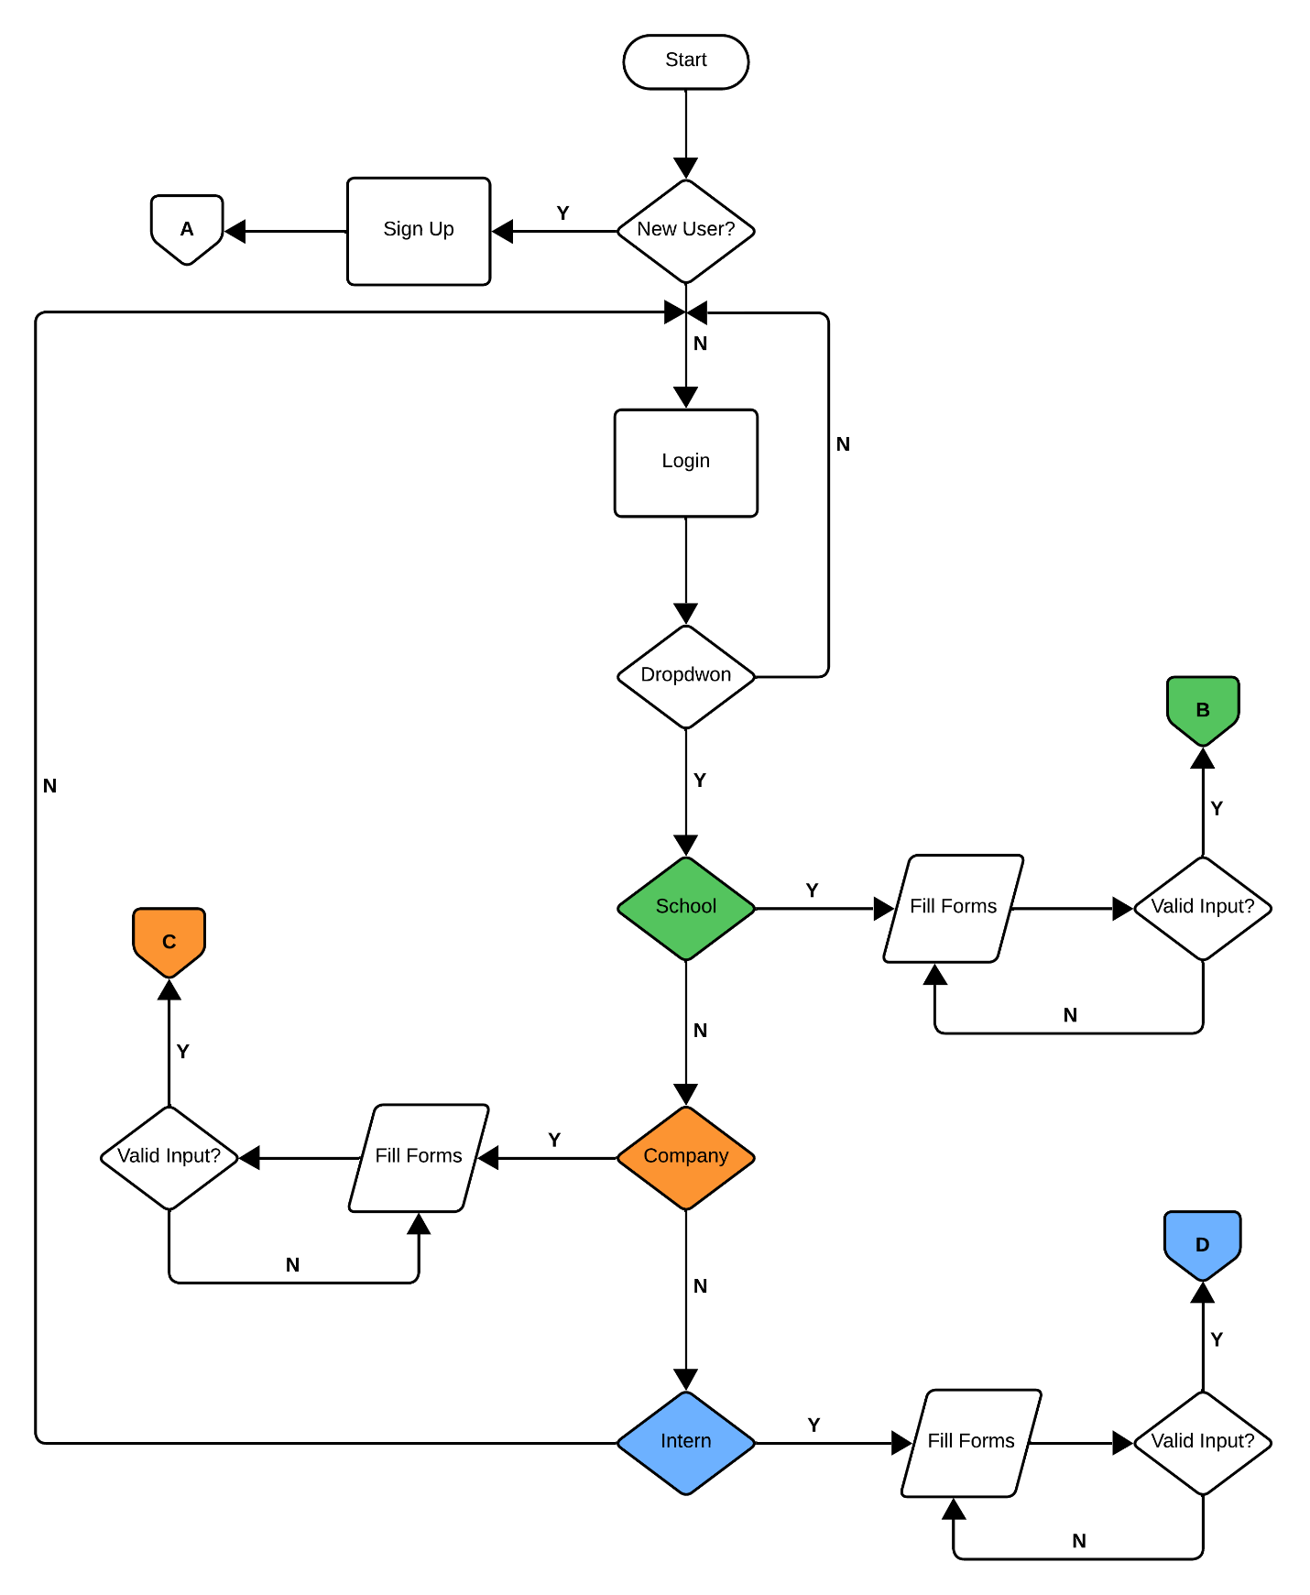**System Flowchart**

Figure 1. Login System Flowchart

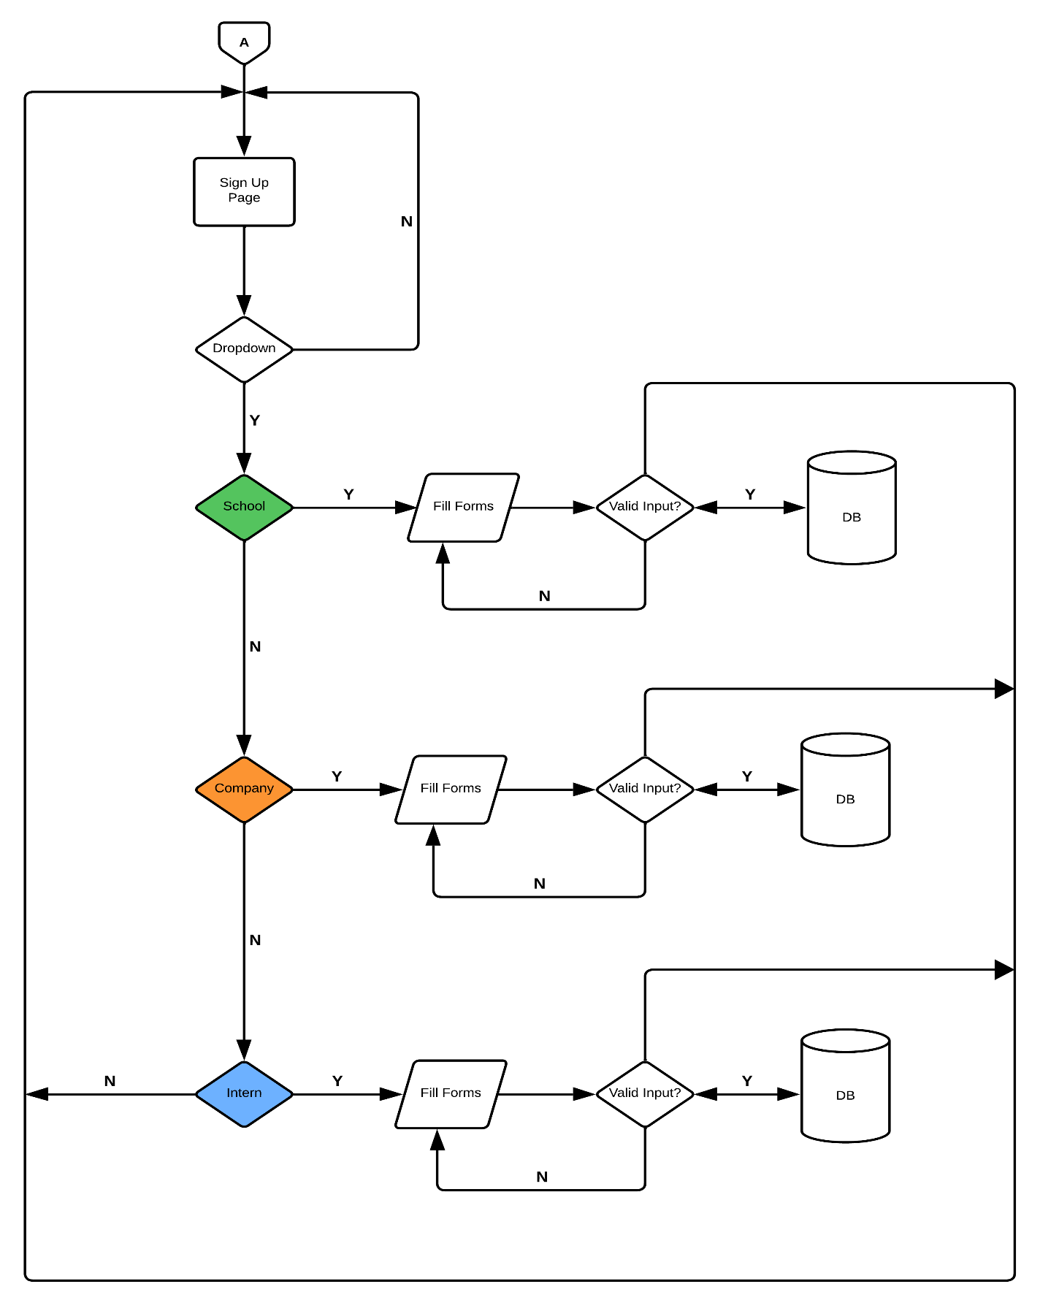

Figure 2. Sign Up System Flowchart

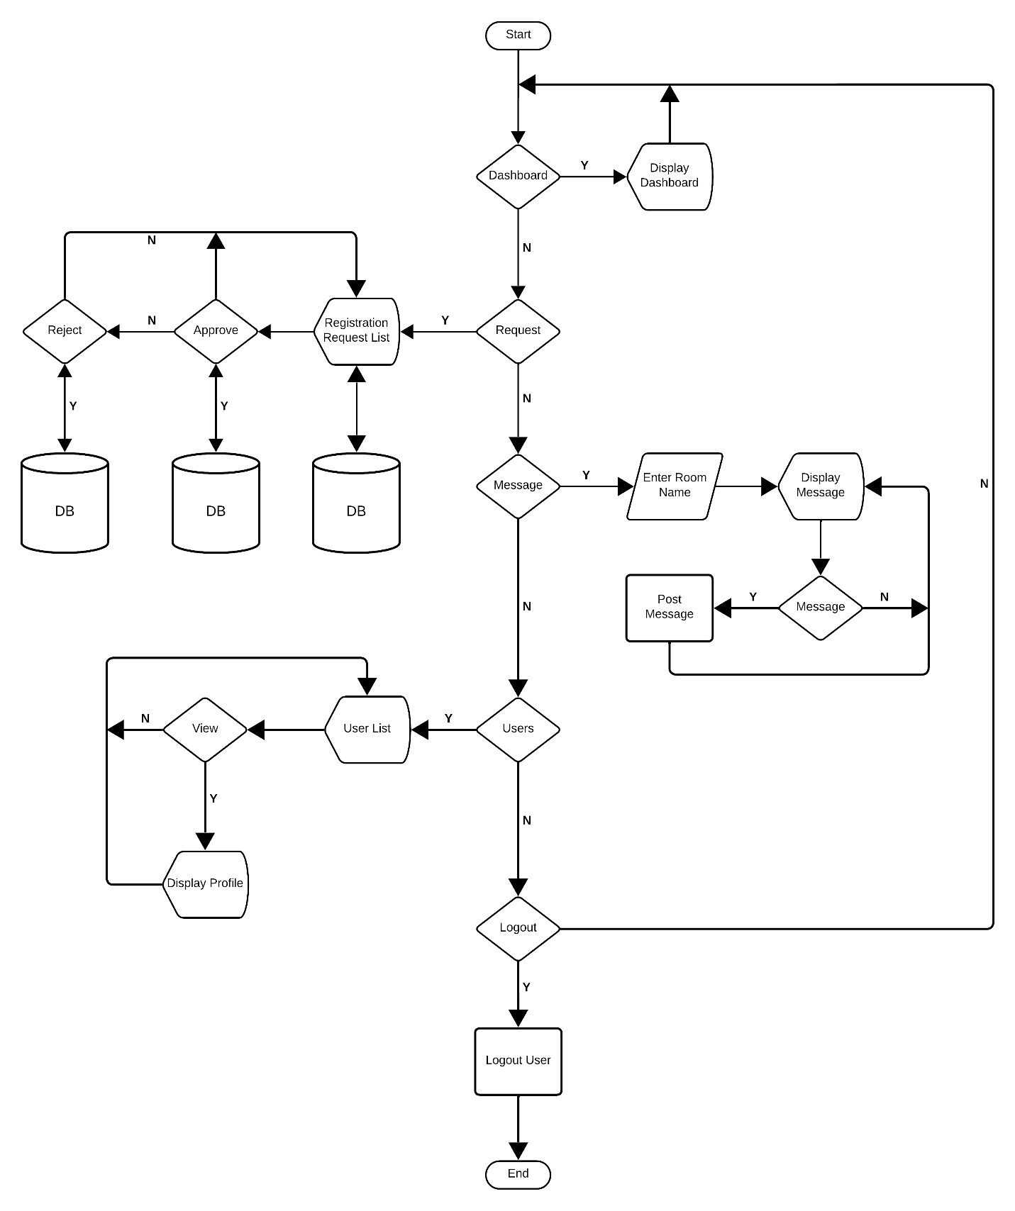

Figure 3. Admin System Flowchart

**System Architecture**



Server



Desktop/Mobile Phone



Admin

Company

School

Intern



Database

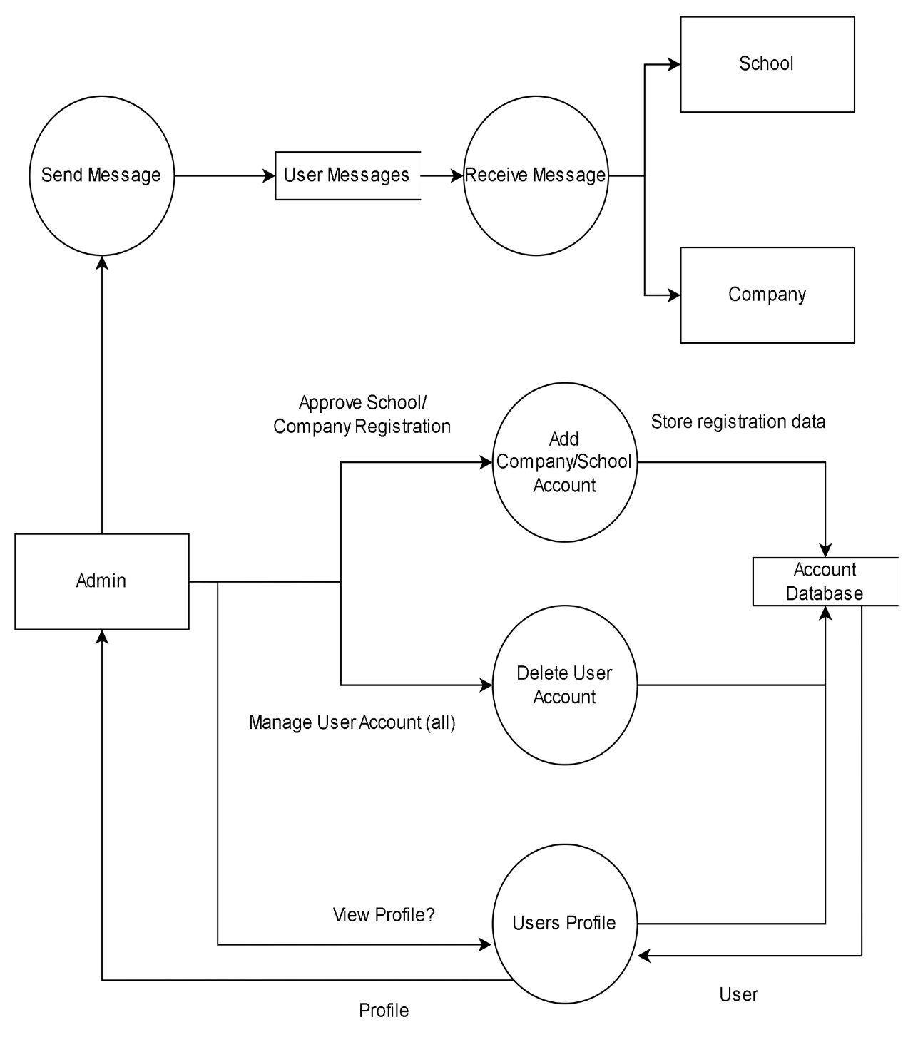**Dataflow Diagram**

Figure 10. Admin Dataflow Diagram

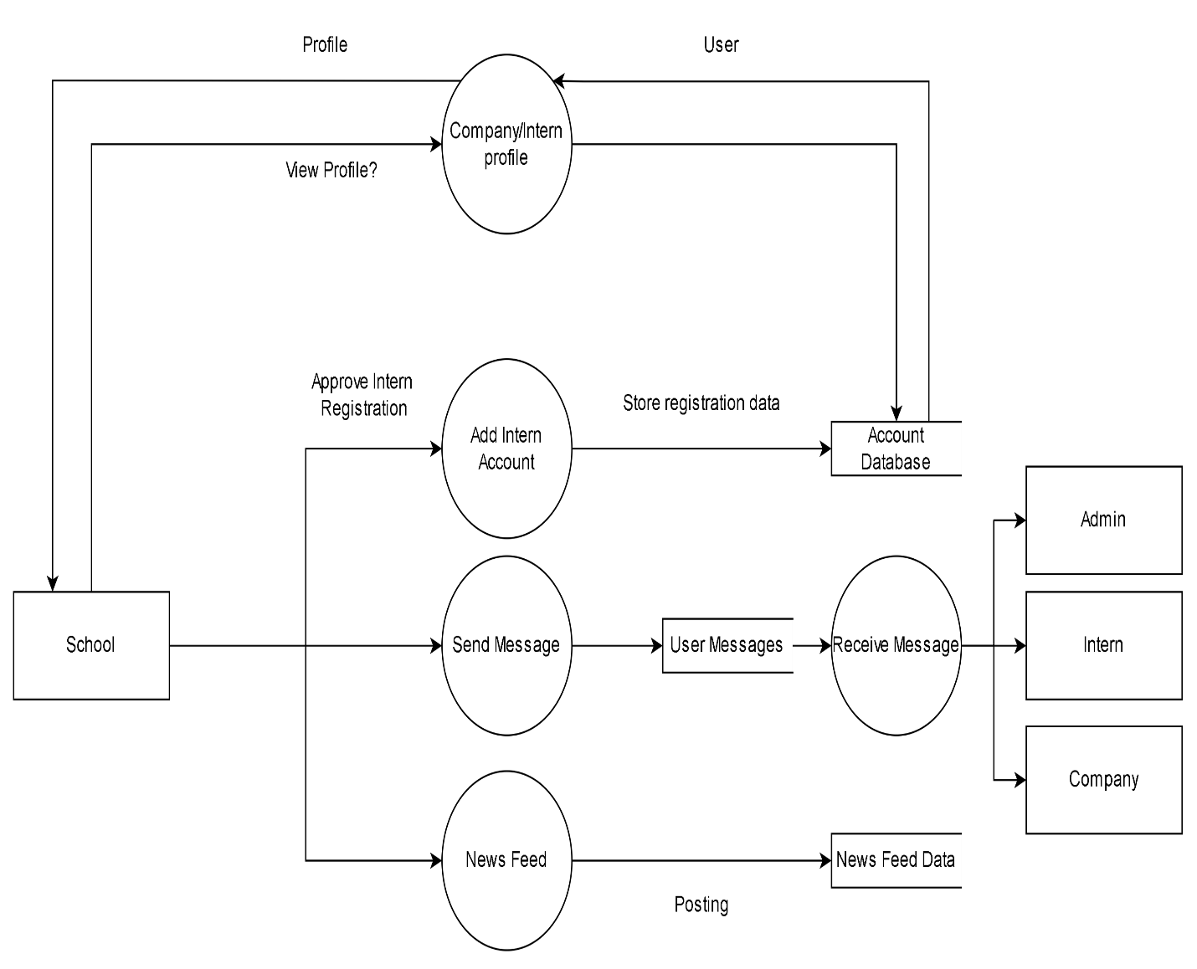

Figure 11. School Dataflow Diagram

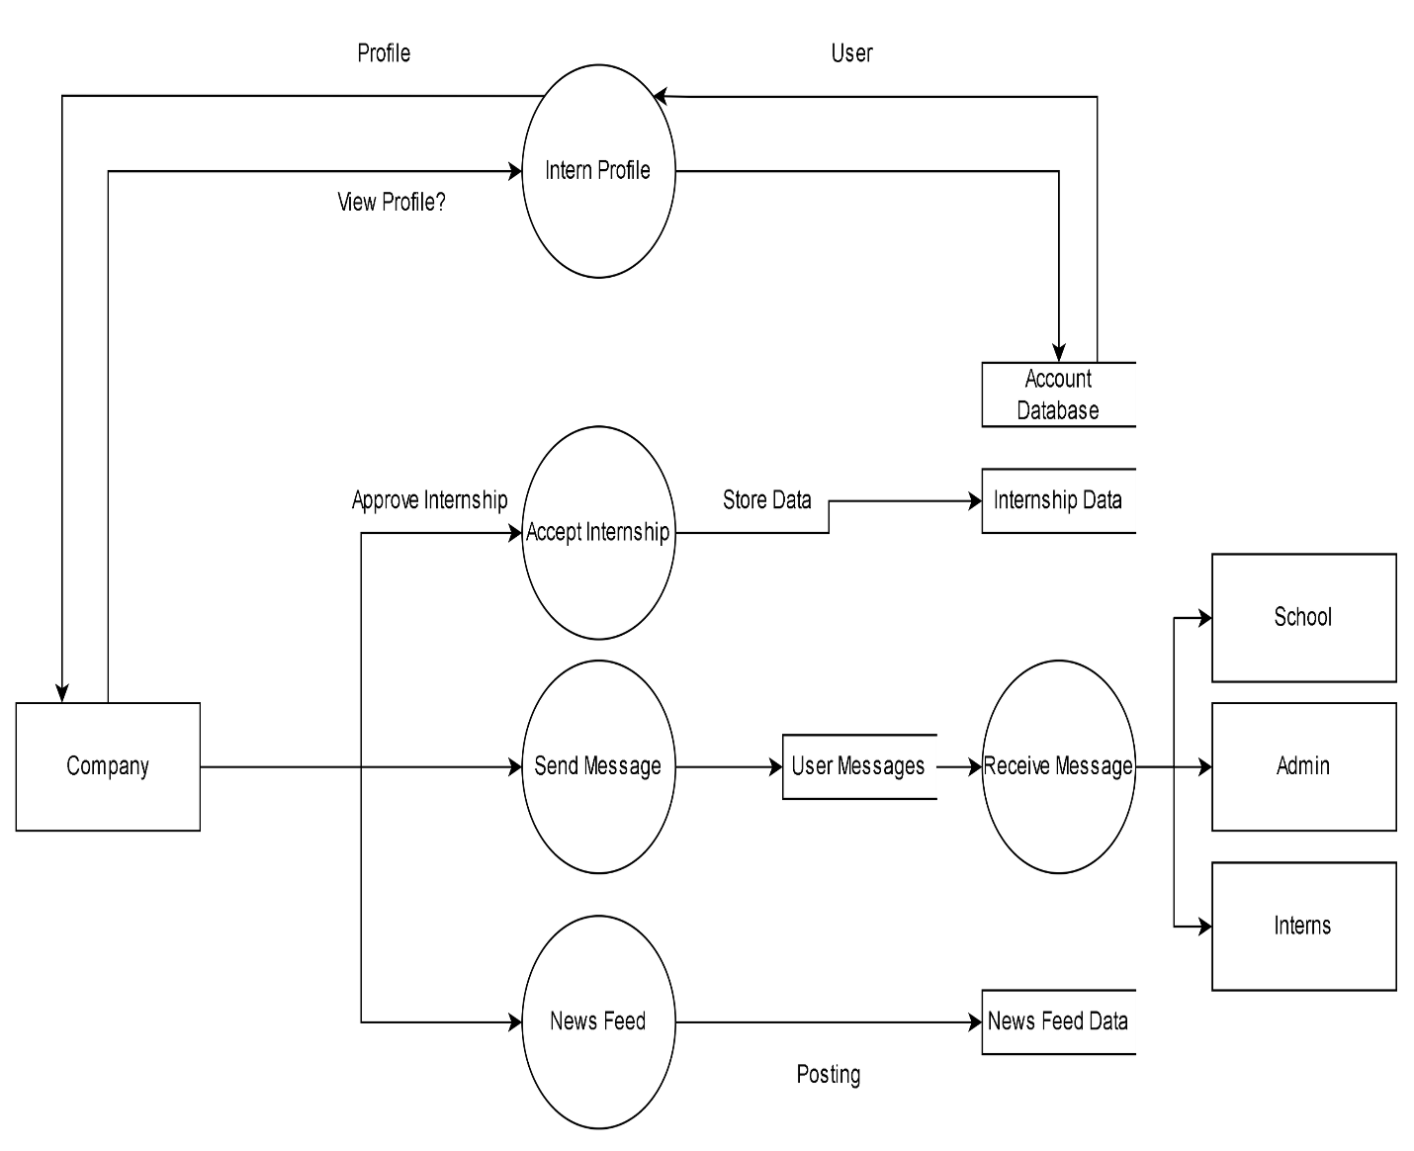

Figure 12. Company Dataflow Diagram

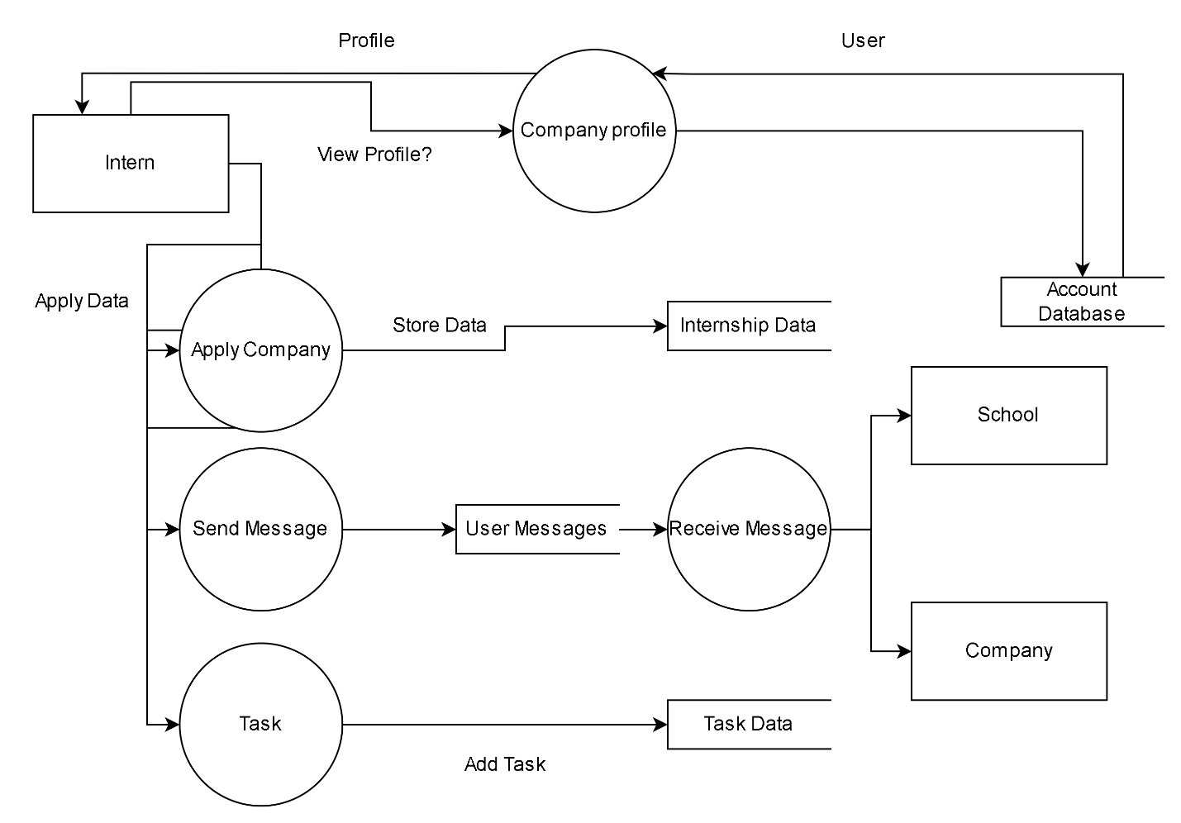

Figure 13. Intern Dataflow Diagram

**Table 1. Ghant Chart**

|  |  |  |  |  |  |  |  |  |  |  |  |  |
| --- | --- | --- | --- | --- | --- | --- | --- | --- | --- | --- | --- | --- |
| ACTIVITIES | 2023 | | | | | | | 2024 | | | | |
| JUN | JUL | AUG | SEP | OCT | NOV | DEC | JAN | FEB | MAY | APR | MAY |
| REQUIREMENTS |  |  |  |  |  |  |  |  |  |  |  |  |
| DESIGN |  |  |  |  |  |  |  |  |  |  |  |  |
| IMPLEMENTATION |  |  |  |  |  |  |  |  |  |  |  |  |
| DEPLOYMENT |  |  |  |  |  |  |  |  |  |  |  |  |
| TESTING |  |  |  |  |  |  |  |  |  |  |  |  |
| MAINTENANCE |  |  |  |  |  |  |  |  |  |  |  |  |

**Ethical Consideration**

To guarantee responsible and equitable use of the system, a number of important ethical concerns must be taken into account while establishing an Intern Portal with the goal of streamlining the internship application process and improving contact between interns and companies.

Data security and privacy are critical; sensitive personal data belonging to interns and organizational employees has to be safeguarded by encryption, and stringent access restrictions. Getting express user approval prior to data collection and maintaining open lines of communication regarding the types of data being gathered and how they will be used are both essential components of informed consent.

Putting verification methods in place and carrying out frequent audits to fix errors are two ways to ensure data accuracy. Maintaining confidentiality requires protecting routes of communication and, where necessary, taking non-disclosure agreements into consideration. Fairness and nondiscrimination should also be promoted by the portal by guaranteeing all qualified users equal access and routinely evaluating algorithms to reduce any potential biases.

Enabling users to control their own data, with the ability to see, edit, or remove information as well as to choose not to utilize particular services, should be a key component of promoting user autonomy. Accountability and transparency are crucial. The portal's functions and decision-making procedures should be made explicit, and there should be procedures in place to deal with any system abuse.

Lastly, in order to continuously develop the site while addressing any ethical problems, feedback and improvement methods should be established, enabling users to offer input and guaranteeing that feedback is taken into consideration. These factors may be taken into account when developing the Intern Portal to ensure that user rights are upheld, justice is served, and data is handled responsibly.