## ANALOG AND DIGITAL COMMUNICATIONS LAB BASED PROJECT

**ON**

**ASK Generation using BJTs**



|  |  |
| --- | --- |
| ID NUMBER | NAME |
| 170040582 | Sk. Mushtaq Hussain |

**DEPARTMENT OF ELECTRONICS AND COMMUNICATION ENGINEERING**



CERTIFICATE

This is to certify that the project based laboratory report entitled **“ASK USING BJT’s”** submitted by name bearing 170040582 (Sk. Mushtaq Hussain) to the “Department of ELECTRONICS AND COMMUNICATION ENGINEERING”, KL University in partial

fulfilment of the Requirements for the completion of a project based Laboratory in **“ANALOG AND DIGITAL COMMUNICATIONS”** course in B Tech 2nd year 2nd semester Semester, is a bonafide record of the work carried out by him under my supervision during the academic year 2018-2019.

PROJECT SUPERVISOR HEAD OF THE DEPARTMENT

**ACKNOWLEDGEMENTS**

It is great pleasure for me to express my gratitude to our honorable President **Sri. Koneru Satyanarayana**, for giving the opportunity and platform with facilities in accomplishing the project based laboratory report.

I express the sincere gratitude to our principal **Dr. K.SUBBARAO** for his administration towards our academic growth.

I express sincere gratitude to our Coordinator **MR.N.SURESH** for his leadership and constant motivation provided in successful completion of our academic semester.

I record it as my privilege to deeply thank our pioneer **Dr. K.KAVYA** HOD- ECE for providing us the efficient faculty and facilities to make our ideas into reality.

I express my sincere thanks to our project supervisor **MR.SYAM SUNDAR** for his/her novel association of ideas, encouragement, appreciation and intellectual zeal which motivated us to venture this project successfully.

Finally, it is pleased to acknowledge the indebtedness to all those who devoted themselves directly or indirectly to make this project report success.

|  |  |
| --- | --- |
|  |  |
|  |  |
| Sk. Mushtaq Hussain | 170040582 |
|  |  |

**ABSTRACT**

Amplitude shift keying - ASK - in the context of digital communications is a modulation process, which imparts to a sinusoid two or more discrete amplitude levels. These are related to the number of levels adopted by the digital message. For a binary message sequence there are two levels, one of which is typically zero. Thus the modulated waveform consists of bursts of a sinusoid.

Figure 1 illustrates a binary ASK signal (lower), together with the binary sequence which initiated it (upper). Neither signal has been bandlimited.

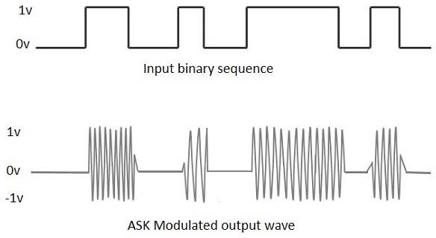

|  |  |  |
| --- | --- | --- |
| S.NO | **INDEX**  TITLE | PAGE.NO |
| 1 | Introduction | 6 |
| 2 | Aim of the Project | 9 |
| 3 | Software and Hardware Requirements | 9 |
| 4 | Implementation | 10 |
| 5 | Outputs | 11 |
| 6 | Conclusion | 12 |

## INTRODUCTION

**Amplitude Shift Keying (ASK)** is a type of Amplitude Modulation which represents the binary data in the form of variations in the amplitude of a signal.

Any modulated signal has a high frequency carrier. The binary signal when ASK modulated, gives a **zero** value for **Low** input while it gives the **carrier output** for **High** input.

# ASK Modulator

The ASK modulator block diagram comprises of the carrier signal generator, the binary sequence from the message signal and the band- limited filter. Following is the block diagram of the ASK Modulator.

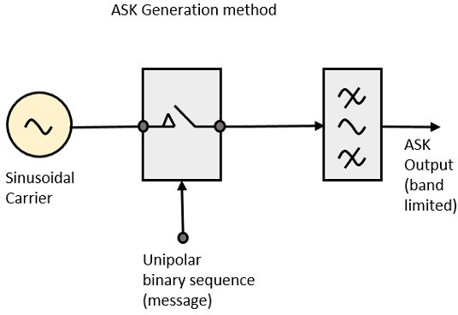

The carrier generator, sends a continuous high-frequency carrier. The binary sequence from the message signal makes the unipolar input to be either High or Low. The high signal closes the switch, allowing a carrier wave. Hence, the output will be the carrier signal at high input. When

there is low input, the switch opens, allowing no voltage to appear. Hence, the output will be low.

The band-limiting filter, shapes the pulse depending upon the amplitude and phase characteristics of the band-limiting filter or the pulse-shaping filter.

# ASK Demodulator

There are two types of ASK Demodulation techniques. They are −

* Asynchronous ASK Demodulation/detection
* Synchronous ASK Demodulation/detection

The clock frequency at the transmitter when matches with the clock frequency at the receiver, it is known as a **Synchronous method**, as the frequency gets synchronized. Otherwise, it is known as **Asynchronous**.

# Asynchronous ASK Demodulator

The Asynchronous ASK detector consists of a half-wave rectifier, a low pass filter, and a comparator. Following is the block diagram for the same.

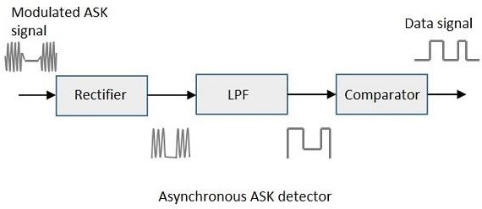

The modulated ASK signal is given to the half-wave rectifier, which delivers a positive half output. The low pass filter suppresses the higher

frequencies and gives an envelope detected output from which the comparator delivers a digital output.

# Synchronous ASK Demodulator

Synchronous ASK detector consists of a Square law detector, low pass filter, a comparator, and a voltage limiter. Following is the block diagram for the same.

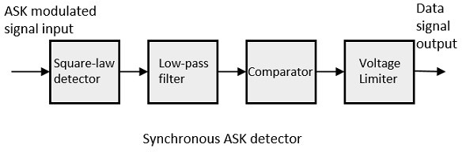

The ASK modulated input signal is given to the Square law detector. A square law detector is one whose output voltage is proportional to the square of the amplitude modulated input voltage. The low pass filter minimizes the higher frequencies. The comparator and the voltage limiter help to get a clean digital output.

## AIM:-

Design a ASK generation circuit using BJTs with the below specifications.

**v(T) = 5cos(4000pi t) when m(t) = Binary 1 v(T) = 0 when m(t) = Binary 0**

**SYSTEM REQUIREMENTS:-**

* **SOFTWARE REQUIREMENTS:**

MULTISIM

ELVIS MEASURMENTS

* **HARDWARE REQUIREMENTS:**
  + BREAD BOARD
  + JUMPER WIRES
  + CONNECTIONG PROBES
  + RESISTERS
    - 1K - 2
    - 10K - 5
    - 100K - 1
  + BJT
* BD137
* BD138
  + OPERATIONAL AMPLIFIER

**IMPLEMENTATION**

4

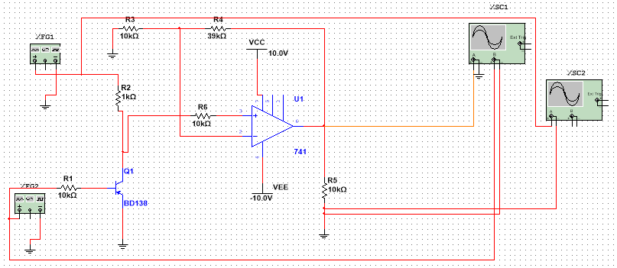

OUTPUTS:

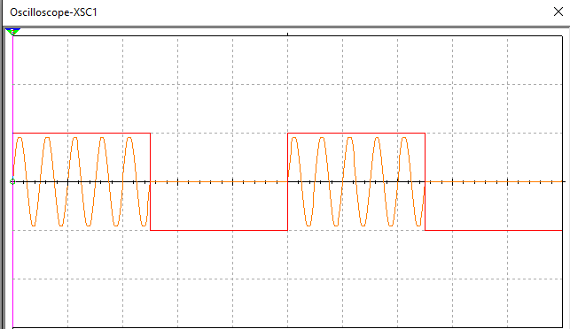

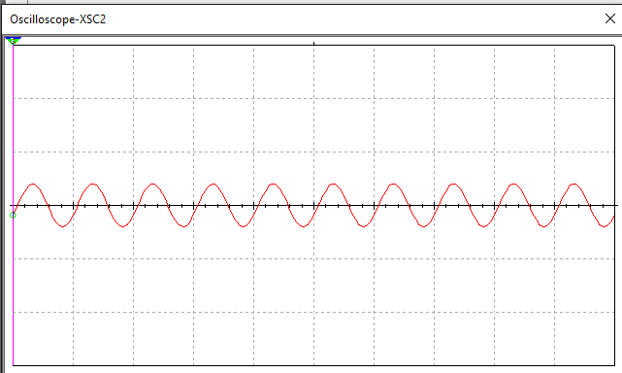

## CONCLUSION:

We have some dis advantages ,we can futhur go to FSk. But ASK can be generated through passing sinsodial signal with unipolar binary sequence. While ASK can be demodulated through passing modulated signal with rectifier , LPF and comparator then the signal we get will be the message signal which we have given. Demodulation can be done through two methods , Asynchronous and synchronous. Like this the signal can be modulated and demodulated using ASK**.**