**KLEF**

**DEPARTMENT OF**

**ELECTRONICS AND COMMUNICATION**

**ENGINEERING**

**DENOISING AN IMAGE USING WAVELET TRANSFORM**

**A Project Based Report**

**For**

**Digital Signal Processing**

**SUBMITTED BY**

I.D NUMBER NAME

170040555 VINAY KUMAR

170040582 MUSHTAQ HUSSAIN

170040604 N.VAISHNAVI

**UNDER THE ESTEEMED GUIDANCE OF**

**Dr. HARI KRISHNA PAIK**

**Professor, Dept. of ECE**



**KLEF Deemed to be University**

Green fields, Vaddeswaram – 522 502

**K L University**

**DEPARTMENT OF ELECTRONICS AND COMMUNICATION ENGINEERING**

CERTIFICATE

This is to certify that this project based lab report entitled “DENOISING AN IMAGE USING DISCRETE WAVELET TRANSFORM” is a bonafide work done by VINAY KUMAR(Id. No.170040555), MUSHTAQ HUSSAIN (Id. No.170040582) and N.VAISHNAVI(Id. No.170040604) in partial fulfilment of the requirement for the award of degree in Bachelor of Technology in Electronics and Communication Engineering during the academic year 2018-2019. We also declare that this project based lab report is of our own effort and it has not been submitted to any other university.

Signature of the Project Guide Signature of Course Coordinator

Head of the Department

**ACKNOWLEDGEMENT**

Before getting into the thickest of things, we would like to thank the personalities who were part of my project in numerous ways, those who gave me outstanding support from birth of the project.

We are extremely thankful to our beloved chairman and President **Koneru Satyanarayana** and special officer **Dr. L S S Reddy** for providing necessary infrastructure and resources for the accomplishment of our project at **Koneru Lakshmaiah Education Foundation**, Vaadeswaram

.

We are very much obligated to our beloved **Dr. Ch Sri Kavya**, Head of the department of

Electronics and Communication Engineering, Koreru Lakshmaiah Engineering college for providing the opportunity to undertake this project and encouragement in completion of this project.

We hereby wish to express our deep sense of gratitude to, **DR . Hari Krishna Paik**

Department of Electronics and Communication Engineering, Koneru Lakshmaiah Engineering college for the esteemed guidance, moral support and invaluable advice provided by him for the success of the project.

We are also thankful to all staff members of Electronics and Communication Engineering department who have co-operated in making our project a success. We would like to thank all our parents and friends who extended their help, encouragement and moral support either directly or indirectly in our project work.

Thanks for Your Valuable Guidance and kind support

**ABSTRACT**

The image de-noising naturally corrupted by noise is a classical problem in the field of signal or image processing. Additive random noise can easily be removed using simple threshold methods. De-noising of natural images corrupted by Gaussian noise using wavelet techniques are very effective because of its ability to capture the energy of a signal in few energy transform values. The wavelet de-noising scheme thresholds the wavelet coefficients arising from the standard discrete wavelet transform. In this paper, it is proposed to investigate the suitability of different wavelet bases and the size of different neighborhood on the performance of image de-noising algorithms in terms of PSNR.

# Wavelet denoising

Wavelet denoising relies on the wavelet representation of the image. Gaussian noise tends to be represented by small values in the wavelet domain and can be removed by setting coefficients below a given threshold to zero (hard thresholding) or shrinking all coefficients toward zero by a given amount (soft thresholding).

In this example, we illustrate two different methods for wavelet coefficient threshold selection: BayesShrink and VisuShrink.

## **VisuShrink**

The VisuShrink approach employs a single, universal threshold to all wavelet detail coefficients. This threshold is designed to remove additive Gaussian noise with high probability, which tends to result in overly smooth image appearance. By specifying a sigma that is smaller than the true noise standard deviation, a more visually agreeable result can be obtained.

## **BayesShrink**

The BayesShrink algorithm is an adaptive approach to wavelet soft thresholding where a unique threshold is estimated for each wavelet subband. This generally results in an improvement over what can be obtained with a single threshold.

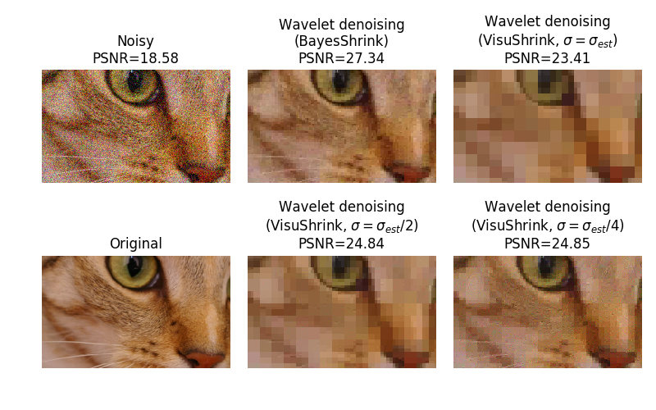

**Image with noise:**

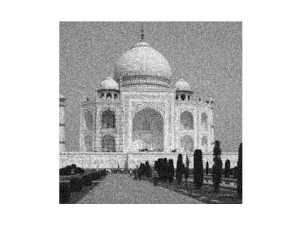

**Image without noise:**

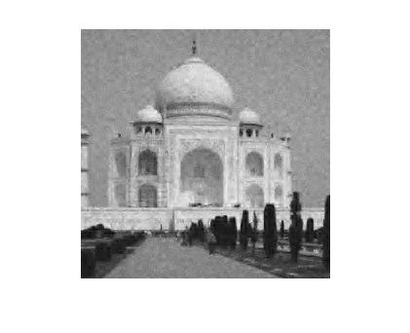

**EXPERIMENT AND RESULT:**

close all

clear

clc

a3=imread('C:\Users\Sk.Mushtaq Hussain\Desktop\dsp project\1.jpg');

a2=rgb2gray(a3);

b=imresize(a2,[256 256]);

b=double(b)+40*rand(size(b));

[a1,b1,c1,d1]=dwt2(b,'db2');

v1=(median(abs(b1(:)))/0.6745);

b1= wthresh(b1,'s',v1);

v2=(median(abs(c1(:)))/0.6745);

c1= wthresh(c1,'s',v2);

v3=(median(abs(d1(:)))/0.6745);

d1= wthresh(d1,'s',v3);

c=idwt2(a1,b1,c1,d1,'db2');

imshow(b,[])

figure,imshow(c,[])

r = snrr(double(b), c)

close all

clear

clc

a3=imread('C:\Users\Sk.Mushtaq Hussain\Desktop\dsp project\1.jpg');

a2=rgb2gray(a3);

b=imresize(a2,[256 256]);

b=double(b)+40*rand(size(b));

th='s';

[a1,b1,c1,d1]=dwt2(b,'db2');

[a2,b2,c2,d2]=dwt2(a1,'db2');

v1=(median(abs(b2(:)))/0.6745);

b2= wthresh(b2,th,v1);

v2=(median(abs(c2(:)))/0.6745);

c2= wthresh(c2,th,v2);

v3=(median(abs(d2(:)))/0.6745);

d2= wthresh(d2,th,v3);

v1=(median(abs(b1(:)))/0.6745);

b1= wthresh(b1,th,v1);

v2=(median(abs(c1(:)))/0.6745);

c1= wthresh(c1,th,v2);

v3=(median(abs(d1(:)))/0.6745);

d1= wthresh(d1,th,v3);

a1=idwt2(a2,b2,c2,d2,'db2');

c=idwt2(a1(1:129,1:129),b1,c1,d1,'db2');

imshow(b,[])

figure,imshow(c,[])

r = snrr(b, c)

close all

clear

clc

a3=imread('C:\Users\Sk.Mushtaq Hussain\Desktop\dsp project\1.jpg');

a2=rgb2gray(a3);

b=imresize(a2,[256 256]);

th='s';

b=double(b)+40*rand(size(b));

[a1,b1,c1,d1]=dwt2(b,'db2');

imshow(b1)

[a2,b2,c2,d2]=dwt2(a1,'db2');

[a3,b3,c3,d3]=dwt2(a2,'db2');

v1=(median(abs(b3(:)))/0.6745);

b3= wthresh(b3,th,v1);

v2=(median(abs(c3(:)))/0.6745);

c3= wthresh(c3,th,v2);

v3=(median(abs(d3(:)))/0.6745);

d3= wthresh(d3,th,v3);

v1=(median(abs(b2(:)))/0.6745);

b2= wthresh(b2,th,v1);

v2=(median(abs(c2(:)))/0.6745);

c2= wthresh(c2,th,v2);

v3=(median(abs(d2(:)))/0.6745);

d2= wthresh(d2,th,v3);

v1=(median(abs(b1(:)))/0.6745);

b1= wthresh(b1,th,v1);

v2=(median(abs(c1(:)))/0.6745);

c1= wthresh(c1,th,v2);

v3=(median(abs(d1(:)))/0.6745);

d1= wthresh(d1,th,v3);

a2=idwt2(a3,b3,c3,d3,'db2');

a1=idwt2(a2,b2,c2,d2,'db2');

c=idwt2(a1(1:129,1:129),b1,c1,d1,'db2');

imshow(b,[])

figure,imshow(c,[])

r = snrr(b, c)

**RESULT**

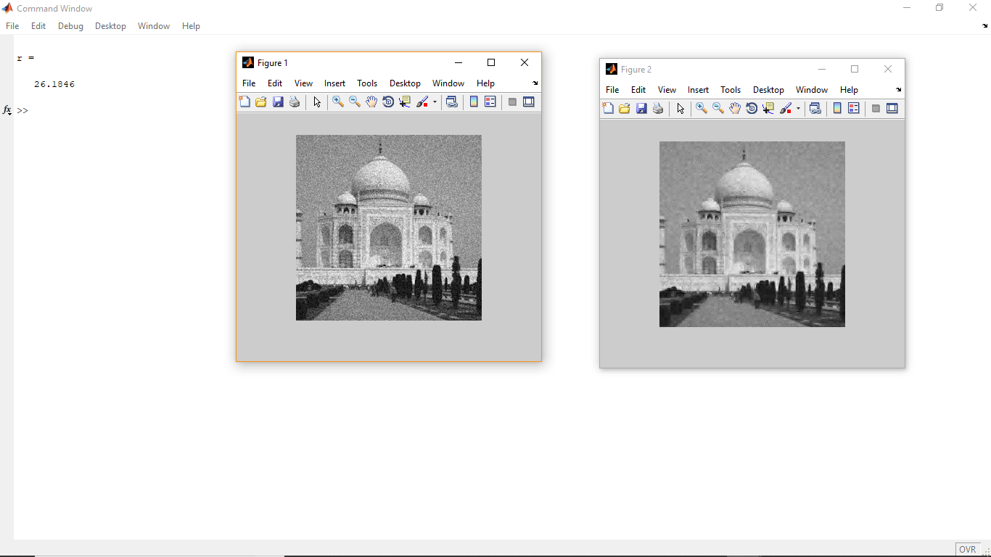

**CONCLUSION**

Noise is a random variation in brightness and color in image or simply we can say that unwanted signals are called noise. The noise is mixed with original signal and cause may troubles. Due to the presence of noise, quality of image is reduced and other features like edge sharpness and pattern recognition are badly affected. In image denoising methods to improve the results a hybrid filter is used for better visualization. The hybrid filter is composed with the combination of three filters connected in series. The hybridization has performed much better in case of salt and pepper type of noise and for most of the medical image type, either MRI, CT, SPECT, Ultra Sound. PSNR values show major improvement in comparison of other existing methods. Future, the results obtained from the presented denoising experiments would be tried to be improved further by using this method with other transform domain methods. Finally, the results are concluded that the proposed approach in terms of PSNR, MSE improvement is outperformed.

**REFERENCE**

1] http://depts.washington.edu/dmgftp/publications/html/smarthouse98-mdg.html

[2] Sleman, A.; Alafandi, M.; Moeller,”Integration of Wireless Fieldbus and Wired Fieldbus for Health Monitoring”; R.;Consumer Electronics, 2009. ICCE '09. Digest of Technical Papers International Conference on 10-14 Jan. 2009 Page(s):1 - 2

[3] Van Nguyen, T.; Jin Gook Kim; Deokjai Choi, "ISS: The Interactive Smart home Simulator," Advanced Communication Technology, 2009. ICACT 2009. 11th International Conference on , vol.03, no., pp.1828- 1833, 15-18 Feb. 2009