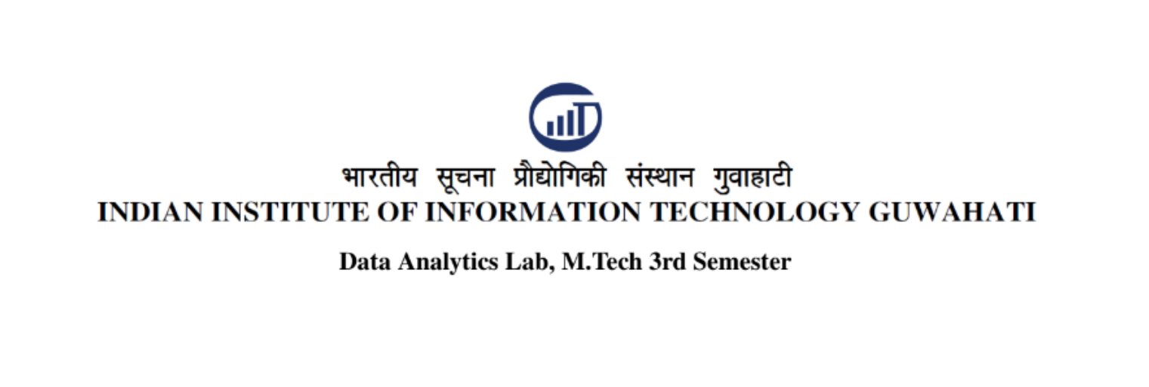

**Assignment-3**

Name - Mushtaq K islam

Roll no. - 2102025

Mode of instruction - Oncampus

**1. Create an array consisting of 20 real values**

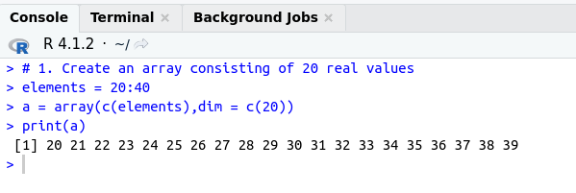

**2. Find sum, count, mean, median, mode, and mid-range**

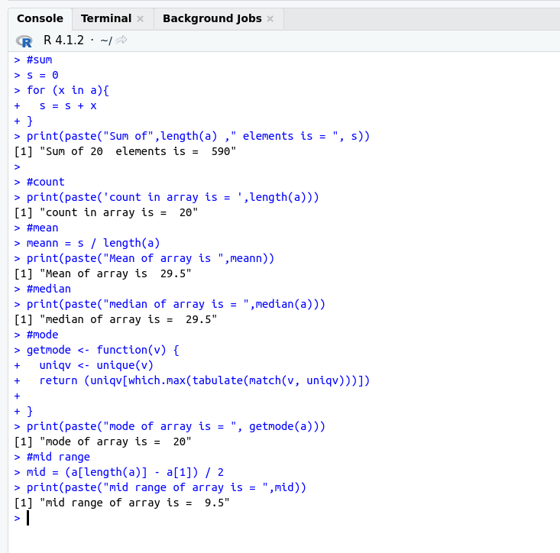

**3. Divide the array into 4 subgroups.**

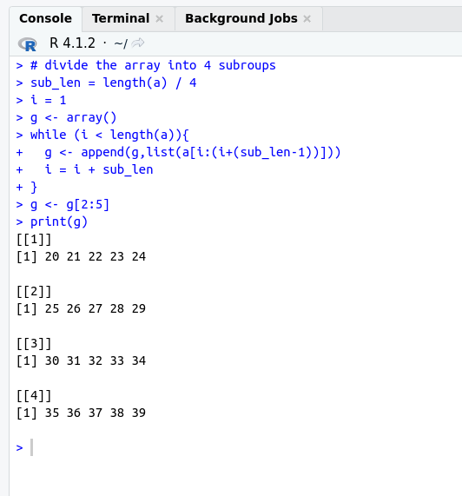

**Q4. Find sum, count, mean, median, mode, and mid-range of sub-groups**

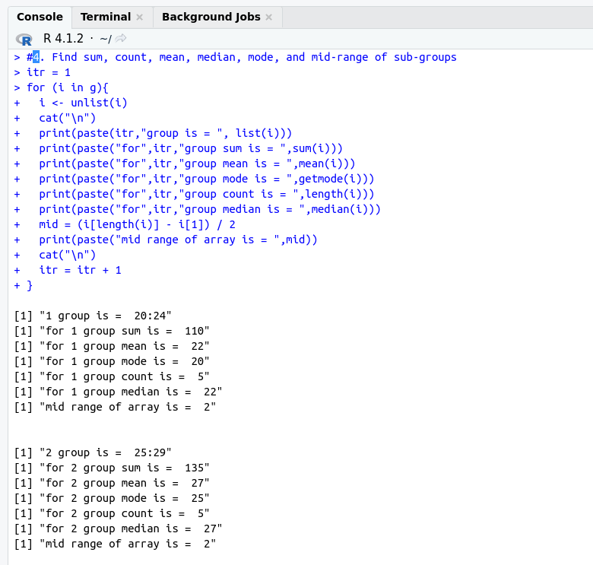

**Q5. Find distributive measures and algebraic measures from the results of 4.**

