

**Assignment-4**

Name - Mushtaq K islam

Roll no. - 2102025

Mode of instruction - Oncampus

1. Create an array by generating 100 random integers in the range [0, 100]. Write separate

functions to find the following:

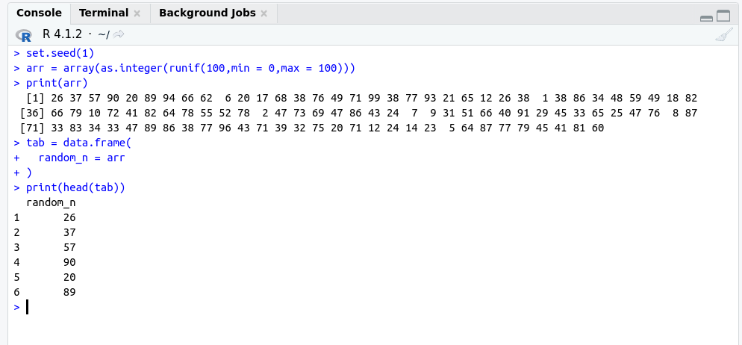

i. Variance and Standard Deviation

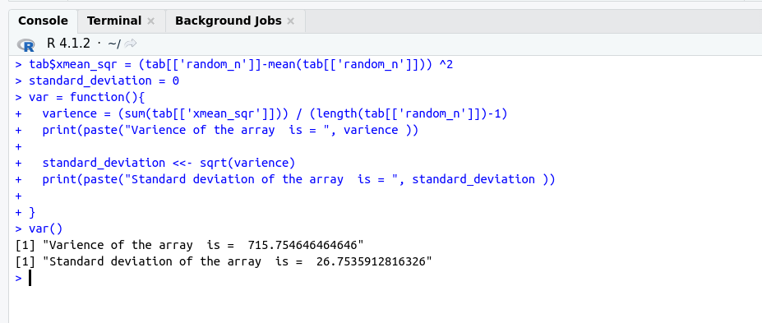

ii. Coefficient of Variation,

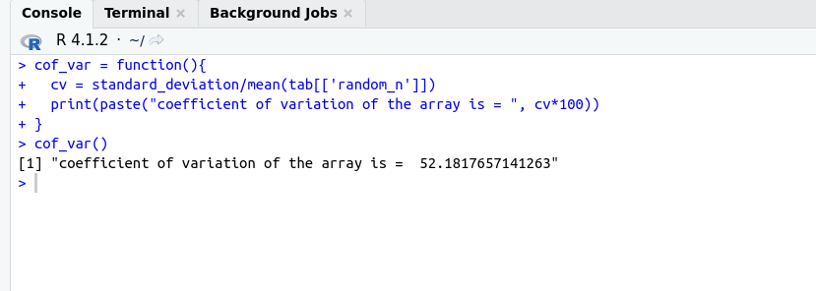

iii. Mean Absolute Deviation (MAD),

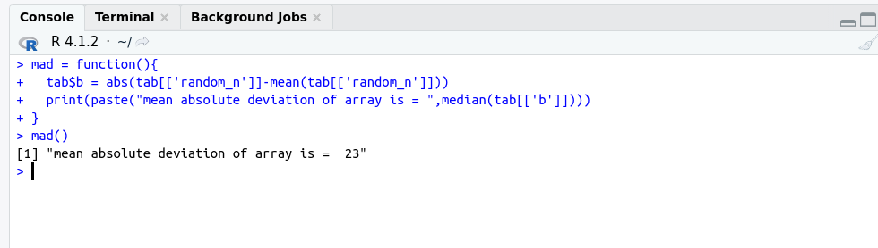

iv. Absolute Average Deviation (AAD),

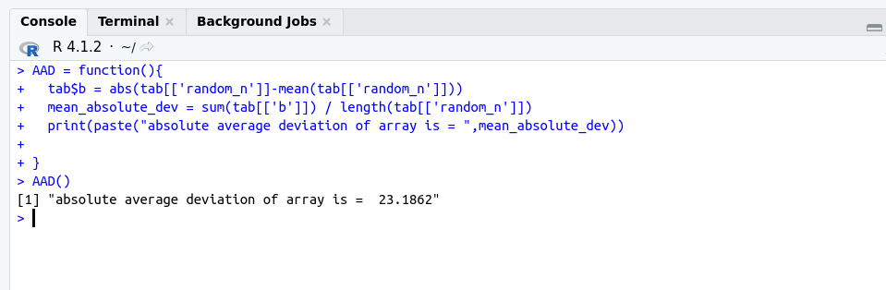

v. Quartiles (Q 1 , Q 2 , Q 3 ) and Interquartile Range

(IQR).

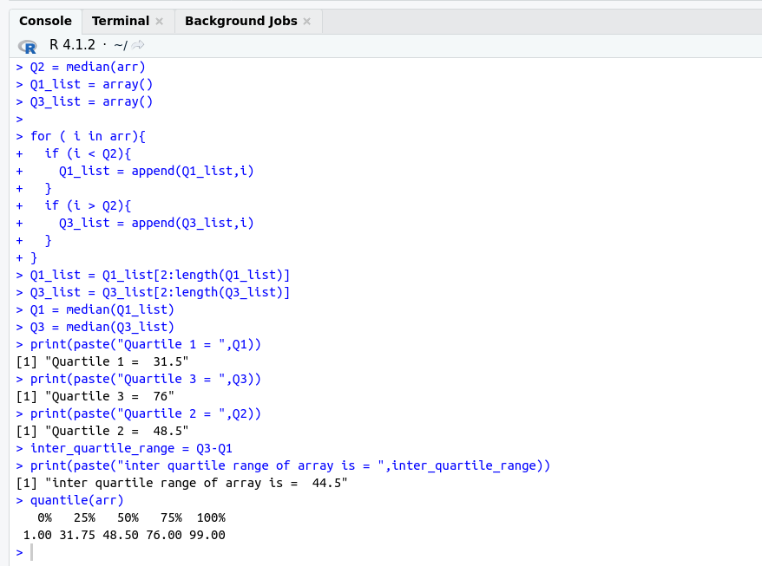

2. Draw boxplot of the five-number summary (Minimum, , Median (), , Maximum) of the data

generated for the above experiment.

