**Assignment**

**High Level Design**

Product Management

|  |  |
| --- | --- |
| VERSION: 1.0 | REVISION DATE: |

|  |  |  |  |
| --- | --- | --- | --- |
| Approver Name | Title | Signature | Date |
| <name> | <title> |  | <Date> |
|  |  |  |  |
|  |  |  |  |

Table of Contents

1 Introduction 3

1.1 Purpose 3

2 Product Managemet 3

2.1 Draft technical flow diagram 4

2.2 Screen-shot 5

5

# Introduction

Product Management is an Spring MVC application implementing the CRUD operations of Product along with Spring security basic concepts

## Purpose

The purpose of this document is to explain the application implementation in a brief .

# Product Managemet

1. User navigates <SERVER IP> :<SERVER PORT>/ProductMgmt/index(http://localhost:9090/ProductMgmt/index)
2. System will navigate to login page
3. User enter the correct user name and password (admin & 123456)
4. System navigates to the list product page with the below modules
   1. One section displaying the Add product form with the following fields
      1. Product Name
      2. Desc
      3. Department
      4. Category
      5. Price
      6. Available
   2. Another section is a table listing the products already created
      1. With following columns
         1. Product ID
         2. Product Name
         3. Product Description
         4. Product Department
         5. Product Category
         6. Product price
         7. Available
      2. Two action links
         1. Edit
         2. Delete
5. User inputs products details and clicks on Add Products.
6. User clicks on Edit link and clicks on Edit Product button
7. User clicks on Delete link to delete the product record
8. User can search, sort the list of products in the tables.

## Draft technical flow diagram

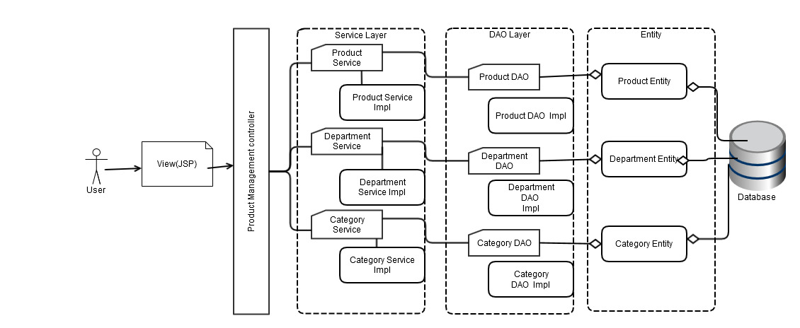

## Screen-shot

# 

