Safety stock calculation process | - During the initial “COREDATA” file creation, choose an initial safety stock based on a percentage of “ORDERS or FORECAST” (whichever is greater).  - Store this in “SafetyStock01” in COREDATA.  - During the secondary “COREDATA2” file creation:  - Perform a six-week rolling average on the initial safety-stock to smooth it out  - Multiply this average value by a “safety-stock factor”. This is an end-client rough determination that safety-stock should be lower or higher than production capacity.  - Then compare this value to the “ending inventory” to see if we are under (stocking out) or over (too much)  - Based on step “b”, determine Outcome01 to be one of: VeryLow, Low, OK, High, VeryHigh.  - Based on limits/triggers stored in the config file, convert the value in step “c” to correction.  - Finally, apply the correction and store the result in “SafetyStock02” in COREDATA2.  - This means that “SafetyStock02” should be the input (correct value) for a supervised model.  - It also means that “SafetyStock03” is “0” as an input and should be determined by the model. Of course, the calculated value will only where Sagemaker is told to export results (e.g. S3 or Snowflake). We would have to pull that information down and merge it with Datagen files if we want to complete the circle.
Recent data in Excel before filtering  (visually messy) | 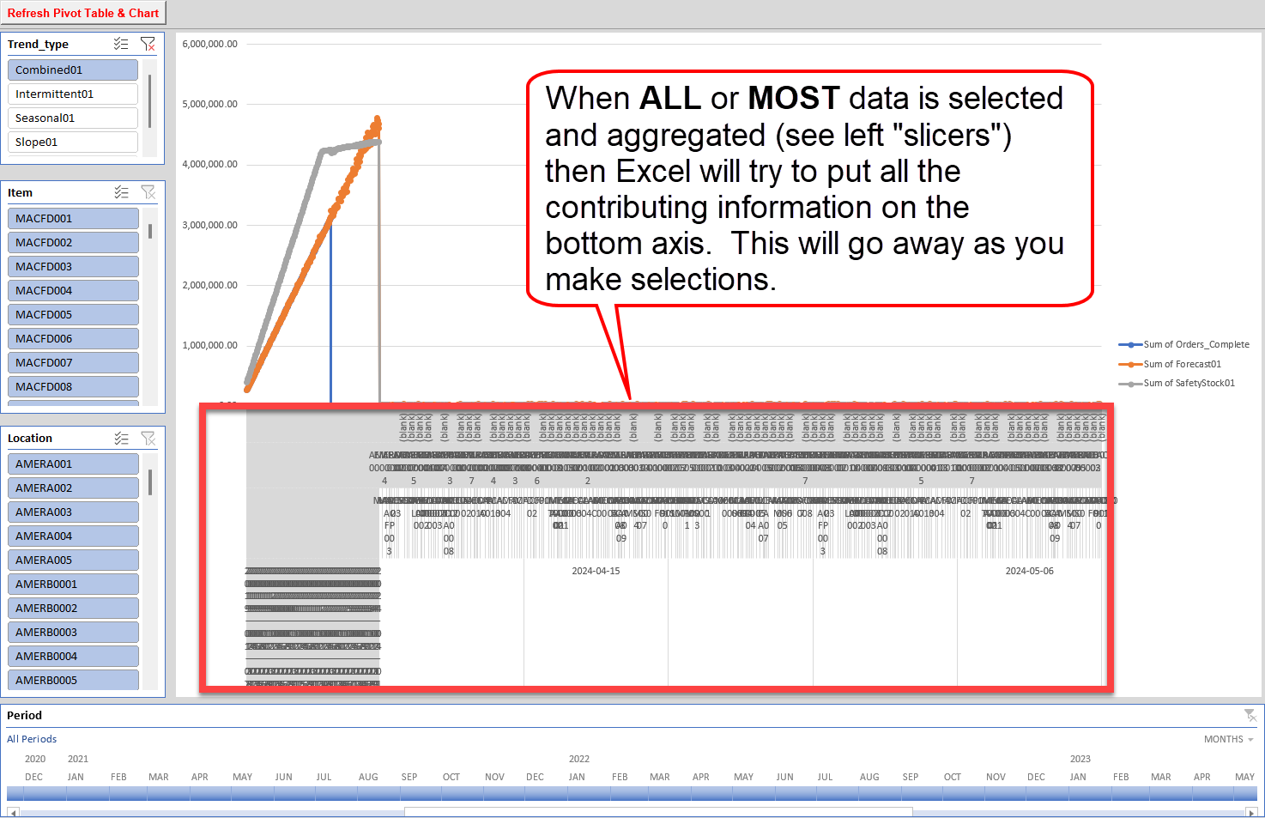
Recent data in Excel after filtering  (visually cleaner) | 