GENERAL USE
01-01-00-00
Use_of_NOTES

Table of Contents
Purpose 2
Outcome (CRP, SIT, UAT) 2
Diagram 2
Summary 3
System Access List 3
Checklist: Use of Notes 3
Questions 4
Issues 4
End 4

Purpose
File ID | 05-01-00-00
File Name | ACME_SCP_EUT_05-01-00-00_WIP_Use_of_NOTES.docx
Purpose | Use_of_NOTES
Pre-reqs | Access via SSO login, Navigation, Searching
History | Date | Contributor | Notes
 | 2025-MAR-09 | IBM | - Document creation

Outcome (CRP, SIT, UAT)
Date Executed
Primary Outcome | PASS
Environment | DEV1
Stakeholders:
Process control: Manual
Process control: Auto | X
Oracle EBS | X | https://ebsdevd.entrust.com:8443
Oracle Cloud |  | https://iaxoqy-dev1.fa.ocs.oraclecloud.com/fscmUI/faces/FuseOverview
Phase | Phase 1: Demand & Supply Planning
Exercise type
User Type(s)
Oracle roles: EBS
Oracle roles: CLOUD
Exception reference

Diagram
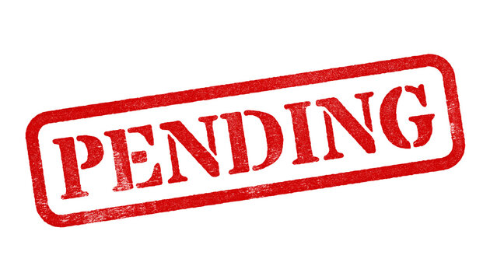

Summary
- Prerequisite
  - SSO is enabled in the Cloud-SCP environment
  - Data has been loaded from Oracle EBS into Cloud-SCP
- User Review
  - Description pending

System Access List
EBS | DEV1 (DEV1) | https://icdajb-dev1.fa.ocs.oraclecloud.com/fscmUI/faces/FuseOverview
 | DEV2 (TEST) | https://icdajb-dev2.fa.ocs.oraclecloud.com/fscmUI/faces/FuseOverview
 | TEST (UAT) | https://icdajb-test.fa.ocs.oraclecloud.com/fscmUI/faces/FuseOverview
 | PROD | < pending >
Cloud-SCP | DEV1 (DEV1) | < pending >
 | DEV2 (TEST) | < pending >
 | TEST (UAT) | < pending >
 | PROD | < pending >

Checklist: Use of Notes
Type | Seq | X▬ | Details | Image (paste image and then resize image to be 3.5” wide or less)
Notes | n/a
Warnings | n/a
Actions / Steps | 010 |  | - Topic  - subtopic | 
 | 020 |  | - Topic  - subtopic | 
 | 030 |  | - Topic  - subtopic | 
 | 040 |  | - Topic  - subtopic | 
 | 050 |  | - Topic  - subtopic | 
 | 060 |  | - Topic  - subtopic | 
 | 070 |  | - Topic  - subtopic | 
 | 080 |  | - Topic  - subtopic | 
 | 090 |  | - Topic  - subtopic | 
 | 100 |  | - Topic  - subtopic | 

Questions
Ref. No. |  | Date | Details
1 |  | yyyy-mmm-dd | Question  Answer
2 |  | yyyy-mmm-dd | Question  Answer
3 |  | yyyy-mmm-dd | Question  Answer

Issues
Ref. No. | Date | Details
1 | yyyy-mmm-dd | Details  Resolution
2 | yyyy-mmm-dd | Details  Resolution
3 | yyyy-mmm-dd | Details  Resolution

End

