IBM Vision Environment
SCM Data Population

Table of Contents
Purpose 2
Minimum Requirements 2
Implementation Order / Dependencies 2
Checklist: MANUALLY-PROVIDED ORG, ITEM, CUST 3
Checklist: RANDOMLY-GENERATED ORG, ITEM, CUST 5
Topics 5
Topics 5
Topics 5
Appendix 6
AI Q&A 6
AI query 6
AI response 7
Points 12
Diagram 12
Checklist: Topic 12
End 12

Purpose
- Set up a target Oracle Cloud SCM environment to perform basic planning activities (plan inputs, S&OP, demand planning, supply planning, and replenishment planning).
- Use totally random information generated by python code; or use a provided set of example ITEMS and LOCATIONS to create combinations.
- Note that the original code was developed for basic ITEM-CUSTOMER combinations with a single fixed ORGANIZATION. Later in 2026-Q1 the code will be modified to include random or fixed ORGANIZATION content as well.

Minimum Requirements
Enterprise
- 1 Legal Entity
- 1 Business Unit
- 1 Item Master Org
- 1 Inventory Org
Master Data
- 10 items
- 1 Supplier
- 1 Customer (optional)
- Sourcing Rule
- Approved Supplier List
- Lead Times
Transaction Data
- 24 months shipment history
- 3 months open sales orders
- On-hand inventory
- Planning Objects
- 1 Assignment Set
- 1 Planning Calendar
- 1 Demand Plan
- 1 Supply Plan
- 1 S&OP Plan
- 1 Replenishment Plan (optional if not testing min/max)
UI
- Default layouts are fine

Implementation Order / Dependencies
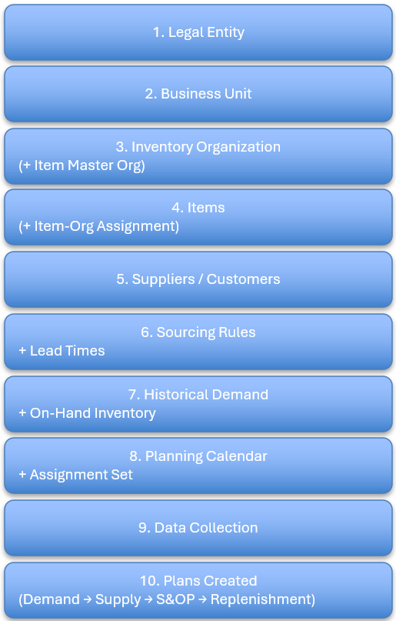

Checklist: MANUALLY-PROVIDED ORG, ITEM, CUST
Type | Seq | X▬ | Details | Image (paste image and then resize image to be 3.5” wide or less)
Notes | n/a |  | - Simple SQL statement for testing: [SELECT SYSDATE AS current_date FROM dual]  - The queries about “legal entity” or “business unit” have to be done from the FIN_IMPL user in Vision.  SELECT bu.business_unit_name,  le.name AS legal_entity  FROM fun_all_business_units_vl bu,  xle_entity_profiles le  WHERE bu.legal_entity_id = le.legal_entity_id  - To locate reasonable “finished good” (FG) items that are likely to have associated structures and which are good candidates for manually-chosen ITEMs for random history generation, go to “Plan Inputs”, search for your ORG, add the “Make or Buy” search field, and choose “Make”… because you are unlikely to ever BUY anything with a structure.
Warnings | n/a
Actions / Steps | 010 |  | - Enterprise Setup  - 1 Legal Entity  - 1 Business Unit  - 1 Item Master Org  - 1 Inventory Org  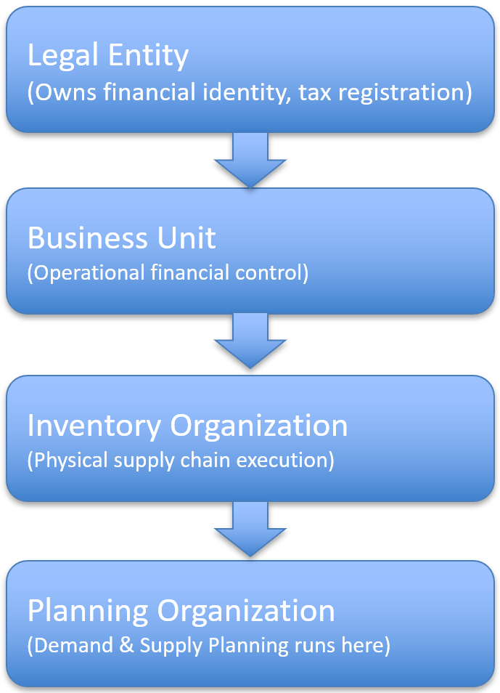 | Purpose Via Value  legal entity Define Legal Entities Manage Legal Entities Assign Legal Entity to Business Unit | |-- to see associated business units US1 Legal Entity Legal entity ID: 300000046973970  business unit Manage Business Unit | |-- export as Excel to see “legal entity” |-- get legal entity id US1 Business Unit Legal entity ID: 300000046973970  master org Manage Inventory Organizations | |-- can’t find a means to determine < how to determine? >  inventory org manage inventory organizations manage planning organizations | |-- export as Excel to see “legal entity” |-- get legal entity id 002
 | 020 |  | - Master Data Setup  - 10 items  - 1 Supplier  - 1 Customer (optional)  - Sourcing Rule  - Approved Supplier List  - Lead Times | Purpose Via Value
 | 030 |  | - Transaction Data Setup  - 24 months shipment history  - 3 months open sales orders  - On-hand inventory  - Planning Objects  - 1 Assignment Set  - 1 Planning Calendar  - 1 Demand Plan  - 1 Supply Plan  - 1 S&OP Plan  - 1 Replenishment Plan (optional if not testing min/max) | Purpose Via Value
 | 040 |  | - UI Setup  - Default layouts are fine | Purpose Via Value
 | 050 |  | - Topic  - subtopic | Purpose Via Value
 | 060 |  | - Topic  - subtopic | Purpose Via Value

Checklist: RANDOMLY-GENERATED ORG, ITEM, CUST
Type | Seq | X▬ | Details | Image (paste image and then resize image to be 3.5” wide or less)
Notes | n/a
Warnings | n/a
Actions / Steps | 010 |  | - Enterprise Setup  - 1 Legal Entity  - 1 Business Unit  - 1 Item Master Org  - 1 Inventory Org | Purpose Via Value
 | 020 |  | - Master Data Setup  - 10 items  - 1 Supplier  - 1 Customer (optional)  - Sourcing Rule  - Approved Supplier List  - Lead Times | Purpose Via Value
 | 030 |  | - Transaction Data Setup  - 24 months shipment history  - 3 months open sales orders  - On-hand inventory  - Planning Objects  - 1 Assignment Set  - 1 Planning Calendar  - 1 Demand Plan  - 1 Supply Plan  - 1 S&OP Plan  - 1 Replenishment Plan (optional if not testing min/max) | Purpose Via Value
 | 040 |  | - UI Setup  - Default layouts are fine | Purpose Via Value
 | 050 |  | - Topic  - subtopic | Purpose Via Value
 | 060 |  | - Topic  - subtopic | Purpose Via Value

Topics

Topics

Topics

Appendix

AI Q&A

AI query
If the goal was to set up a basic Oracle Fusion/Cloud SCM (supply chain management) environment to perform basic planning activities (S&OP, Demand Planning, Supply Planning, and Replenishment planning), what is the likely minimum amount of information required? Possible examples for consideration are shown following this paragraph; assess and improve as appropriate.

REQUIRED:
- at least one "legal entity"
- at least one "business unit"
- at least one "calendar" and knowledge of monthly, weekly, or daily periods for each type of plan
- at least one "item"
- at least one "organization"
- at least one "customer"
- at least one "item catalog" (which acts as a product hierarchy)
- at least one "assignment set"
- at least one forecast-capable combination per item (e.g. item-organization-customer or item-organization or item-customer).
- at least 24 periods (and likely 24 calendar months regardless) of historical sales information ("bookings history" or "sales history")
- at least 3 periods periods of open orders in the past and 3 to 6 periods of open orders in the future.
- at least one FBDI file to load items
- at least one FBDI file to load locations
- at least one FBDI file to load bookings-history and/or shipment-history
- at least one FBDI file to open sales orders
- at least one "S&OP plan" with an associated "calendar" and "assignment set"
- at least one "demand plan" with an associated "calendar" and "assignment set"
- at least one "supply plan" with an associated "calendar" and "assignment set"
- at least one "replenishment plan" with an associated "calendar" and "assignment set"
- at least one "page layout" for each type of plan
- at least one "table" for each type of plan (which is assigned to a "page layout" and appears as a menu tab in the layout)

OPTIONAL:
- exception sets
- ODBI or BIP report
- lots and lot-control
- subinventories (per organization)
- segments (for planning)
- custom measures
- custom dimensions

QUESTIONS:
- Should the "locations" available be considered "organizations" or "customers" or should there be both separately?
- To reasonably model a real company, would MANY items with ONE organization with MANY customers be sufficient?
- what else may be REQUIRED vs OPTIONAL?

AI response
Minimum required:
Enterprise
- 1 Legal Entity
- 1 Business Unit
- 1 Item Master Org
- 1 Inventory Org
Master Data
- 10 items
- 1 Supplier
- 1 Customer (optional)
- Sourcing Rule
- Approved Supplier List
- Lead Times
Transaction Data
- 24 months shipment history
- 3 months open sales orders
- On-hand inventory
- Planning Objects
- 1 Assignment Set
- 1 Planning Calendar
- 1 Demand Plan
- 1 Supply Plan
- 1 S&OP Plan
- 1 Replenishment Plan (optional if not testing min/max)
UI
- Default layouts are fine

REQUIRED vs OPTIONAL Summary
REQUIRED for Core Planning
- Legal structure
- Item + Item-Org assignment
- Calendar
- Assignment set
- Historical demand
- Sourcing rule
- Lead times
- On-hand
- Supply type (Make/Buy)
OPTIONAL
- Custom tables
- Custom layouts
- Exception sets
- ODBI/BIP
- Segments
- Custom measures
- Multiple orgs
- Multi-currency
- Lot control

Practical Advice
If your goal is:
- Technical validation → 10 items is enough.
- Statistical credibility → 50–200 items minimum.
- Realistic S&OP modeling → 2–3 orgs (plant + DC).

DETAIL: 1
Truly REQUIRED – Foundation Configuration
- These are structural objects without which planning won’t even run.
Enterprise Structure
- ✅ 1 Legal Entity
- ✅ 1 Business Unit
- ✅ 1 Inventory Organization
- Must be inventory-enabled
- Must be planning-enabled
- ✅ 1 Item Master Organization
- (Can be the same as inventory org in a minimal build, but logically distinct)
- Minimum realistic footprint:
1 Legal Entity → 1 BU → 1 Inventory Org → 1 Item Master Org

Calendars
- You need:
- ✅ 1 Planning Calendar
- Weekly or Monthly buckets
- Typically 24–36 future periods
- ✅ Historical coverage for at least 24 months (for forecasting stability)
- You do NOT need separate calendars per plan type unless modeling different time grains.

Planning Framework Objects
- ✅ 1 Assignment Set
- Assigns items to organizations
- Required for supply planning
- ✅ 1 Collection Definition
- To collect data into Planning Central
- ✅ At least 1 Planning Measure Set (standard is fine)

DETAIL: 2
REQUIRED – Master & Transactional Data
Items
Minimum:
- ✅ 1 Forecastable Item
- Must be:
- Inventory-enabled
- Planning-enabled
- Stockable (if doing supply)
- Make or Buy (if supply planning)
- Assigned to Inventory Org
- In an Item Catalog (for hierarchy)
Realistically:
- 10–50 items minimum to test planning logic meaningfully.

Organizations
- ✅ At least 1 Inventory Organization
- Optional but recommended:
- 1 Supplier (if Buy item)
- 1 Manufacturing Work Definition (if Make item)

Customers
- Required ONLY if:
- You want Customer-level forecasting
- If you forecast at:
- Item-Org level → customer not required.
- Item-Customer-Org level → YES, customer required.

Historical Data (Critical for Demand Planning)
- Your estimate is good but slightly refined:
- ✅ 18–36 months of shipments OR bookings history
- ✅ Open Sales Orders:
- Past-due
- Future 3–6 months
- Less than 18 months produces weak statistical forecasts.

DETAIL: 3
REQUIRED – Per Plan Type
S&OP (Sales & Operations Planning)
Minimum:
- 1 S&OP Plan
- Planning Calendar
- Measure catalog
- Assignment Set
Technically you do NOT need:
- Custom tables
- Custom layouts
- Exception sets
Default layouts are sufficient.

Demand Plan
Minimum:
- 1 Demand Plan
- Forecast profiles
- Historical measures loaded
- Planning calendar

Supply Plan
Minimum:
- 1 Supply Plan
- Assignment set
- Sourcing rules (VERY important)
- Bills of Material (if Make item)
- Suppliers + Approved Supplier List (if Buy item)
- Safety stock method (optional but realistic)
⚠ This is where many "minimal builds" fail:
Supply planning requires:
- Sourcing rule
- ATP rule (sometimes)
- Lead time
- Supply type (Make/Buy/Transfer)

Replenishment Planning
Minimum:
- Replenishment Plan
- Min/Max or reorder policy
- On-hand inventory
- Subinventory
Without subinventory and on-hand, replenishment planning does nothing meaningful.

DETAIL: 4
FBDI Files – What’s Actually Required?
You do NOT strictly need FBDI if manually entering small data.
But practically, yes:
Common minimum loads:
- Item FBDI
- Item-Organization Assignment
- On-Hand FBDI
- Shipment History FBDI
- Sales Order FBDI
- Supplier + Supplier Site
- Approved Supplier List (if Buy)
Location FBDI is only required if modeling customer or supplier geography.

DETAIL: 5
Answers to Your Specific Questions

❓ Should "locations" be organizations or customers?
They are different entities:
Concept | Represents
Organization | Internal facility (warehouse, plant)
Customer | External demand source
Location | Address object used by both
You generally need:
- 1 Inventory Org
- 1 Customer (optional)
- 1 Supplier (if Buy item)
- Locations tied to each
So YES — organizations and customers are separate.

❓ MANY items + ONE organization + MANY customers — sufficient?
Yes — for demand planning this is very realistic.
Typical simplified test company:
- 1 Warehouse
- 100 items
- 20 customers
- Forecast at Item-Customer level
- Supply plan at Item-Org level
This is absolutely sufficient for testing S&OP + Demand + Supply.
You do NOT need multiple orgs unless testing transfers or multi-echelon planning.

❓ What else is REQUIRED that you didn’t list?
Important missing items:
🔹 Sourcing Rules (for Supply Planning)
Without them, supply plan errors.
🔹 Lead Times
- Processing lead time
- Preprocessing
- Postprocessing
- Supplier lead time
🔹 Planning Parameters
- Demand Time Fence
- Planning Time Fence
- Release Time Fence
🔹 Collection Setup
- Planning Data Collection
- Refresh cadence
🔹 Work Definition (if Make item)

Points
- Topics
  - subtopic
- Topics
  - subtopic

Diagram
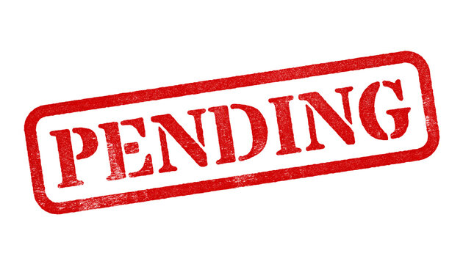

Checklist: Topic
Type | Seq | X▬ | Details | Image (paste image and then resize image to be 3.5” wide or less)
Notes | n/a
Warnings | n/a
Actions / Steps | 010 |  | - Topic  - subtopic | 
 | 020 |  | - Topic  - subtopic | 
 | 030 |  | - Topic  - subtopic | 
 | 040 |  | - Topic  - subtopic | 
 | 050 |  | - Topic  - subtopic | 

End

