## **Personal Portfolio Website Planning Document**

|  |  |  |
| --- | --- | --- |
| **Checklist for Planning a Website** | |  |
| Topic | Web Developer Questions | Answers (Give brief but thoughtful and realistic answers with the cooperation of all team members. No, the website will not be *real* but it does need to be *realistic.*) |
| Purpose of the Website | What is the purpose and goal of the website? | The purpose of the website is to showcase my work and skills. The home page should explain who I am and what I do. I would also like to provide my educational background, interests, online resume, and room to add links to my personal projects as I complete them. |
|  | What is the company’s mission statement? | My personal mission is to live with integrity and positivity while using every experience as an opportunity for improvement and growth. |
| Target Audience | Describe the target audience (age, gender, demographics) | Potential employers (both male and female) in any branch of computer science. I want to show a combination of technical knowledge and creativity so I can leave the door open for new, interesting opportunities. |
|  | What information is most pertinent to the users? | My personal projects and academic profile, as well as my job experience. |
| Multiplatform Display | Will you design for multiple platform display or only focus on a desktop or mobile design? | I will attempt to research how to make a design adaptable from the start, so that I can focus on a desktop design that will transfer well to mobile devices and not have to worry about changing it too much later. |
| Wireframe | How many pages will be included in the website? | 3 pages I am considering having 4 pages now |
|  | How will the pages be organized? | The menu on the home page (which should include a downloadable resume) has links to separate pages for education, projects, honors and perhaps a “Contact Me” page (provided that the textbook explains how to set that up). |
|  | What type of website structure is appropriate for the content? | I think a webbed website structure would be appropriate for the content, since webpage visitors will be able to go directly from the home page to any of the other pages and vice versa. |
| Graphics | What graphics will you use on the website? | A professional photo on the main page, and images that convey my teaching philosophy of combining creativity with logic to foster growth. |
| Color | What colors will you use within the site to enhance the purpose and brand? | My plan is to create a lot of contrast, perhaps utilizing white text on a very dark background for the about page to make it look more professional. I would like to use a neutral beige color for the background on the project page so it conveys a friendly, fresh feeling, and the same color when hovering over links. I am planning on using maroon for the honors page and brown for the teaching philosophy page to convey dependability. |
| Typography | What font styles will you use within the website? | I plan on using the font family: futura-pt for menu, FortescueRegular for headings, and adobe-garamond pro for the paragraph text. I feel that this font combination will add a professional, polished look to the portfolio, as well as aid in the simple yet elegant design I’m trying to achieve. |
| Accessibility | How will the website accommodate people with disabilities? | I will make sure to provide simple, concise descriptions for all images I add to my website. I will also make clickable links as clear and obvious as I can to make them easy to find and access. |

Sketch the wireframe for the home page below:

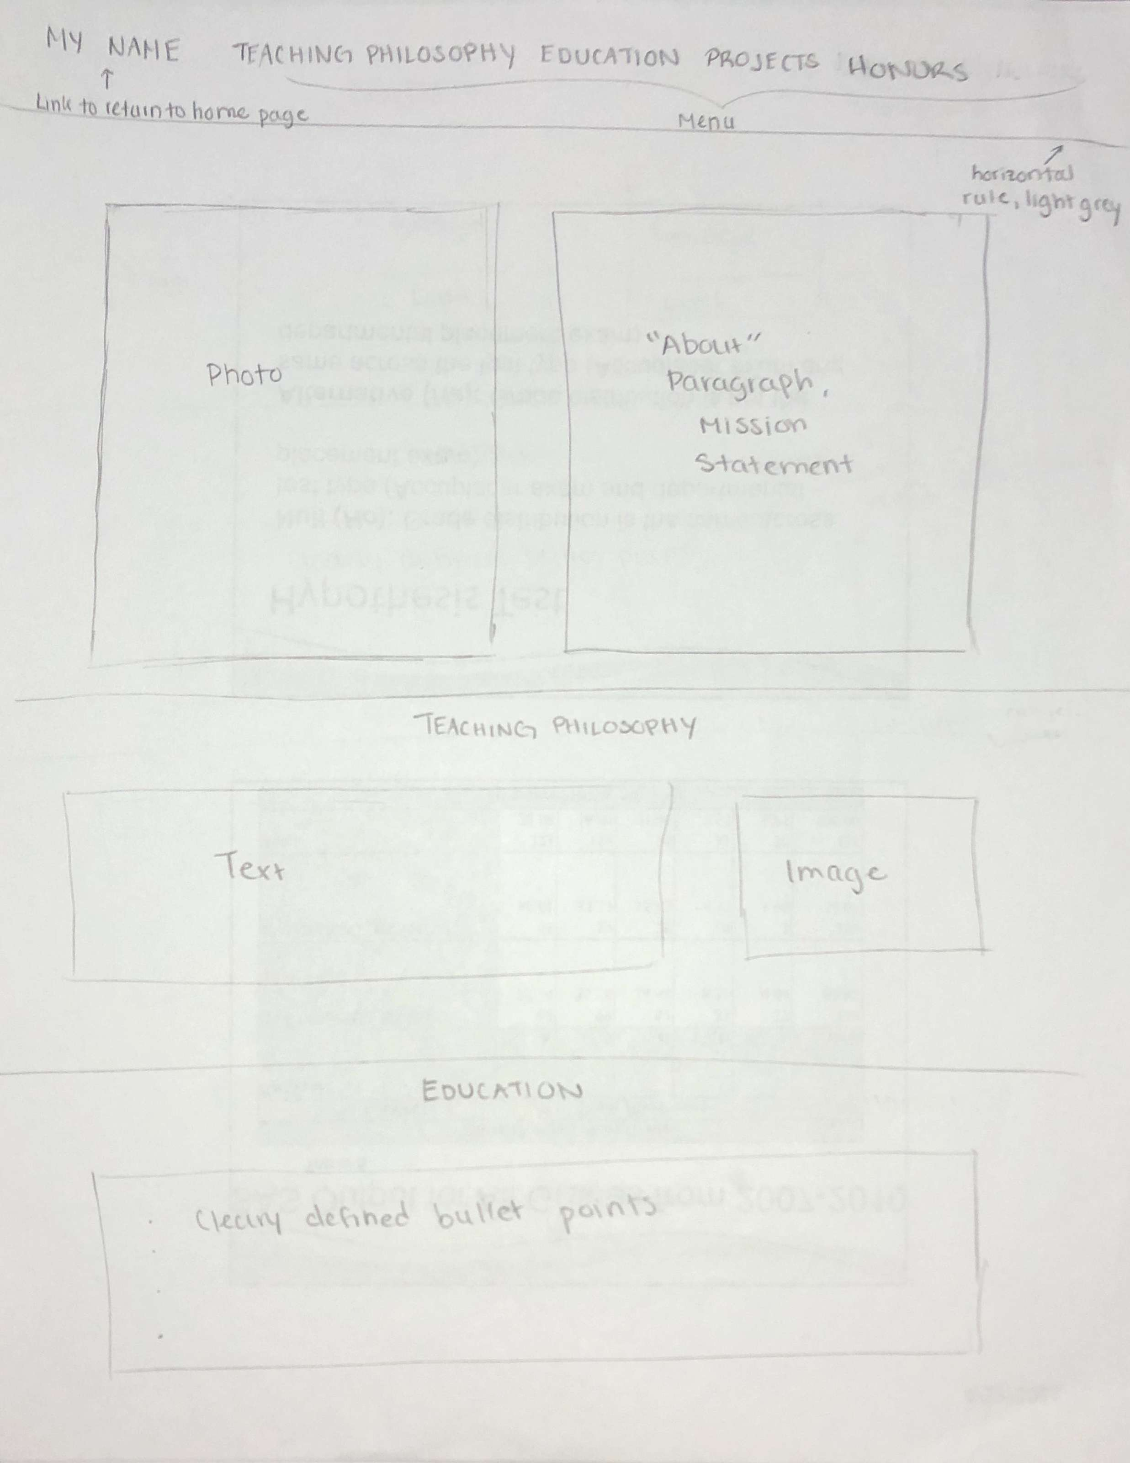

I’ve decided to change this section to Strengths, Technologies & Other for now

What do you want this website to accomplish?

The purpose of the website is to showcase my work and skills. The home page should explain who I am and what I do. I would also like to provide my educational background, interests, online resume, and room to add links to my personal projects as I complete them to make it easier for employers to see if I am a good fit for the jobs they have available.

What new ideas did you find that you want to incorporate into your own personal electronic portfolio?

* Something that has worried me about the “Projects” section of an electronic portfolio is not having anything I have done for a company listed. But I found an article (<https://www.themuse.com/advice/4-secrets-to-building-a-portfolio-thatll-make-everyone-want-to-hire-you)> that helped me realize that it’s ok to include projects created for classwork or even to create mock samples of work (in my case, I might add a couple of lesson plans, even if I haven’t had the chance to use them yet).
* This site (<https://learntocodewith.me/posts/portfolio-tips/)> suggested including a downloadable resume on electronic portfolios. I thought this was a great idea, since it makes it easier for potential employers to print it out if they want to. I plan on incorporating a downloadable resume into my website.
* Researching online, I found that a good principle to follow when designing any website is to not make the user have to think about using it. Navigating through the site should be straightforward enough that they only have to focus on content. This site (<https://onextrapixel.com/60-clean-and-simple-examples-of-portfolio-design/)> proved to me that simple is better, and I plan on incorporating this simplistic, yet effective design into my electronic portfolio.

Screenshot of webpage validation check:

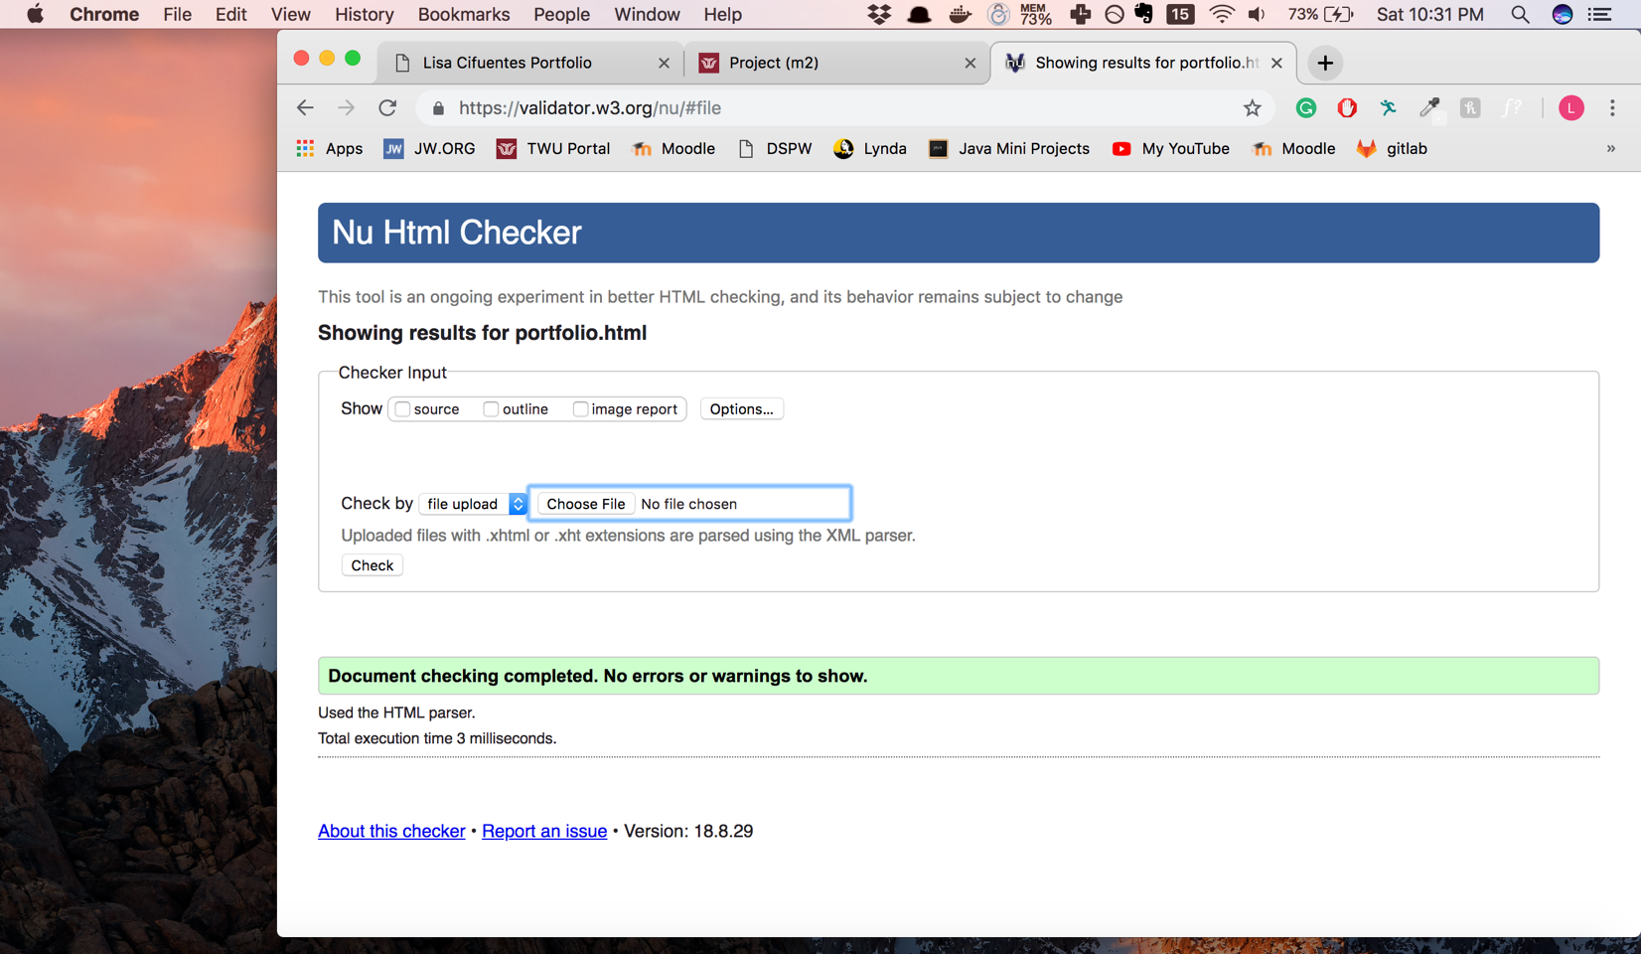

**Search Engine Optimization**

* This webpage (<https://www.rankpay.com/seo-tips-and-tricks/)> made me realize the importance of finding the right keywords to use multiple times throughout my pages to help SEO performance.
* I did not know that Google offered a free service to track SEO, but this webpage (<https://neilpatel.com/blog/google-analytics-strategies-to-measure-seo/)> taught me some tips on how to use it that I plan on applying after I publish my website, such as the how to use the timeline view, most successful key words, and page-load times.
* Lastly, I plan on adding internal links to other pages on my domain. This website (<https://www.creativebloq.com/self-promotion/essential-seo-tips-beginners-101517295)> explained that linking not only helps visitors stay onsite, but also helps search engines better rank website pages in its listings. This gives me good reason to using linking as a key part of my SEO strategy.