Documentation for Flight Search

This is a short documentation on how to install the database using Code First and how to generate the test data

# Installing the Database

1. Open Visual Studio and go to the web.config located under FlightSearch.Web. Change the connection string to where you want the database to install, but don’t change database name.
2. In the Visual Studio IDE, go to View > Other Windows > Package Manager Console

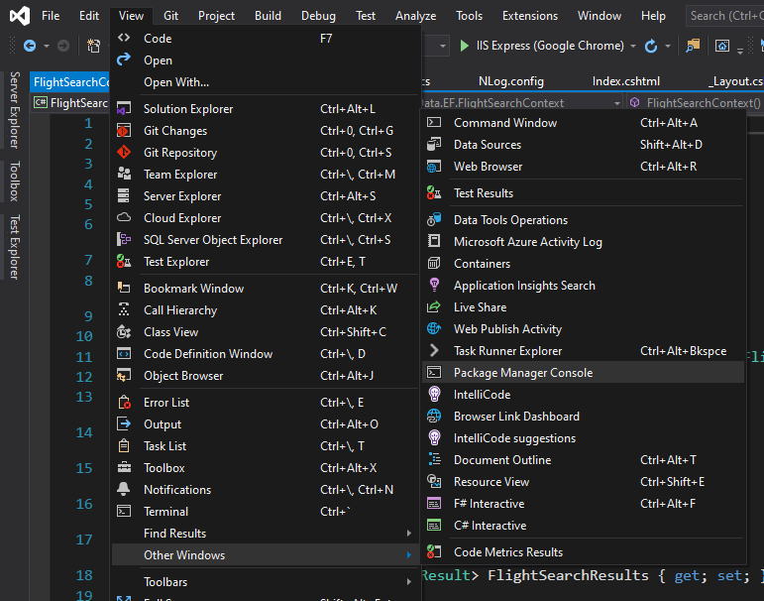

1. Set the default project to FlightSearch.Data. And in the console itself, type update-database -verbose then press Enter.

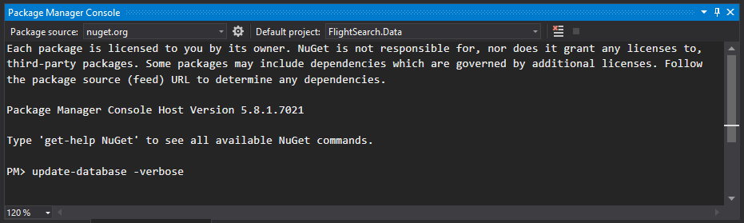

1. Once it is done, the database will be created along with the tables and the stored procedures in it.

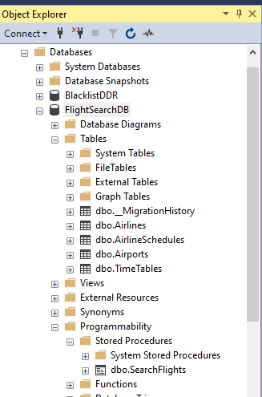

# Generate Test Data

1. Upon running of the application, click the Load Data link

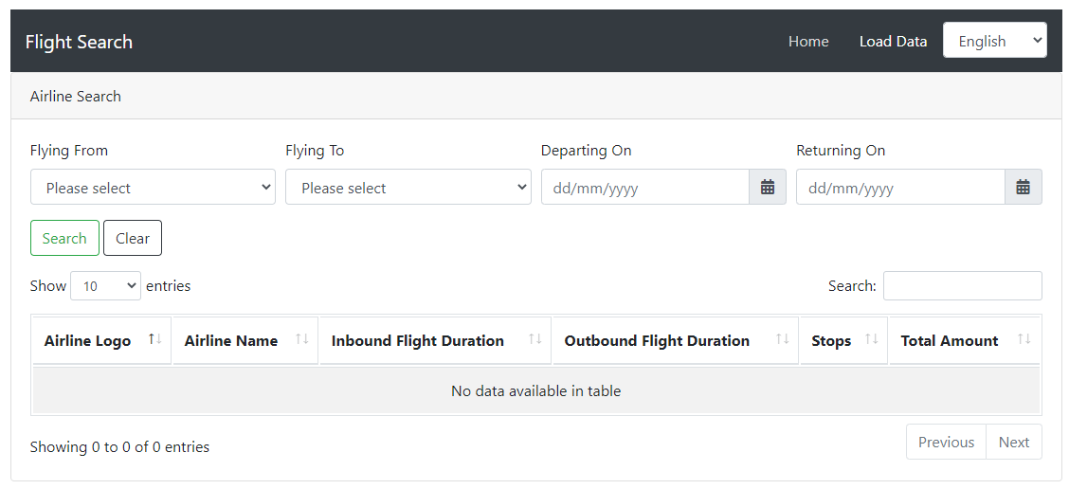

1. Enter the start date, end date and airline. Click Process Dates. It will generate the test data to be used for the Flight Search. Repeat for other airlines or dates if needed.

