

**DEDAN KIMATHI UNIVERSITY OF TECHNOLOGY**

**SCHOOL OF COMPUTER SCIENCE AND IT**

**UNIT: DISTRIBUTED SYSTEMS**

**LECTURER: SAMMY KAMUNDI**

**Group Members**

**Group 3**

|  |  |
| --- | --- |
| **NAME** | **REG NUMBER** |
| **JOHN KARANU KIMANI** | **C026-01-1290/2019** |
| **BRIAN MUSILI** | **C026-01-1304/2019** |
| **DENNIS GICHANA** | **C026-01-1884/2019** |
| **SAMUEL KUNG'U** | **C026-01-2222/2019** |

Our middleware project was designing a software that sends information to the server side where the data is stored in database in this mysql and then through the middleware data from server is displayed in client side.

Our application is web based where we used javascript and its framework. The front end or the client side we used REACT JS which is a framework of javascript and in the server side we used NODE JS.

In NODE JS is where we find the middleware we used which is BODY-PARSER which is module in NODE JS which connects the server side and the client side.

Below are the screenshot of the application in both server and client side:

**THE CLIENT SIDE**

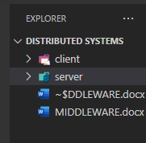

From the vs code the software is under two folders: client and server:

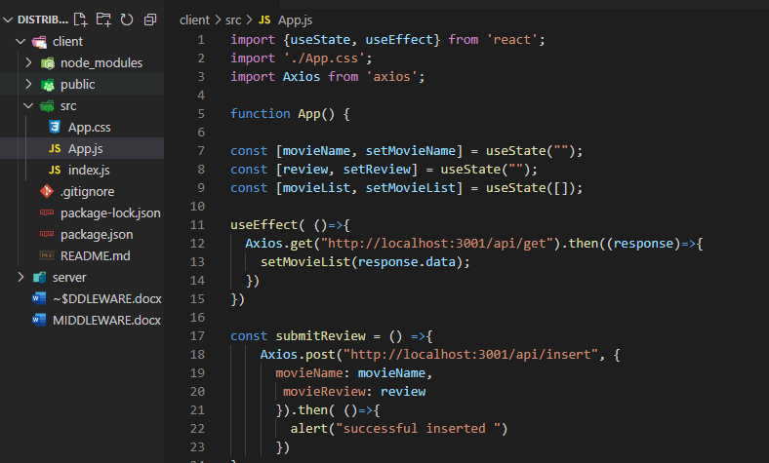

In the client side it contains three files:

App.js – where the content of the front end is contained.

Index.js – where the react work is rendered in the page.

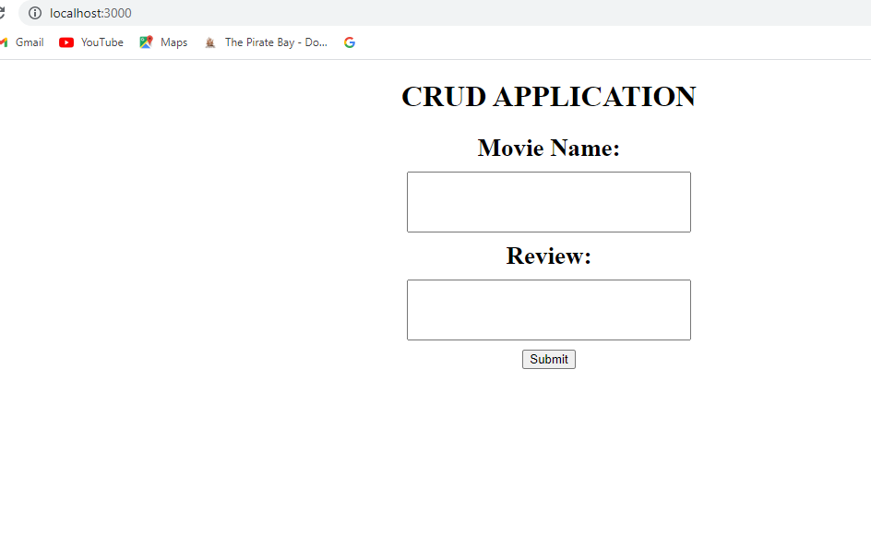

On running the client side, this what the software is intended to accept the data from user on about movies. On submitting, the data in send in the database.

In order to display the data from database is through getting it in the server side and connecting them with a middleware.

**THE SEVER AND MIDDLEWARE SIDE.**

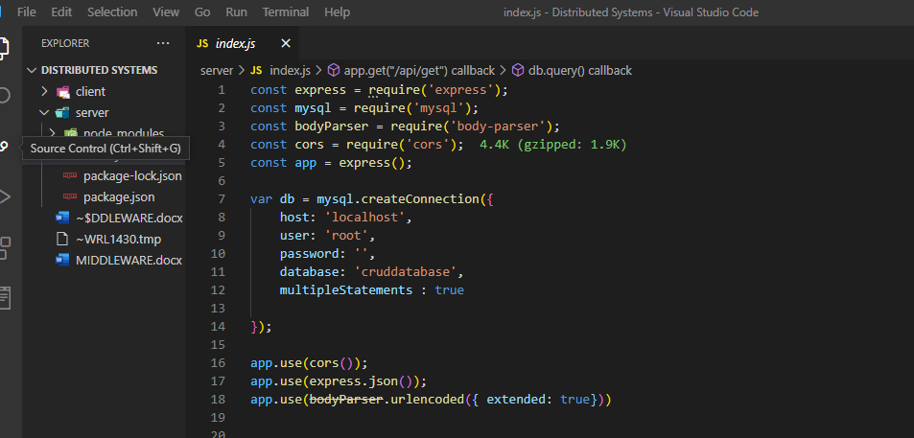

The server side in NODE JS contain one file which is:

Index.js – In this file in the first part we require the modules which will be used.

In the second part is connecting it with mysql database which is storing the information from the client side. On running the server side, the information will be send to web through the use of middleware.

**THE MIDDLEWARE**

After connecting it with the database, the third part is where we find the middleware.

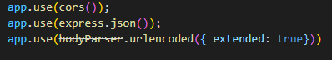

So the data is stored in json format using the express.json is converting it into objects. The bodyParser is the middleware we used which is connecting both client and server side.

**THE FINAL SOFTWARE**

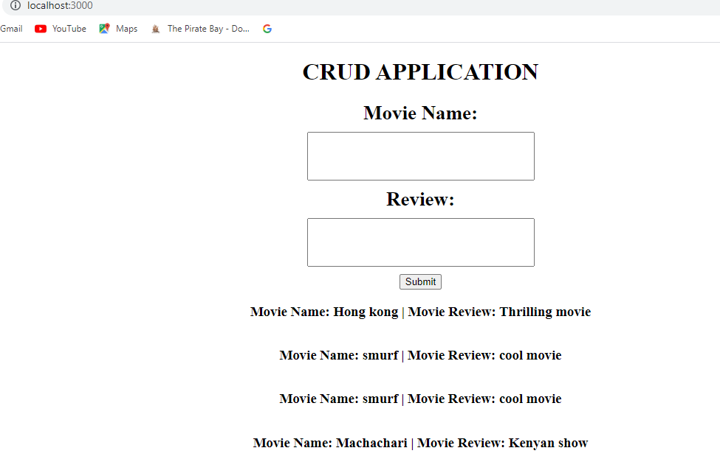

On running the server, the data is got from the database then send to the web through middleware which is BODY – PARSER.