**Quiz App User Guide**

**Table of Contents**

1. Introduction

2. Installation from Executable

- Download the Installer

- Run the Installer

- Follow the Installation Wizard

- Select Installation Location

- Create Desktop Shortcut

- Install the App

- Complete Installation

3. Getting Started

- Launch the Quiz App

- Explore User Roles

- Enjoy Learning

4. User Roles

- Teacher Interface

- Biometric Authentication

- Managing Subjects

- Log in

- Adding Subjects

- Adding Questions

- Student Interface

- Select a Subject

- Taking a Quiz

- Viewing Performance

- Querying Best Students

5. Troubleshooting

- System Requirements

- Contact Support

6. Feedback and Support

**Introduction**

Welcome to the Quiz App! This comprehensive user guide aims to provide detailed instructions on installing, navigating, and utilizing the features of the application. Whether you're a teacher managing subjects or a student eager to take quizzes, this guide will ensure a smooth and enriching experience.

Installation from Executable (exe)

1. Download the Installer:

- Navigate to the provided link or location for the Quiz App installation package.

- Download the executable file (exe) to your computer.

2. Run the Installer:

- Locate the downloaded exe file on your computer.

- Double-click on the file to initiate the Quiz App installation wizard.

3. Follow the Installation Wizard:

- The installation wizard will appear, guiding you through the setup process step by step.

- Click "Next" at each step to proceed.

4. Select Installation Location(optional):

- Choose the directory where you want to install the Quiz App on your computer, otherwise it will be installed on drive C by default which is also fine.

- Click "Next" to continue.

5. Create Desktop Shortcut:

- Opt to create a desktop shortcut for convenient access to the Quiz App. This will be created by default on your desktop immediately the installation wizard completes the process of creation.

- Click "Next" to proceed.

6. Install the App:

- Click "Install" to start the installation process.

- Wait for the installer to copy files and set up the application.

7. Complete Installation:

- Once the installation is complete, click "Finish" to exit the installer.

- The Quiz App is now installed on your computer.

Getting Started

1. Launch the Quiz App:

- Locate the Quiz App icon on your desktop or in the installation directory.

- Double-click on the icon to launch the application.

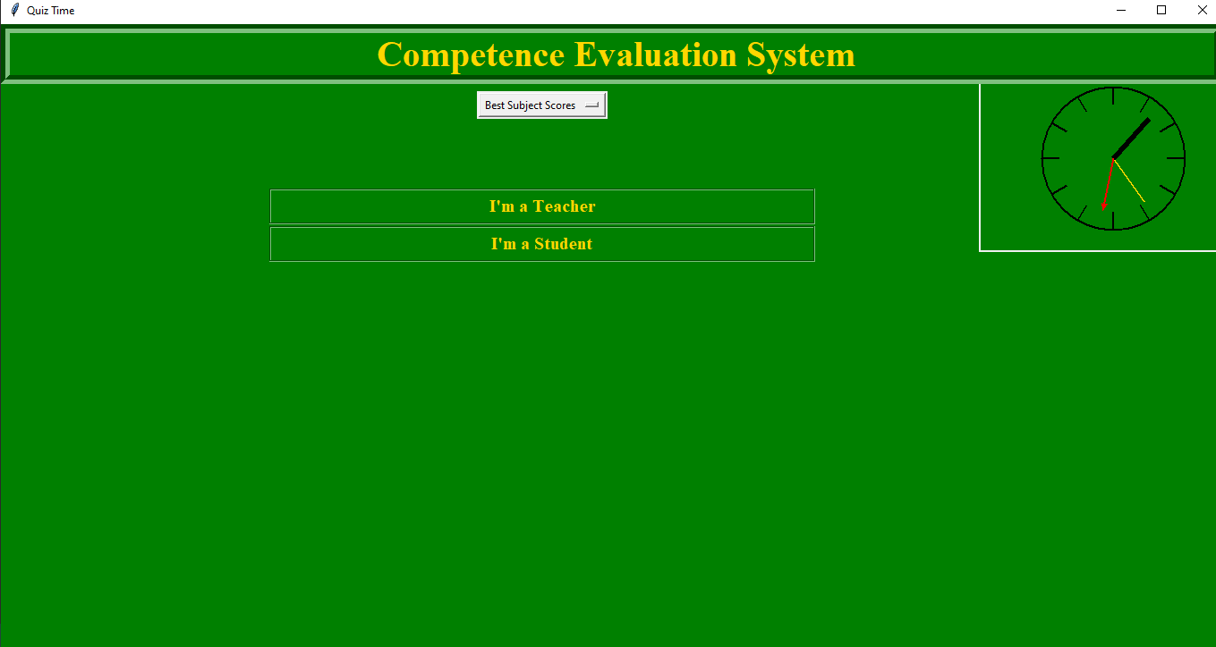

2. Explore User Roles:

- Depending on your role (teacher or student), follow the respective steps in the user guide sections:

- Teacher Interface(teacher-interface)

- Student Interface(student-interface)

3. Enjoy Learning:

- Start managing subjects, taking quizzes, and exploring the features of the Quiz App.

User Roles

Teacher Interface

Biometric Authentication

1. Access Teacher Interface:

- Click on "Teacher Interface" to access teacher-specific features.

2. Biometric Authentication:

- Follow the prompts for biometric authentication(This function is restricted to computers with inbuilt cameras).

- Ensure your face is well-recognized(enrolled) by the system to access teacher functions securely.

Managing Subjects

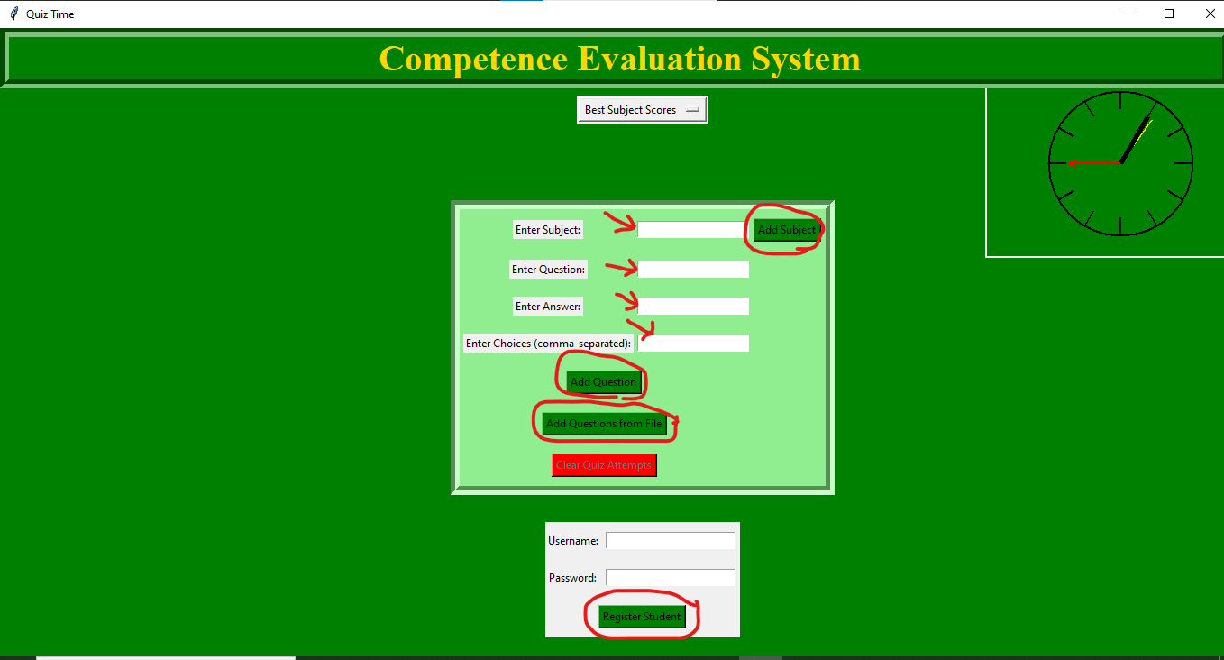

1. Log in:

- Use your provided credentials or biometric authentication to log in.

2. Adding Subjects:

- Click "Add Subject."

- Enter the subject name and click "Add Subject" to save.

3. Adding Questions:

- Enter subject details along with the question, answer, and choices.

- Click "Add Question" to save quiz questions.

In addition, you can delete quiz attempts which will delete every attempt thus removing all marks from the system. This is aimed at encouraging students to continuously make attempts. This can be periodical.

Student Interface

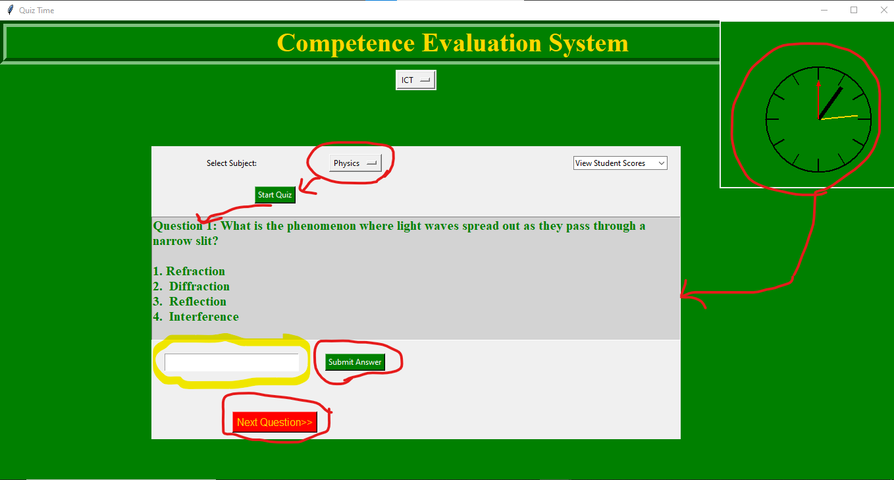

1. Select a Subject:

- Choose a subject from the dropdown menu to focus your quiz experience.

2. Taking a Quiz:

- Click "Start Quiz" to initiate the quiz session the clock immediately starts counting to the end of the time. When the student takes more than the time schedule, the system grades him/her with the appropriate mark and advises him accordingly!

-The clock on the top right hand side is working appropriately as all wall clocks do to enable the student keep watching the time as he does the exam.

- Answer questions presented and submit responses.

- View your results upon completing the quiz.

3. Viewing Performance:

- For Students: Instantly view your quiz results post-completion.

- For Teachers and students: Explore the option to query best students based on subjects. For the student side, its aimed at encouraging competitiveness by viewing each other’s marks in different exam attempts.

4. Querying Best Students:

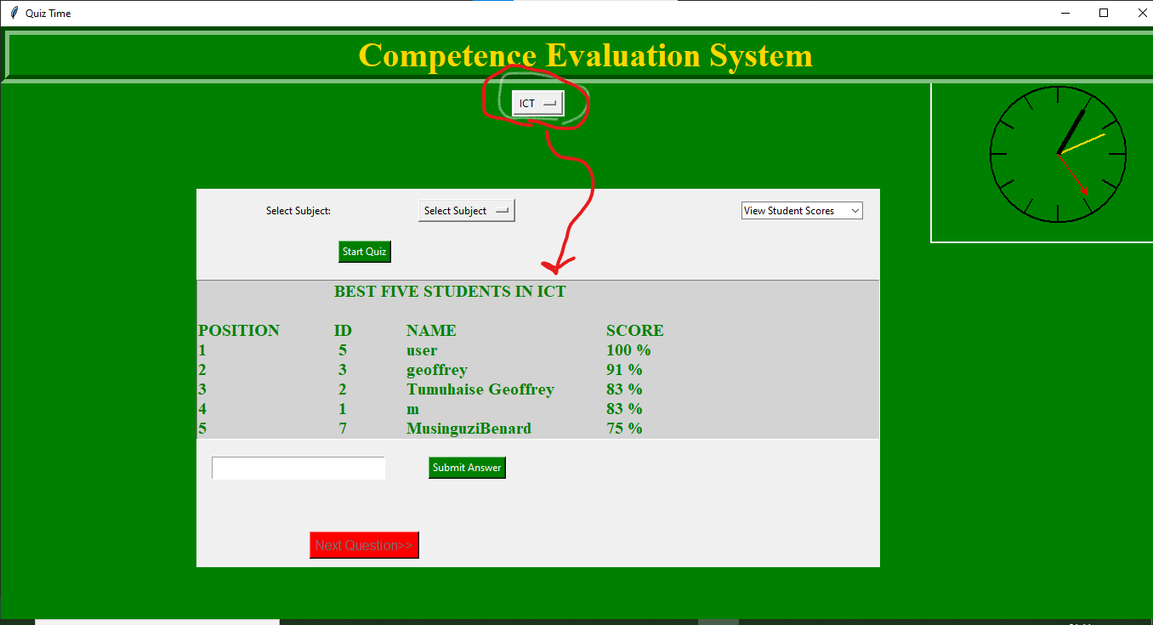

- For Teachers and students

- Click "Query Best Students."

- Explore the list of top-performing five students based on subject-wise performance. This enables students to aim higher to be in the best five students.

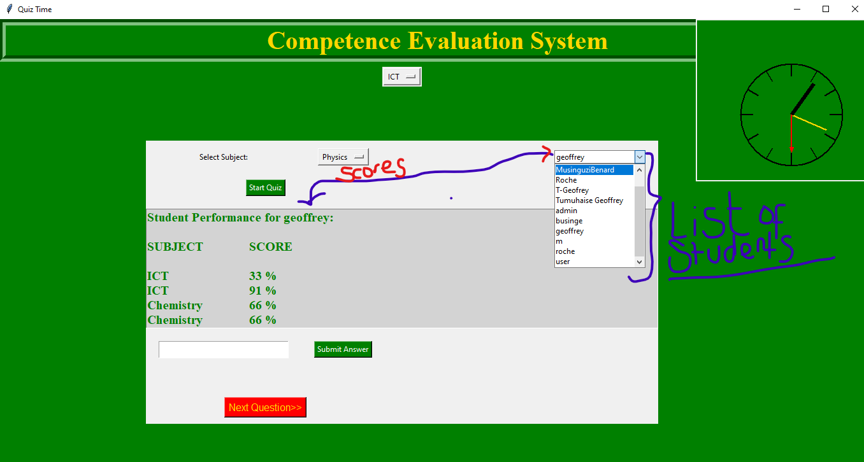

**Troubleshooting**

If you encounter issues while using the Quiz App, consider the following steps:

- System Requirements:

- Ensure your computer meets the specified system requirements for the Quiz App. Its mainly developed following the standards of Microsoft windows operating system.

- Ensure you have a disk space of about 100 MBs to install.

- Internet Connection:

- Typically offline. For this version, no need for internet connection

- Contact Support:

- If issues persist, contact the support team for assistance. Provide relevant details about the problem for a more effective resolution.

Feedback and Support

We value your feedback! For assistance or to share your thoughts on the Quiz App, please reach out to our support team:

- Support Email: rochecodecamp@gmail.com

- Support Hotline: +256 (763) 313-707

Our dedicated team is here to help you make the most of your Quiz App experience.

***Enjoy your journey of learning and exploration with the Quiz App!***