ASSIGENMENT-2
NAME: MUSKAN KUMARI(2501010265)
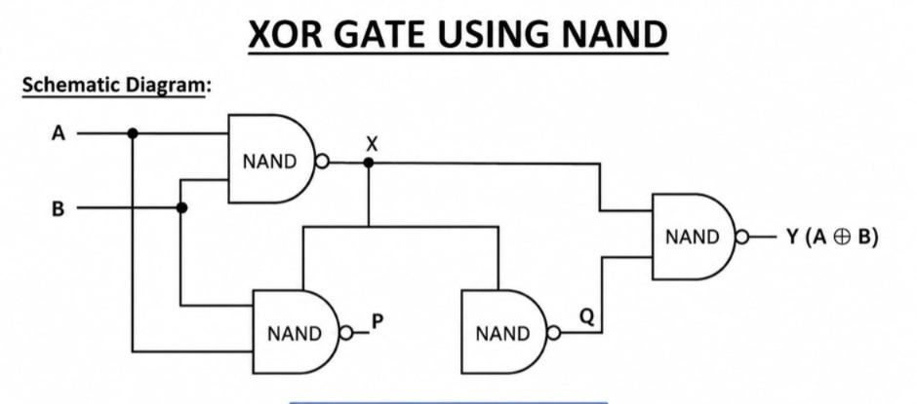
BOOLEAN EXPRESSION: Y’ = (AB’+A’B’)’
Y = Y’’ = ((AB’)’.(A’B)’)’
CODE: CHIP XOR {
IN a, b;
OUT out;
PARTS:
Nand(a=a, b=a, out=x);
Nand(a=b, b=b, out=y);
Nand(a=a, b=y, out=z);
Nand(a=b, b=x, out=z1);
Nand(a=z, b=z1, out=out);
}
TRUTH TABLE:
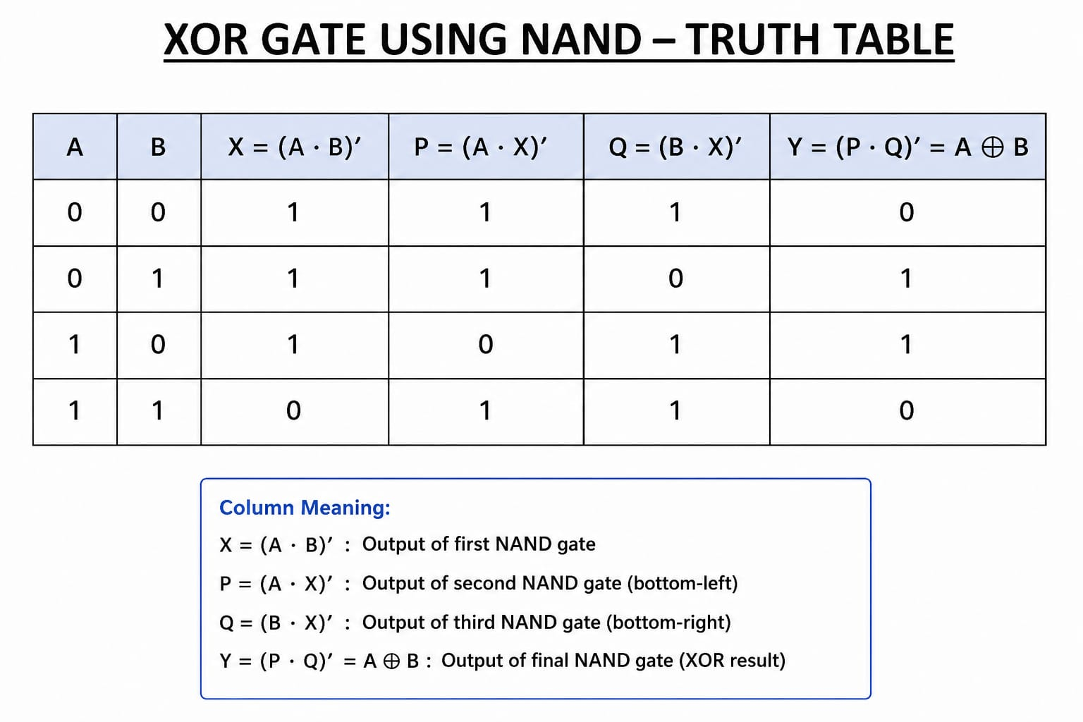
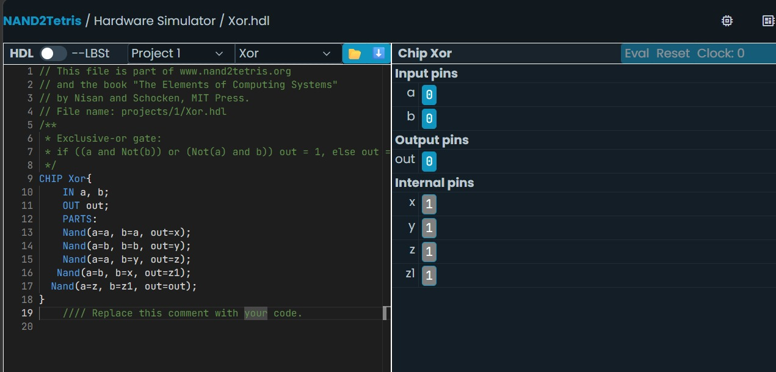
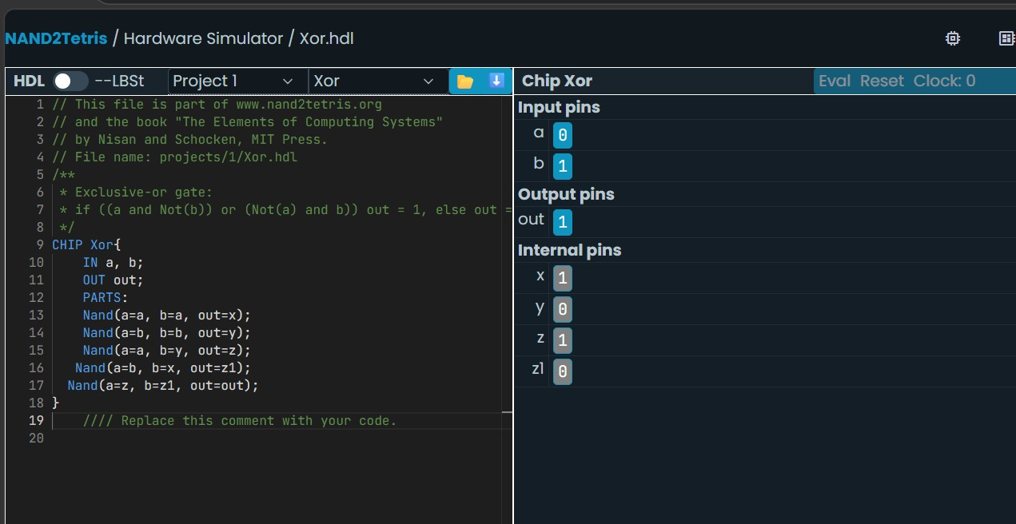
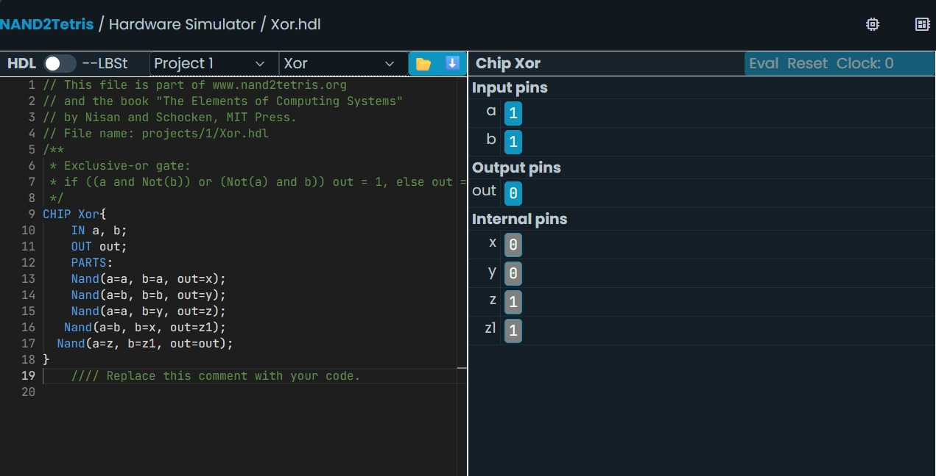


MULTIPLEXER(2-WAY MUX) USING NAND GATES
DIAGRAM:
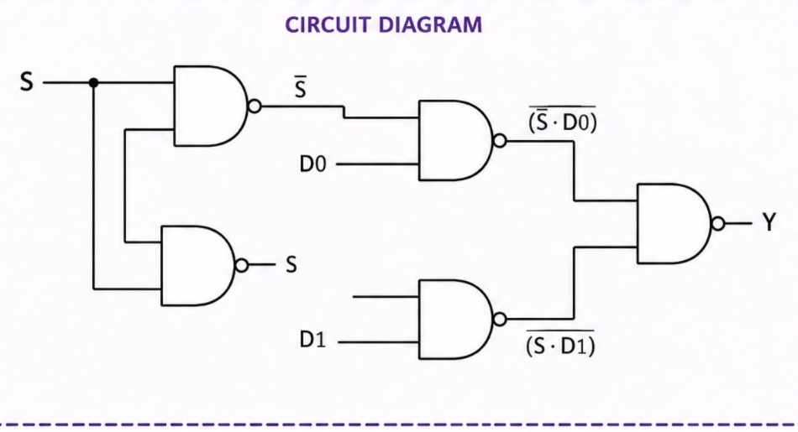
CODE: CHIP Mux16 {
IN a[2], b[2], sel;
OUT out[2];

PARTS:
Not(in=sel , out=nsel);
And(a=a[0], b=nsel, out=x);
And(a=a[1], b=nsel, out=x1);

And(a=b[0], b=sel, out=y);
And(a=b[1], b=sel , out=y1);

Or(a=x, b=y , out=out[0]);
Or(a=x1 , b=y1 , out=out[1]);
}
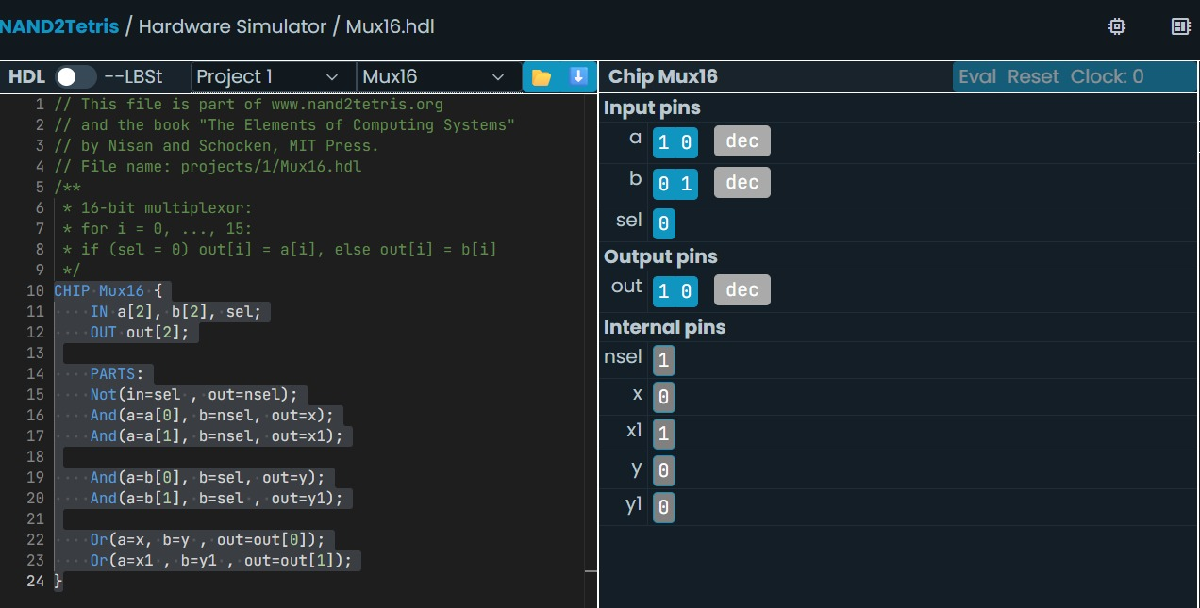
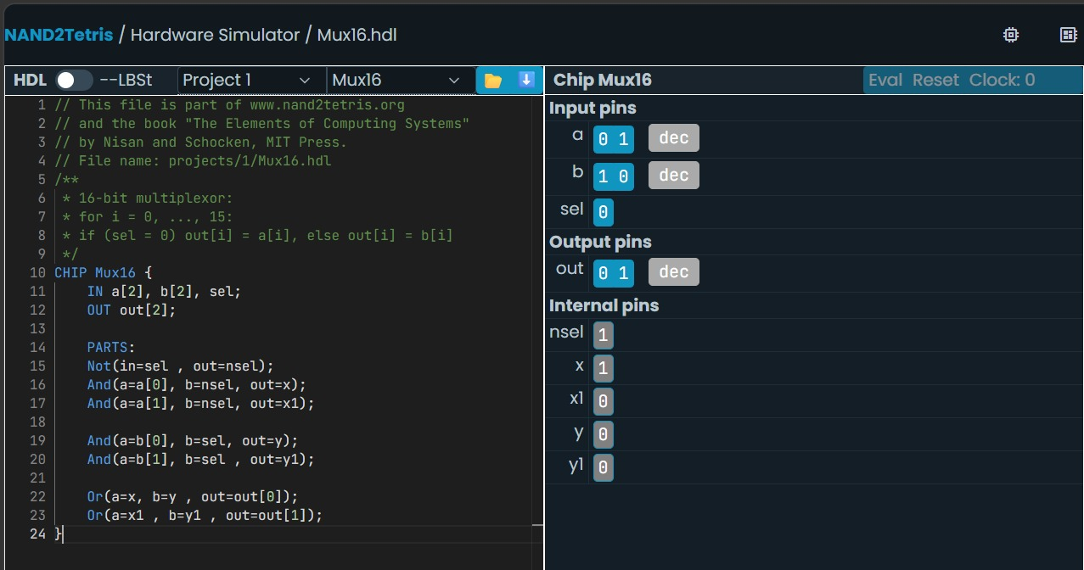
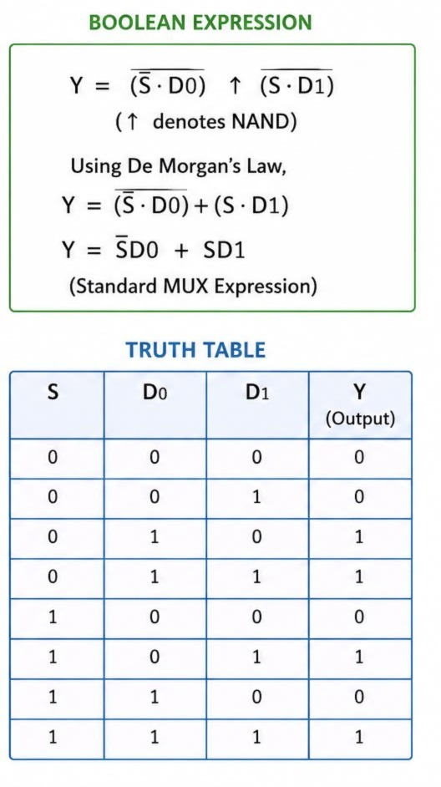
MULTIPLEXER(4-WAY MUX) USING NAND GATES:
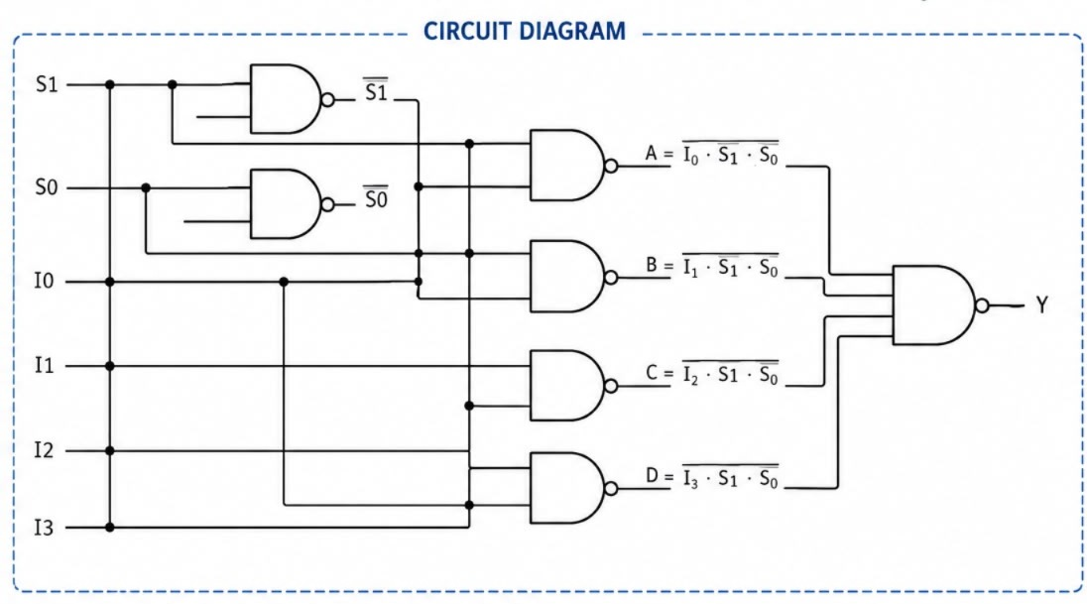
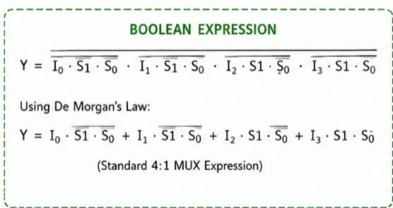
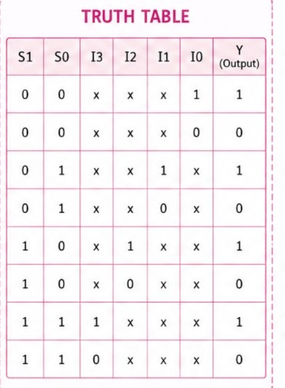
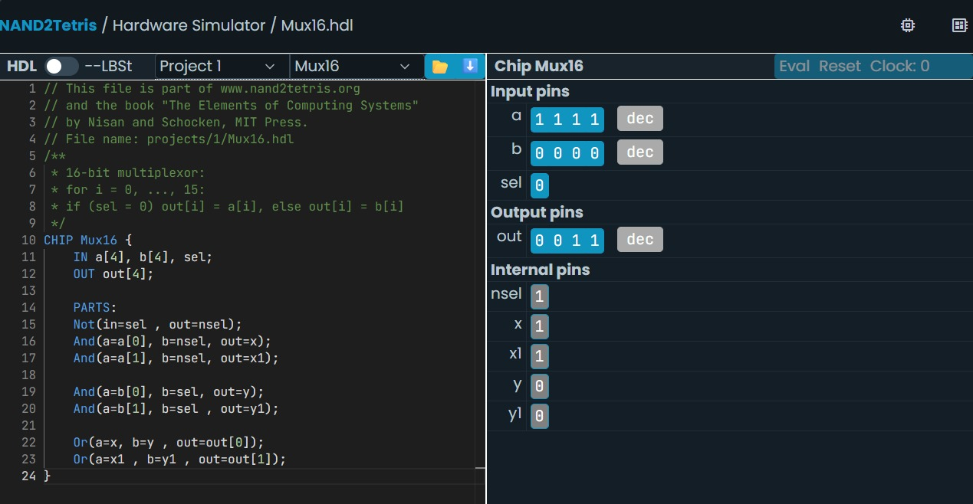
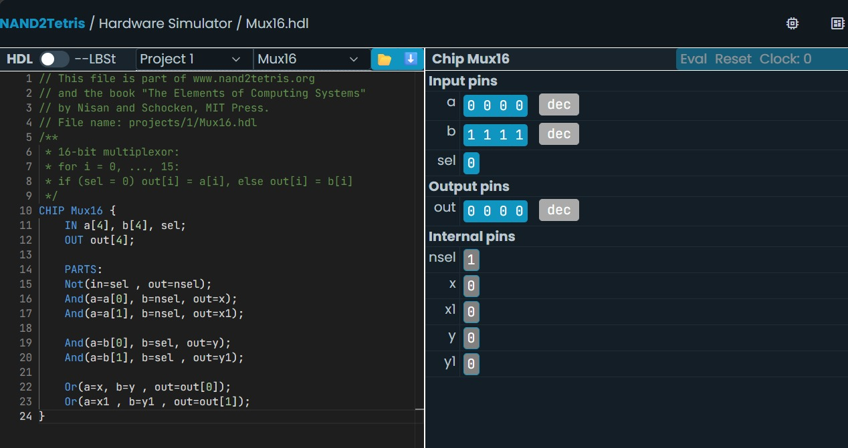
CODE: CHIP Mux16 {
IN a[4], b[4], sel;
OUT out[4];

PARTS:
Not(in=sel , out=nsel);
And(a=a[0], b=nsel, out=x);
And(a=a[1], b=nsel, out=x1);
}

DEMUX USING NAND GATES:
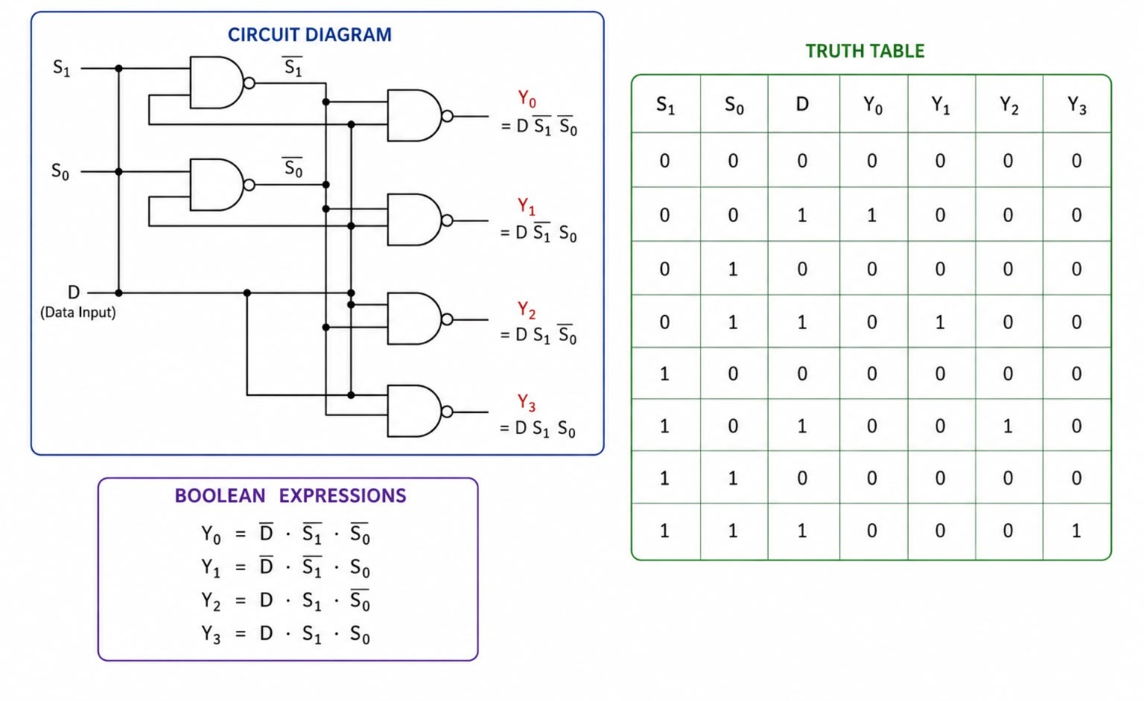
CODE:
CHIP DMux {
IN in, sel;
OUT a, b;

PARTS:
Nand(a=sel, b=sel, out=notSel);
Nand(a=in, b=notSel, out=x);
Nand(a=x, b=x, out=a);
Nand(a=in, b=sel, out=y);
Nand(a=y, b=y, out=b);
}
