Zepto Sales & Customer Analytics Dashboard
Dashboard Preview
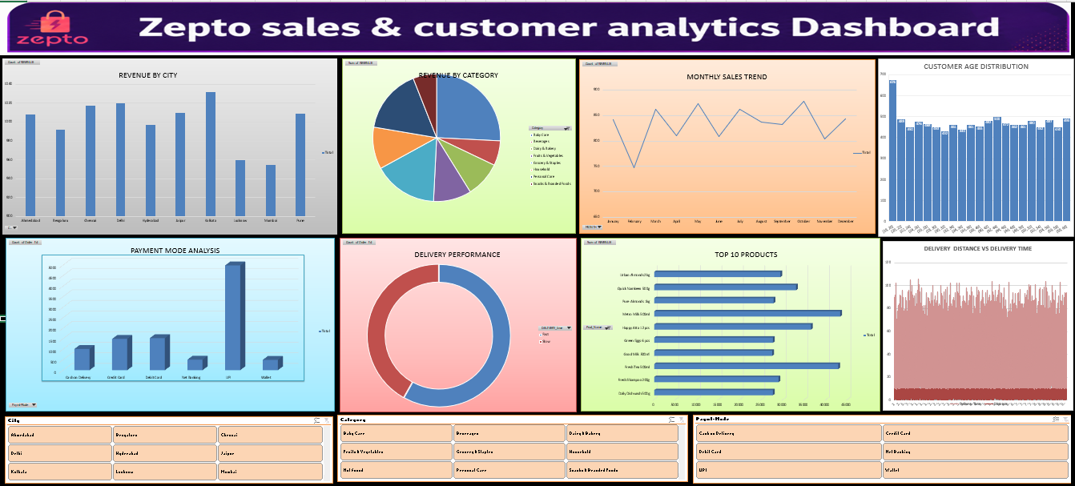

Project Overview
This Project Analysis Zepto-Style Grocery Delivery Data Using Microsoft Excel. The Dashboard Provides Insights Into Sales Performance, Customer Behaviour, Product Performance, Customer Satisfaction, And Delivery Efficiency.

Dataset Information
The Dataset Consists Of Six Business Tables:
- Customer
- Product
- Orders
- Transactions
- Ratings
- Delivery
These Tables Were Combined Into A Master Dataset Using Excel Functions And Data Modelling Techniques.

Key Performance Indicators (Kpis)
- Total Revenue: ₹874,090
- Total Orders: 10,000
- Average Rating: 3.88/ 5
- Average Delivery Time: 41.60Minutes

Dashboard Features
Sales Analysis
- Revenue By City
- Revenue By Category
- Monthly Revenue Trend
Customer Analysis
- Customer Age Distribution
- Rating Distribution
Operations Analysis
- Delivery Status Analysis
- Distance Vs Delivery Time
Product Analysis
- Top Products By Revenue

Tools & Techniques Used
- Microsoft Excel
- XLOOKUP
Data Cleaning
- Pivot Tables
- Pivot Charts
- KPI Cards
- Dashboard Design
- Data Visualization

Key Insights
- Identified The Highest Revenue-Generating Cities.
- Analysed Top-Performing Product Categories.
- Evaluated Customer Satisfaction Through Ratings.
- Studied Delivery Performance Using Delivery Time And Distance Metrics.
- Examined Customer Purchasing And Payment Behaviour.

Project Outcome
Successfully developed an interactive Excel dashboard using Zepto-style grocery delivery data. The dashboard transforms raw transactional data into meaningful business insights covering sales performance, customer analytics, product trends, customer satisfaction, and delivery operations.

Project Repository: GitHub
Dataset Size: 5000+ Records
Dashboard Type: Interactive Excel Dashboard

