CV Assignment - The Lazy Artist

Abstract
Image classification models tend to lean towards shortcut unimportant features like backgrounds or colors ignoring the important features such as edges or shape of the object in the image. Therefore, to test this hypothesis, a simple 3-layered CNN model was trained on ColourMNIST, a dataset designed to lure the model towards biasness. The model achieved 100% accuracy on Train and validation but considerably failed on test data with 8.3% accuracy proving the validity of the above hypothesis. Further, 2 different re-training strategies were applied (without changing the dataset) to force the model to important features after which the test accuracy improved to 30%. Additionally, after each training, the feature maps of the model were visualized to understand what shortcut features the model has learned. Finally, a Sparse Autoencoder was trained to decompose the intermediate hidden states of projection layer of the model, into an overcomplete representation to find neurons related to human-understandable features. These neurons were then perturbed to steer the model towards fairness.
Code available at: https://github.com/Muskaan06/The_Lazy_Artist

Related Works
Selvaraju et al. [1] introduced Grad-CAM, a method that uses the gradients flowing into the final convolutional layer to produce a localization map identifying the image regions important for a given prediction. Erhan et al. [2] proposed activation maximization as a technique for visualizing what individual neurons in deep networks respond to, by optimizing an input image to maximally activate a target unit. Nguyen et al. [3] provided a comprehensive survey of such feature visualization methods, categorizing activation maximization techniques and discussing their probabilistic interpretations. On the dataset biases, Geirhos et al. [4] demonstrated that ImageNet-trained CNNs are strongly biased towards texture over shape, contrasting sharply with human visual strategies, and showed that training on stylized images can shift this bias. The same group later formalized the broader problem as shortcut learning [5], arguing that many deep learning failures emerges from models relying on spurious correlations that hold during training but fail at test time. Ross et al. [6] proposed a gradient-based regularization approach, penalizing input gradients on regions known to be irrelevant, to train models that are "right for the right reasons," applied to datasets with spatially separable confounds like Decoy-MNIST.
While these works individually address either visualization, bias diagnosis, or debiasing, this assignment combines all of them into a single end-to-end pipeline on a custom dataset (ColoredMNIST) where the spurious feature (color) and the real feature (shape) spatially overlap on the digit itself. Unlike Geirhos et al. [4] where texture and shape occupy different frequency bands, and unlike Ross et al. [6] where the confound (corner patches) is spatially disjoint from the digit, our setting makes the two features inseparable at the pixel level. This makes gradient masking (Method 1, adapted from [6]) ineffective here since penalizing background gradients cannot address a shortcut that lives on the foreground. Method 2 (color deviation penalty) is a custom solution not directly drawn from any of the above papers. Additionally, the assignment goes beyond diagnosis and retraining by using a Sparse Autoencoder to decompose the model's internal representations into interpretable features and validating them through activation patching, connecting the interpretability tools from [1–3] with the mechanistic interpretability direction not covered by these papers.

Tasks

Task 0 - The Biased Canvas (creation of ColourMNIST)
To test the model on biases, the digits MNIST dataset was customized in a way to give the model an easy way to learn data. The following setting was used to create the train test split:
- The ‘Easy’ train set: where every digit was represented by a specific colour with all having the same black background. Following is the digit-colour mapping used:
0: Orange, 1: Red, 2: Blue, 3: Green, 4: Yellow, 5: Purple, 6: Cyan, 7: Hot Pink, 8: Brown, 9: Turquoise
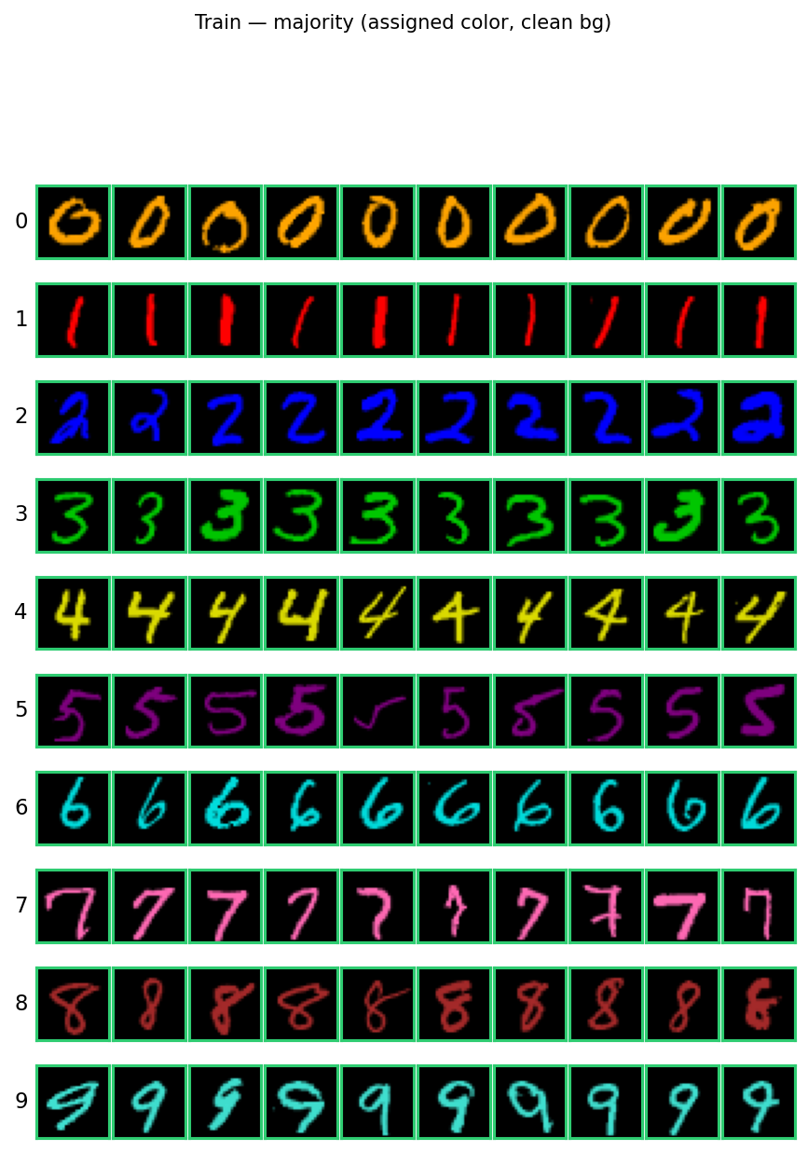

- The ‘Hard’ test set: The colour of each digit were never same as that of the train set with background being textured.

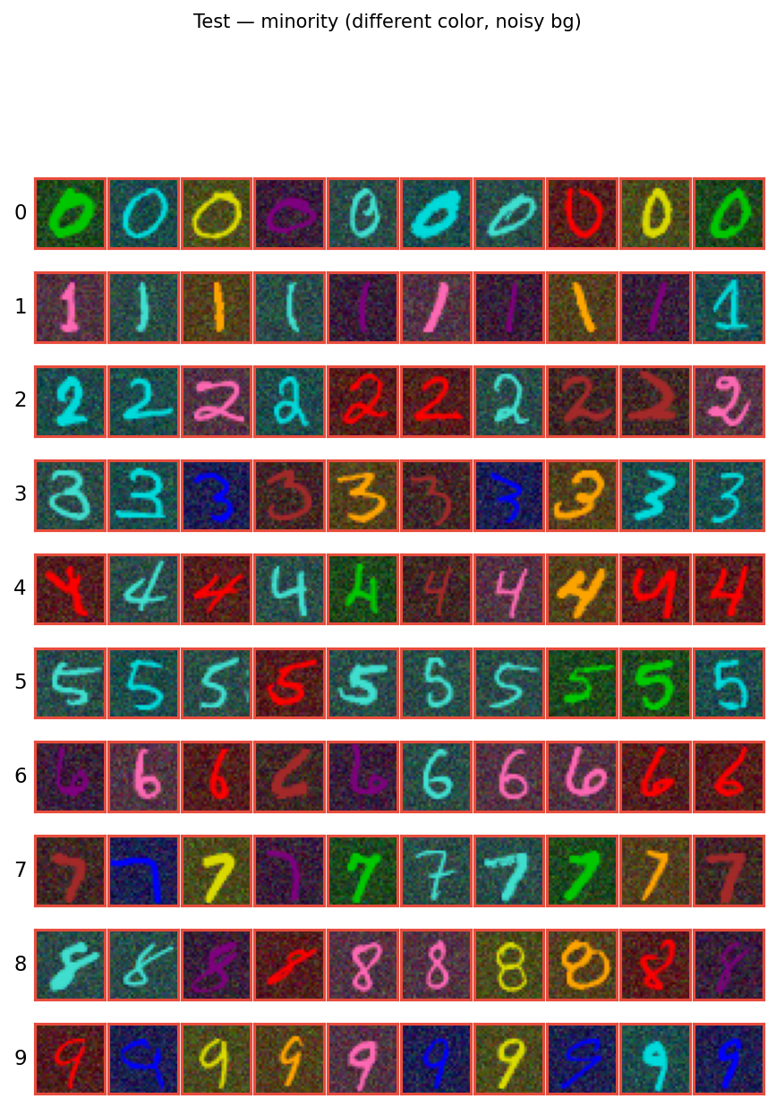

Task 1 - The Cheater (training the biased model)
A simple custom 3-layer CNN classifier was designed and trained on above created dataset. It takes 3-channel RGB images of size 28x28 as input and processes them through a series of convolutional layers. The encoder stage applies 16 filters with 3x3 kernels, maintaining the spatial dimensions of 28x28. The middle stage doubles the channel depth to 32 while halving the spatial dimensions to 14x14. The decoder stage reduces the channel depth back to 16, keeping the spatial dimensions at 14x14. Batch normalization and ReLU activations are applied after each convolutional layer to stabilize training and introduce non-linearity. The learned features from the decoder are then flattened into a 1D vector of size 3136. This flattened representation is passed through a small fully-connected classifier head, which first maps it to a 64-dimensional space and then to the final 10 output classes.

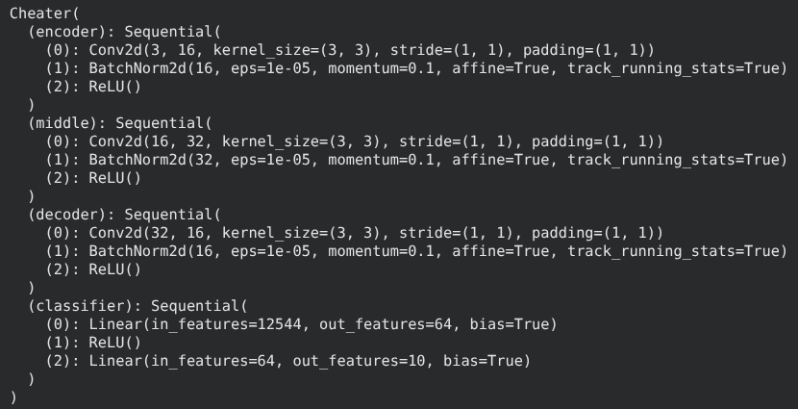

Experimental Setup
- Loss function: Cross-entropy loss (nn.CrossEntropyLoss())
- Optimizer: Adam optimizer (torch.optim.Adam) with a learning rate of 0.001
- Number of epochs: 20 (default)

Results
Split | Loss | Accuracy
Train | 0.00 | 100%
Validation | 0.0002 | 99.99%
Test | 47.35 | 3.27%

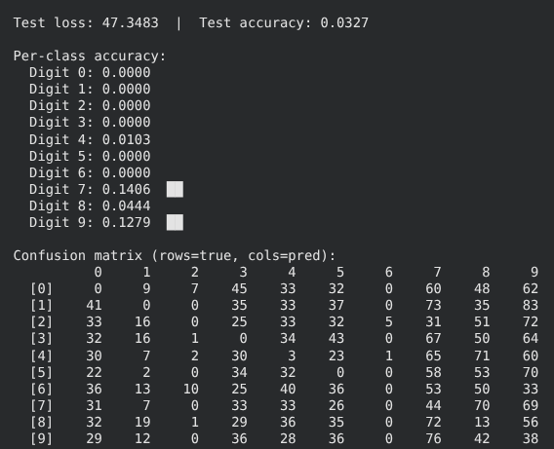

Observation
The model had learned the shortcut to predict classes through colours therefore, performing confidently in training data but poorly in train data where colours of the digits were changed. This proves the biasness of model towards a specific feature.

Task 2 - The Prober (analysing what neurons see)

What does neuron mean in a CNN?
Neurons have different meaning depending on the context in which it is being used. A neuron in feed forwards networks sees the entire previous layer features whereas a neuron in CNN only sees a small local region. Each activation in a feature map of a CNN is considered as a neuron. In above 3-layer CNN model the encoder has 16*28*28 neurons (corresponding to a single image).
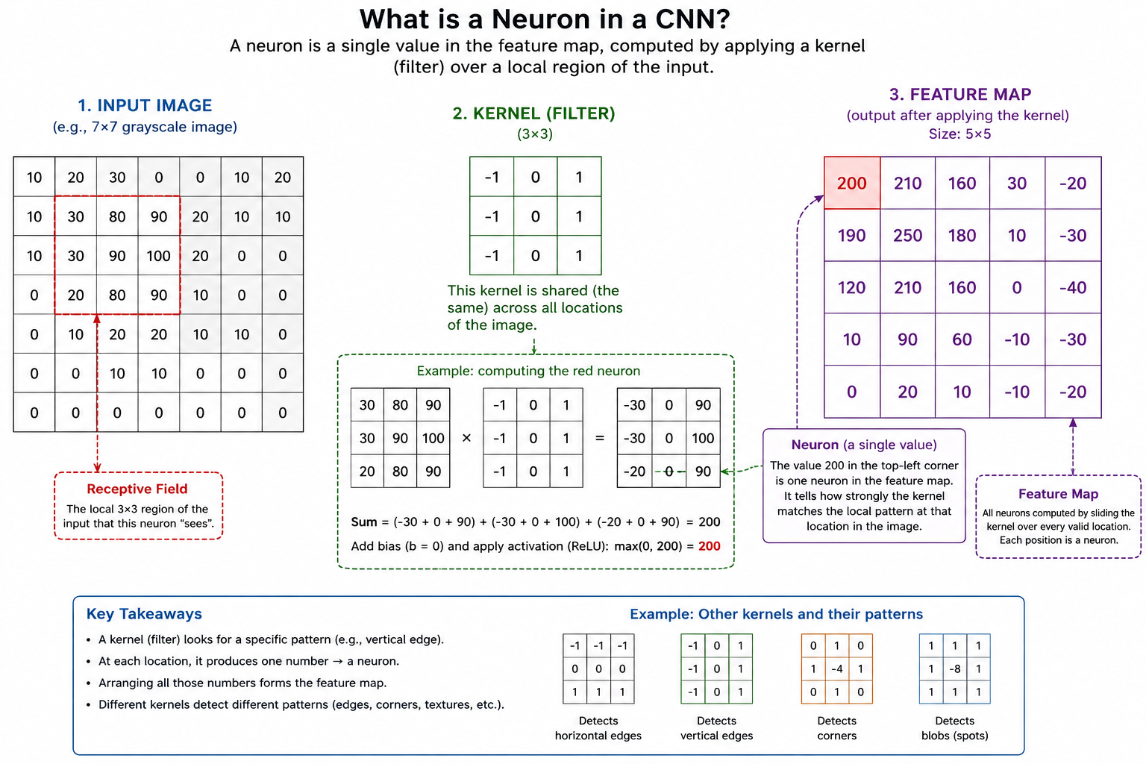

On visualizing all neurons of a feature map can tell us what that specific hidden channel in the model was paying attention to. The purpose of this task is to find out whether neurons of a feature map are receptive colour through a method named activation maximization.

Activation Maximization: This method is used to discover the input patterns like colors, edges, textures, shapes, object parts, that cause a neuron or feature map in a CNN to become highly active.
Step 1: constructing random image
Step 2: taking activation of target neuron after passing the random image on trained model
Step 3: compute gradient of this activation.The reason we add the gradient of the activation with respect to the input, is because this gradient tells us which direction in the input space will increase the neuron's activation the fastest.
Step 4: update random image
Step 5: repeat s3 and s4 for around 50000 times (this will start showing what that neuron was focusing on) So in case of color detection, one of the channels (RGB) will be highlighted and the reconstructed image will have that color as dominant.

Setups:
The feature maps of ____ layer of the model was chosen for this task as feature understanding mostly happens in that layer.
Case1: activation maximization without regularization (code written by me)
Case2: with regularization (fixes suggested by AI)

Observation:
Case 1:

Visuals are mostly noisy as it was performed without regularization.
Channel 0: Uniformly yellow. This channel appears to activate on a constant/background signal.
Channel 1: Mostly green with few yellow/cyan patches. Appears to activate mostly on green with occasionally on yellow and cyan.
Channel 2: Checkerboard-like pattern with strong primary colors (red, blue, yellow, green). A potential edge or texture detector.
Channel 3, 4, 9, 12, 15: Dense, noisy mix of many colors with no clear spatial structure. Could indicate a less interpretable channel.
Channel 5: Cyan/green dominant with a checkerboard-like pattern and scattered magenta/black spots. Likely detecting periodic color-contrast patterns, possibly edge or texture features in a specific color subspace.
Channel 6: Strongly dominated by blue with vertical pink/cyan bars. This channel probably responds to vertical edges likely in the blue color channel.
Channel 7: Horizontal banding pattern with alternating colored rows (black, pink, yellow). Detects horizontal stripe/edge features
Channel 8: Strong horizontal green/cyan/black stripes. Another horizontal edge/stripe detector, but in the green-cyan color space.
Channel 10: Noisy with prominent red/pink clusters. May respond to red regions or digit strokes in warm colors.
Channel 11: uniform cyan
Channel 13: Dominated by pink/red with horizontal stripe patterns. Detects horizontal features for a different color subspace.
Channel 14: Yellow-dominant with scattered colored patches in the upper portion. Seems to respond to partial spatial regions, possibly detecting features localized to the top of the image (like tops of digits).

Case 2:
Constant/uniform channels (0, 1, 6, 11, 14): These five channels show uniform solid colors (yellow, green, blue, cyan, yellow respectively).
Noisy channels with subtle structure (2, 3, 4, 5, 7, 8, 9, 10, 12, 13, 15): These all show scattered colored pixels. Still, the spatial features are barely visible.

Task 3 - The Interrogation (Mathematical proving of model’s biasness)
This tasks is to prove mathematically how the model is biased towards the colour feature. This shown through a tool named Grad-CAM (Gradient Weighted Class Activation Mapping) which finds the gradient of the logits with respect to feature maps. The method uses these gradients to provide weightage to the feature maps showing which part of the image influenced the model to produce that prediction.

Mathematically, this is defined as:
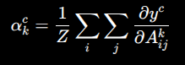
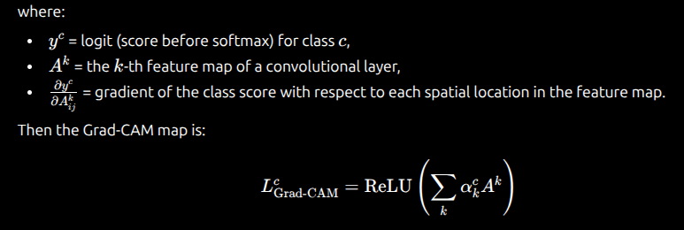

Observation:
The model seems to be focusing on the digit area where both colour and shape are present. So, GradCAM alone cannot conclude whether the model is focusing on shape or colour. But combining the test result from Task 2 with GradCAM result, we can probably infer that model might be looking at colour in the biased data.
In the conflicting data, due to presence of noisy background and different colour of the data, the heatmap appears to be smeared.

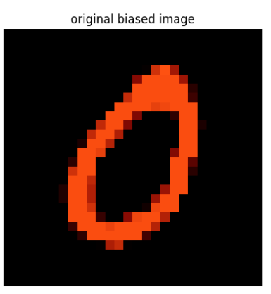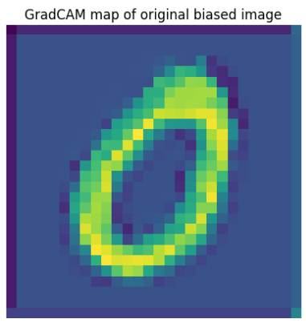

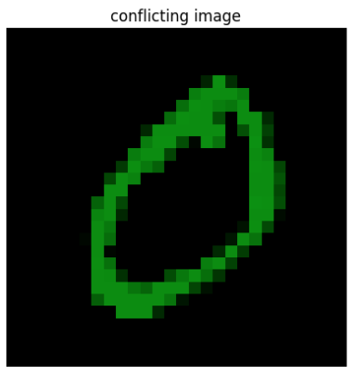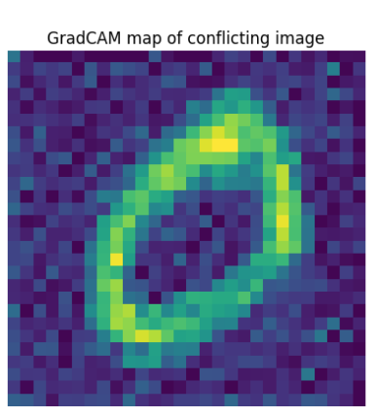

Task 4 - The Intervention
In this task, the model was re-trained to ignore the colour and focus on shape.
Constraint: The original colourMNIST dataset should not be changed and neither can the input be converted to grayscale before sending to the model.

Training Strategy:

Method 1: As introduced by the paper “Right for Right Reasons: Large Language Models for Verifiable Commonsense Knowledge Graph Question Answering”.
In this paper, the authors use input gradients as explanations of what the model is paying attention to, and then add a penalty term to the loss function that discourages the model from relying on features known to be irrelevant.

Step 1: gradient tracking on the input. Converting each pixel in input image into variable for gradient calculation.
Step 2: forward pass
Step 3: input gradient (d(loss)/d(input) and masking
Step 4: penalty term calculation using input gradient * masks
Step5: total_loss = classification_loss + λ × gradient_penalty
Step 6: backpropagation

Results:

Split | Loss | Accuracy
Train | 0.0003 | 100%
Validation | 0.0001 | 100%
Test | 40.58 | 5.37%

Observation:
This method did not work since it was designed for spatial feature. In the paper, they used Decoy MNIST (MNIST images with misleading 4×4 color swatches in corners whose shade correlates with the digit label during training but is random at test time). These datasets were specifically chosen or constructed to contain spurious confounds where the model can achieve high training accuracy using shortcuts that fail to generalize at test time.
Since shape and colour feature overlap in colourMNIST data, it is difficult to segregate both and penalize one.

Method 2:
Method 1 penalizes the total gradient magnitude on digit pixels which was a little too aggressive as it forced the model not rely on digit appearance at all. This method penalizes only the color deviation of gradients on digit pixels, it allows gradients to be large but forces them to be equal across R, G, B channels. This tells the model "you can look at the digit, but you must treat all color channels the same," which preserves shape information while removing color bias.

Step 1: Gradient tracking on the input. Converting each pixel in input image into a variable for gradient calculation.
Step 2: Forward pass to get classification logits.
Step 3: Input gradient (∂(target_score)/∂(input)) computed and masked to digit region only.
Step 4: Normalize gradients, compute per-channel mean, then measure how much each channel (R,G,B) deviates from that mean — this deviation is the color bias.
Step 5: total_loss = cross_entropy_loss + λ × color_deviation_penalty.
Step 6: Backpropagation and weight update.

Results:

Split | Loss | Accuracy
Train | 0.5167 | 84.61%
Validation | 0.4771 | 84.34%
Test | 9.32 | 17.67%

Observation:
Yields comparatively better results than method 1 but did not reach satisfactory accuracy.

Additional remark:
The lambda1 (penalty regulator) was chosen based on hit and trail method. The log for this experimentation can be found in the /log folder of github repo.
Similarly, the method 2 results was chosen after performing different combination of hyperparameters (epochs, lambda1, learning rate). This is also available at /log folder of github.

Task 5: The Invisible Cloak (targeted Adversarial Attack)
This is a strength testing task for the newly re-trained robust model to check its ability to be fooled. For this task, PGD (Projected Gradient Descent) algorithm was used. The steps are as follows:
Step 1. Start with a image of 7 from dataset .
Step 2. Add small random noise within an allowed limit (epsilon, ε < 0.05) to get a starting point.
Step 3. Feed the perturbed image through the model and compute the loss (e.g., cross-entropy) against the true label. This loss needs to be maximized as I want to fool the model into understand that this is not 7.
Step 4. Backpropagate to get the gradient of the loss with respect to the input image (not the weights). This tells the direction in which each pixel should change to increase the model's confusion.
Step 5. Update the image by moving each pixel a small step (α) in the direction of the gradient's sign. perturbed_image = perturbed_image + α * sign(gradient)
Step 6. Keeping changes within the allowed epsilon: if any pixel has moved more than ε away from the original image it was clipped back.
Step 7. Repeat step 3-6 from around 200 iterations.

Observation
The model’s probability of choosing 3 increased slightly but with less confidence score showing that model was reluctant to choose 3 even after being lured (atleast till 300 iterations!)

Task 6 - The Decomposition
In this task, the dense features represented by the classifier layer of the model was projected into sparse features in order to find more meaningful features. The ability to decompose the intermediate hidden states into an overcomplete representation is seen in sparse autoencoders, a simple 2 layered encoder-decoder neural network.
The training objective of a SAE is to sparsely reconstruct the output of a layer’s activation (having polysemantic features) into a representation having more number of monosemantic features. The encoder of the SAE projects the dense input into higher dimension thus, exposing features to be represented more sparsely among more number of neurons. This is called the latent representation and is usually denoted by z. On analysing this latent representation, we can understand the features learned by the model more intuitively and efficiently.
The loss function of SAE contains two objectives: A) reconstructions B) sparsity. The reconstruction loss should be minimized while sparsity should be maximized.

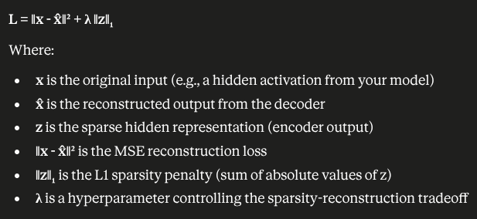

The SAE was trained for this task to reconstruct the output of classifier of the model. Following are the hyperparameters of the training:
- Loss function: MSE (Mean Squared Error) for reconstruction
- Optimizer: Adam with learning rate 1e-3 and weight decay 0.001
- Sparsity penalty (λ): 0.001
- Hidden_representation size : 32768

Finding colour-related features
Approach:
- For a given colour (e.g., green, red, blue), the code filters samples by checking the average RGB values of the digit pixels (using the mask) against predefined colour rules. For example, a pixel region is considered "green" if the green channel is greater than both red and blue.
- For each filtered sample, the image is passed through the CNN to get activations, then through the SAE to get the latent representation.
- The top-k (k=10) most active features in the latent vector are recorded for each sample.
- Feature frequency is counted across multiple samples of the same colour and digit combination.
- This is repeated for different colour-digit pairs (e.g., green 3 vs green 9) and the common and unique features between them are compared.
How colour features were identified:
- Features that appear frequently across samples of the same colour but different digits are likely encoding colour information rather than shape.
- A dictionary (feature_to_colors) was built that maps each feature to all the (colour, digit) pairs it appeared in.
- Features that appeared across many colours were considered colour-encoding features.
- The final list (idx_colour) contains the indices of features identified as colour-related.
Similarly the shape related features were also found. The top highly activating features are shown in details in the notebook.

Performing feature activation patching to validate the above found features

Colour Feature Validation

Sub-Data creation
- Extracted train/test images, labels, and masks from dataloaders.
- Identified each image's colour by matching the brightest digit pixels' average RGB to predefined colours using Euclidean distance.
- Grouped images by colour (0–9) for both train and test sets.
Creating colour-specific dataloaders:
- For each colour, picked 100 random train samples + all test samples of that colour.
- Combined them into a single dataloader per colour containing all 10 digits but only one colour.
Baseline test:
- Ran the model on a colour-specific loader (e.g., colour 9) to get baseline accuracy.
Perturbation:
- Registered a hook on classifier[0] that passes the output through the SAE encoder, zeros out all previously identified colour feature neurons (idx), then decodes back.
- Tested the model again with the hook active.
Result:
The test accuracy after perturbation od colour feature decrease to substantial extent showing the importance of those neurons in capturing the colour related aspects.

Shape Feature Validation
Similar steps were performed as above with perturbing shape features.

Result:

Did not find any decrease in accuracy of test results probably due to models inability to capture shape related features.

The results of this experimentation is logged in details and is provided in Github.

Additional observation on polysemantic neurons:

Polysemantic neurons: are neurons that respond to multiple unrelated features or concepts rather than encoding a single specific feature

Following neurons were found to activate on both colour and shapes:

1438, 3543, 5702, 6469, 7219, 8918, 9603, 10228, 11375, 13136, 14126, 14360, 14626, 15006, 18034, 20613, 21836, 26463, 27137, 30715

Conclusion
The simple 3-layered CNN model showed biases towards colour feature after training on coloured MNIST. On further analysis, some neurons (feature maps) were found to detect specific colours while none of them were seen detecting shapes (edges/curves etc). Due to overlapping of shape and colour feature in the same spatial location of images, it was difficult to make the learn shape features and ignore colour features. The re-trained model was seen to handle target adversarial attack well. Finally, using SAEs, feature related neurons were discovered and verified using activation patching.

References
[1] Selvaraju et al., "Grad-CAM: Visual Explanations from Deep Networks via Gradient-Based Localization," ICCV 2017.
[2] Erhan et al., "Visualizing Higher-Layer Features of a Deep Network," Technical Report, University of Montreal, 2009.
[3] Nguyen et al., "Understanding Neural Networks via Feature Visualization: A Survey," Explainable AI, Springer, 2019.
[4] Geirhos et al., "ImageNet-trained CNNs are biased towards texture; increasing shape bias improves accuracy and robustness," ICLR 2019.
[5] Geirhos et al., "Shortcut Learning in Deep Neural Networks," Nature Machine Intelligence, 2020.
[6] Ross et al., "Right for the Right Reasons: Training Differentiable Models by Constraining their Explanations," IJCAI 2017.

Missing attempt:
The last task of the assignment expected steering of the biased CNN model towards learning shapes using neurons discovered from SAE. This could not be done as features related to shapes were not found (as proved in the last stage of activation patching where the found features were not affecting the test performance after perturbation).
I will continue to work on the re-training (Task 4) until I find a way to make the model focus on the shape. Once this step is fixed, I assume to find shape related features which I can perturb to steer model towards fairness.

